
0113 258 1150
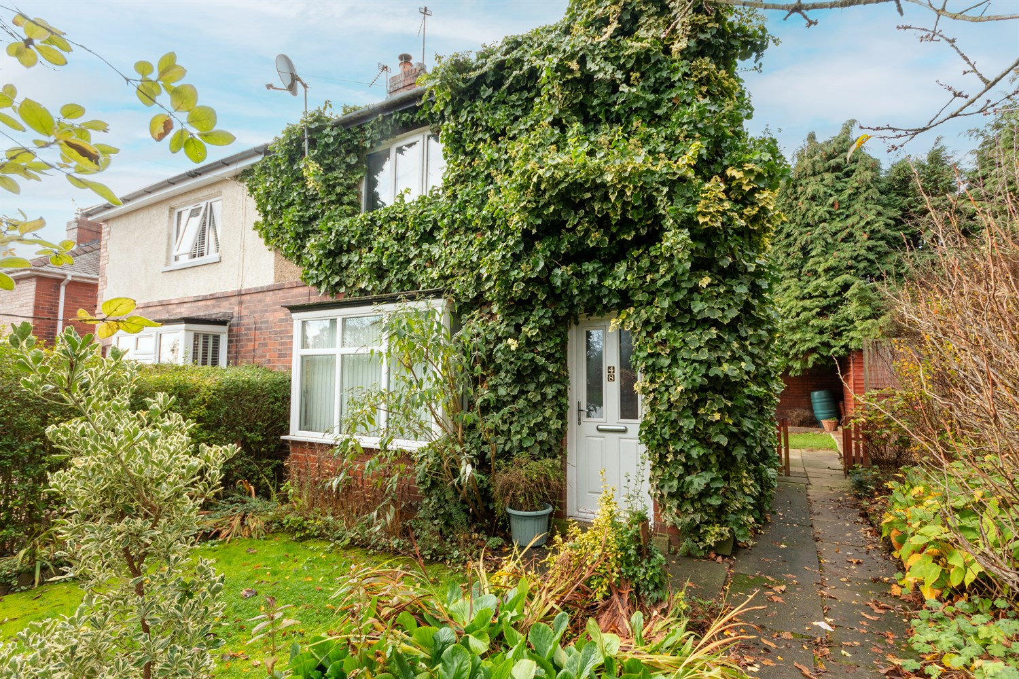



For Sale £139,950.00

Sunnyfield, East Ardsley

**THREE BEDROOM SEMI-DETACHED HOUSE with GARAGE - IN NEED OF UPDATING** Adair Paxton are pleased to offer this three bedroom semi-detached property situated in the sought after location of East Ardsley. This three bedroom house is now in need of updating and briefly comprises; Lounge, kitchen, bathroom and separate toilet to the ground floor. To the first floor there are three bedrooms. Externally the property has gardens to three sides and a detached garage.
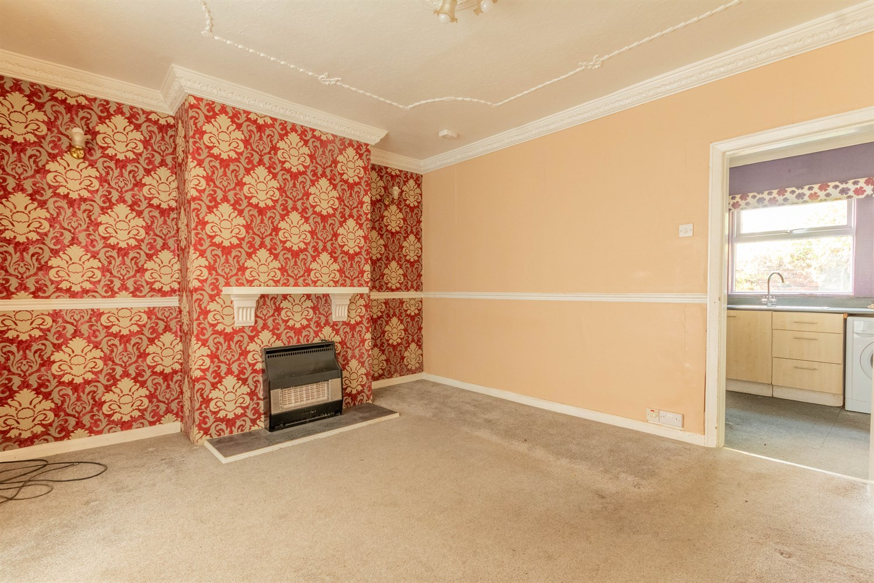
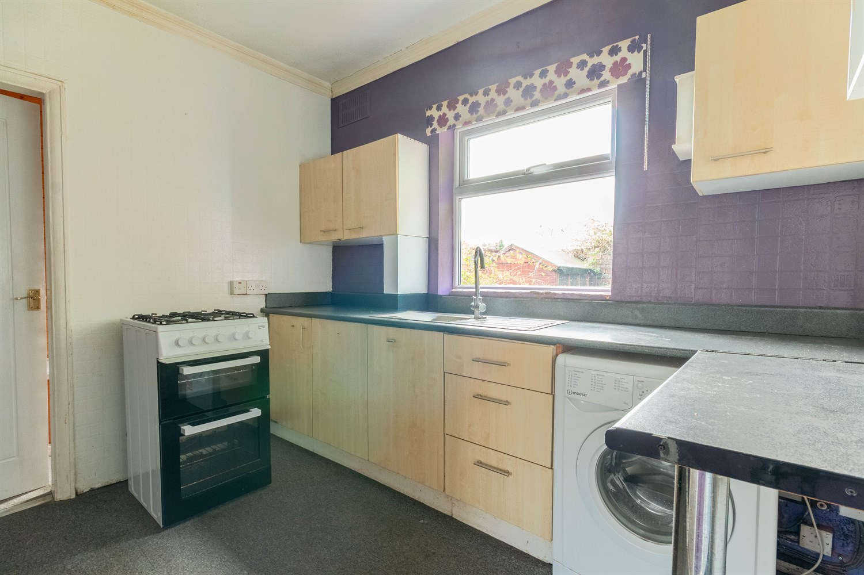
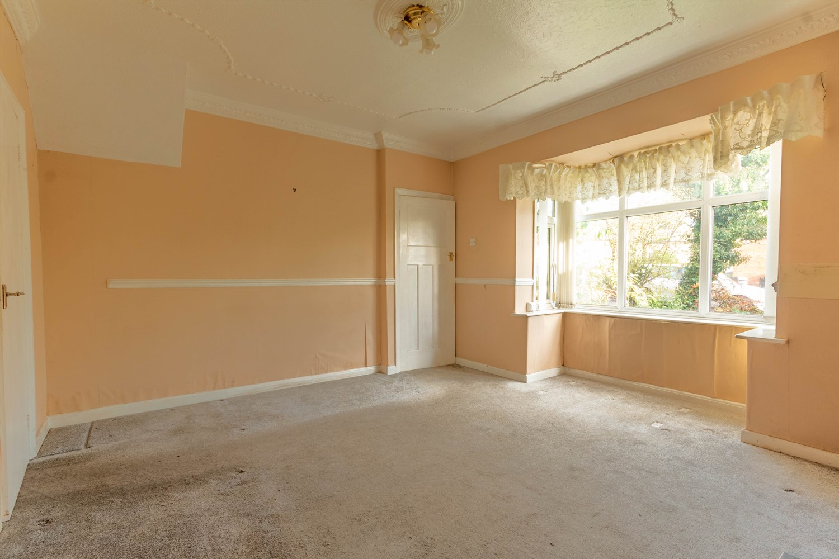
1 Bathroom(s)
1 Reception(s)
3 Bedroom(s)
00
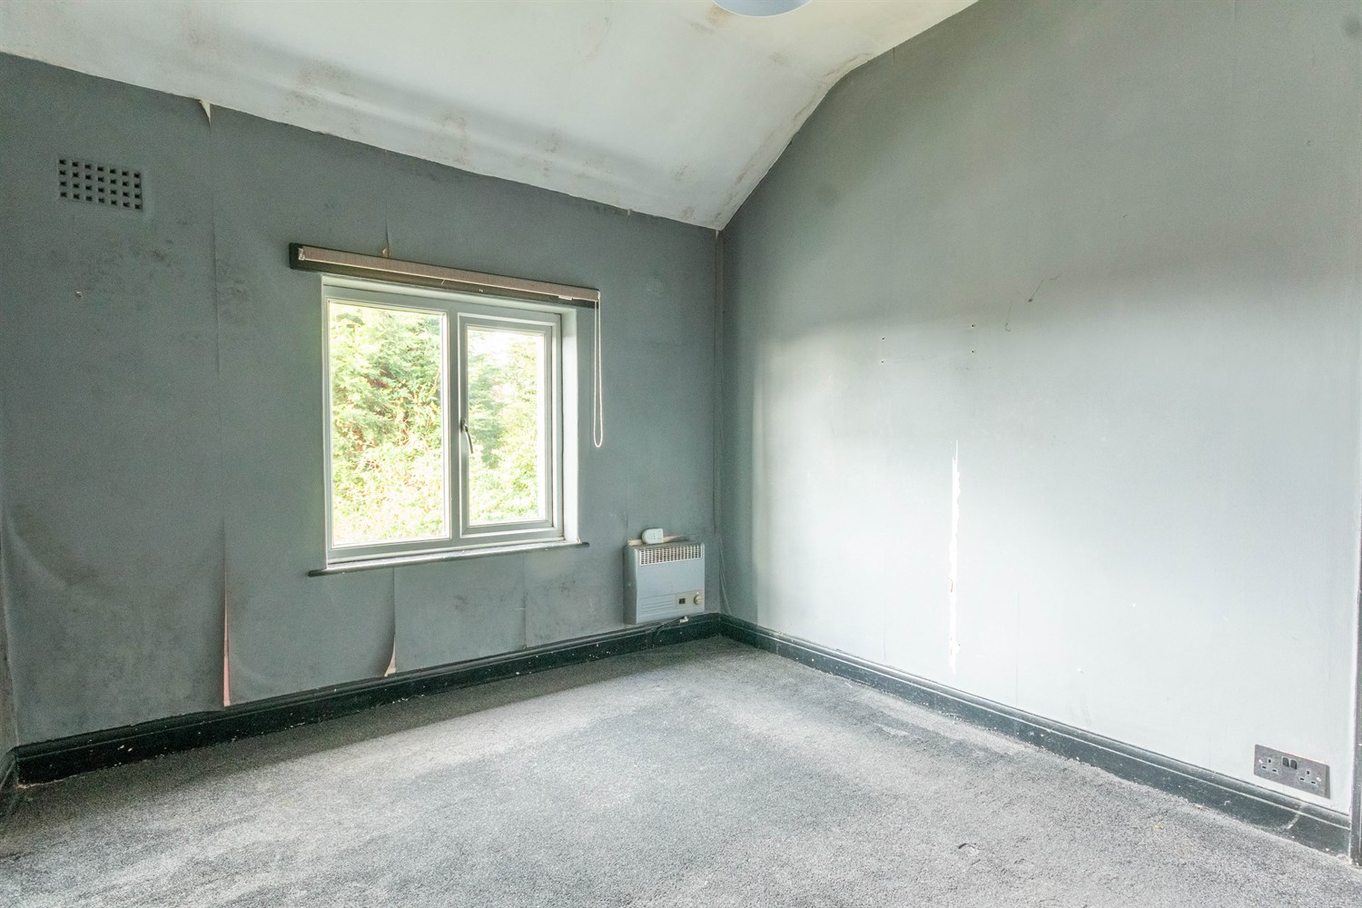
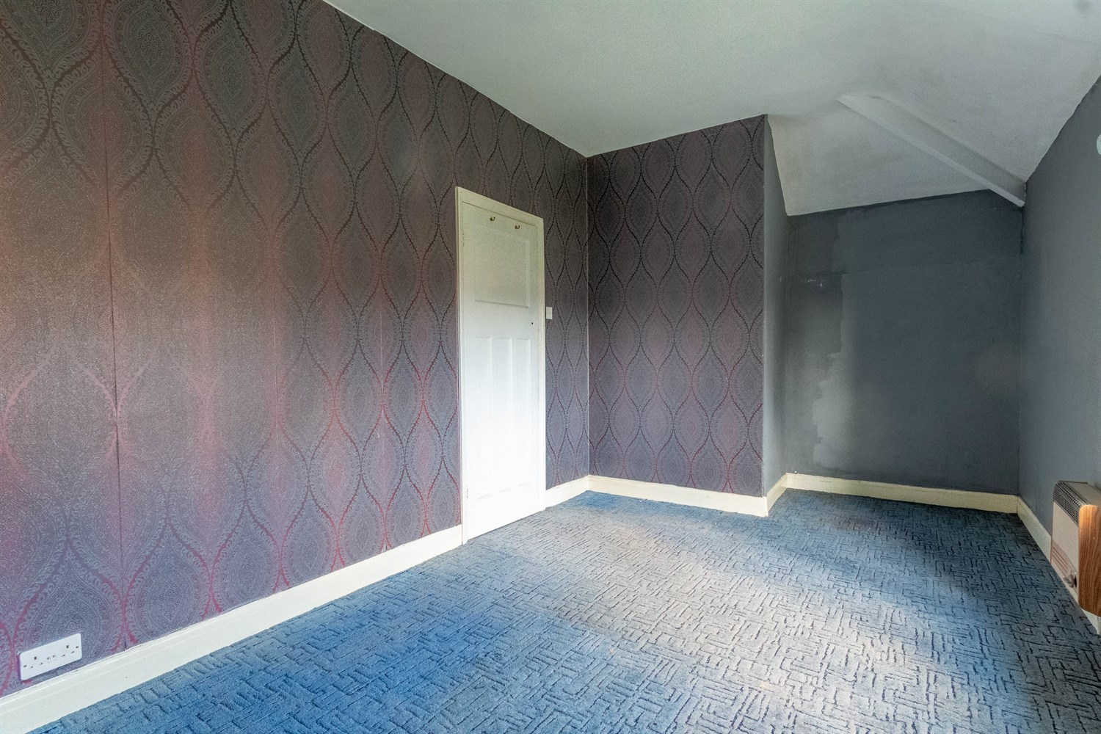
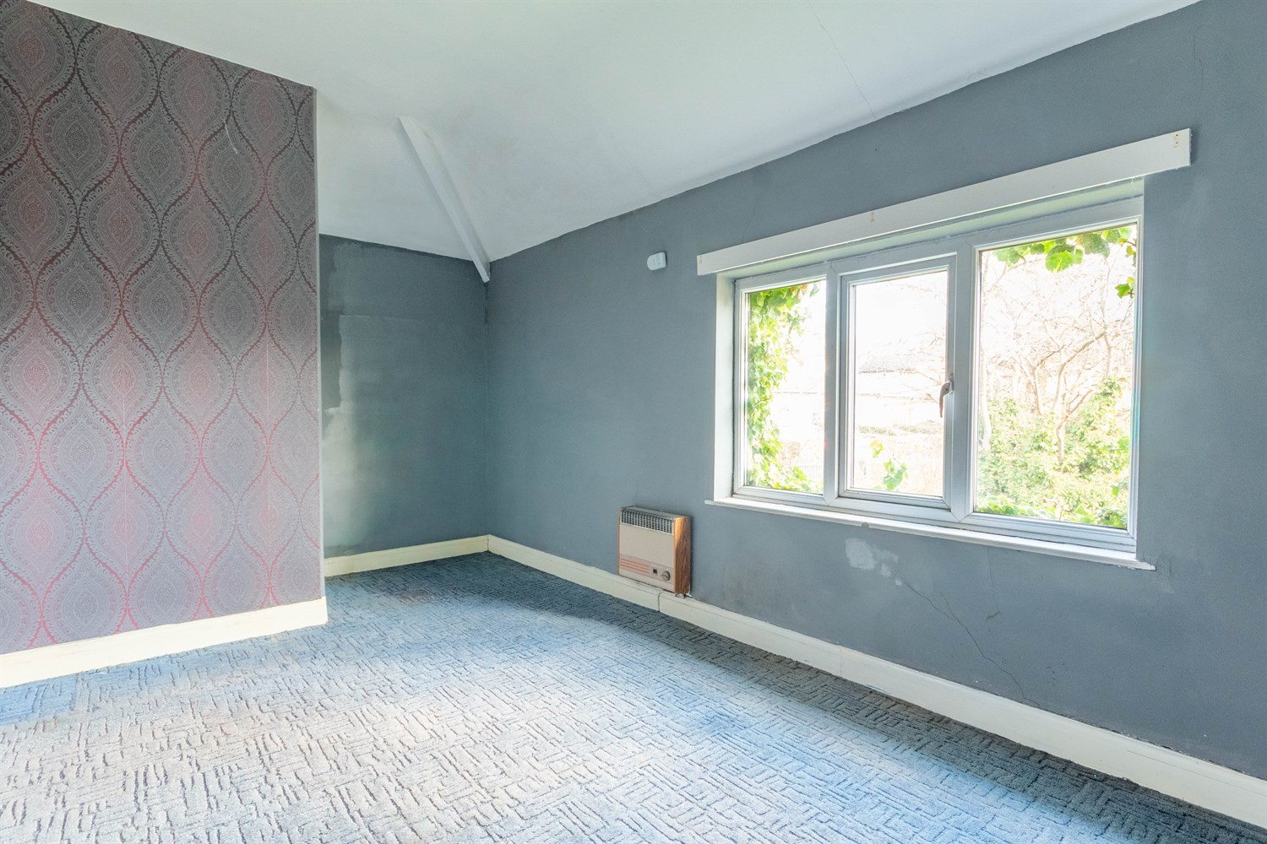
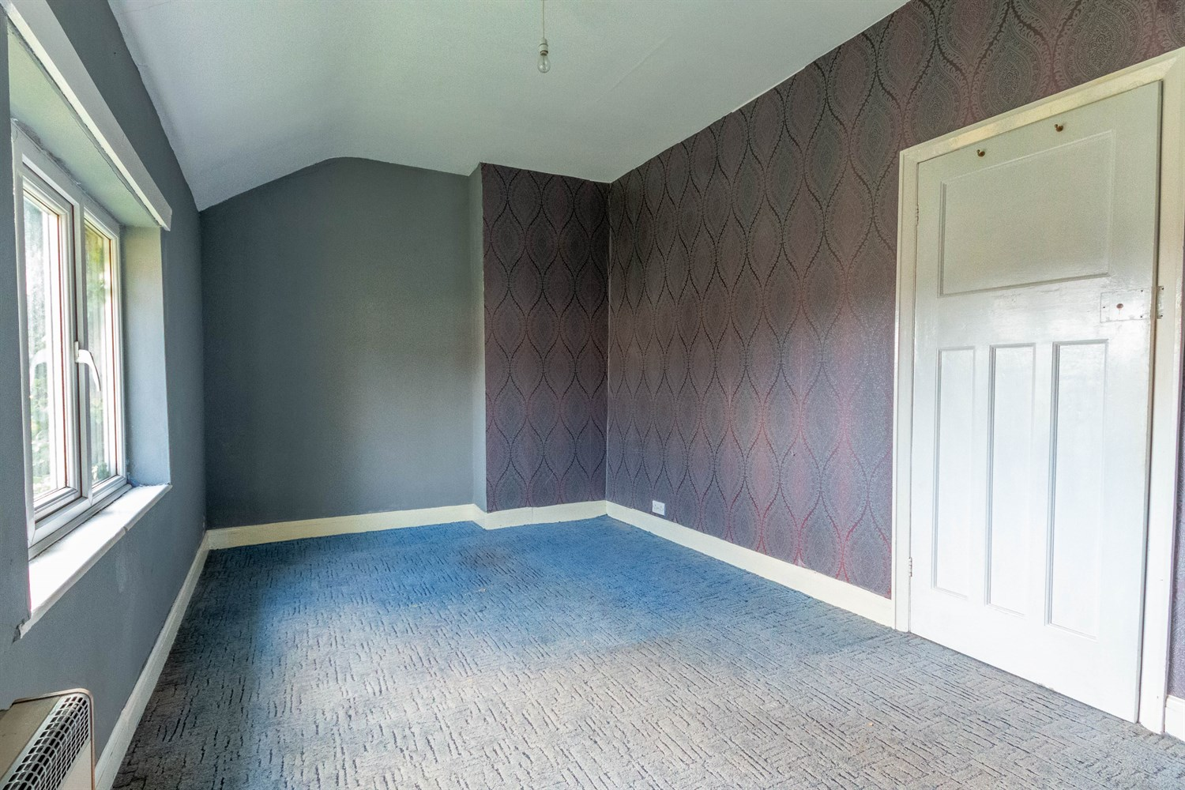
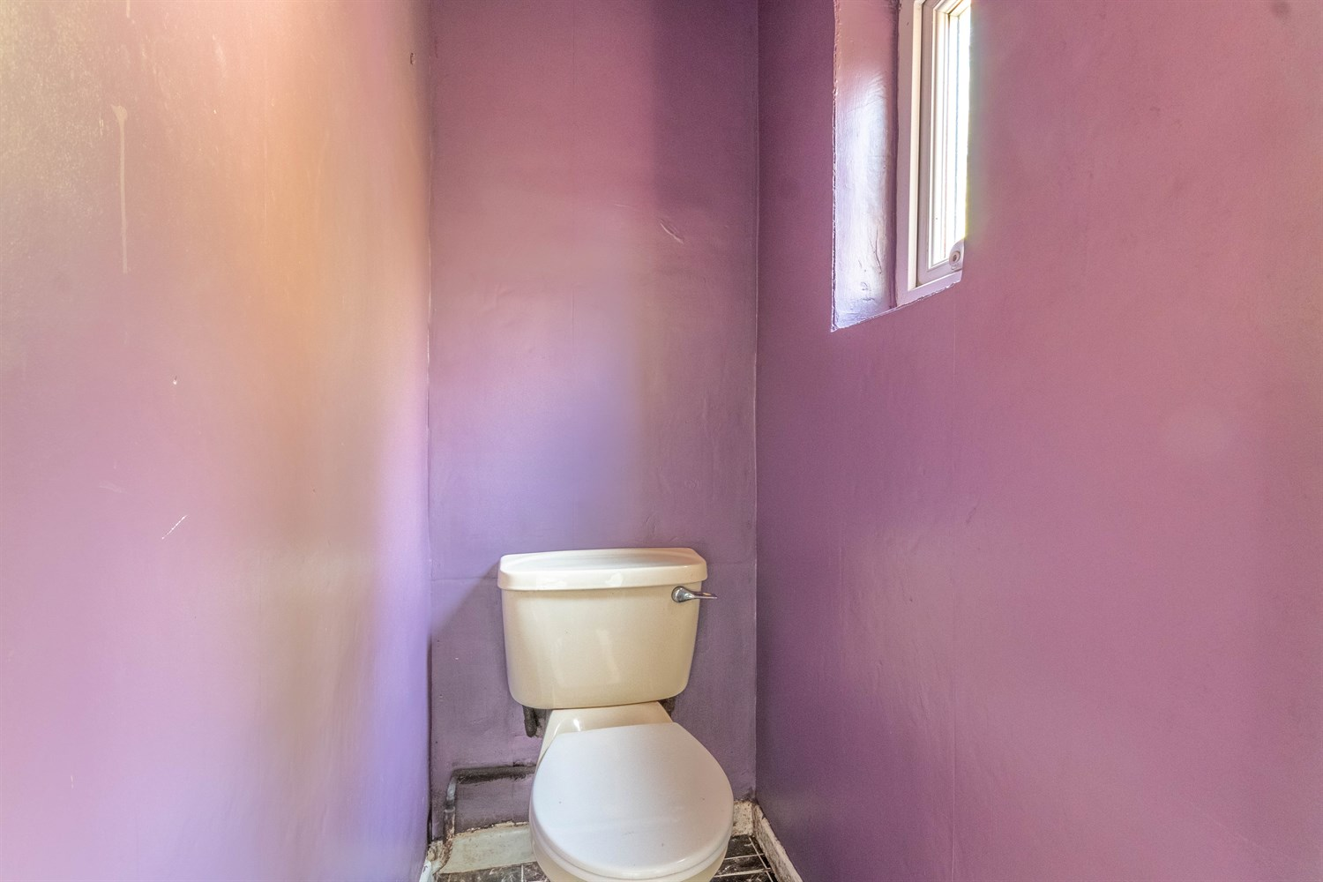
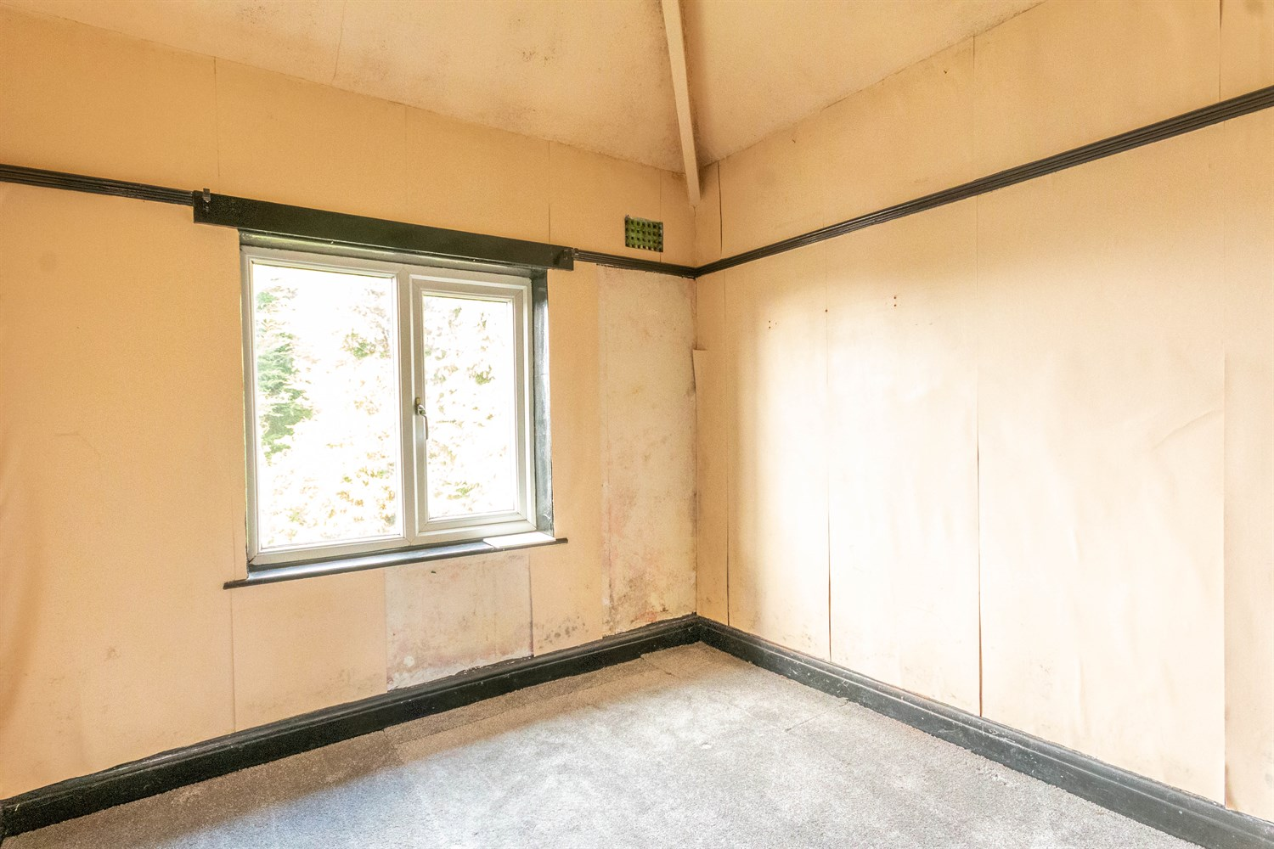
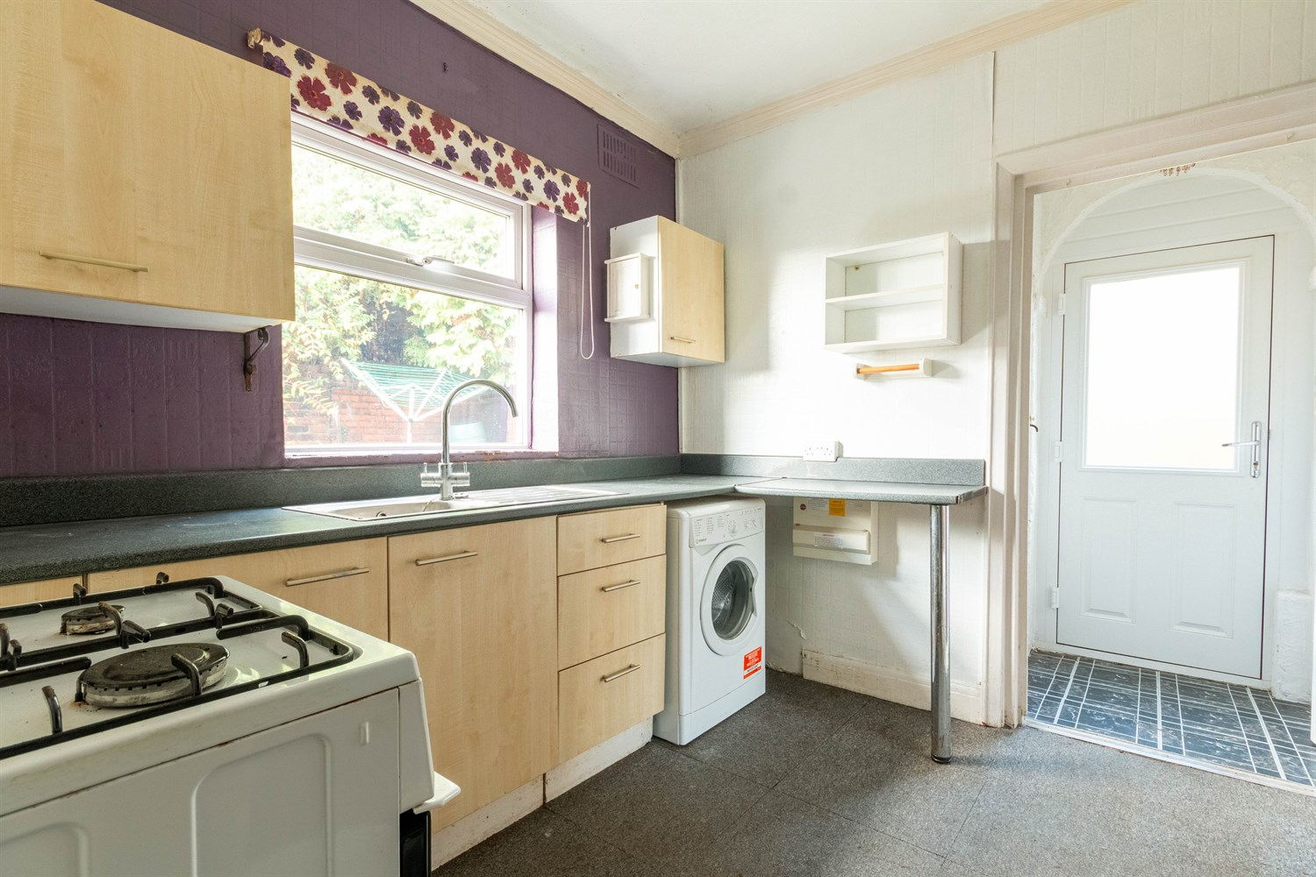
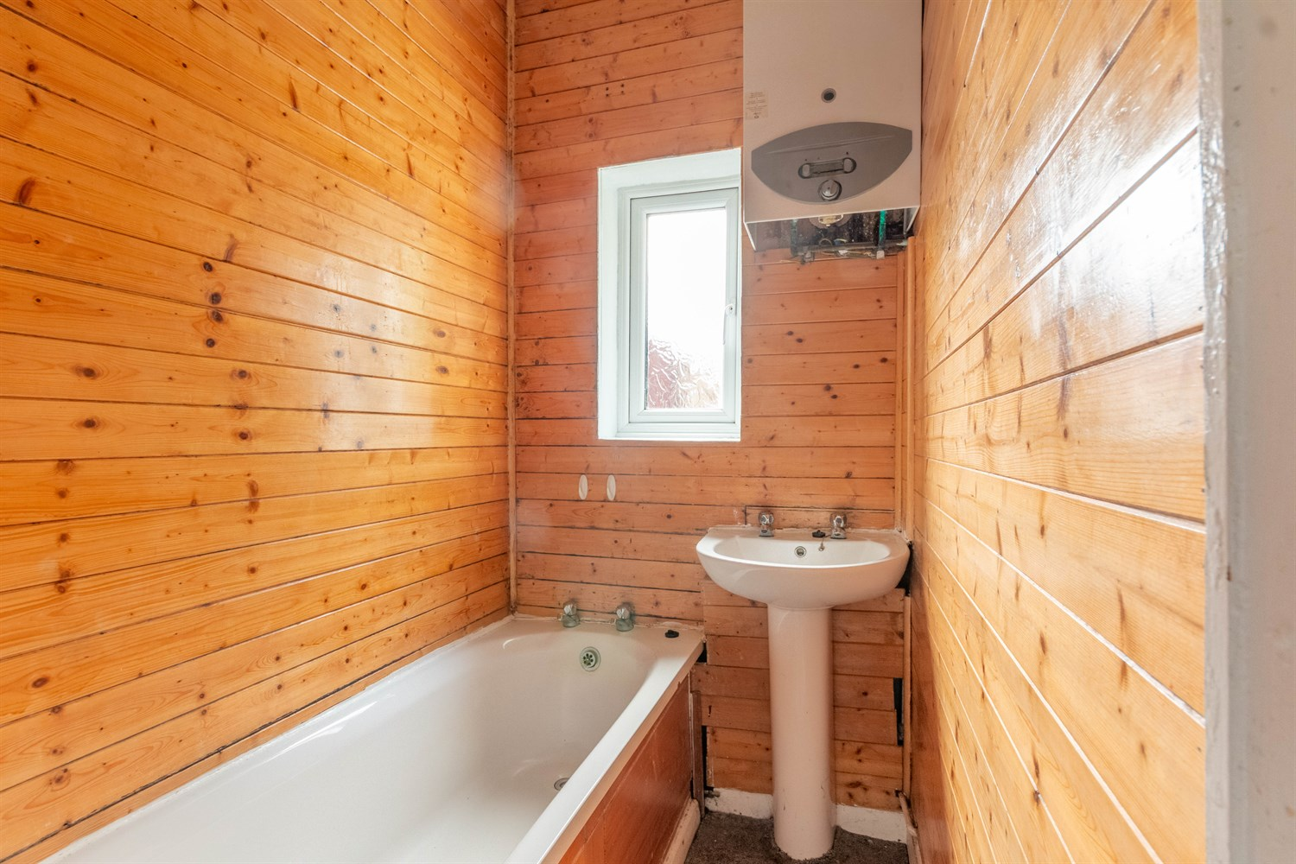

Sitting Room 4.44m (14'7) x 3.7m (12'2)
Sitting room with double glazed window to front. Gas fire.

Kitchen 3.04m (10') x 2.4m (7'10)
Fitted with a range of wall, base and drawer units with worktops over. Space for washing machine and cooker. Stainless steel sink. Double glazed window to rear.

Bathroom
Fitted with a two piece suite comprising bath and WC. Double glazed window.

Separate WC
WC. Double glazed window.

First Floor

Bedroom 1 5.63m (18'6) x 2.74m (9')
Double bedroom with double glazed window to front.

Bedroom 2 2.82m (9'3) x 3.37m (11'1)
Second double bedroom with double glazed window.

Bedroom 3 2.64m (8'8) x 2.4m (7'10)
Third bedroom with double glazed window to front.

Outside
Lawned gardens to three sides. Detached garage useful for storage.

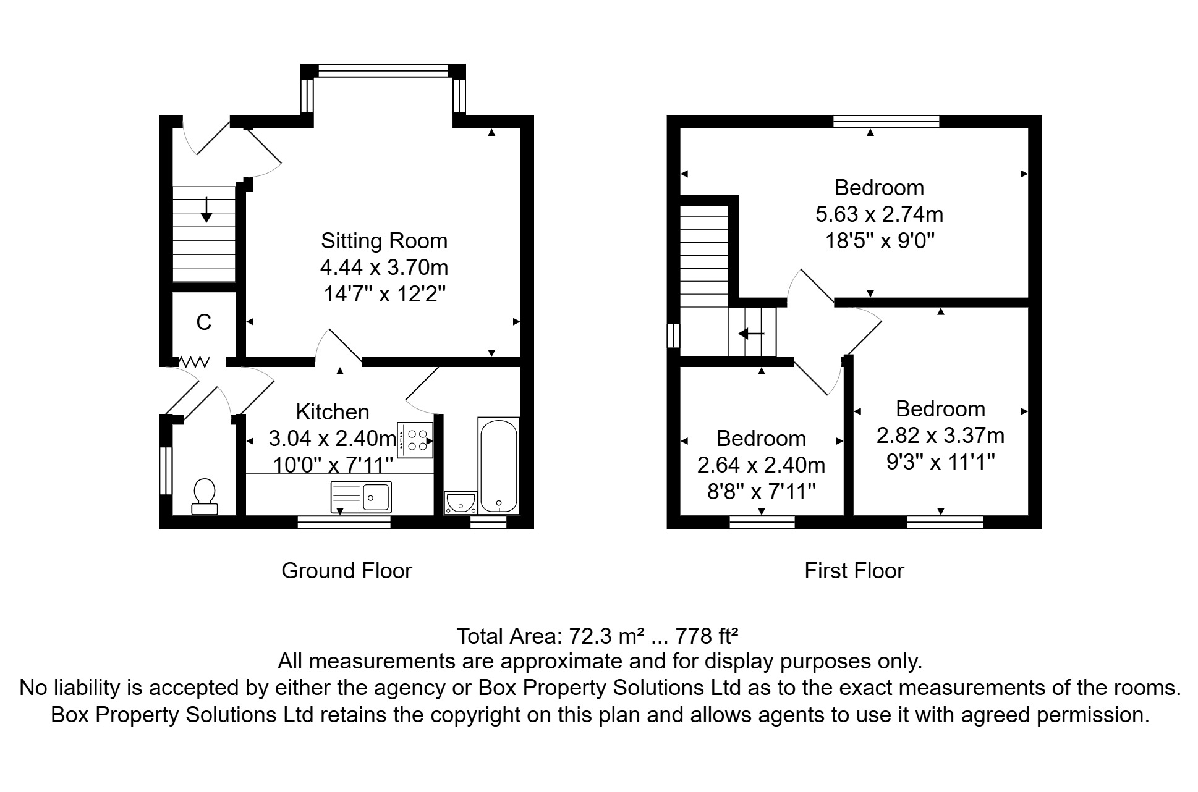

These particulars are intended to give a fair description of the property, but their accuracy cannot be guaranteed, and they do not constitute an offer of contract. Intending purchasers must rely on their own inspection of the property. None of the above appliances/services have been tested by ourselves. We recommend purchasers arrange for a qualified person to check all appliances/services before legal commitment.  Property Ref: 8113  For more information, please contact  0113 258 1150 | sales@adairpaxton.co.uk | www.adairpaxton.co.uk | 