
0113 258 1150
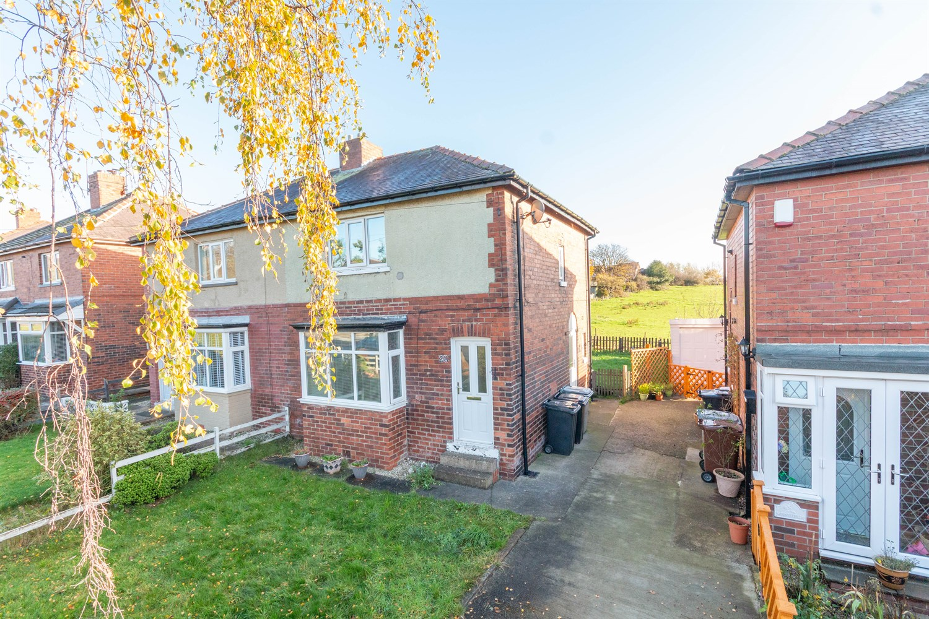



For Sale £139,950.00

Sunnyfield, East Ardsley

**THREE DOUBLE BEDROOM SEMI-DETACHED HOUSE - VIEWS OVER OPEN FIELDS - NO CHAIN - IN NEED OF UPDATING** Adair Paxton are pleased to offer to the market this three bedroom semi-detached house situated in a quiet cul-de-sac location. The property is now in need a refurbishment and briefly comprises; Hallway, lounge, kitchen, bathroom and guest WC to the ground floor. To the first floor there are three bedroom. Externally, the property has a garden to the front and a shared driveway to the side. To the rear of the property is an enclosed garden overlooking open fields.
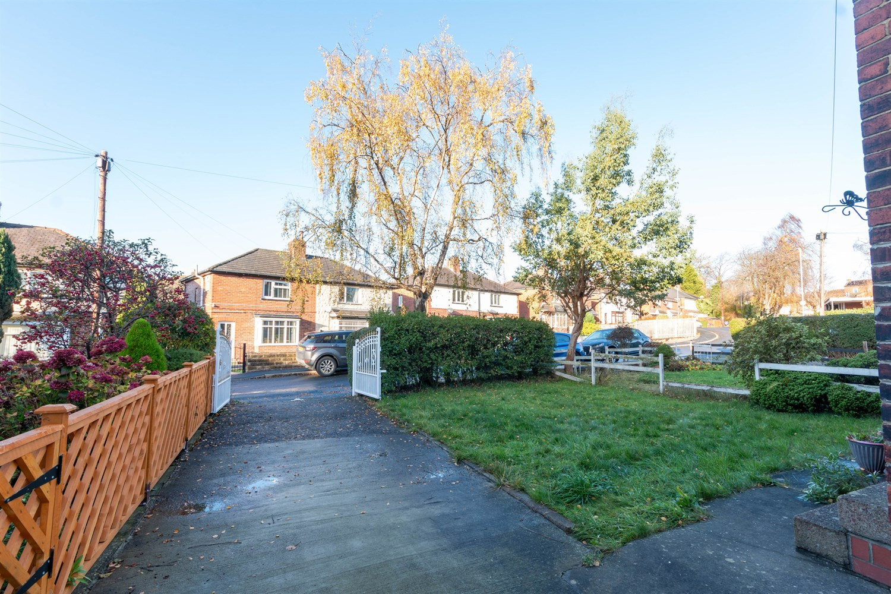
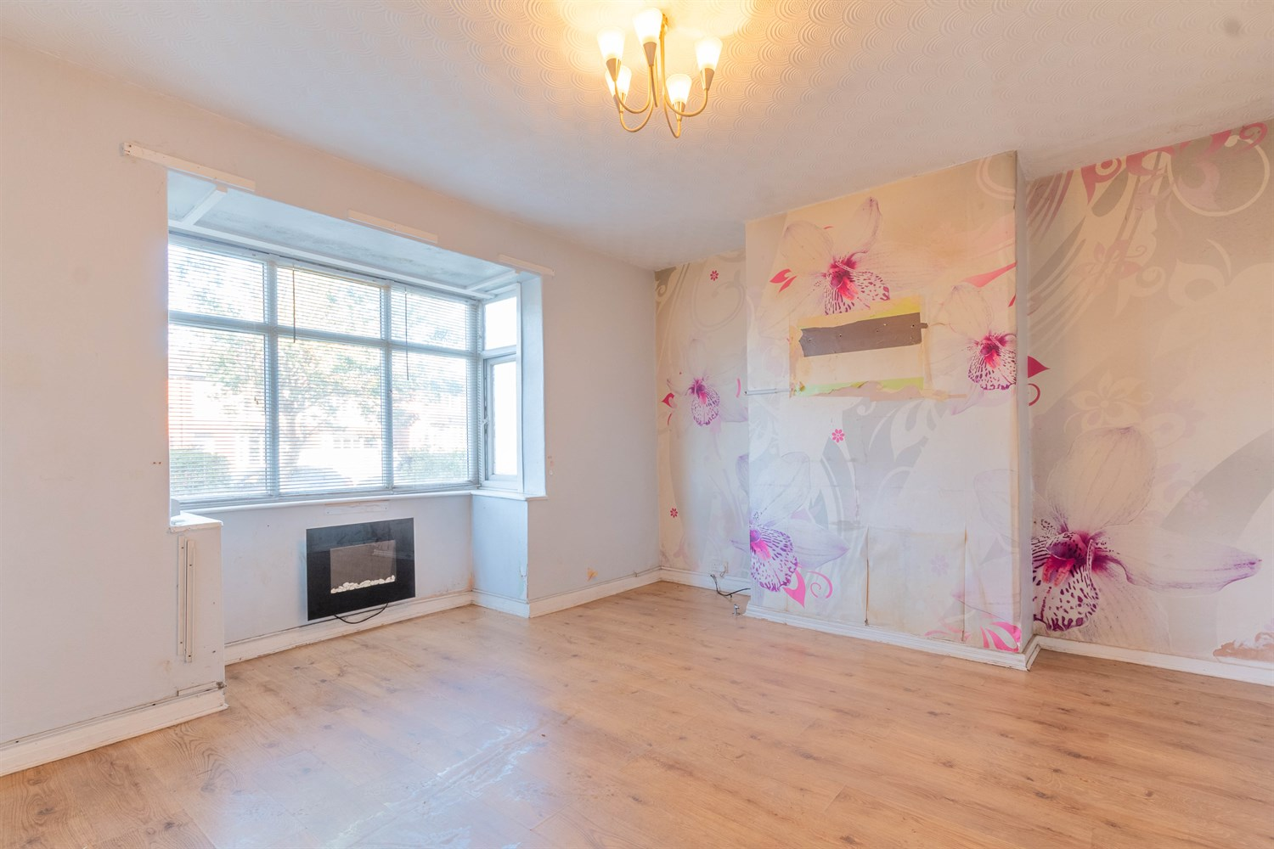
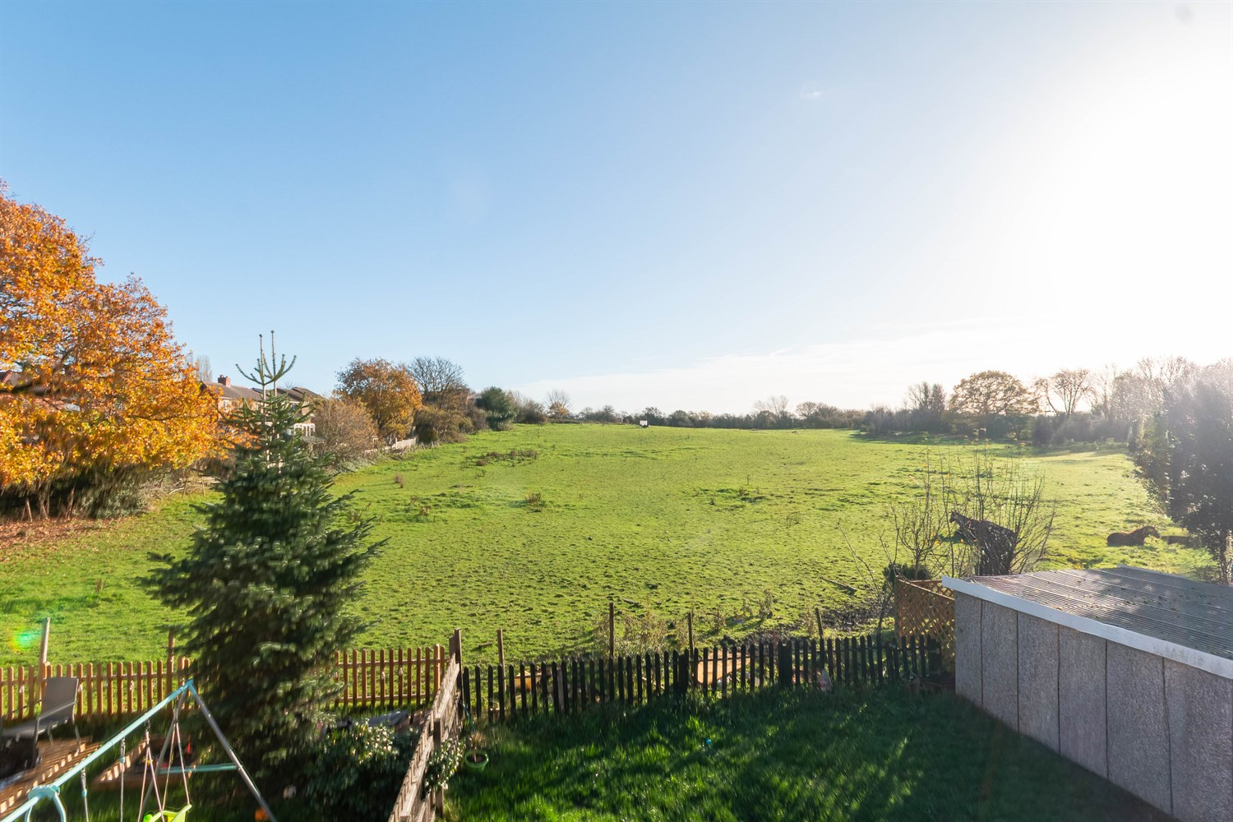
1 Bathroom(s)
1 Reception(s)
3 Bedroom(s)
00
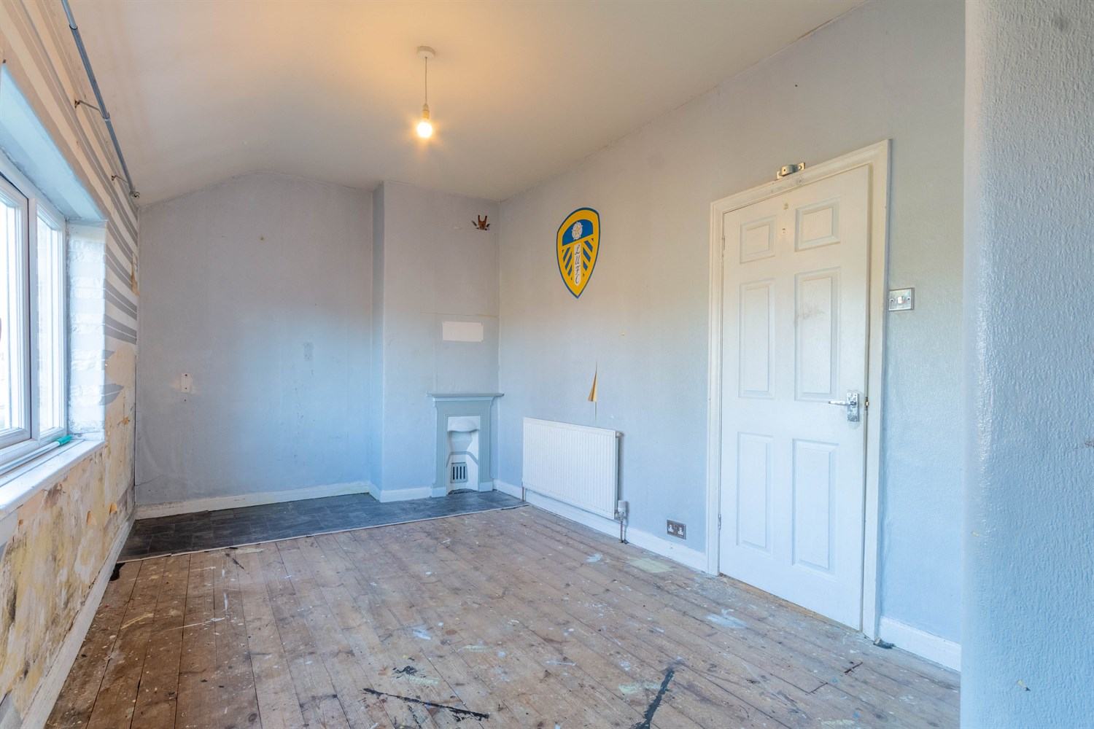
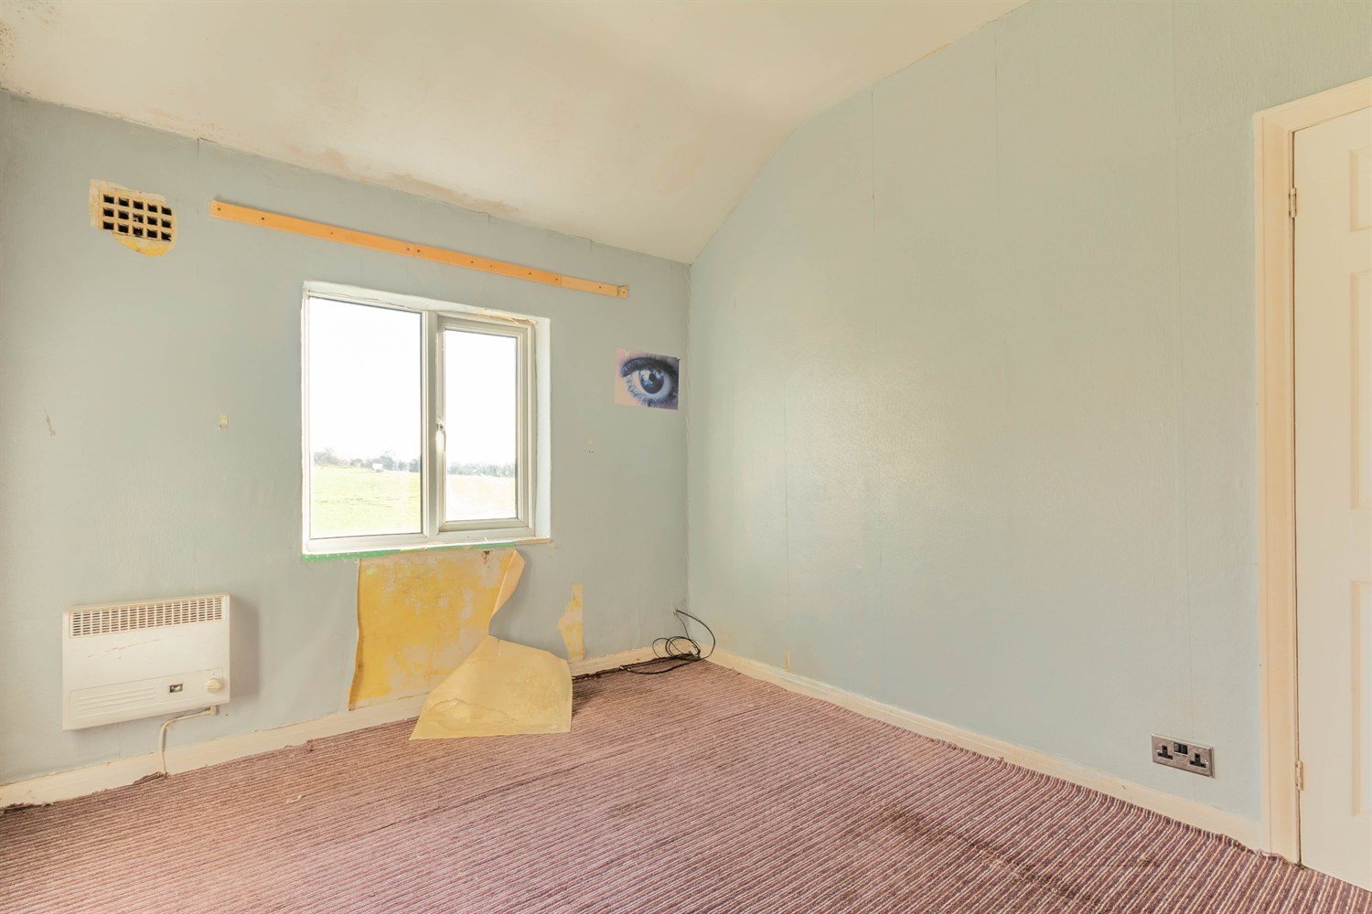
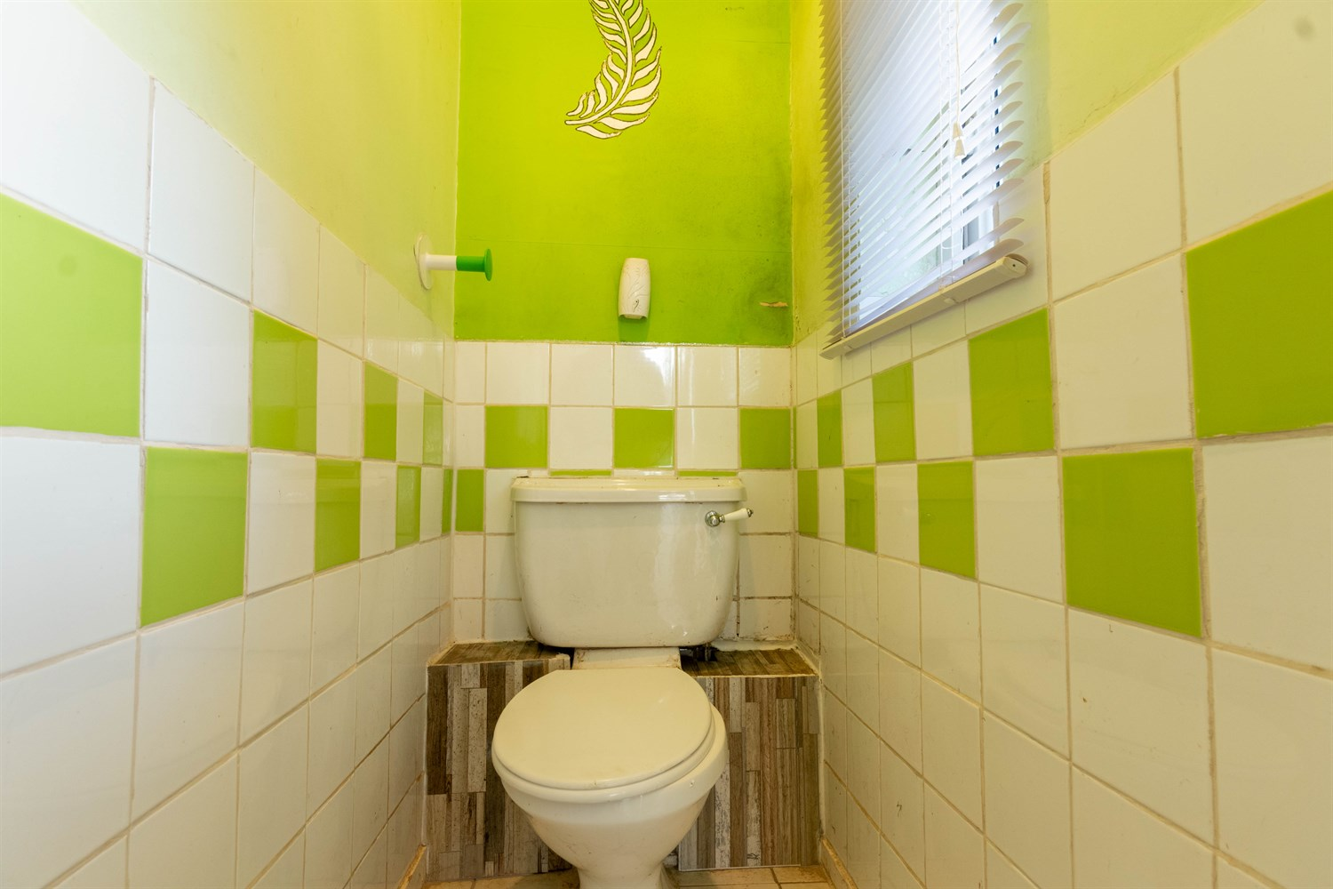
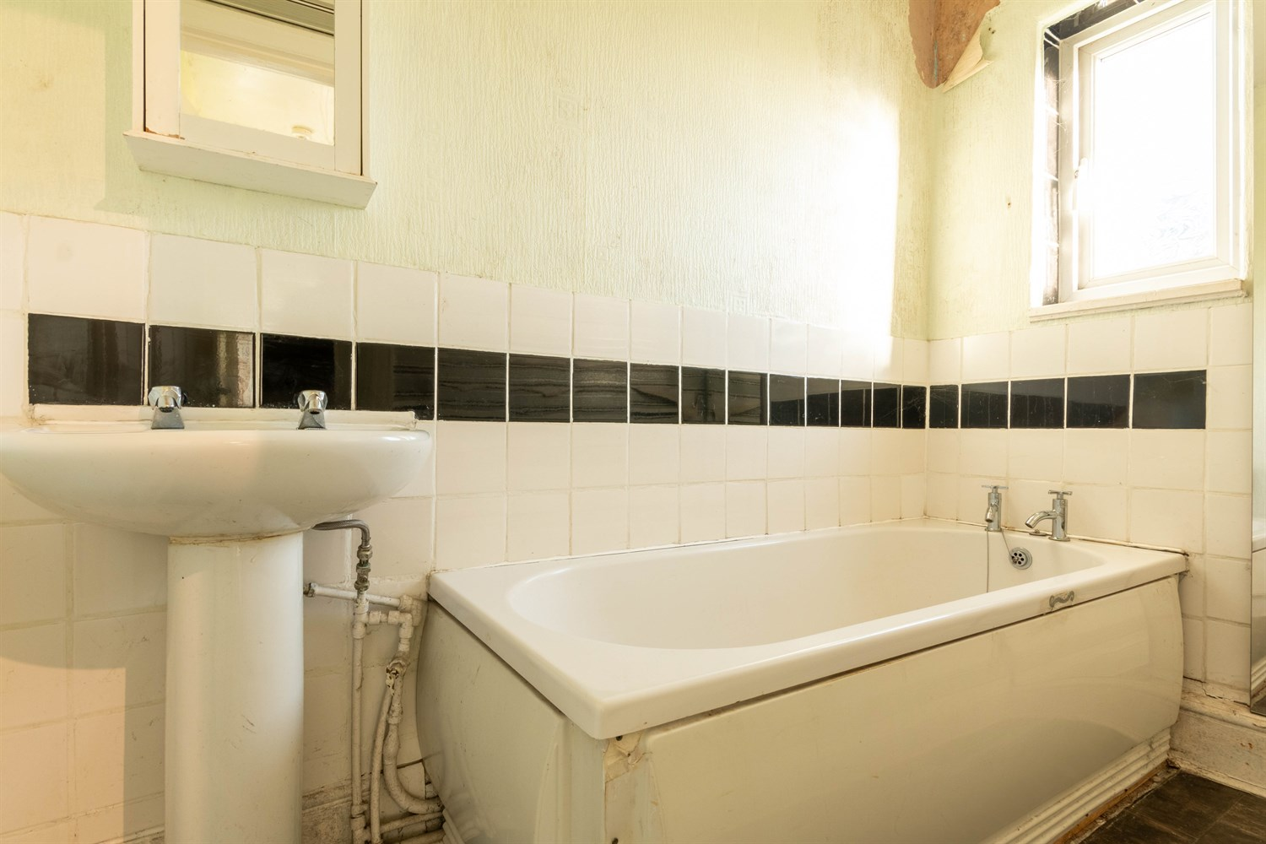
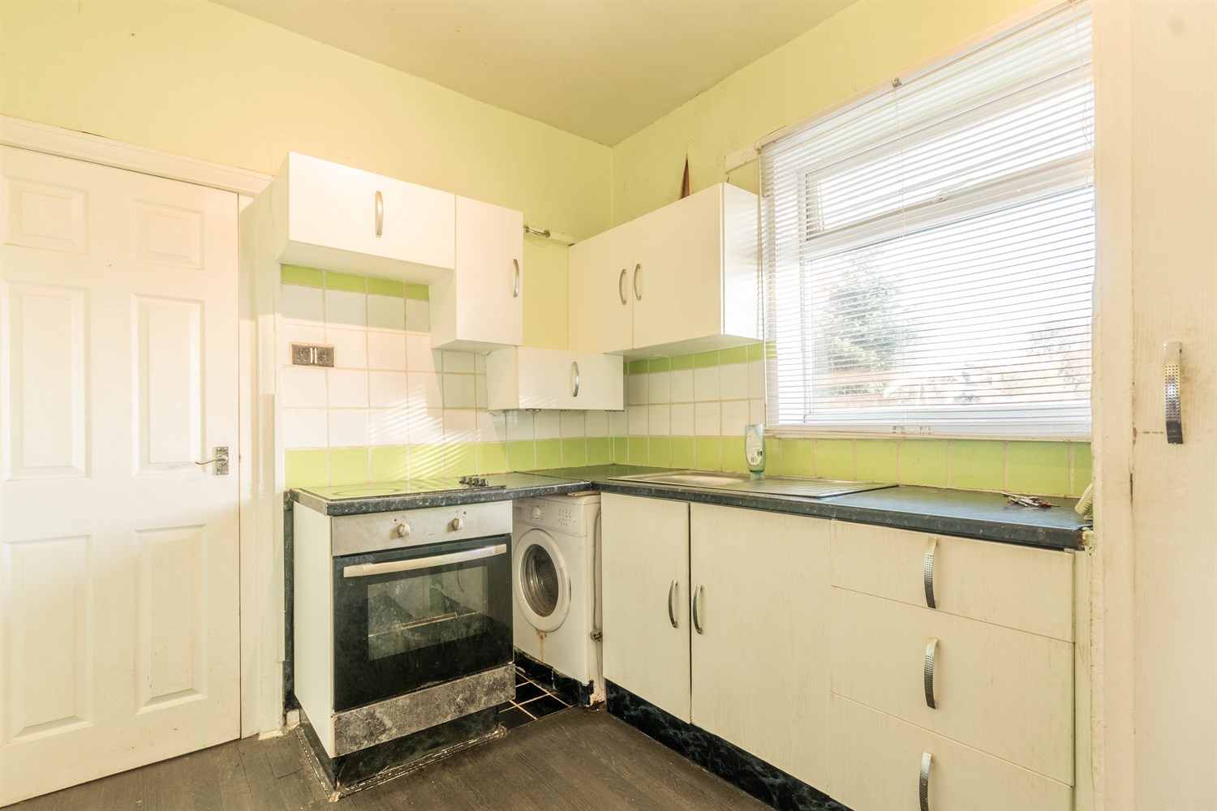
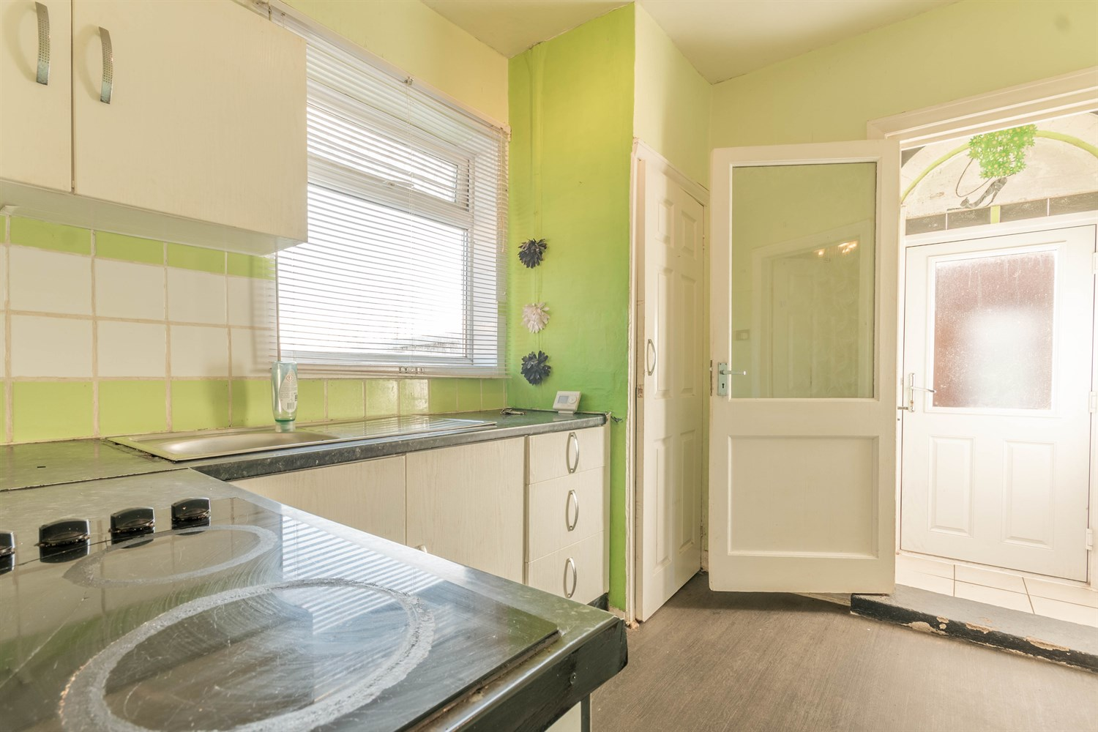
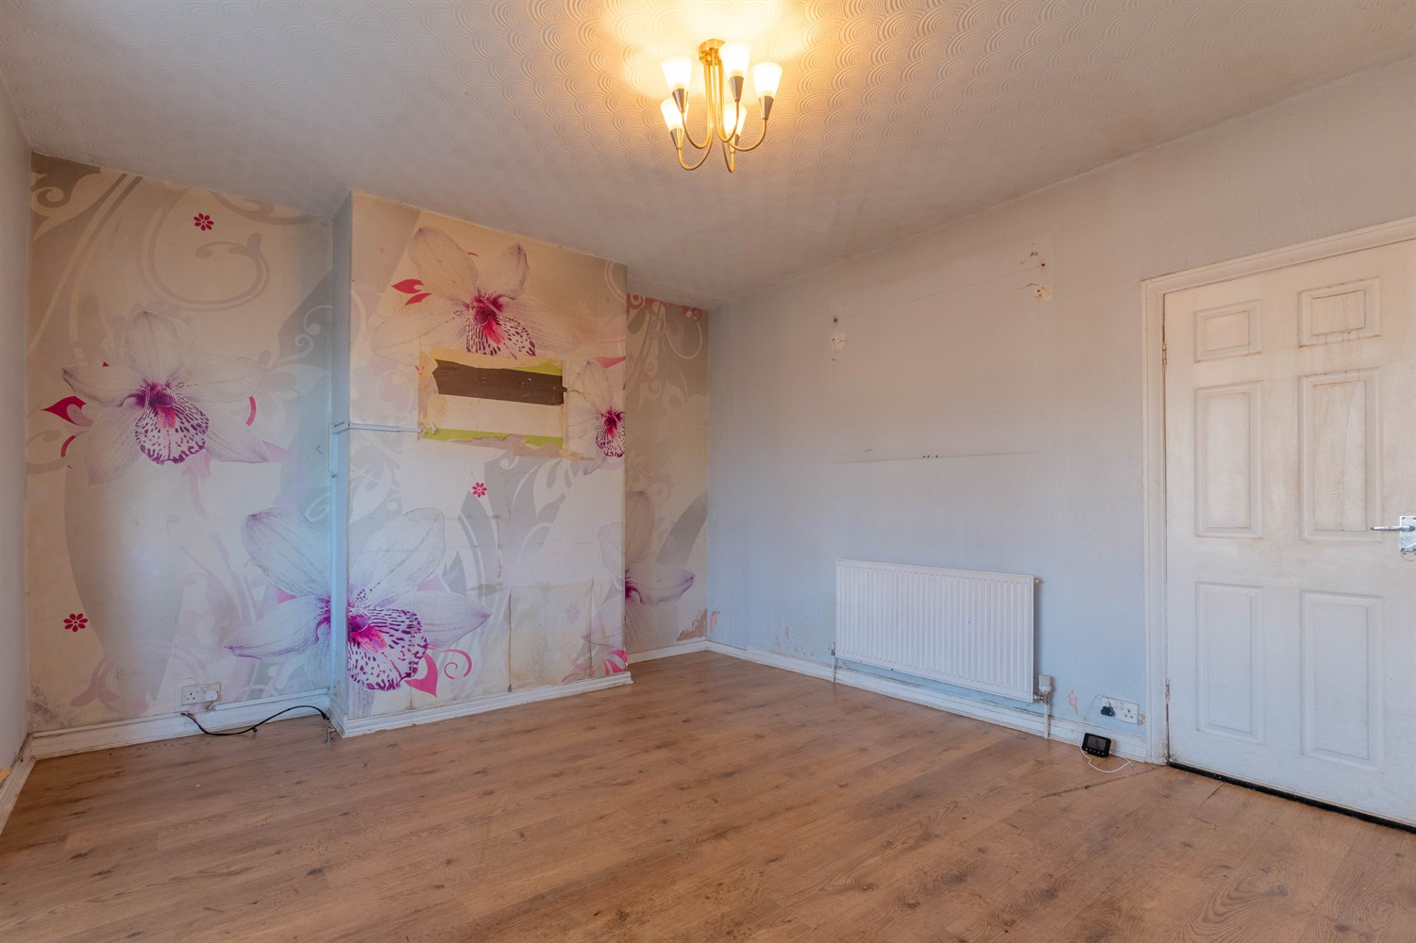
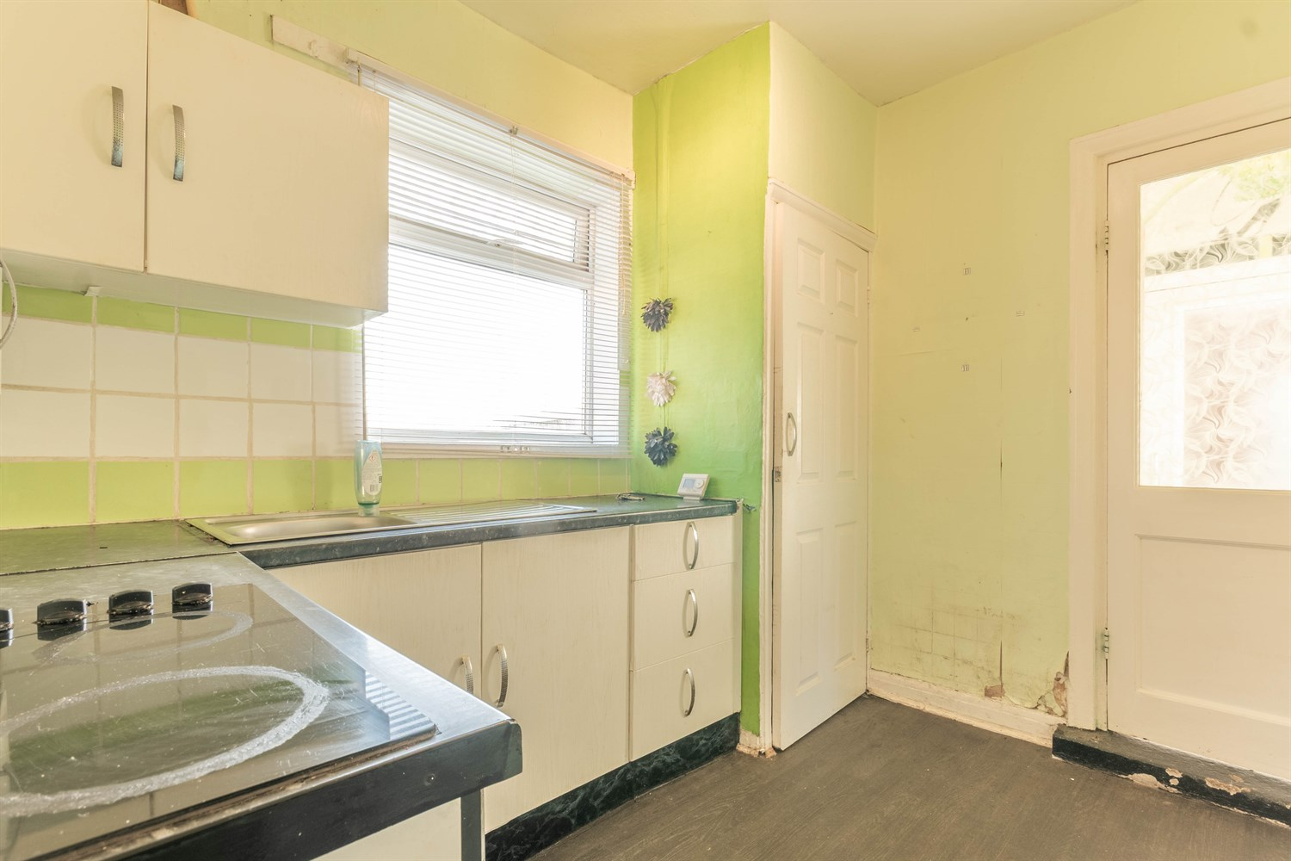

Hallway
Via front entrance door. Stairs to first floor.

Lounge 4.44m (14'7) x 3.7m (12'2)
Living room with double glazed window to front. Gas central heatign radiator.

Kitchen 3.04m (10') x 2.4m (7'10)
Fitted with a range of wall, base and drawer units with worktops over. Stainless steel sink with mixer tap and drainer. Double glazed window to rear. Part tiled walls. Store cupboard.

Bathroom
Fitted with a two piece suite comprising bath and WC. Double glazed window.

Separate WC
WC. Double glazed window.

First Floor
Landing

Bedroom 1 5.63m (18'6) x 2.74m (9')
Double bedroom with double glazed window to front. Gas central heating radiator.

Bedroom 2 2.82m (9'3) x 3.37m (11'1)
Second double bedroom with double glazed window to rear.

Bedroom 3 2.64m (8'8) x 2.4m (7'10)
Third bedroom with double glazed window to rear. Gas central heating radiator.

Outside
To the front of the property is a driveway offering off street parking. Lawned gardens to the front and rear.

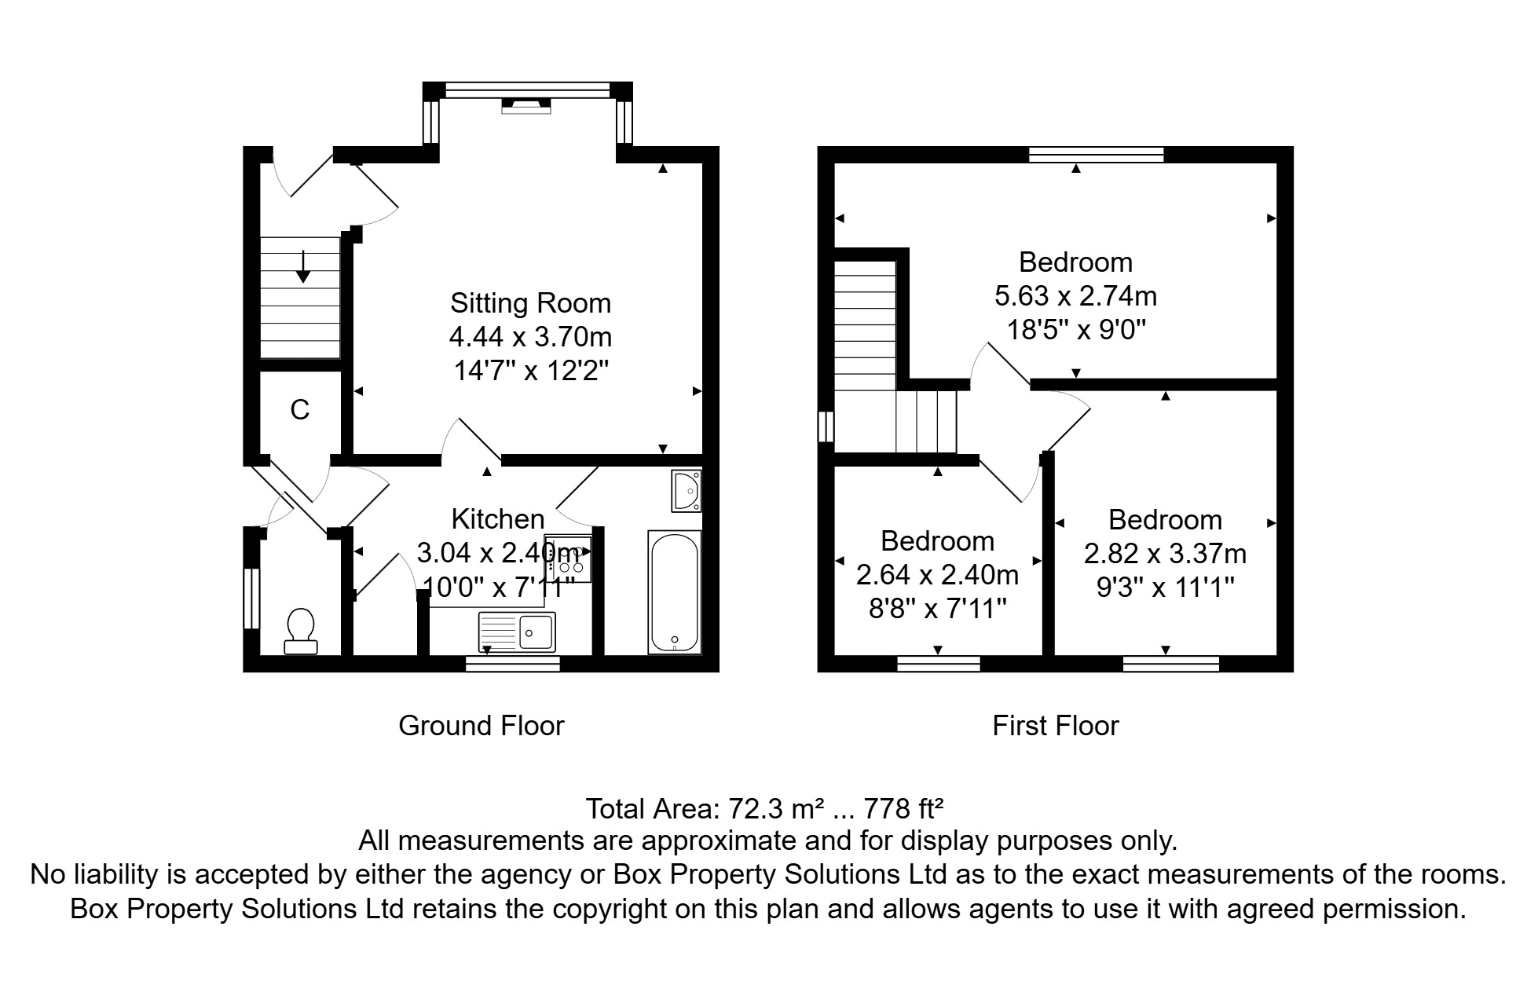

These particulars are intended to give a fair description of the property, but their accuracy cannot be guaranteed, and they do not constitute an offer of contract. Intending purchasers must rely on their own inspection of the property. None of the above appliances/services have been tested by ourselves. We recommend purchasers arrange for a qualified person to check all appliances/services before legal commitment.  Property Ref: 8112  For more information, please contact  0113 258 1150 | sales@adairpaxton.co.uk | www.adairpaxton.co.uk | 