
0113 258 1150
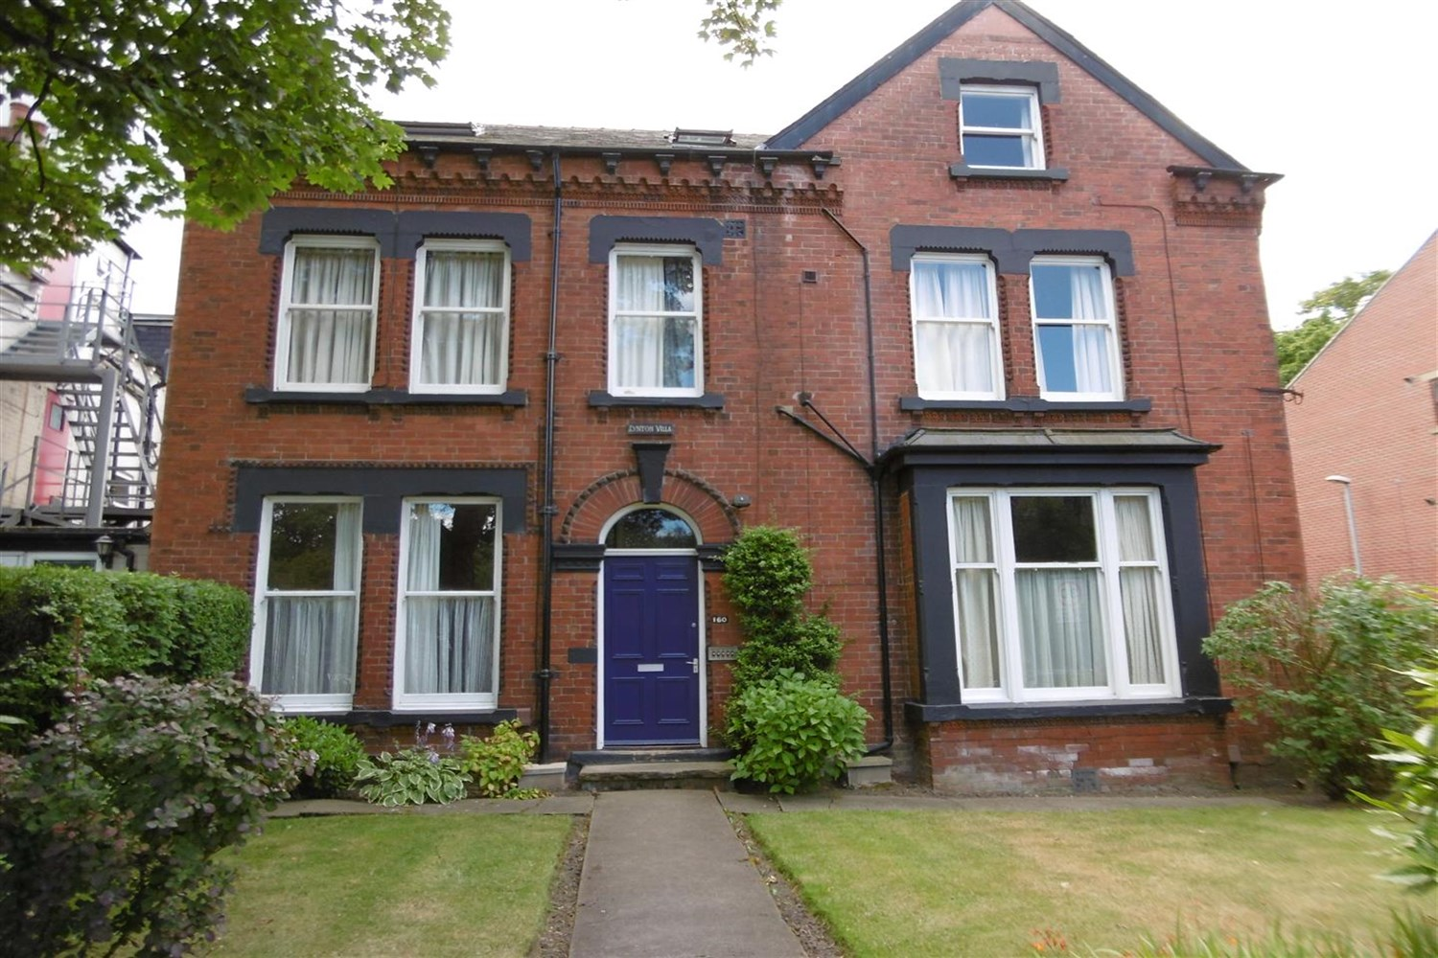



Available to let £725.00pcm

160 Woodsley Road, Leeds

*** STUDIO FLAT IN CHARACTER BUILDING*** Furnished one bedroom flat with neutral decor and well maintained communal areas and garden. This flat is situated close to local amenities and has easy access to Park Lane College, Leeds University and Leeds Becket. Comprising; combined lounge/bedroom separate kitchen and bathroom with shower over bath. Council tax band A according to council authority website. On street parking available subject to permit from Leeds City Council. Council Tax Band A EPC Rating D Furnished. Deposit £835. Available 23rd December 2024. Sorry no pet
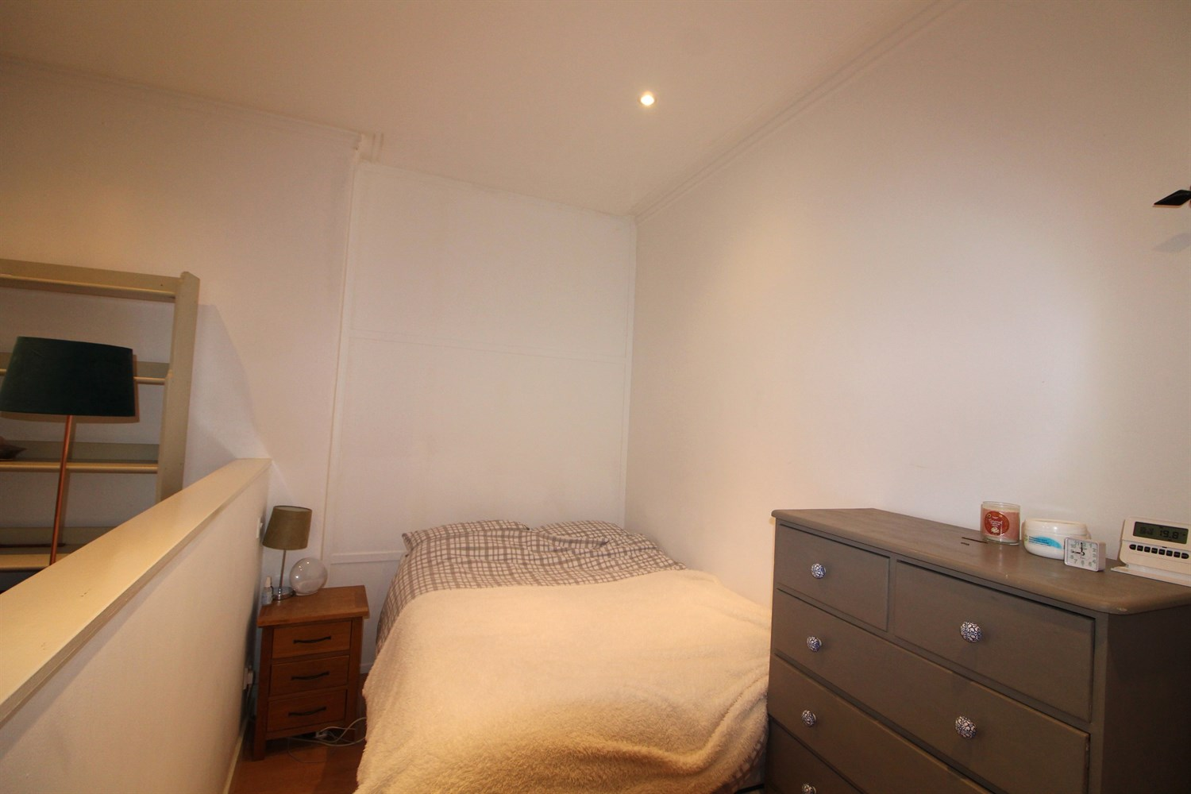
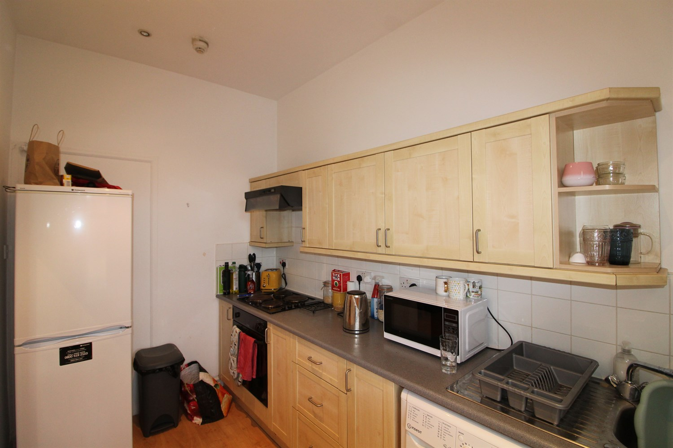
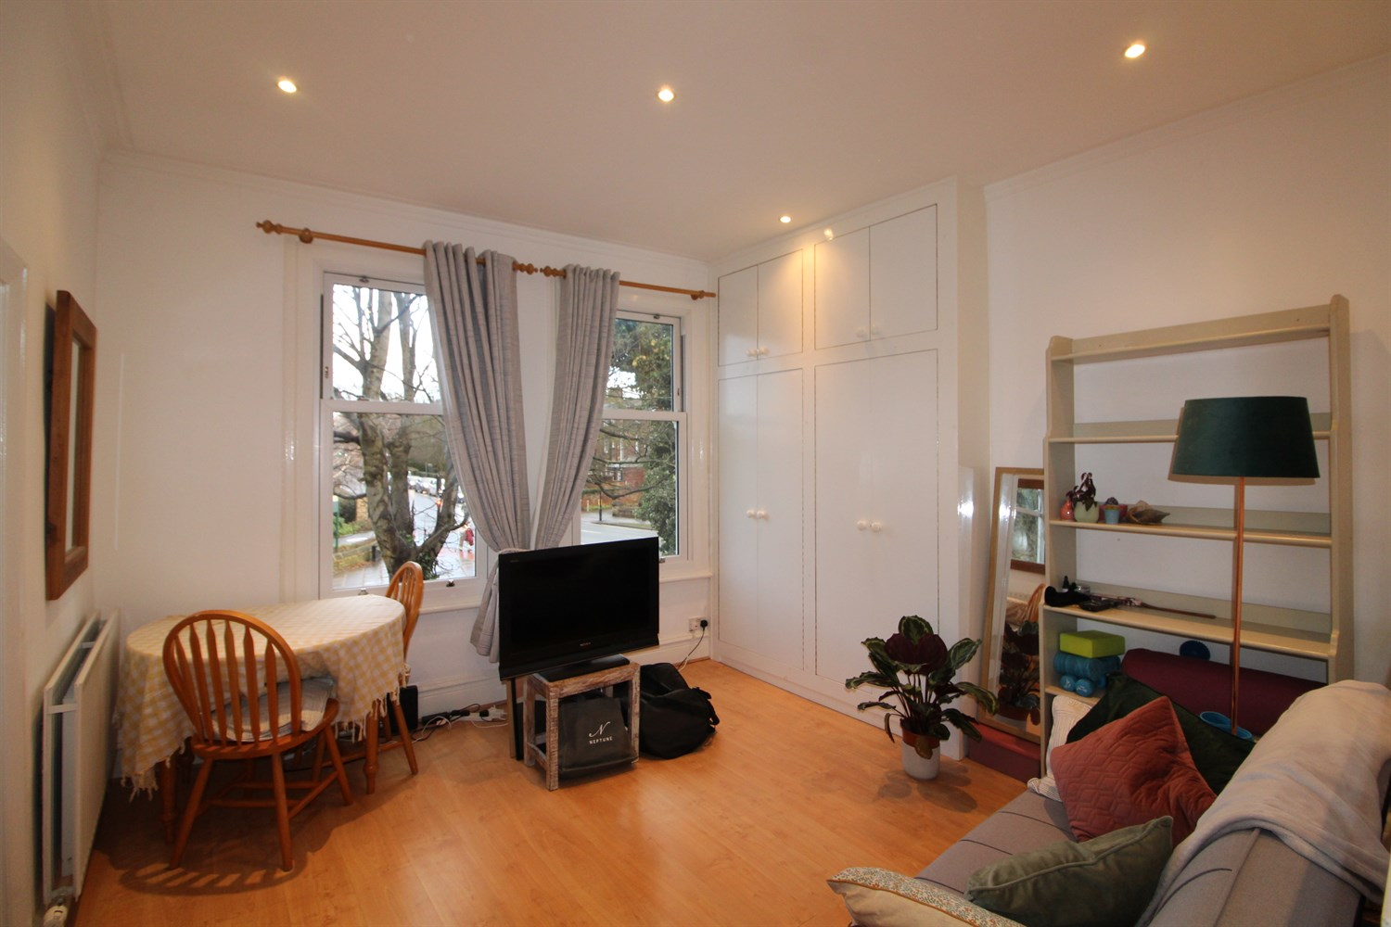
1 Bathroom(s)
1 Reception(s)
0 Bedroom(s)
00

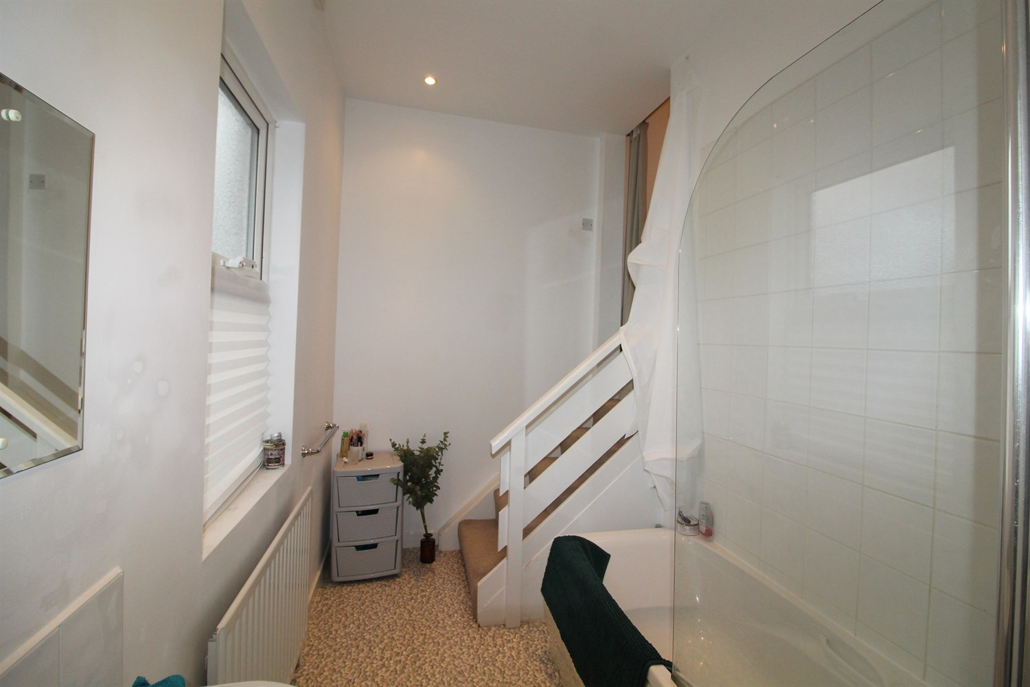

Living/Bedroom
Living area with window to front, gas central heating. Low wall separating the bedroom area.

Kitchen
Kitchen comprising a range of wall and base mounted units, single drainer stainless steel sink unit with mixer tap, integrated oven, hob and extractor and wood effect flooring.

Bathroom
Three piece white bathroom suite with shower over and shower screen, w/c and hand wash basin, part tiled.

Home Information
Tenancy. 12 months.
COUNCIL TAX BAND: A
EPC Rating D
Leasehold property
Permit Parking
Broadband:
Standard 8 Mbps 0.9 Mbps Good
Superfast 80 Mbps 20 Mbps Good
Ultrafast 1000 Mbps 1000 Mbps
Mobile availability: EE Limited coverage.
Three likely to have good coverage
O2 Likely Likely to have good coverage
Vodafone Limited coverage.
Utilities: Water supplied on standard meters. Electric mains supplied on standard meters.

These particulars are intended to give a fair description of the property, but their accuracy cannot be guaranteed, and they do not constitute an offer of contract. Intending purchasers must rely on their own inspection of the property. None of the above appliances/services have been tested by ourselves. We recommend purchasers arrange for a qualified person to check all appliances/services before legal commitment.  Property Ref: 4605  For more information, please contact  0113 258 1150 | lettings@adairpaxton.co.uk | www.adairpaxton.co.uk | 