
Broadgate Lane, LS18
Available to let £875.00pcm

This spacious family home is located on a quiet residential street just off BROADGATE LANE in Horsforth. Ideally located for access to all local amenities, bars and restaurants, and with excellent commuter links with Leeds and Bradford, This property recently been decorated and new carpets, it briefly compromises of large kitchen, living room and two bedrooms, small garden. Available Now, EPC rating D, Council tax band A, deposit £1005.
0113 258 1150
0800 000 000
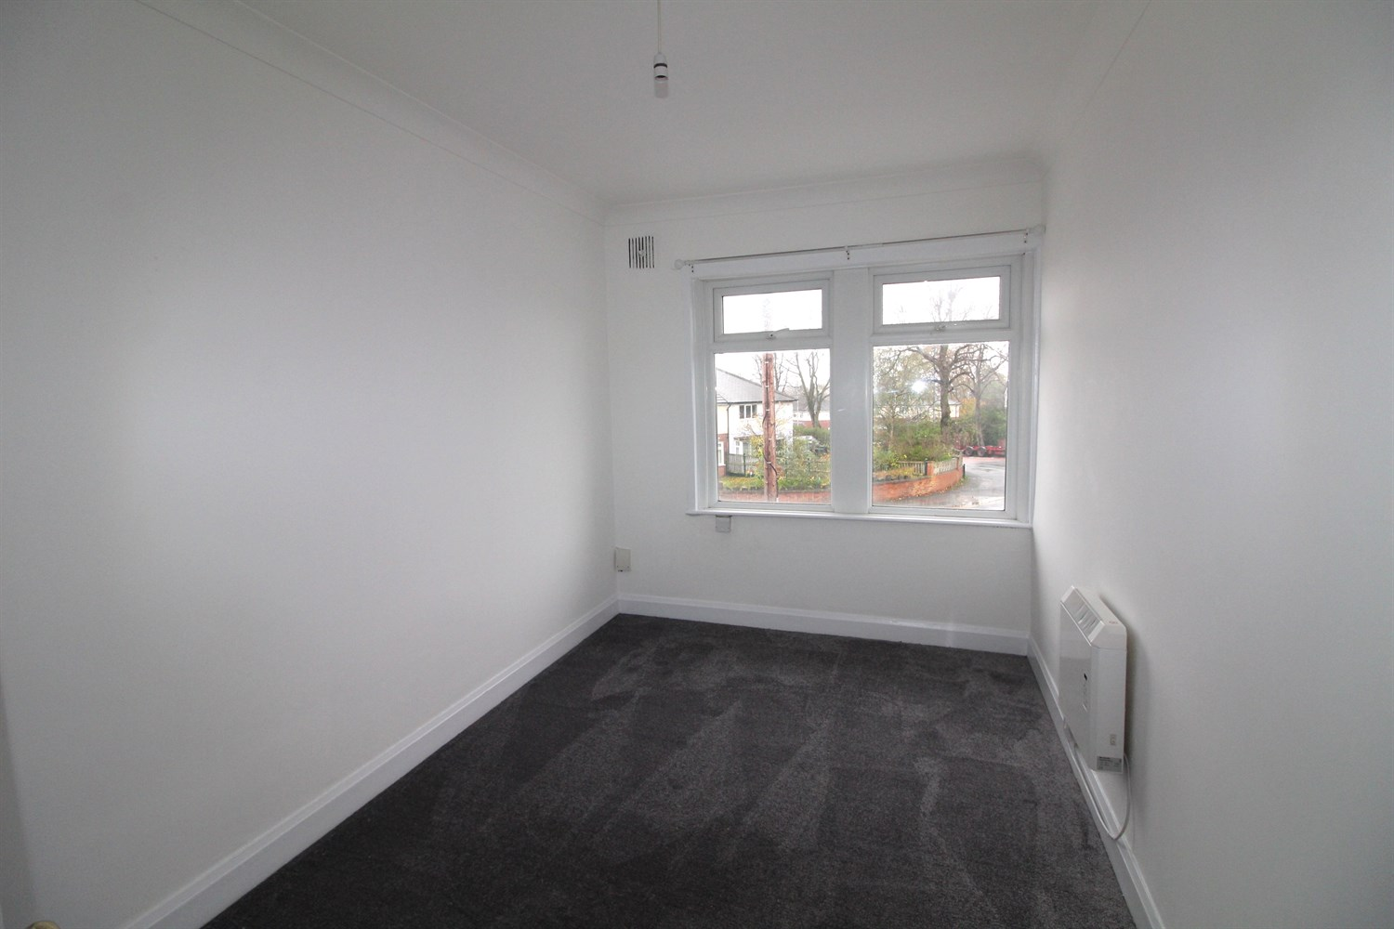



1 Reception(s)
1 Bathroom(s)
2 Bedroom(s)
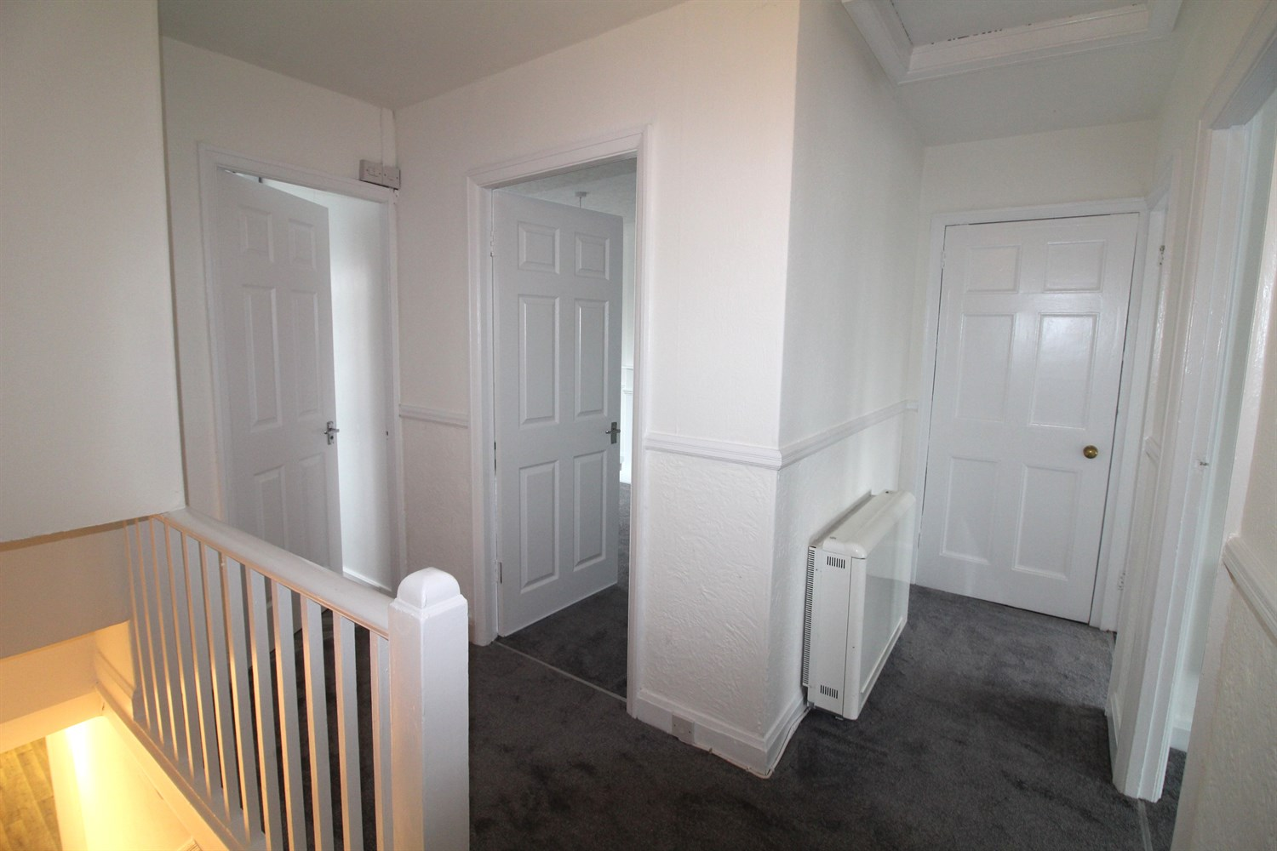
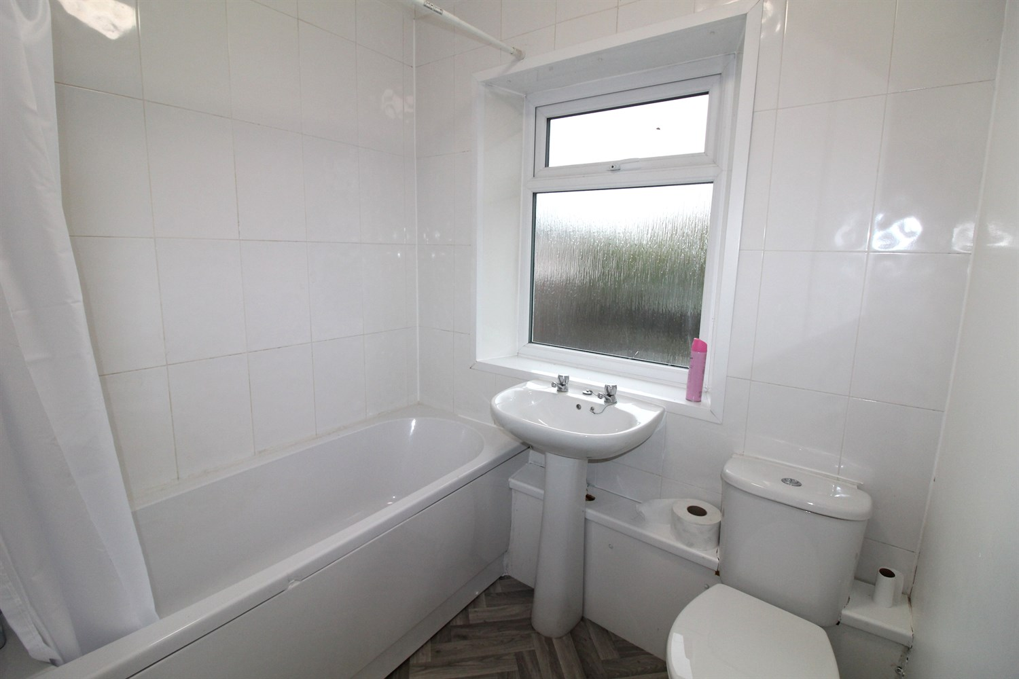
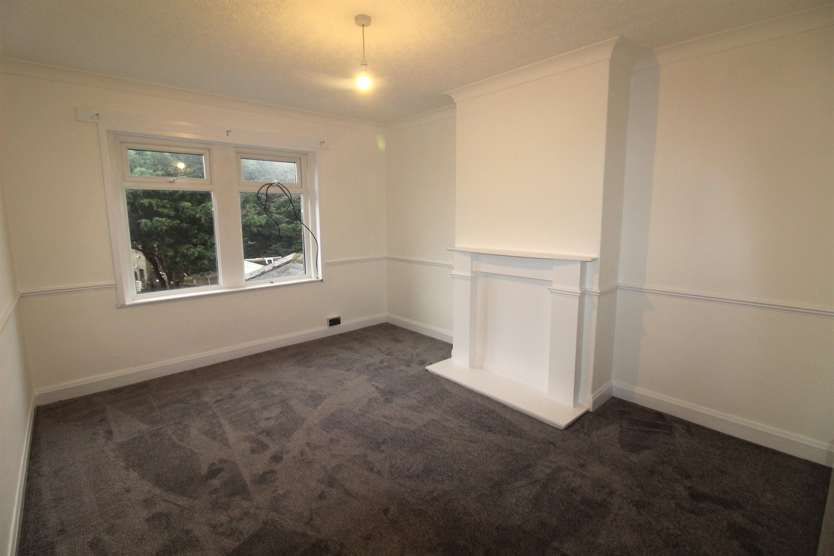
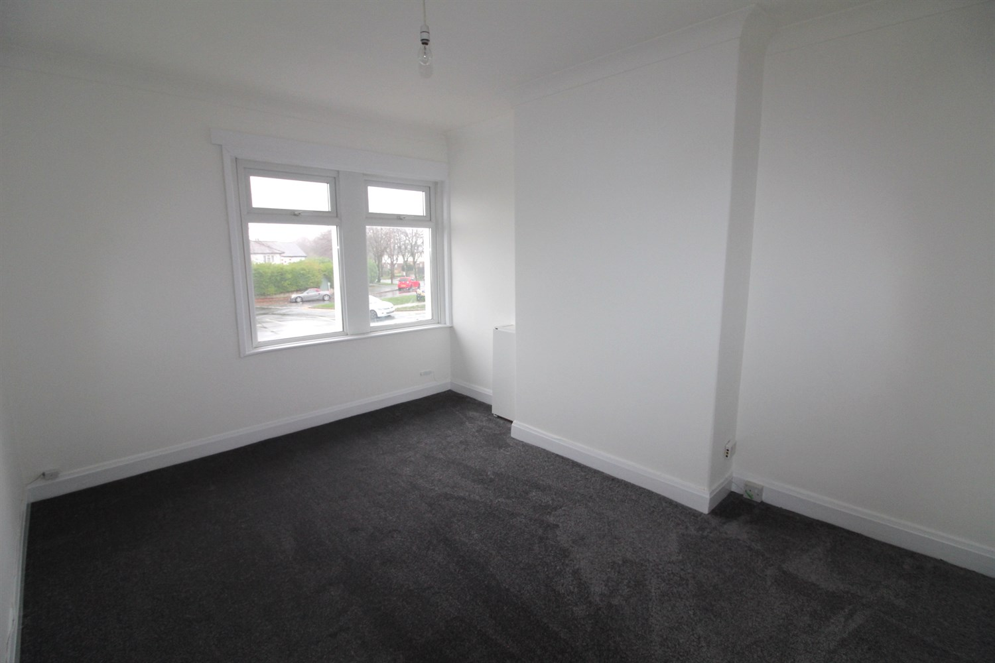

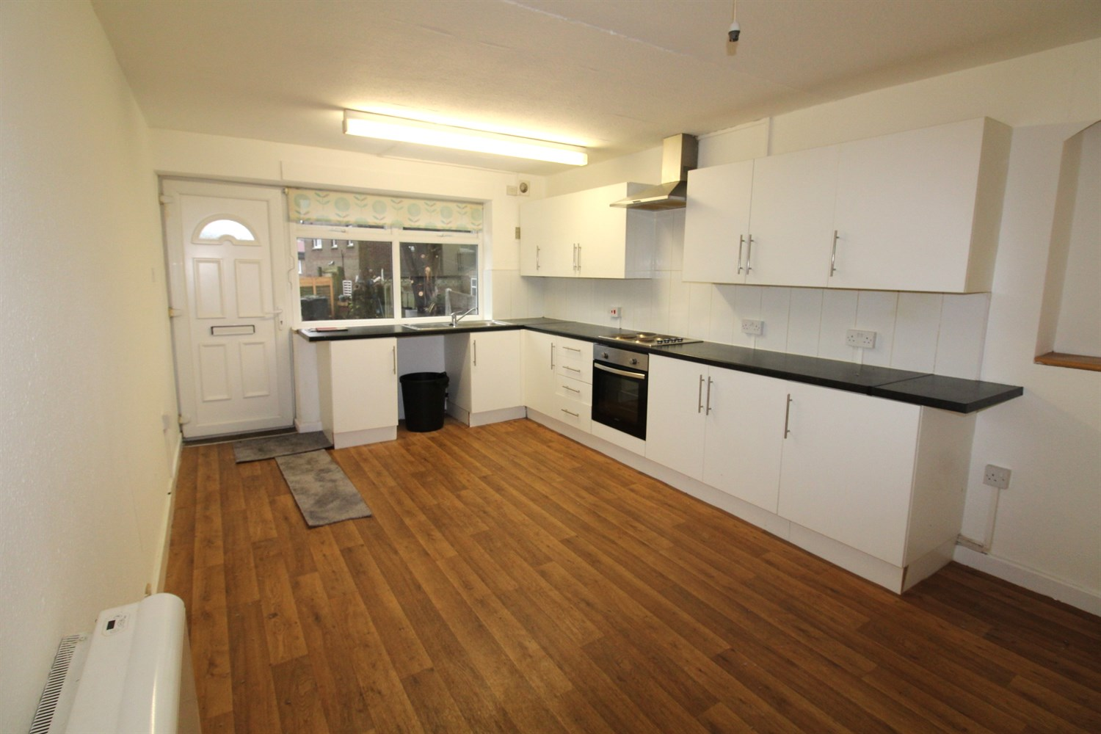

Kitchen
Located on the ground floor is a large kitchen fitted with a range of wall and base units, sink with drainer, space for a dining table.

Lounge
Spacious lounge with with window to front, gas central heating radiator.

Bedroom 1
Carpeted double bedroom with window and gas central heating radiator.

Bedroom 2
Carpeted double bedroom with window and gas central heating radiator.

Bathroom
Three piece white bathroom suite with shower over bath, w/c an hand wash basin. Tiled walls.

Small Garden
Enclosed garden.

Home Information
COUNCIL TAX BAND: A
EPC Rating: D
Leasehold property:
Broadband:
Standard 8 Mbps 0.9 Mbps Good
Superfast 56 Mbps 16 Mbps Good
Ultrafast 1800 Mbps 220
Mobile availability: EE limited coverage. Three limited coverage. O2 likely to have good coverage. Vodafone likely to have good coverage.
Utilities: Water supplied on standard meters. Gas and Electric mains supplied on standard meters.

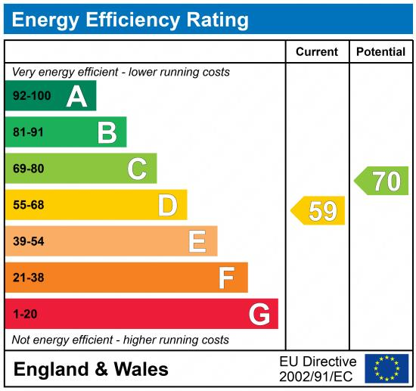

These particulars are intended to give a fair description of the property, but their accuracy cannot be guaranteed, and they do not constitute an offer of contract. Intending purchasers must rely on their own inspection of the property. None of the above appliances/services have been tested by ourselves. We recommend purchasers arrange for a qualified person to check all appliances/services before legal commitment.

Property Ref: 8098

For more information, please contact

0113 258 1150 | lettings@adairpaxton.co.uk | www.adairpaxton.co.uk

