
0113 258 1150
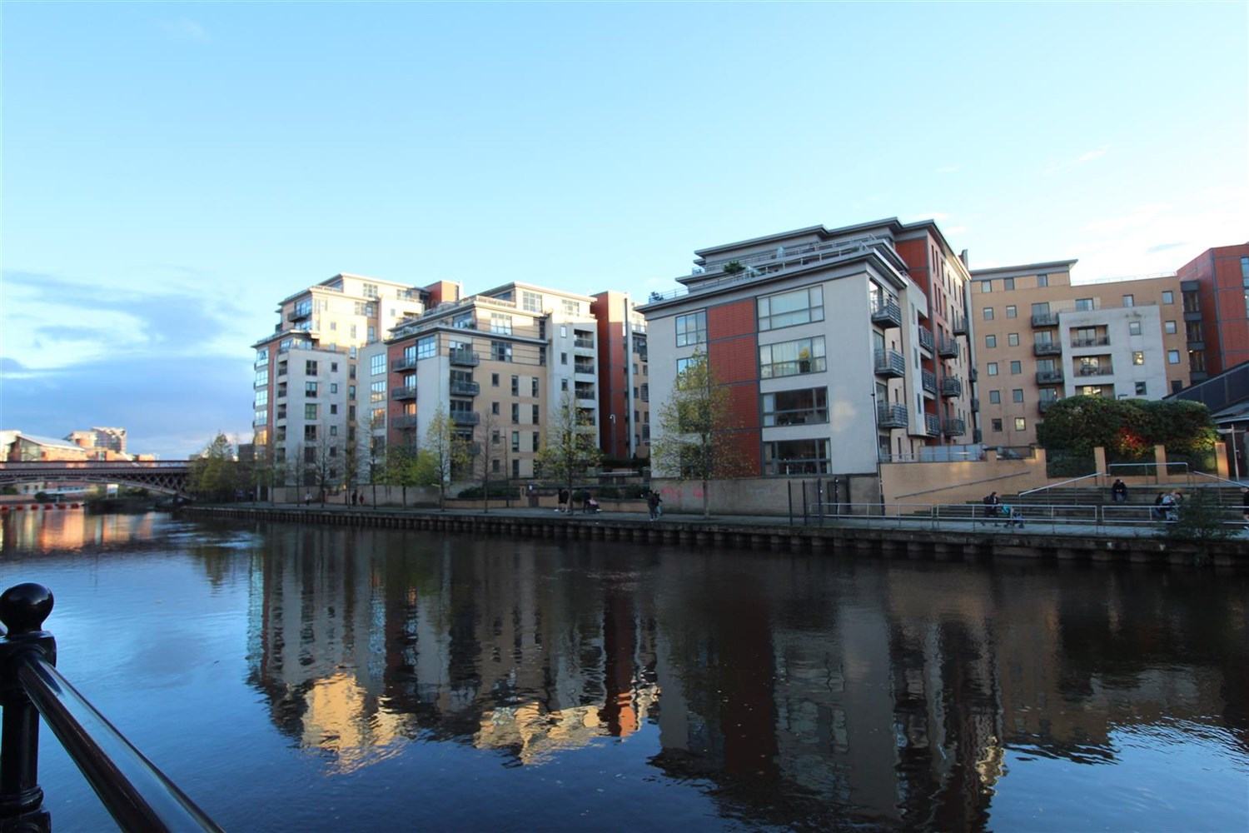



Available to let £1,650.00pcm

Regents Quay, Bowman Lane, Leeds

**TWO BEDROOM, TWO BATHROOM FOURTH FLOOR APARTMENT with VIEWS OVER THE RIVER***A truly stunning riverside apartment with uninterrupted views of the River Aire available at Brewery Wharf, Leeds City Centre. The property is immaculate throughout with two double bedrooms, two bathrooms and two balconies. Secure allocated parking is included. The development benefits from on site concierge, private residents gym and immaculate communal grounds. An internal viewing is highly recommended to appreciate the accommodation on offer. Council Tax Band D. EPC rating B. Available Now. Deposit £1900.
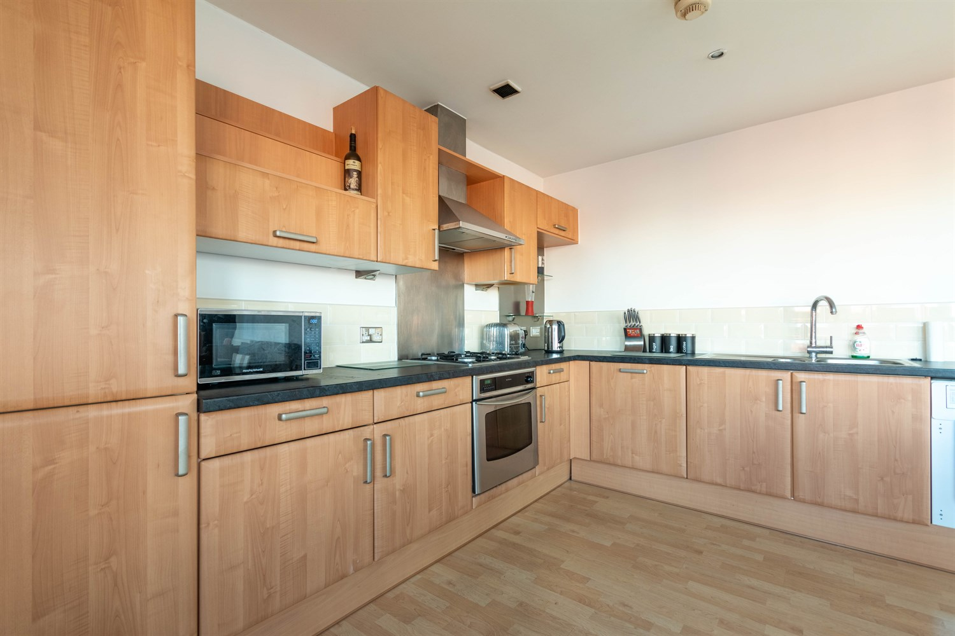
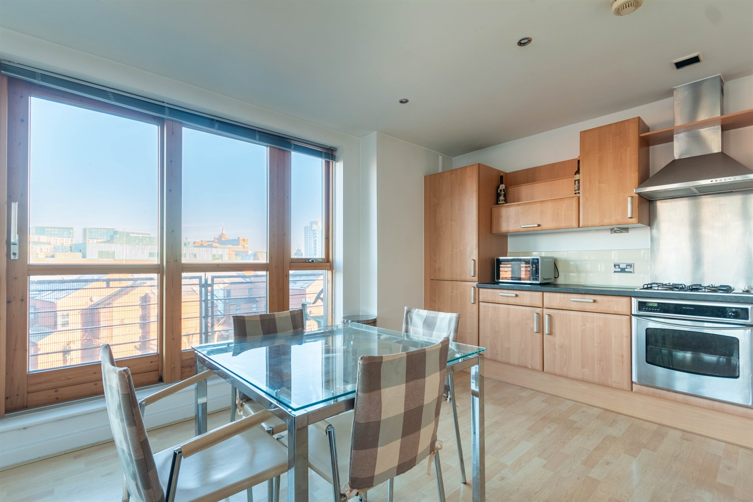
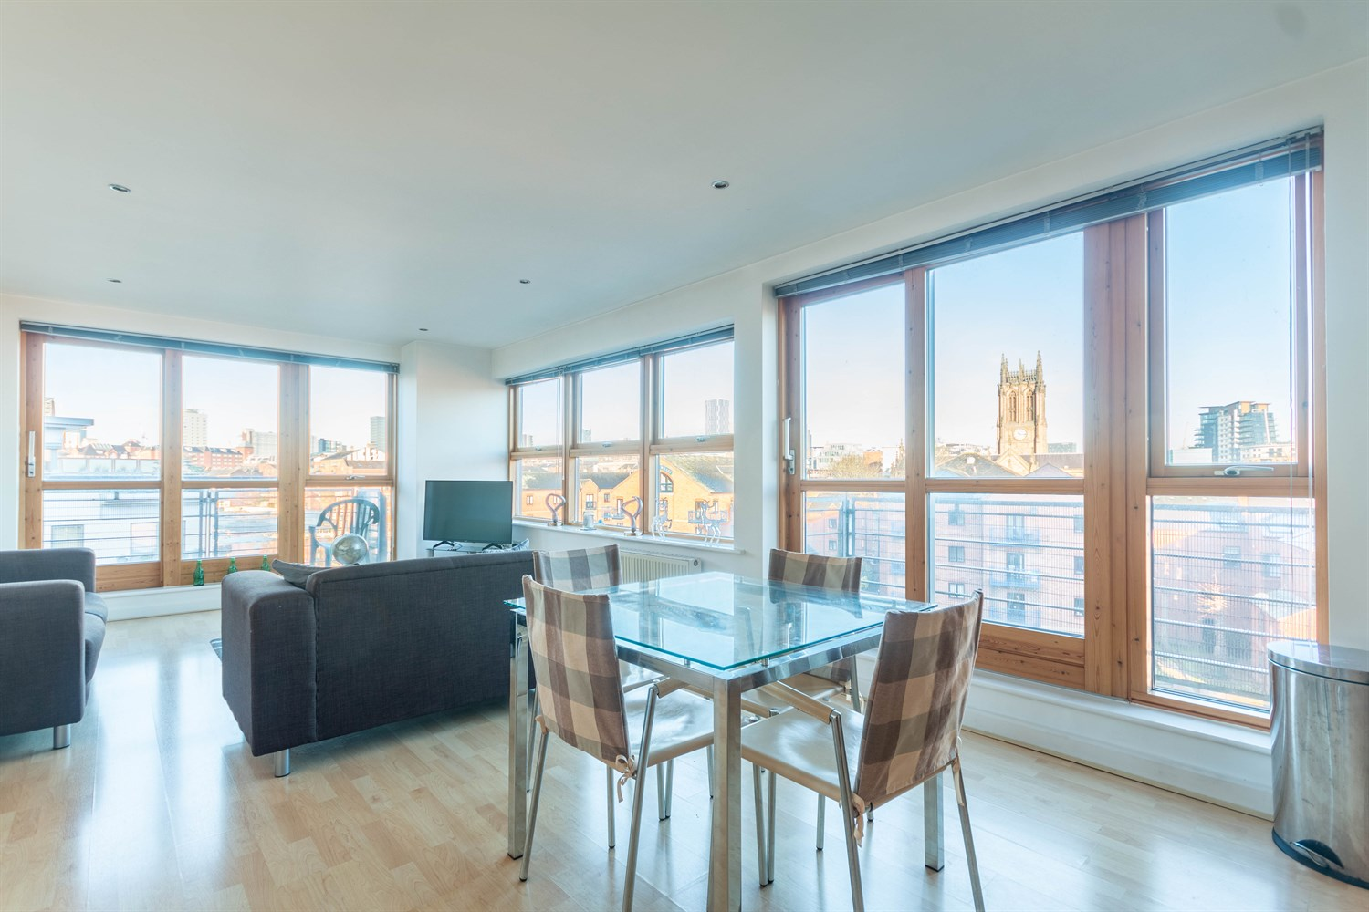
2 Bathroom(s)
1 Reception(s)
2 Bedroom(s)
00
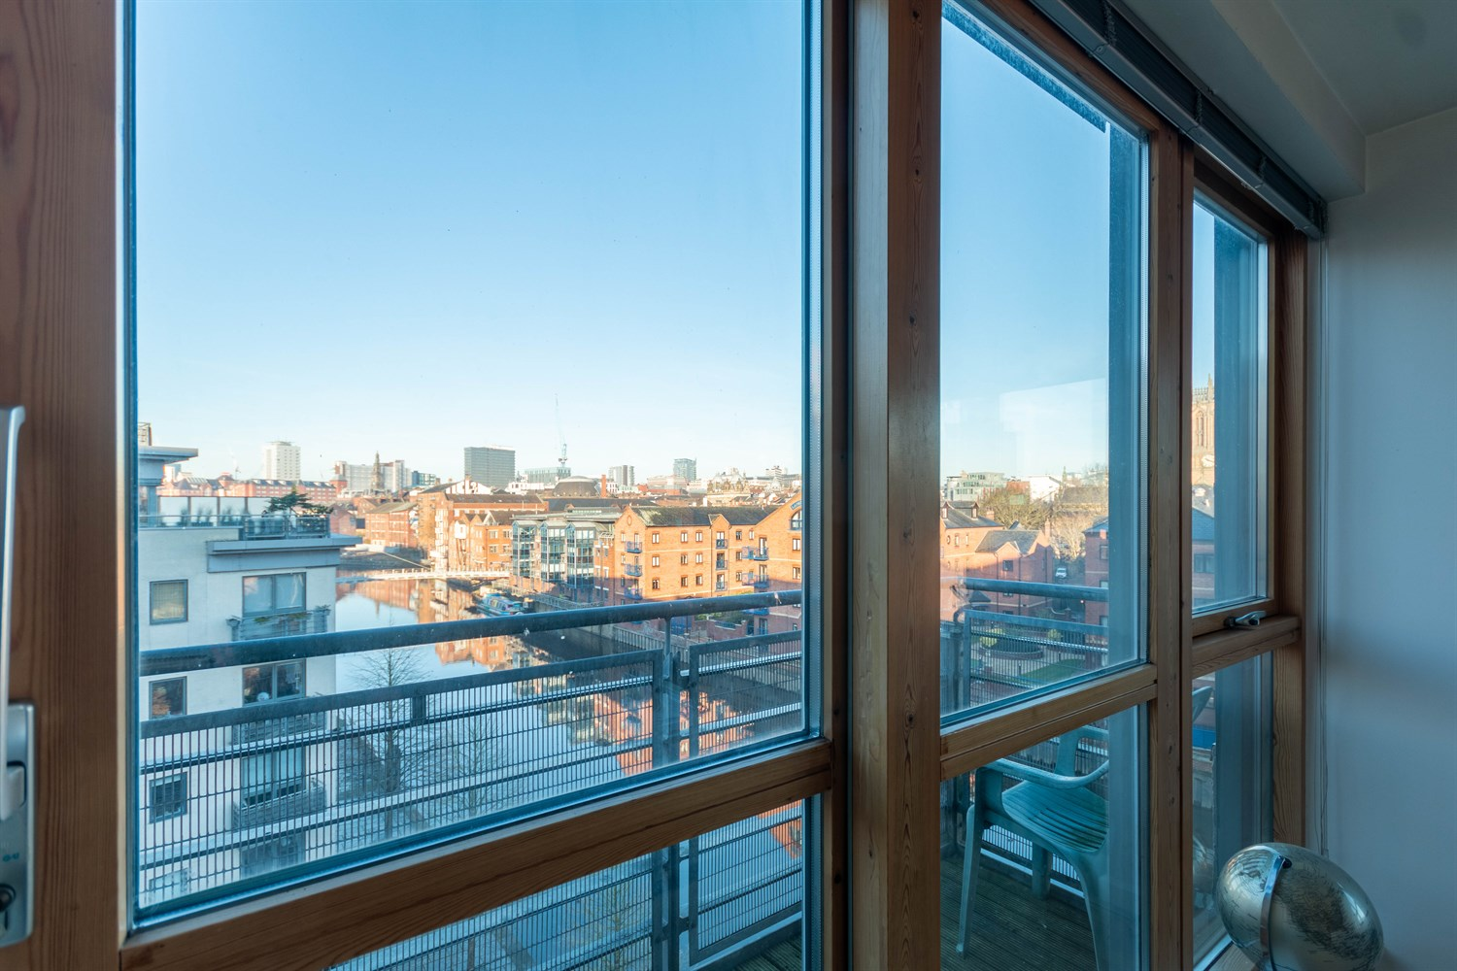
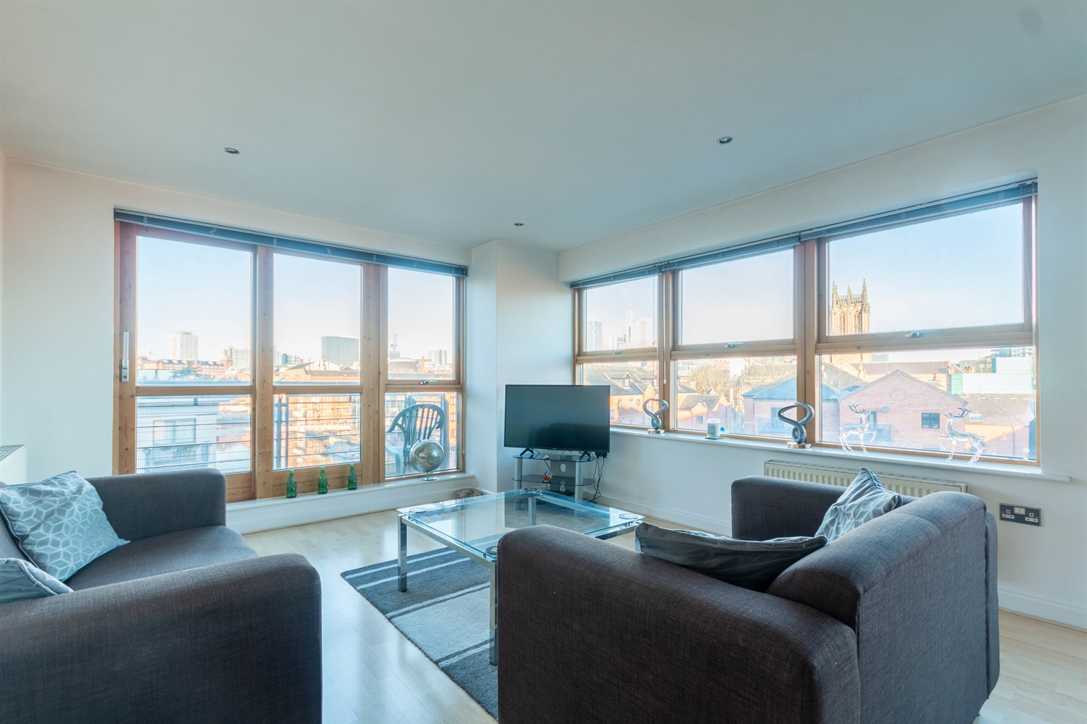
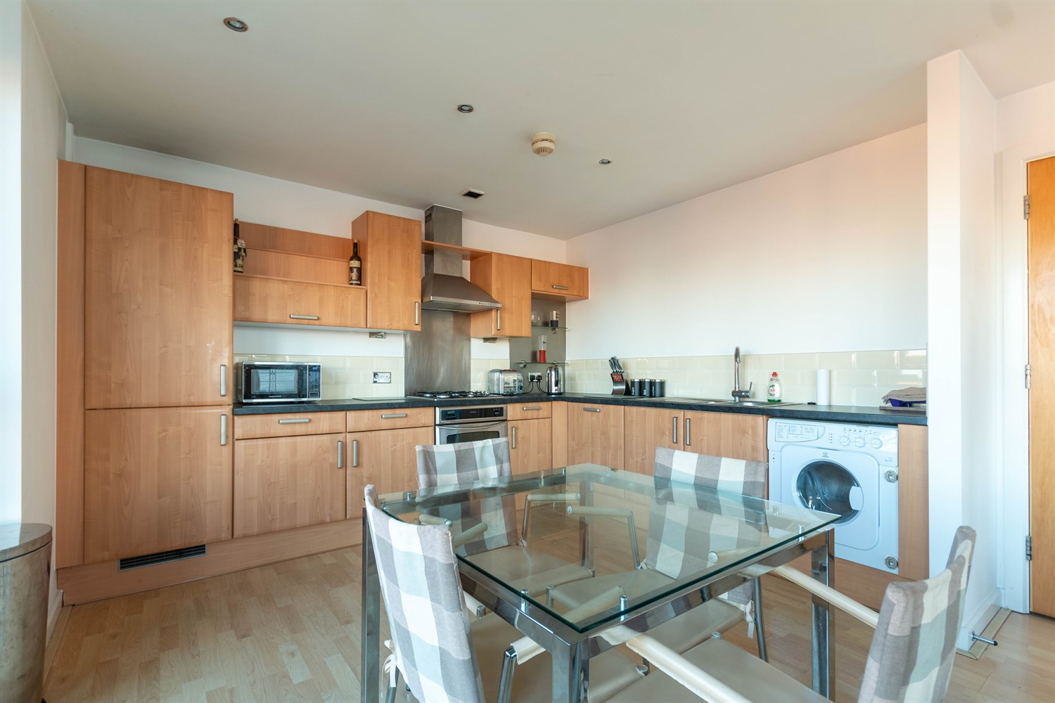
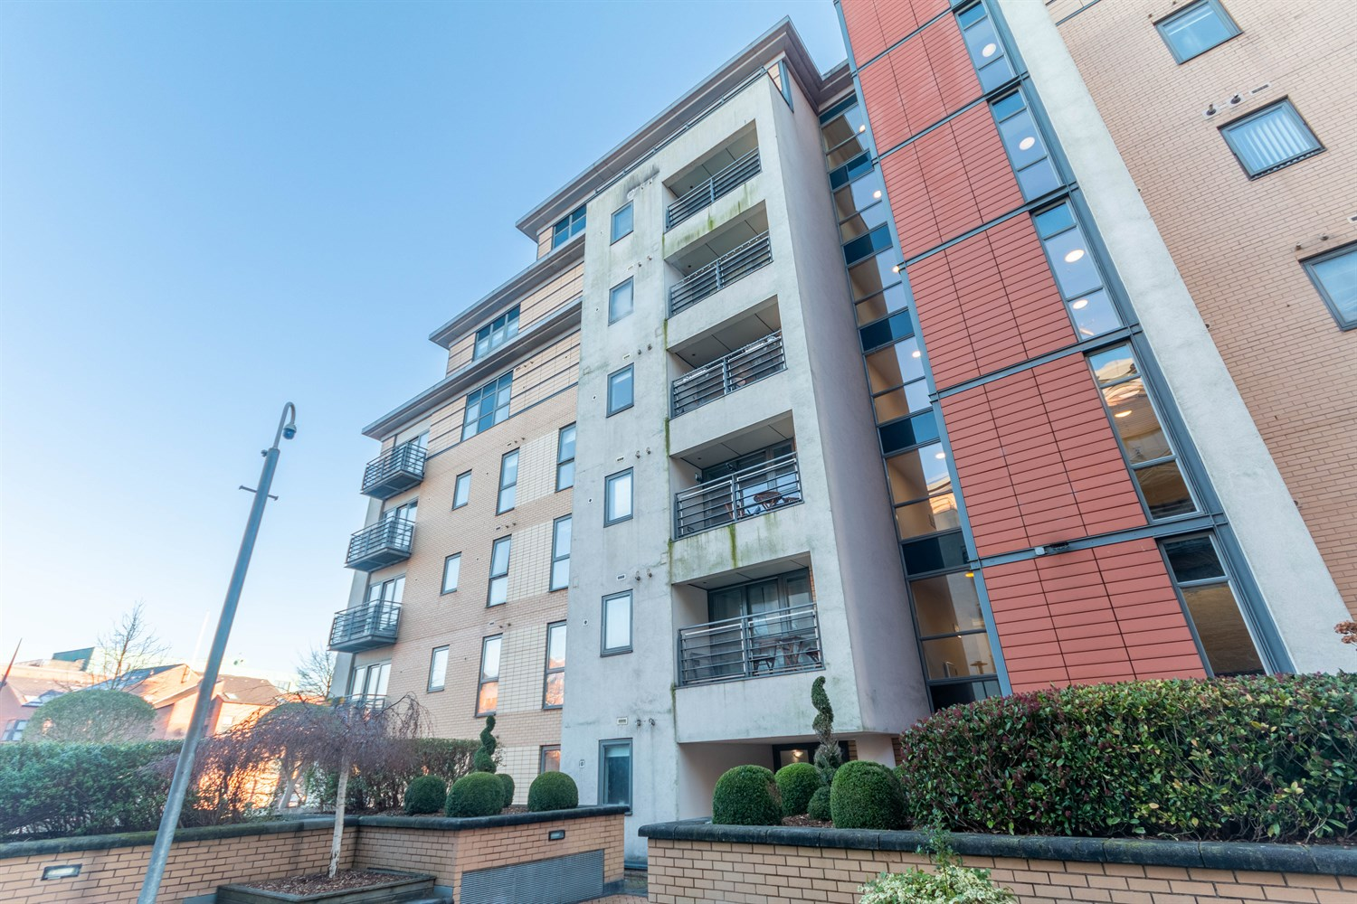
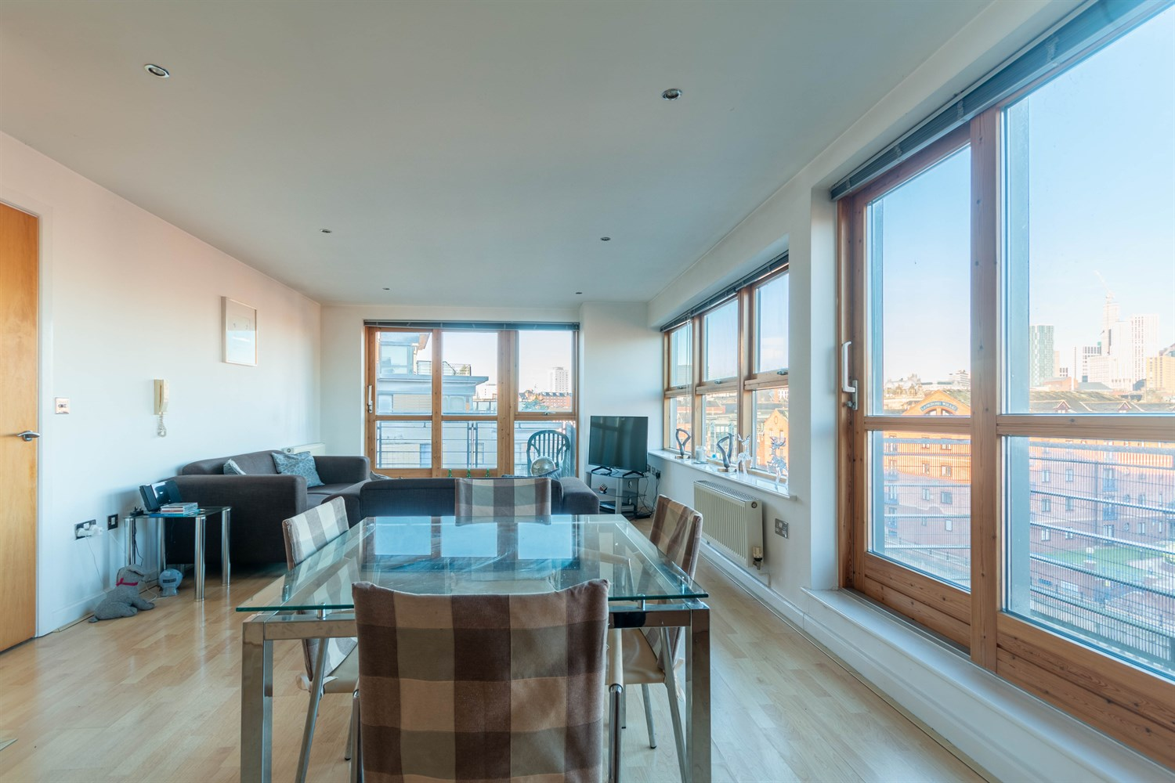
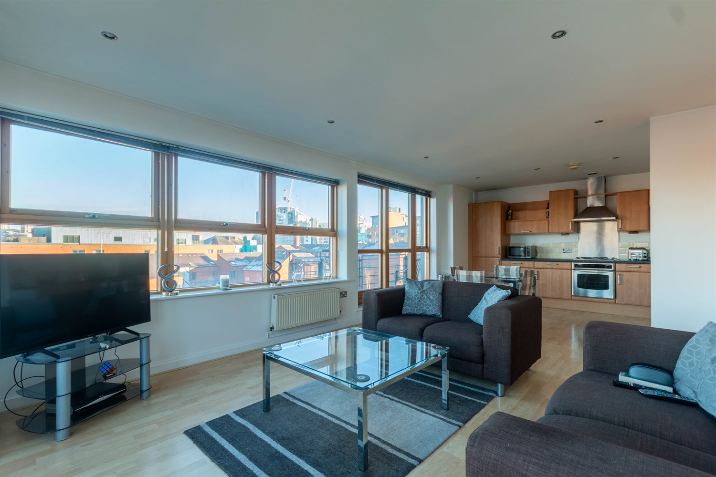
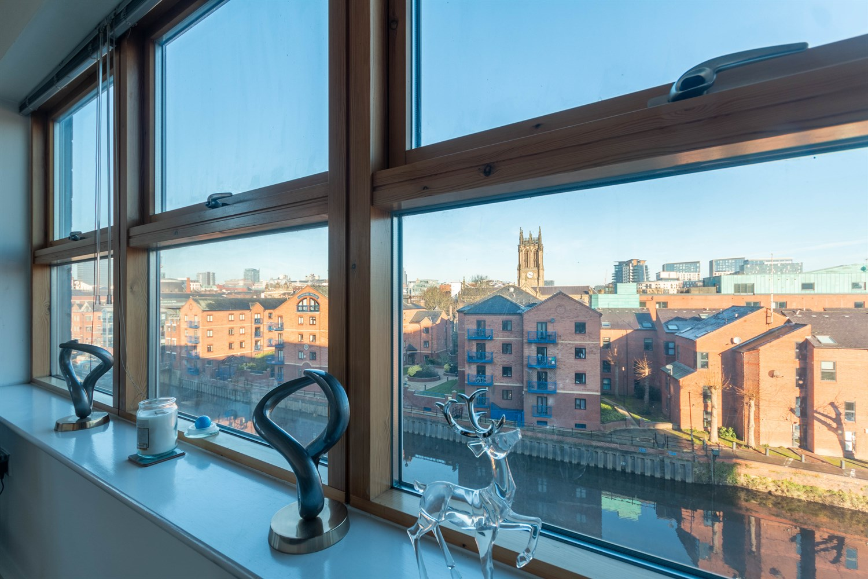
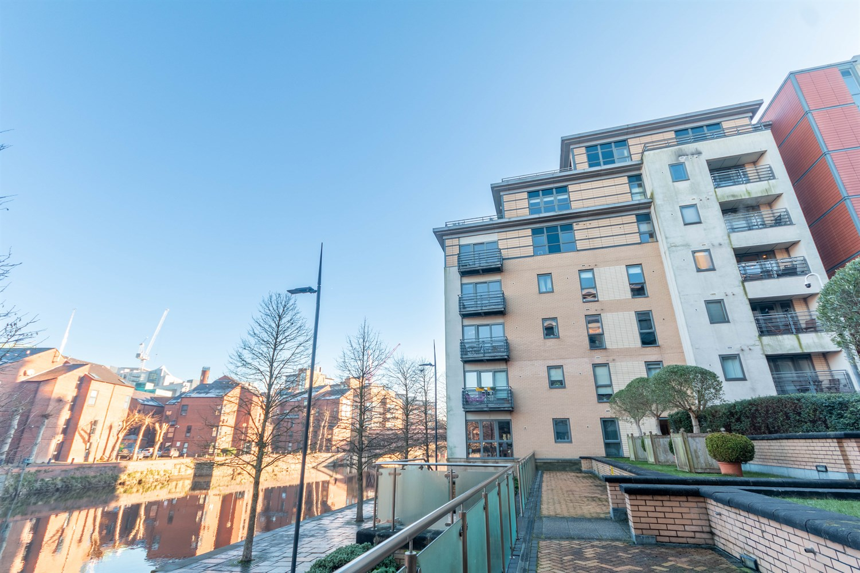

Communal Entrance Hall
Via front entrance door. Stairs and lift to all floors.

Private Entrance Hall
Via front entrance door. Secure entry phone system. Storage cupboard.

Reception 1
Good sized open plan living area with floor to ceiling windows and two balconies with panoramic views overlooking the River Aire and communal gardens. The room has laminate flooring throughout, two gas central heating radiators and inset ceiling spotlights.

Kitchen
This open plan kitchen has a range of fitted base and wall units and integrated appliances include; integrated fridge/freezer, dishwasher, washing machine. Electric oven with four ring gas hob and extractor above. Stainless steel sink with mixer tap and drainer.

Bedroom 1
Double bedroom with double glazed window. Gas central heating radiator.

En Suite
Three-piece suite in white comprising integrated W.C, basin and shower with glass door. Black tiled walls. Stainless steel towel rail. Recessed mirror shelving unit. Shaver point.

Bedroom 2
Second double bedroom with double glazed window. Gas central heating radiator.

House Bathroom
White three piece suite comprising integrated W.C basin and bath with shower over and glass screen. Part-tiled walls. Stainless steel towel rail. Recessed mirror shelving unit. Shaver point.

Parking
One secure allocated underground car parking space with lift access

Home Information
COUNCIL TAX BAND: D
EPC Rating:B
Leasehold property
Parking available
Standard 16 Mbps 1 Mbps Good
Superfast 147 Mbps 20 Mbps Good
Ultrafast --Not available --Not available
Mobile availability: Vodaphone likely to have good coverage. Three likely to have good coverage. O2 likely to have good coverage. EE limited coverage.
Utilities: Water supplied on standard meters. Gas and Electric mains supplied on standard meters.

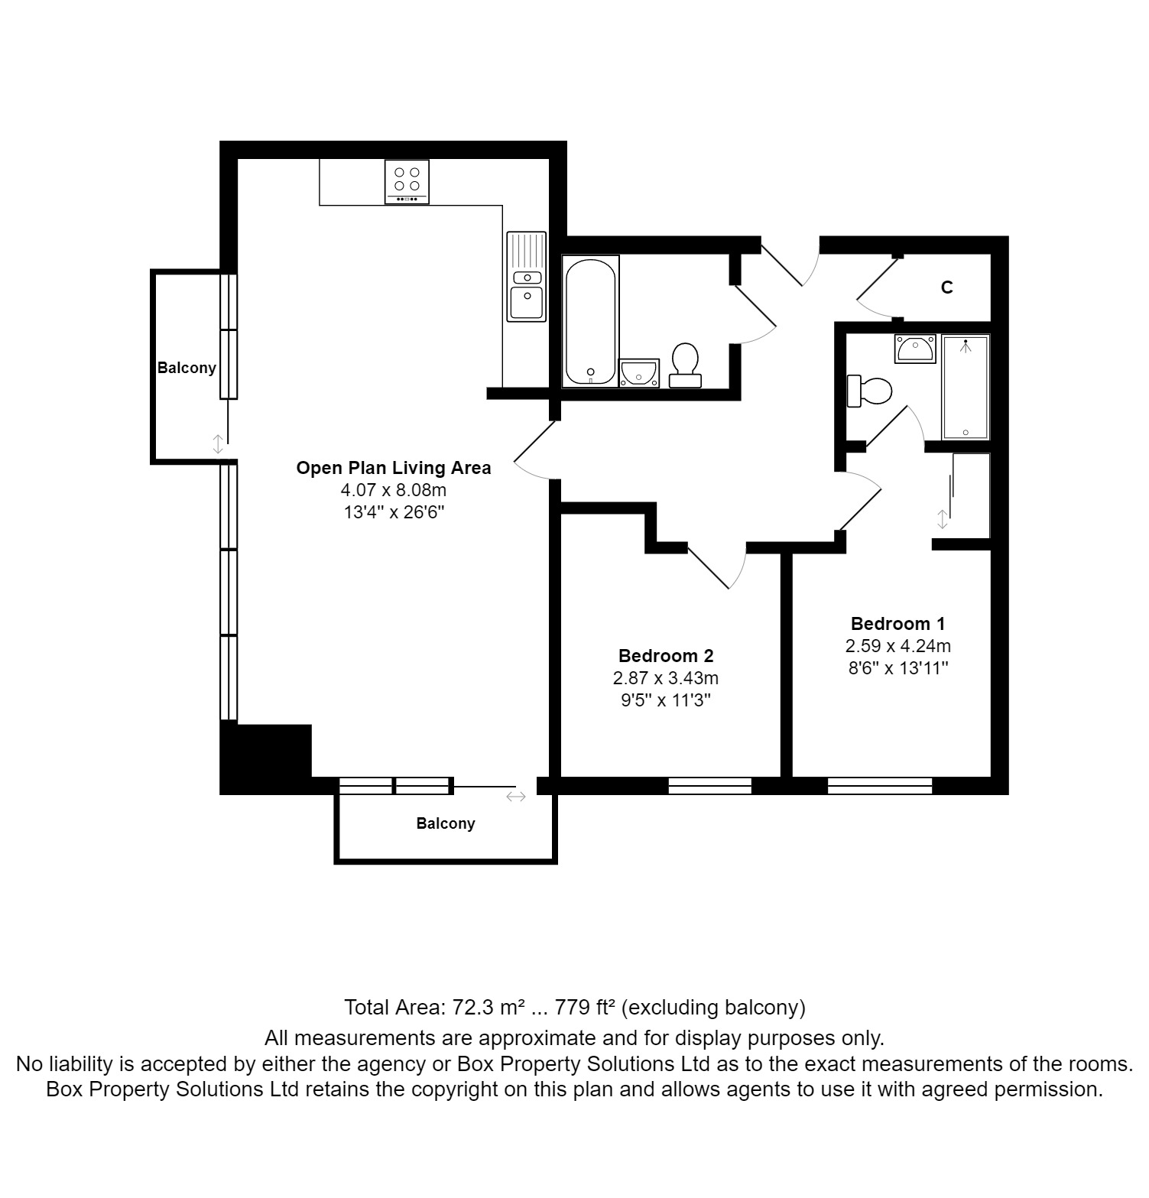

These particulars are intended to give a fair description of the property, but their accuracy cannot be guaranteed, and they do not constitute an offer of contract. Intending purchasers must rely on their own inspection of the property. None of the above appliances/services have been tested by ourselves. We recommend purchasers arrange for a qualified person to check all appliances/services before legal commitment.  Property Ref: 4970  For more information, please contact  0113 258 1150 | lettings@adairpaxton.co.uk | www.adairpaxton.co.uk | 