
Foxhill Court, Weetwood
For Sale £175,000

**TWO BEDROOM GROUND FLOOR APARTMENT with NO ONWARD CHAIN** Adair Paxton are pleased to offer this two bedroom ground floor apartment with well kept communal gardens, surrounded by fields in the sought after location of Weetwood. The property briefly comprises; Communal entrance, entrance hall, lounge, kitchen, two bedrooms with built in wardrobes and a house bathroom with separate WC. The property benefits from both gas central heating and double glazing. Externally, the property has well maintained communal gardens, an allocated garage and off street parking.
0113 258 1150
0800 000 000
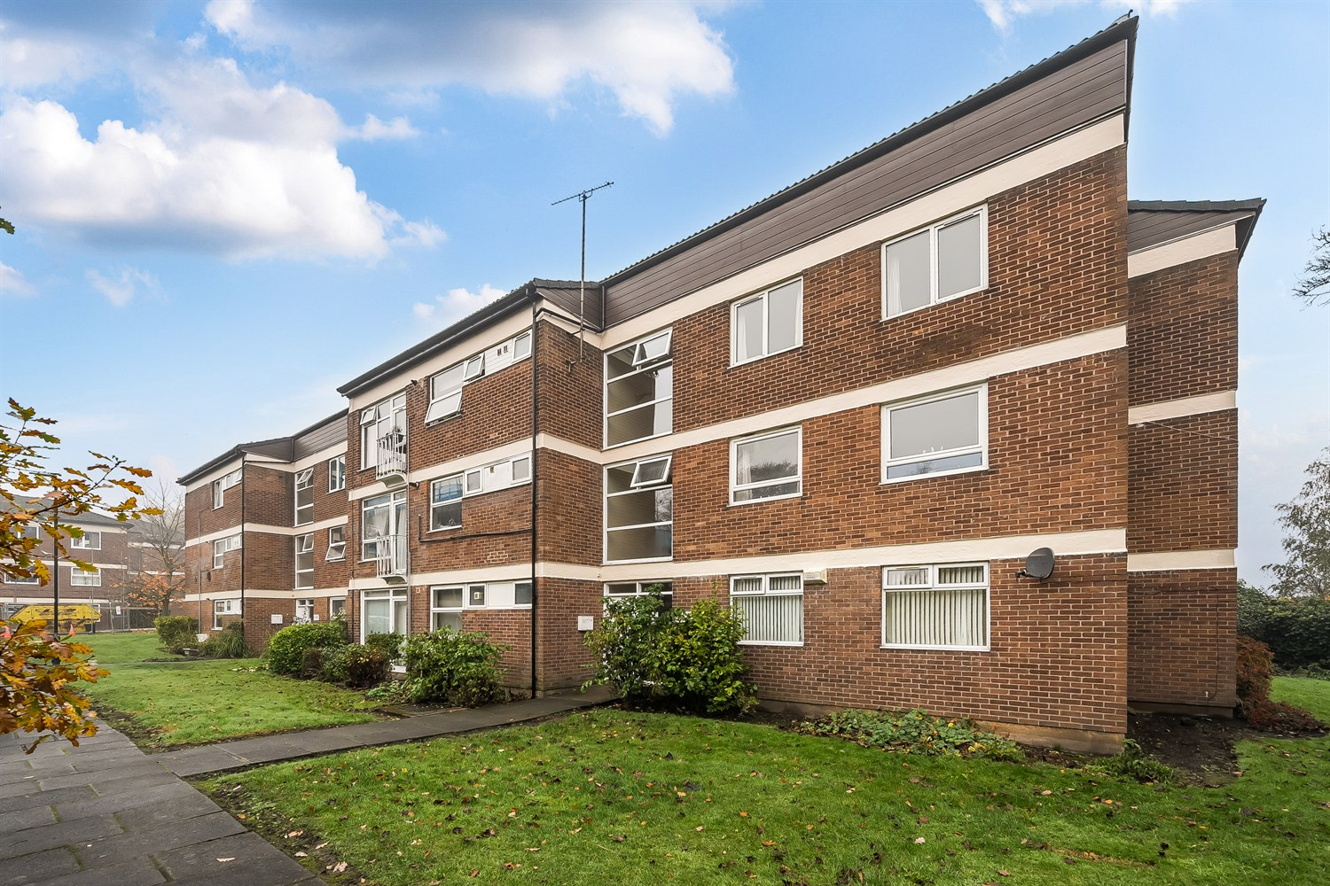



1 Reception
1 Bathroom
2 Bedrooms
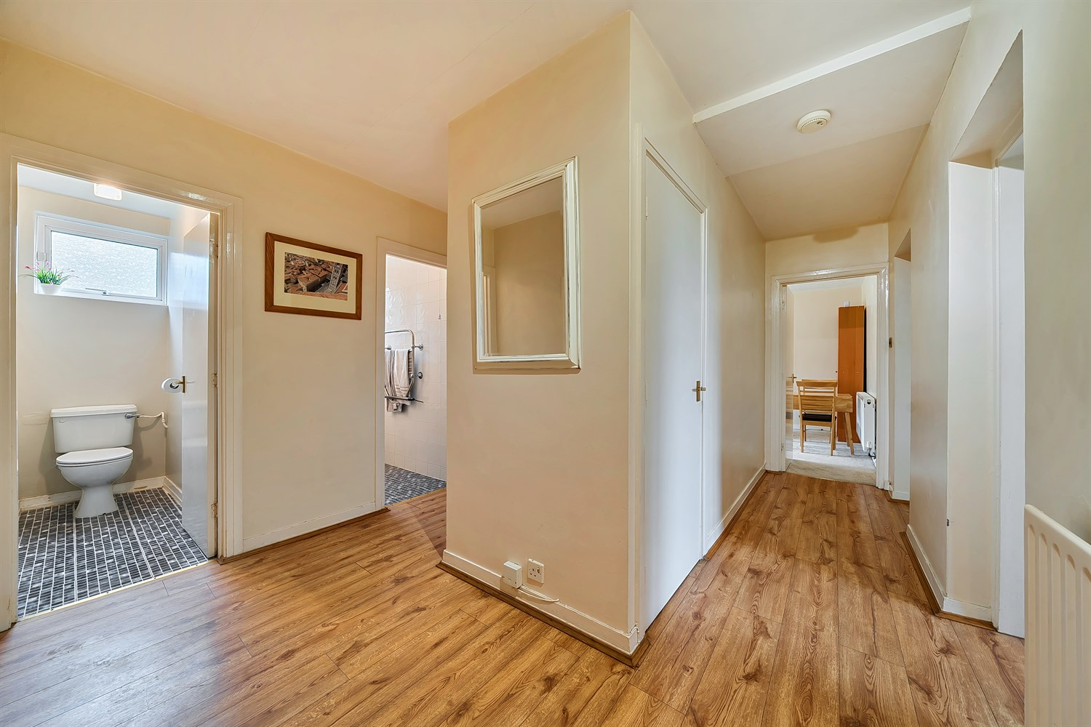
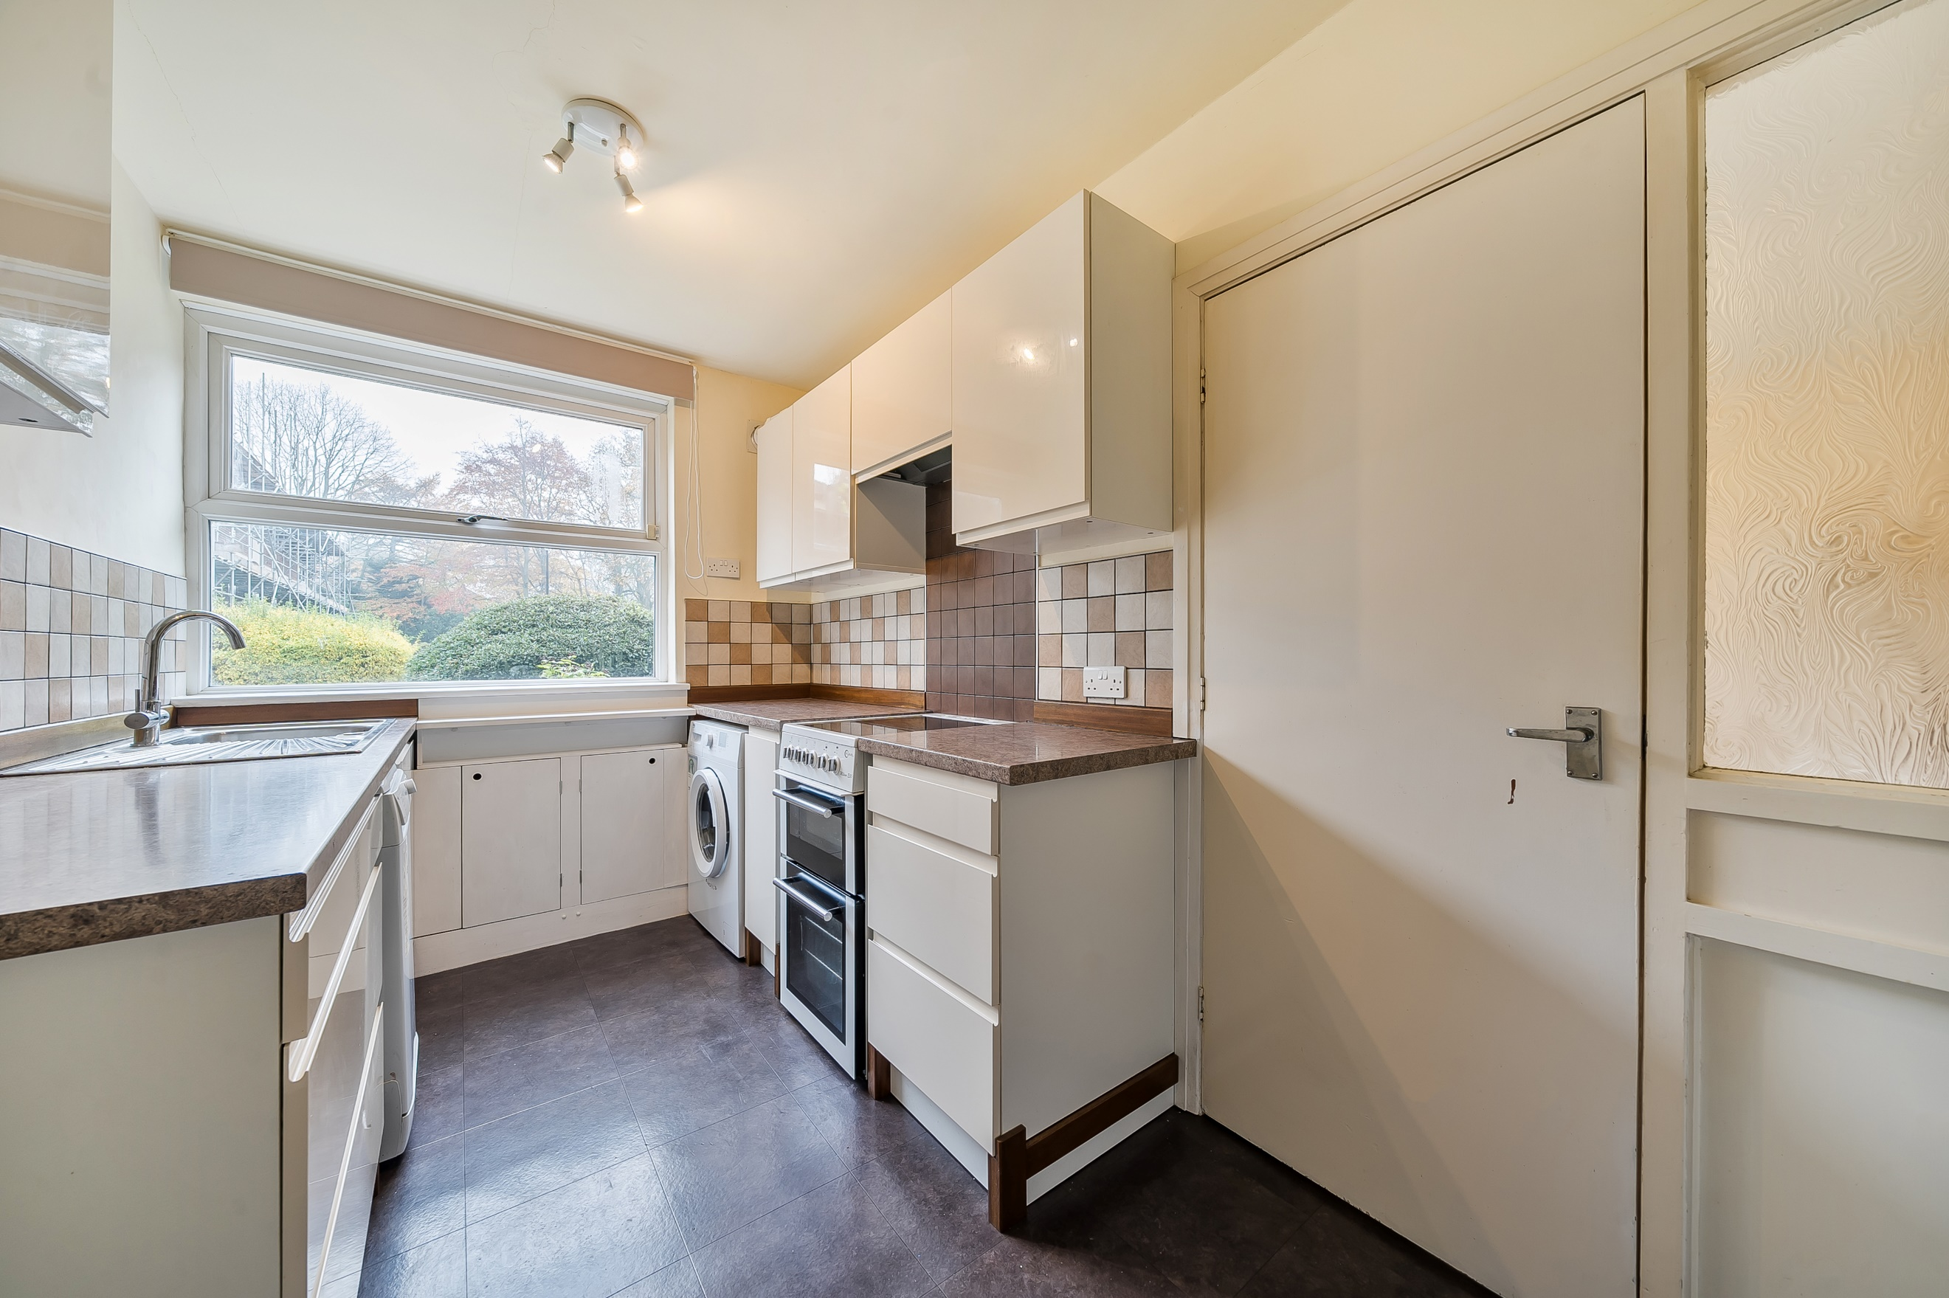
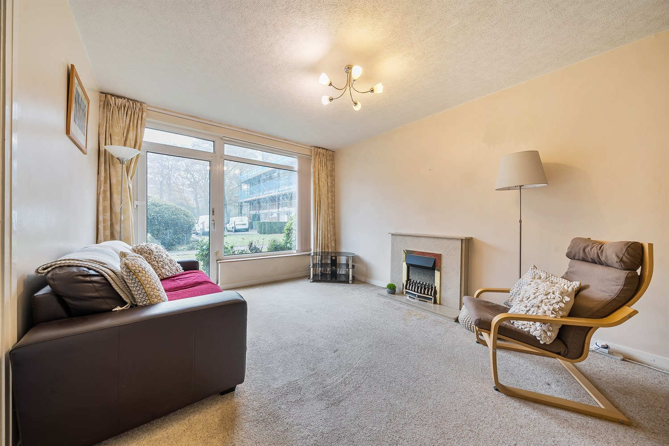
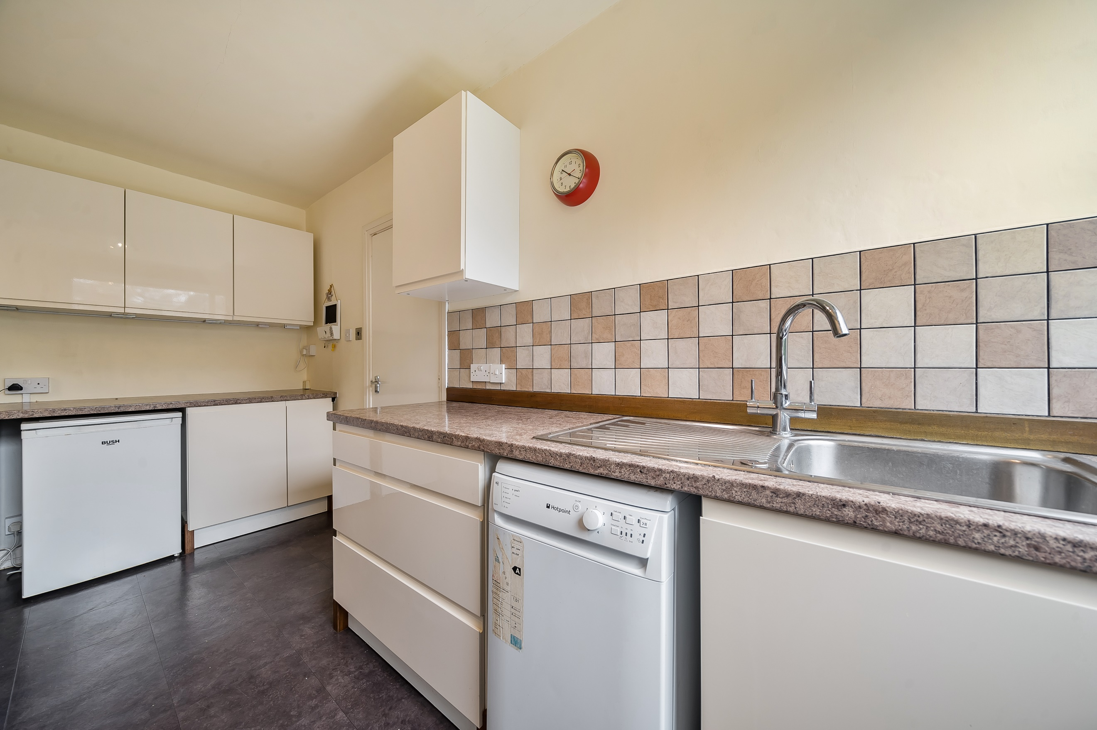

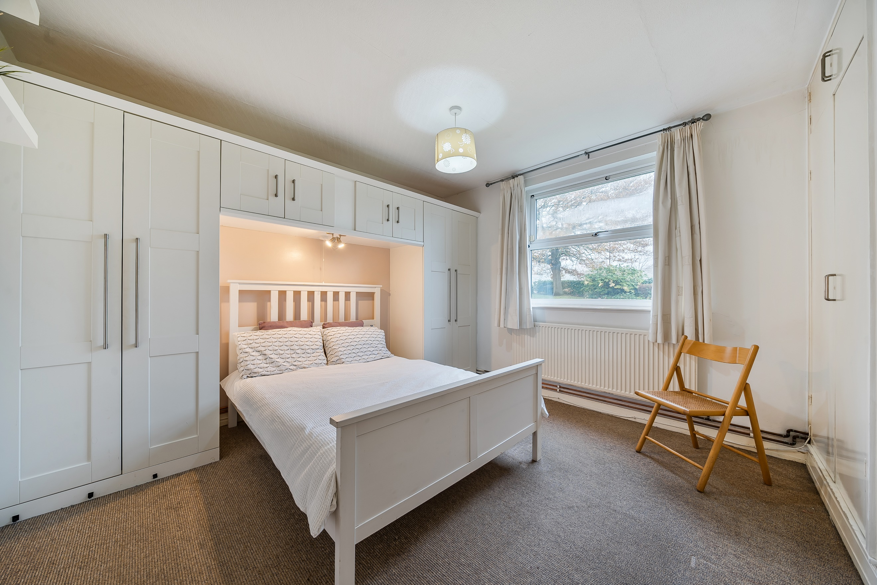
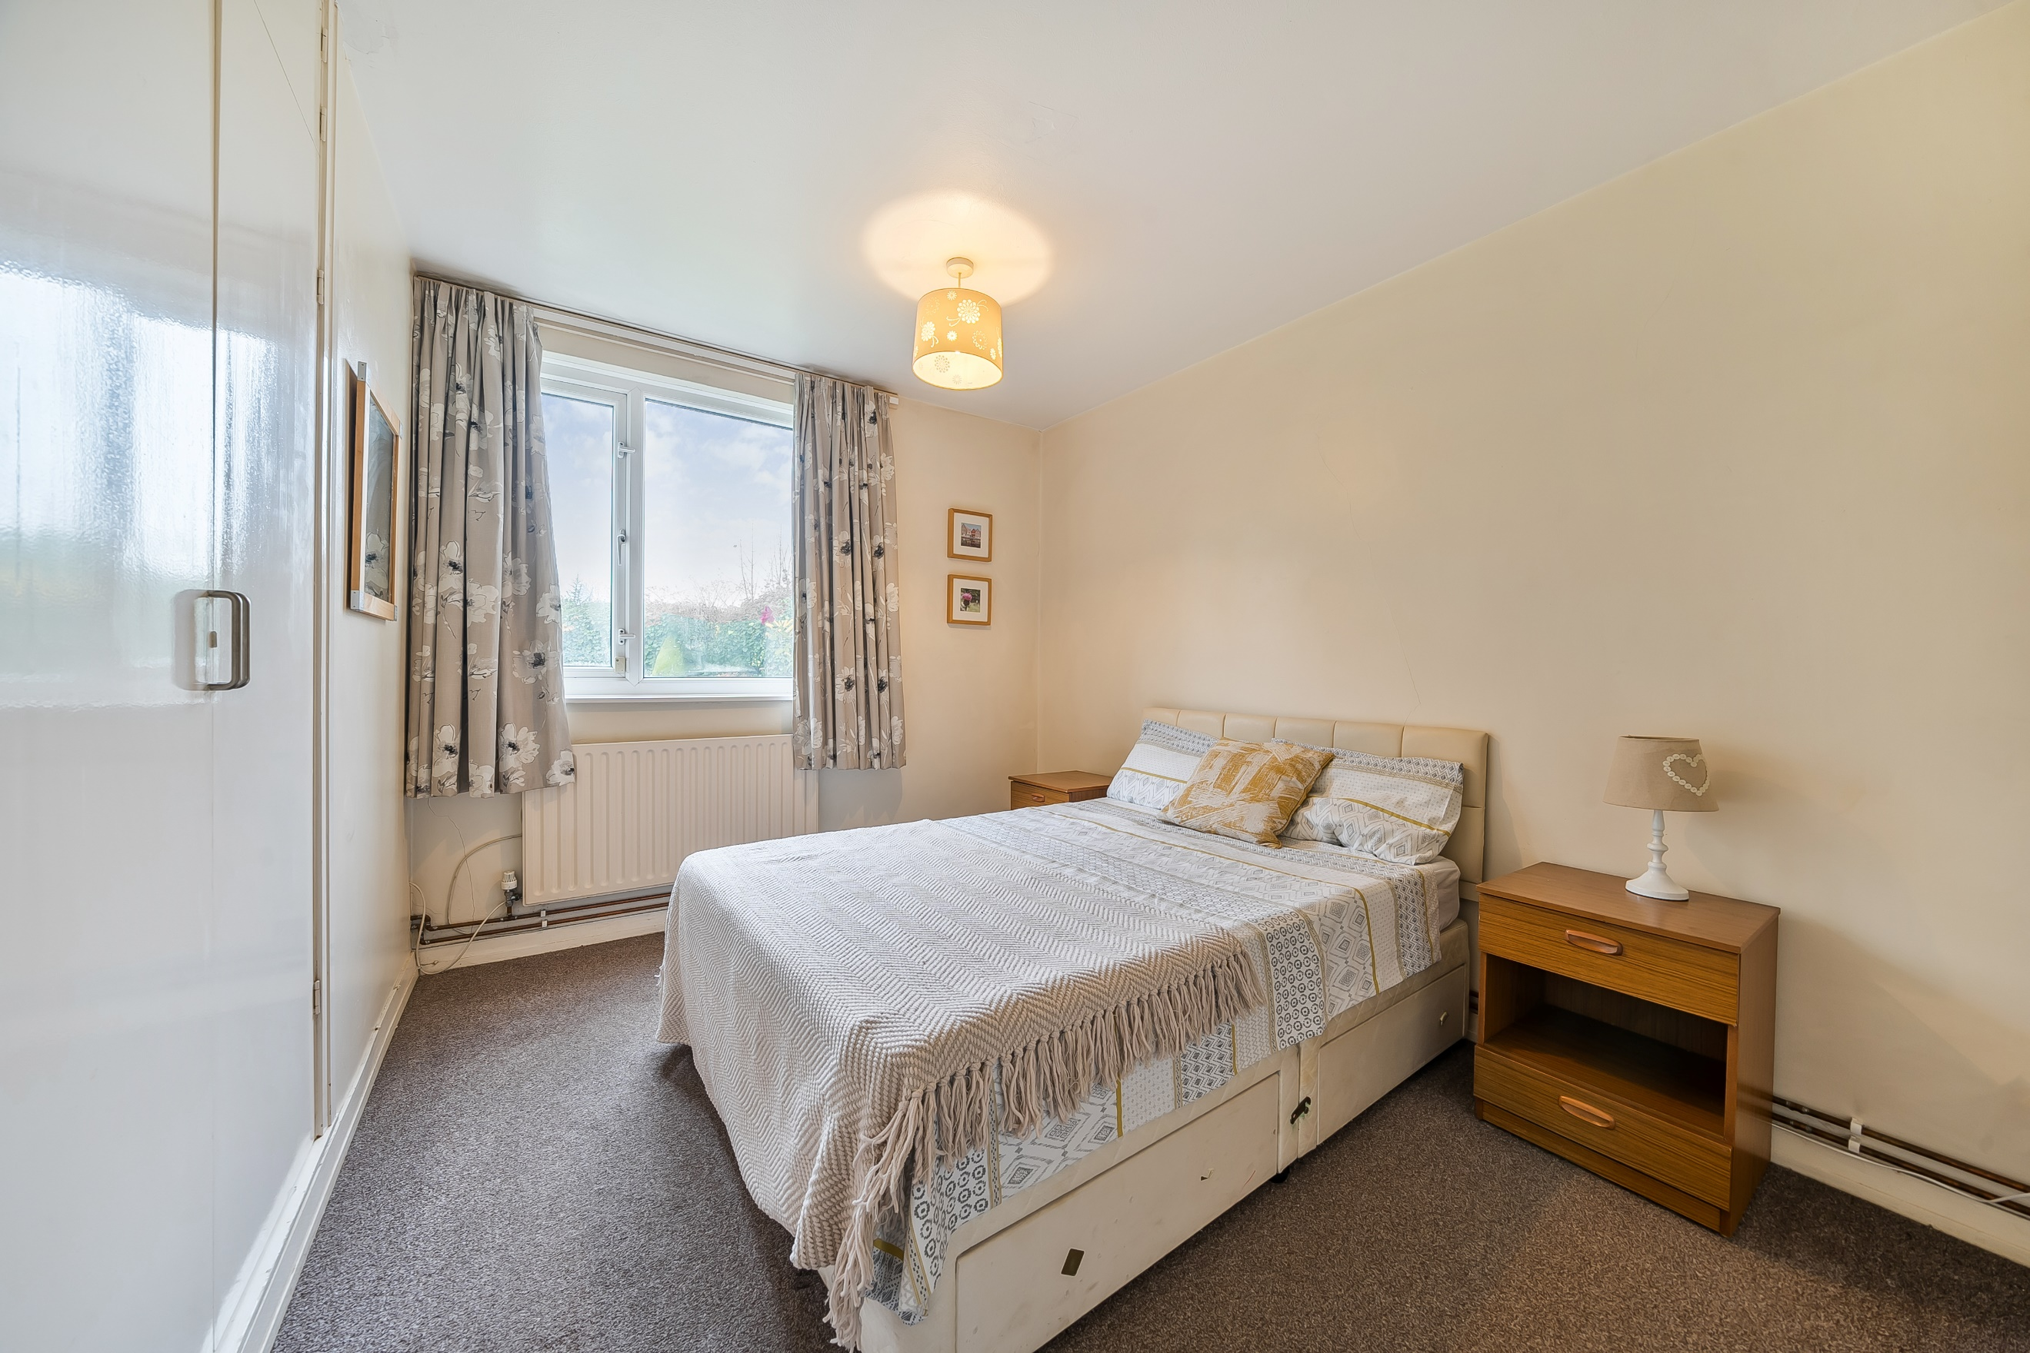
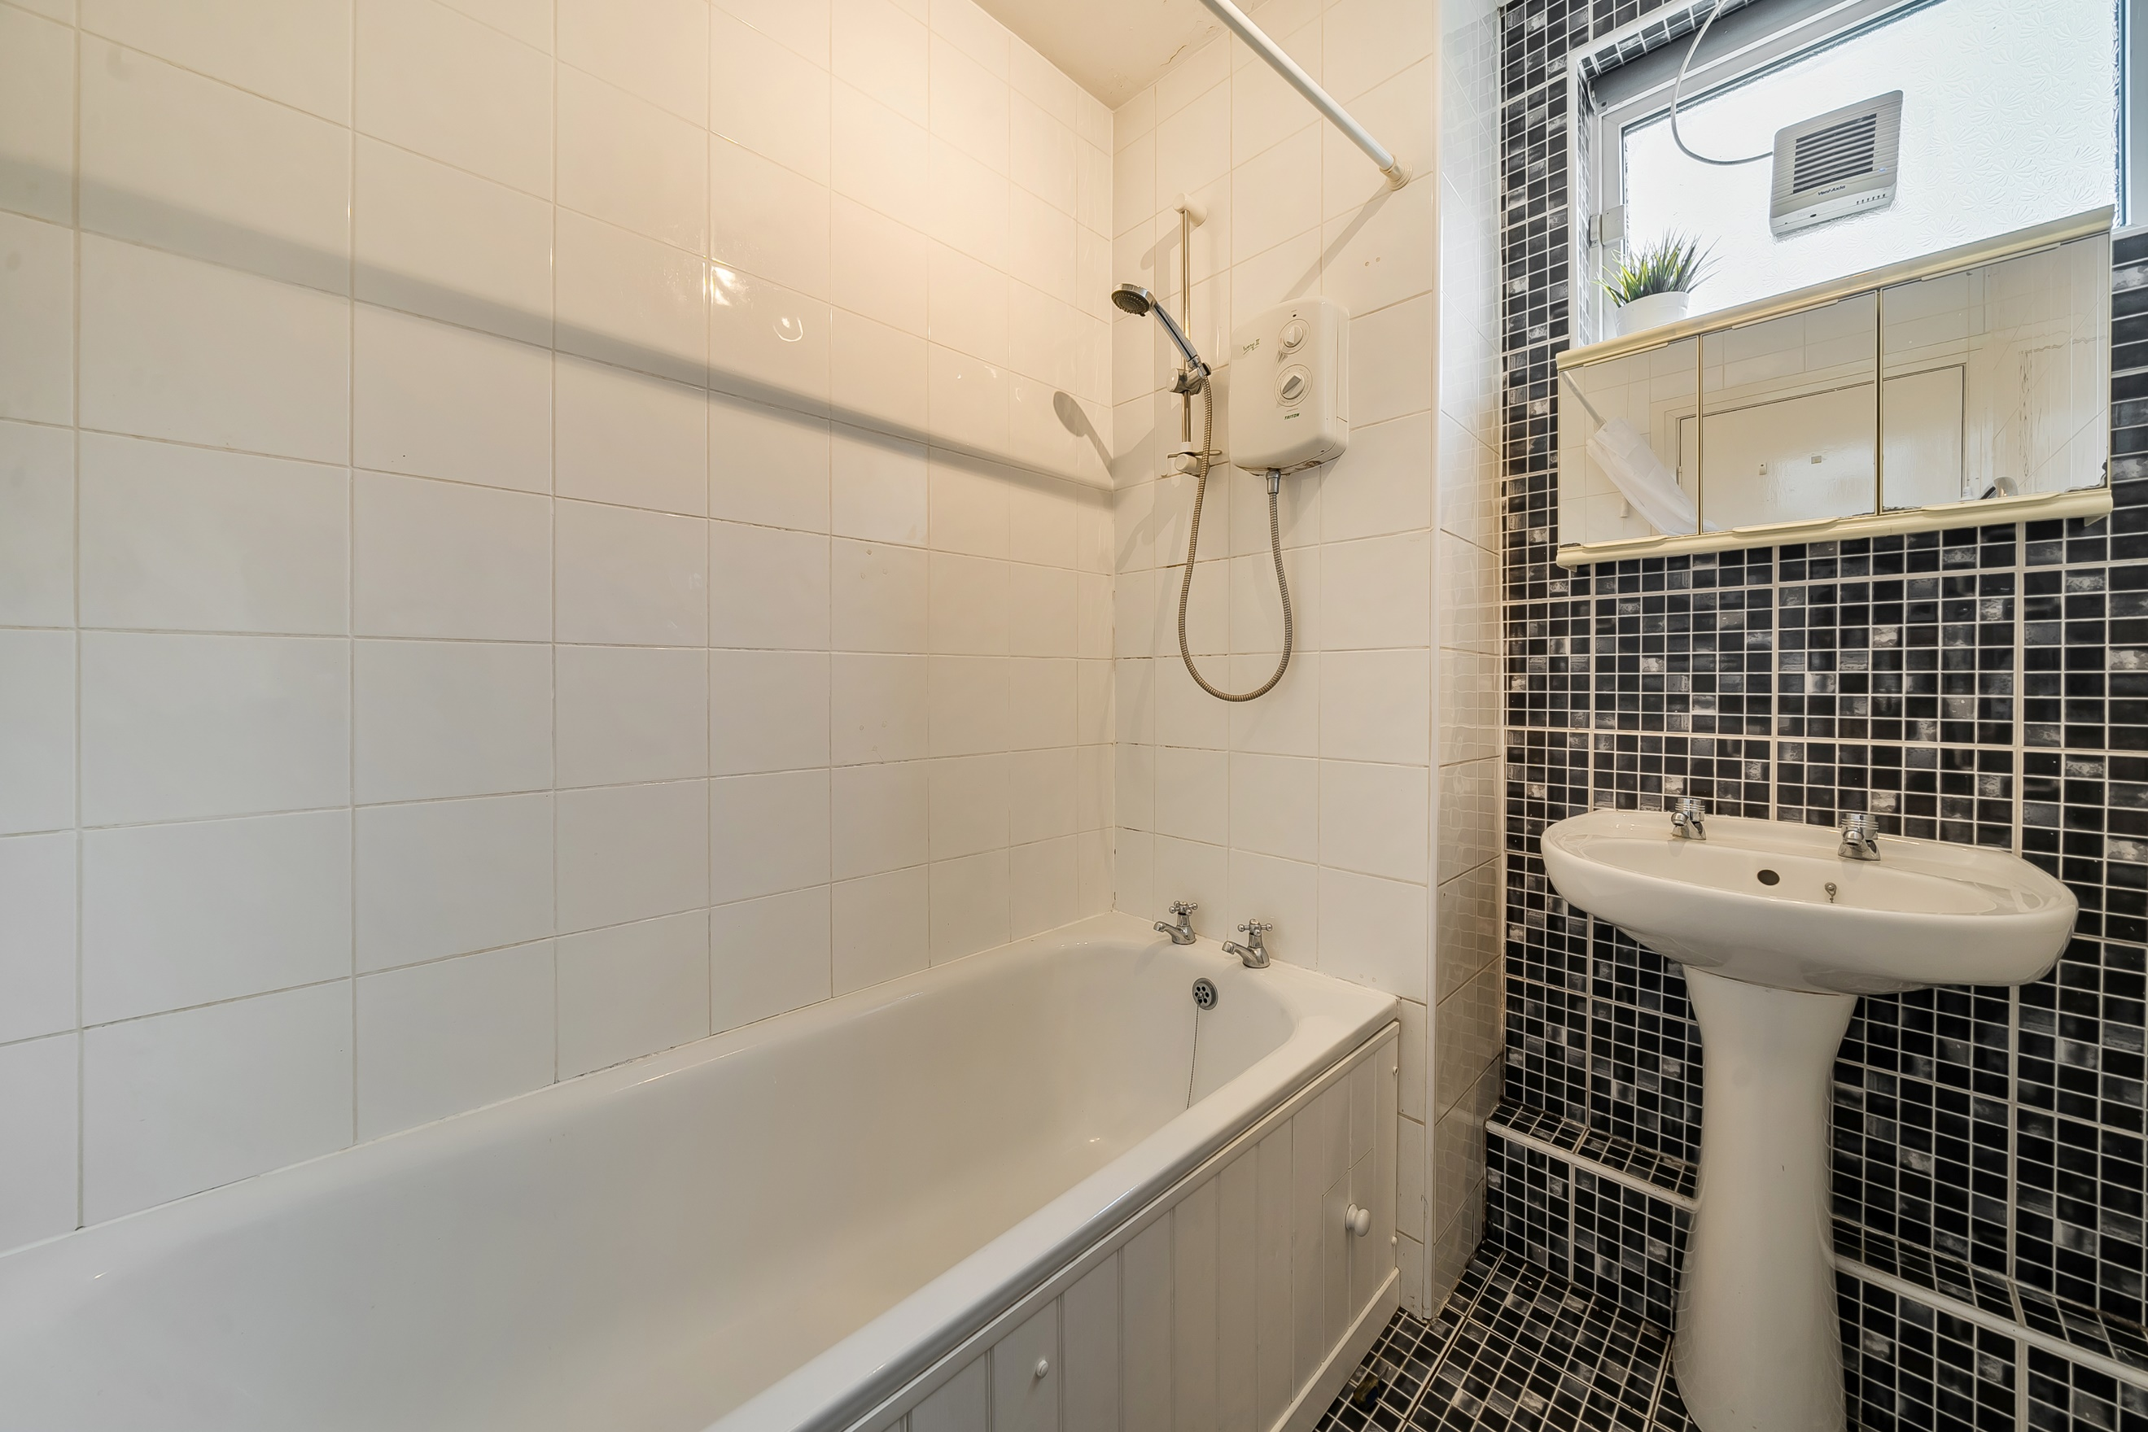

Communal Hallway
Via front entrance door. Secure entry phone system.

Hallway
Via front entrance door. Gas central heating radiator.

Lounge 5.24m (17'2) x 3.33m (10'11)
Spacious living area with uPVC double glazed window and door leading out to the communal gardens. Gas central heating radiator.

Kitchen 4.16m (13'8) x 2.13m (7')
Fitted with a range of wall, base and drawer units with worktops over. Stainless steel sink with mixer tap and drainer. Space for dishwasher, washing machine, fridge and cooker. Double glazed window to front. Part tiled walls.

Bedroom 1 3.86m (12'8) Max x 3.61m (11'10)
Double bedroom with uPVC double glazed window. Built in wardrobes. Gas central heating radiator.

Bedroom 2 3.61m (11'10) x 3.23m (10'7) Max
Second double bedroom with uPVC double glazed widow. Built in wardrobes. Gas central heating radiator.

Bathroom
Fitted with a two piece suite comprising bath with shower over and WC. Tiled walls.

Separate WC
Fitted with WC. uPVC double glazed window.

Garage
Single garage with up and over door.

Outside
Well maintained communal gardens.

Parking
Residents Parking.

Service Charge
The service charges are £400.00 per quarter.

Tenure
Leasehold.
999 years from 1960
Ground Rent - £0

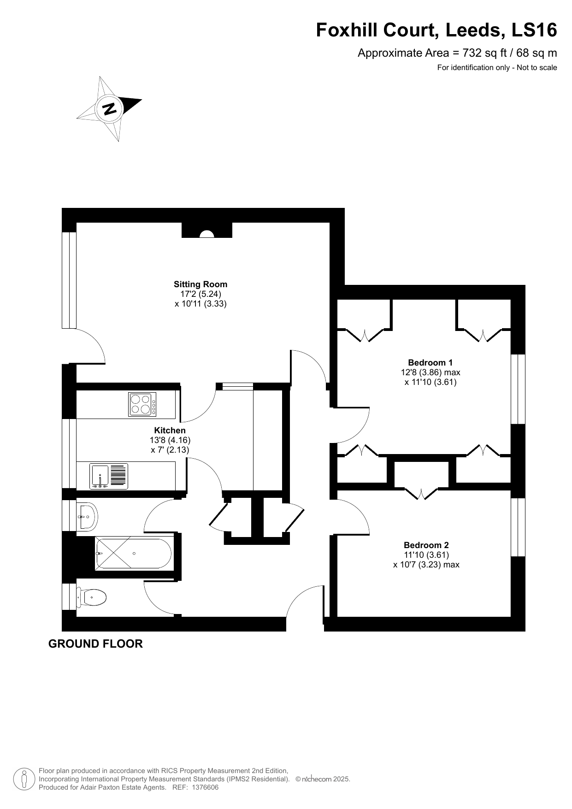

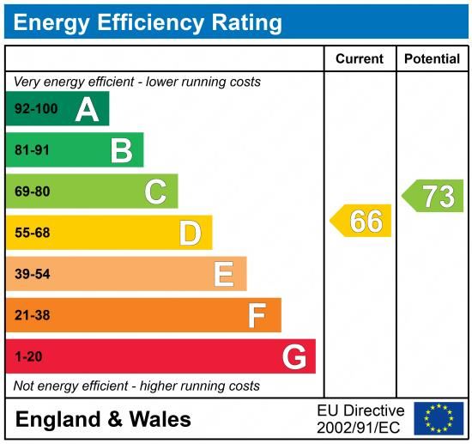

These particulars are intended to give a fair description of the property, but their accuracy cannot be guaranteed, and they do not constitute an offer of contract. Intending purchasers must rely on their own inspection of the property. None of the above appliances/services have been tested by ourselves. We recommend purchasers arrange for a qualified person to check all appliances/services before legal commitment.

Property Ref: 3834

For more information, please contact

0113 258 1150 | sales@adairpaxton.co.uk | www.adairpaxton.co.uk

