

Bouverie Court, LS9
Valuation £750.00pcm

This top floor fully furnished apartment is located in the ever popular Bouverie Court Development. An ideal property for city centre professionals, hospital employees and international students. 10 mins walk to Leeds Dock, Corn Exchange, Bus Station, BBC Building, Northern Ballet. he apartment is spacious with entrance hallway, Double Bedroom with built-in wardrobe, double-glazed window, the bathroom has bath with shower over, basin, WC , extractor and heated towel rail. The lounge-diner- kitchen also has sofa, table, dining table and chairs. There's a double-glazed Juliet balcony. Leeds City Station is only 20 minutes walk. Available 17th November, Council tax band, EPC rating, deposit £835.
0113 258 1150
0800 000 000
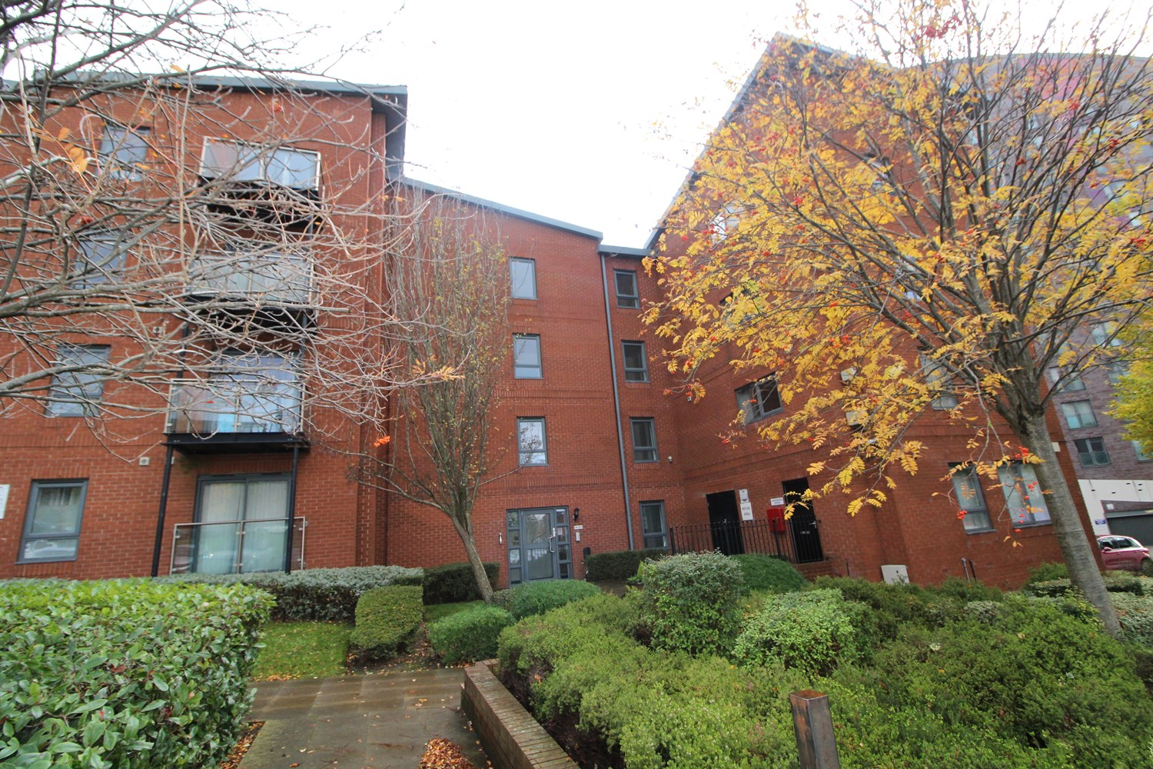



1 Reception(s)
1 Bathroom(s)
1 Bedroom(s)
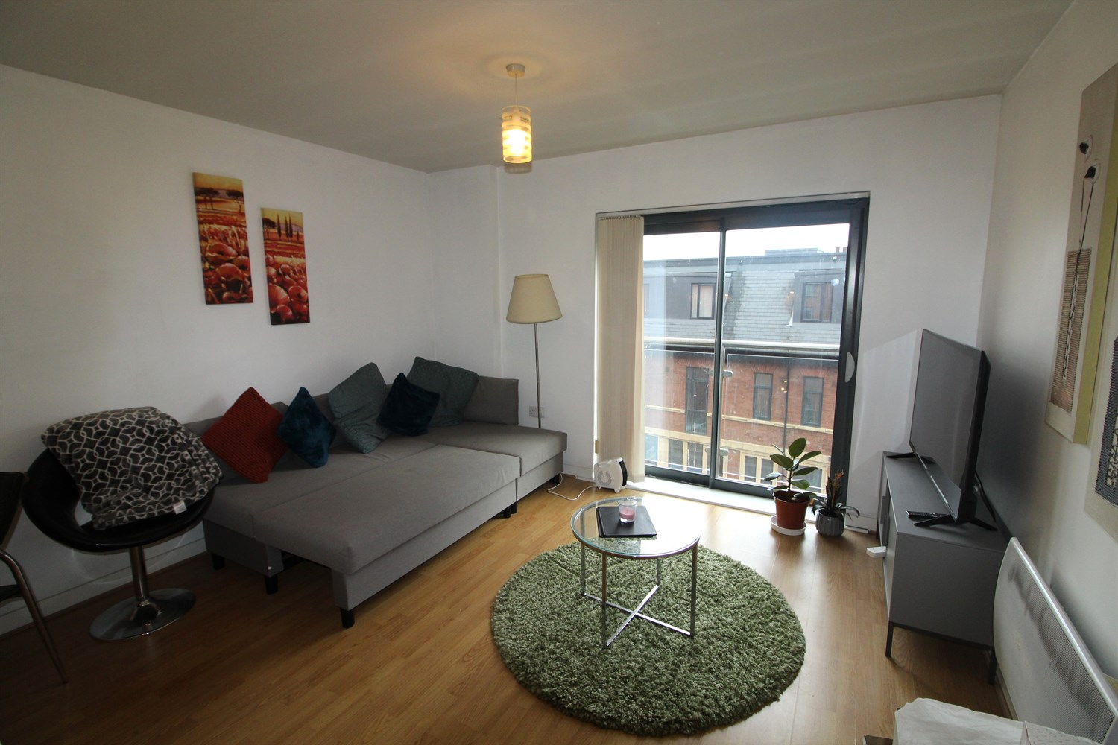
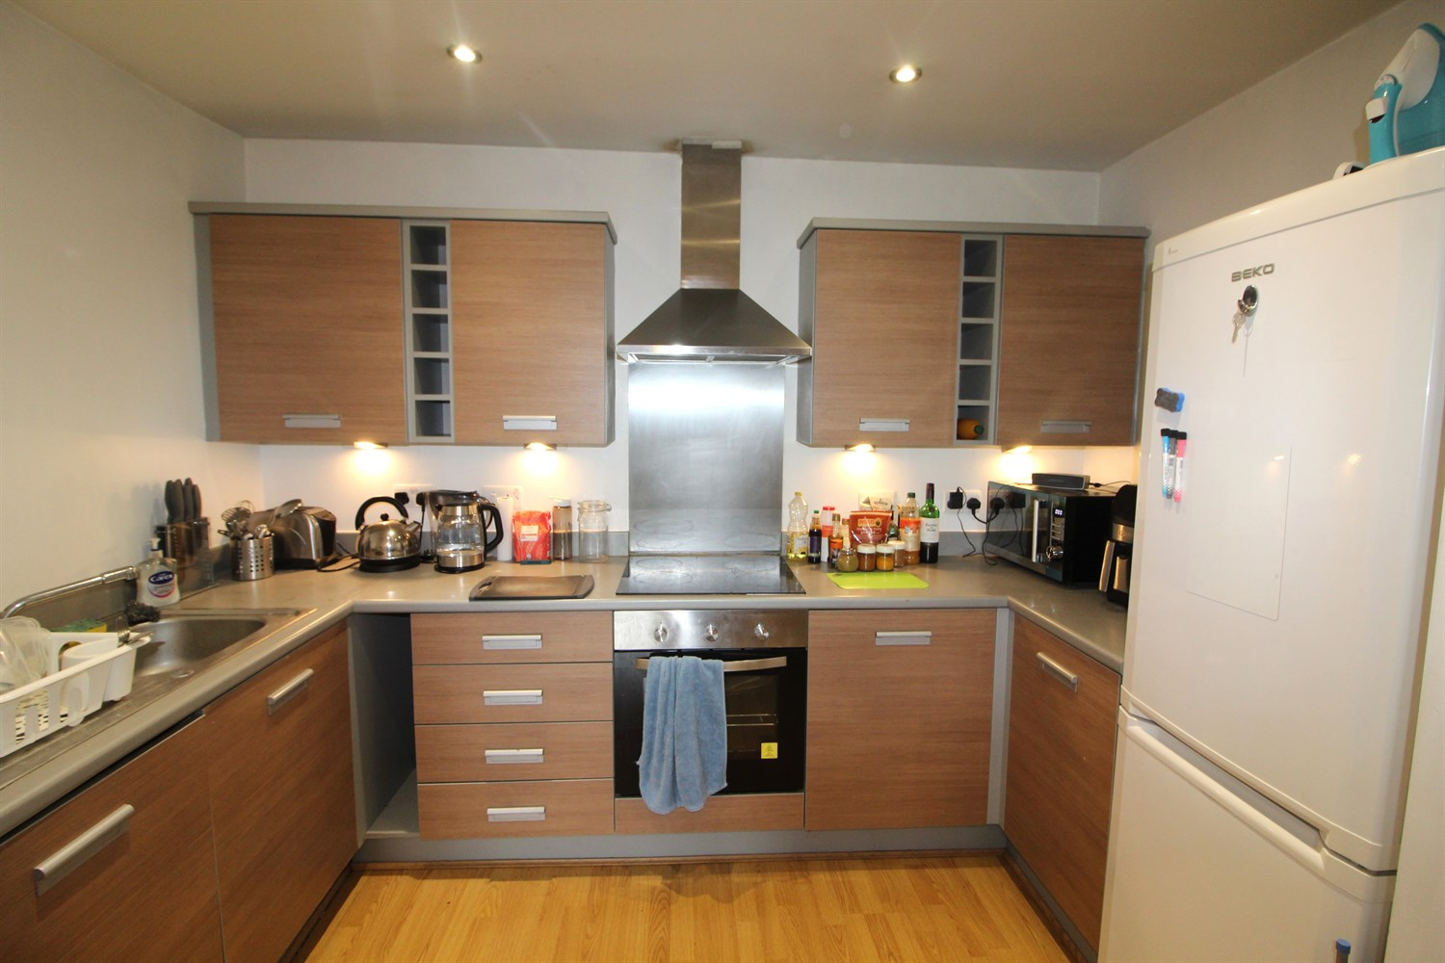
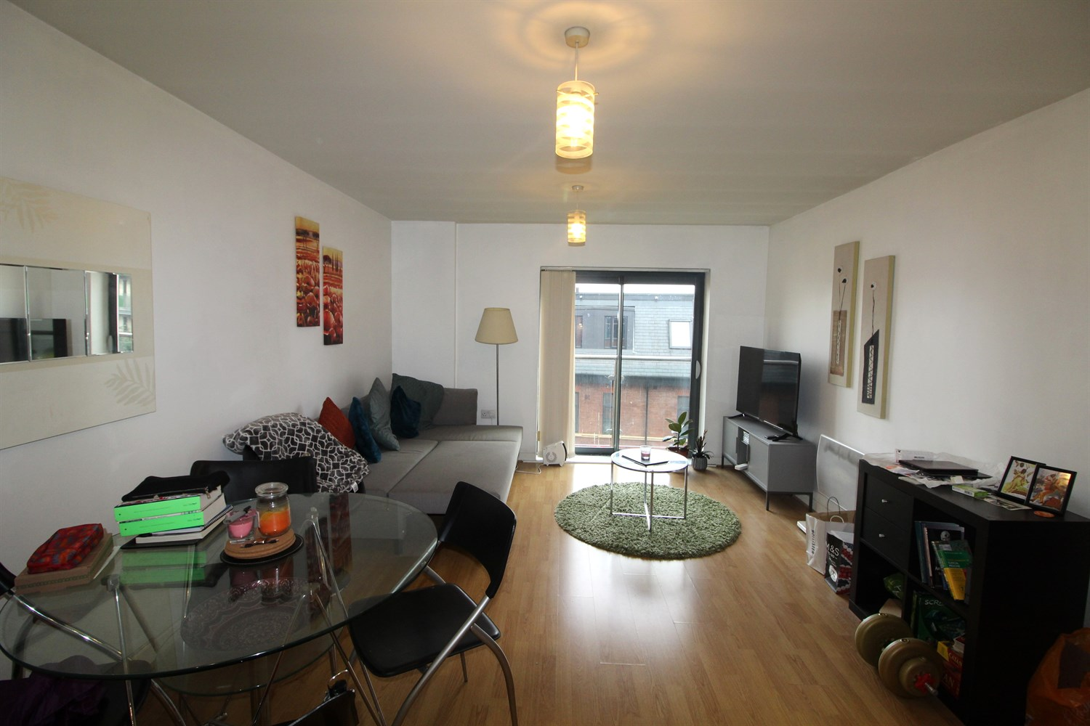
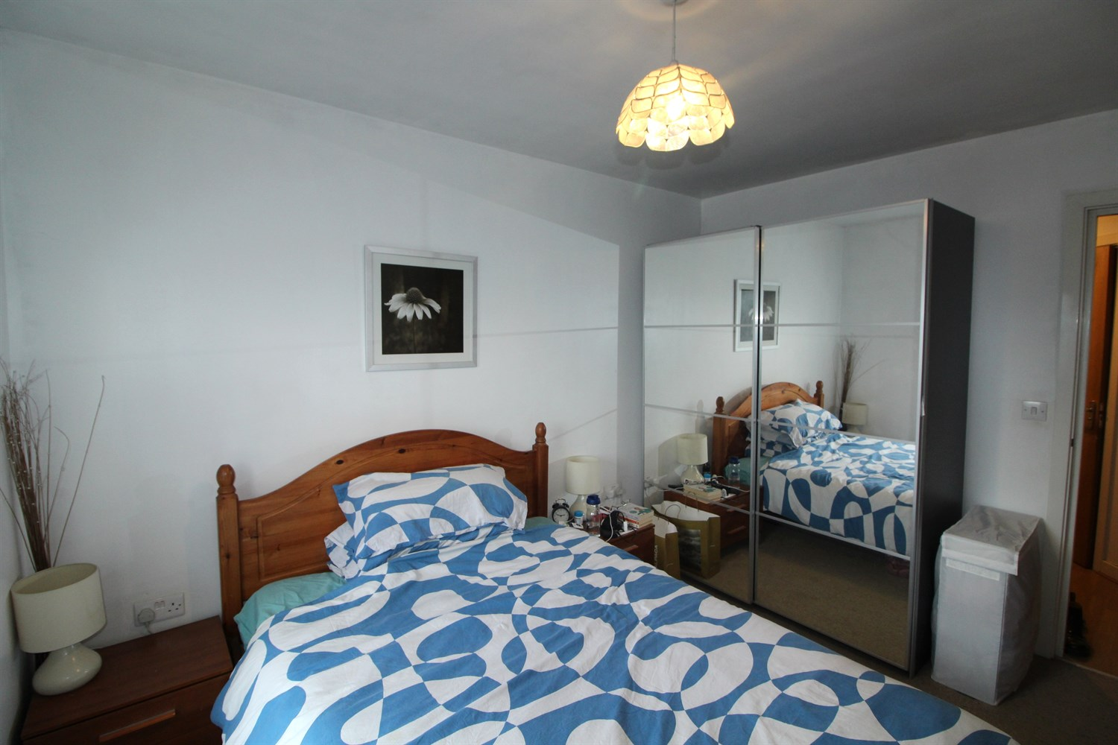

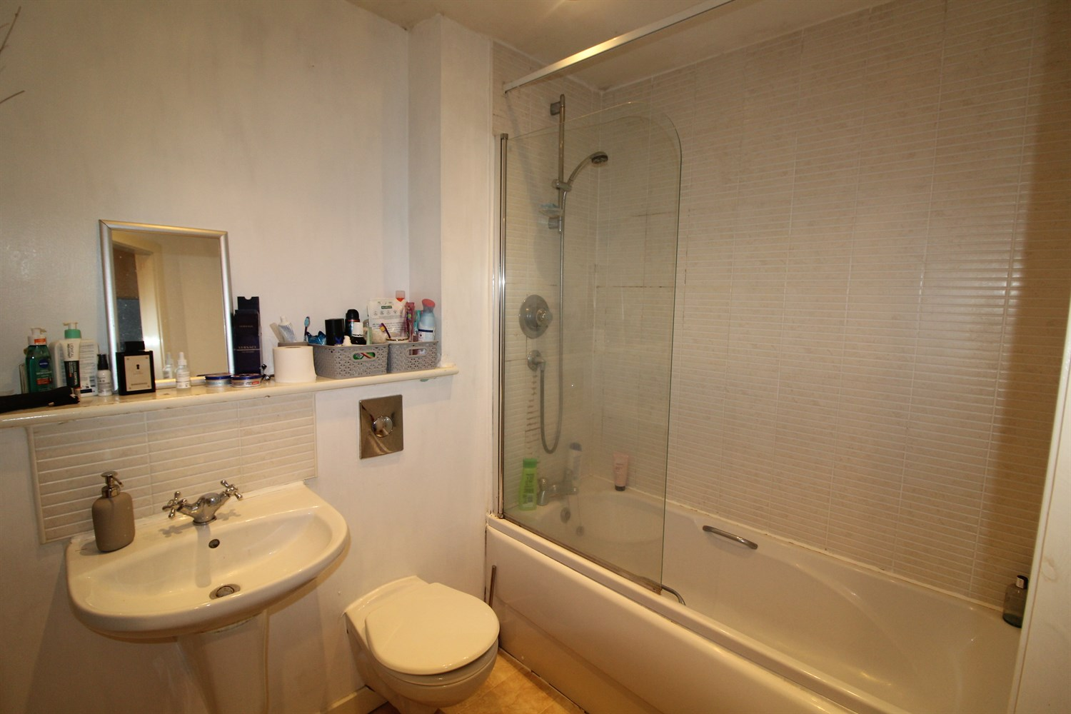

Communal Entrance
Communal entrance hall with stairs leading to all floors.

Hallway
Spacious hallway with storage cupboard housing water panel.

Reception 1
Spacious lounge with doors opening up to a Juliet balcony. Open plan to kitchen, electric wall heater.

Kitchen
Fitted with a range of wall and base units, with worktops over. Stainless steel sink with mixer tap, integrated washing machine. Part tiled. Open plan to living room.

Bedroom 1
Large double bedroom with double glazed window to front, electric wall heater.

Bathroom
Spacious bathroom fitted with a bath tub and shower, hand wash basin and w/c, part tiled large mirror and electric towel radiator.

Communal Garden

Home Information
COUNCIL TAX BAND: B
EPC Rating D
Leasehold property
Broadband:
Standard 9 Mbps 0.9 Mbps Good
Superfast 80 Mbps 20 Mbps Good
Ultrafast 1000 Mbps 1000 Mbps
Mobile availability: EE Limited ThreeLikely to have good coverage O2 Likely to have good coverage Vodafone Likely to have good coverage.
Electric mains supply, water on mains supply.

These particulars are intended to give a fair description of the property, but their accuracy cannot be guaranteed, and they do not constitute an offer of contract. Intending purchasers must rely on their own inspection of the property. None of the above appliances/services have been tested by ourselves. We recommend purchasers arrange for a qualified person to check all appliances/services before legal commitment.

Property Ref: 8010

For more information, please contact

0113 258 1150 | lettings@adairpaxton.co.uk | www.adairpaxton.co.uk

