
The Cross, Church Hill, Bramhope
For Sale £249,950.00

**THREE BEDROOM MID-TERRACED HOUSE - NO ONWARD CHAIN** Adair Paxton are pleased to offer to the market this three bedroom mid terrace house full of charm and character, in the heart of the beautiful and popular village of Bramhope. Just a short stroll to the famous "Fox and Hounds" pub and other local amenities, this lovely property briefly comprises; Hallway, living room, kitchen and utility room to the ground floor. To the first floor there are three bedrooms and a house bathroom. Externally the property has a lawned garden to the front, a courtyard style garden to the rear and on street parking. Council Tax Band D. EPC rating D.
0113 258 1150
0800 000 000
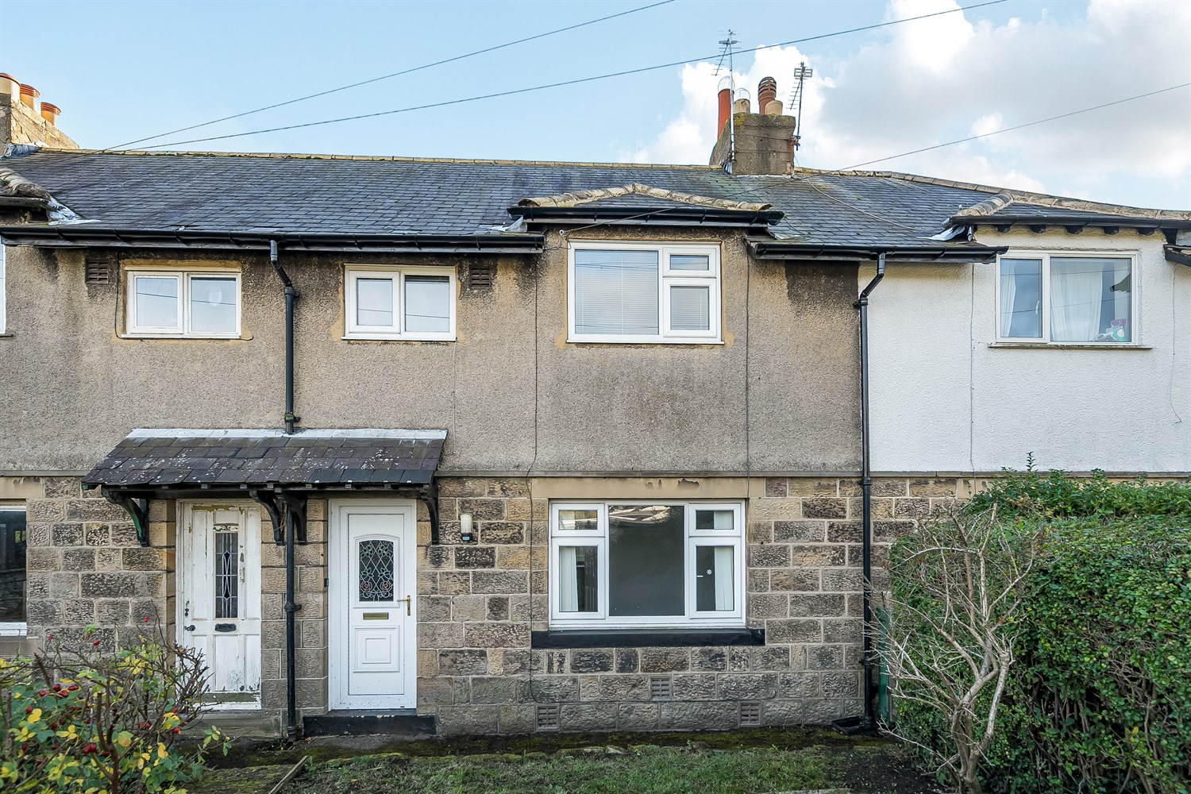



1 Reception
1 Bathroom
3 Bedrooms
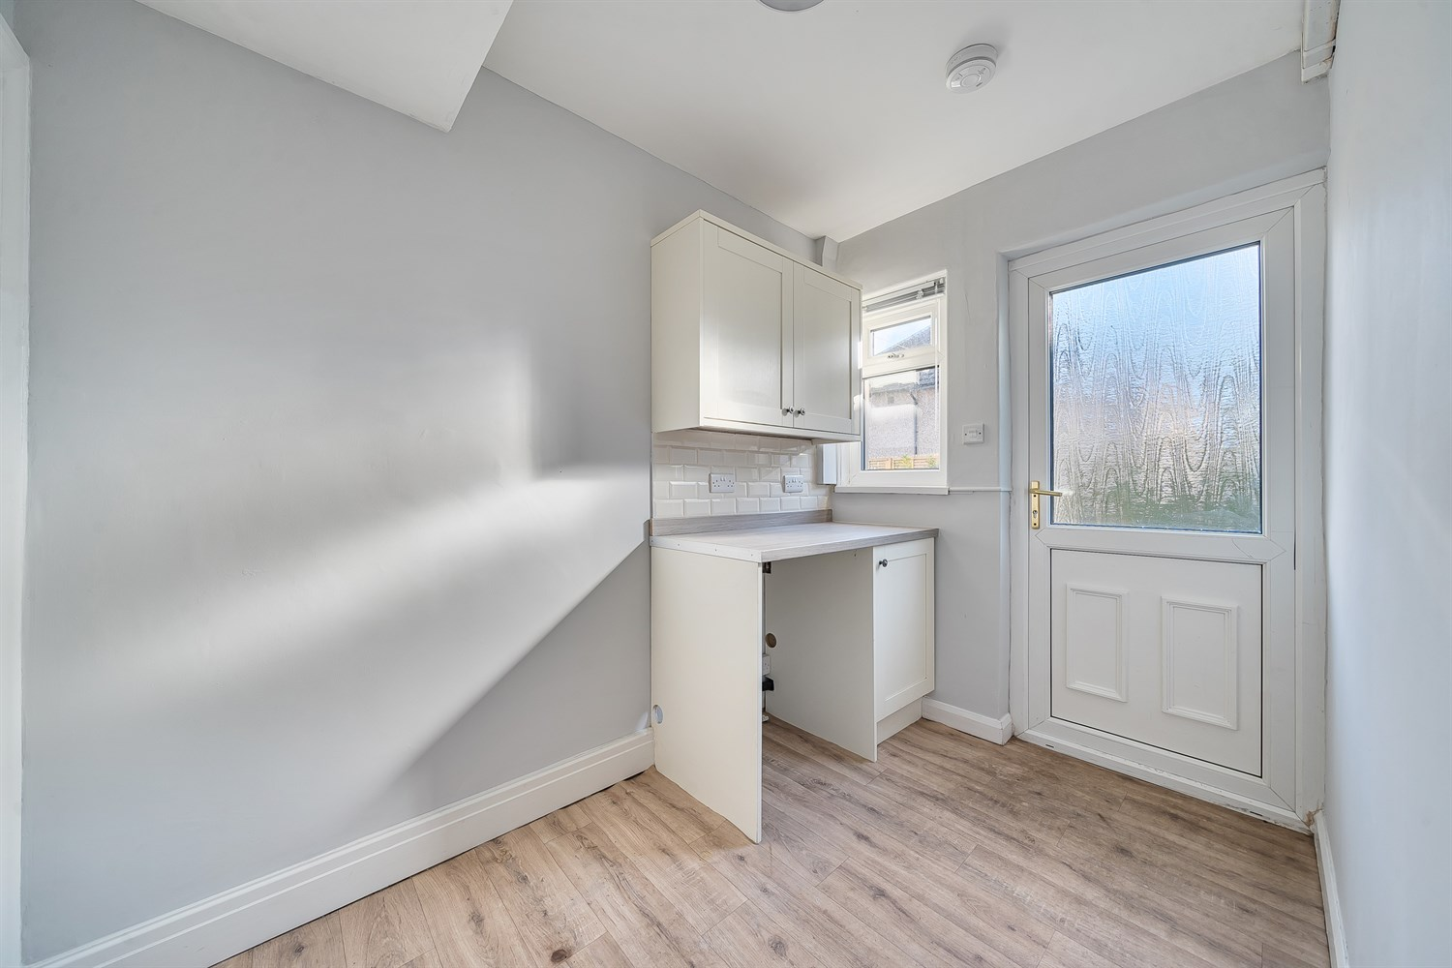
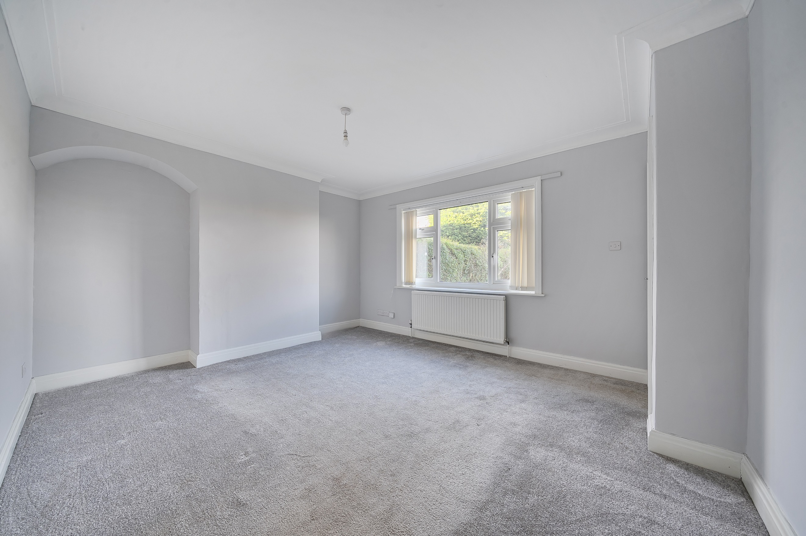
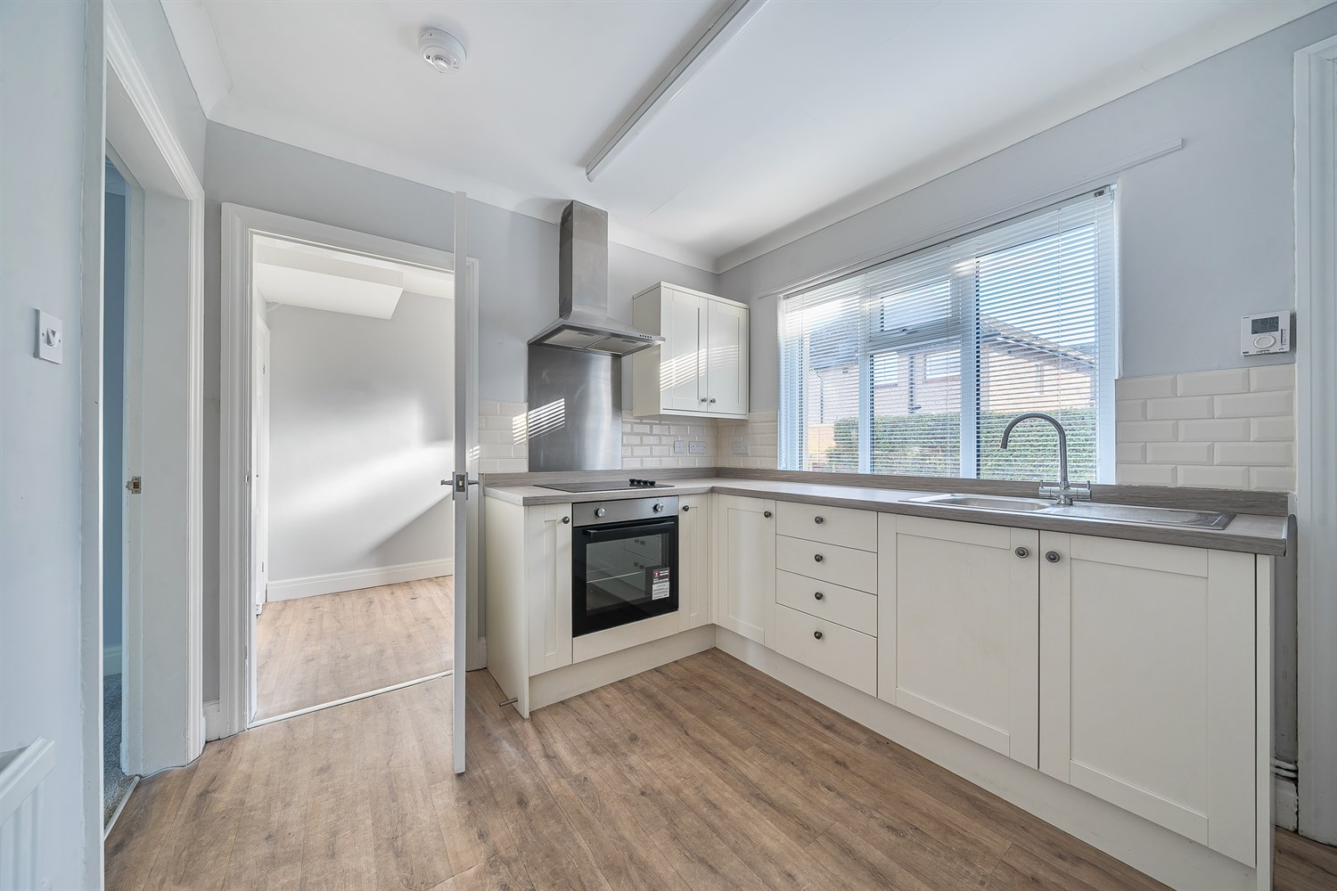
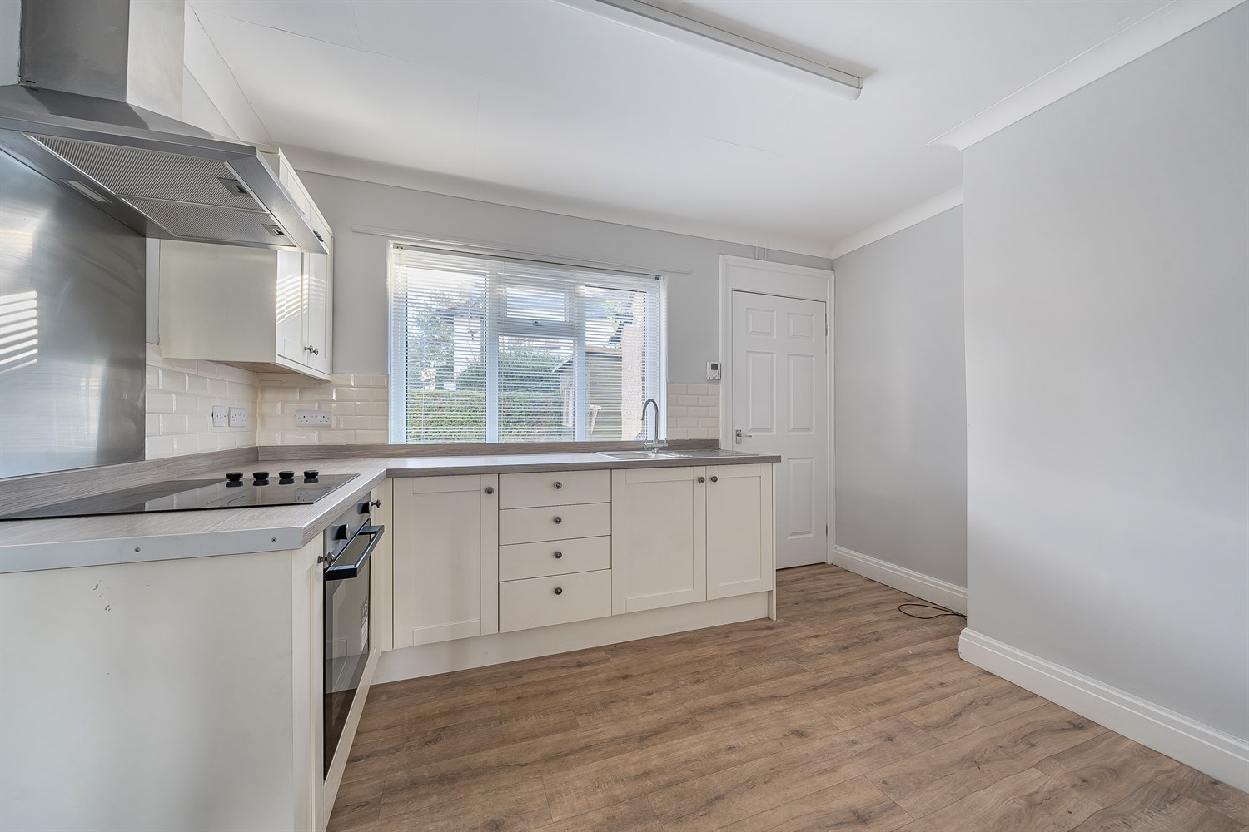
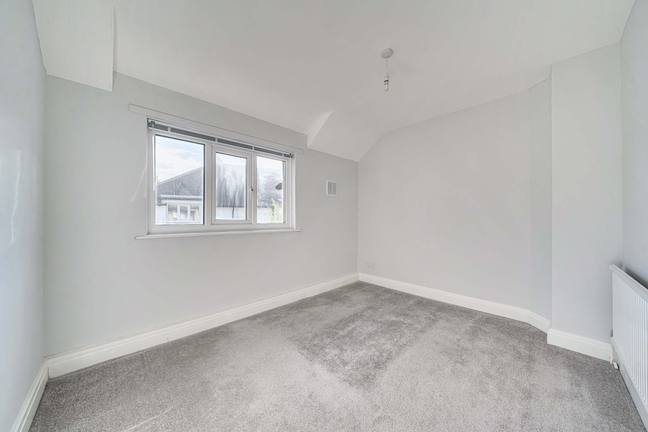
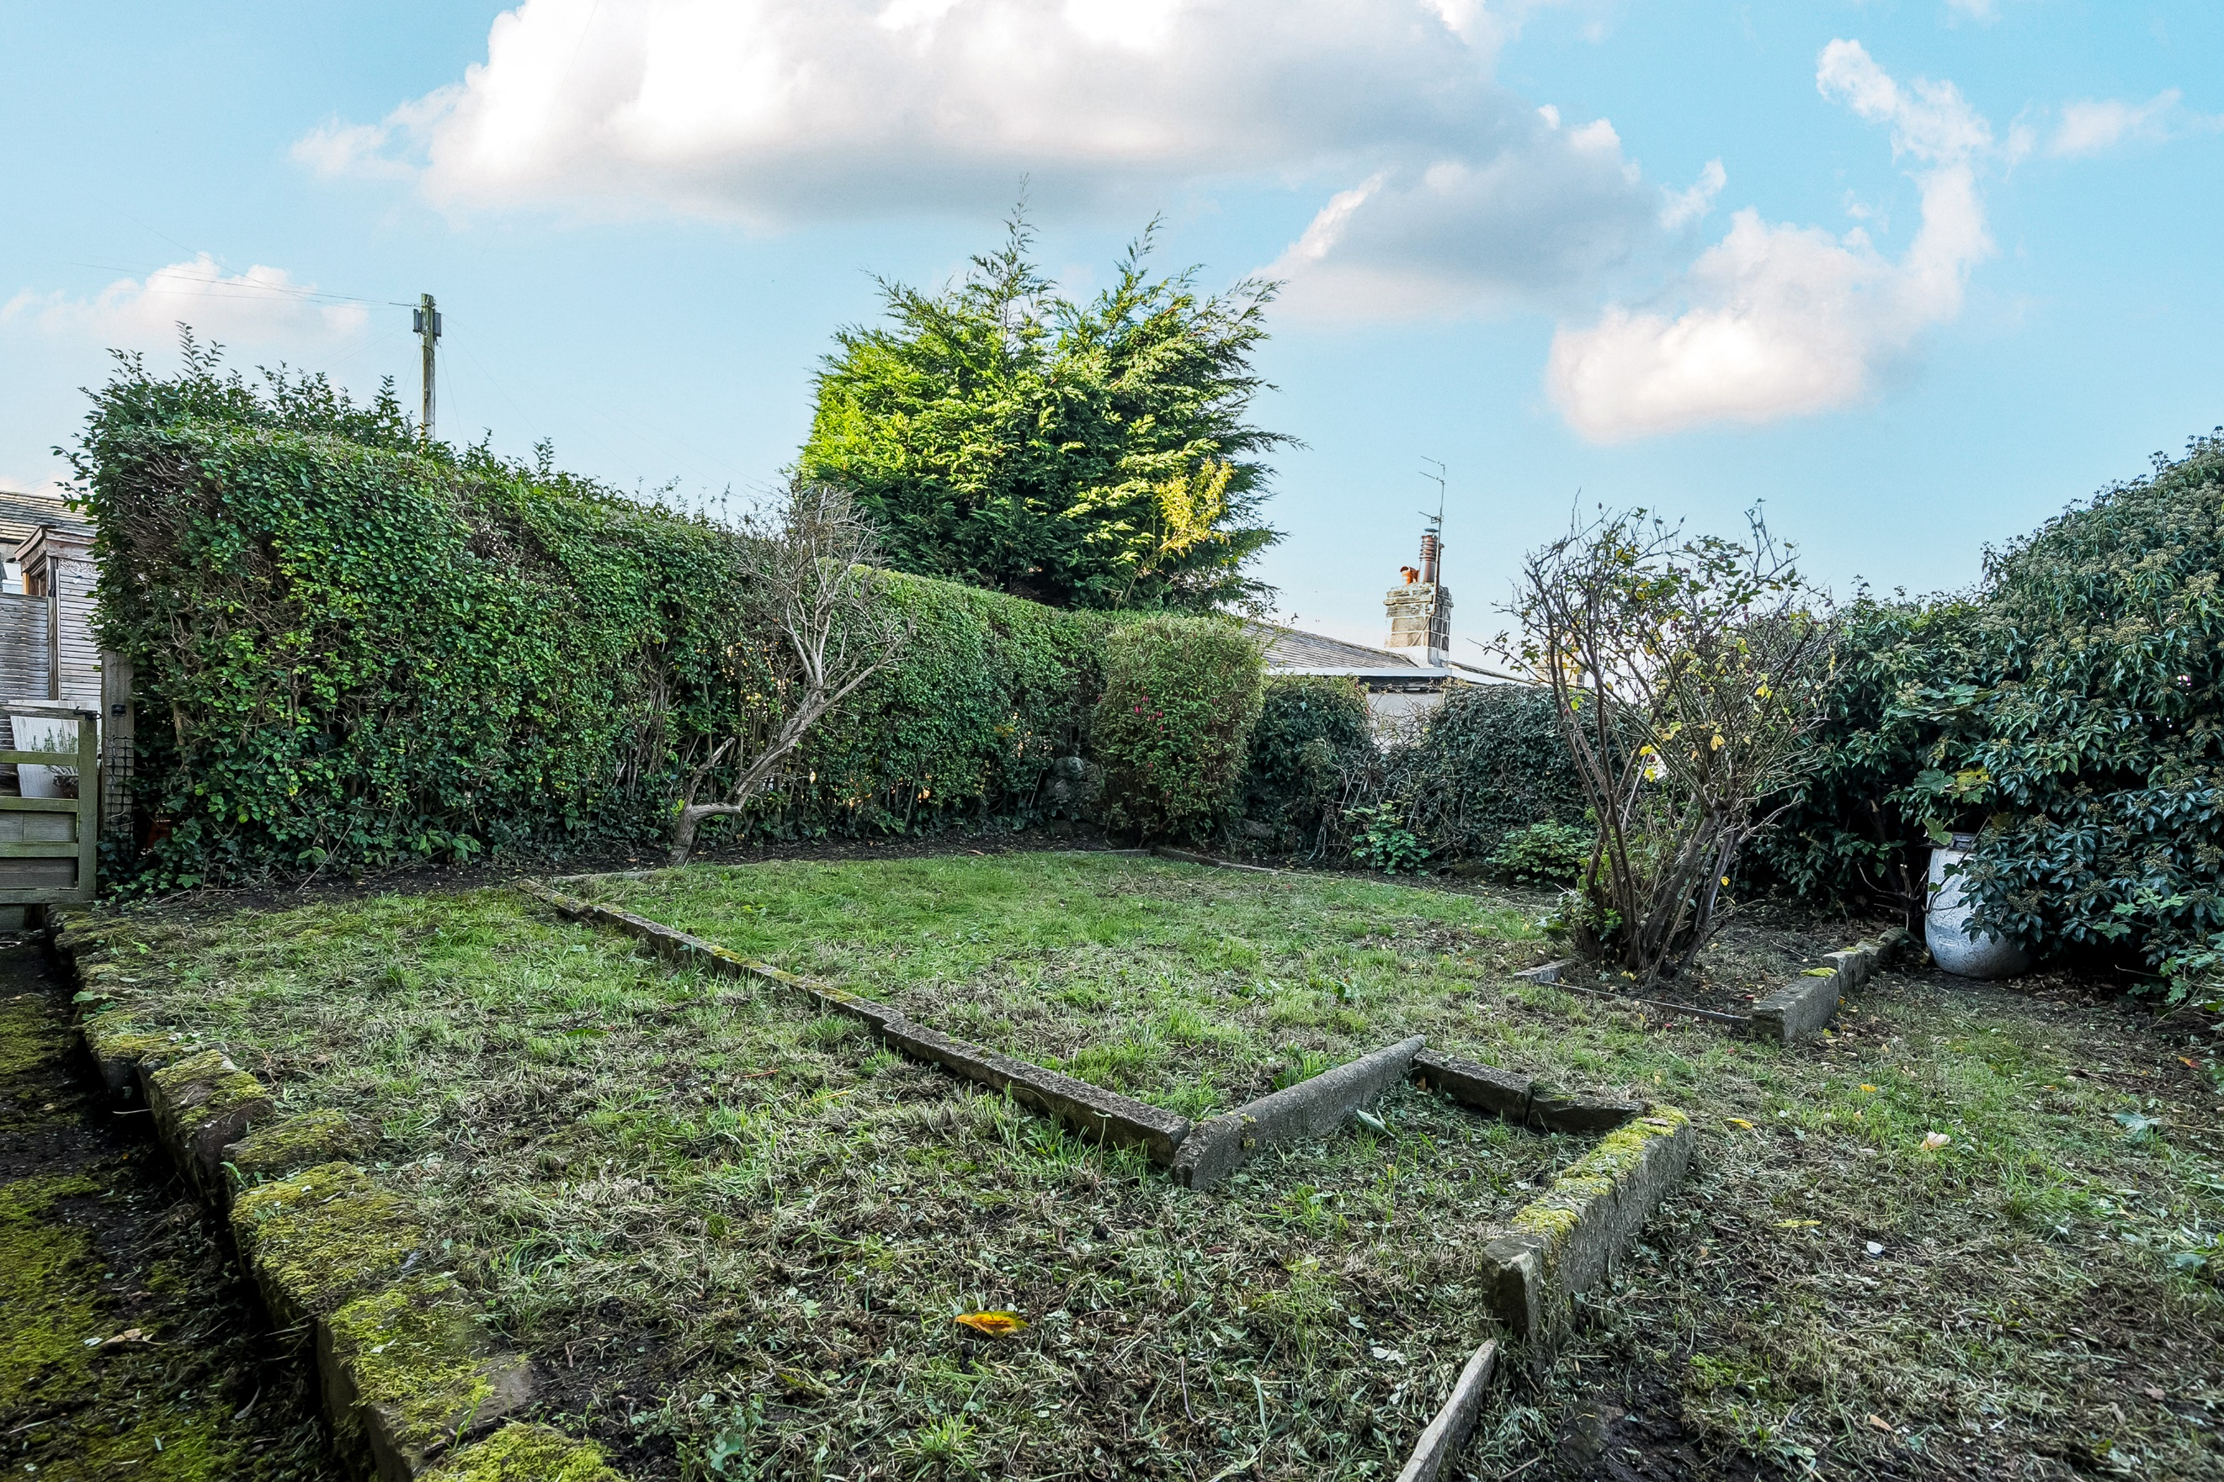
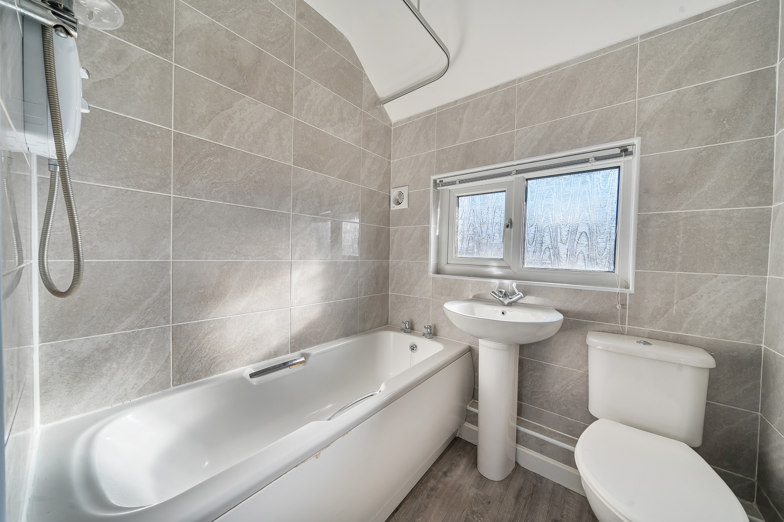
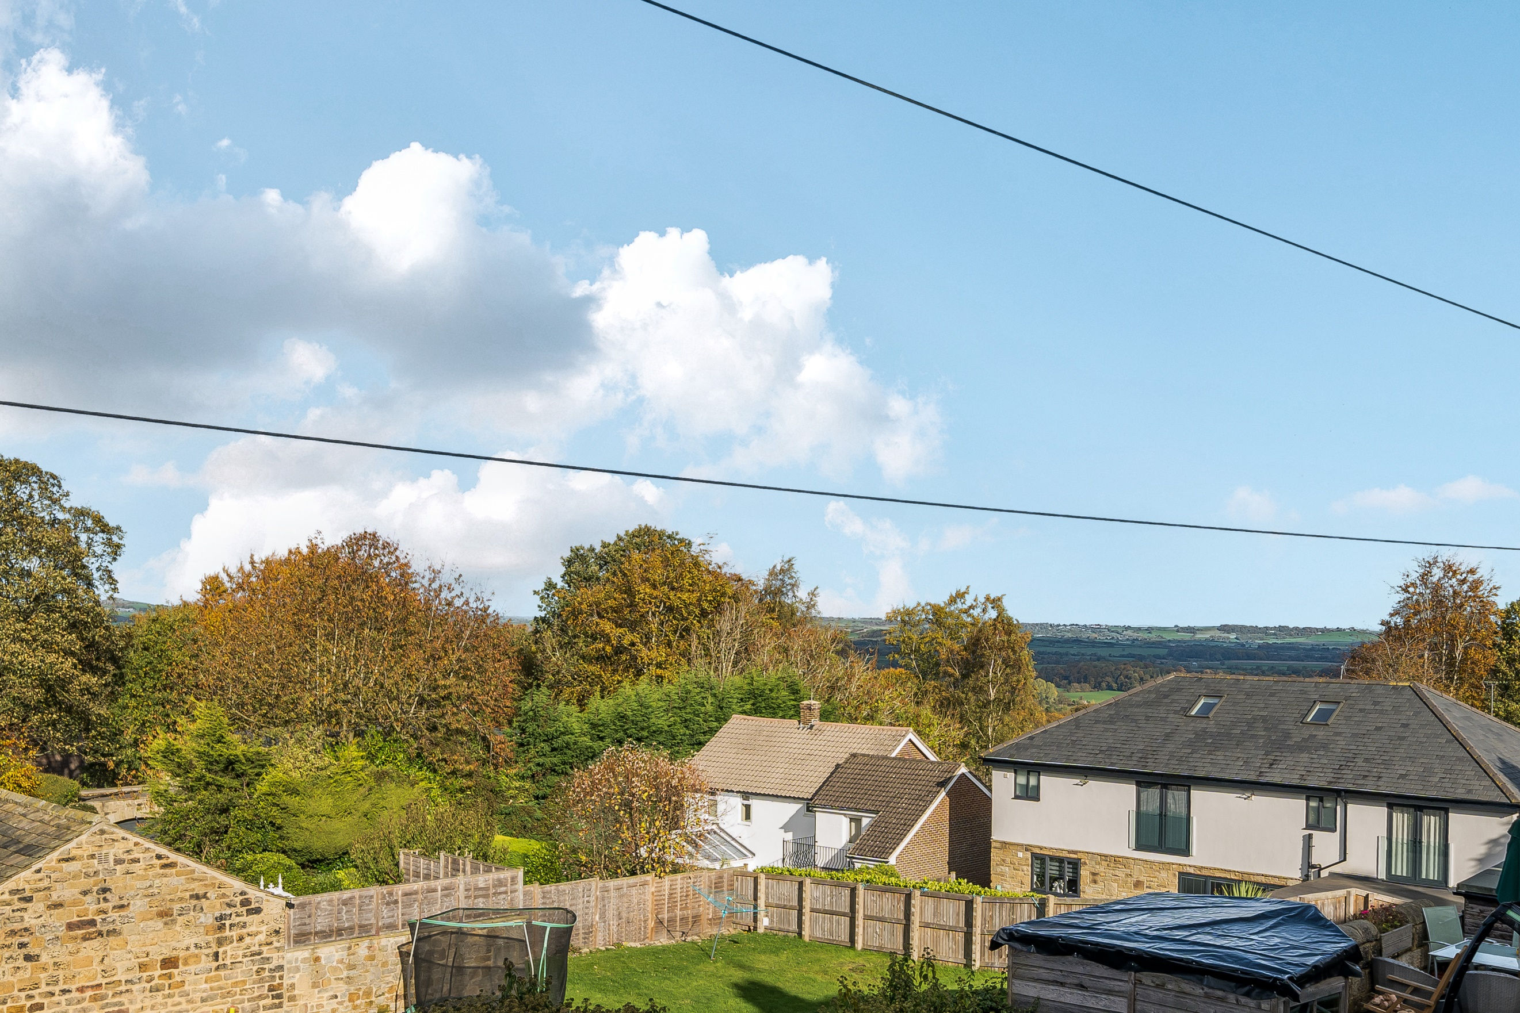

Entrance Hall
Via front entrance door. Stairs to first floor.

Lounge 4.45m (14'7) x 3.76m (12'4)
Light and airy living room with uPVC double glazed window to front. Gas central heating radiator.

Kitchen/Diner 3.5m (11'6) x 2.73m (8'11)
Fitted with a range of wall, base and drawer units with worktops over. Integrated oven with electric hob and extractor hood over. Space for fridge/freezer. Part tiled walls. uPVC double glazed window. Door to store cupboard.

Utility 2.71m (8'11) x 1.8m (5'11)
Fitted with matching units and worktops to the kitchen. Plumbing for washing machine. Door leading to rear garden.

First Floor

Bedroom 1 3.82m (12'6) x 3.57m (11'9)
Double bedroom with uPVC double glazed window to front with far reaching views. Gas central heating radiator.

Bedroom 2 3.5m (11'6) x 2.73m (8'11)
Second double bedroom with uPVC double glazed window to rear. Gas central heating radiator.

Bedroom 3 2.65m (8'8) x 1.81m (5'11)
Third bedroom with uPVC double glazed window to front with far reaching views. Gas central heating radiator.

House Bathroom
Fitted with a three piece suite comprising bath with shower over, WC and wash hand basin. Tiled walls. uPVC double glazed window to rear.

Outside
To the front of the property is a garden which has been mainly laid to lawn. To the rear is a courtyard style garden.

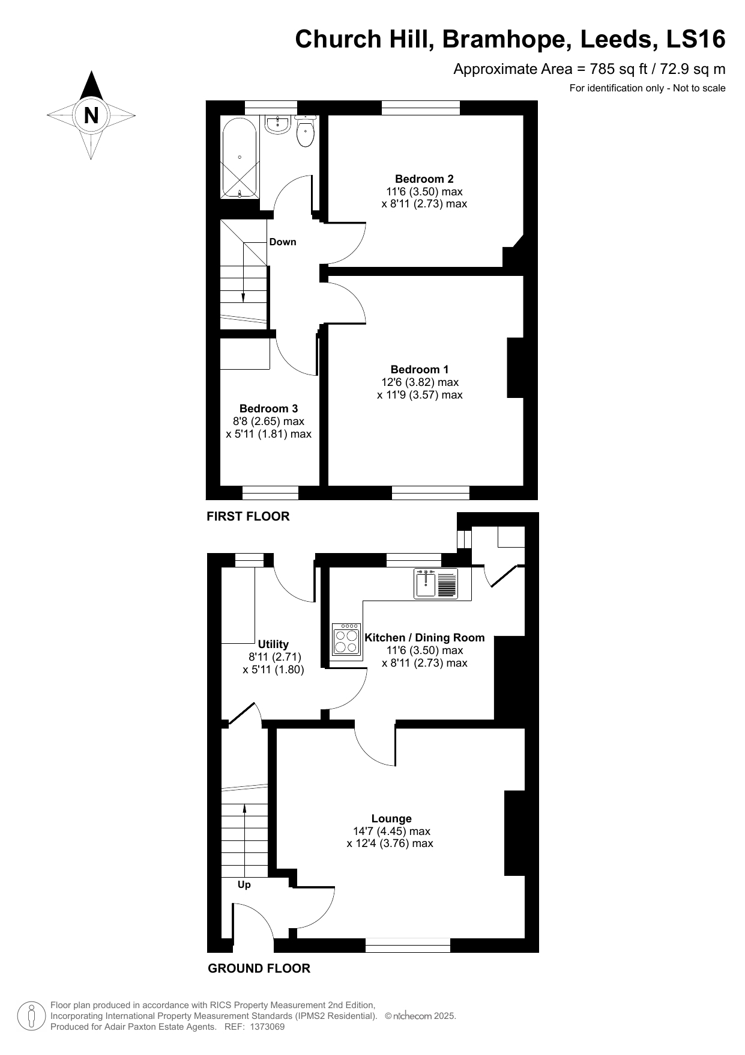

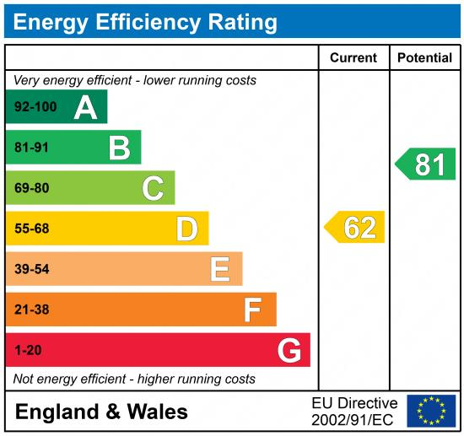

These particulars are intended to give a fair description of the property, but their accuracy cannot be guaranteed, and they do not constitute an offer of contract. Intending purchasers must rely on their own inspection of the property. None of the above appliances/services have been tested by ourselves. We recommend purchasers arrange for a qualified person to check all appliances/services before legal commitment.

Property Ref: 7934

For more information, please contact

0113 258 1150 | sales@adairpaxton.co.uk | www.adairpaxton.co.uk

