
Frizley Gardens, Bradford
Available to let £675.00pcm
A lovely large two bedroom, well decorated second and third floor flat situated a 3 minute walk from Frizinghall train station is available to rent. Property briefly compromising of living room, kitchen, balcony, and two bedrooms.
The property is located on a quiet, residential area but is just a 15 minute walk away from the local supermarket and Foster square shops. It also has a handy corner shop at the end of the road. Available 10th November, council tax band A, EPC rating C.
0113 258 1150
0800 000 000
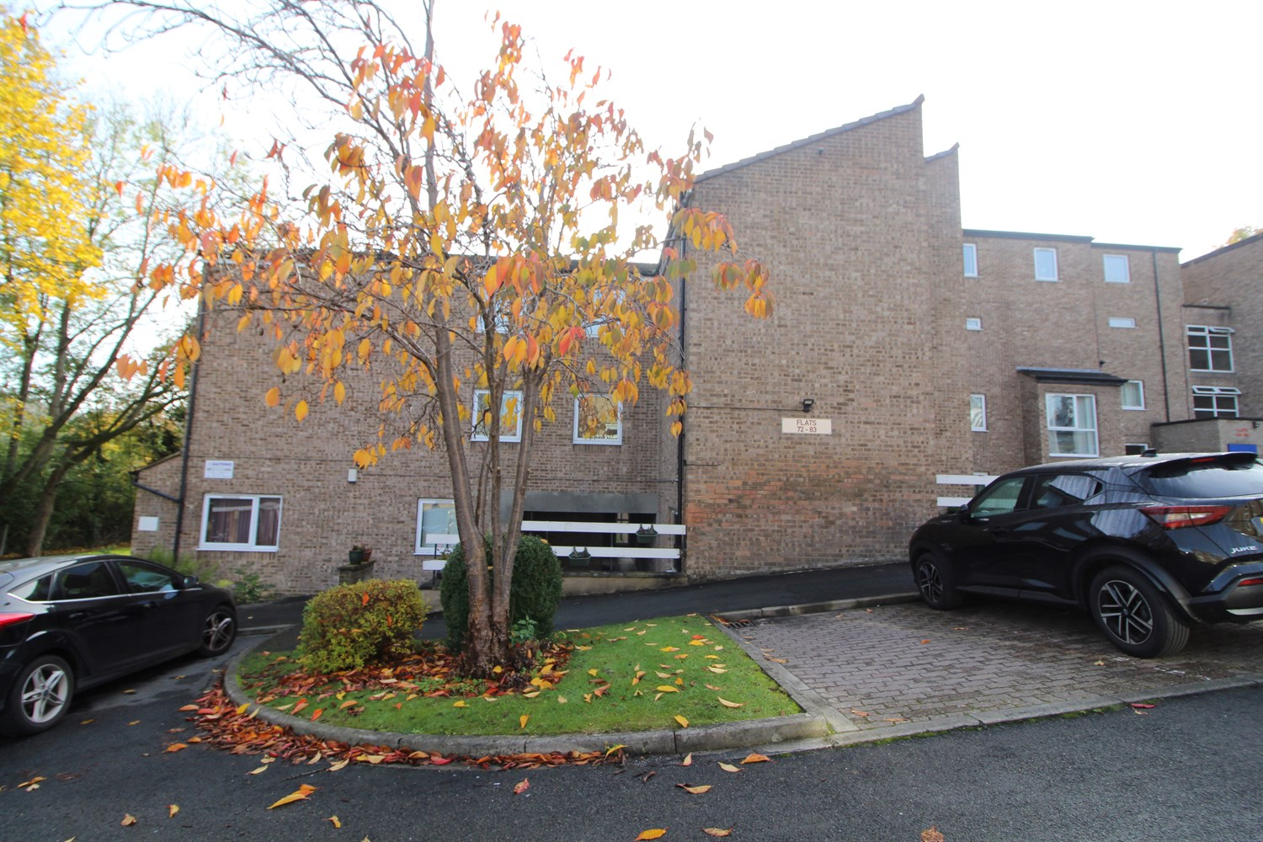

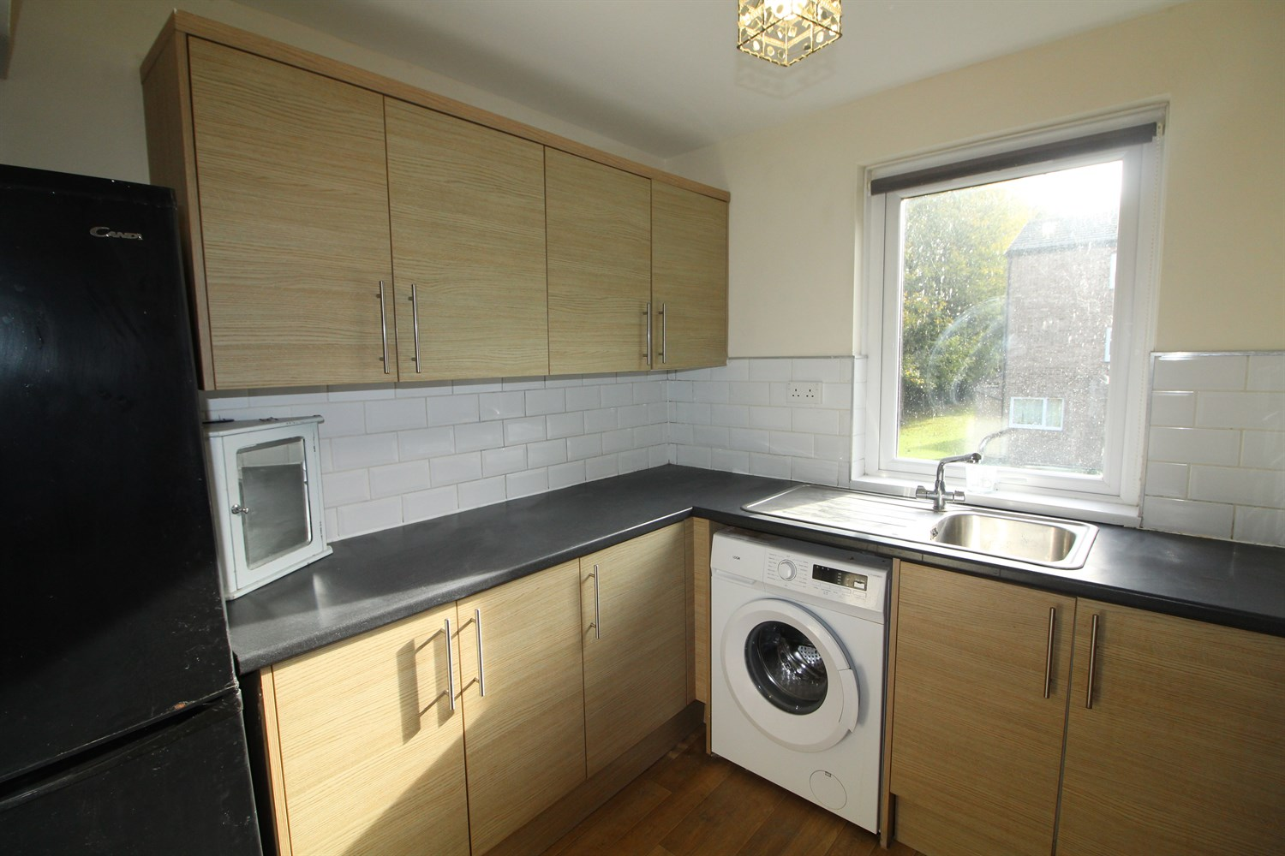
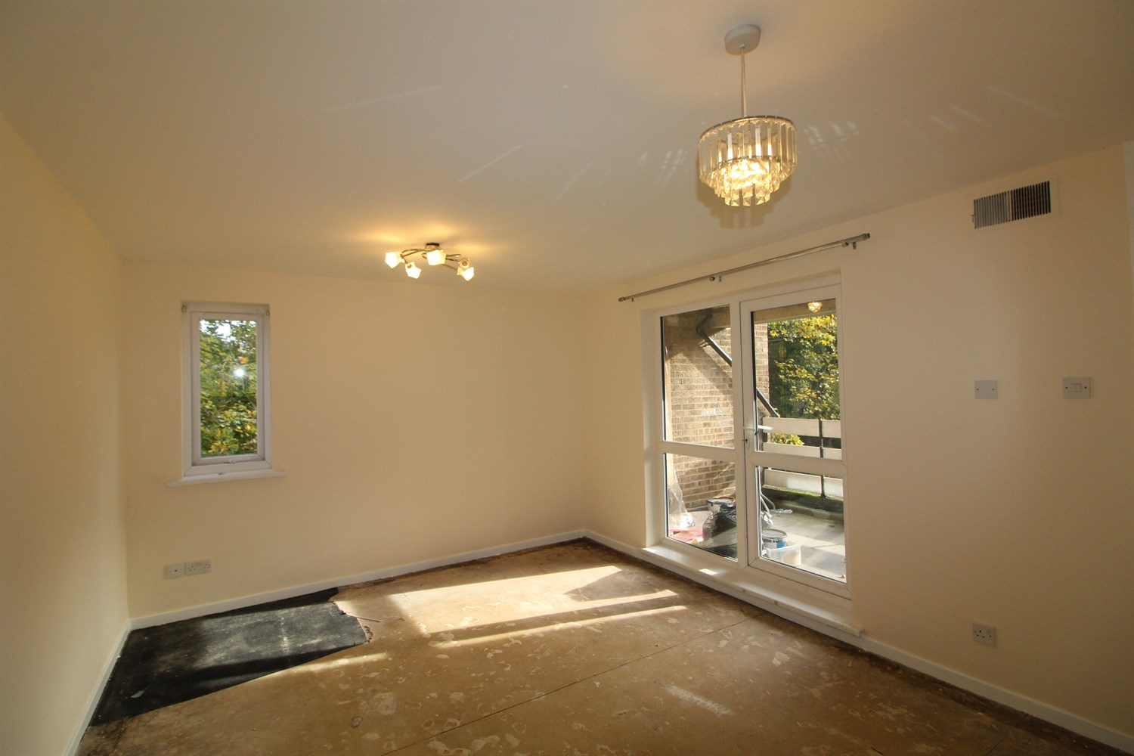
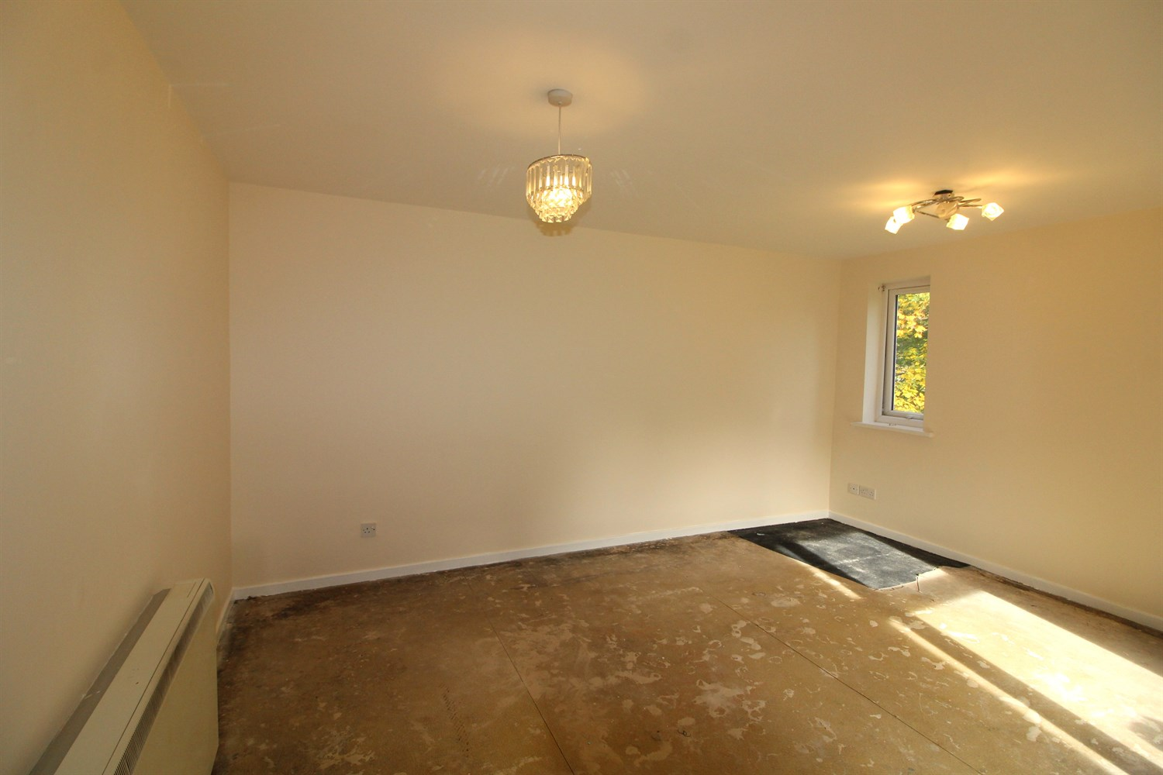
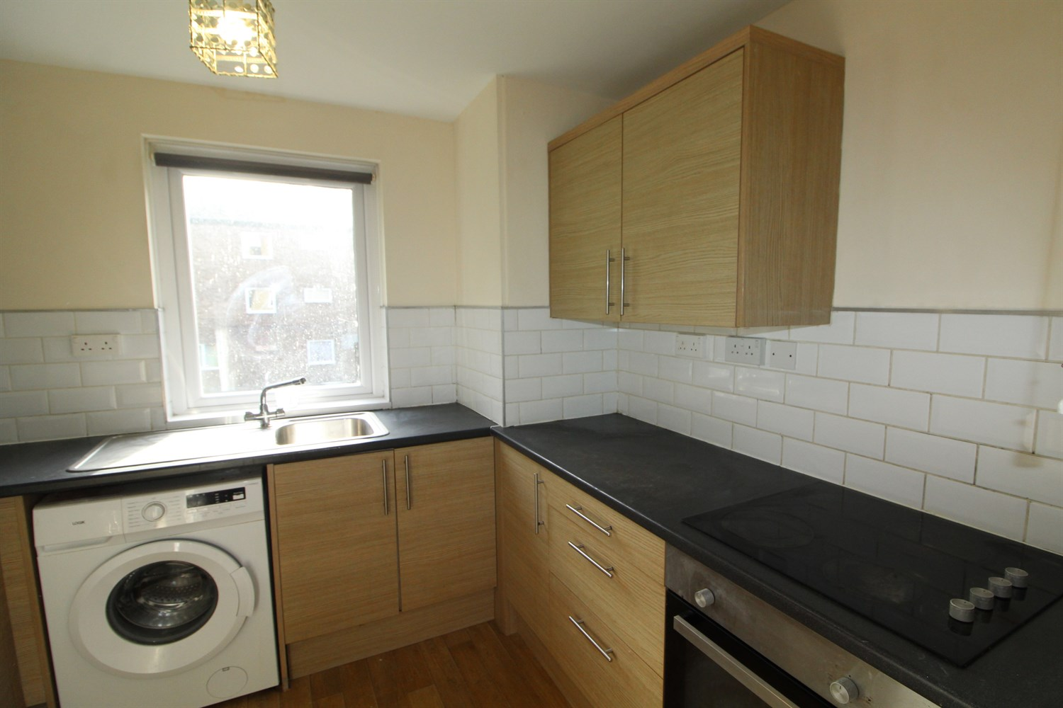
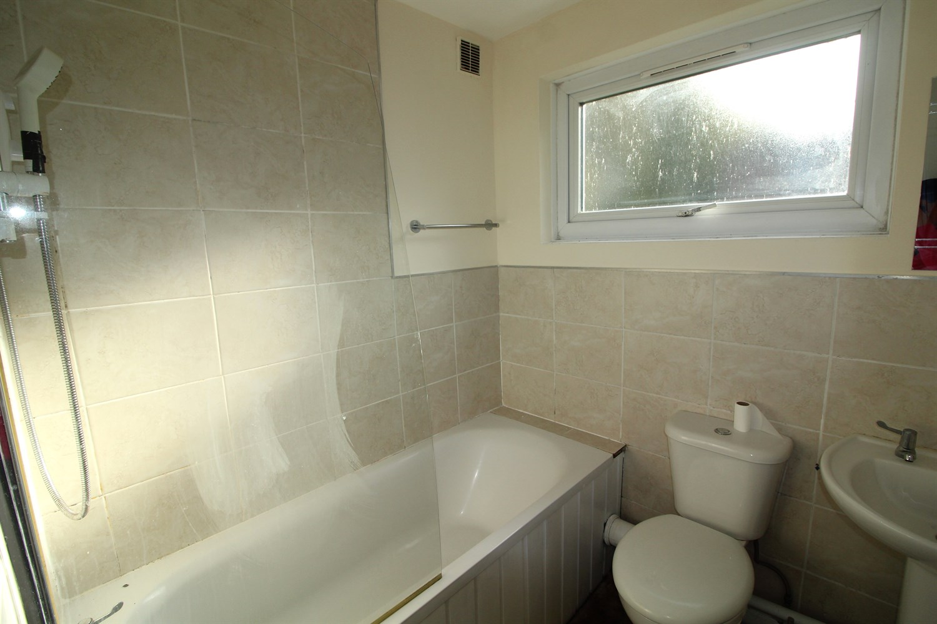
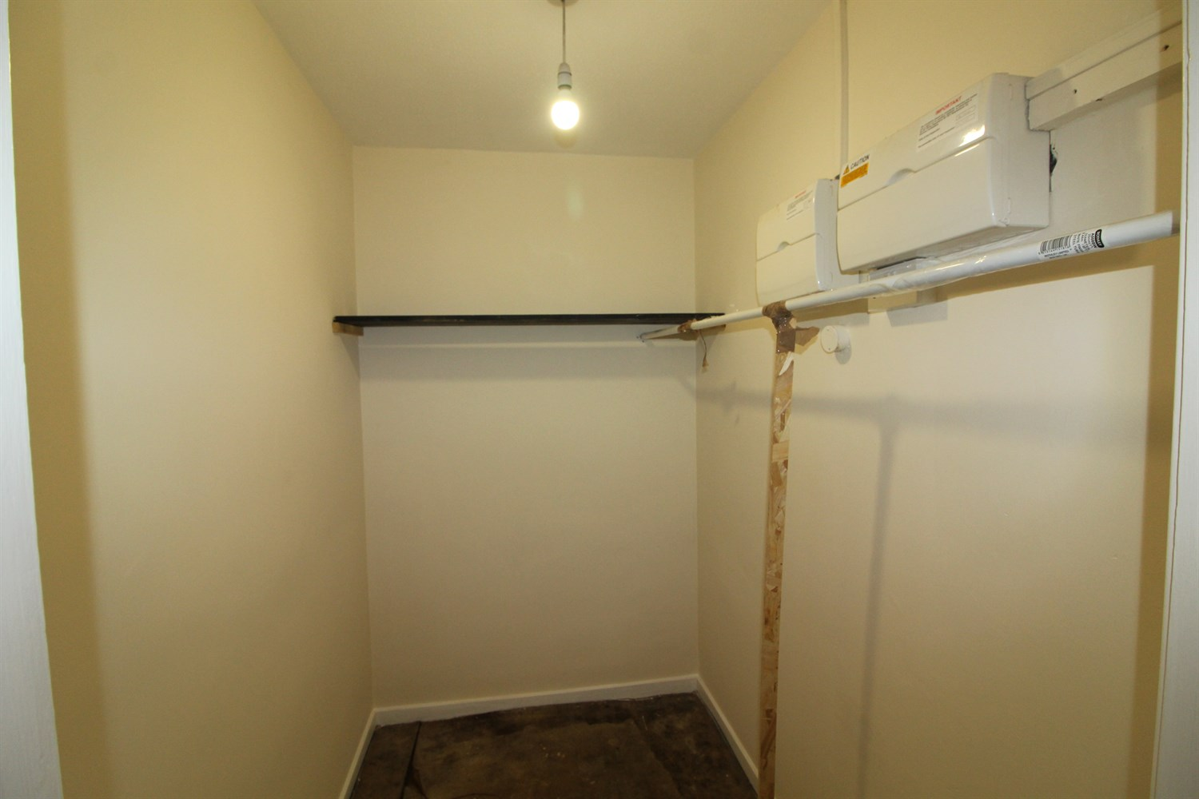
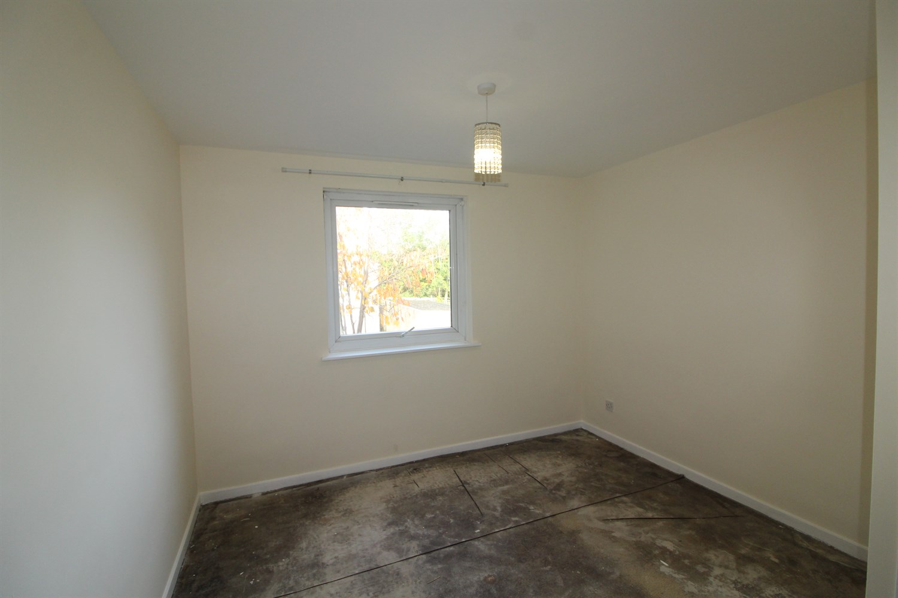
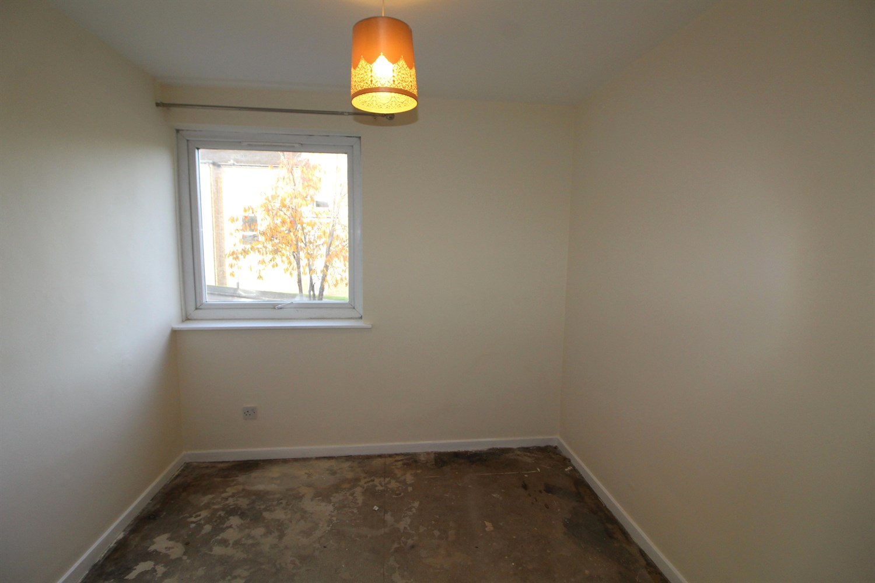

Hallway
Hallway with large storage room/ office space.

Living Room
Lounge with uPVC double glazed windows and patio doors leading to balcony and electric wall mounted heater.

Kitchen
Kitchen uPVC double glazed windows, matching wall and base units, integrated cooker and electric hob with extractor fan over.

Master Bedroom
Master bedroom with uPVC double glazed window and wall mounted electric heater.

Bedroom 2
Second bedroom with uPVC double glazed window and wall mounted electric heater.

Bathroom
3 piece bathroom suite briefly comprising of a low level flush toilet, sink with pedestal and bath tub with shower over, electric towel rail.

Home Information
COUNCIL TAX BAND: A
EPC Rating C
Leasehold property
Parking Space
Broadband:
Standard 15 Mbps 1 Mbps Good
Superfast --Not available --Not available Unlikely
Ultrafast 2000 Mbps 2000 Mbps
Mobile availability: EE Good coverage.
Three Good coverage
O2 Limited coverage
Vodafone Good coverage.
Utilities: Water supplied on standard meters. Electric mains supplied on standard meters.

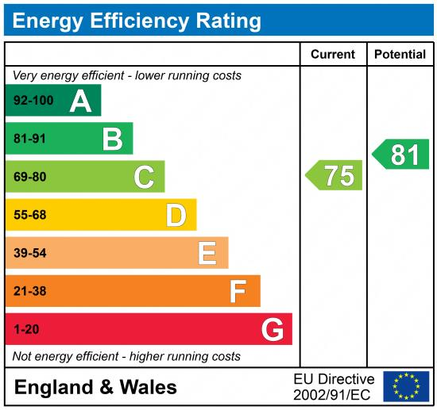

These particulars are intended to give a fair description of the property, but their accuracy cannot be guaranteed, and they do not constitute an offer of contract. Intending purchasers must rely on their own inspection of the property. None of the above appliances/services have been tested by ourselves. We recommend purchasers arrange for a qualified person to check all appliances/services before legal commitment.

Property Ref: 7930

For more information, please contact

0113 258 1150 | lettings@adairpaxton.co.uk | www.adairpaxton.co.uk

