

Bouverie Court, Leeds
Available to let £925.00pcm

***STUNNING TWO BEDROOM APARTMENT WITH PARKING AND EN-SUITE TO MASTER***Beautifully presented two double bedroom apartment with balcony. The apartment briefly comprises; open plan Lounge/Dining Kitchen area having patio doors which lead out onto the balcony, two double Bedrooms, master having en-suite Shower room, modern house Bathroom with shower over bath. This apartment is fully furnished to a high standard and comes with a secure, allocated parking space. Ideally located only a short distance from Leeds City centre and the nearby Clarence Dock development as well as being ideally accessible for the motorway network. Furnished. Deposit £1065. Available 3rd November
0113 258 1150
0800 000 000
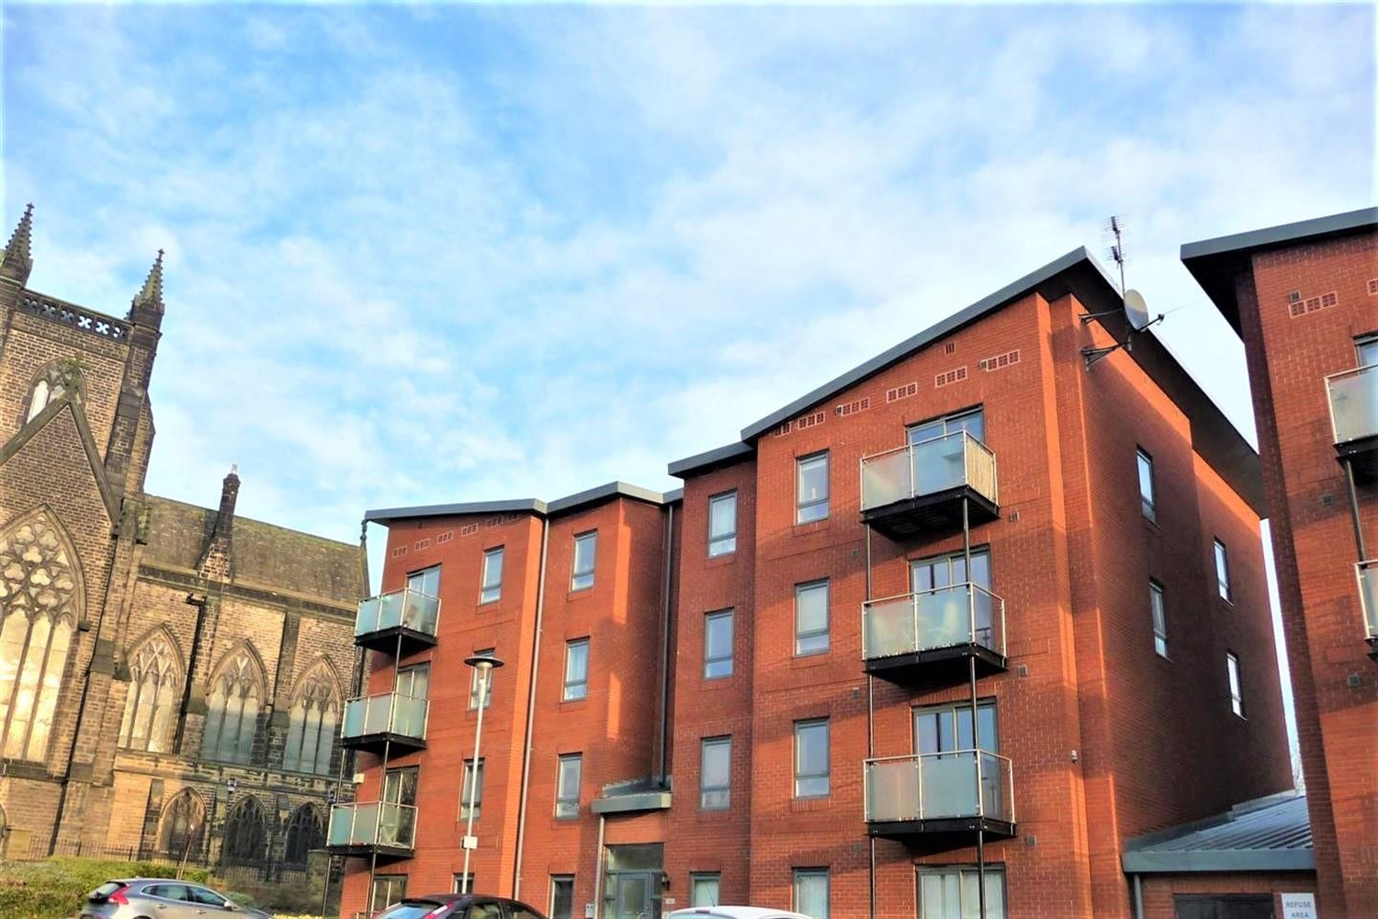



1 Reception(s)
2 Bathroom(s)
0 Bedroom(s)
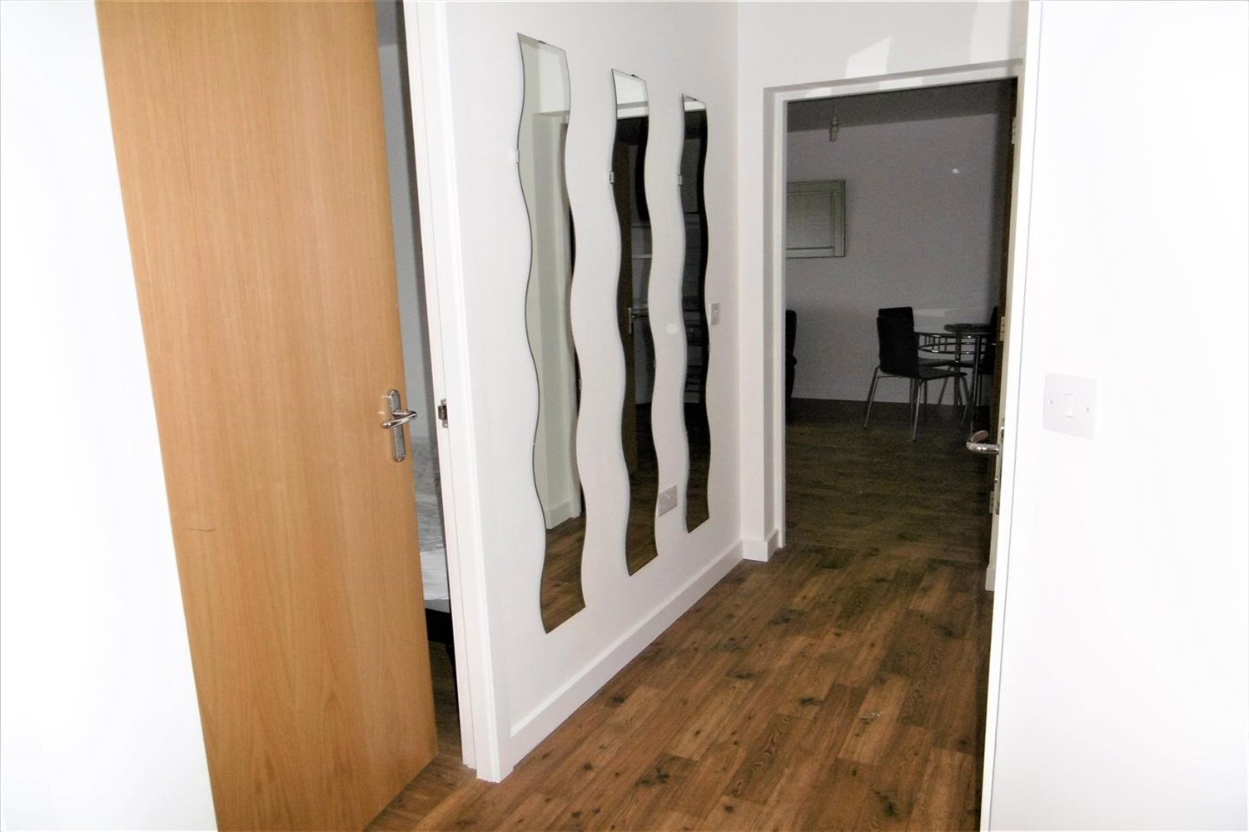
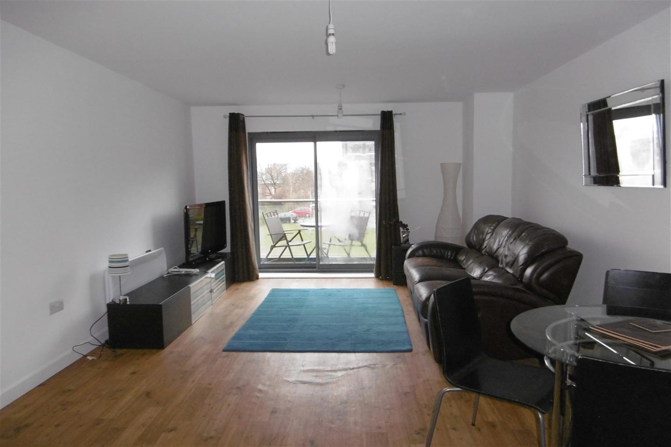
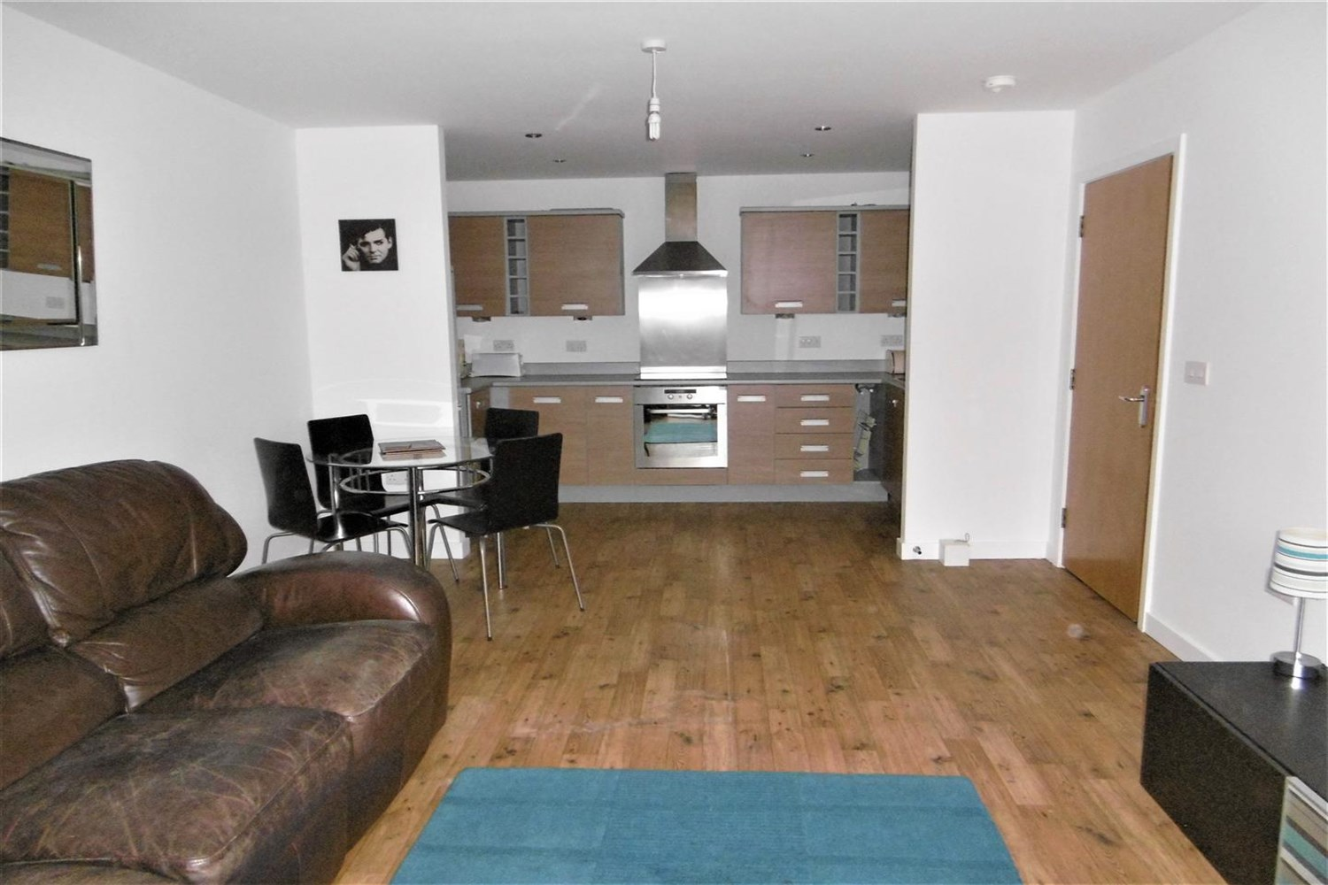
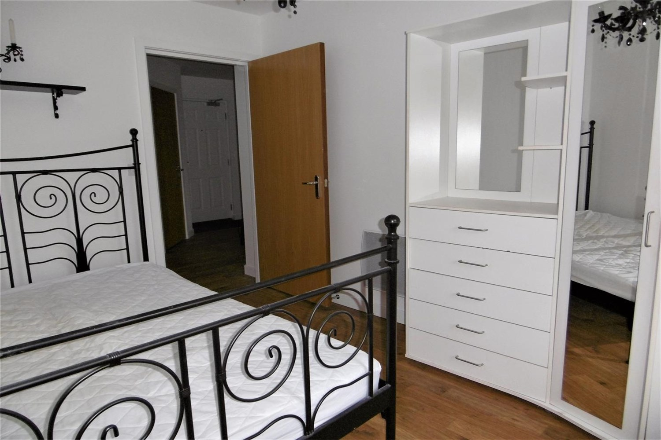
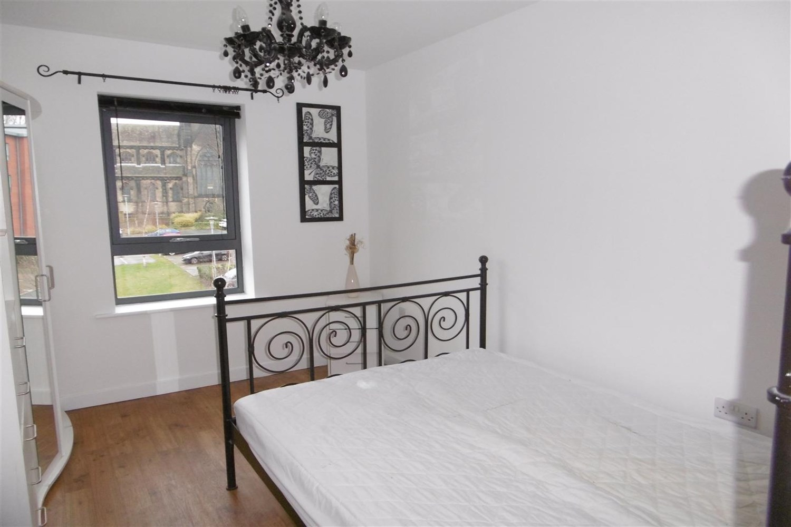

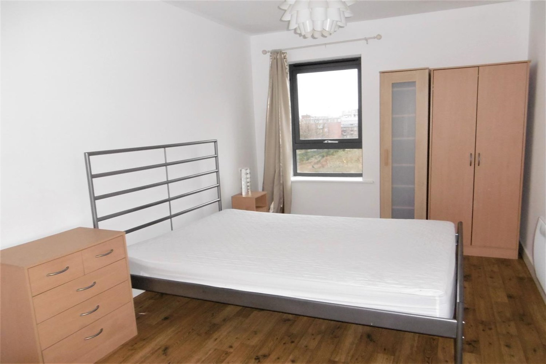
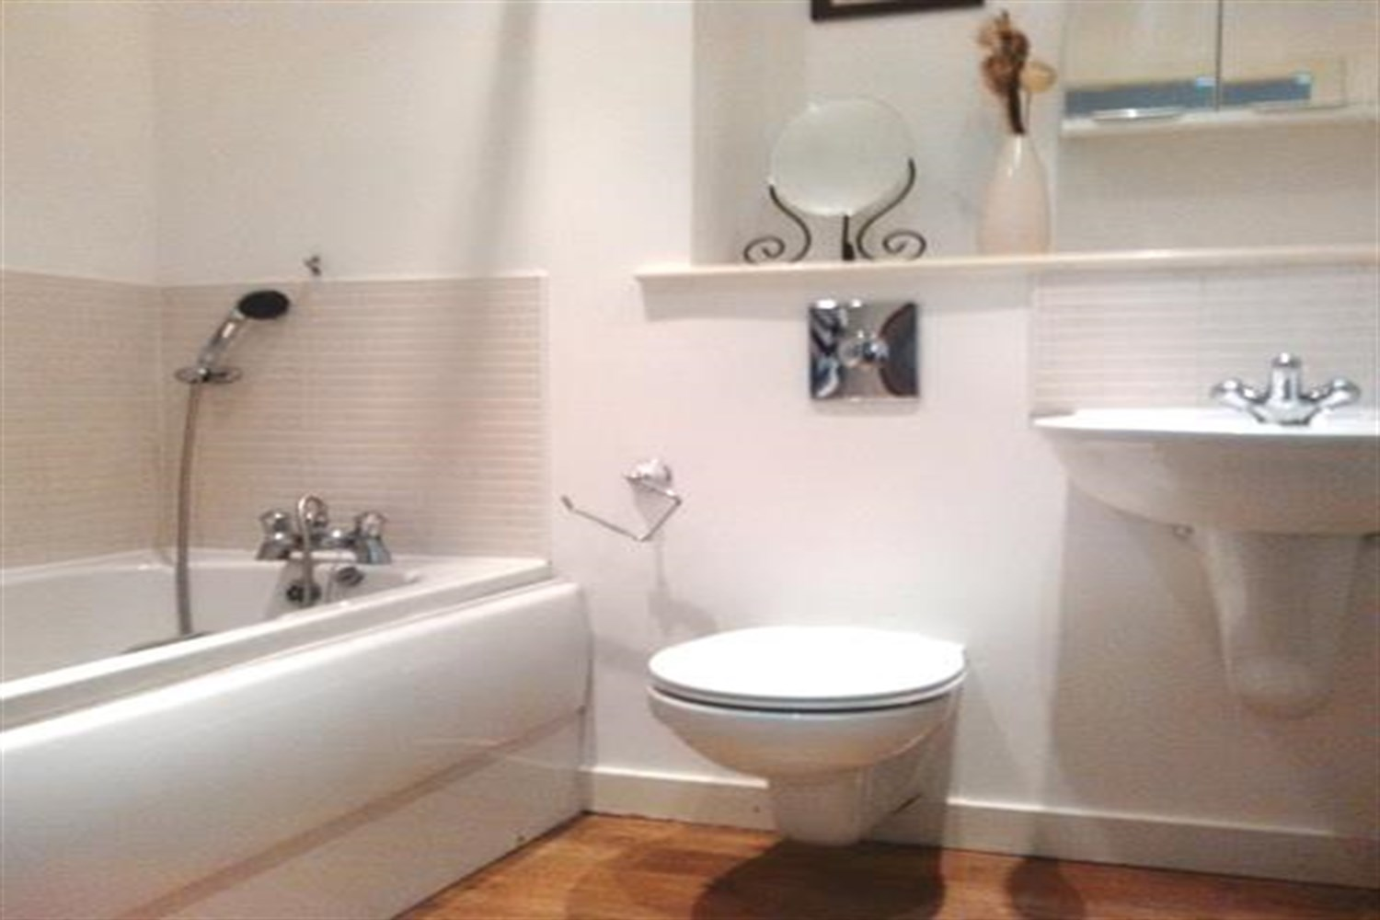

Open Plan Kitchen and Living Room
Open plan living/dining room and kitchen with access to the balcony. Kitchen is fitted with a range wall and base units with worktops over, electric oven and hob with extractor fan, integrated fridge freezer, stainless steel sink with mixer tap and drainer.

Bedroom 1
Double bedroom with double glazed window and wall mounted electric radiator.

En Suite
Three piece suite compromising of walk in shower, w/c and hand wash basin.

Bedroom 2
Double bedroom with double glazed window and wall mounted electric radiator.

House Bathroom
Fitted with a white three piece suite compromising of bath with shower over head, shower screen, W/C, hand wash basin and a towel rail, part tiled.

12 month Tenancy.
COUNCIL TAX BAND: C
EPC Rating C
Leasehold property
Parking included
Broadband: Standard 8 Mbps 925.9 Mbps Good
Superfast 71 Mbps 18 Mbps Good
Ultrafast 1925925925 Mbps 1925925925 Mbps
Mobile availability: EE limited coverage. Three likely to have good coverage. O2 likely to have good coverage. Vodafone limited coverage .
Utilities: Water supplied on standard meters. Electric mains supplied on standard meters.

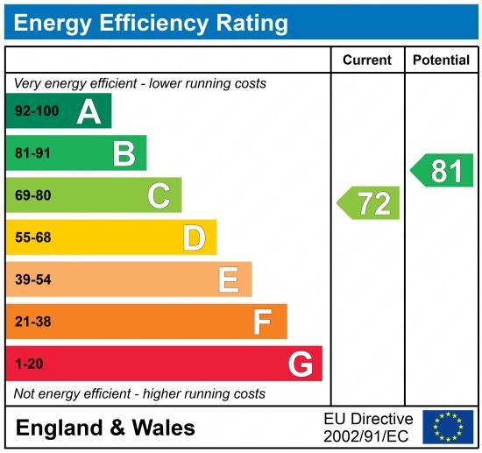

These particulars are intended to give a fair description of the property, but their accuracy cannot be guaranteed, and they do not constitute an offer of contract. Intending purchasers must rely on their own inspection of the property. None of the above appliances/services have been tested by ourselves. We recommend purchasers arrange for a qualified person to check all appliances/services before legal commitment.

Property Ref: 3773

For more information, please contact

0113 258 1150 | lettings@adairpaxton.co.uk | www.adairpaxton.co.uk

