
Thirsk Grove, LS10
Available to let £1,050.00pcm

DELIGHTFUL THREE BEDROOM DETACHED HOUSE NEWLY DECORACTED AND NEW CARPETS. Unfurnished. Immaculately presented throughout, modern bathroom, gas central heating, PVCu double glazing, electric charge point, lawned gardens, driveway. Briefly comprises: entrance hallway, lounge, dining kitchen with electric oven & gas hob, 1st floor landing, 2 double bedrooms, a single bedroom & contemporary bathroom. Available Now. Deposit £1210, Council tax band B, EPC rating
0113 258 1150
0800 000 000
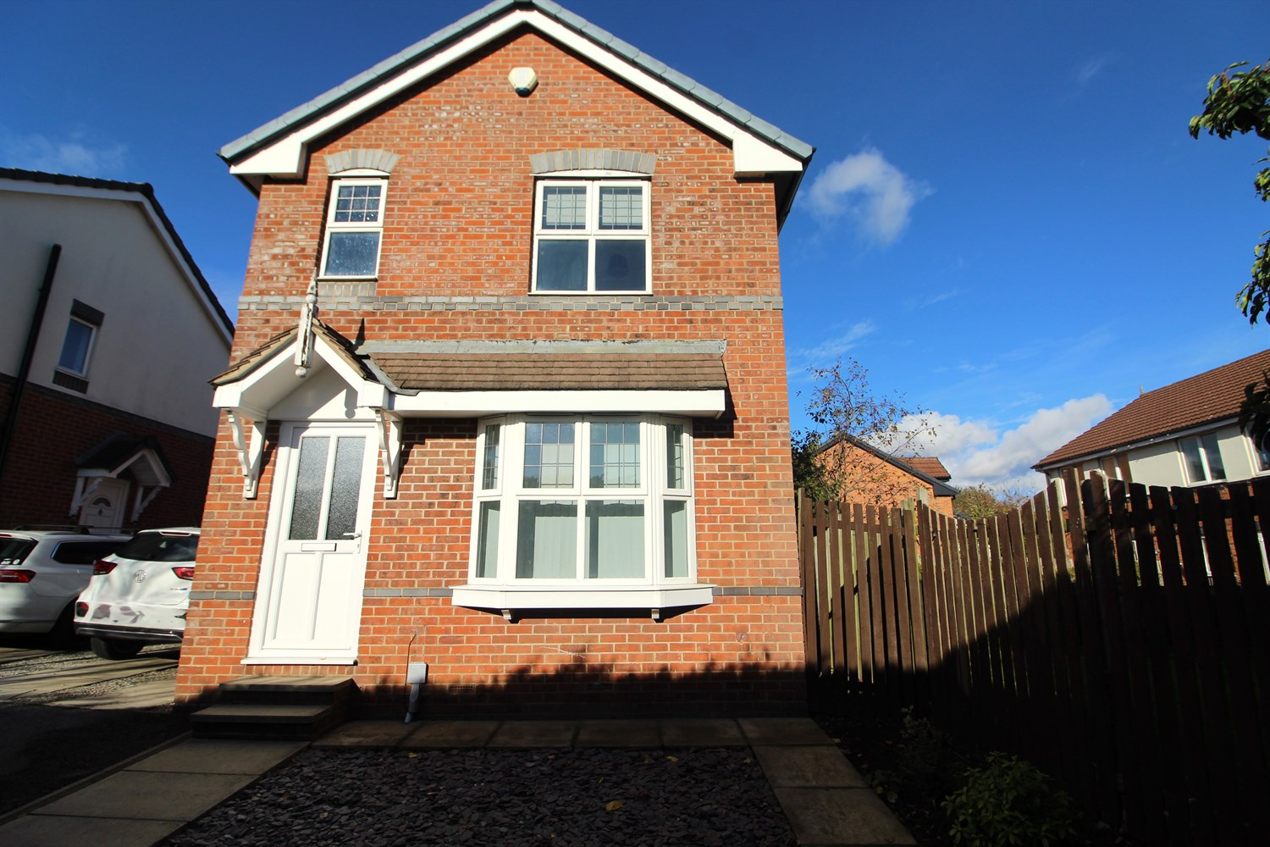

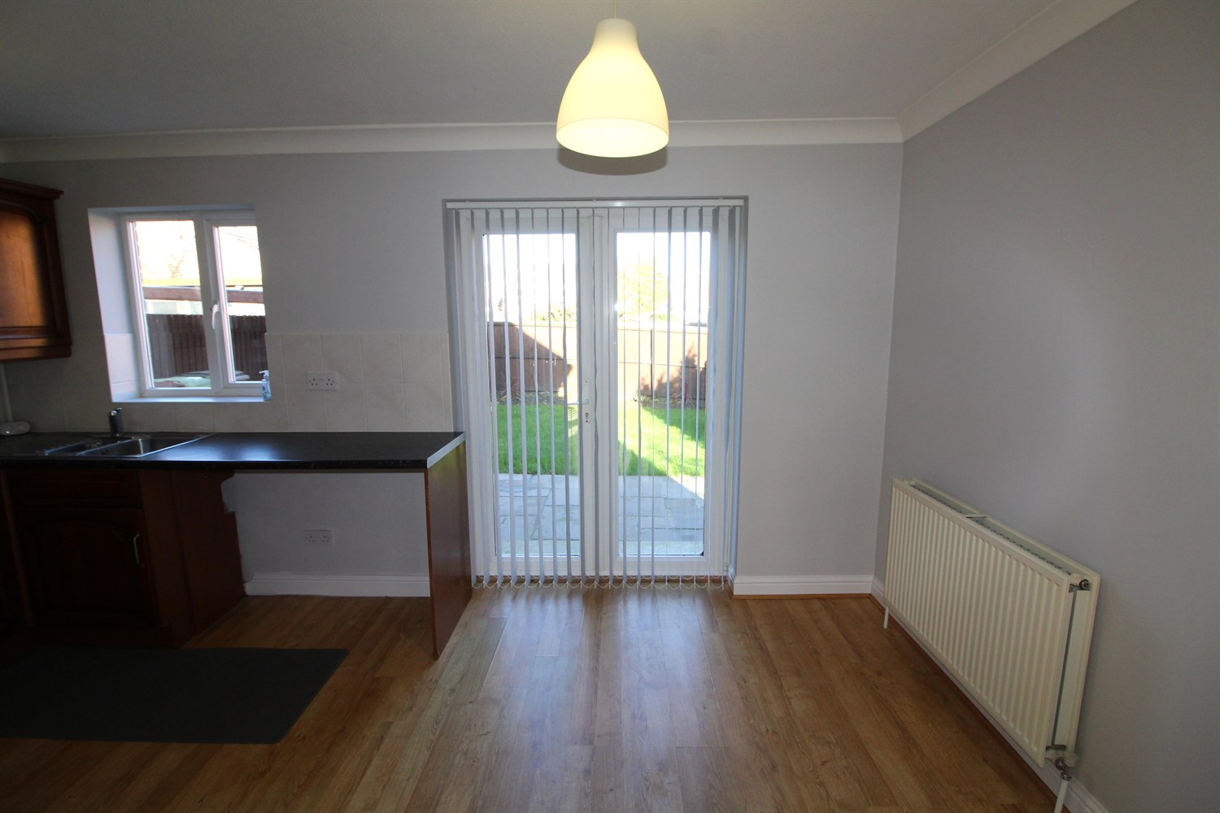
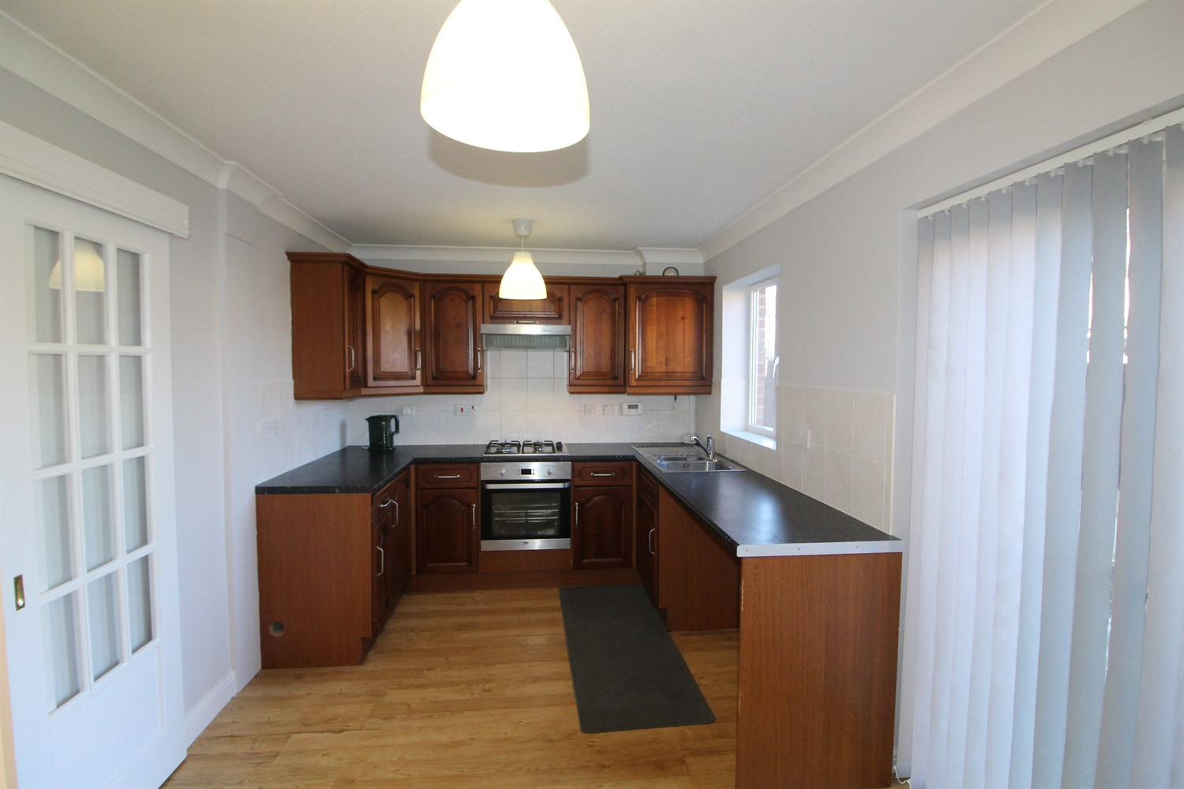
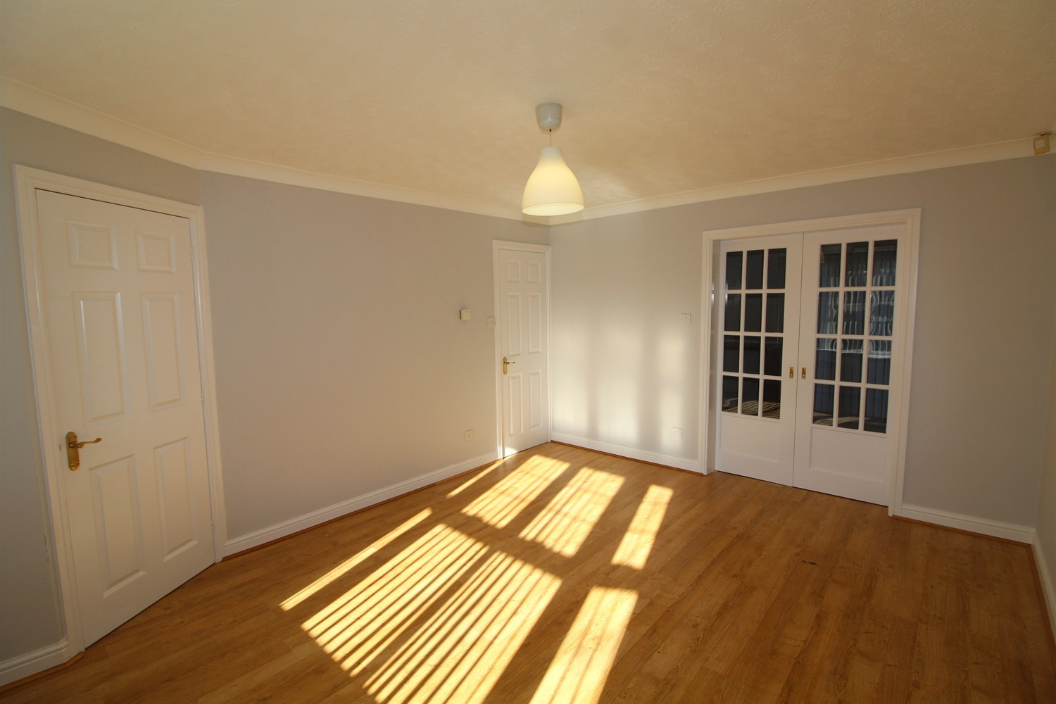
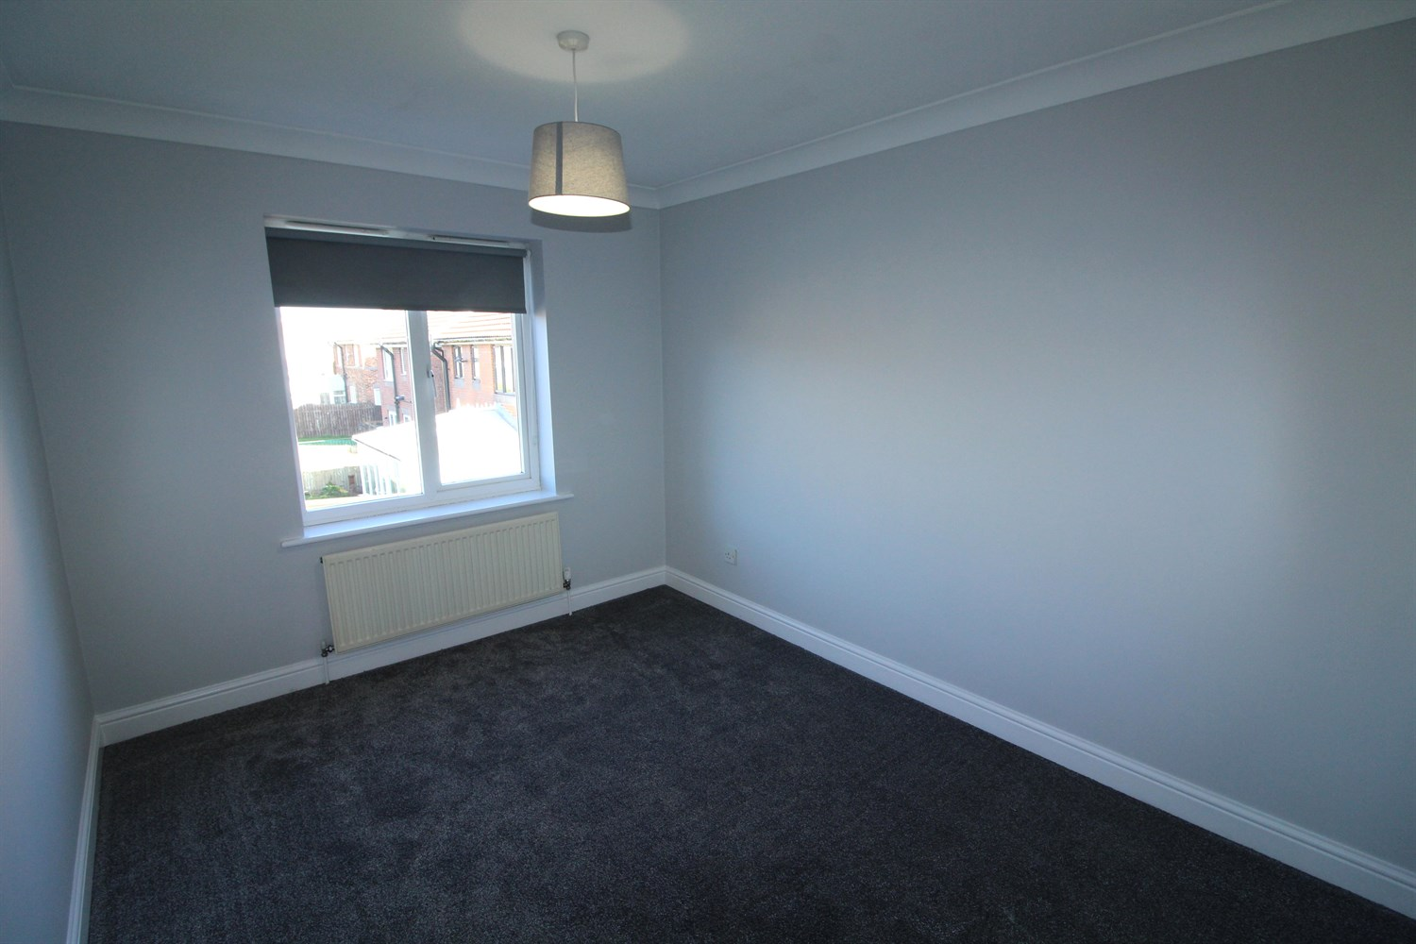
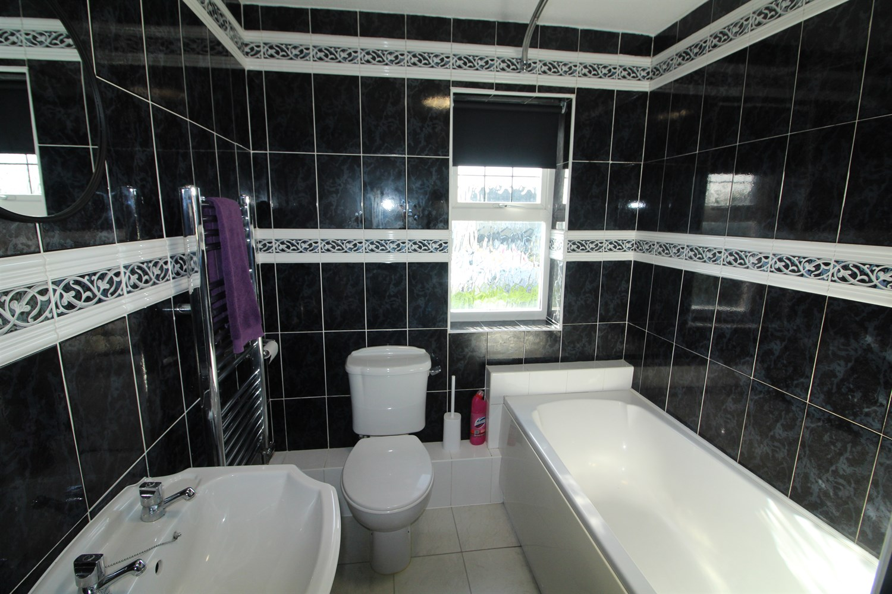
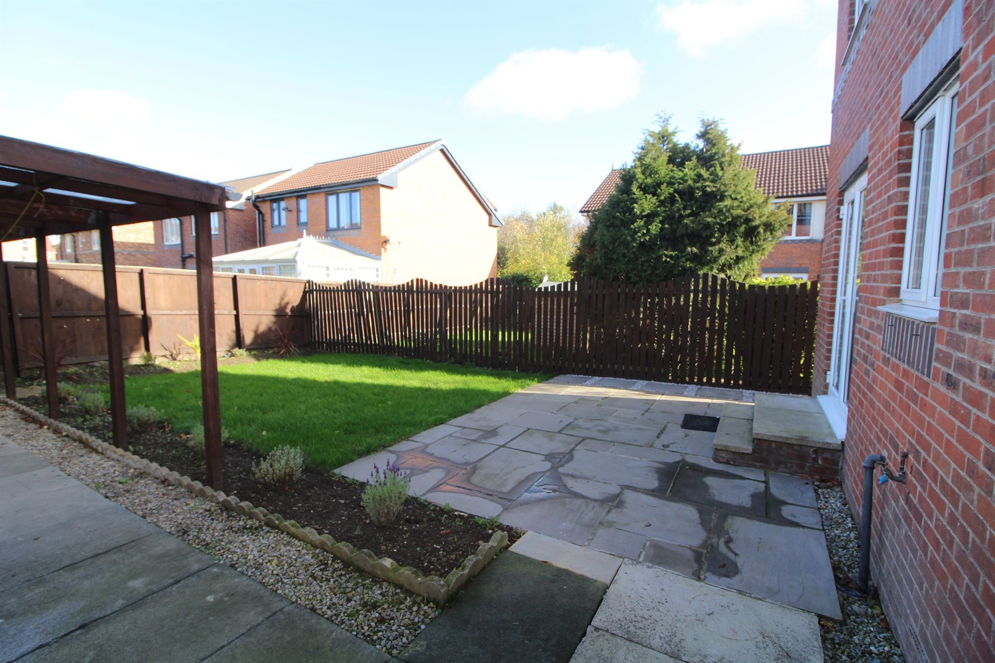
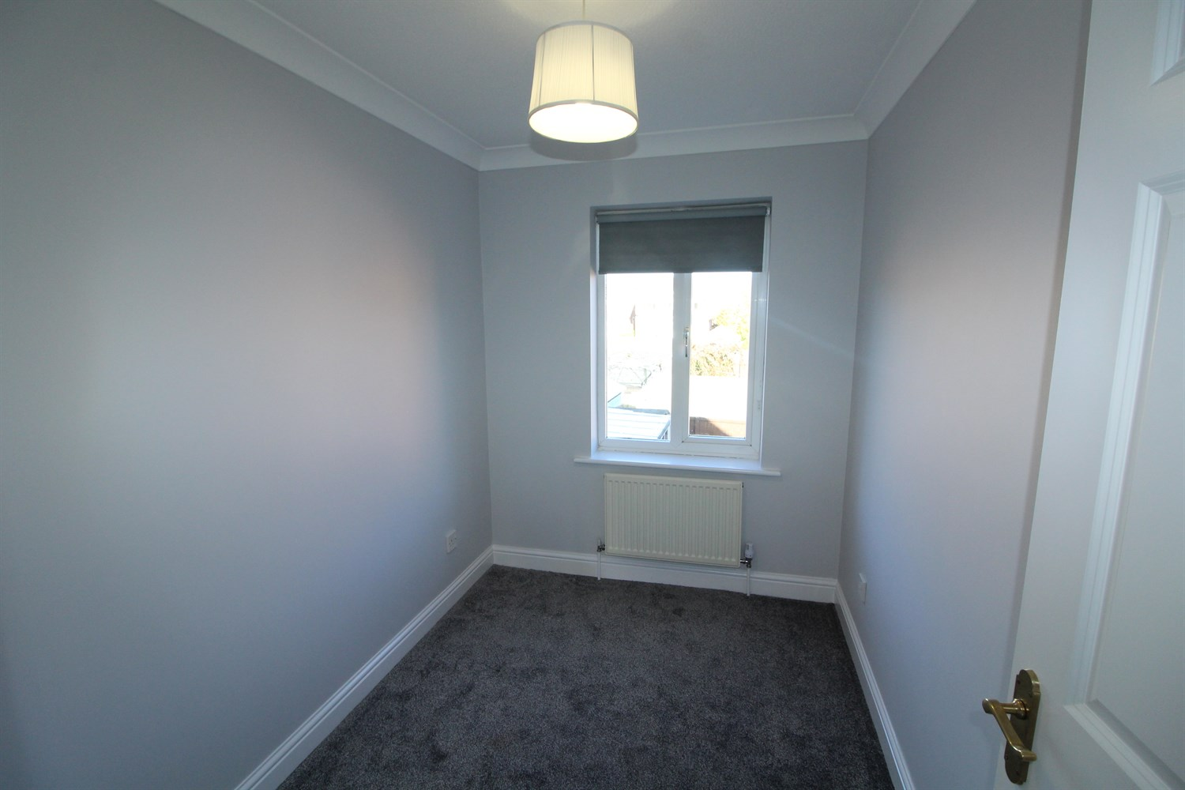
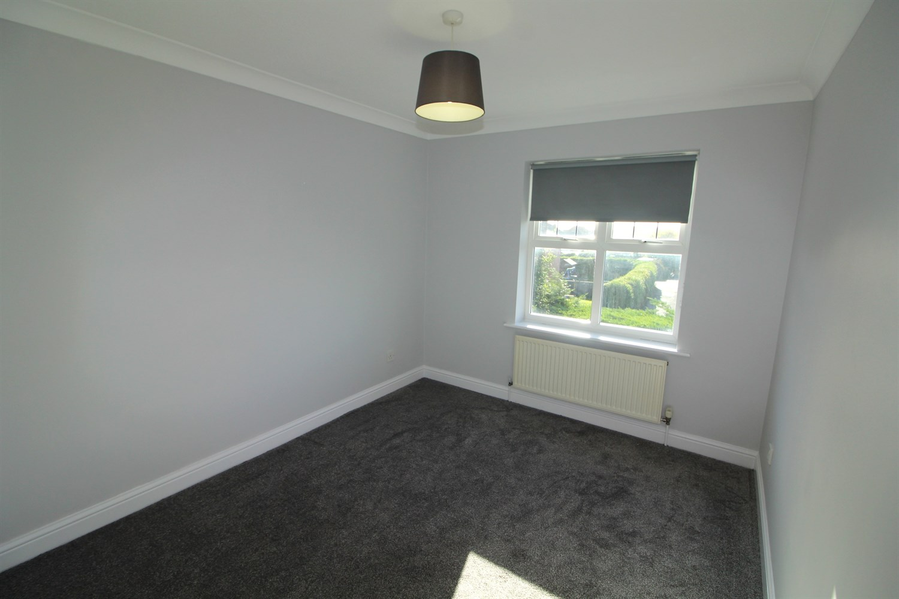

Hallway
uPVC door, stairs to first floor.

Living Room
Large living room with window to front, doors opening to kitchen, large understairs storage.

Kitchen
Fitted with a range of wall and base units, with window to rear, stainless steel sink with mixer tap, gas cooker and electric oven, extractor over head. space for under counter washer.

First Floor

Bedroom 1
Carpeted double bedroom with window to front, gas central heating radiator.

Bedroom 2
Carpeted double bedroom with window to rear, gas central heating radiator.

Bedroom 3
Carpeted single bedroom with window to rear, gas central heating radiator.

Bathroom
Three piece white bathroom suite, with shower over bath, w/c and hand wash basin, tiled walls.

Home Information
COUNCIL TAX BAND: C
EPC Rating C
Freehold property
Driveway.
Broadband:
Standard 2 Mbps 0.3 Mbps Good
Superfast 271 Mbps 41 Mbps Good
Ultrafast 1800 Mbps 1000 Mbps
Mobile availability: EE Good coverage.
Three Good coverage
O2 Likely to have good coverage
Vodafone Good coverage.
Utilities: Water supplied on standard meters. Gas and Electric mains supplied on standard meters.

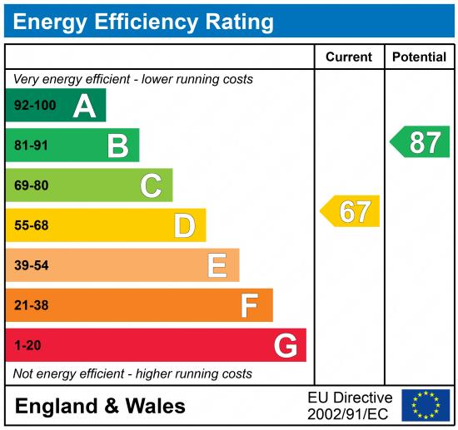

These particulars are intended to give a fair description of the property, but their accuracy cannot be guaranteed, and they do not constitute an offer of contract. Intending purchasers must rely on their own inspection of the property. None of the above appliances/services have been tested by ourselves. We recommend purchasers arrange for a qualified person to check all appliances/services before legal commitment.

Property Ref: 7931

For more information, please contact

0113 258 1150 | lettings@adairpaxton.co.uk | www.adairpaxton.co.uk

