

Clarence Road, Horsforth
For Sale £189,950.00

0113 258 1150
0800 000 000
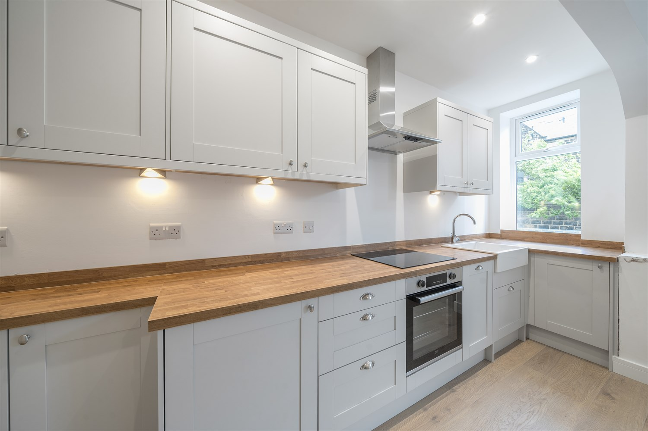



1 Reception(s)
1 Bathroom(s)
1 Bedroom(s)
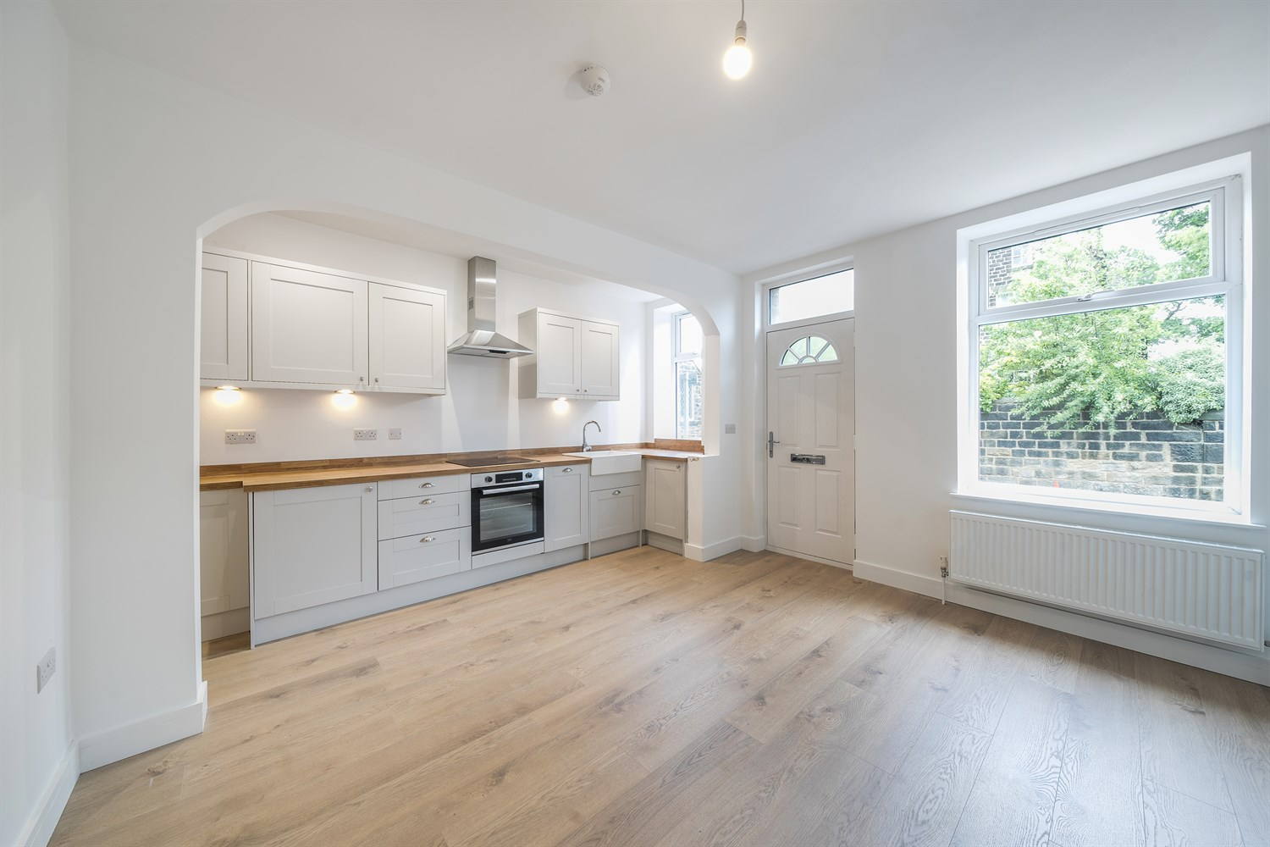
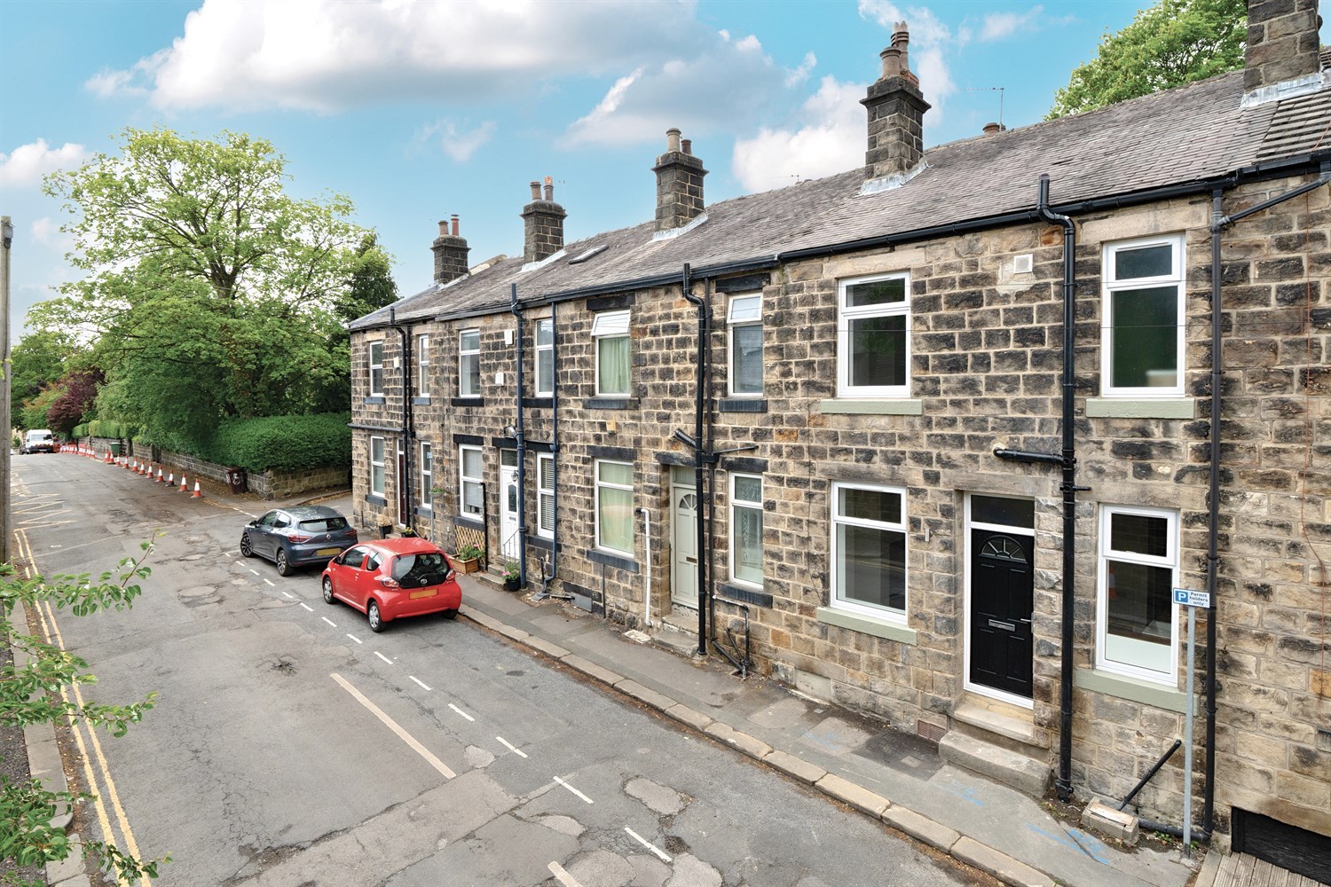
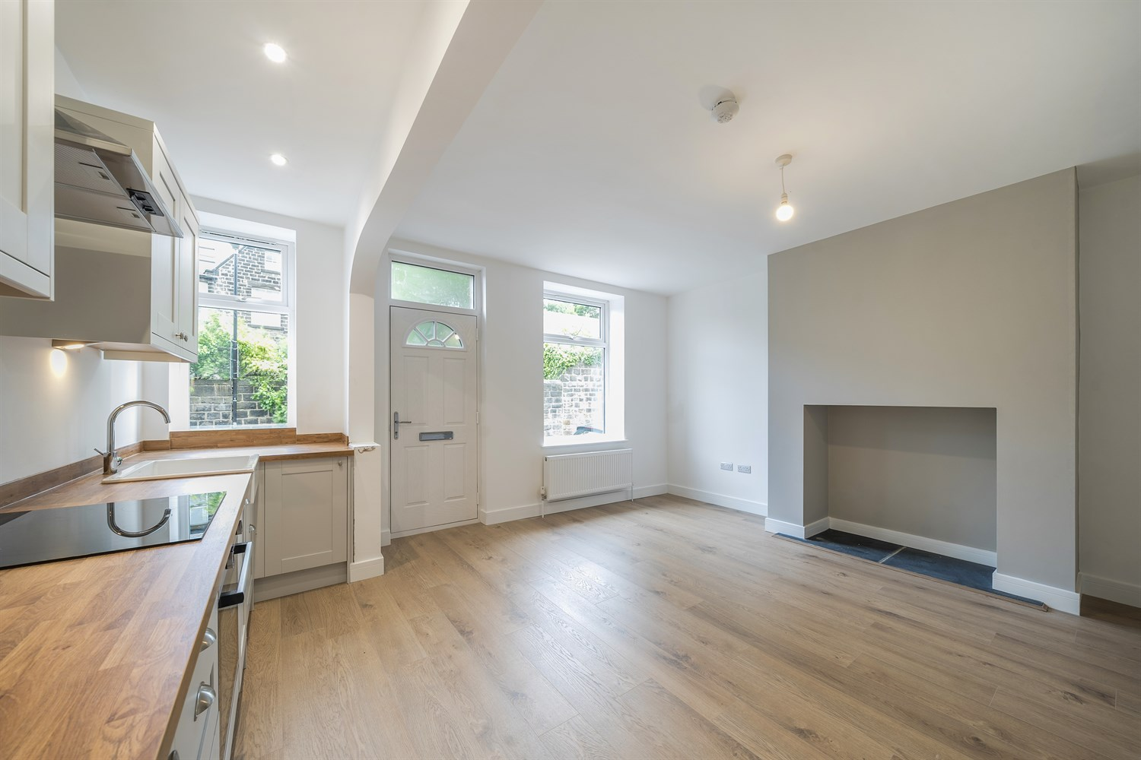
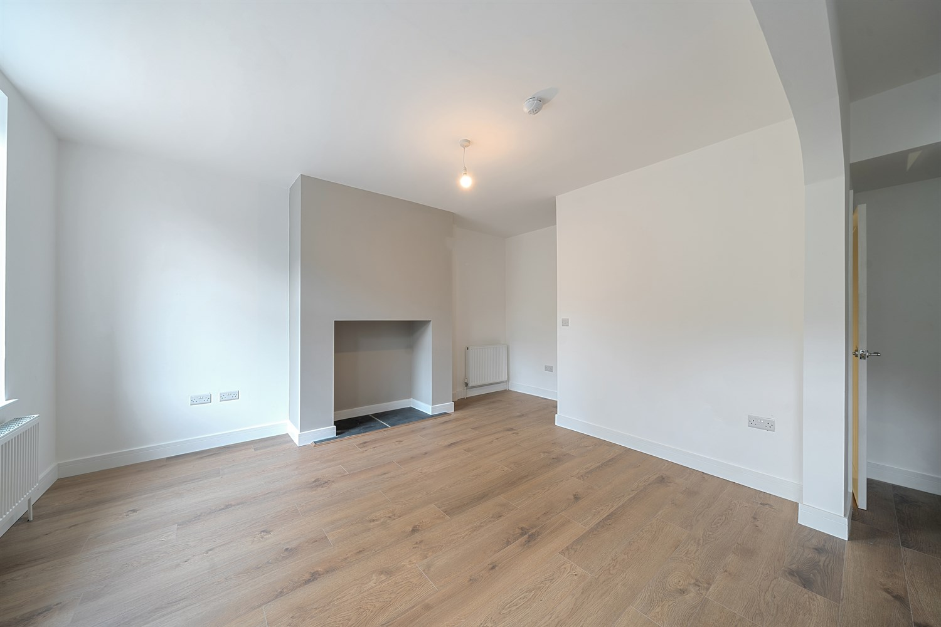
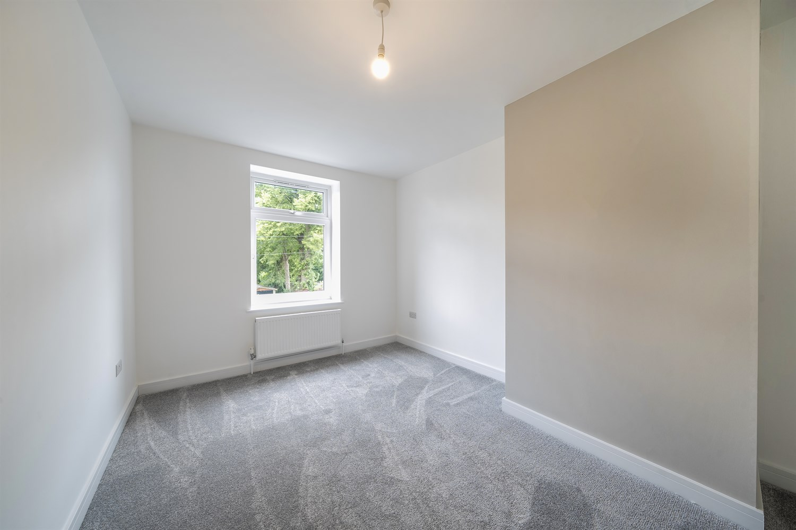
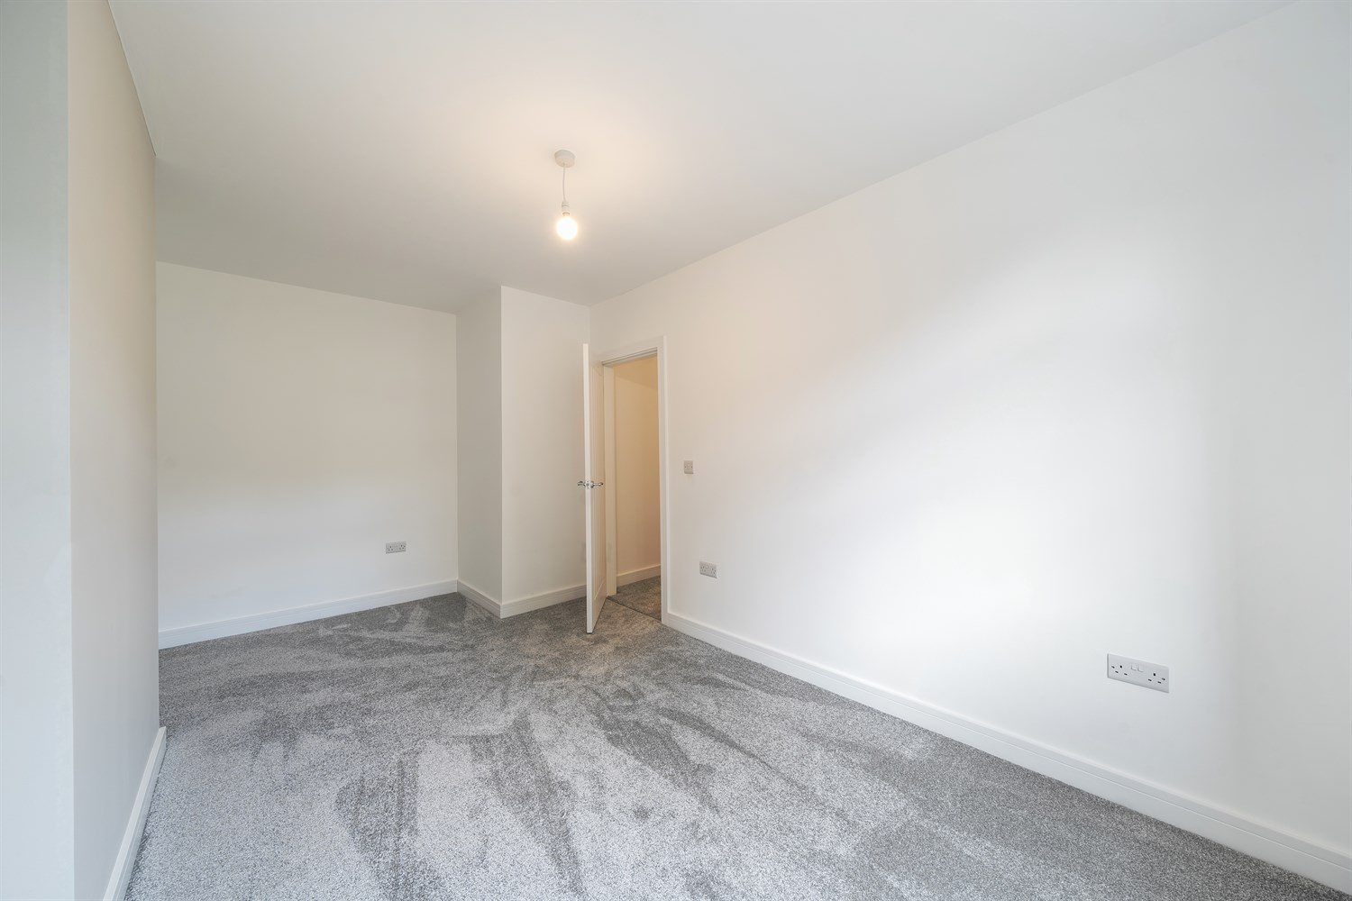
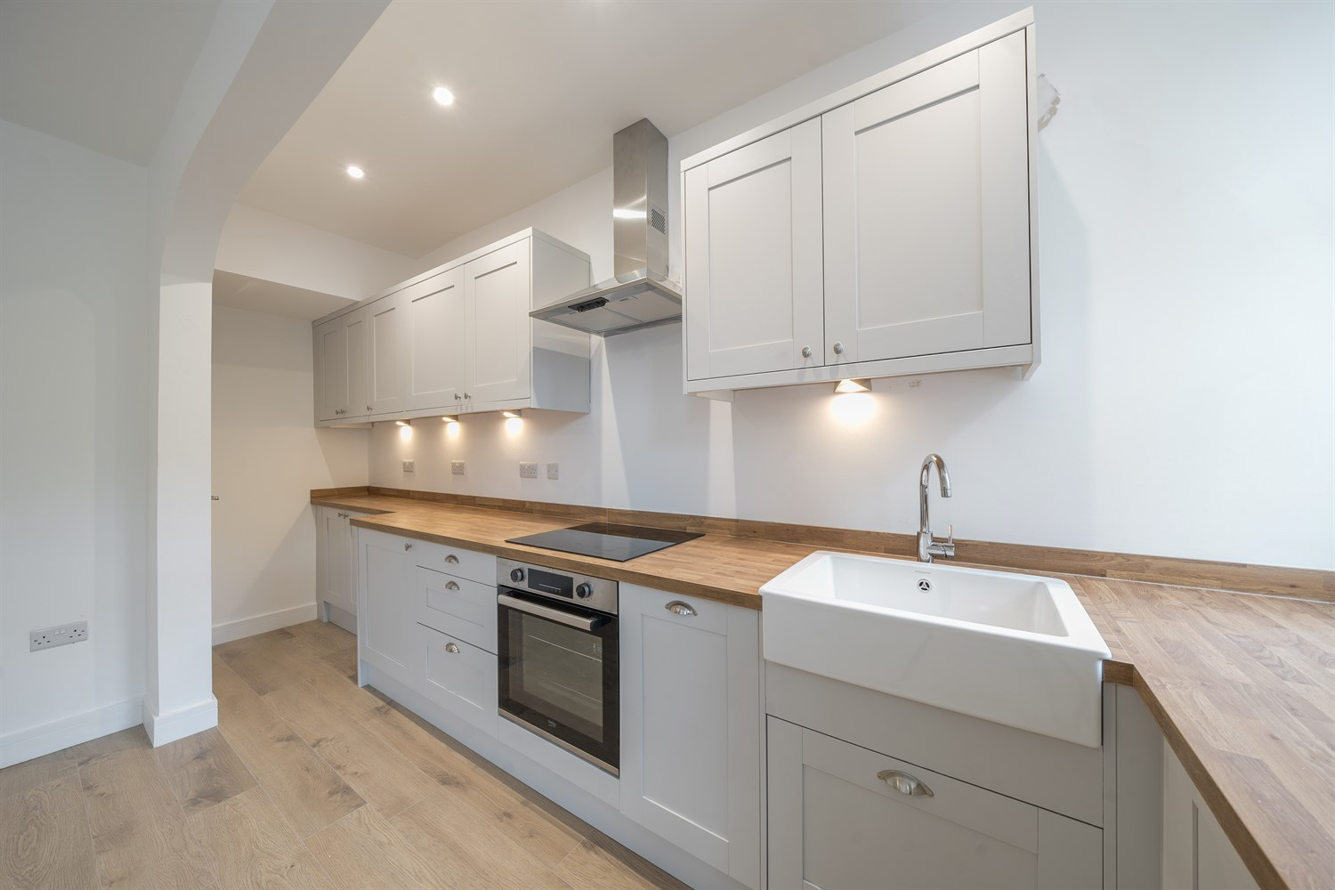
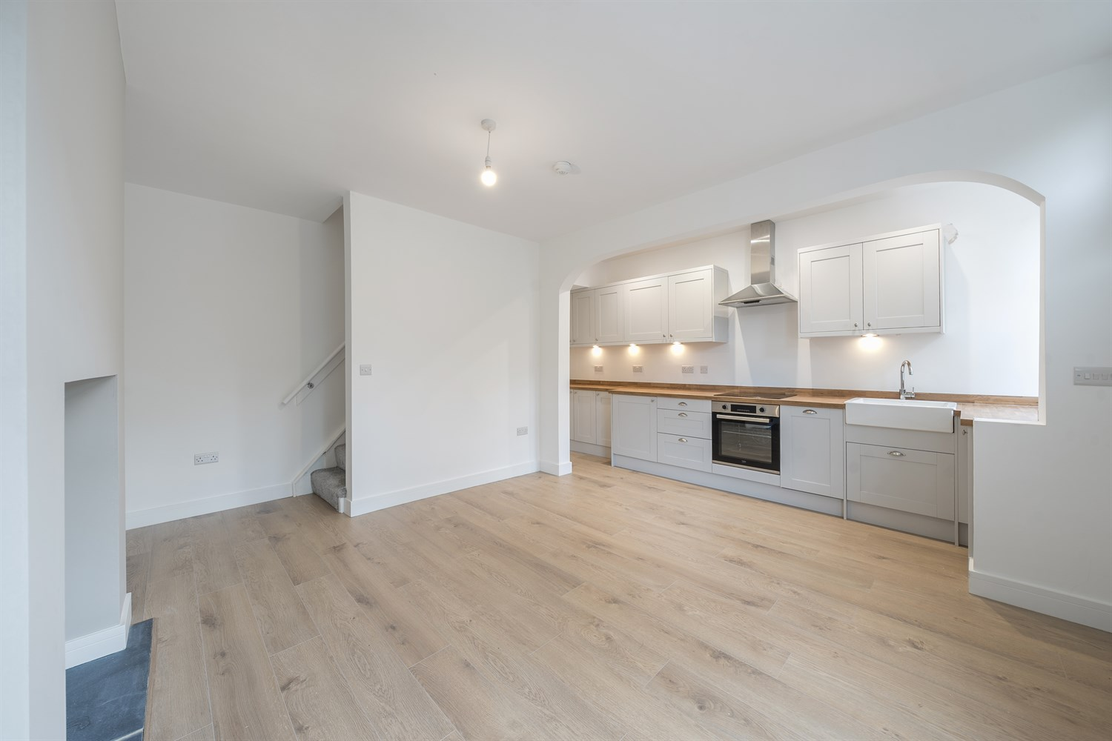

Open Plan Kitchen/Lounge 5.02m (16'6) x 4.92m (16'2)
Via front entrance door. Modern open plan living room/kitchen. Fitted with a range of wall, base and drawer units with work surface over. Ceramic sink and with mixer tap. Integrated electric oven and induction hob with stainless steel extractor above. Integrated dishwasher and fridge. Two UPVC double glazed windows to the front. Feature open fireplace ideal for log burning stove. Gas central heating radiator.

Cellar
Housing combi boiler. Useful for storage.

First Floor Landing

Bedroom 4.92m (16'2) x 2.96m (9'9)
Light and airy double bedroom with uPVC double glazed window to front. Gas central heating radiator.

Shower Room
Beautiful fitted shower room comprising; walk in shower cubicle, vanity wash hand basin and WC. Tiled walls. Wall mounted heated towel rail. uPVC double glazed window.

On Street Parking

Central Heating

Double Glazing

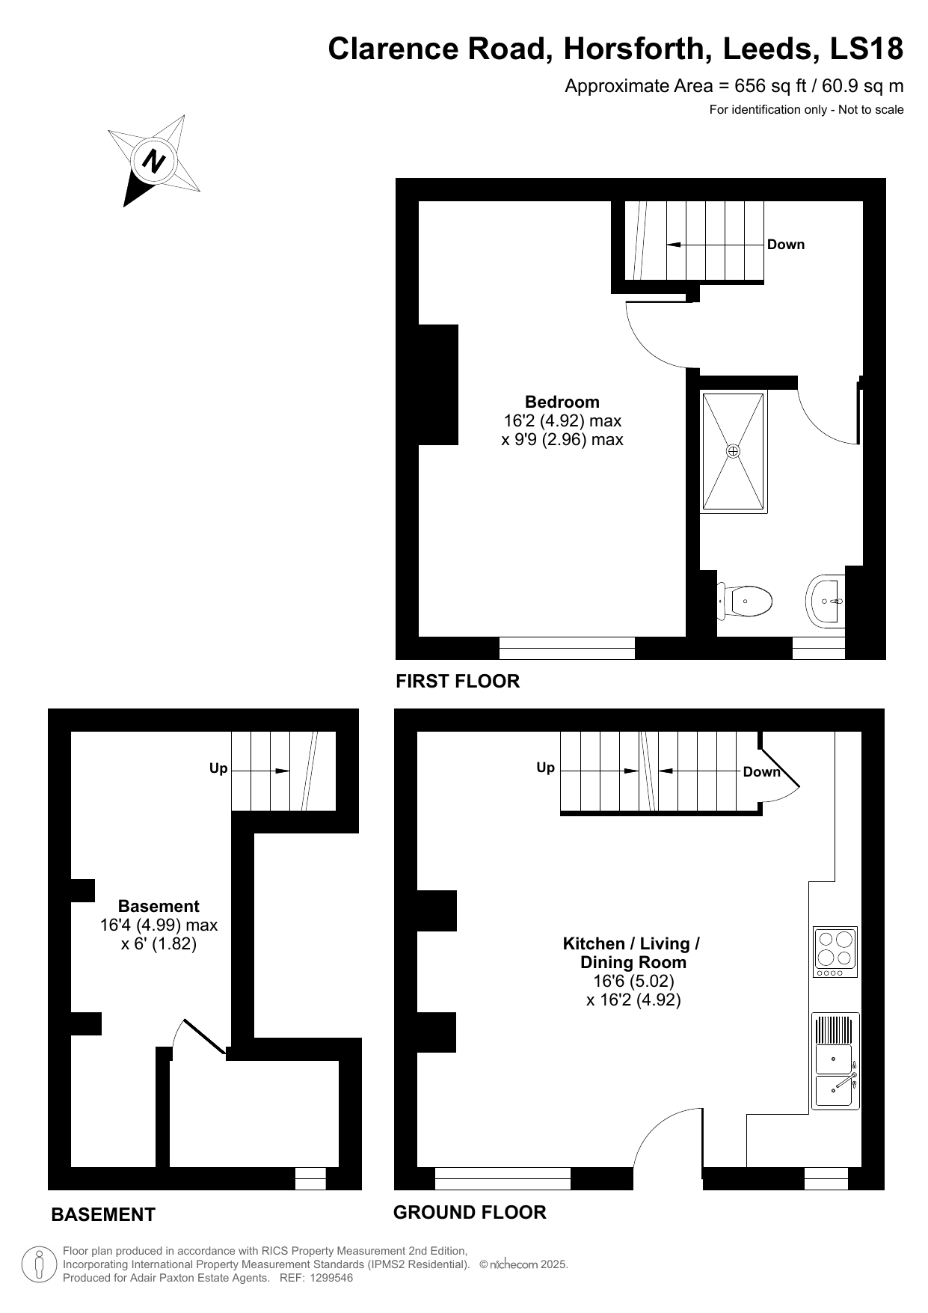

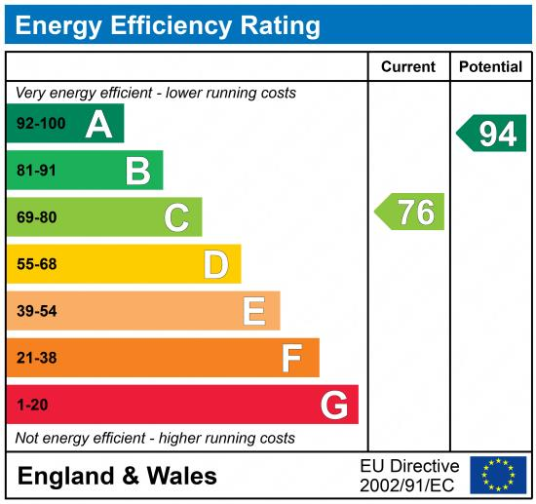

These particulars are intended to give a fair description of the property, but their accuracy cannot be guaranteed, and they do not constitute an offer of contract. Intending purchasers must rely on their own inspection of the property. None of the above appliances/services have been tested by ourselves. We recommend purchasers arrange for a qualified person to check all appliances/services before legal commitment.

Property Ref: 6304

For more information, please contact

0113 258 1150 | sales@adairpaxton.co.uk | www.adairpaxton.co.uk

