
12 Walesby Court, LS16
Available to let £725.00pcm

***ONE BEDROOM GROUND FLOOR FLAT WITH ALLOCATED PARKING*** Situated on a corner position in the sought after location of Cookridge. Close to all amenities, great transport links to Leeds city centre and surrounding area and within walking distance of the train station. Comprising; entrance porch with storage area, spacious lounge, kitchen with shaker style units to include oven/hob/extractor, double bedroom with wardrobes and storage area, fully tiled bathroom with shower over bath. Neutral decor and carpets throughout. Gas central heating. Allocated parking. Council tax band A. EPC rating C, Unfurnished. deposit £835. Available Now.
0113 258 1150
0800 000 000
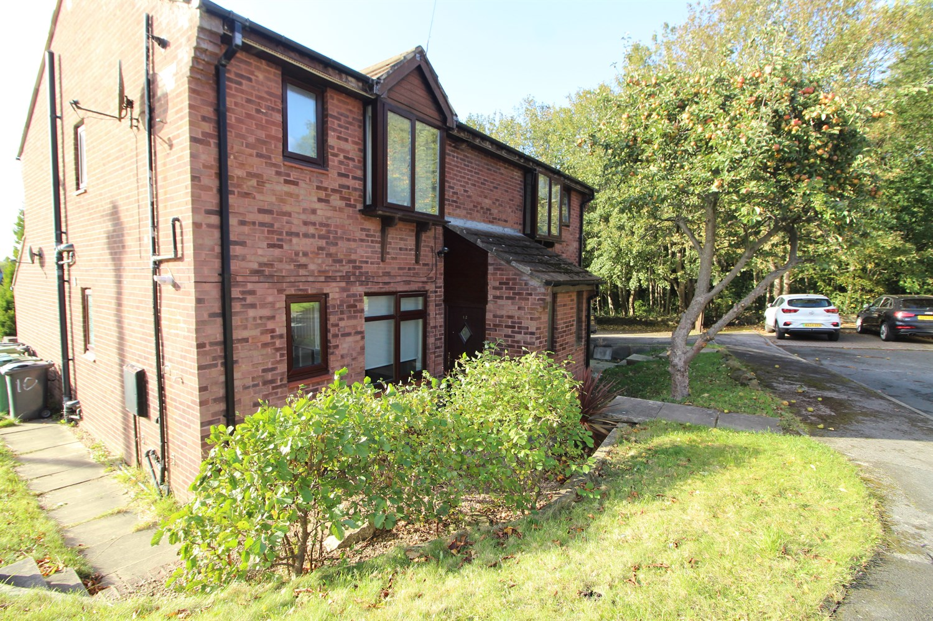

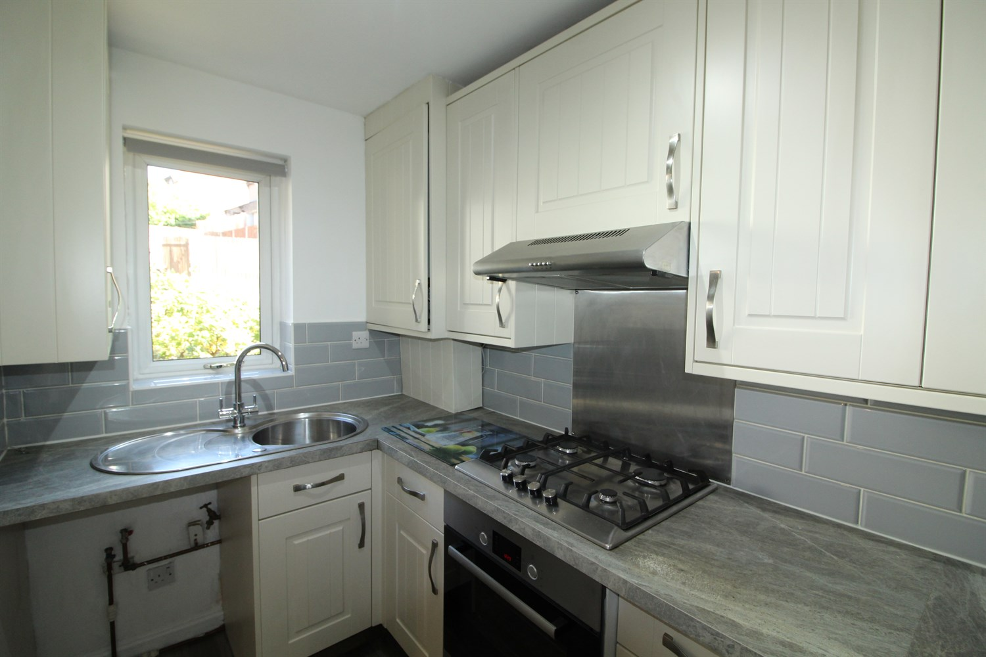
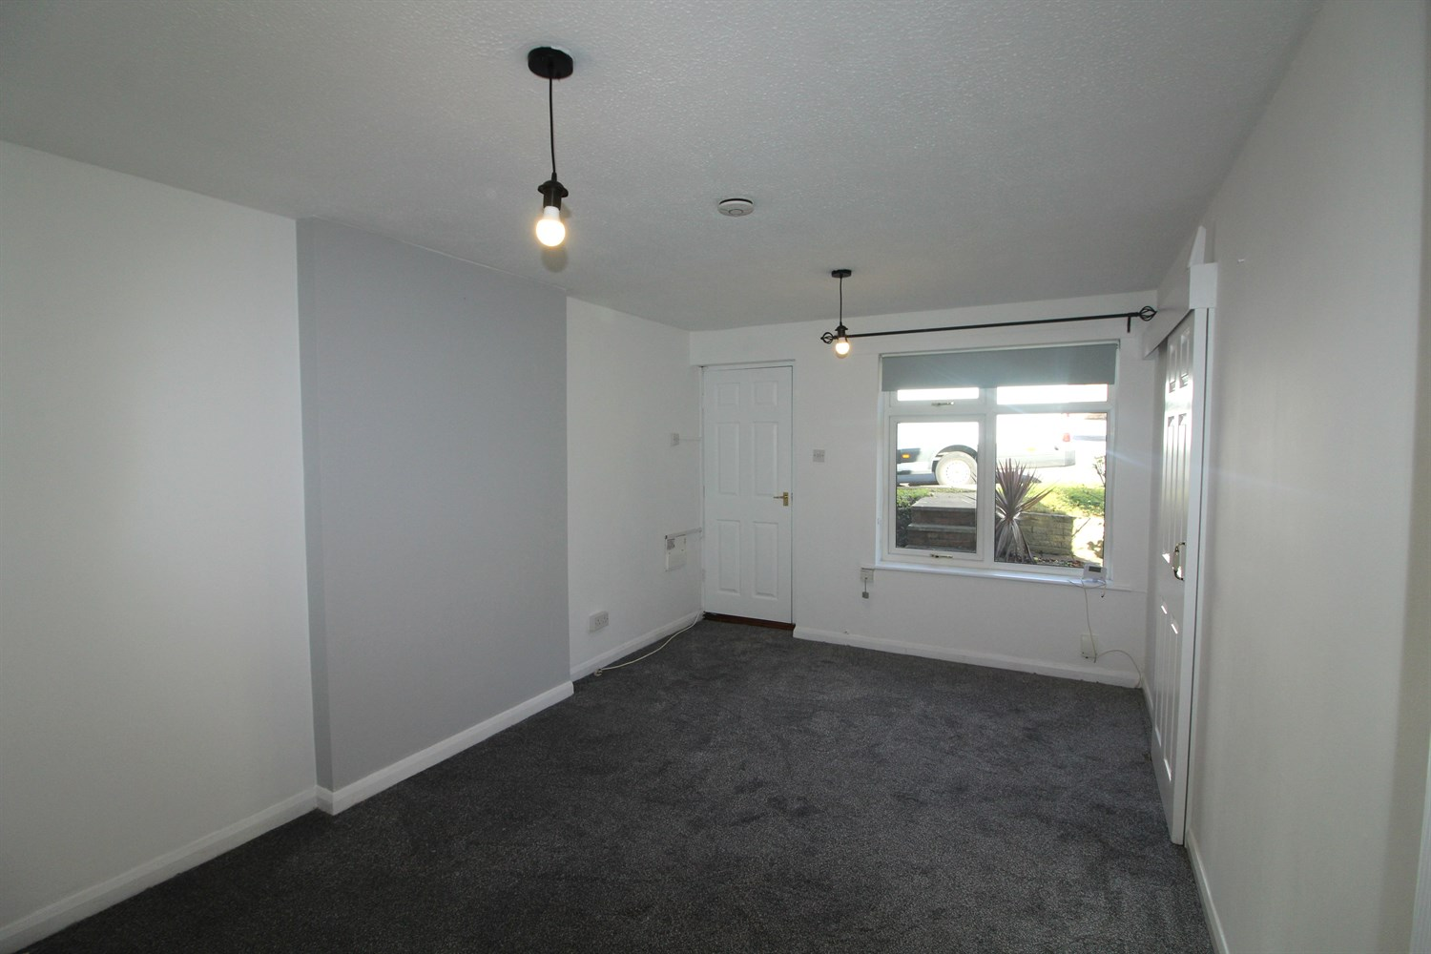
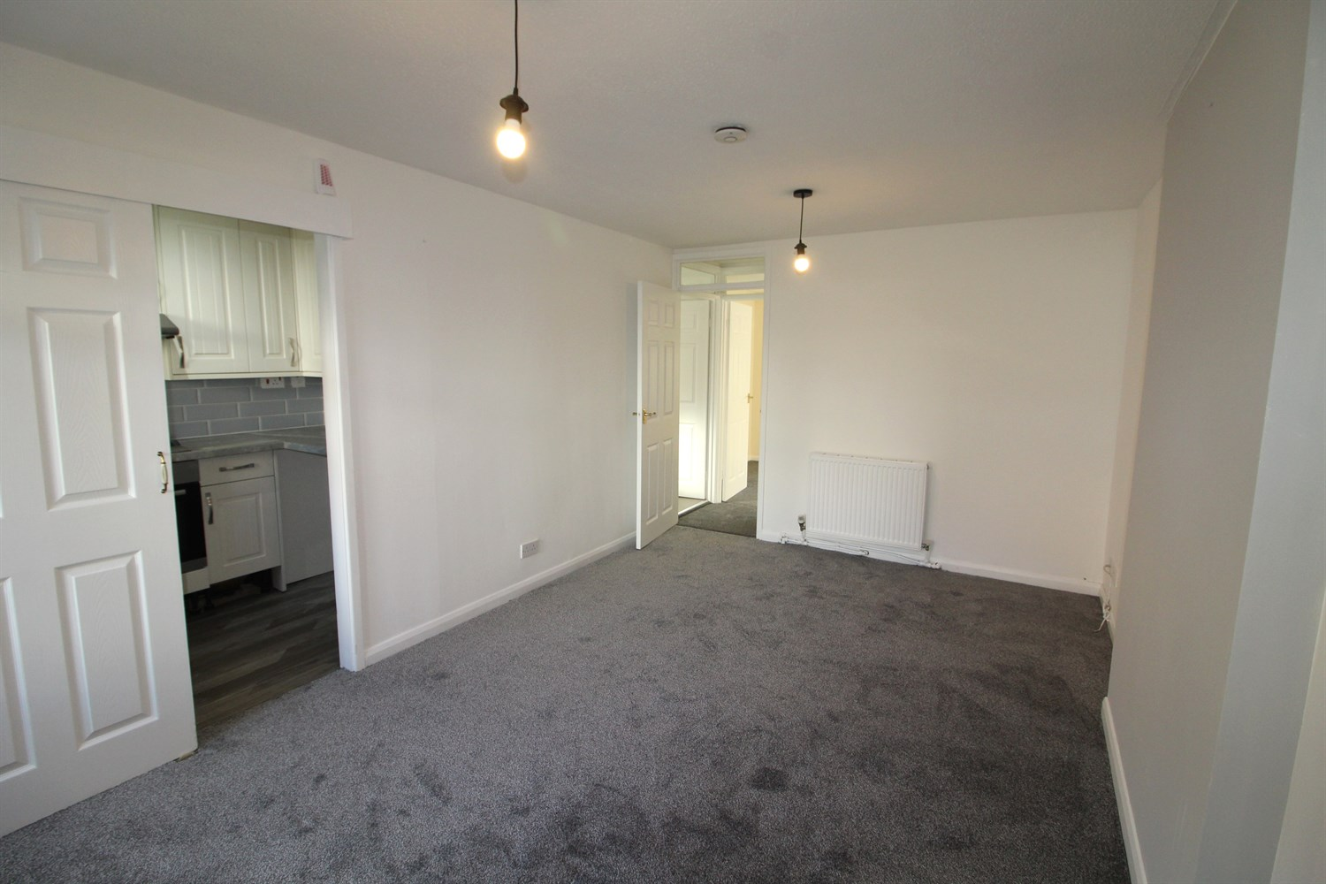
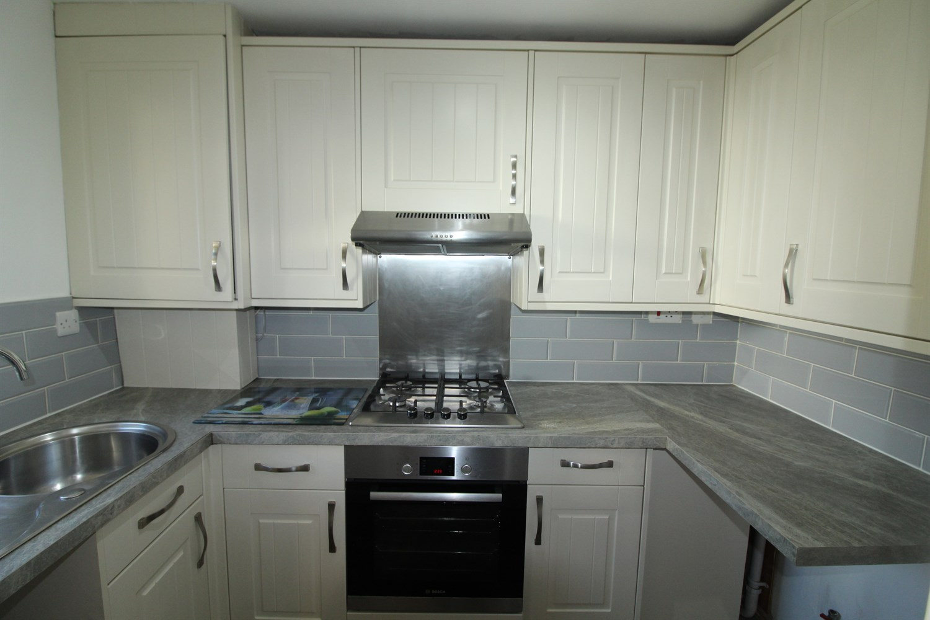
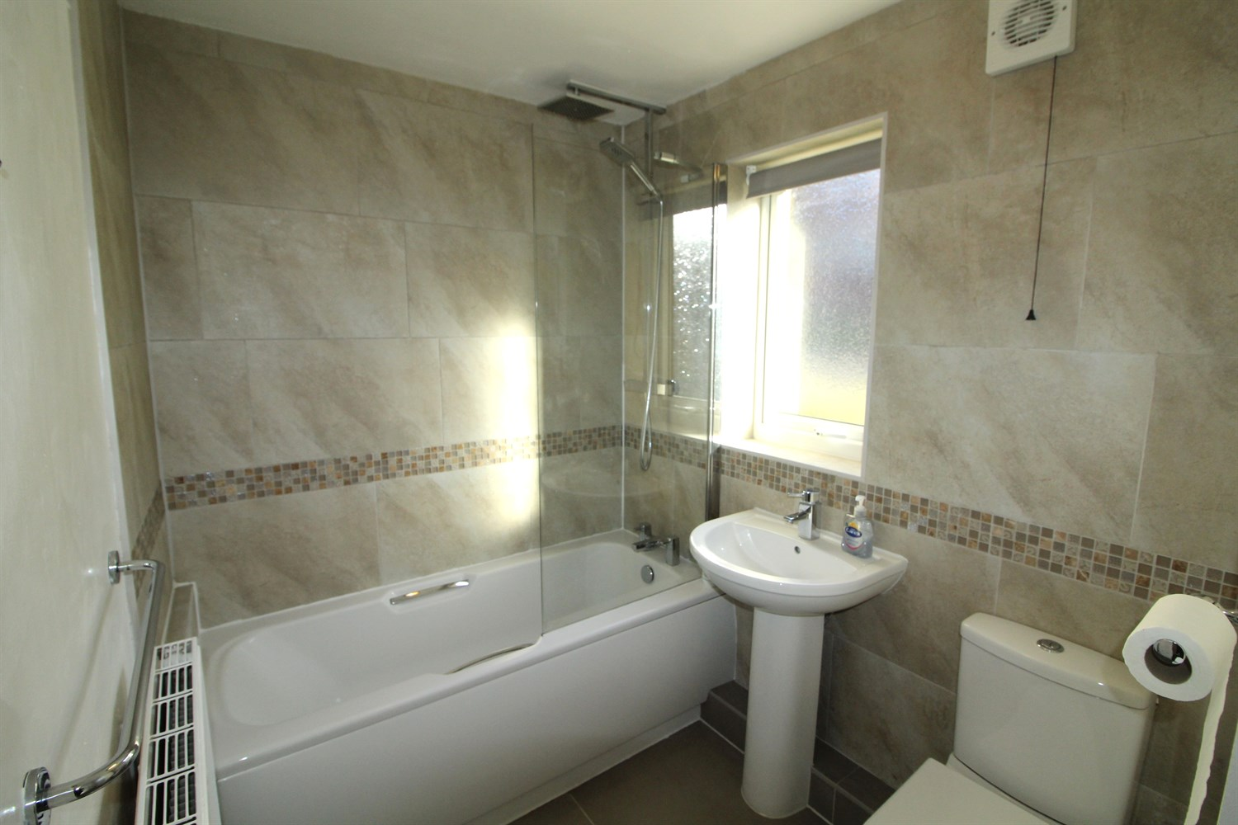

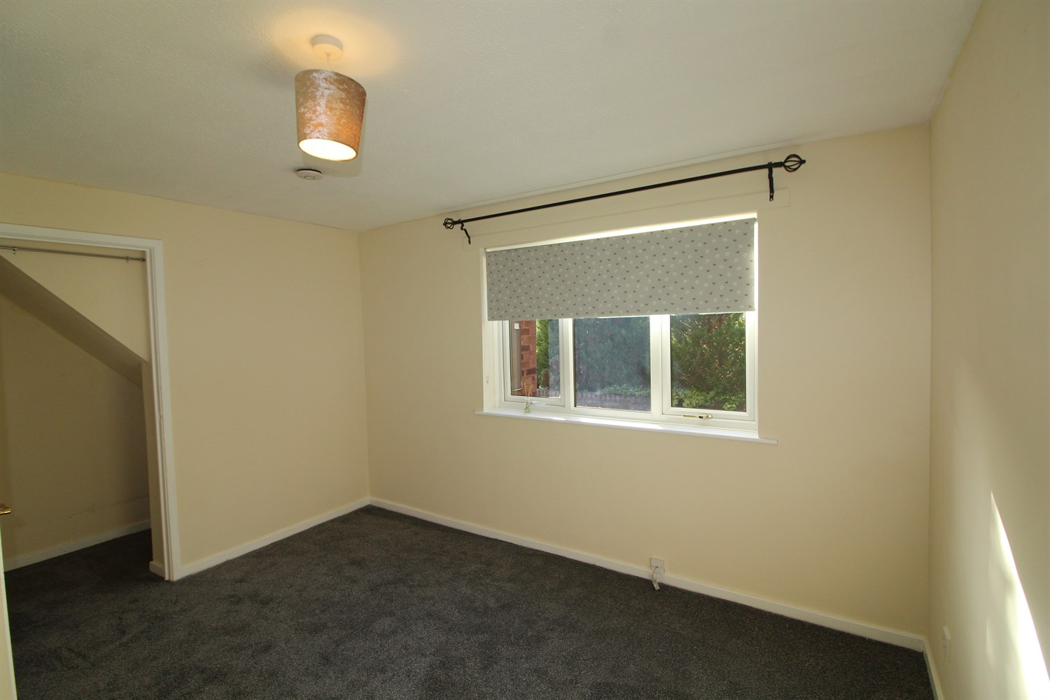
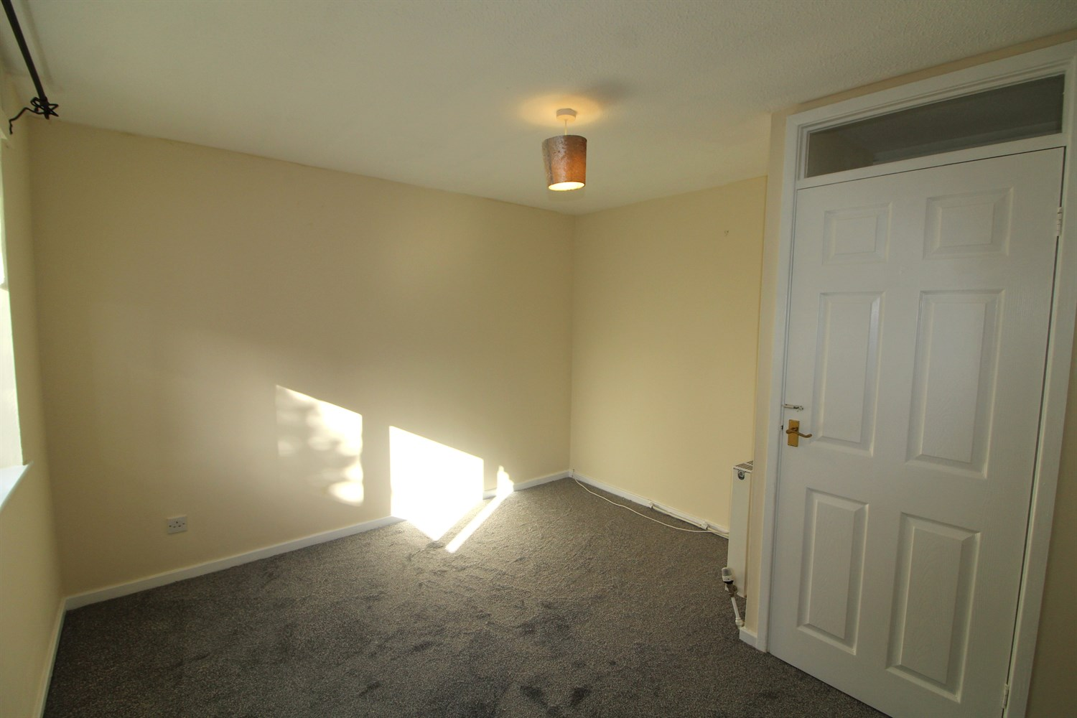

Private Entrance Hall
Private entrance with porch.

Living Room
Light and airy lounge with window to front. Gas central heating radiator.

Kitchen
Fitted with a range of wall and base units with worktops over, stainless sink, part tiled walls window to front.

Bedroom
Carpeted double bedroom with window to rear, gas central heating radiator.

Bathroom
Fitted with a three piece bathroom suite with shower over bath, shower screen, w/c and hand wash basin. Tiled walls, window.

Allocated Parking
Allocated parking space.

Home Information
Council Tax Band A.
EPC rating C.
Leasehold Property.
Allocated Parking
MAINS UTILITY CONNECTIONS - gas, electricity and water.
MOBILE Networks: Likely to have good coverage on all networks.
BROADBAND: Standard 16 Mbps 1 Mbps Good
Superfast 80 Mbps 20 Mbps Good
Ultrafast 1800 Mbps 220 Mbps

These particulars are intended to give a fair description of the property, but their accuracy cannot be guaranteed, and they do not constitute an offer of contract. Intending purchasers must rely on their own inspection of the property. None of the above appliances/services have been tested by ourselves. We recommend purchasers arrange for a qualified person to check all appliances/services before legal commitment.

Property Ref: 7866

For more information, please contact

0113 258 1150 | lettings@adairpaxton.co.uk | www.adairpaxton.co.uk

