
West Park Drive West, Roundhay
For Sale £375,000.00

***SPACIOUS THREE BEDROOM SEMI-DETACHED HOUSE - NO ONWARD CHAIN*** This three bedroom semi-detached house is situated in the popular location of West Park Drive West, Roundhay. The property is in walking distance of Street Lane that has a range of amenities including shops, bars, restaurants and the famous Roundhay Park which is a short walk from the property. This great family home is now in need of some updating and briefly comprises; Entrance hall, kitchen, dining room and lounge to the ground floor. To the first floor there are two good sized double bedrooms, a single bedroom, house bathroom and separate WC. Externally the property has a driveway offering off street parking. To the rear and front of the property, there are lawned gardens with borders of plants and shrubs. An Early internal viewing is highly recommended.
0113 258 1150
0800 000 000
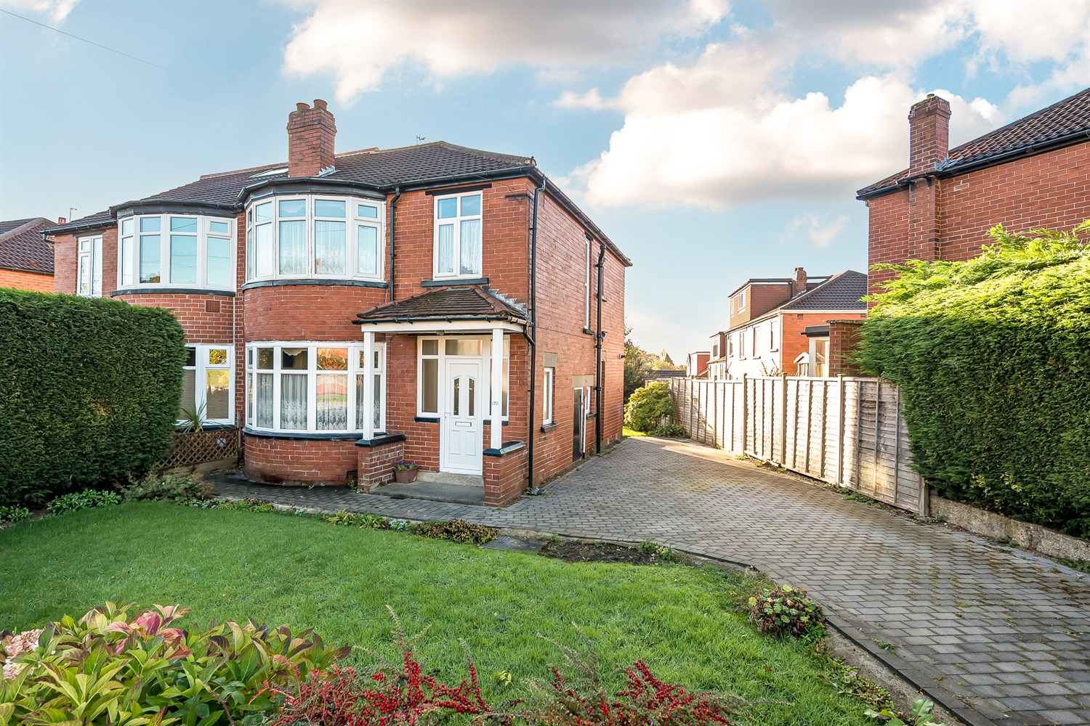



2 Receptions
1 Bathroom
3 Bedrooms
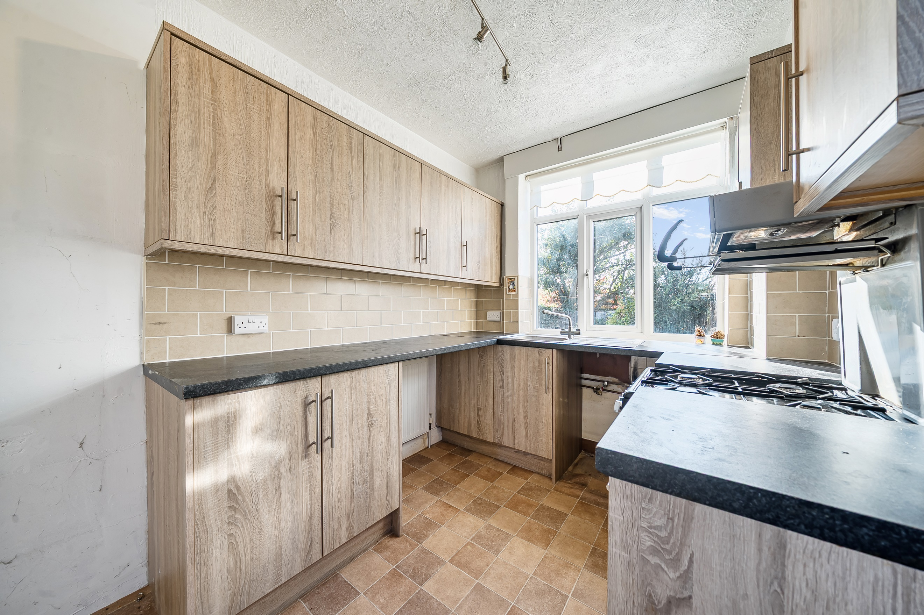
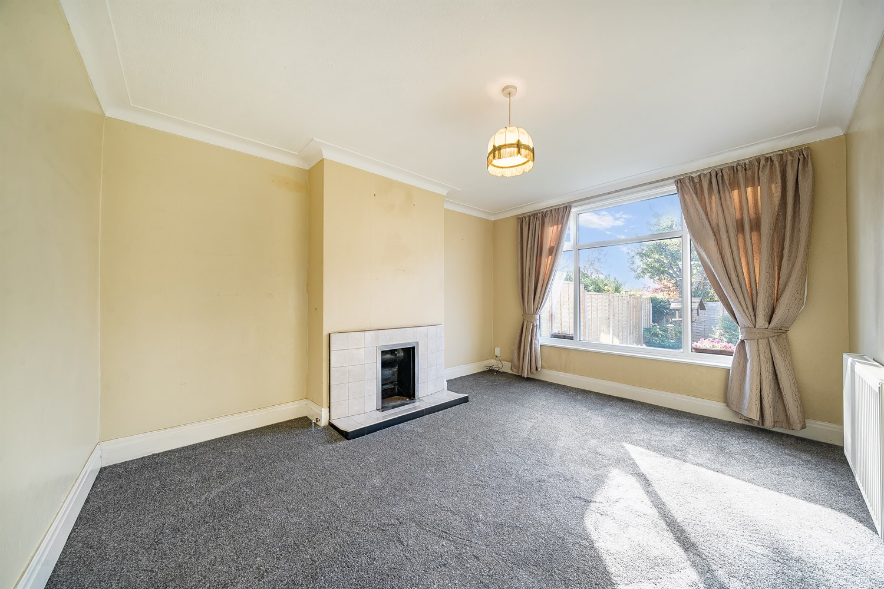
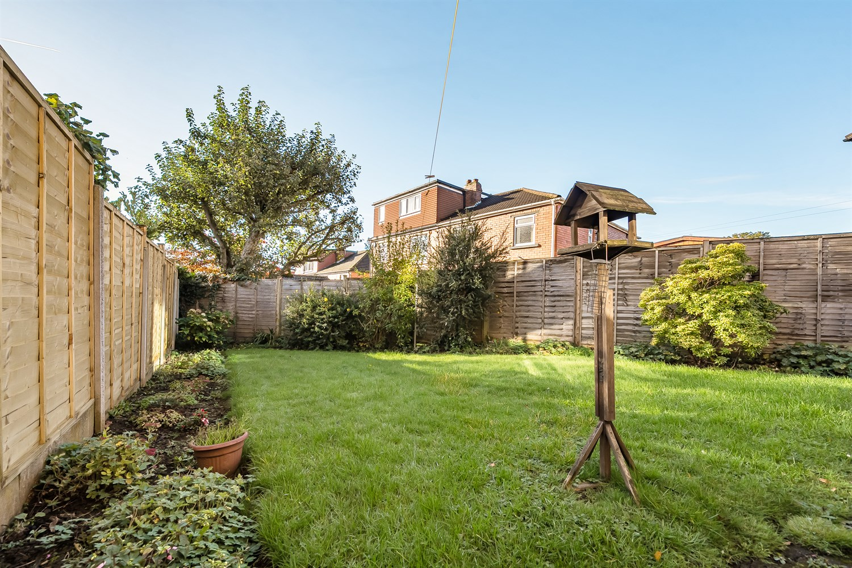
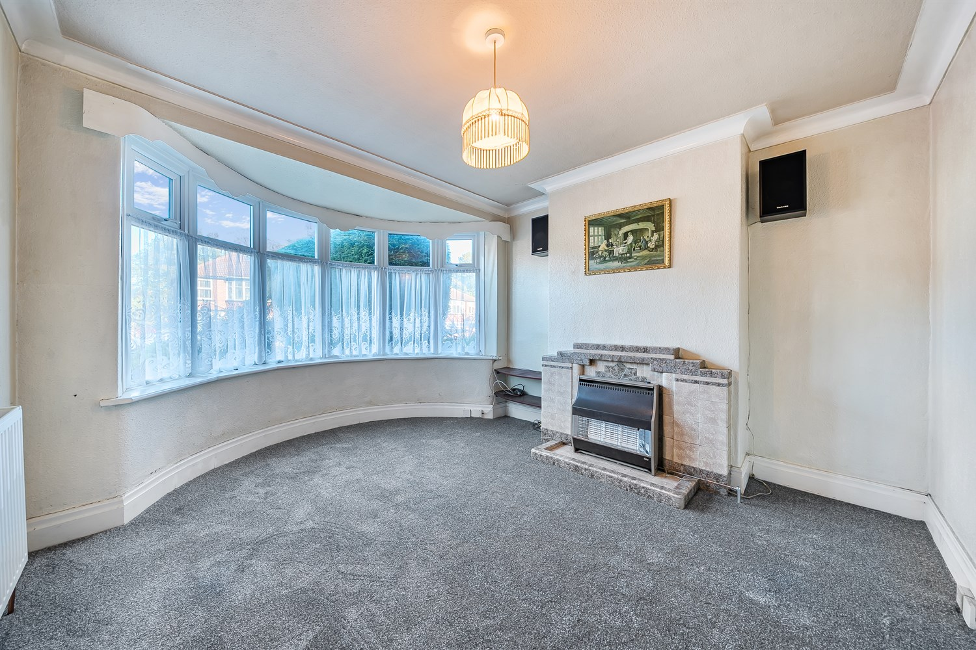
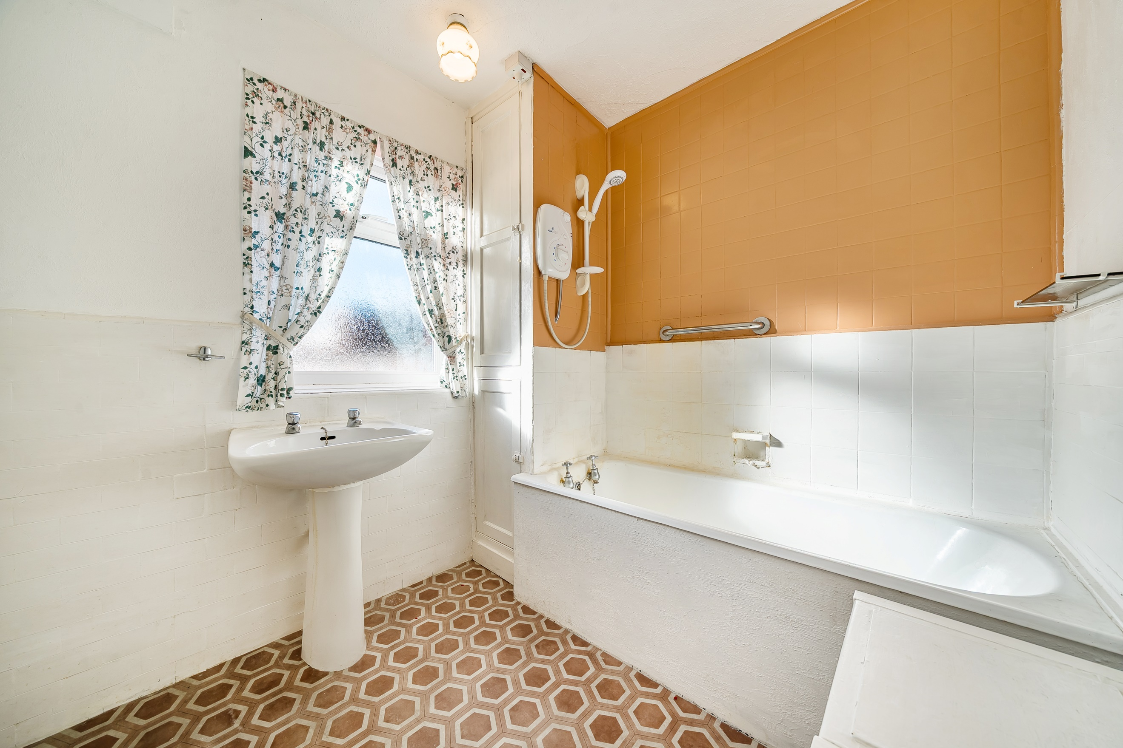
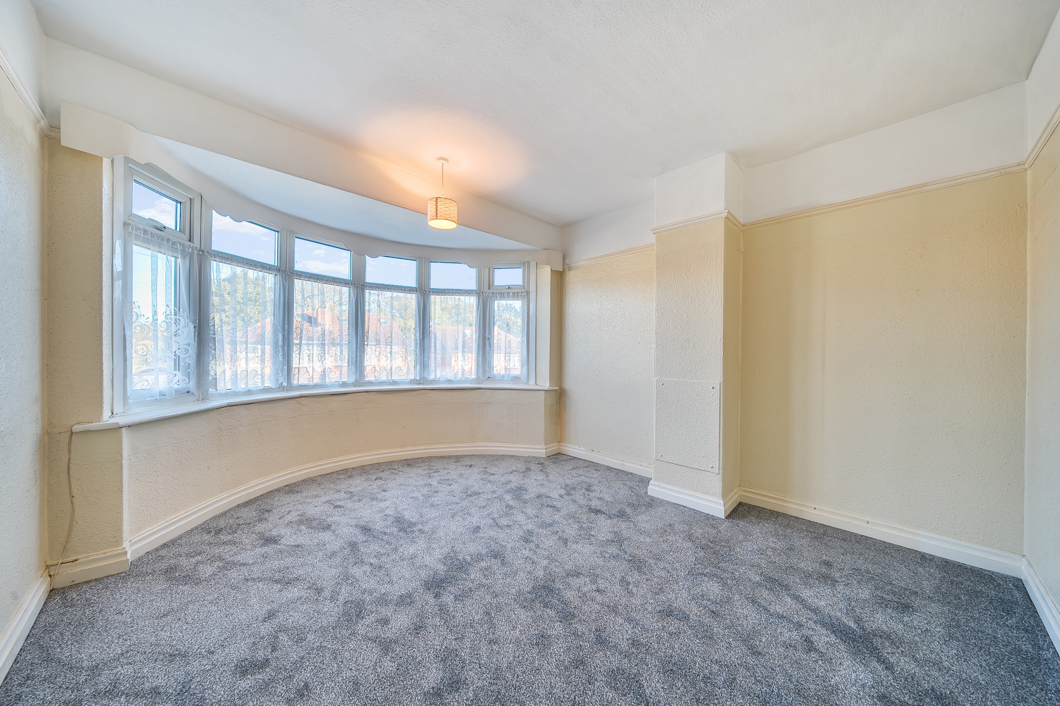
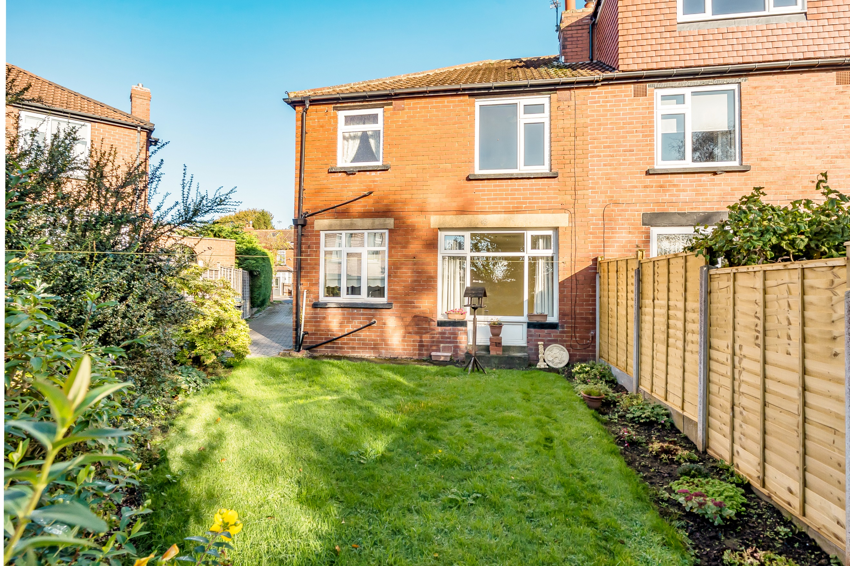
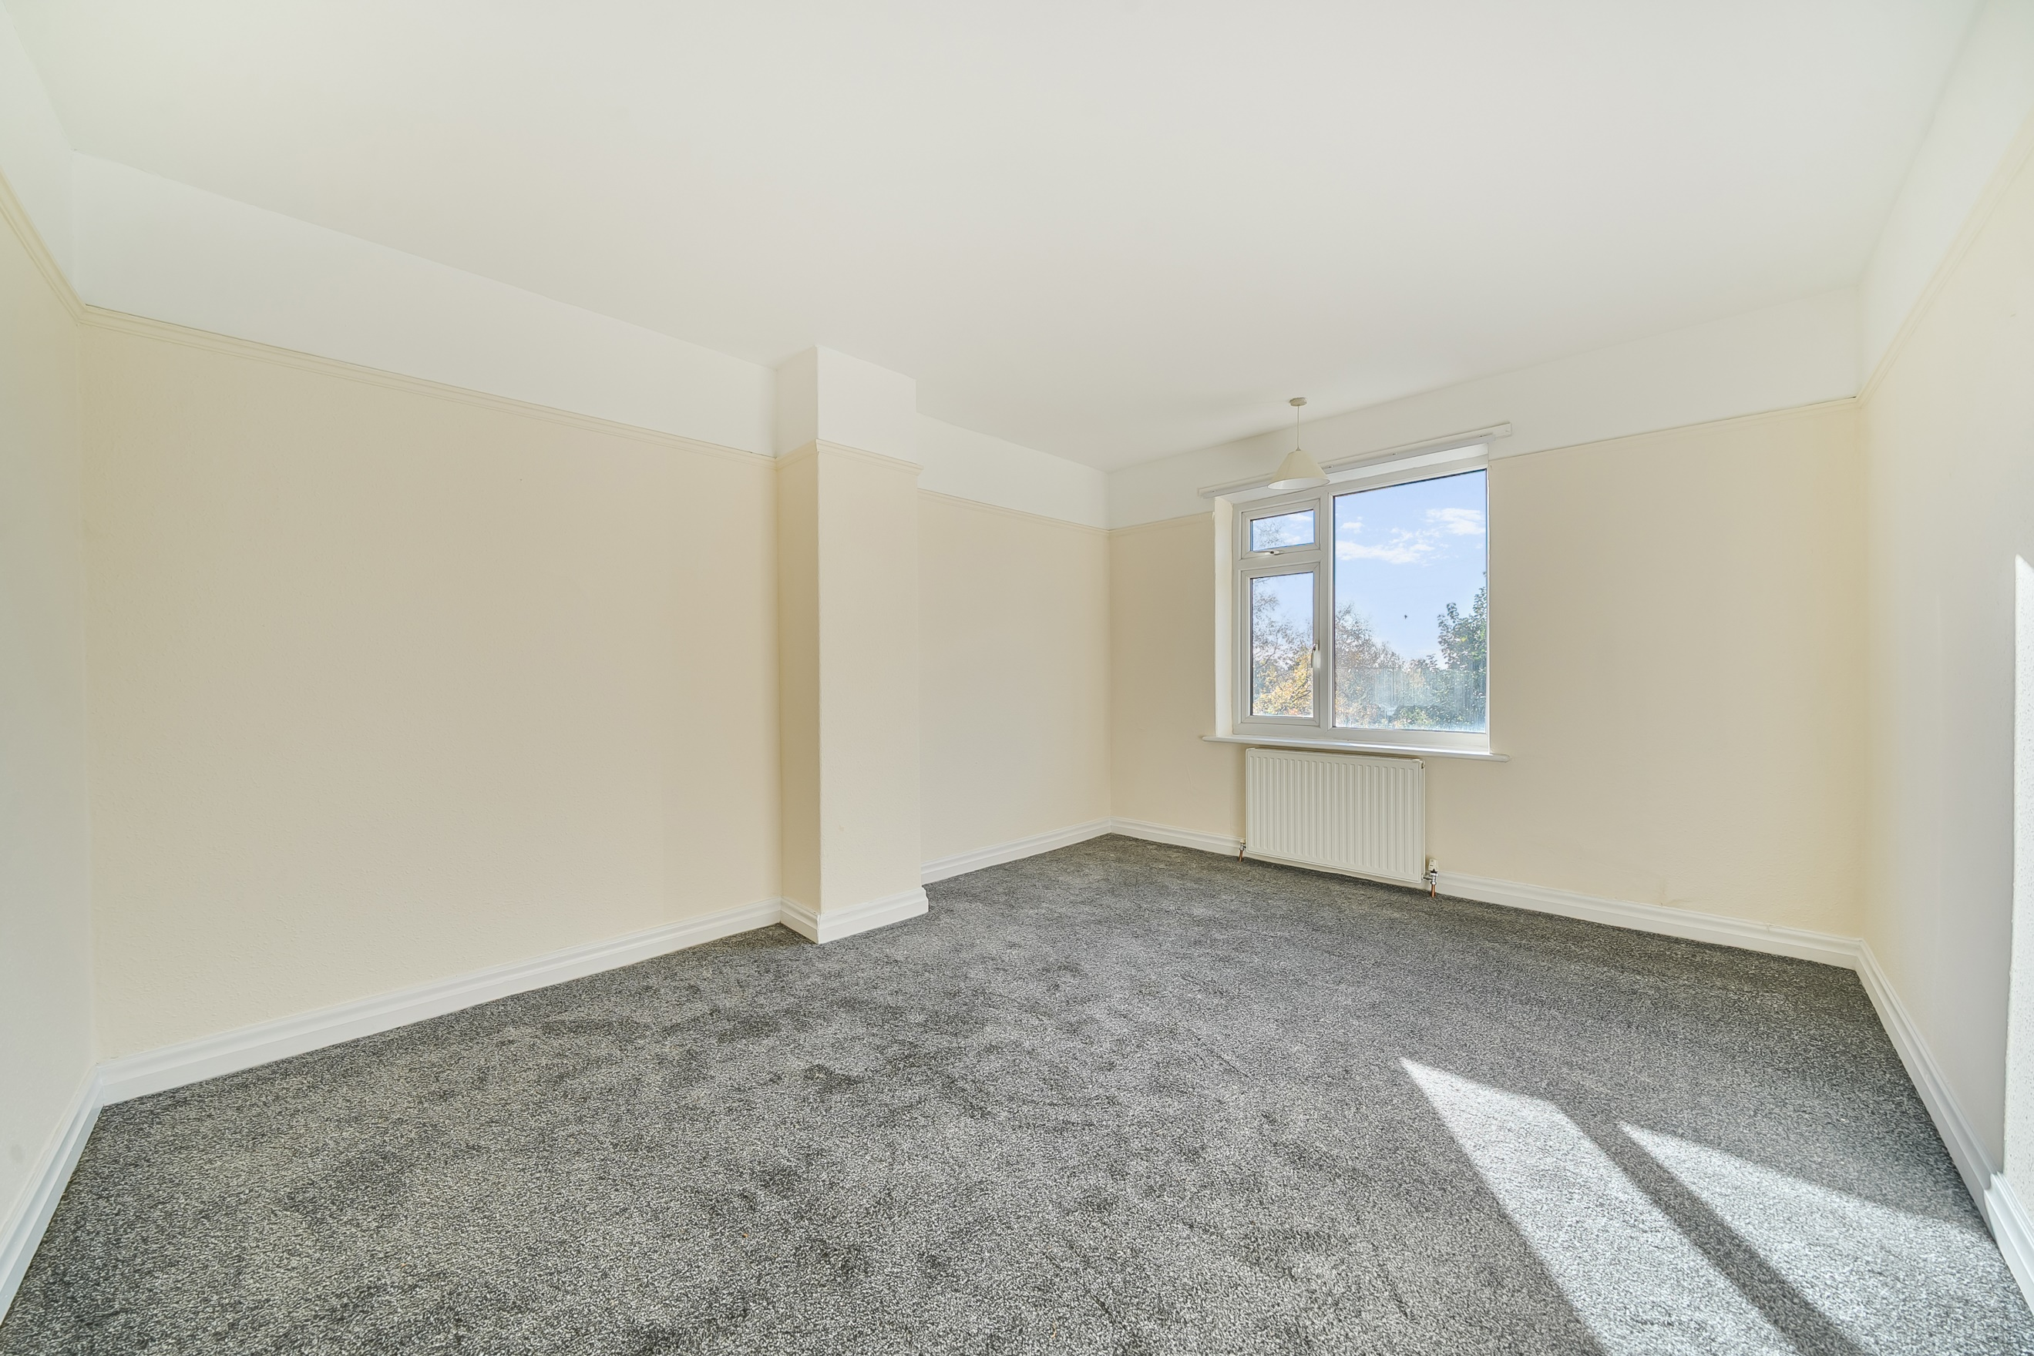

Entrance Hall
Via front entrance door. Gas central heating radiator. Window to side. Stairs to first floor.

Lounge 4.01m (13'2) Into Bay x 3.67m (12'0) Max
Light and airy living area with uPVC double glazed bay window to front. Gas central heating radiator.

Dining Room 4.24m (13'11) Max x 3.4m (11'2) Max
Second spacious reception room with uPVC double glazed window to rear. Gas central heating radiator.

Kitchen 3.03m (9'11) x 2.24m (7'4)
Fitted with a range of wall, base and drawer units with worktops over. Space for cooker, washing machine and fridge/freezer. Stainless steel sink with mixer tap and drainer. uPVC double glazed window to rear. Gas central heating radiator. Under stairs storage cupboard.

First Floor Landing

Bedroom One 4.25m (13'11) x 3.45m (11'4)
Double bedroom with uPVC double glazed window to rear. Gas central heating radiator.

Bedroom Two 4.03m (13'3) Into Bay x 3.45m (11'4) Max
Second double bedroom with uPVC double glazed bay window to front. Gas central heating radiator.

Bedroom Three 2.29m (7'6) x 2.1m (6'11)
Third bedroom with uPVC double lazed window to front. Gas central heating radiator.

Bathroom
Fitted with a two piece suite comprising bath and WC. uPVC double glazed window to rear. Gas central heating radiator.

Separate WC
WC. uPVC double glazed window.

Outside
To the front of the property is a driveway offering off street parking. Lawned gardens to the front and rear with borders of plants and shrubs.

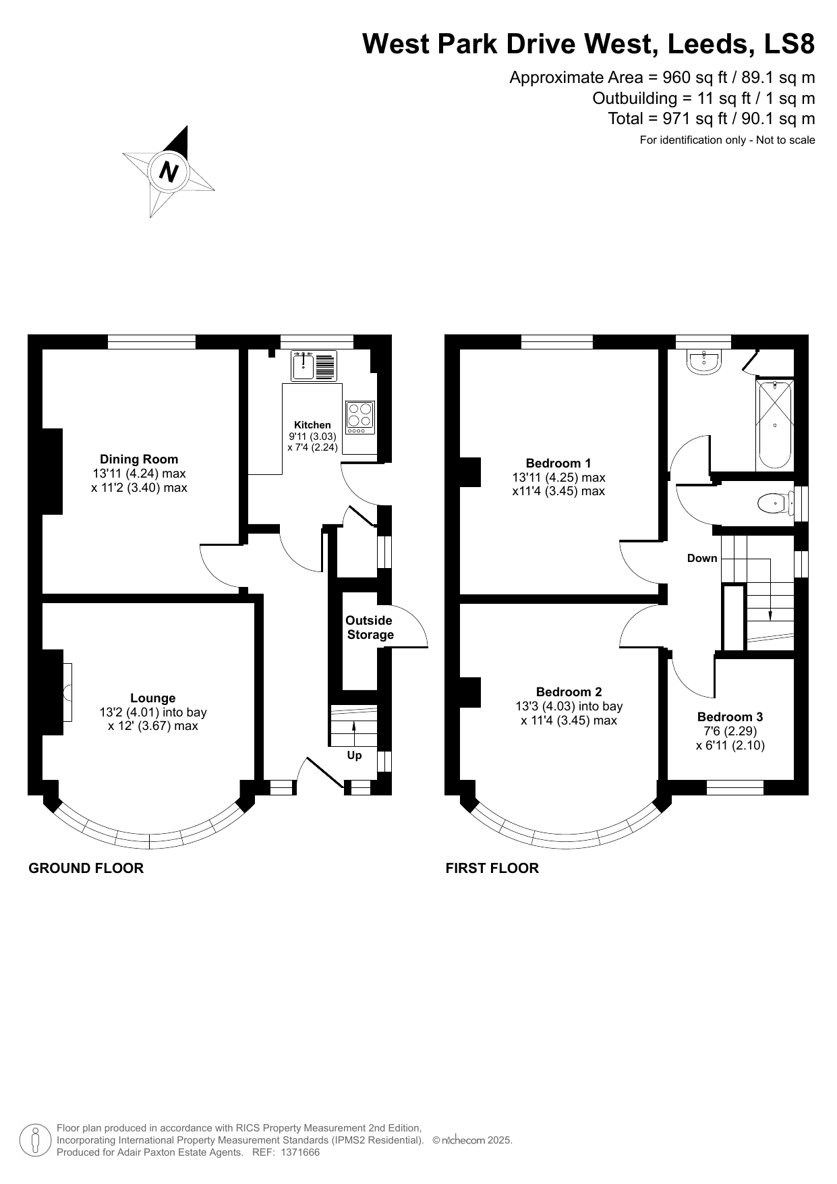

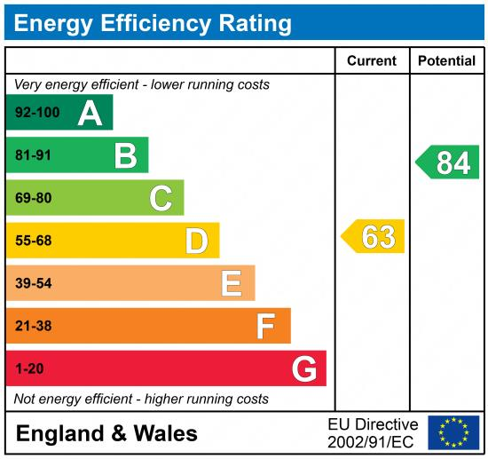

These particulars are intended to give a fair description of the property, but their accuracy cannot be guaranteed, and they do not constitute an offer of contract. Intending purchasers must rely on their own inspection of the property. None of the above appliances/services have been tested by ourselves. We recommend purchasers arrange for a qualified person to check all appliances/services before legal commitment.

Property Ref: 7891

For more information, please contact

0113 258 1150 | sales@adairpaxton.co.uk | www.adairpaxton.co.uk

