

3 Whitehall Quay, Leeds
Available to let £1,200.00pcm

***TWO DOUBLE BEDROOM APARTMENT IN THE HEART OF LEEDS*** Occupying an enviable position on the Fifth floor of this superb development in Leeds City Centre. Handy for the train station and all amenities this vibrant City has to offer, this property will appeal to couples and sharers alike. The property briefly comprises: communal entrance hall with lift access to all floors, private hallway with storage cupboard, lounge with river facing balcony, fitted kitchen with integral appliances to include dishwasher, washer/dryer and fridge/freezer, two double bedrooms and bathroom with shower over bath. Furnished, deposit £1380. Available 20th October.
0113 258 1150
0800 000 000
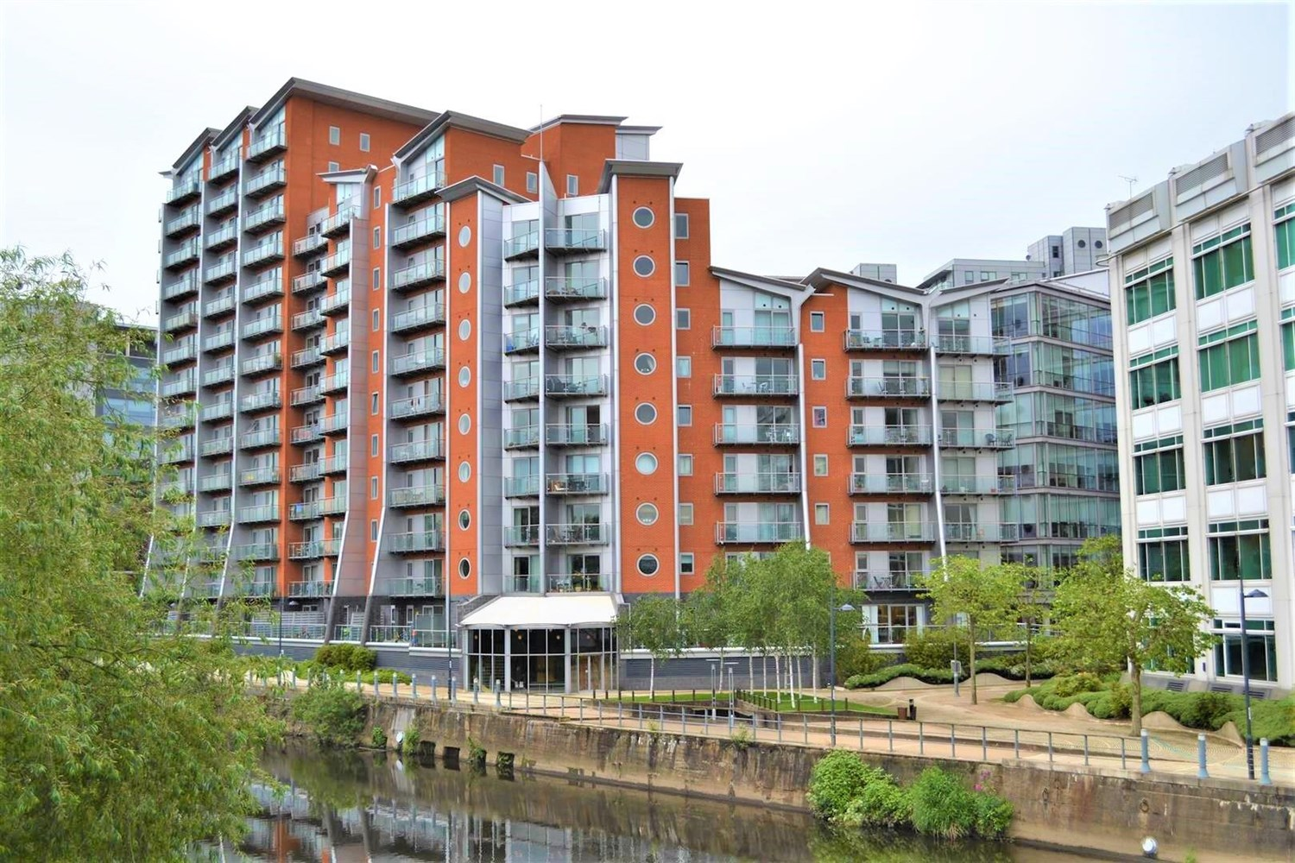



1 Reception(s)
1 Bathroom(s)
2 Bedroom(s)
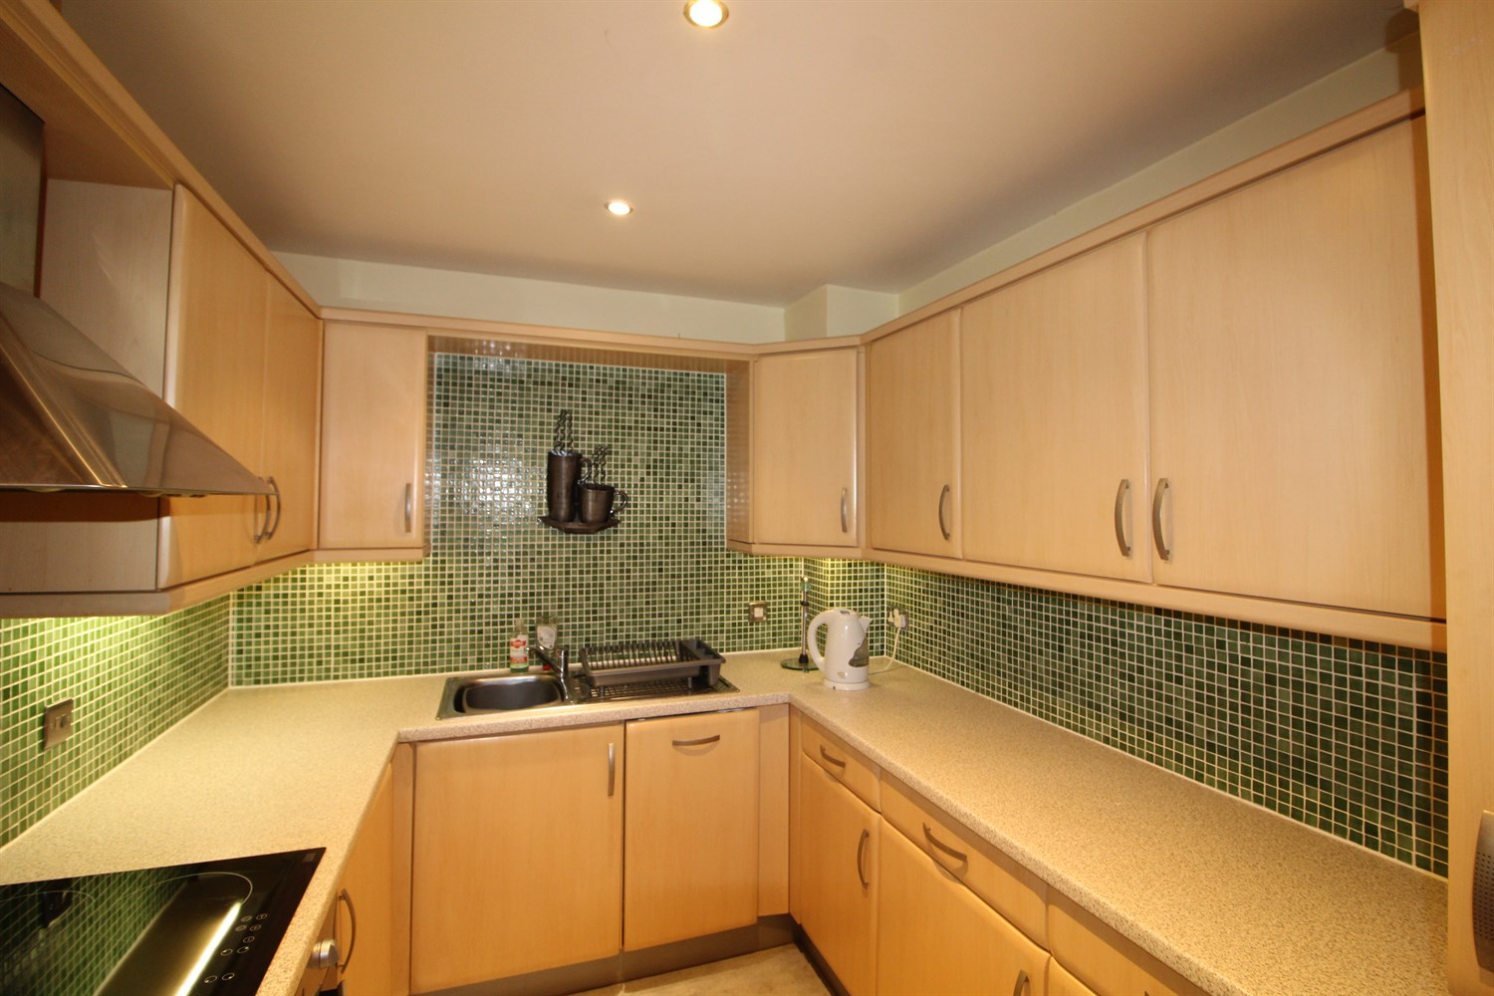
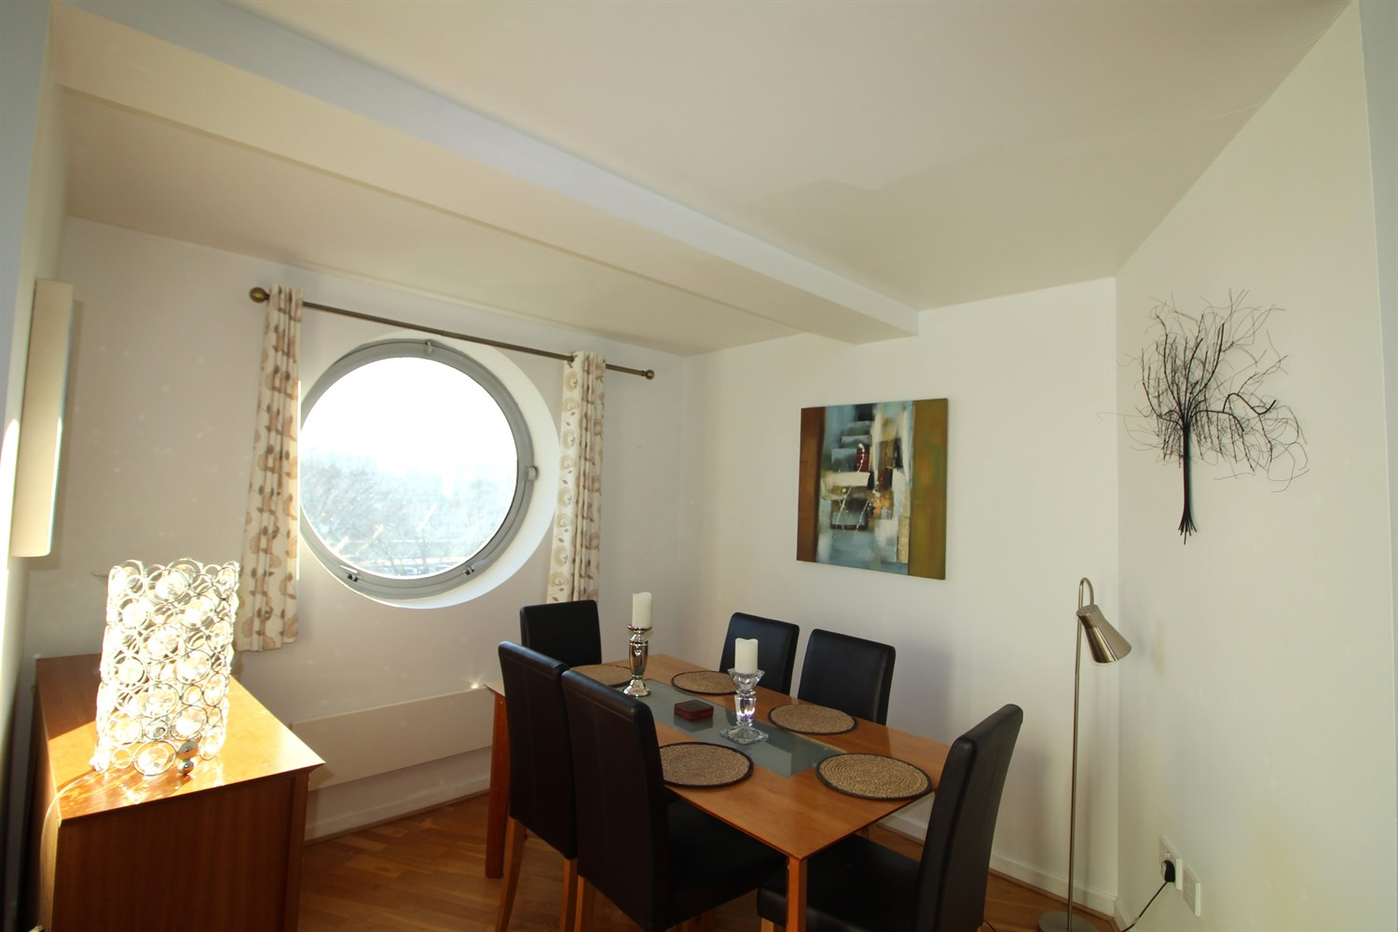
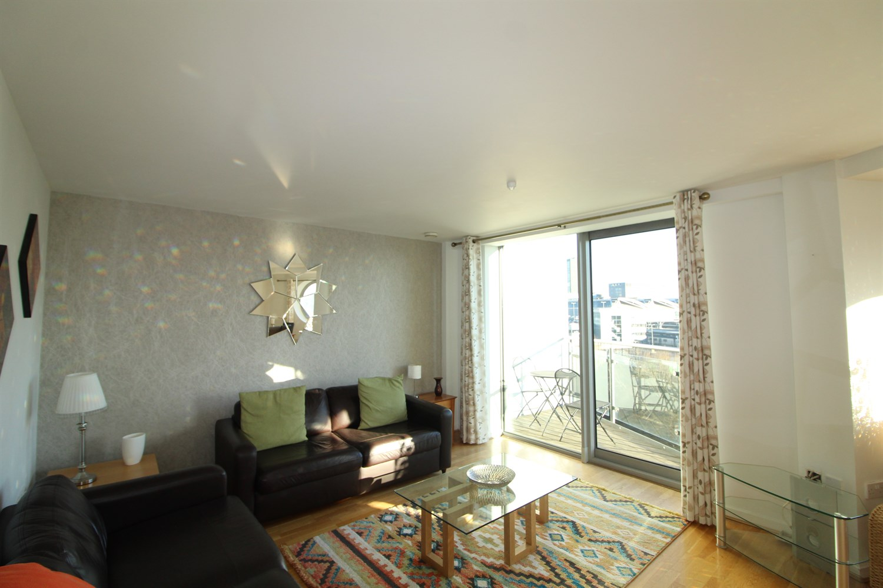
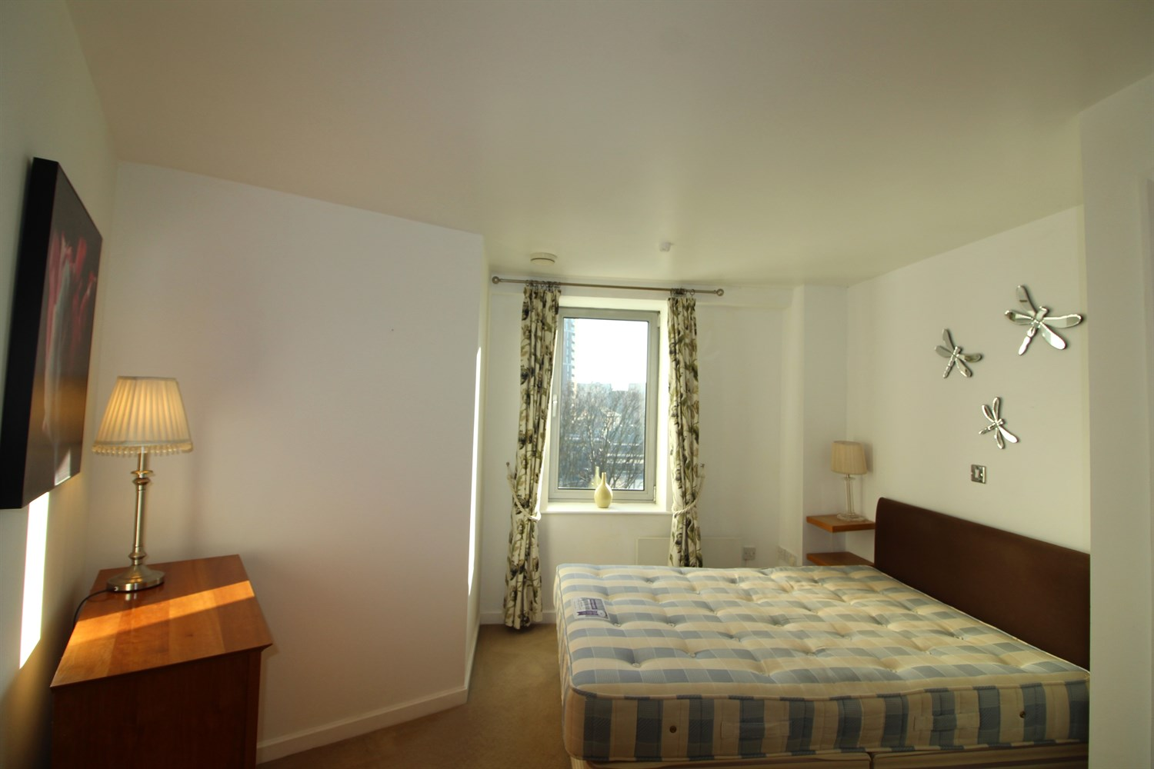
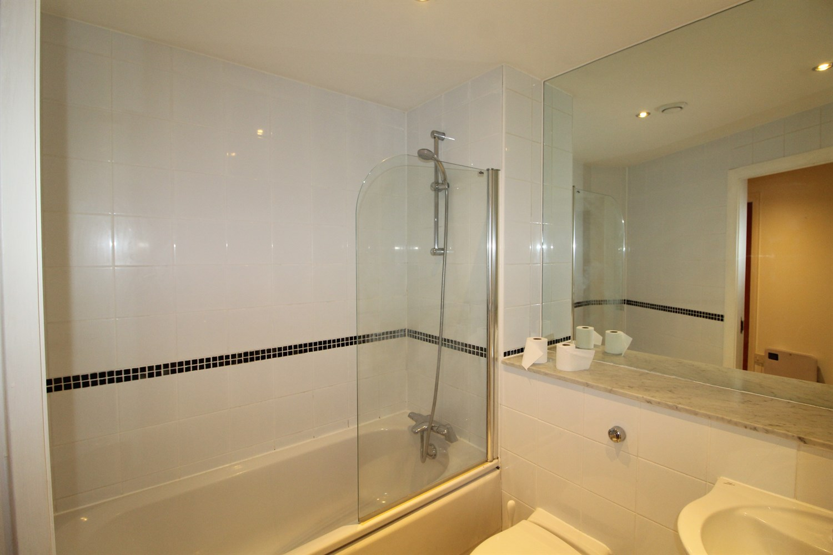
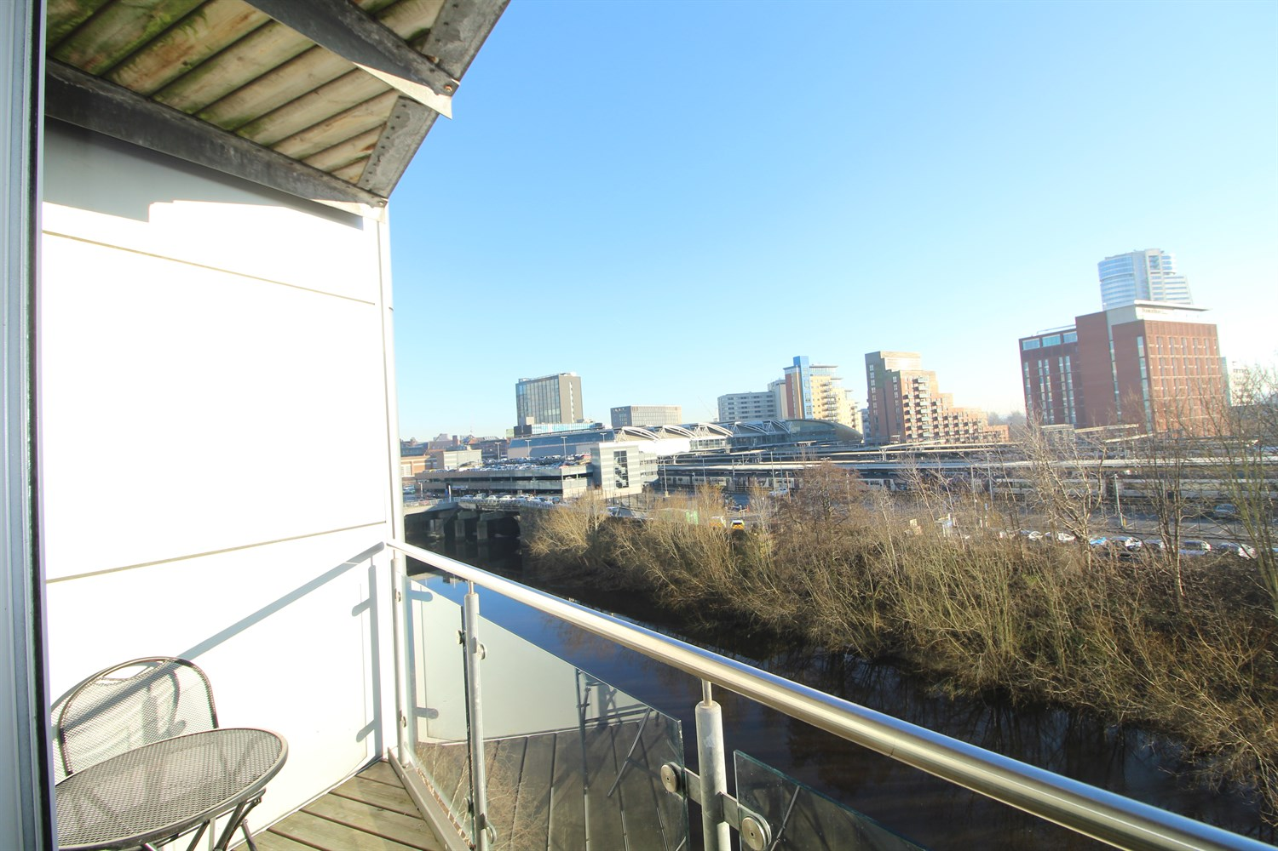
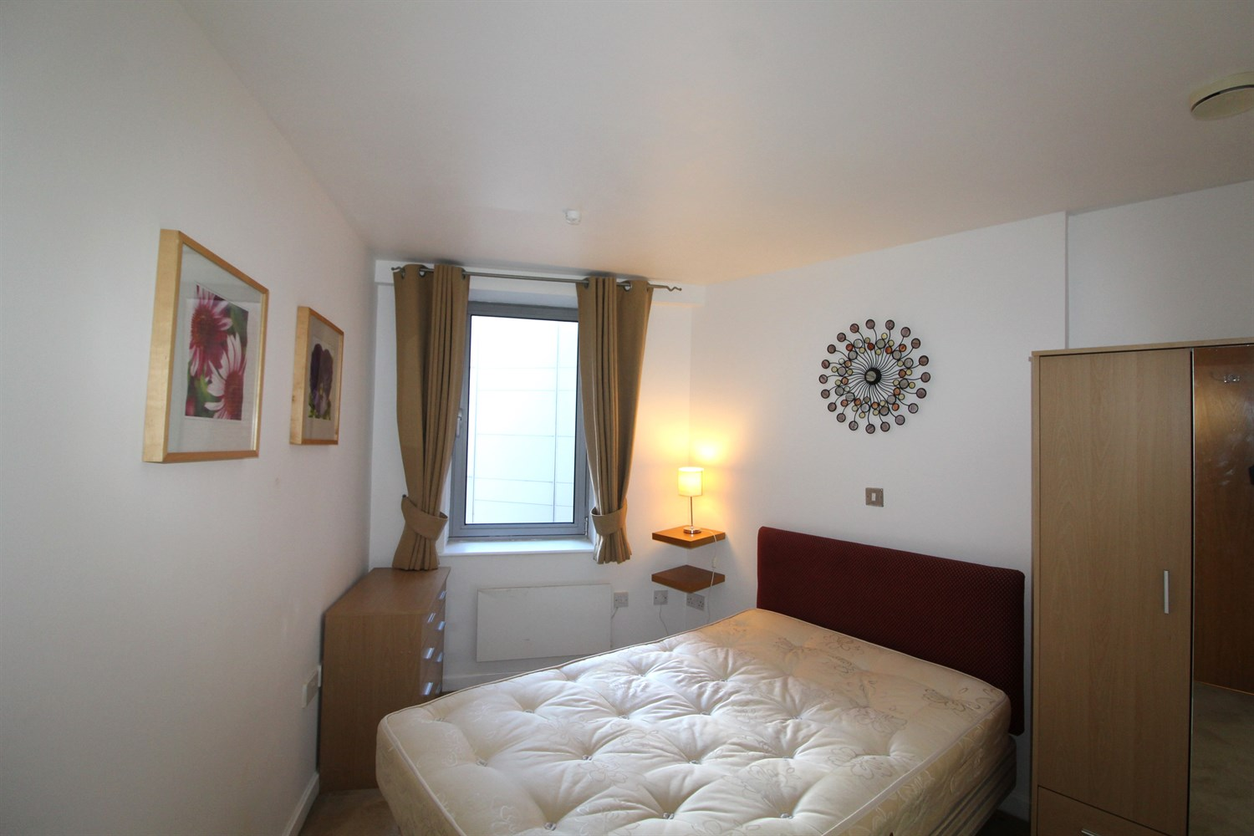
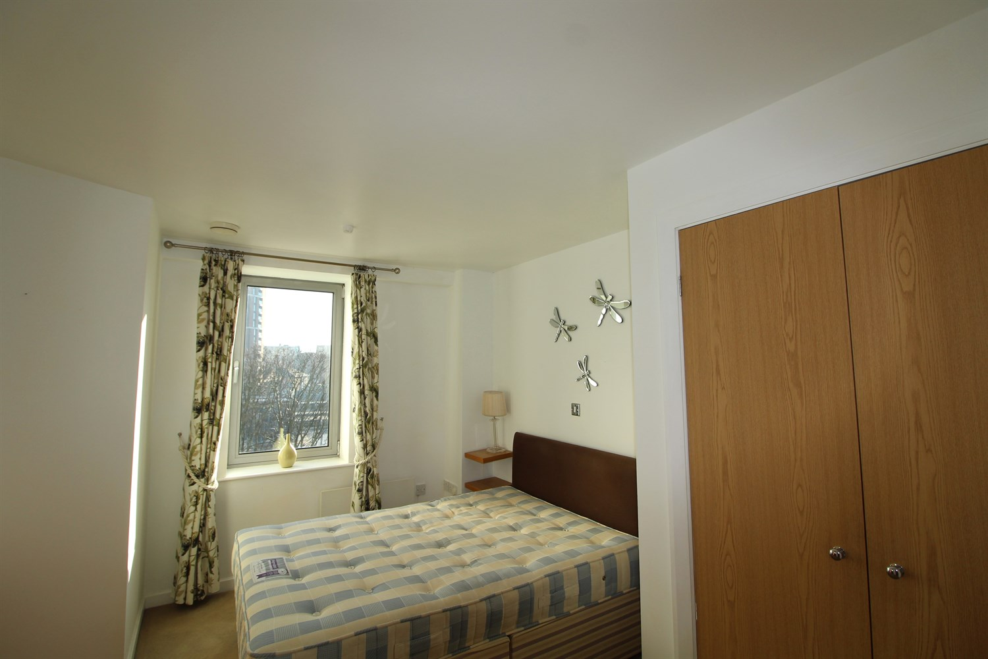

Living/Dining 4.11m (13'6) x 4.4m (14'5)
large living room with dining area. Sliding doors leading to balcony with river views. Electric heater.

Kitchen 3.12m (10'3) x 2.38m (7'10)
Fitted kitchen with integral appliances to include dishwasher, washer/dryer and fridge/freezer. Electric induction hob and electric oven with extractor over head. Stainless steel sink with drainer and mixer tap.

Bedroom 1 3.74m (12'3) x 4.02m (13'2)
Double bedroom with double glazed uPVC window and electric heater.

Bedroom 2 3.23m (10'7) x 3.46m (11'4)
Second double bedroom with double glazed uPVC window and electric heater.

Bathroom
Three piece white bathroom suite with shower over head, w/c and hand wash basin. Tiled walls an floor, large mirror, electric heater.

Parking
Allocated Parking.

Home Information
EPC BAND: C
COUNCIL TAX BAND: D
Cladding work pending
Leasehold property
Allocated Parking
Broadband: Standard highest download speed: 16mbps. Standard highest upload speed: 1mbps. Ultrafast highest download speed: 1000mbps. Ultrafast highest upload speed: 1000mbps.
Mobile availability: EE likely to have good coverage. Three likely to have good coverage. O2 likely to have good coverage. Vodafone likely to have good coverage.
Utilities: No gas. Water supplied on a meter. Electric mains supplied on standard meters.

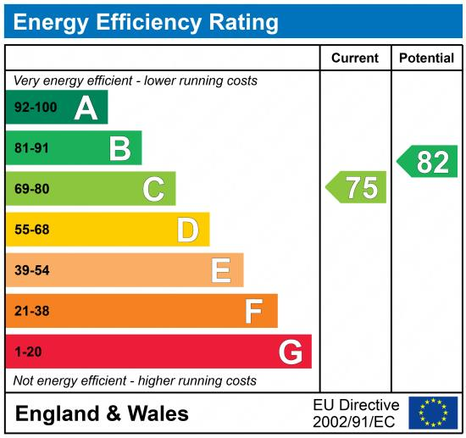

These particulars are intended to give a fair description of the property, but their accuracy cannot be guaranteed, and they do not constitute an offer of contract. Intending purchasers must rely on their own inspection of the property. None of the above appliances/services have been tested by ourselves. We recommend purchasers arrange for a qualified person to check all appliances/services before legal commitment.

Property Ref: 4508

For more information, please contact

0113 258 1150 | lettings@adairpaxton.co.uk | www.adairpaxton.co.uk

