
Church Avenue, Meanwood
For Sale £350,000

***THREE BEDROOM SEMI-DETACHED HOUSE with NO ONWARD CHAIN - READY TO MOVE INTO - SOUGHT AFTER LOCATION*** Adair Paxton are pleased to offer to the market this beautifully presented three bedroom semi-detached house within walking distance of Meanwood's range of amenities including bars, restaurants, Waitrose, David Lloyd Leisure Centre, and the Moor Allerton retail complex. This home is perfect for families or first time buyers and briefly comprises; entrance hall, lounge, modern kitchen/diner, light and airy conservatory and shower room to the ground floor. To the first floor there are two double bedrooms with built in wardrobes, a single bedroom with built in wardrobes and a house bathroom. Externally, the property has a paved driveway to the front offering off street parking for two vehicles. To the rear of the property is an enclosed rear garden.
Excellent transport links provide easy access to Leeds City Centre and surrounding areas.
0113 258 1150
0800 000 000
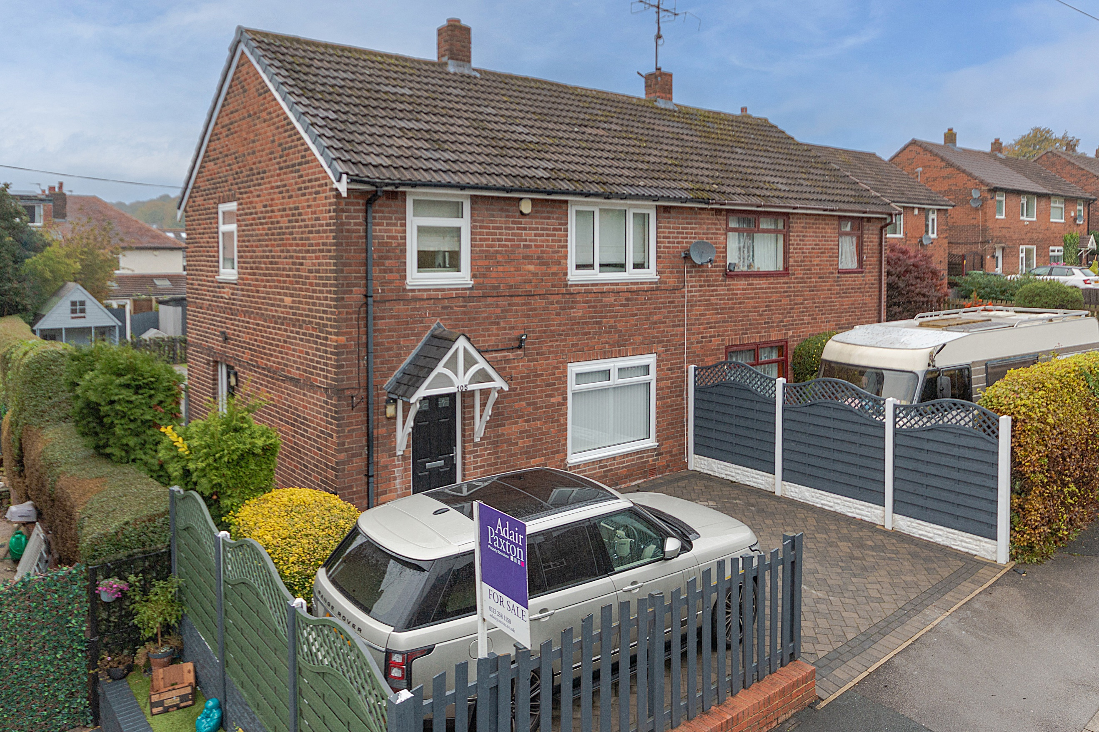



2 Receptions
2 Bathrooms
3 Bedrooms
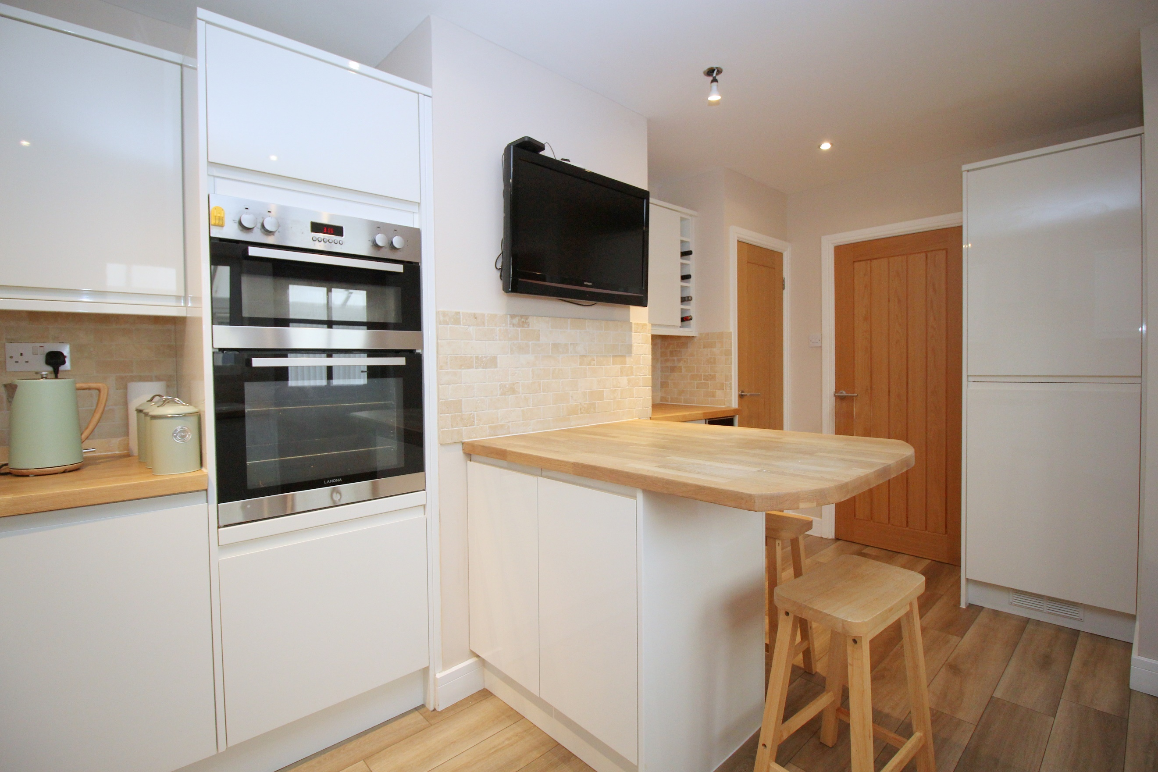
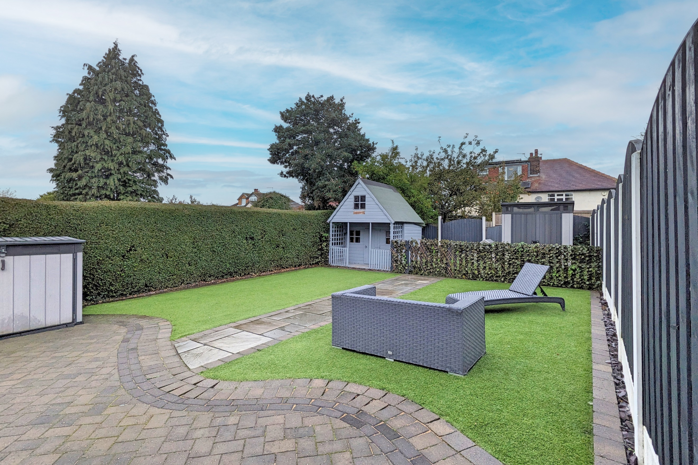
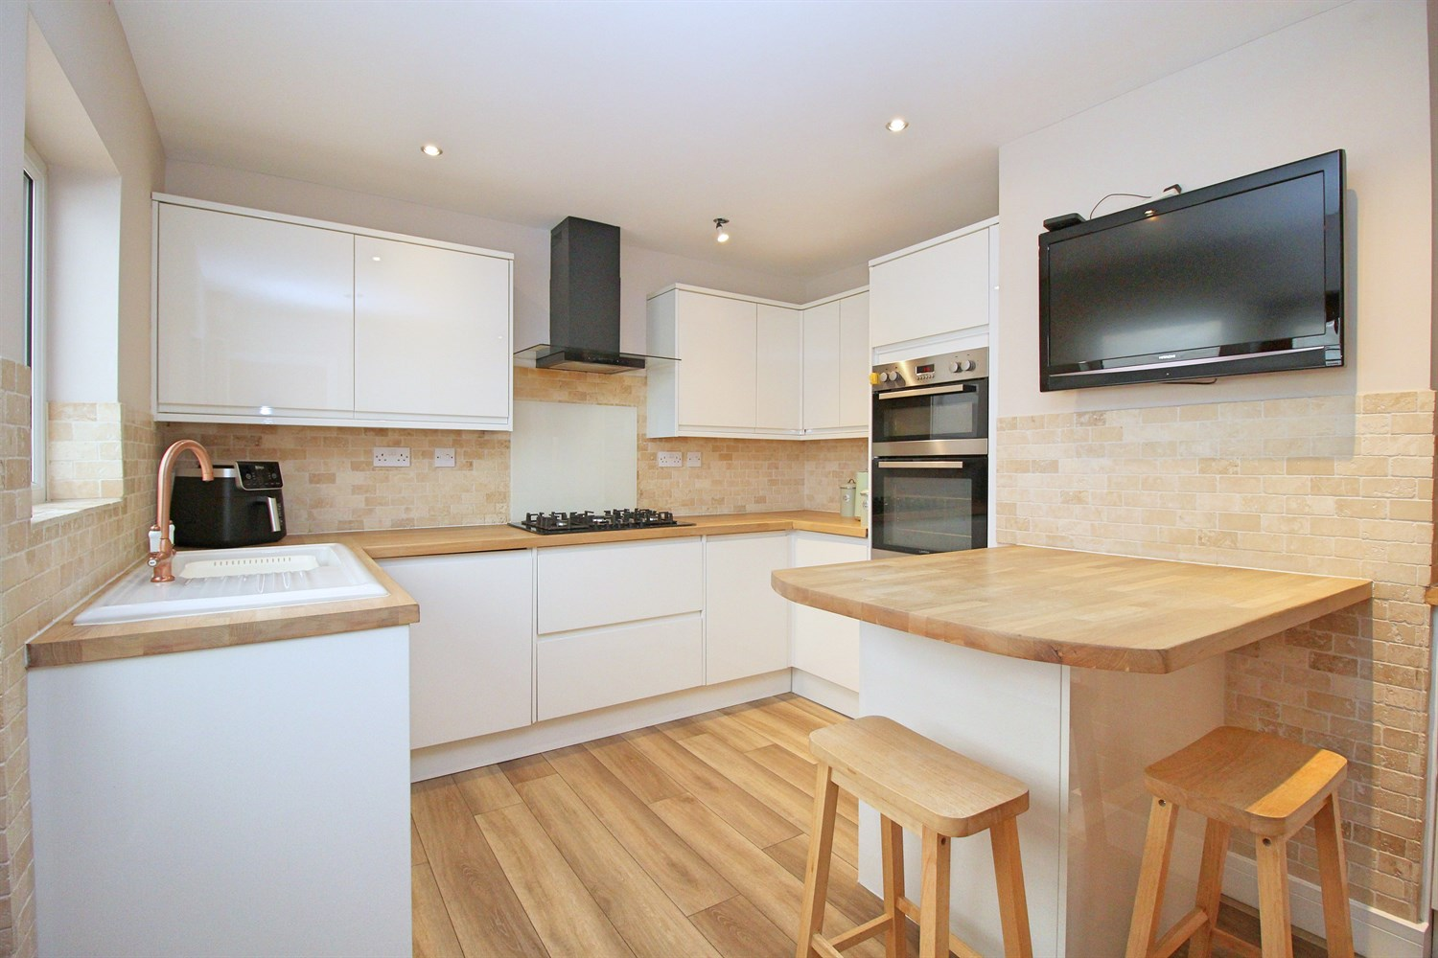
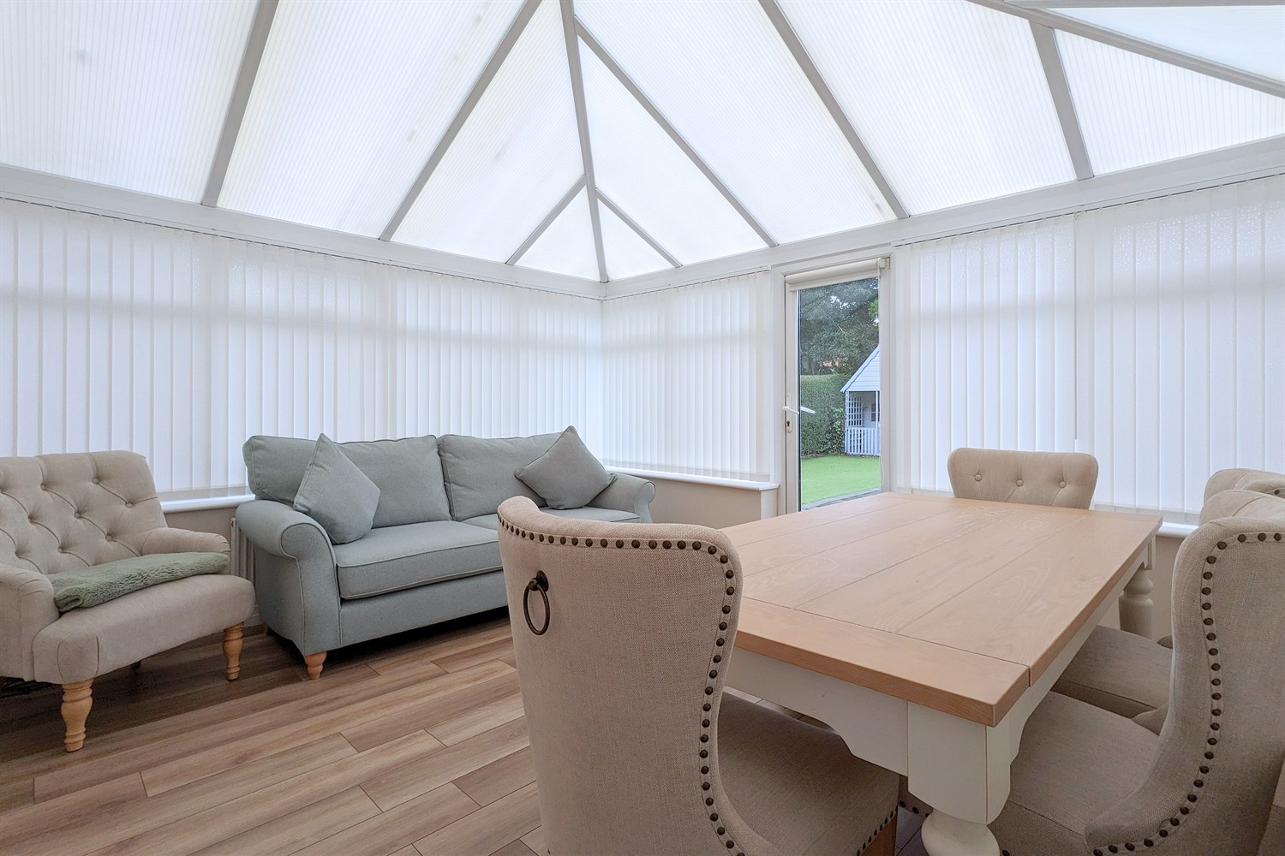
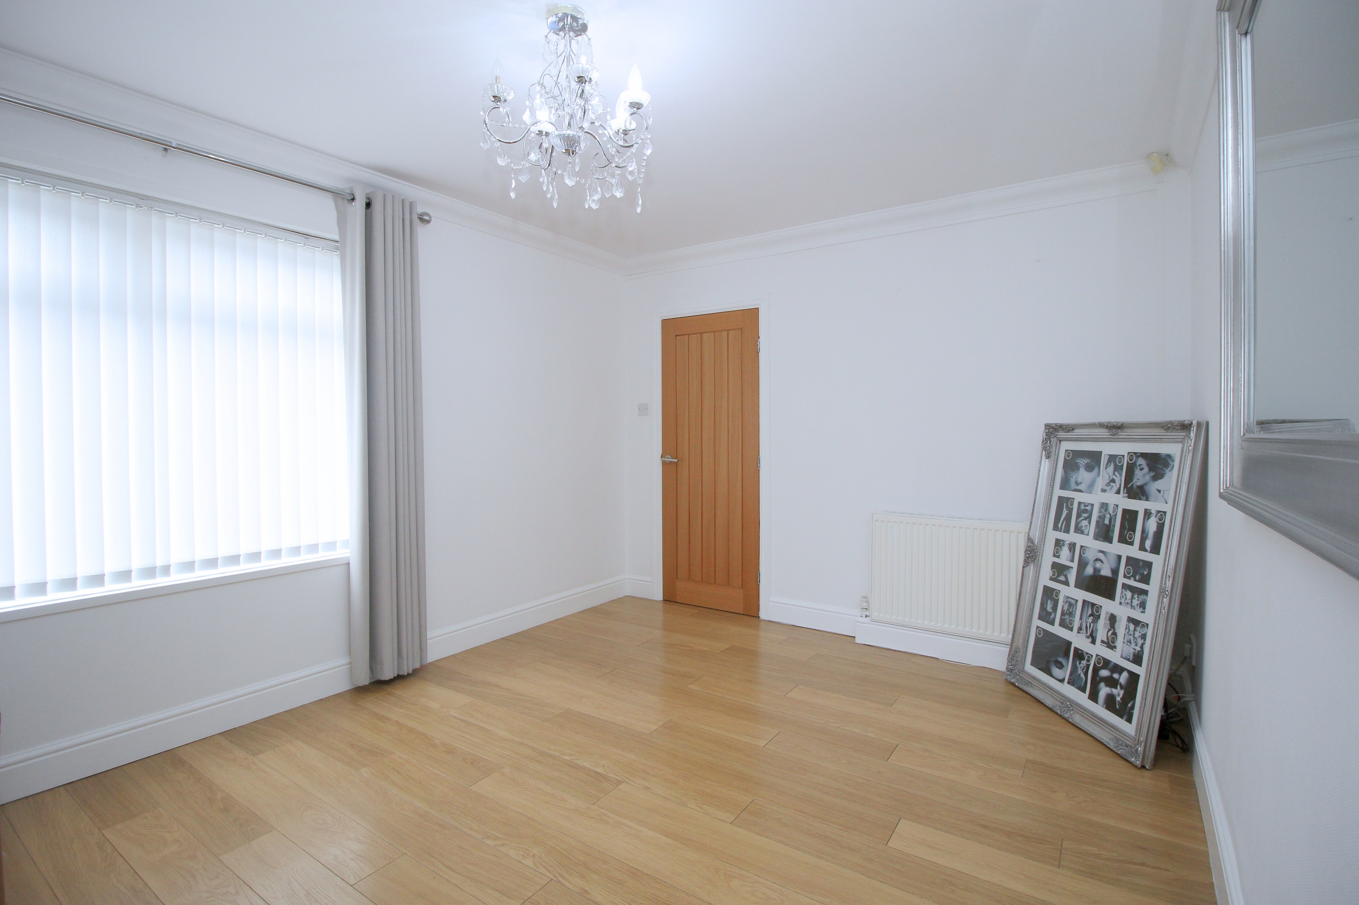
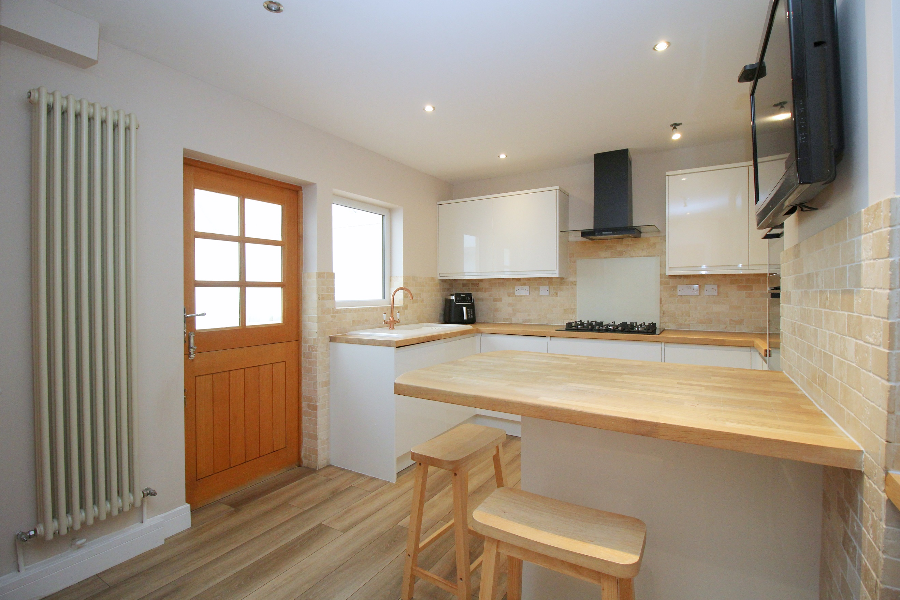
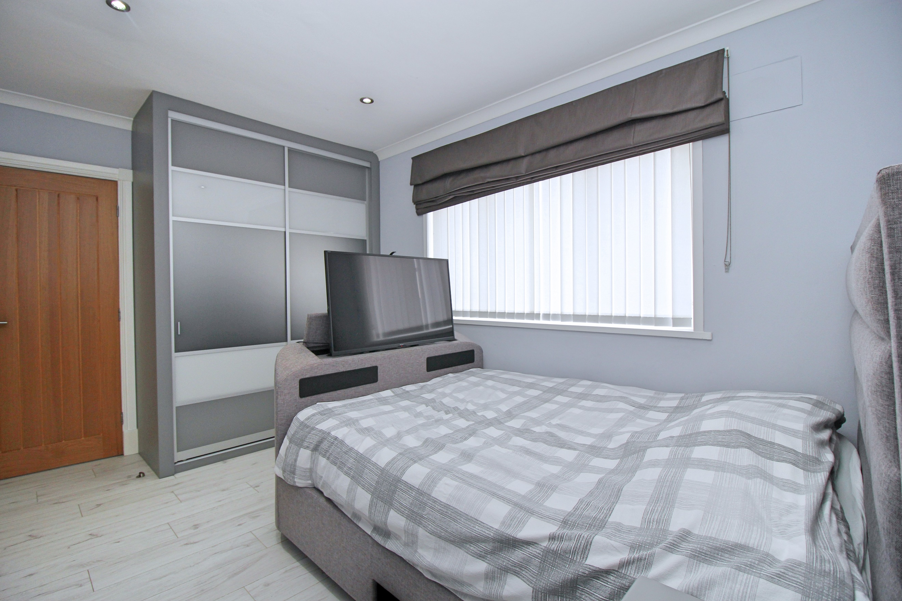
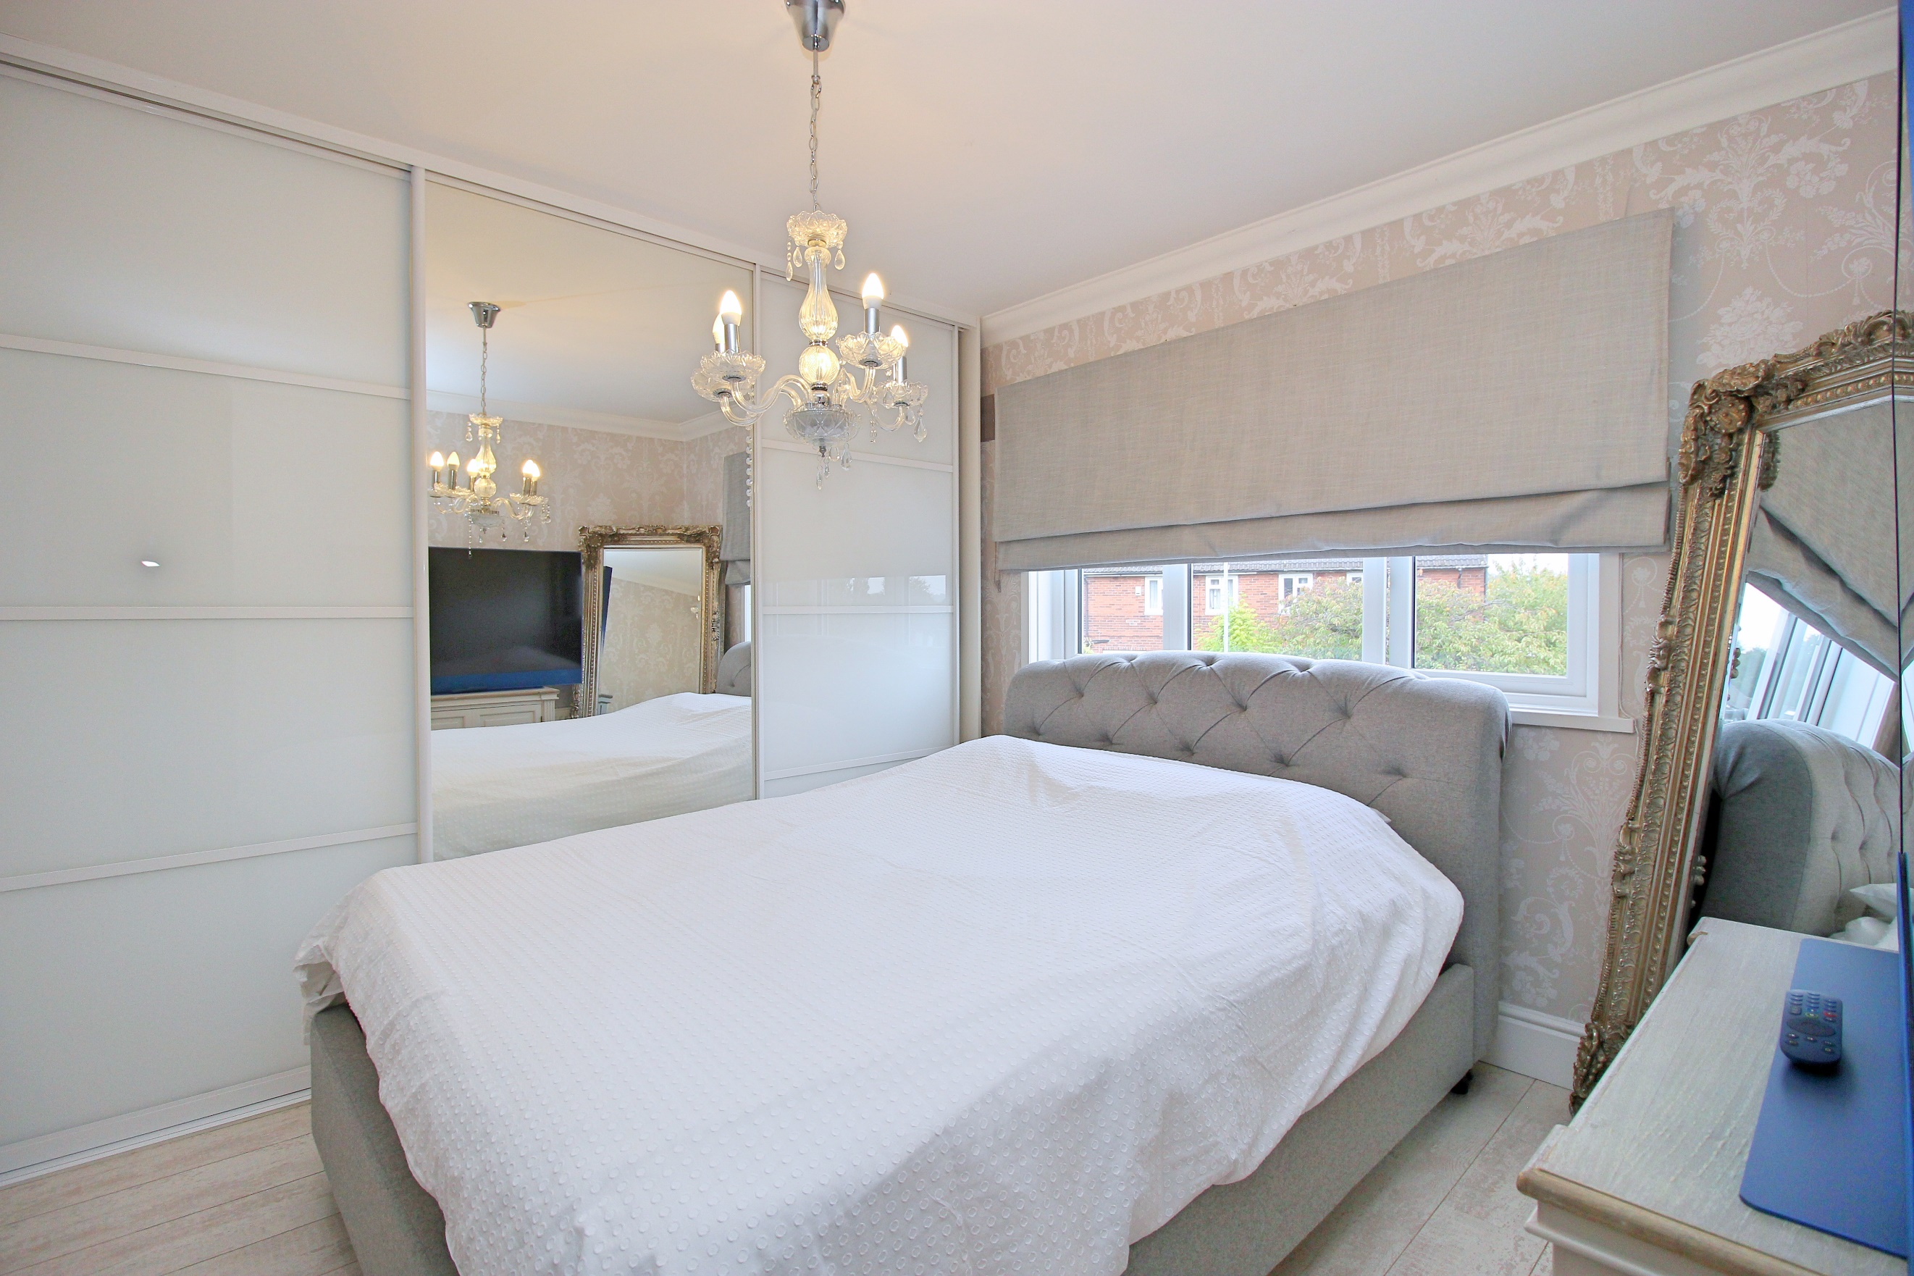

Entrance Hall
Via front entrance door. Gas central heating radiator. Stairs to first floor. Understairs storage cupboard.

Lounge 4.59m (15'1) x 3.2m (10'6)
Light and airy living room with uPVC double glazed window to front. Gas central heating radiator.

Kitchen 4.59m (15'1) x 3.22m (10'7)
Beautifully presented open plan kitchen/diner. Fitted with a range of wall, base and drawer units with worktops over. Integrated oven and grill. 5-ring gas hob with extractor hood over. Integrated fridge/freezer and washing machine. Integrated wine cooler. 1.5 bowl sink with mixer tap and drainer. Part tiled walls. Inset ceiling spotlights. uPVC double glazed windows. Tall gas central heating radiator. Two store cupboards.

Conservatory 3.85m (12'8) x 3.51m (11'6)
Great additional reception room with uPVC double glazed windows to three sides. uPVC double glazed double doors leading out to the rear garden.

Downstairs Shower Room
Convenient shower room to the ground floor comprising; shower, WC and wash hand basin.

First Floor
First floor landing with uPVC double glazed window to side.

Bedroom 1 3.59m (11'9) x 3.21m (10'6)
Double bedroom with uPVC double glazed window to front. Built in wardrobes. Gas central heating radiator.

Bedroom 2 4.08m (13'5) x 3.21m (10'6)
Second double bedroom with uPVC double glazed window to front. Built in wardrobes. Gas central heating radiator.

Bedroom 3 2.83m (9'3) x 2.3m (7'7)
Third bedroom with uPVC double glazed window to front. Built in wardrobes. Gas central heating radiator.

House Bathroom
Fitted with a three piece white suite comprising; bath, WC and wash hand basin. uPVC double glazed window.

Outside
To the front of the property is a block paved driveway offering off street parking for two vehicles. To the rear of the property is a well maintained, enclosed rear garden.

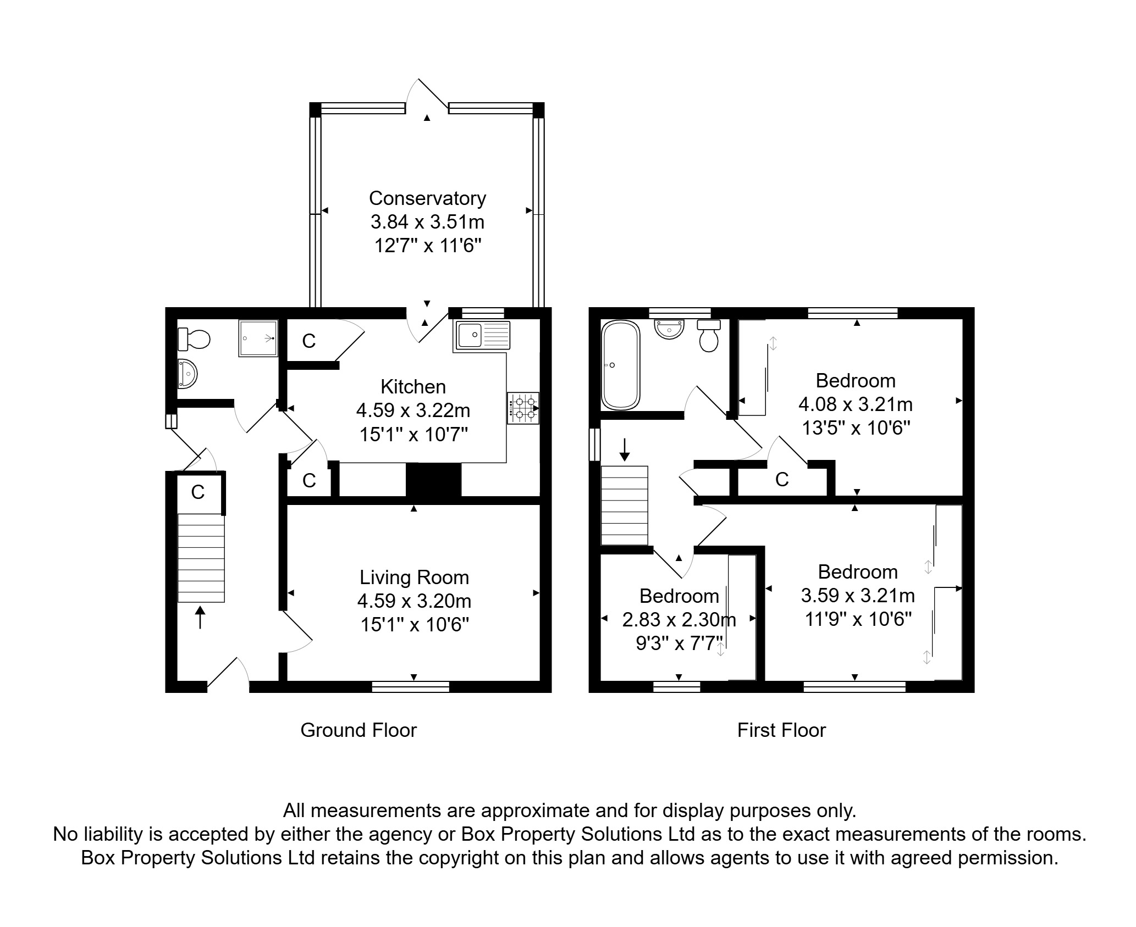

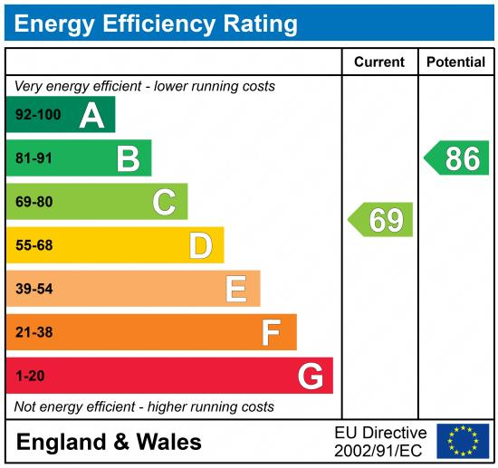

These particulars are intended to give a fair description of the property, but their accuracy cannot be guaranteed, and they do not constitute an offer of contract. Intending purchasers must rely on their own inspection of the property. None of the above appliances/services have been tested by ourselves. We recommend purchasers arrange for a qualified person to check all appliances/services before legal commitment.

Property Ref: 7784

For more information, please contact

0113 258 1150 | sales@adairpaxton.co.uk | www.adairpaxton.co.uk

