

**Holmefield House,, Headingley, LS6**

**Available to let £1,250.00pcm**

This stunning TWO BEDROOM cottage style mews is located just off North Hill Road, nestled away in the Headingley Hill Conservation area. Ideally situated between the vibrant hubs Hyde Park, this FURNISHED property is ideally for couple or sharers looking to be in a very convenient location. This property briefly compromises of large hallway, Kitchen, bathroom, living room and two double bedrooms to the first floor. Available now, deposit £1440. Council tax band C, EPC rating C

**0113 258 1150**

**0800 000 000**

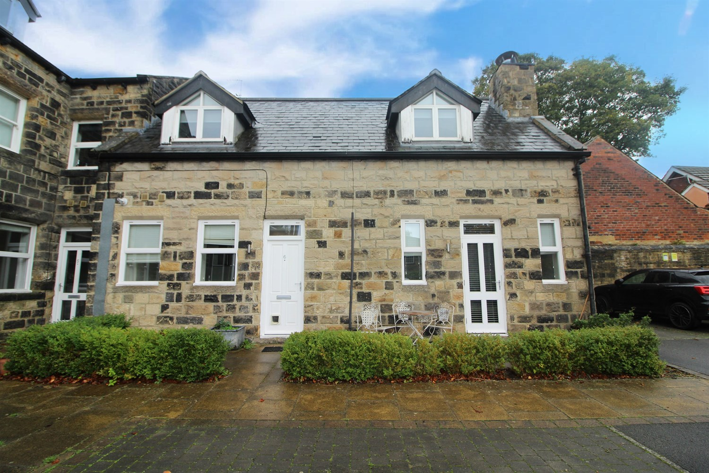

.

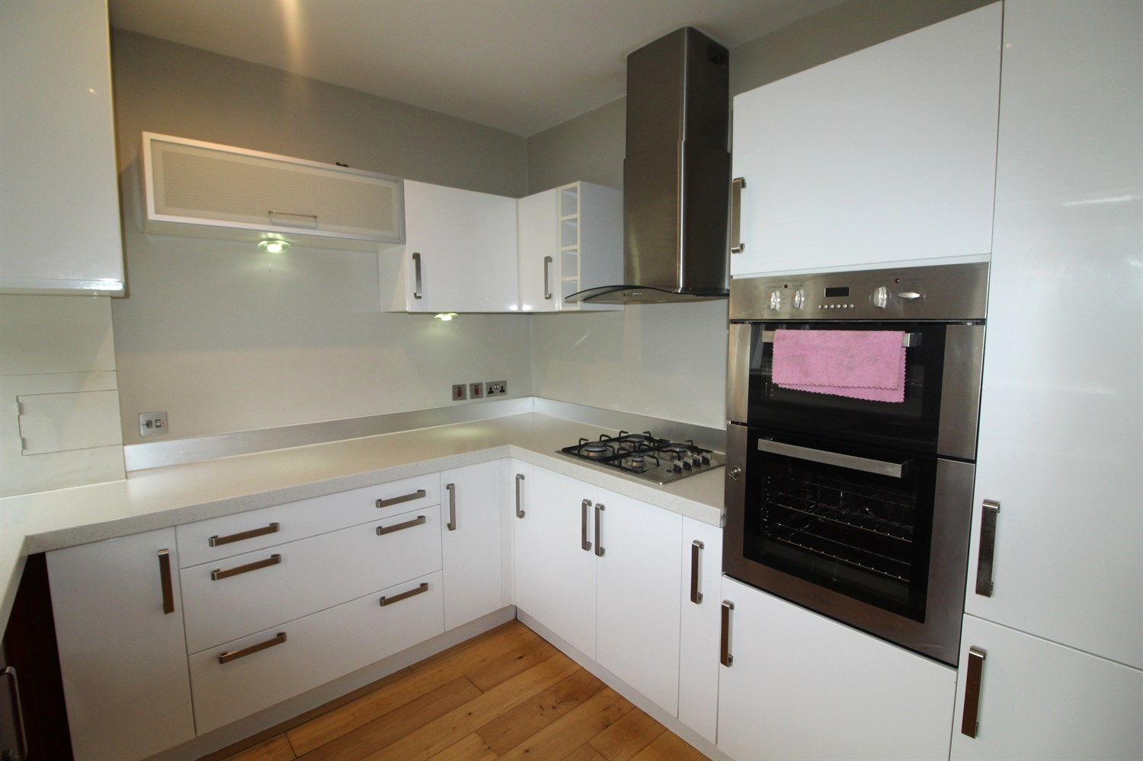

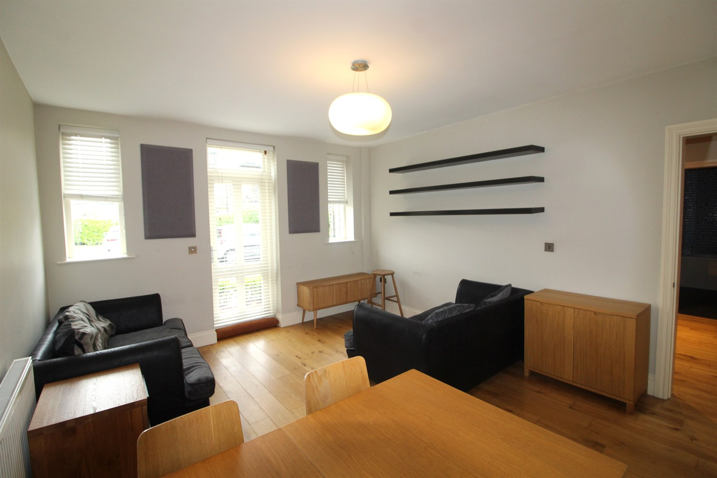

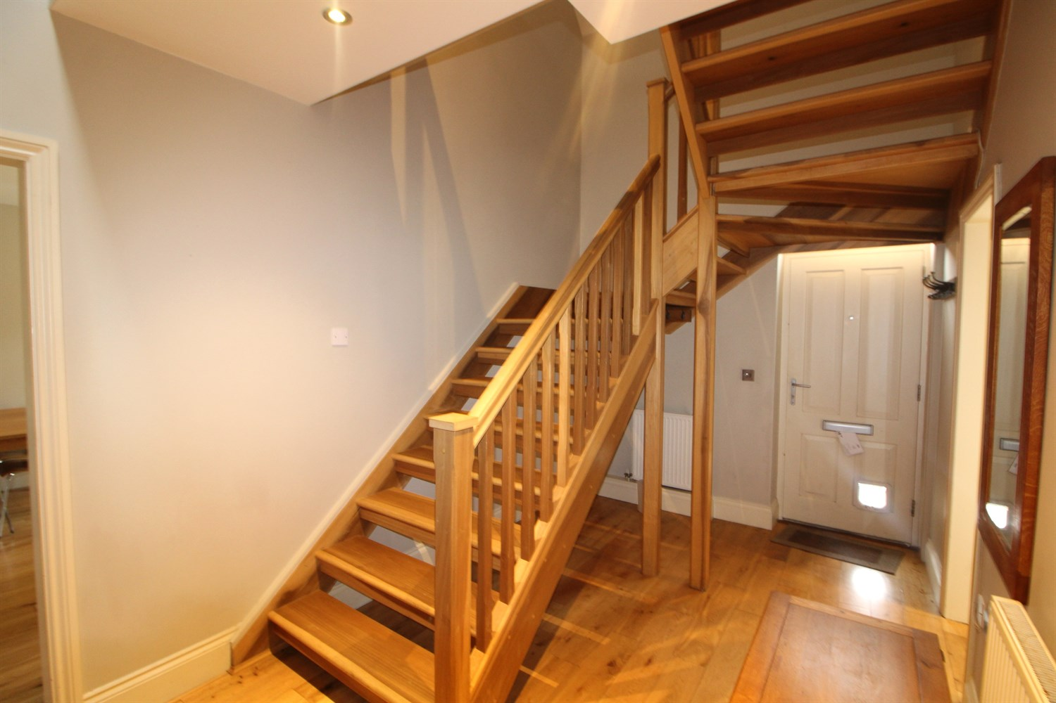

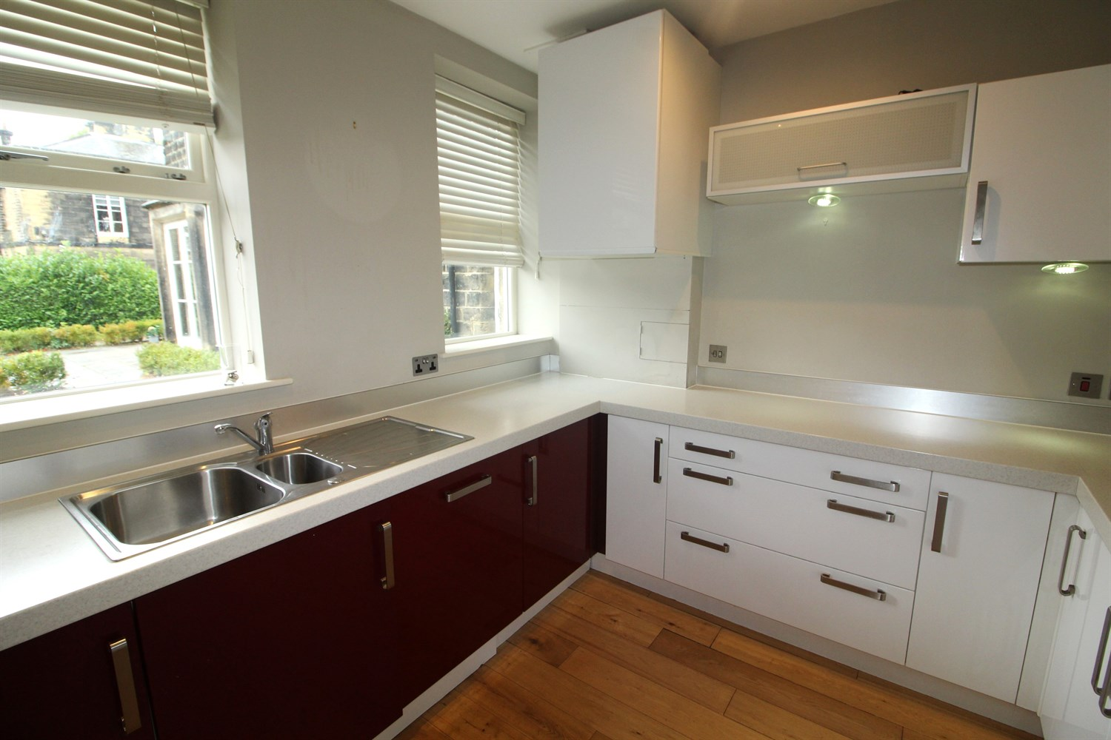

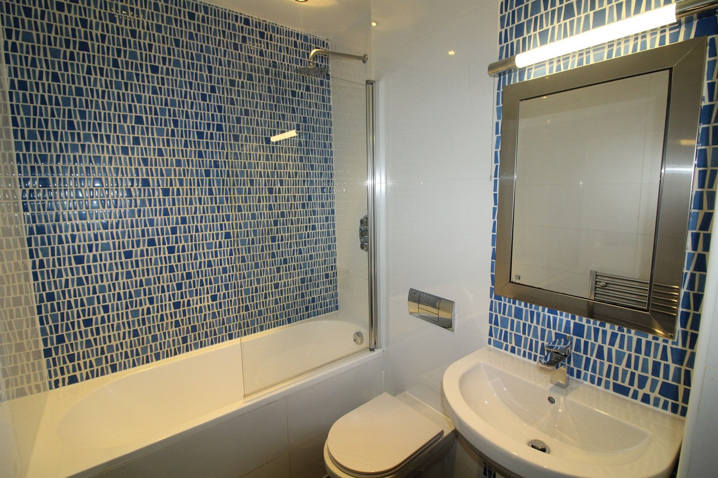

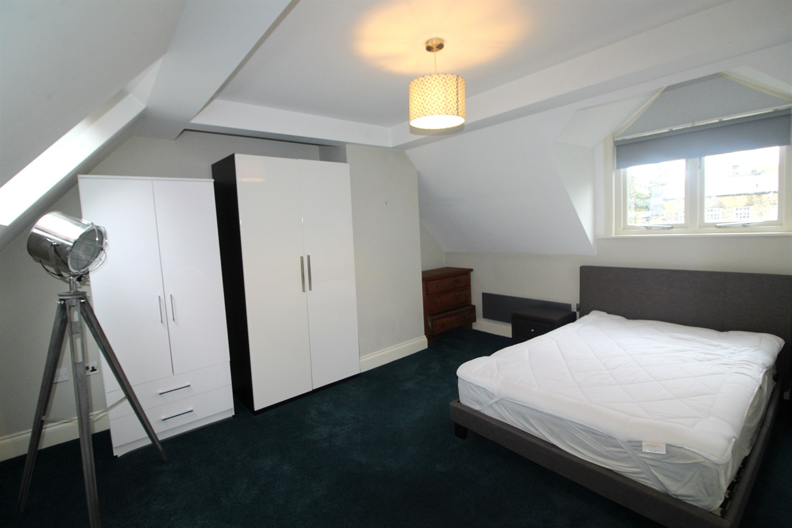

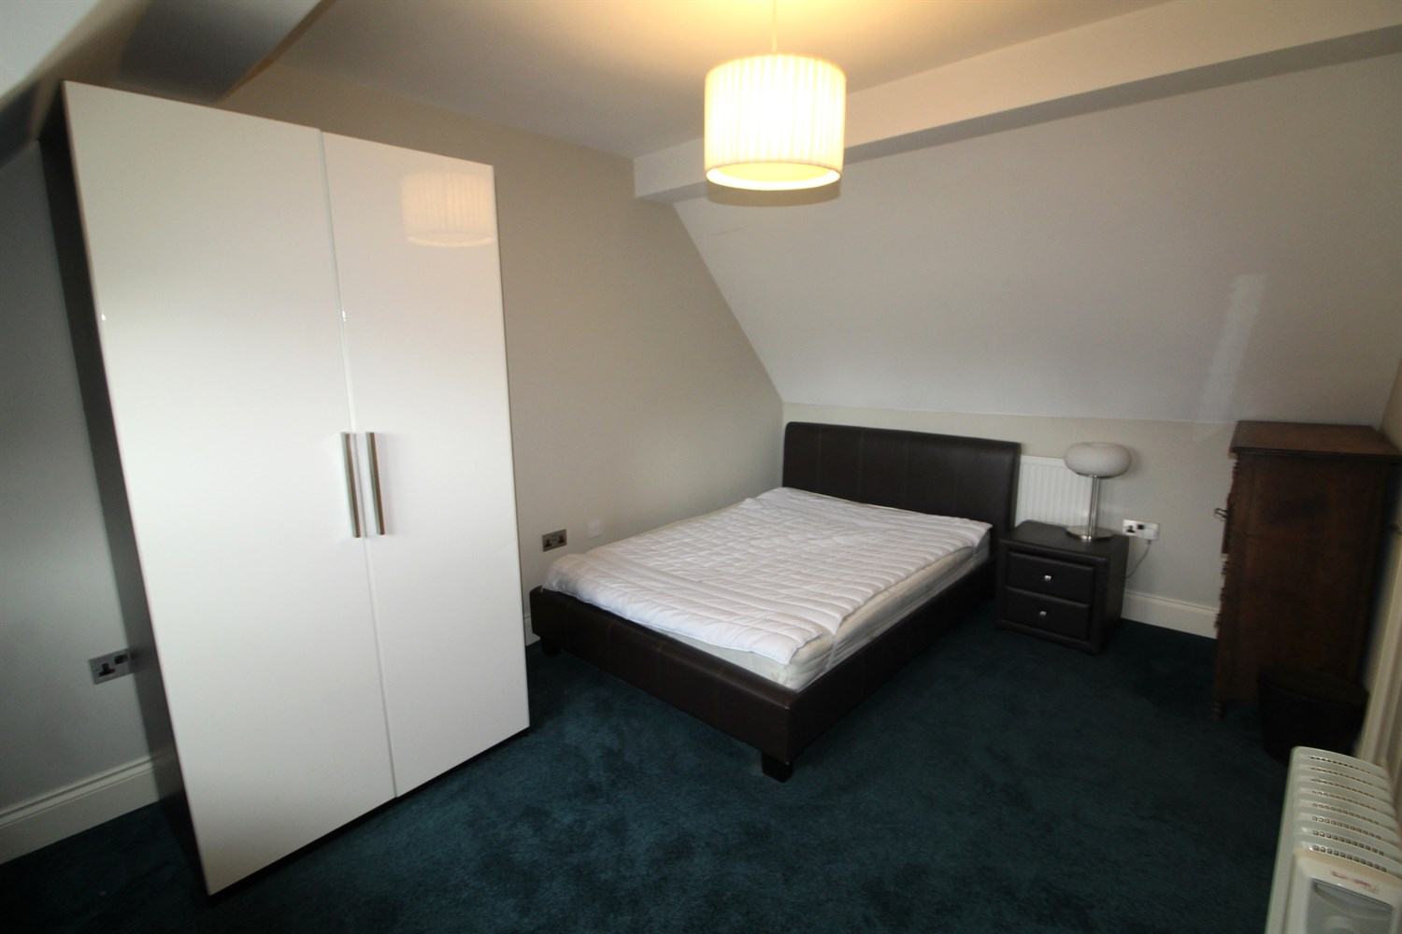

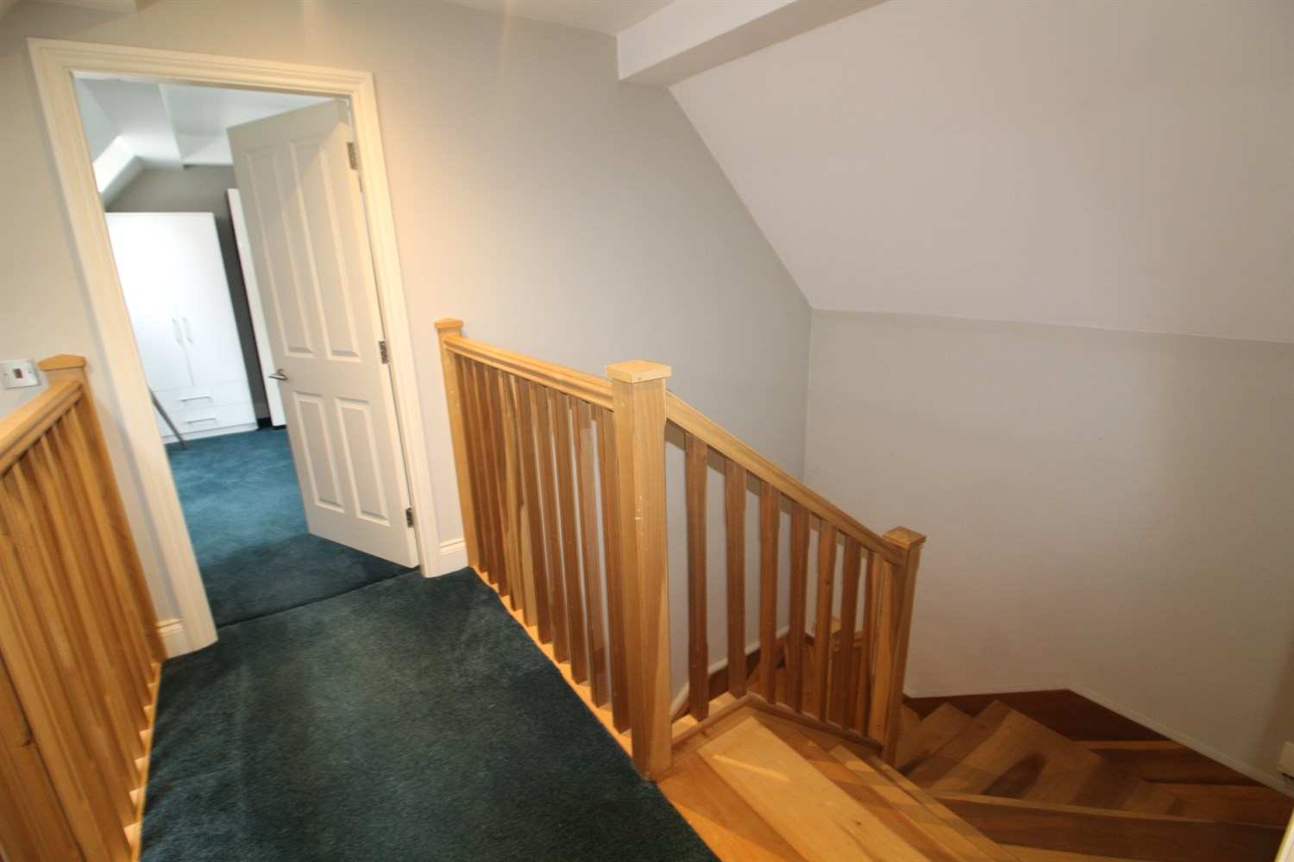

|  |
| --- |
| **Entrance Hall**  Large hallway with space under stairs. |
| **Living Room 4.63m (15'2) x 3.86m (12'8)**  Spacious lounge with windows to front and door leading to patio area. Gas central heating radiator. |
| **Kitchen 2.93m (9'7) x 2.81m (9'3)**  Fitted with a range of wall and base units integrated fridge freezer, stainless steel sink, wind ow to front. |
| **Bathroom 4.58m (15'0) x 2.95m (9'8)**  Three piece bathroom suite with shower over bath, w/c and hand wash basin, part tiled walls. Cupboard housing washing machine. |
| **Bedroom 1 4.64m (15'3) x 3.85m (12'8)**  Carpeted double bedroom with Velux window. Gas central heating radiator. |
| **Bedroom 2**  Carpeted double bedroom with Velux window. Gas central heating radiator. |
| **Home Information**  COUNCIL TAX BAND: C EPC Rating C  Leasehold property Parking  Broadband:  Standard 15 Mbps 1 Mbps Good Superfast 51 Mbps 8 Mbps Good Ultrafast 1800 Mbps 1000 Mbps Mobile availability: EE Limited coverage. Three limited coverage O2 Likely Likely to have good coverage Vodafone Limited coverage.  Utilities: Water supplied on standard meters. Gas and Electric mains supplied on standard meters. |

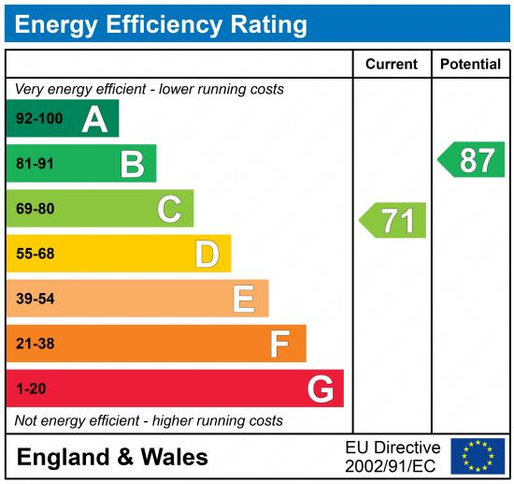

|  |
| --- |
|  |

These particulars are intended to give a fair description of the property, but their accuracy cannot be guaranteed, and they do not constitute an offer of contract. Intending purchasers must rely on their own inspection of the property. None of the above appliances/services have been tested by ourselves. We recommend purchasers arrange for a qualified person to check all appliances/services before legal commitment.

**Property Ref:** 7858

**For more information, please contact**

0113 258 1150 **|** [lettings@adairpaxton.co.uk](mailto:lettings@adairpaxton.co.uk) **|** www.adairpaxton.co.uk