

**Landseer Drive, Bramley**

**Available to let £750.00pcm**

Located in the highly sought-after area of Bramley, this charming first-floor flat is now available for immediate occupancy. Perfect for singles or couples, the property boasts a spacious layout that offers comfort and functionality.  
The flat comes unfurnished, providing a blank canvas for you to make it your own. This property briefly compromises of own entrance, living room, kitchen and bedroom. unfurnished. Available now, Council tax band A, EPC rating C. Deposit £865.

**0113 258 1150**

**0800 000 000**

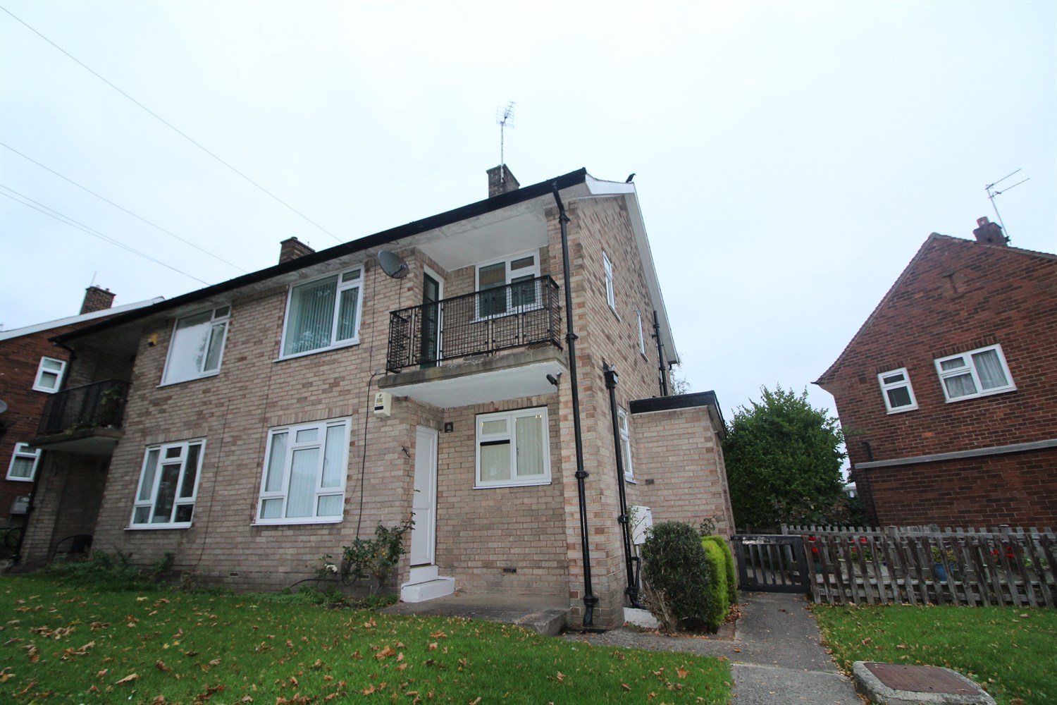

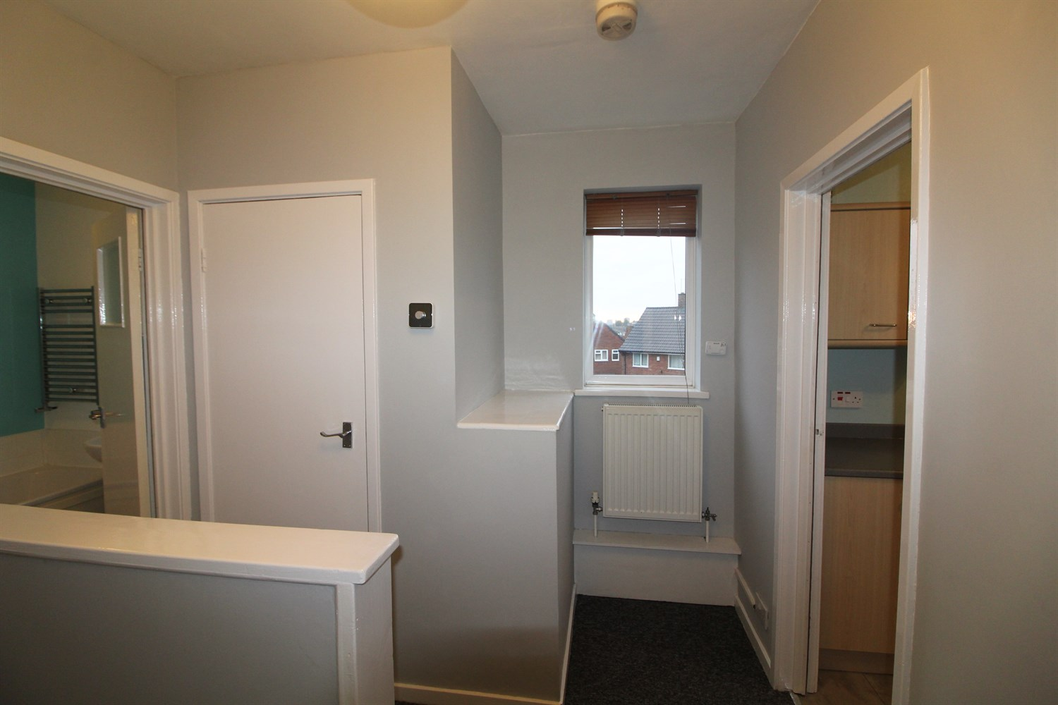

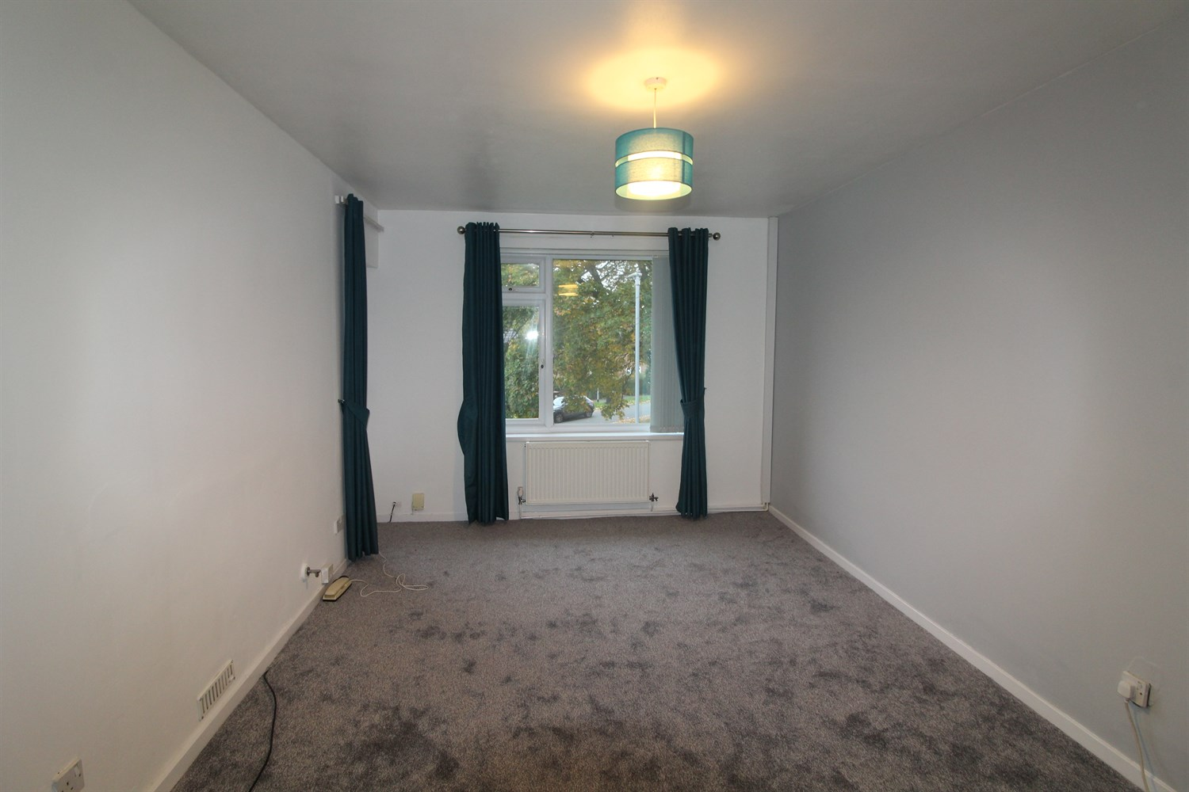

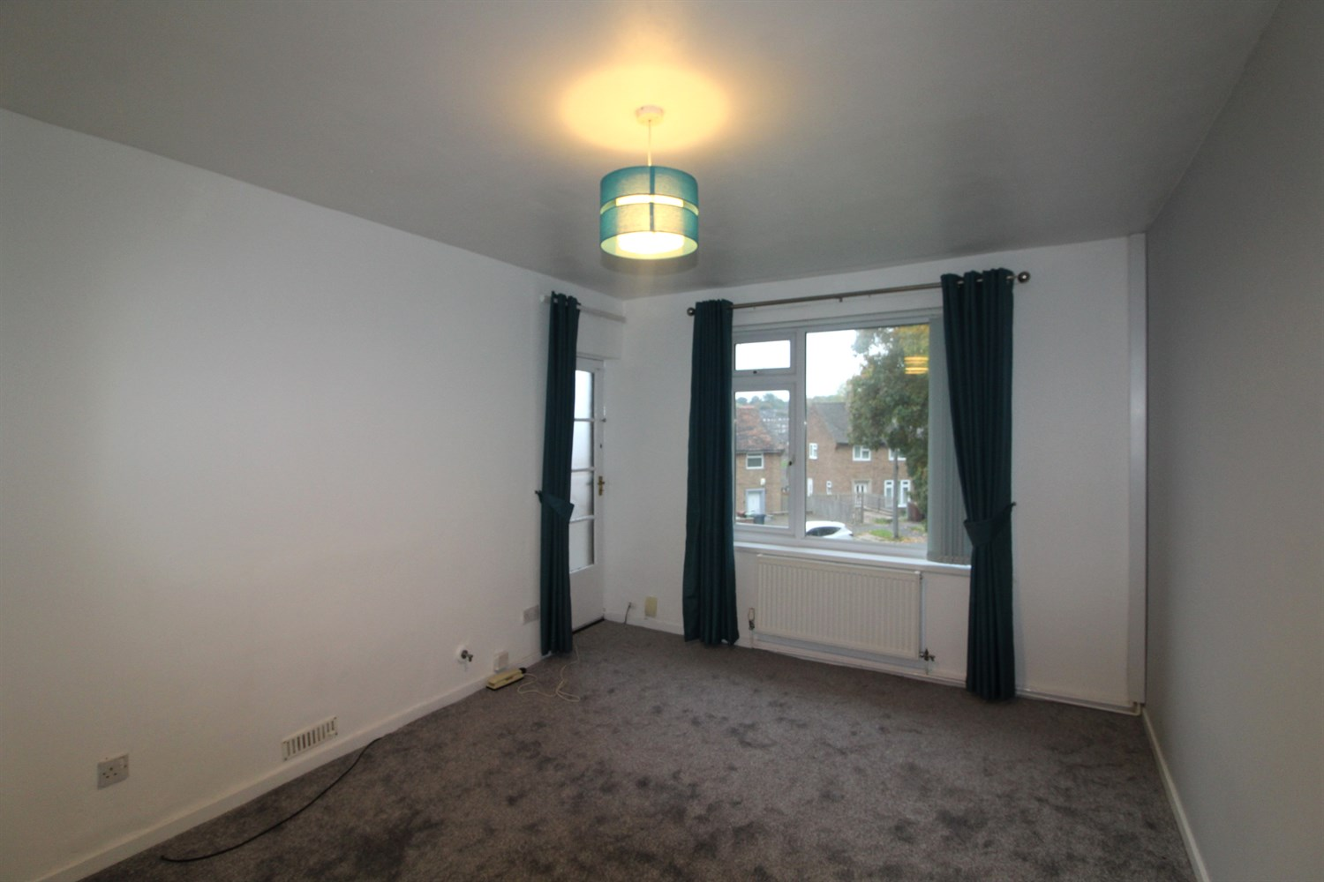

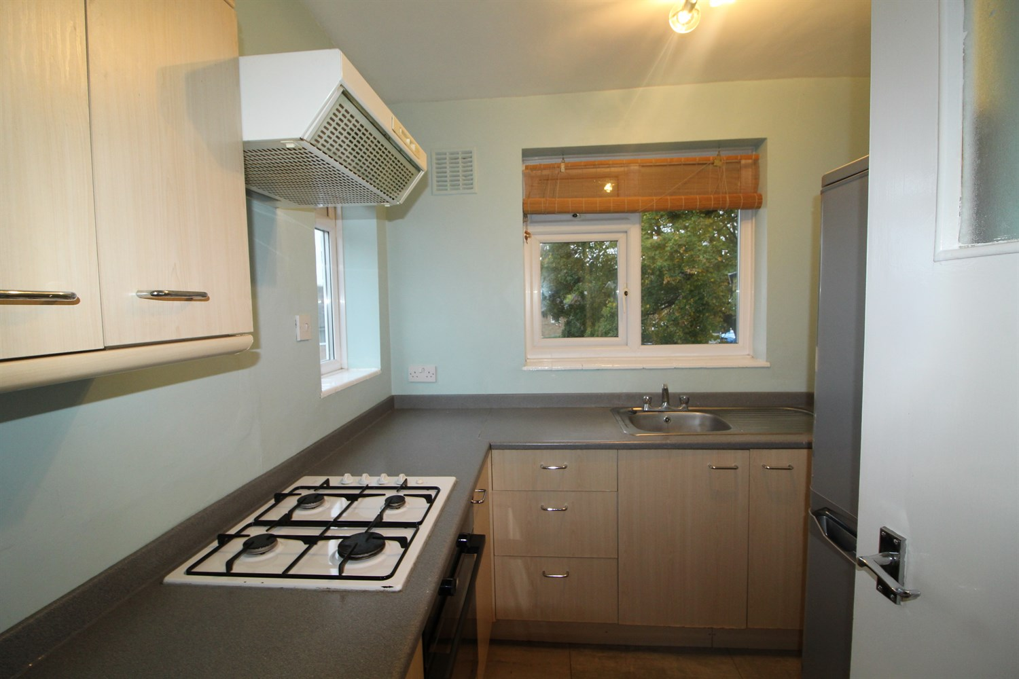

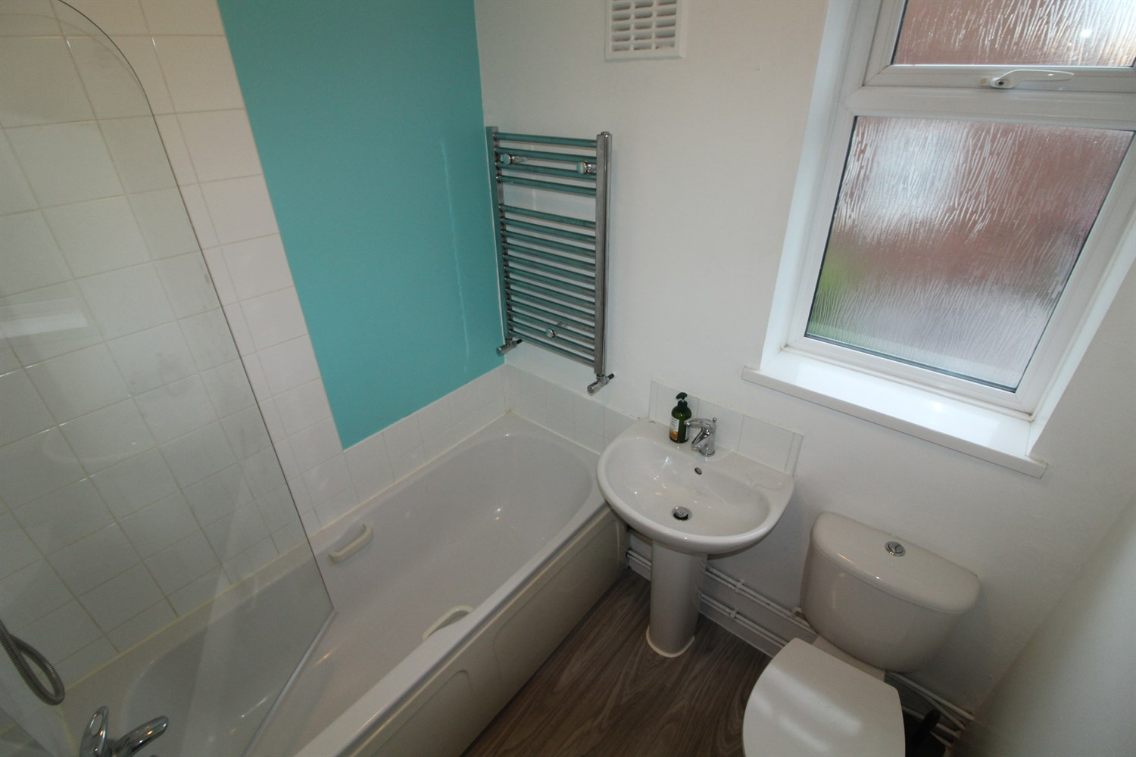

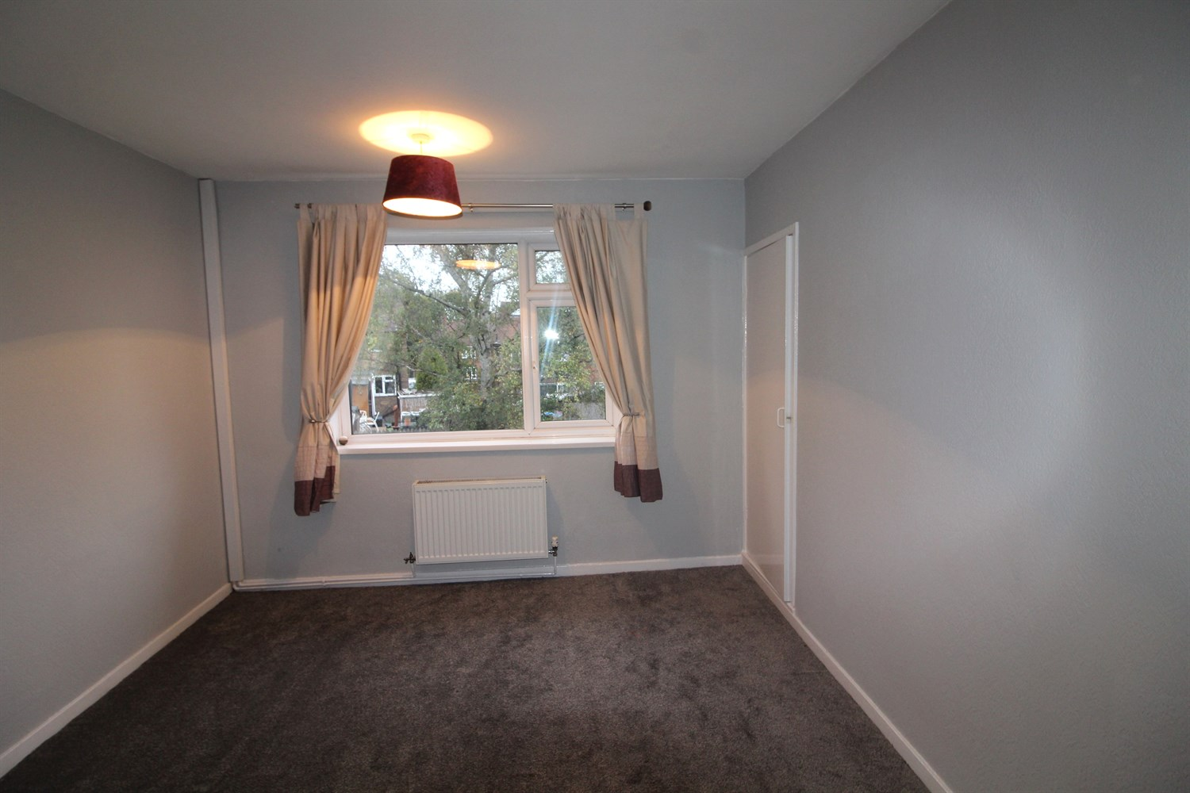

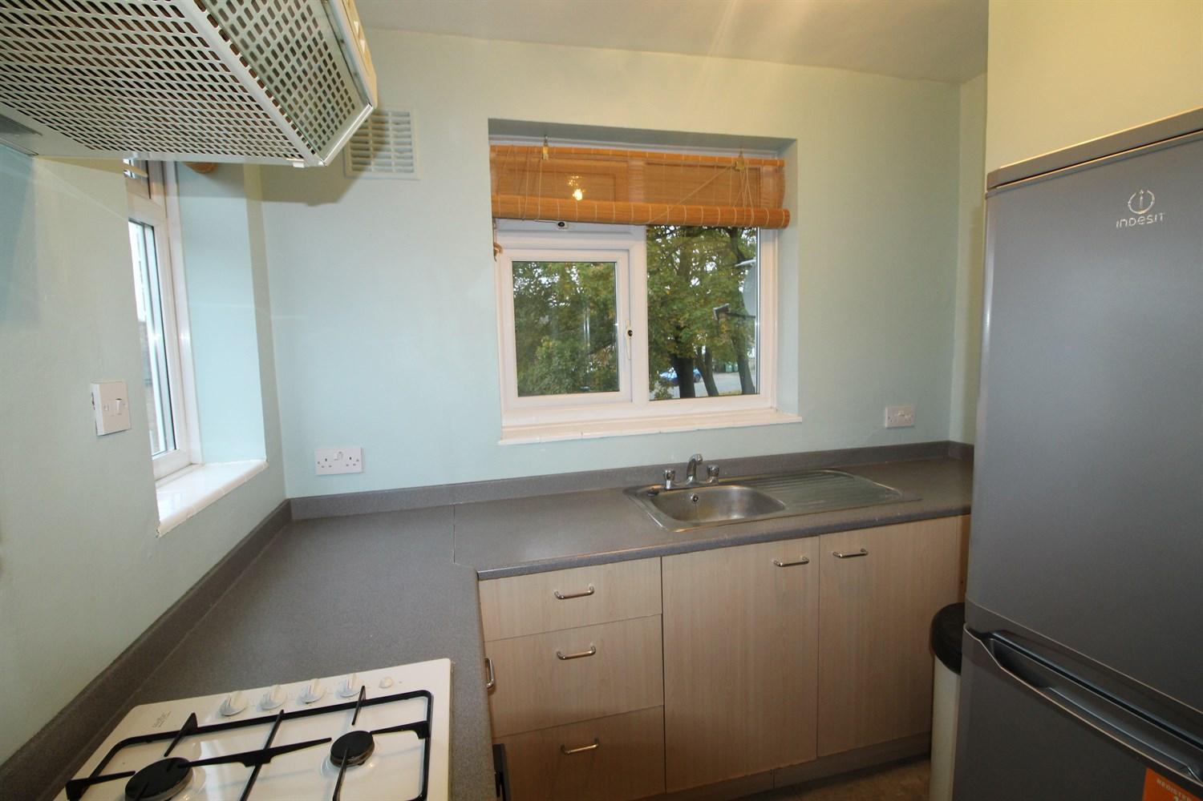

|  |
| --- |
| **Reception 1**  Spacious lounge with window to front and access to balcony. New carpets. Gas central heating. |
| **Kitchen**  Fitted with a range of wall and base units with worktops over, stainless steel sink with mixer tap, part tiled. Window to front. |
| **Bedroom 1**  Double bedroom with window to rear, built in wardrobe, gas central heating radiator. |
| **Bathroom**  Three piece bathroom suite with shower over bath, w/c and hand wash basin, part tiled. Window to side. |
| **Small Garden**  Small garden fenced off at rear. |
| **Parking**  On street parking. |
| **Home Information**  COUNCIL TAX BAND: A EPC Rating C  Leasehold property Street parking.  Broadband:Standard 5 Mbps 0.7 Mbps Good Superfast 80 Mbps 20 Mbps Good Ultrafast 1800 Mbps 1000 Mbps   Mobile availability: EE likely to have good coverage. Three Likely to have good coverage. O2 likely to have good coverage. Vodafone likely to have good coverage.  Utilities: Water supplied on standard meters. Gas and Electric mains supplied on standard meters. |

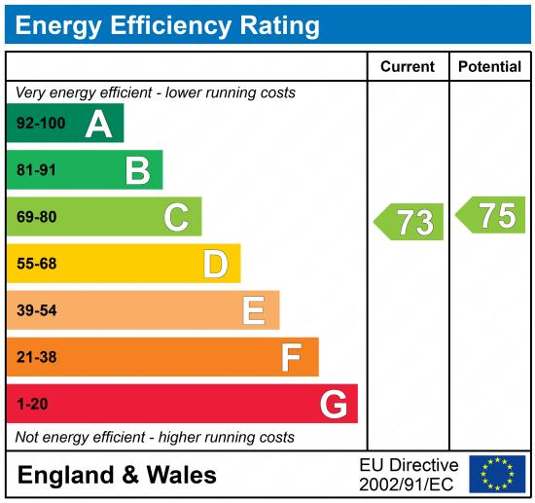

|  |
| --- |
|  |

These particulars are intended to give a fair description of the property, but their accuracy cannot be guaranteed, and they do not constitute an offer of contract. Intending purchasers must rely on their own inspection of the property. None of the above appliances/services have been tested by ourselves. We recommend purchasers arrange for a qualified person to check all appliances/services before legal commitment.

**Property Ref:** 7838

**For more information, please contact**

0113 258 1150 **|** [lettings@adairpaxton.co.uk](mailto:lettings@adairpaxton.co.uk) **|** www.adairpaxton.co.uk