
The Highlands, Harrogate Road, Alwoodley
For Sale £269,950.00

**FABULOUS TWO BEDROOM, TWO BATHROOM, SECOND FLOOR APARTMENT - SOUTH FACING - IDEAL LIVING FOR OVER 50's - NO ONWARD CHAIN** This delightful apartment simply must be viewed to be appreciated. This two bedroom top floor apartment sits within one of the most prestigious gated apartment complexes in this most desirable & exclusive part of North Leeds. Offering spacious accommodation throughout and benefitting from high ceilings, an updated fitted kitchen and recently renovated en-suite shower room, the apartment briefly comprises; Communal entrance with communal sitting areas, lift to all floors, private entrance hall with large store cupboard, Light and airy sitting room with dining area leading out to a private balcony, modern fitted kitchen, master bedroom with brand new en-suite shower room, second double bedroom and house shower room. Externally, the development offers well maintained gardens and a secure parking space. This property is located within Alwoodley - a highly regarded suburb within North Leeds which really does not get much better. Offering excellent access links into the City centre and surrounding regions, Harrogate, Ilkley Wetherby etc. Extensive shopping and leisure facilities are on hand within a short drive, including fabulous amenities at Moortown Corner, Moor Allerton complex, Street Lane, and Chapel Allerton.
0113 258 1150
0800 000 000
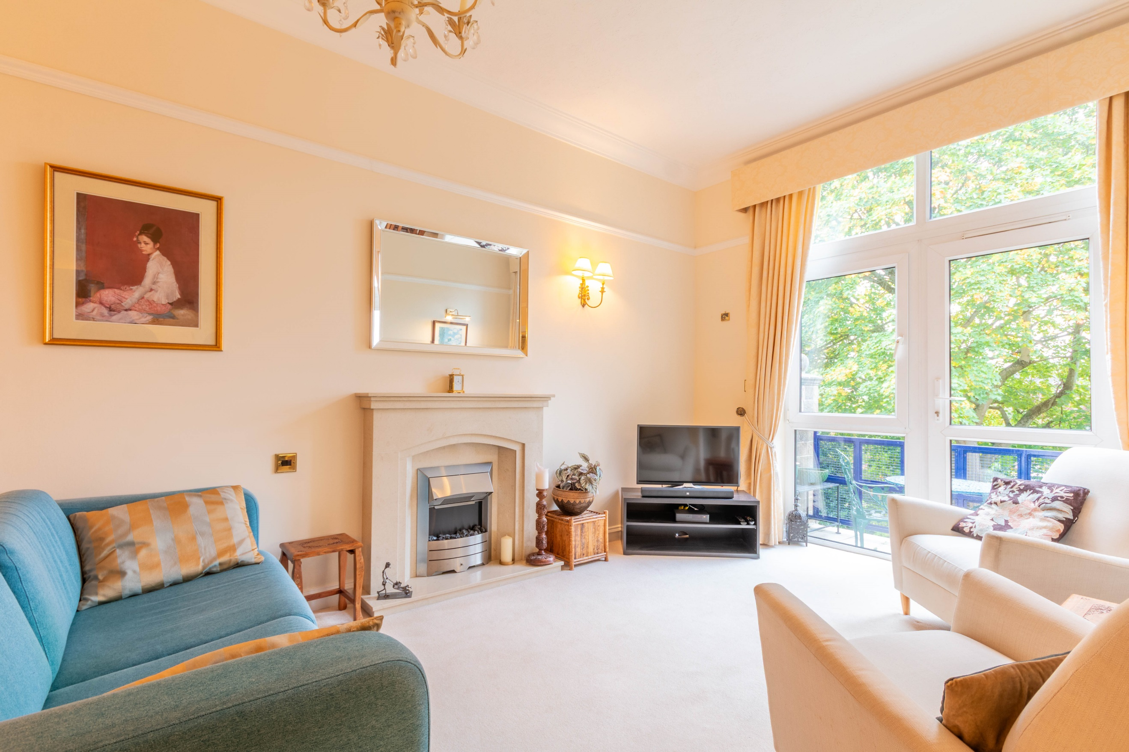
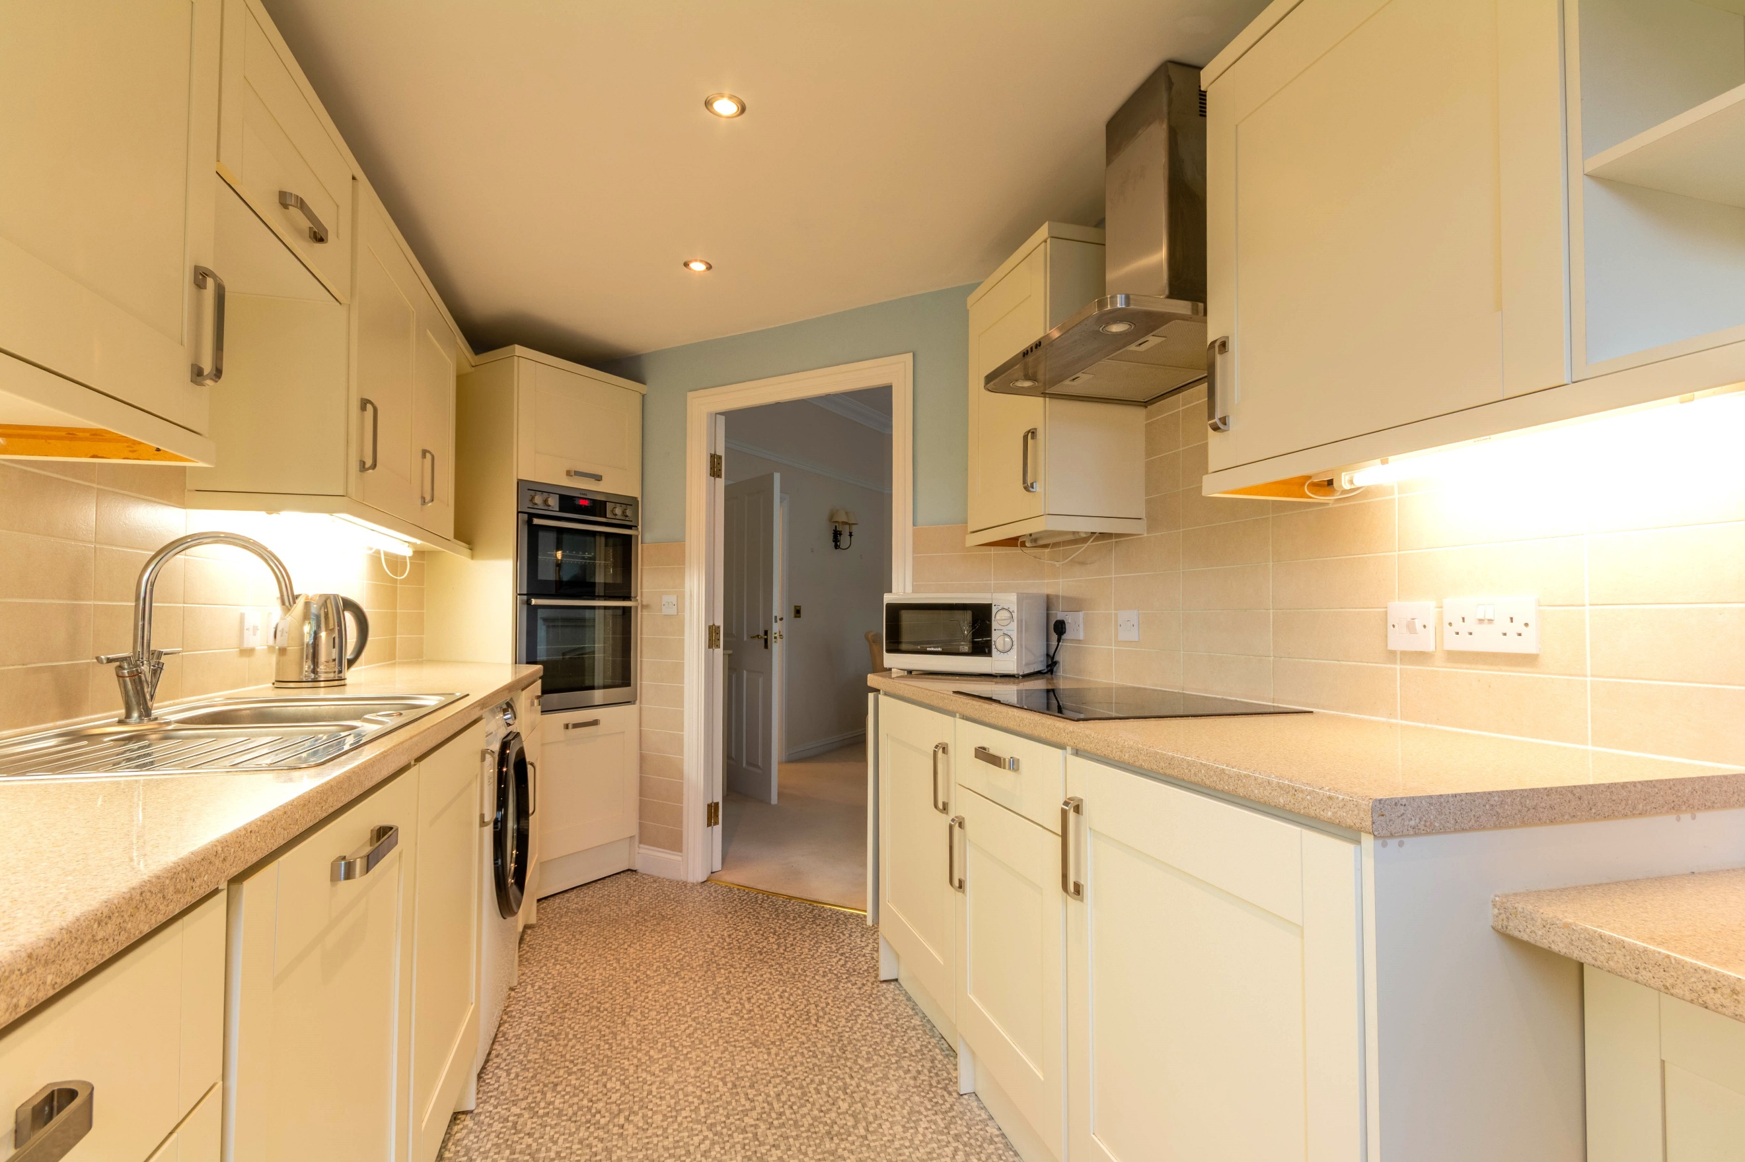
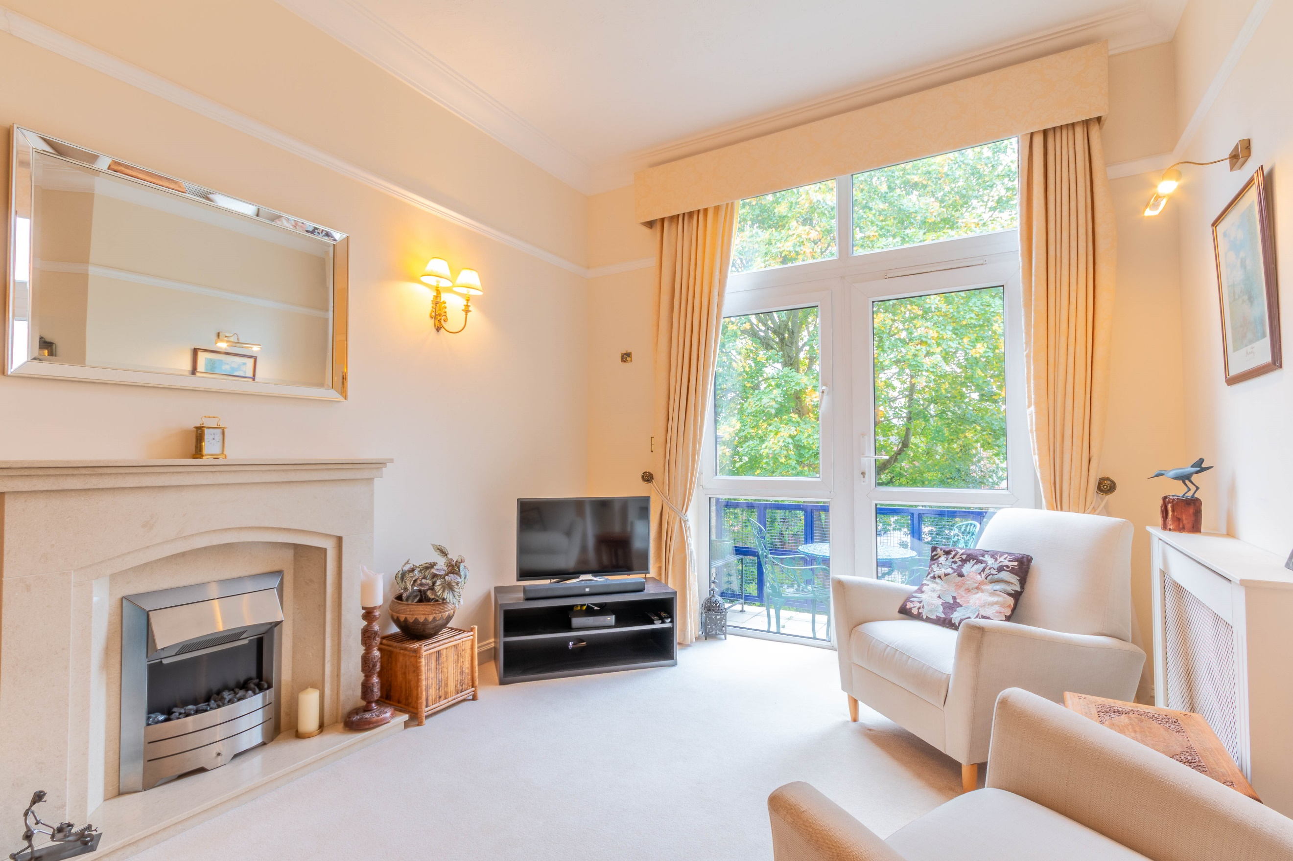
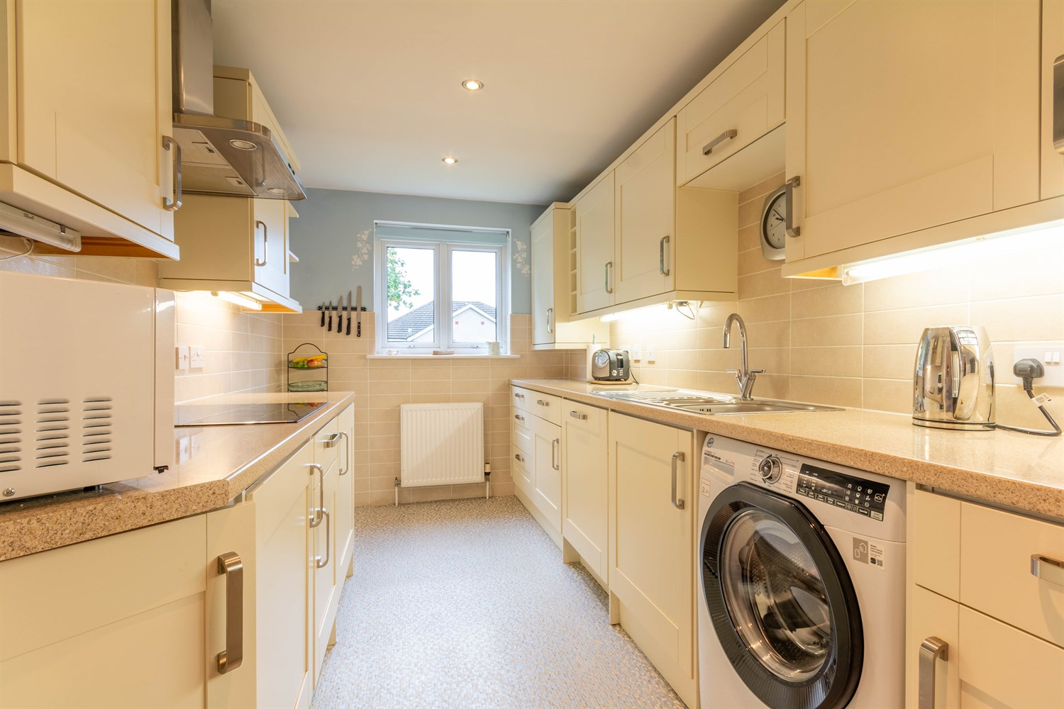
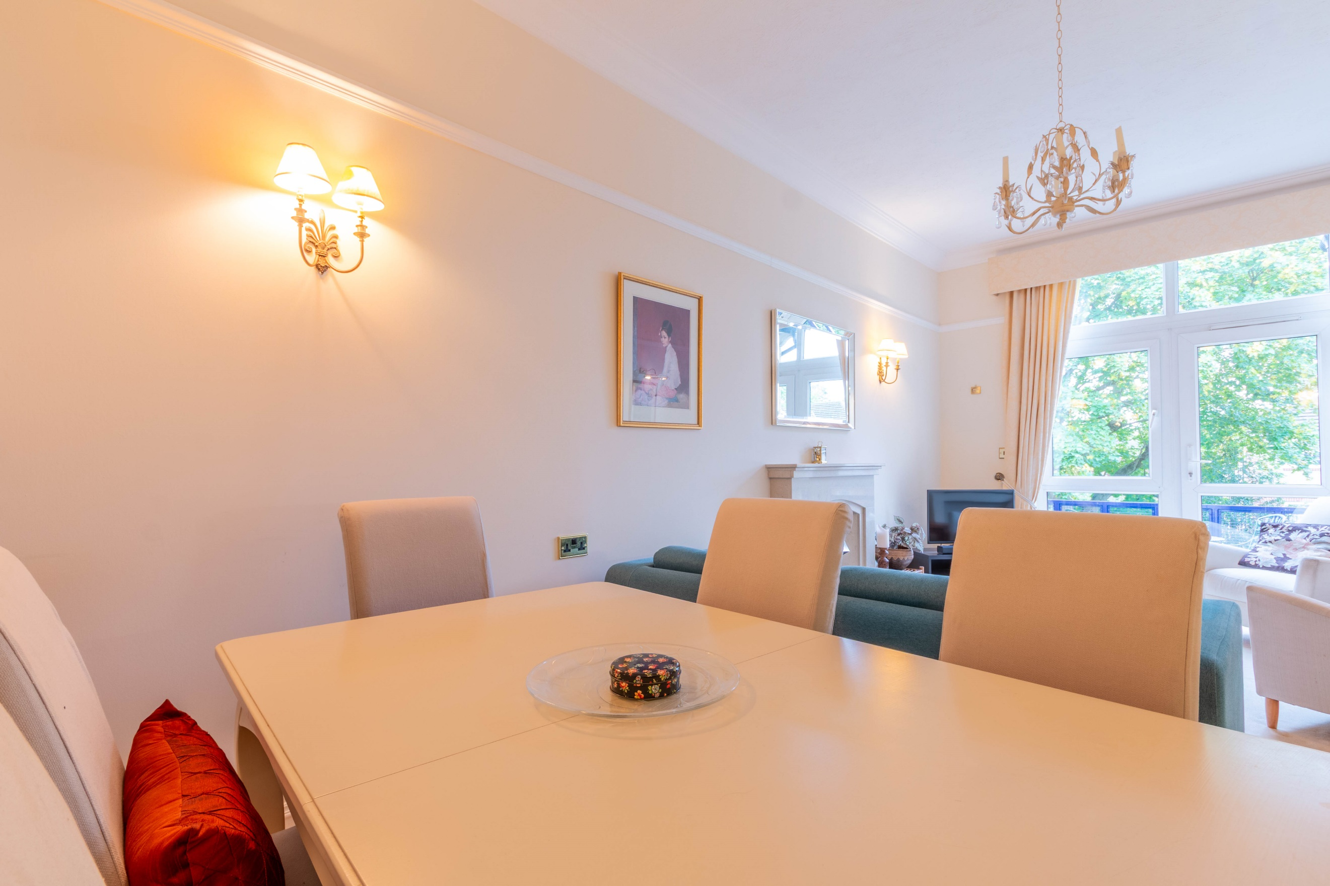
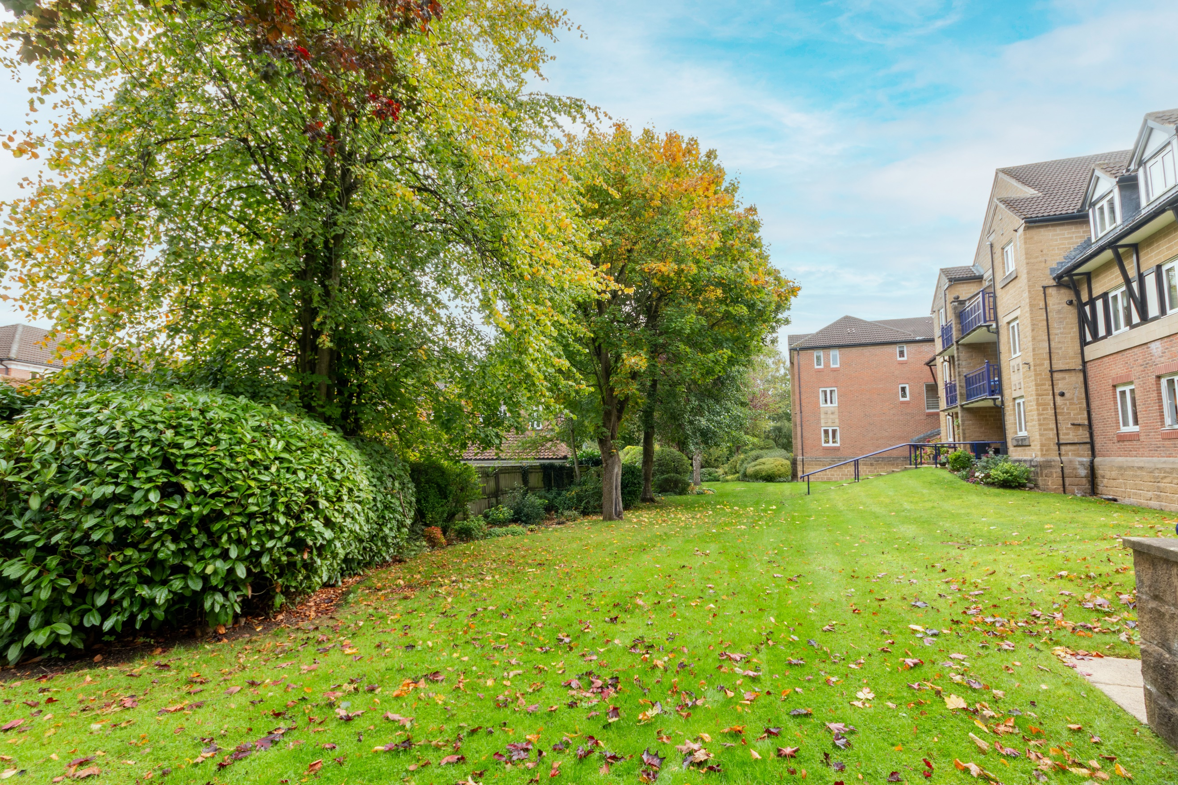
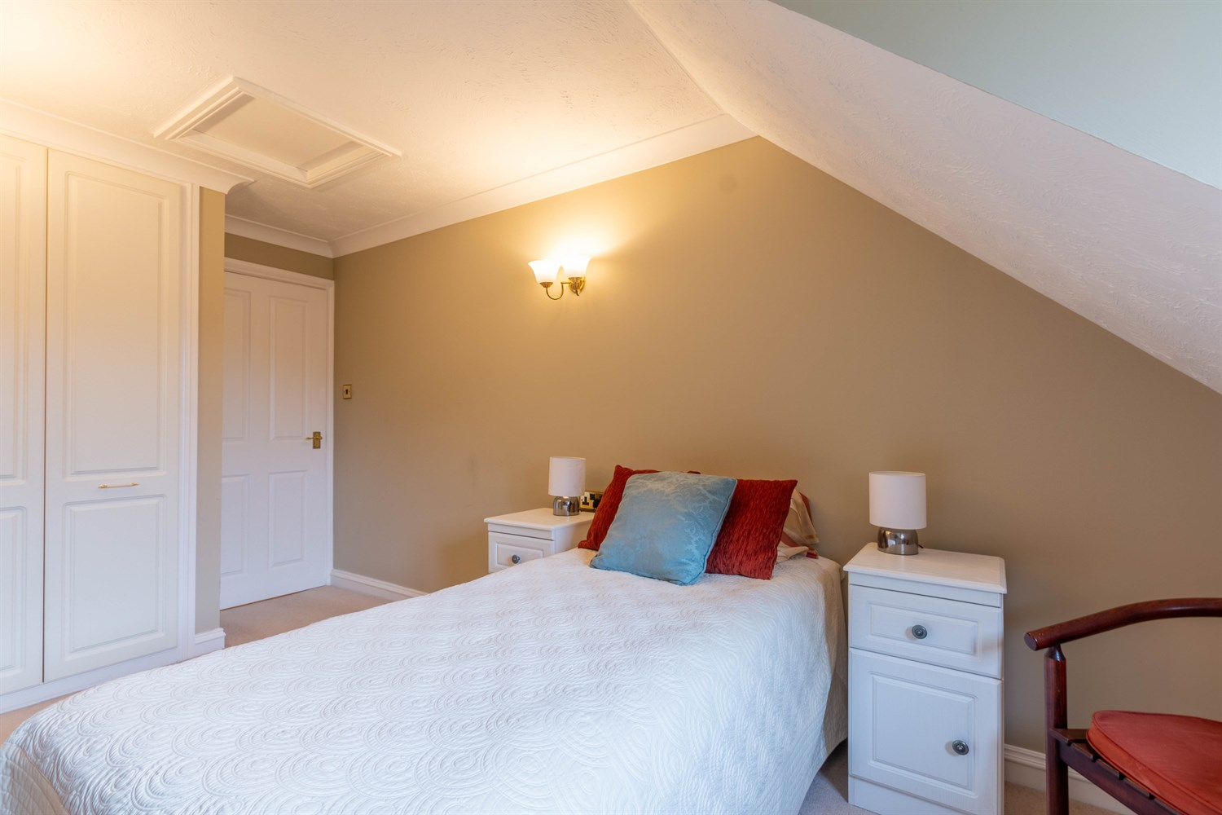
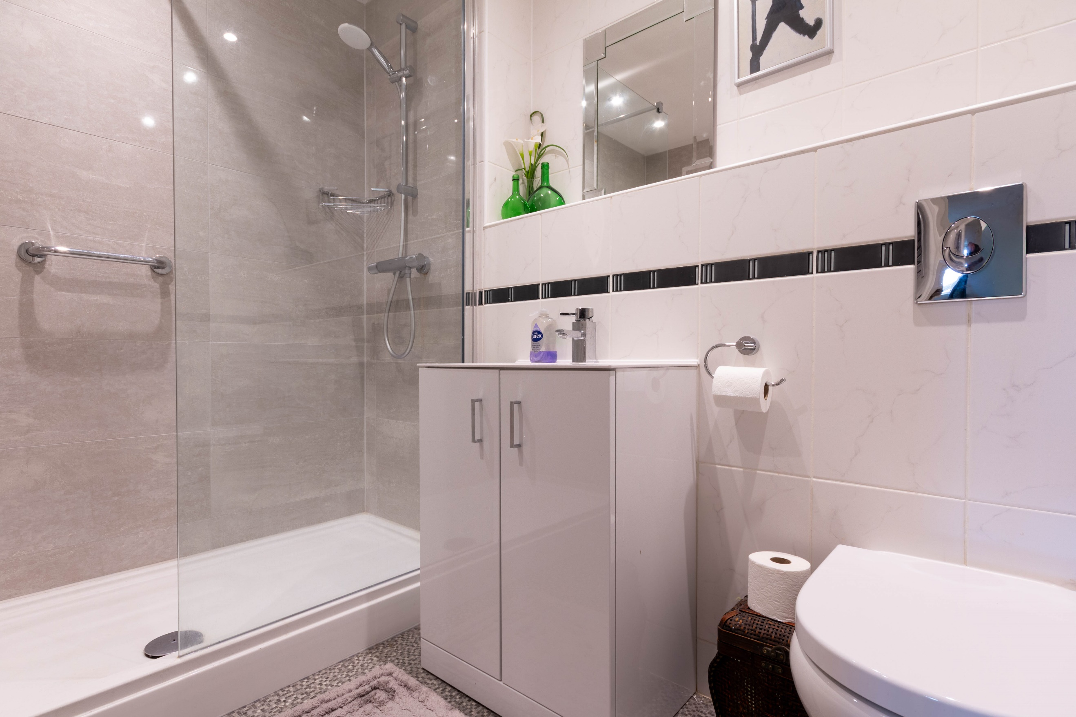
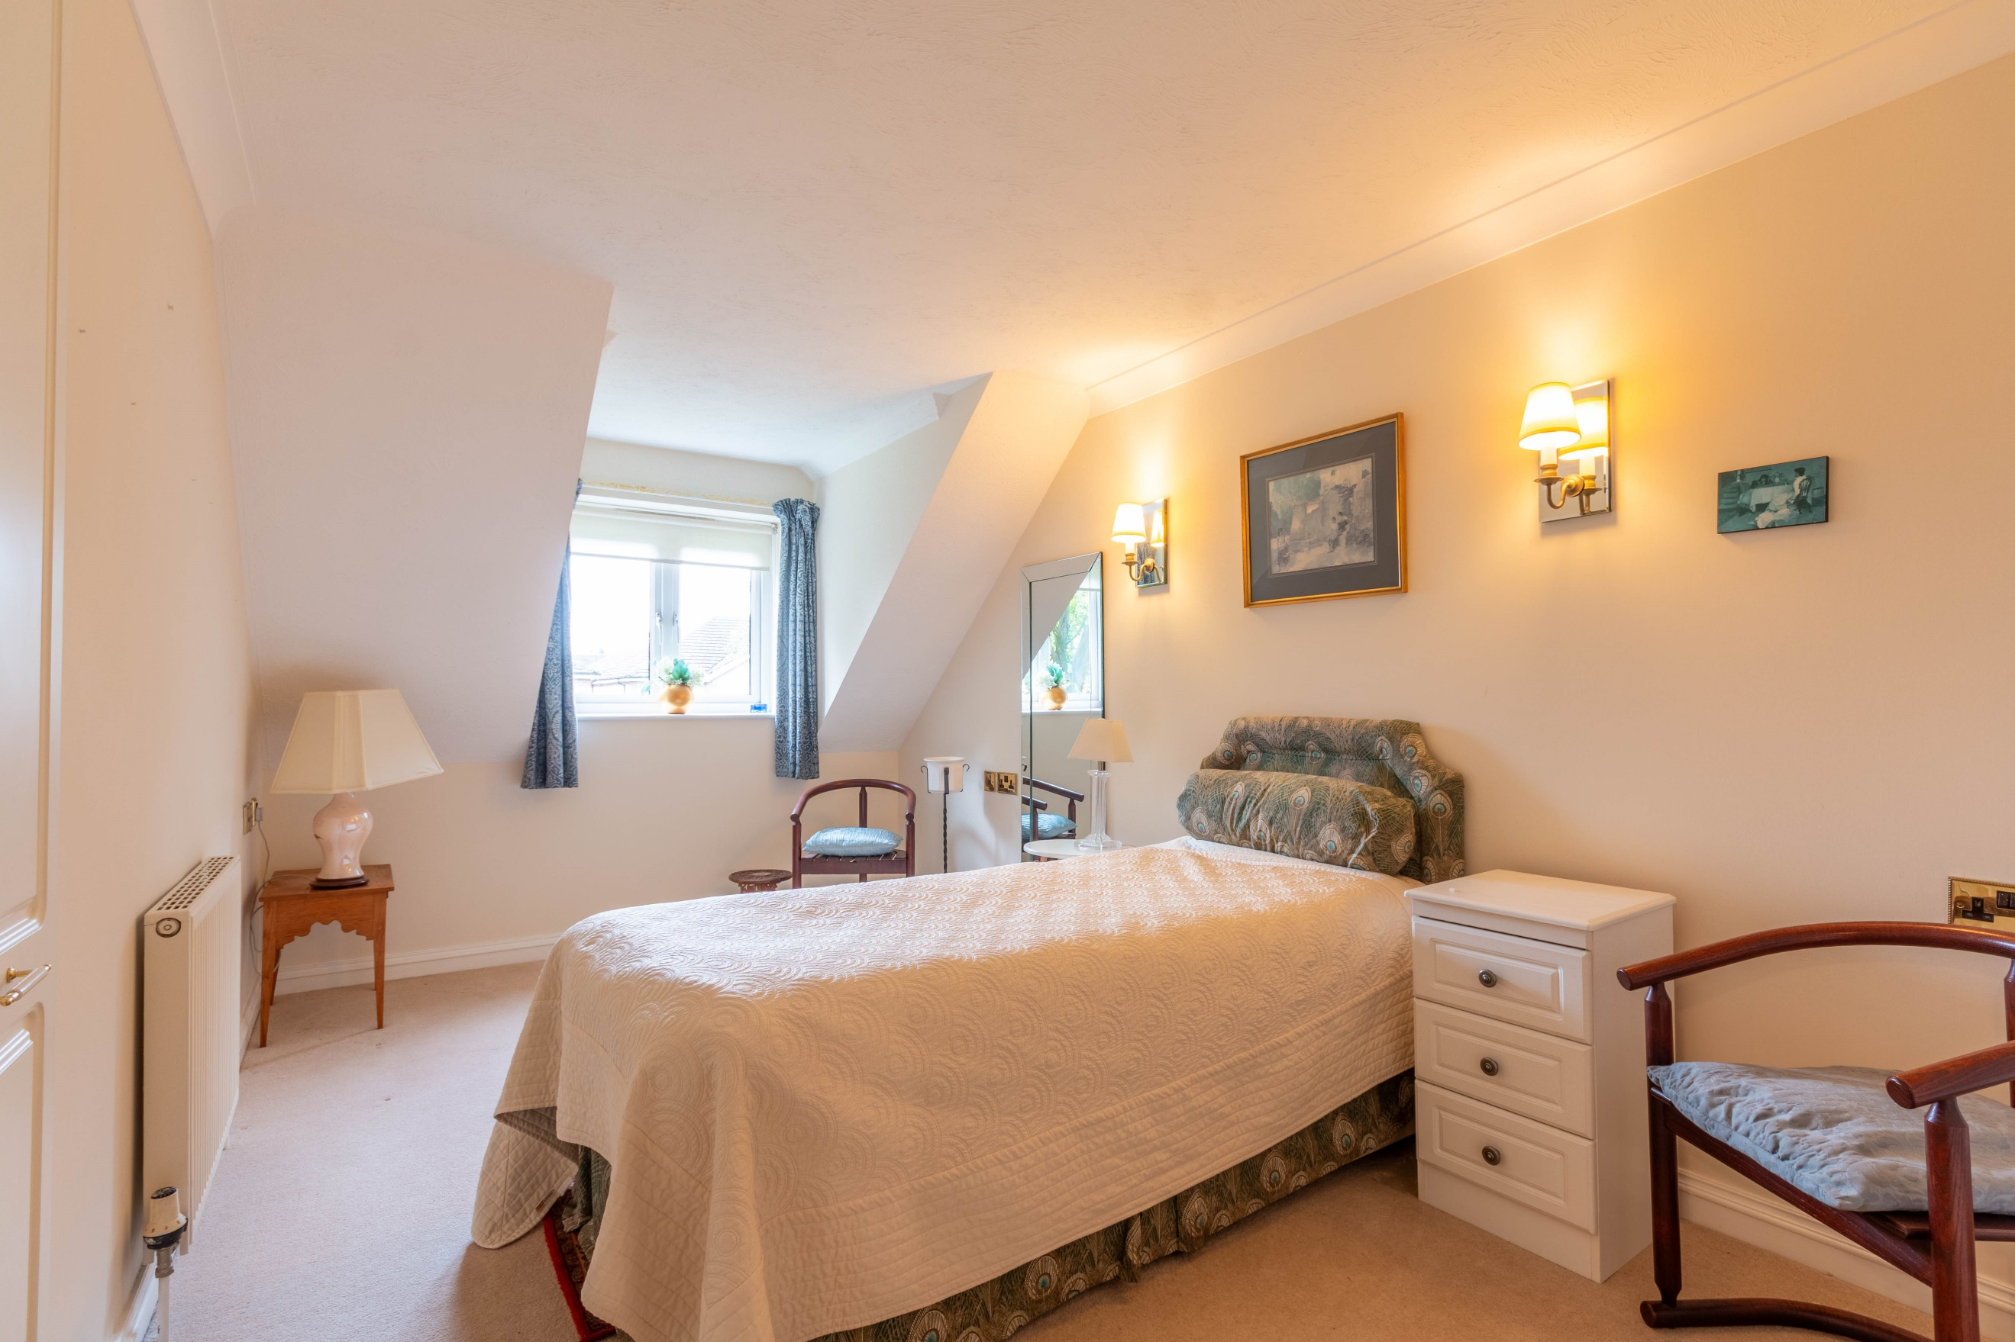

Communal Entrance
Secure intercom entry phone system. Communal sitting room. Stairs and lift to all floors.

Hallway
Spacious entrance hall with generous store cupboard. Secure entry phone system.

Lounge/Diner 4.33m (14'2) x 5.74m (18'10)
Light and airy living area with high ceiling. uPVC double glazed window and door leading out to a South facing private balcony overlooking the gardens. Gas central heating radiator. Electric fire. Open plan to the dining area. Double doors to the kitchen.

Kitchen 2.2m (7'3) x 4.46m (14'8)
Fitted with a range of wall, base and drawer units with worktops over. Integrated double oven, 4-ring hob with extractor hood over. Integrated dishwasher, fridge and freezer. 1.5 bowl stainless steel sink with mixer tap and drainer. Space for washing machine. Gas central heating radiator. uPVC double glazed window. Inset ceiling spotlights.

Master Bedroom 2.68m (8'10) x 4.84m (15'11)
Master bedroom with uPVC double glazed window. Gas central heating radiator. Built in wardrobes.

En-Suite Shower Room
Recently refurbished shower room comprising; walk in shower cubicle, WC and vanity wash hand basin. Tiled walls. Inset ceiling spotlights.

Bedroom Two 2.66m (8'9) x 4.64m (15'3)
Second double bedroom with uPVC double glazed window. Built in wardrobes. Gas central heating radiators. Access to part boarded loft offering extra storage.

Shower Room
Fitted with a three piece suite comprising; shower cubicle, WC and vanity wash hand basin. Tiled walls. Gas central heating radiator.

Outside
Secure allocated parking space, plus additional visitor parking. Manicured and well-maintained private gardens.

Service Charge
Service Charge - £287pcm.

Tenure
Leasehold - 125 years from 1997
Ground rent - £357 paid half yearly.

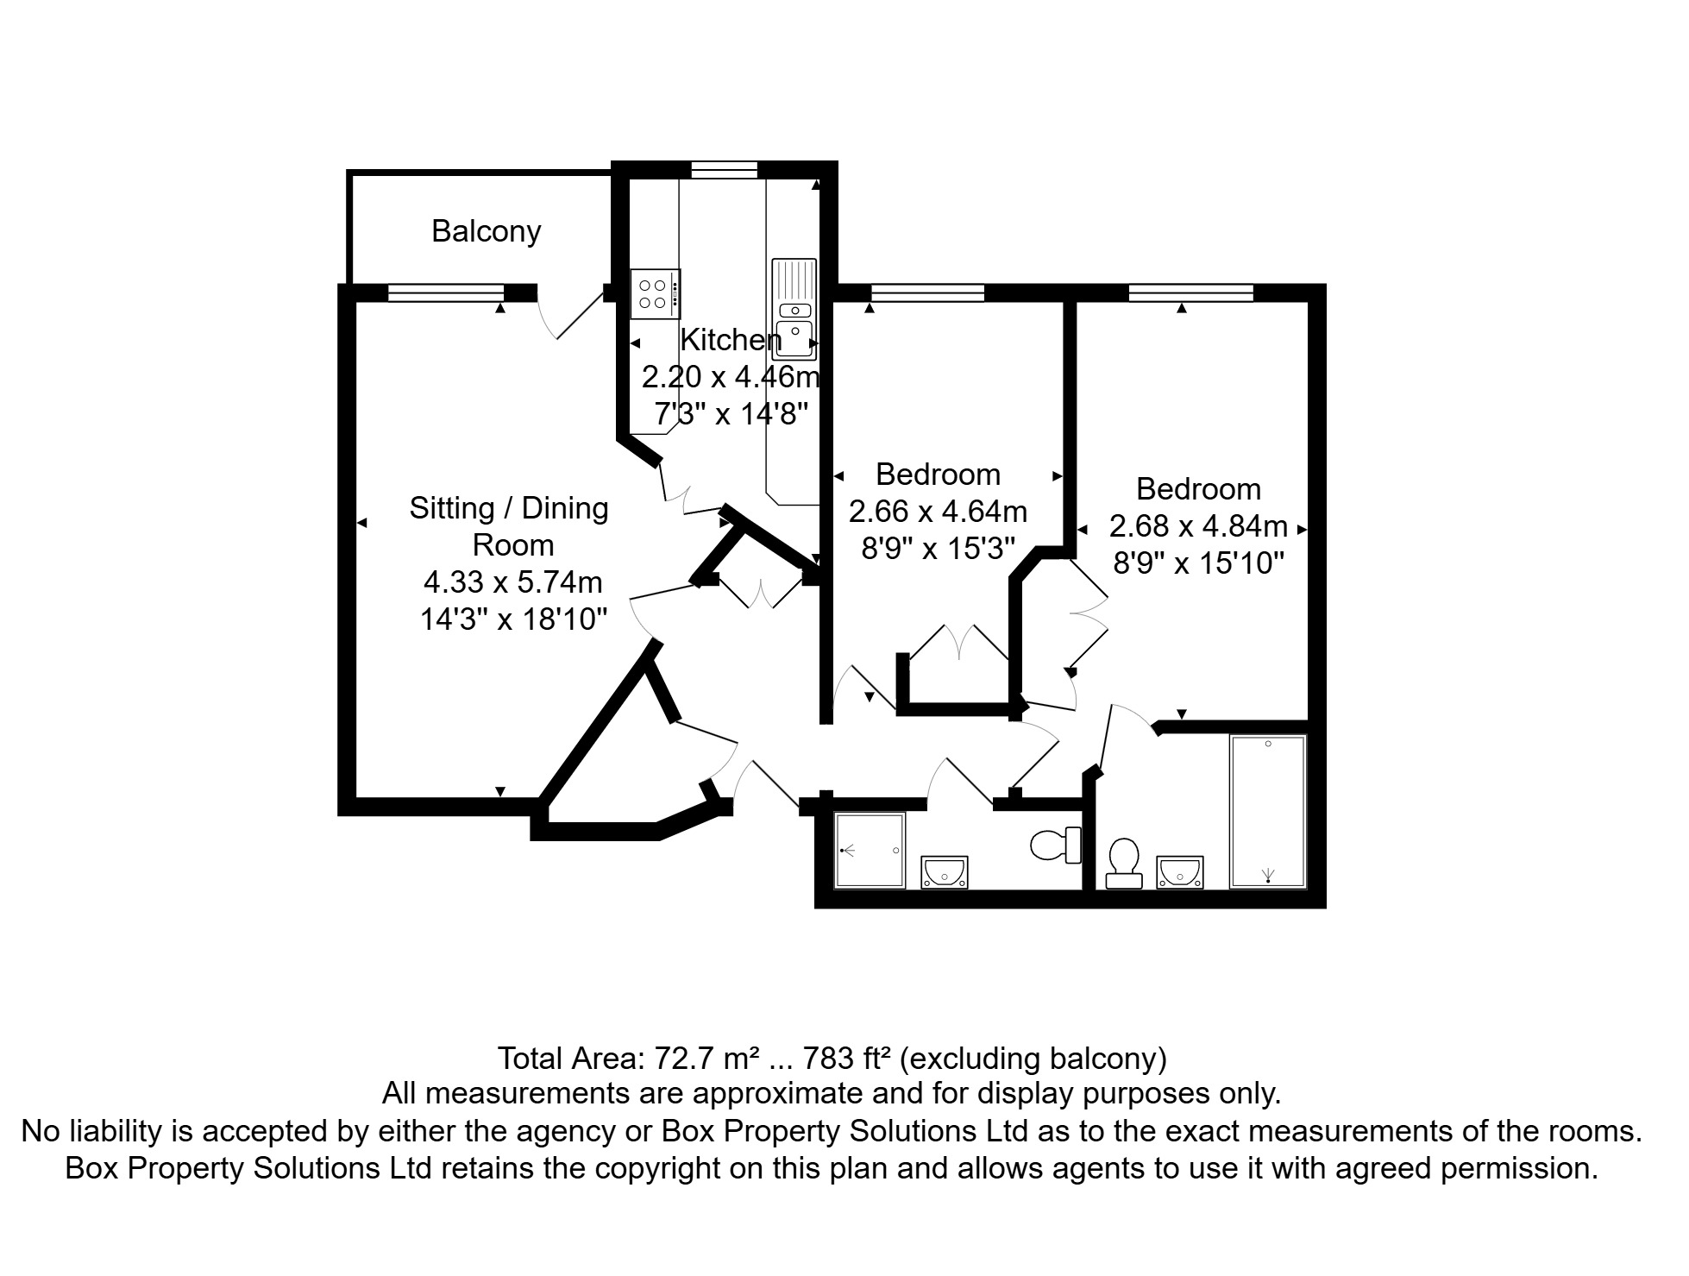

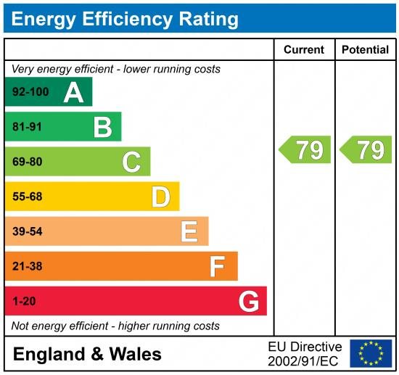

These particulars are intended to give a fair description of the property, but their accuracy cannot be guaranteed, and they do not constitute an offer of contract. Intending purchasers must rely on their own inspection of the property. None of the above appliances/services have been tested by ourselves. We recommend purchasers arrange for a qualified person to check all appliances/services before legal commitment.

Property Ref: 7685

For more information, please contact

0113 258 1150 | sales@adairpaxton.co.uk | www.adairpaxton.co.uk

