
0113 258 1150
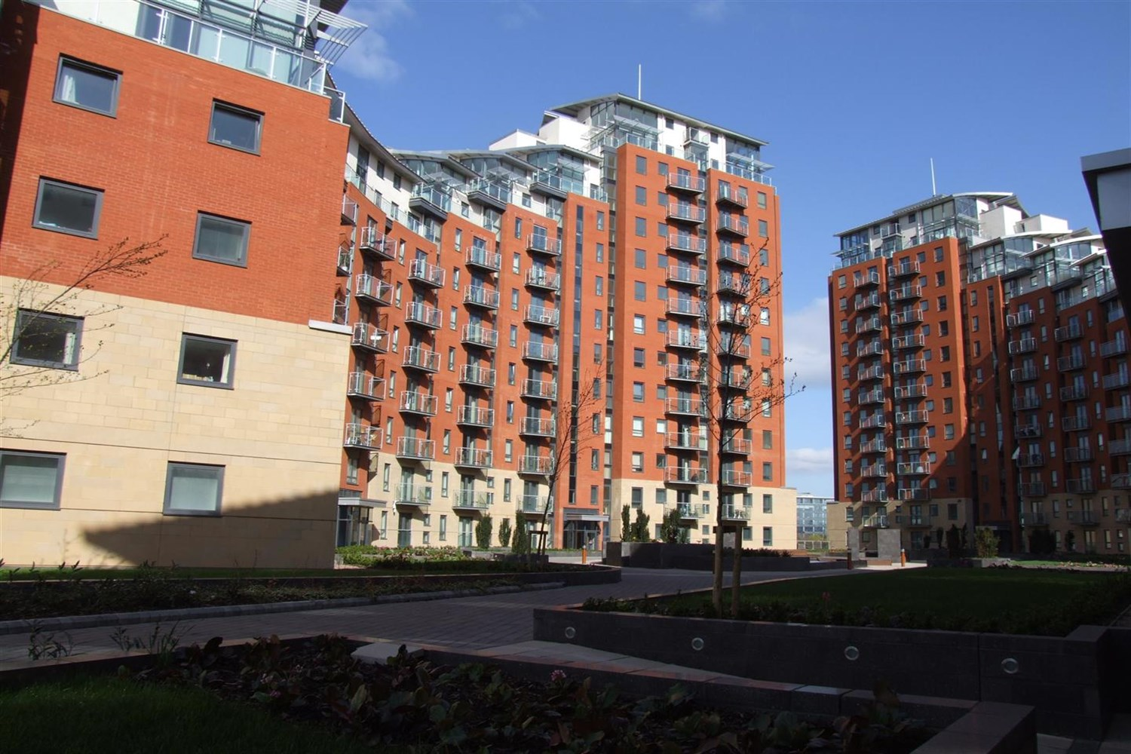



For Sale £195,000.00

Faroe, City Island, Leeds

NO ONWARD CHAIN. Superbly spacious two bedroom apartment WITH PARKING at the popular City Island development. Situated on the 8th floor, this fabulously furnished flat has the benefit of a balcony and its very own secure under croft parking space. The development is well placed for easy access to the motorway network, and is just a short stroll from the heart of Leeds City Centre. Council tax band D, EPC rating C Deposit £1325. Available 20th October.
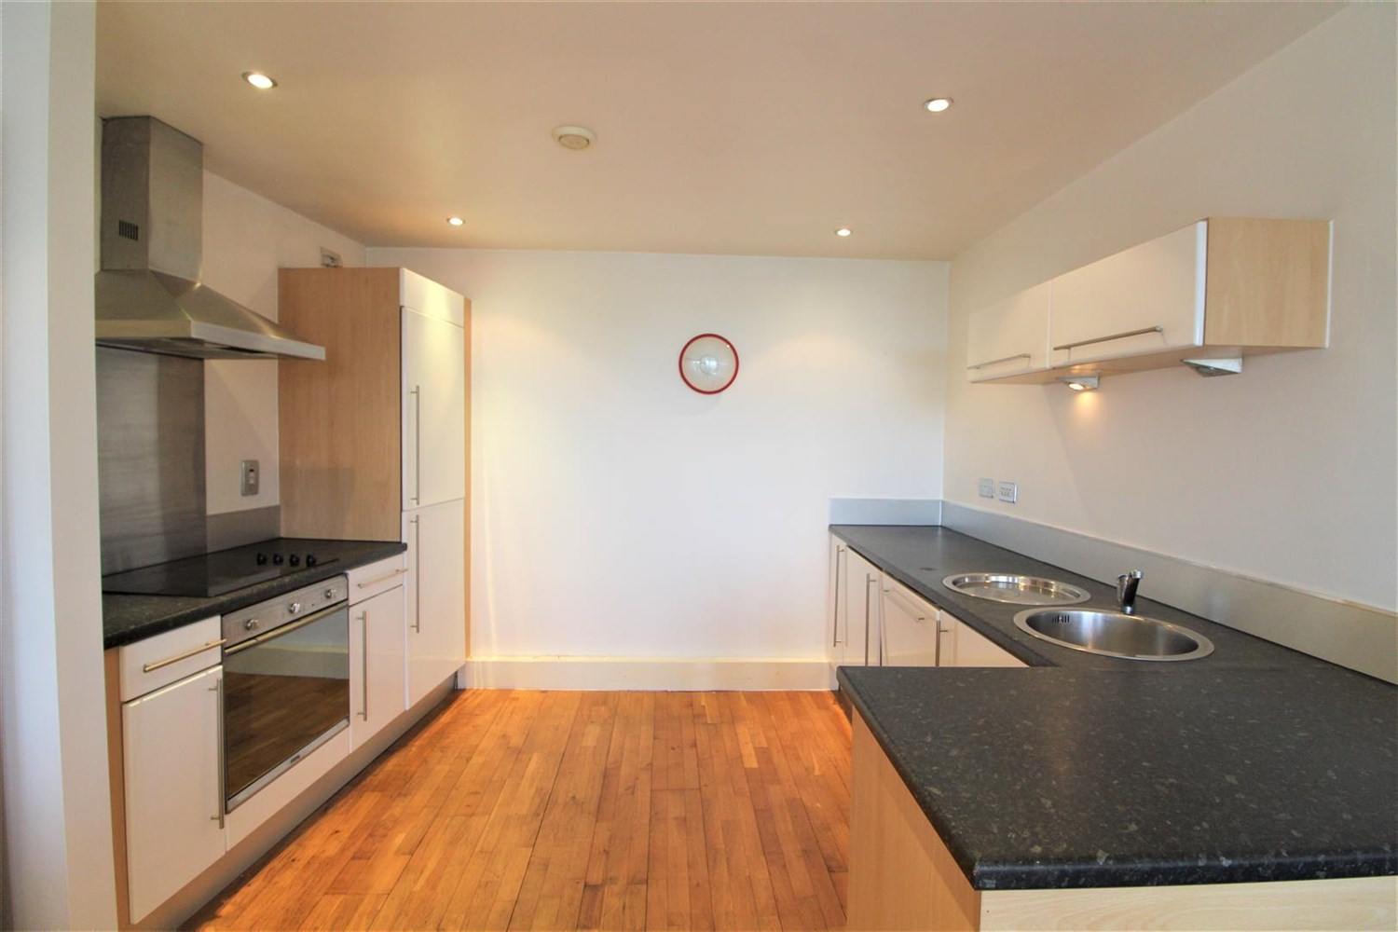
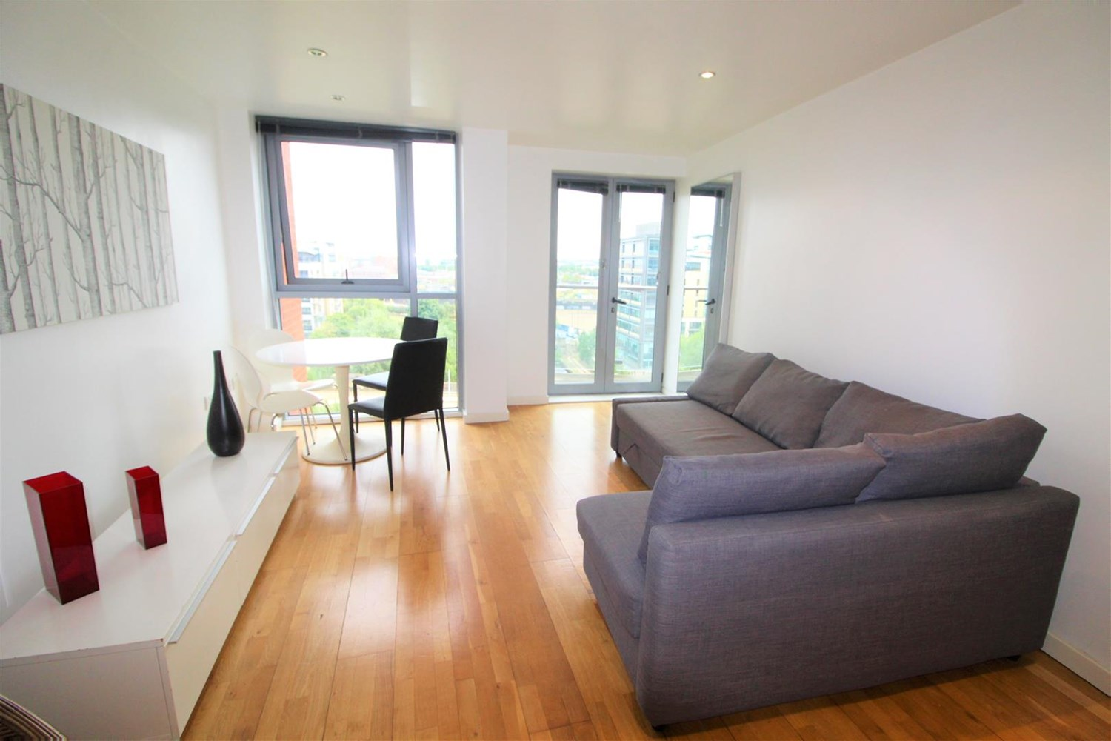
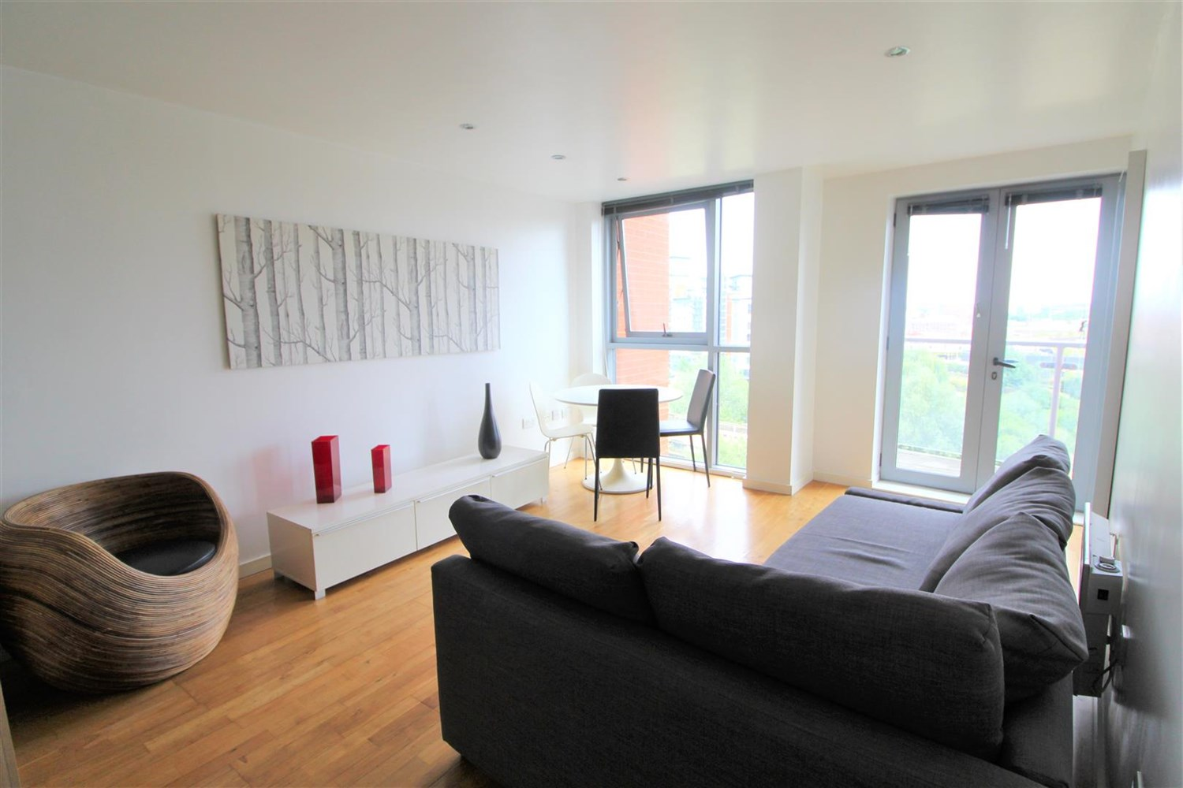
1 Bathroom(s)
1 Reception(s)
2 Bedroom(s)
00

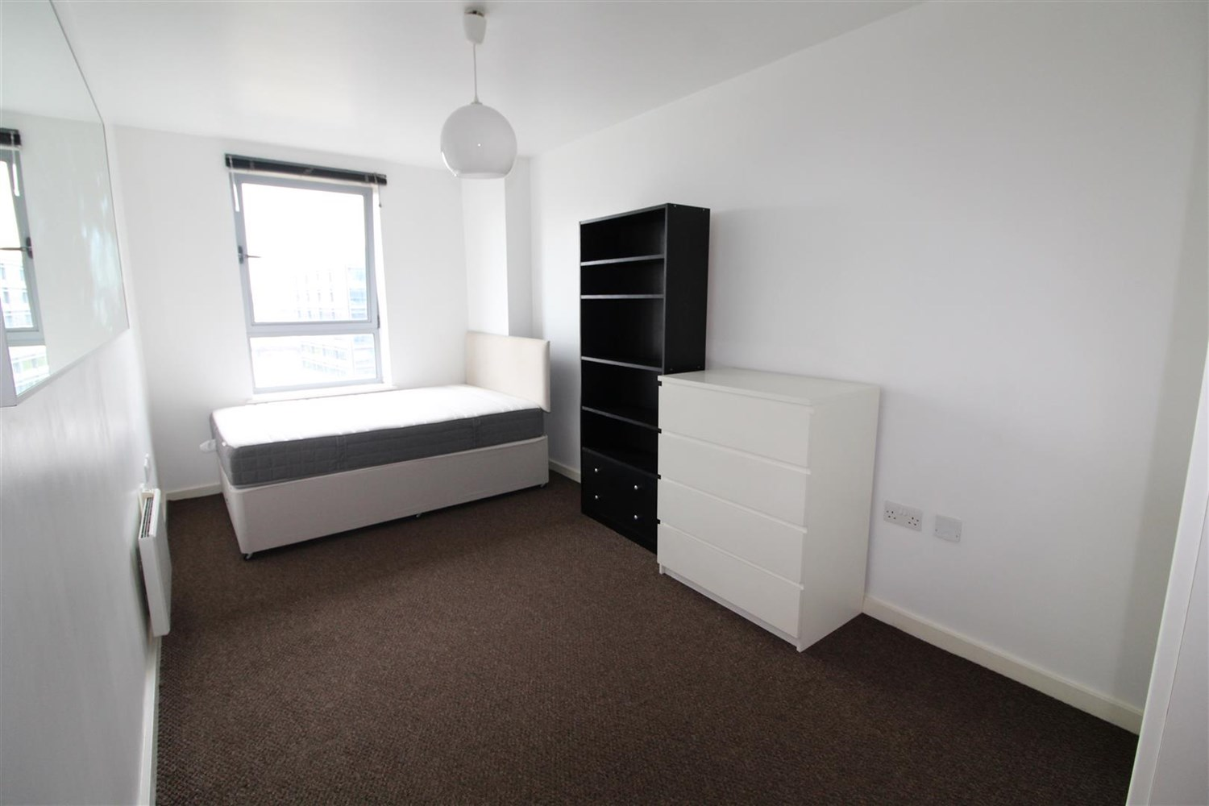

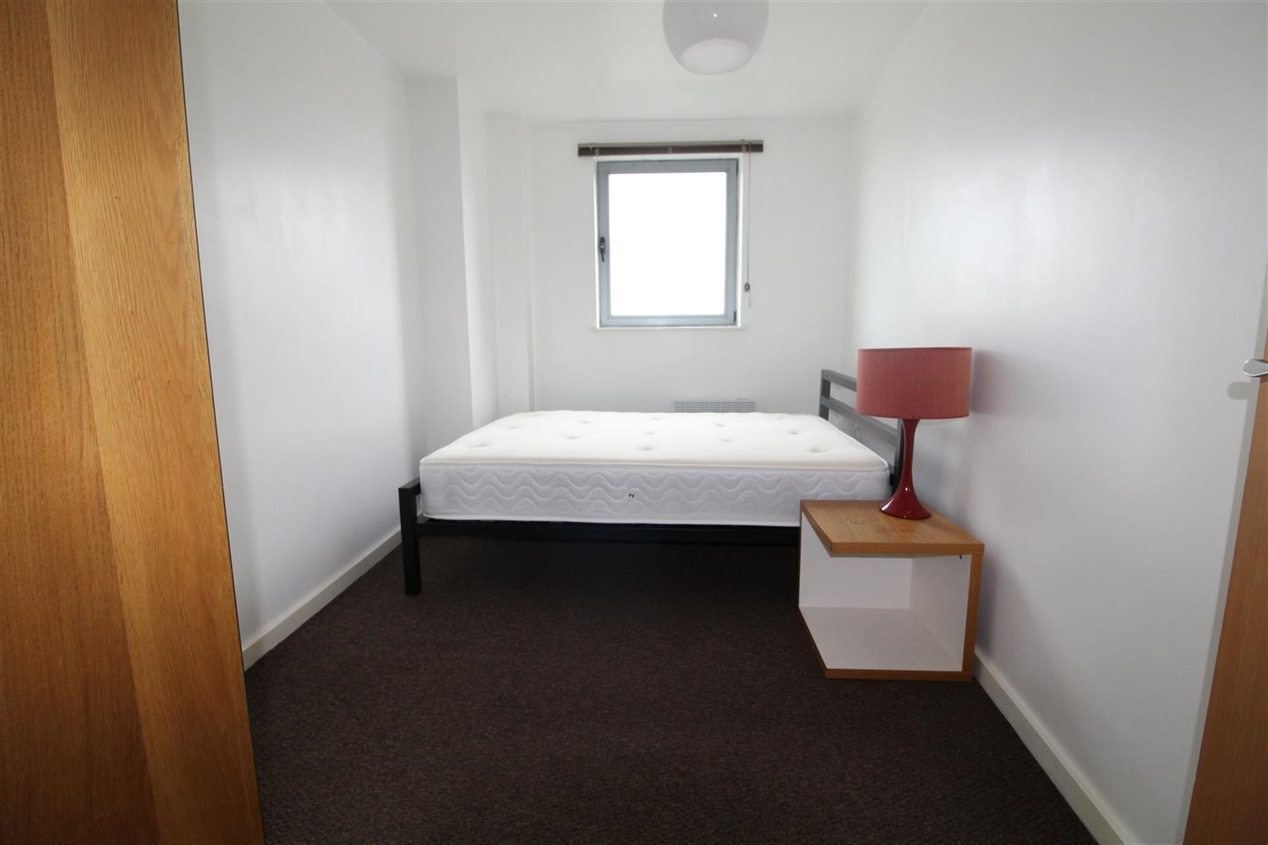
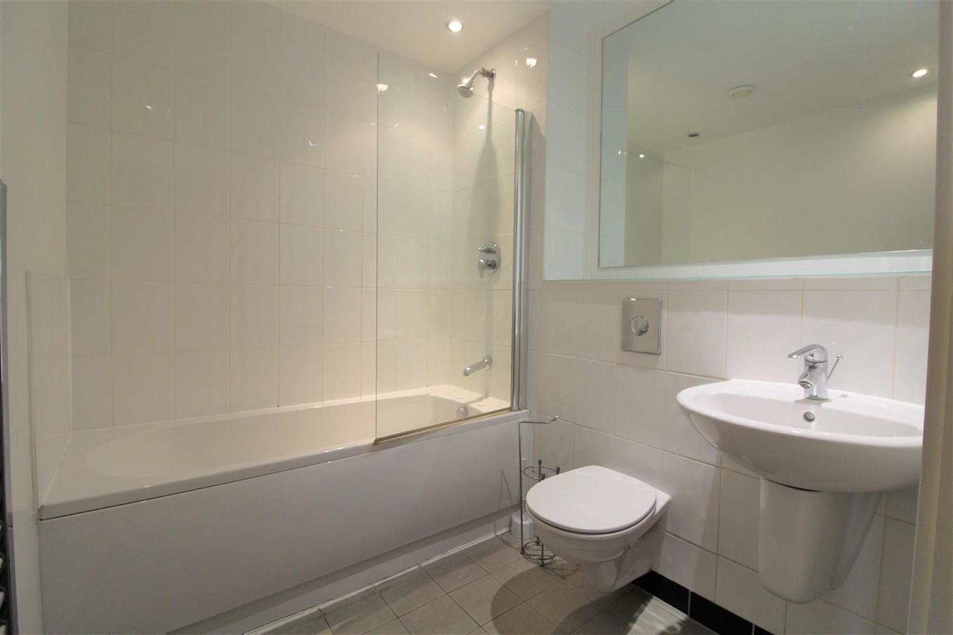

Hallway
Hallway with wall mounted intercom system.

Living/Dining room
Light and airy living and dining room with a floor to ceiling window, electric radiator and double doors leading onto a balcony.

Kitchen
Kitchen are comprising a range of wall and base mounted units, single drainer stainless steel sink unit with mixer tap, integrated oven, hob and extractor, built in washing machine, fridge freezer and dishwasher and wood effect flooring.

Bedroom 1
Spacious double bedroom with a wall mounted electric radiator and a window.

Bedroom 2
Second double bedroom with a wall mounted electric radiator and a large window.

Bathroom
Three piece suite comprising: shower over bath, hand wash basin and W/C. Tiled walls and an electric radiator.

Secure Allocated Parking
Secure shutter underground parking.

COUNCIL TAX BAND: D
EPC Rating C
Leasehold property
Parking included
Broadband: Standard 16 Mbps 1 Mbps Good
Superfast 201 Mbps 29 Mbps Good
Ultrafast 1000 Mbps 1000 Mbps
Mobile availability: EE limited coverage. Three limited coverage. O2 likely to have good coverage. Vodafone limited coverage.
Utilities: Water supplied on standard meters. Electric mains supplied on standard meters.

Service Charge/Ground rent
Ground Rent £200 per annum
Service Charge £1,033.93 every 6 months
Carpark £16 every 6 months

These particulars are intended to give a fair description of the property, but their accuracy cannot be guaranteed, and they do not constitute an offer of contract. Intending purchasers must rely on their own inspection of the property. None of the above appliances/services have been tested by ourselves. We recommend purchasers arrange for a qualified person to check all appliances/services before legal commitment.  Property Ref: 7629  For more information, please contact  0113 258 1150 | sales@adairpaxton.co.uk | www.adairpaxton.co.uk | 