

**0113 258 1150**

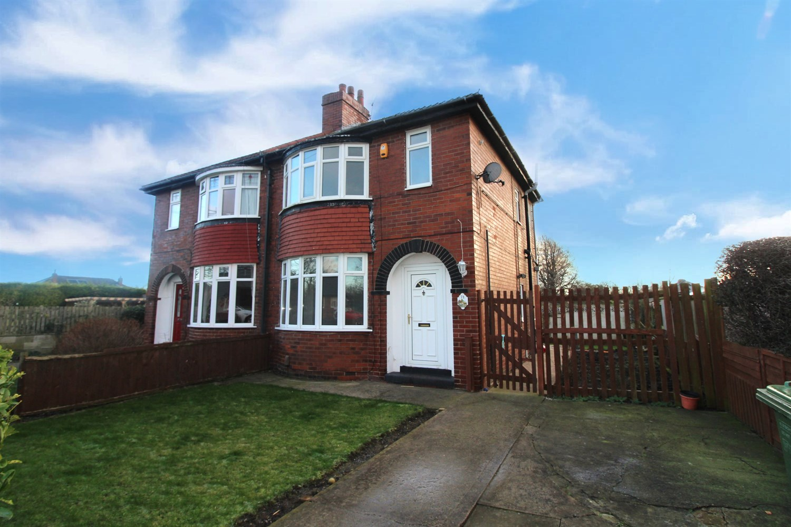



**For Sale £159,950.00**

**Westmead, WF10**

**THREE BEDROOM SEMI-DETACHED HOUSE - NO ONWARD CHAIN** Adair Paxton are pleased to offer to the market this three bedroom semi-detached house in this much sought after location. The property is now in need of updating and briefly comprises; hallway, living room and kitchen/diner to the ground floor. To the first floor there are two double bedrooms, a third bedroom ideal for a study/nursery and a house bathroom. Externally the property sits on a generous sized plot with a driveway to the front and lawned gardens to the front and rear. The property does benefit from double glazing and gas central heating.

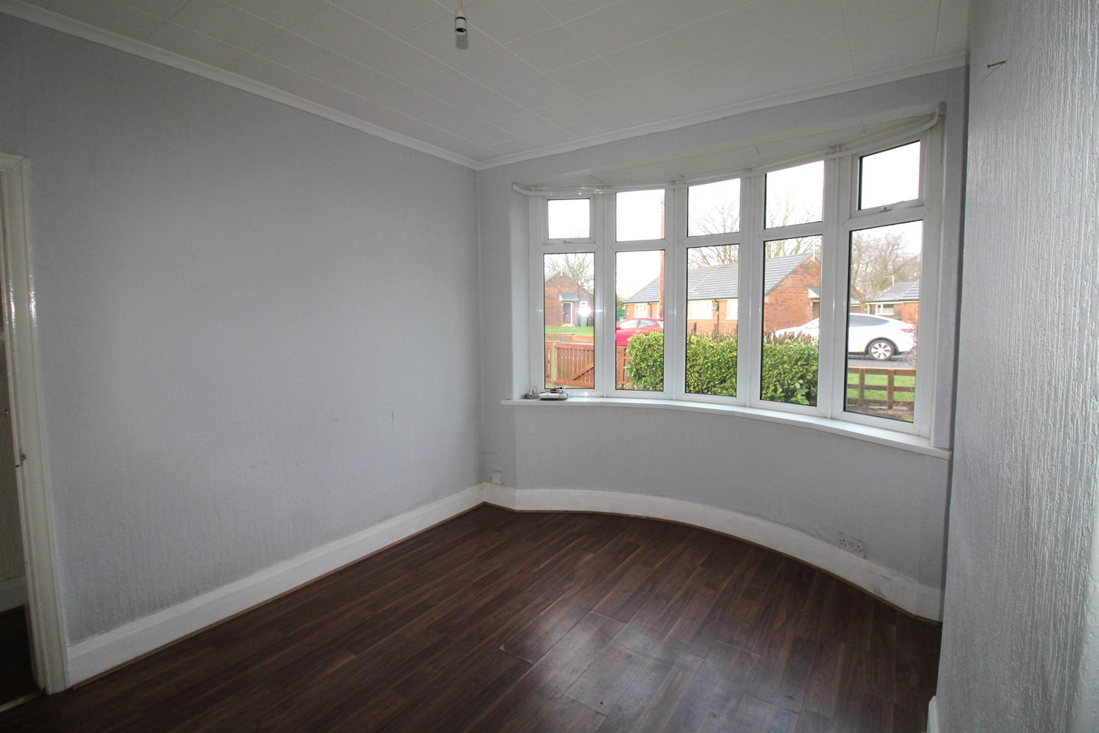

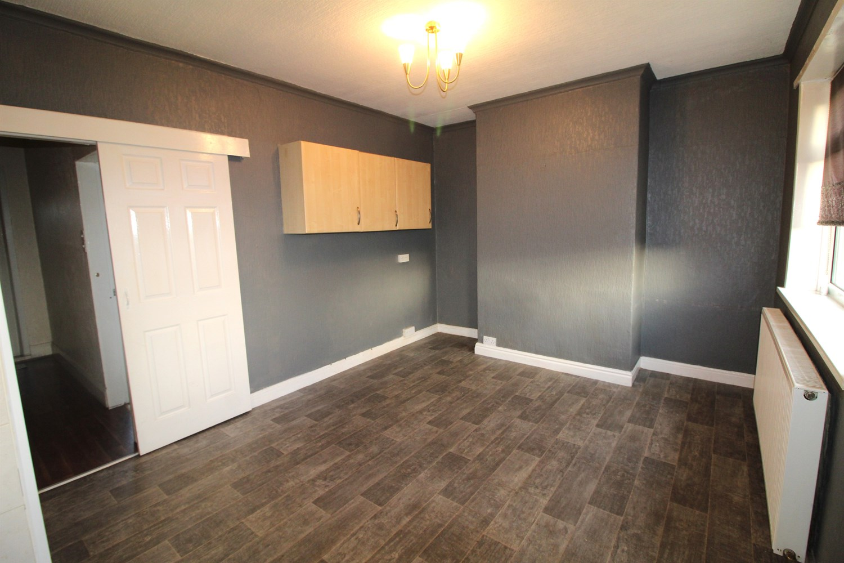

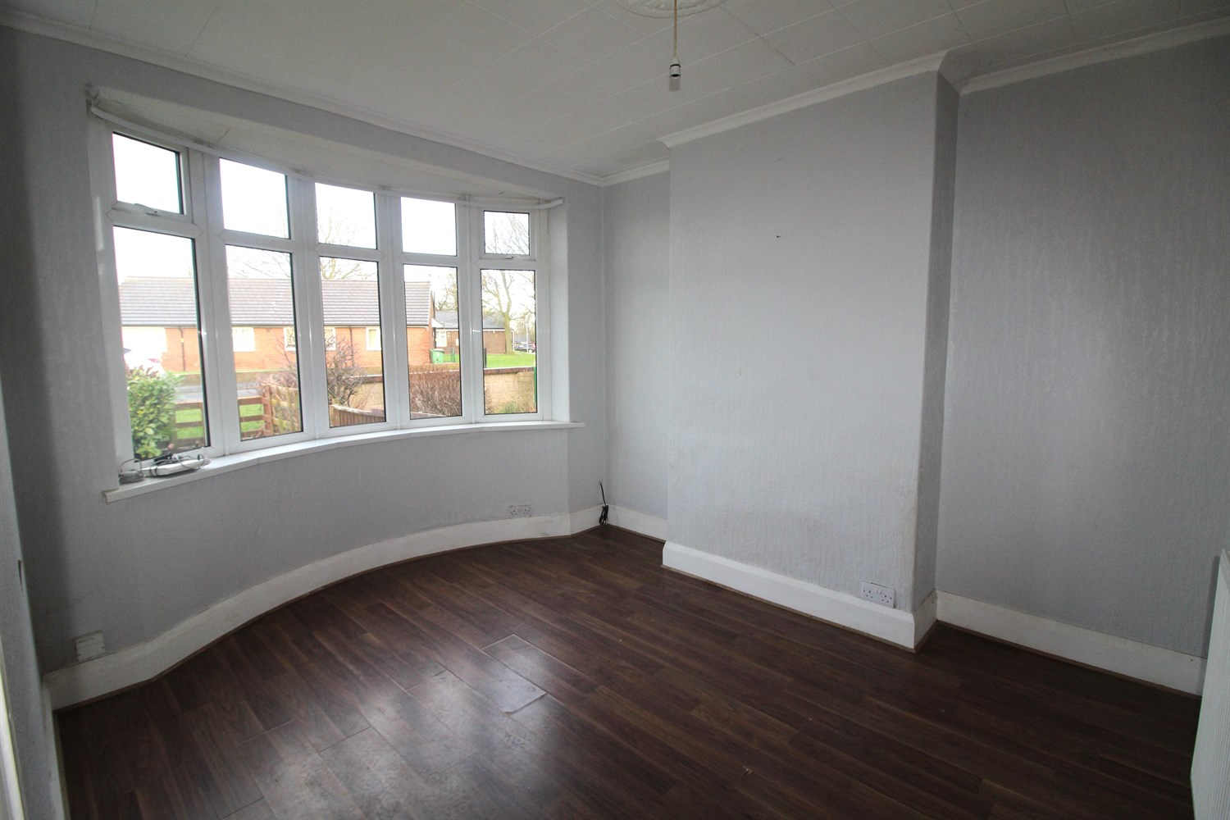

1 Bathroom(s)

1 Reception(s)

3 Bedroom(s)

00

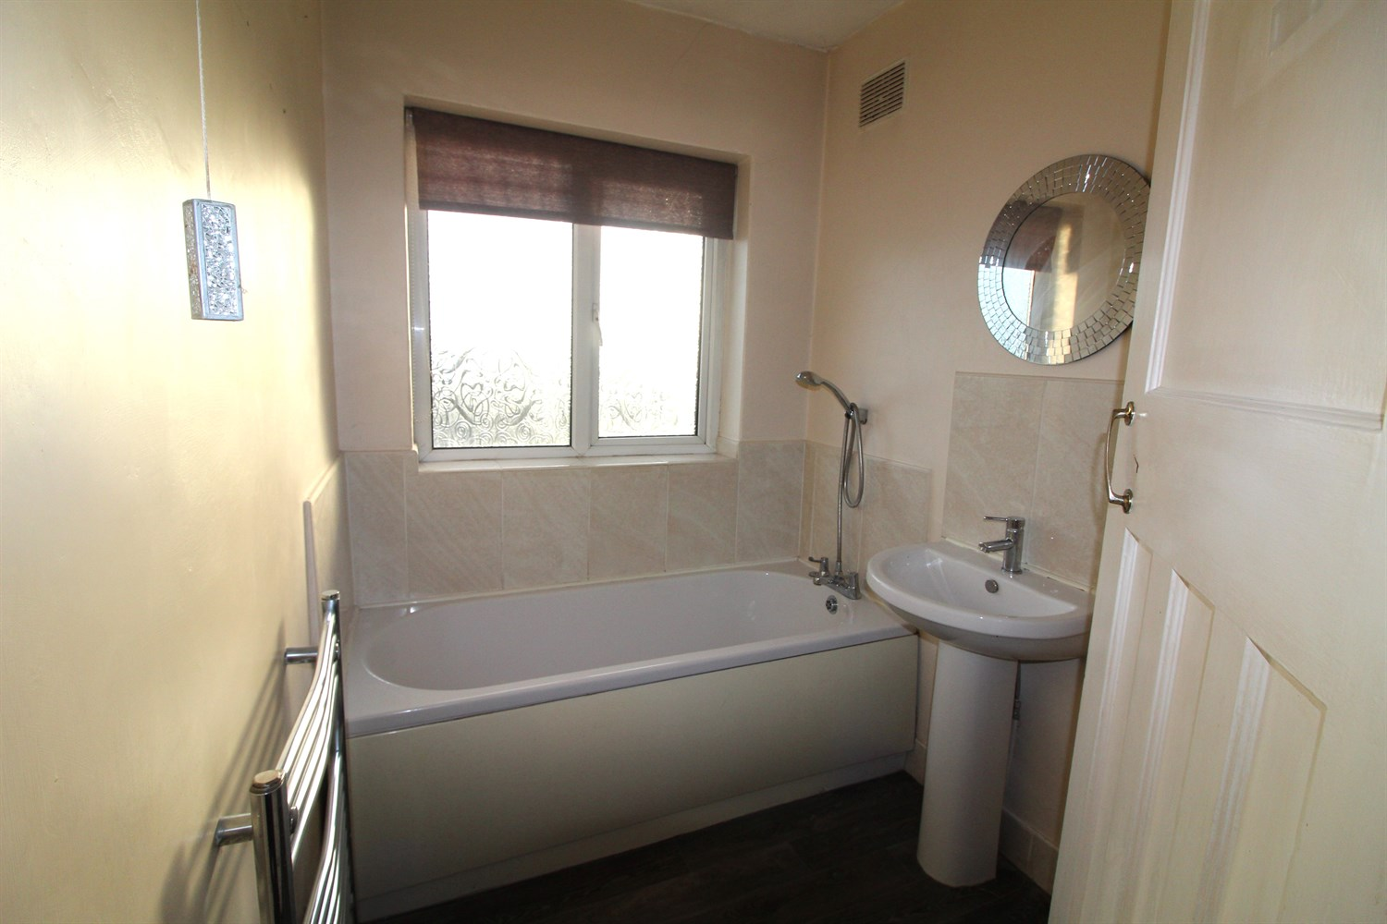

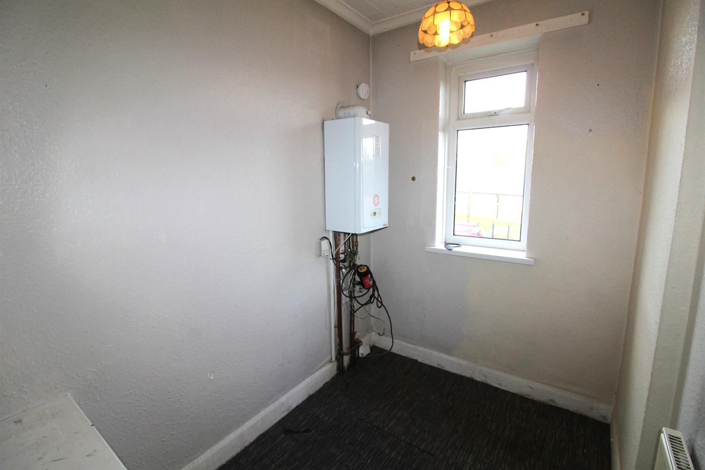

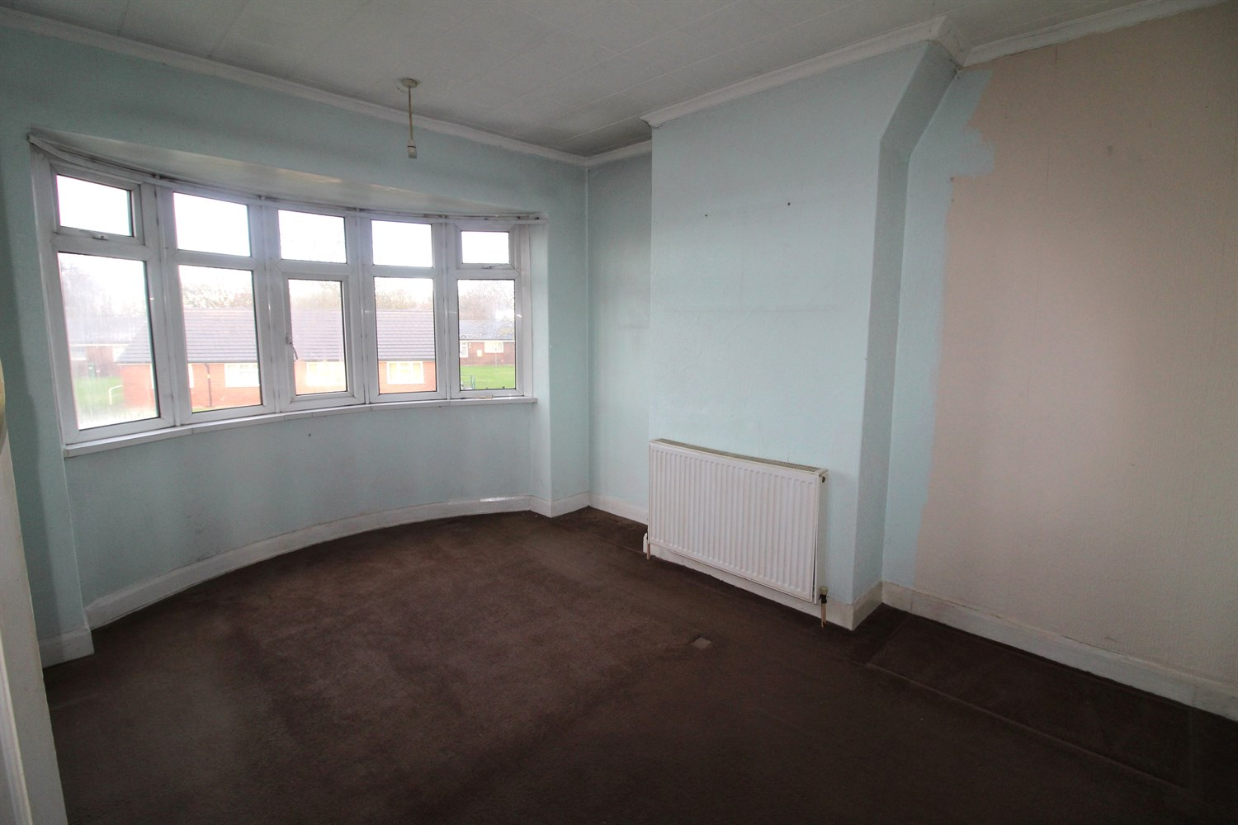

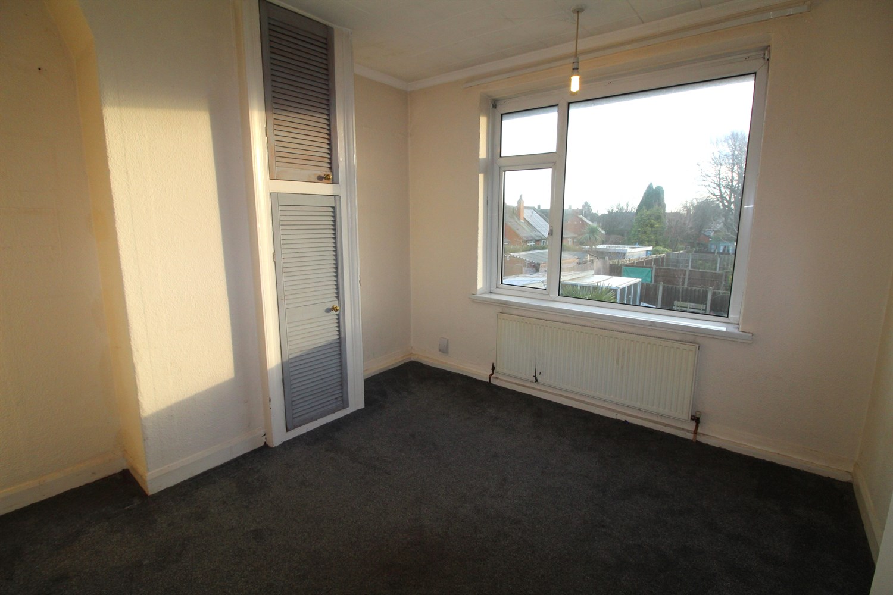

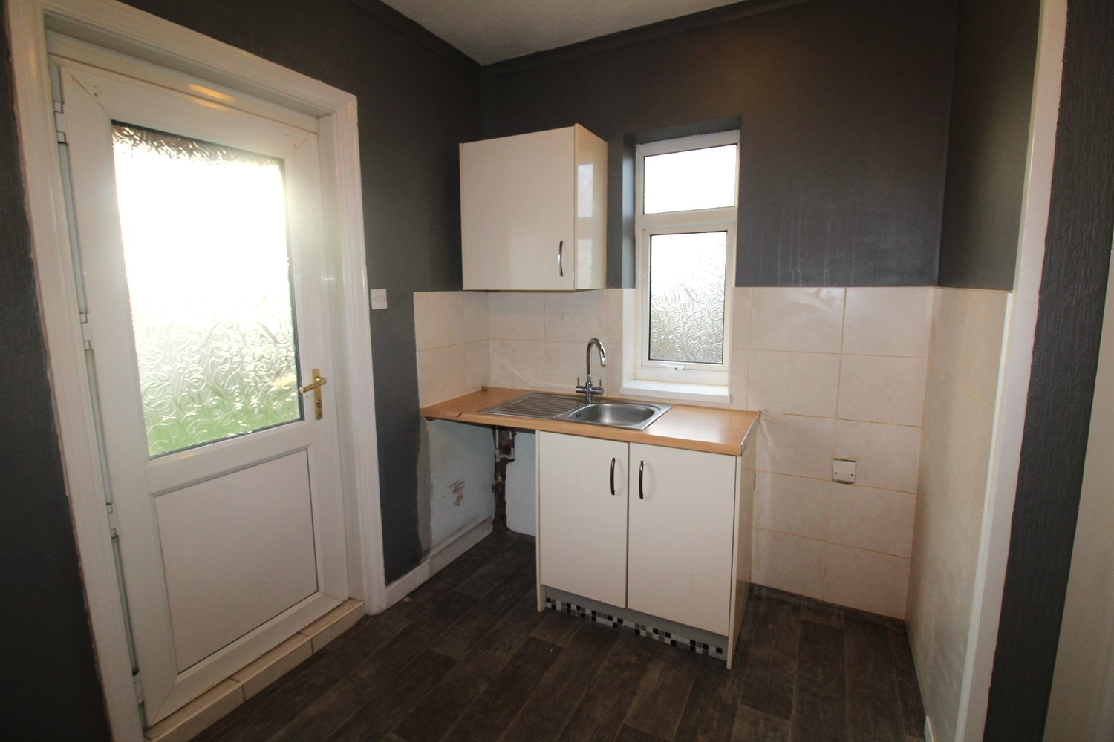

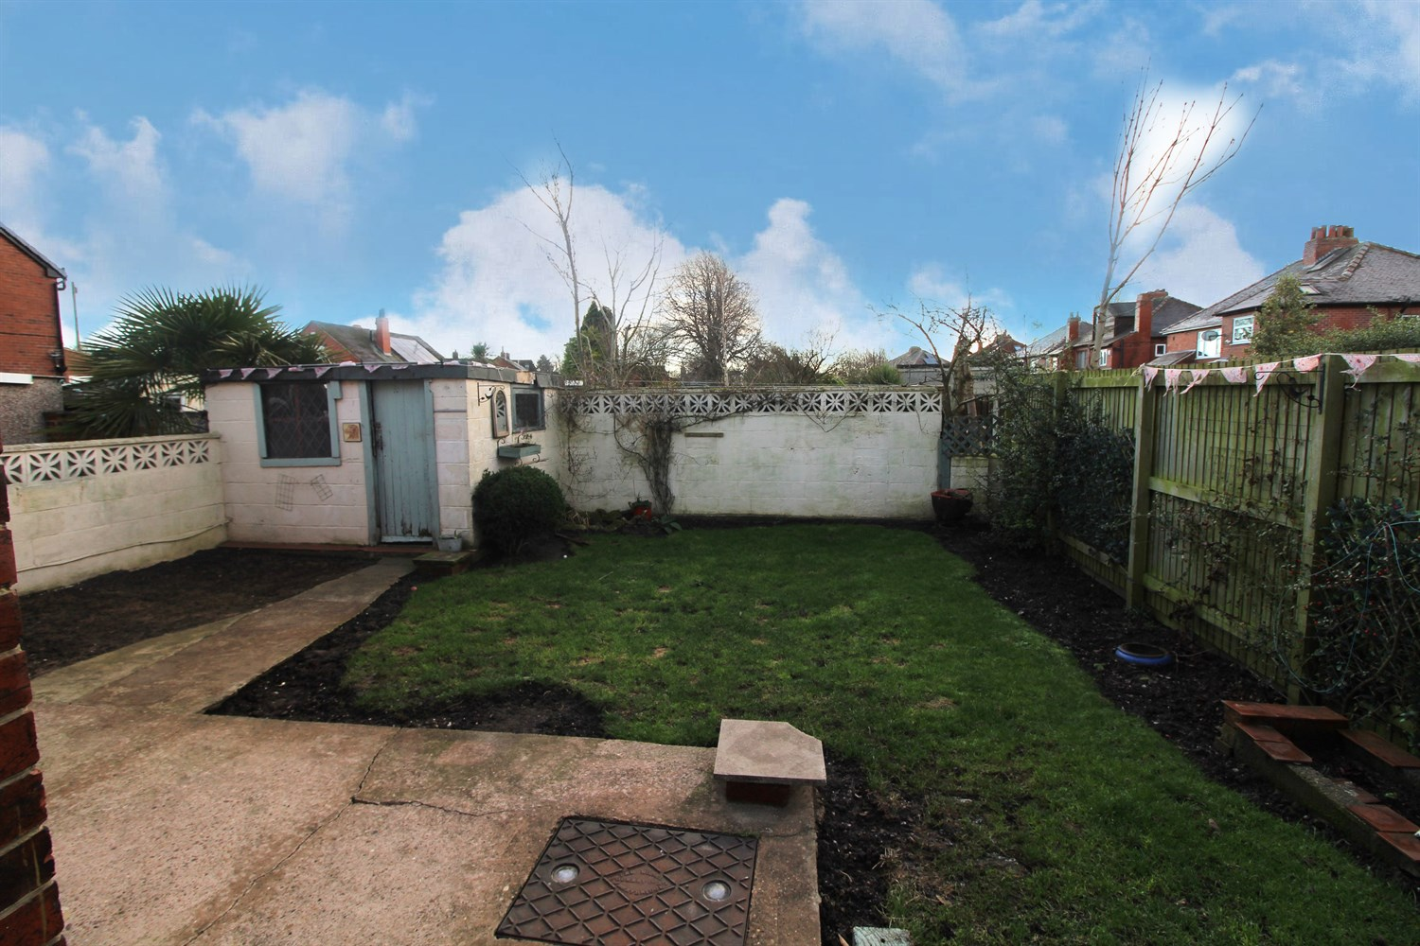

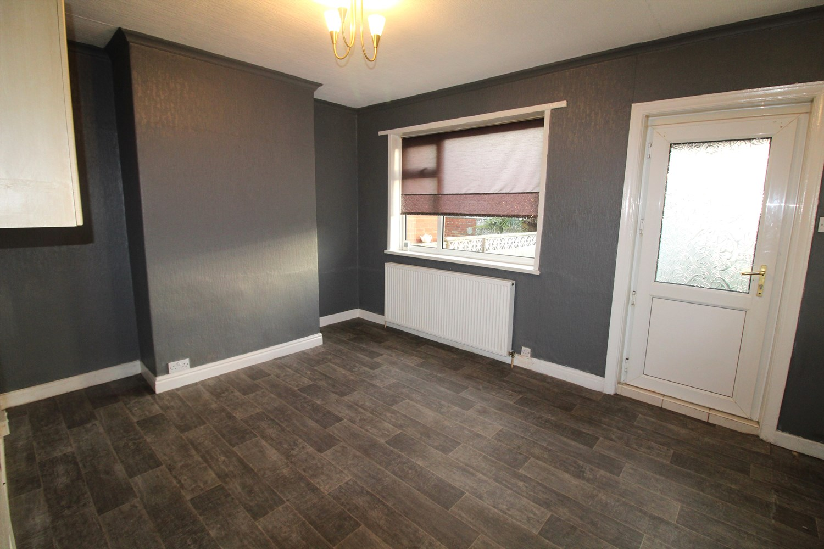

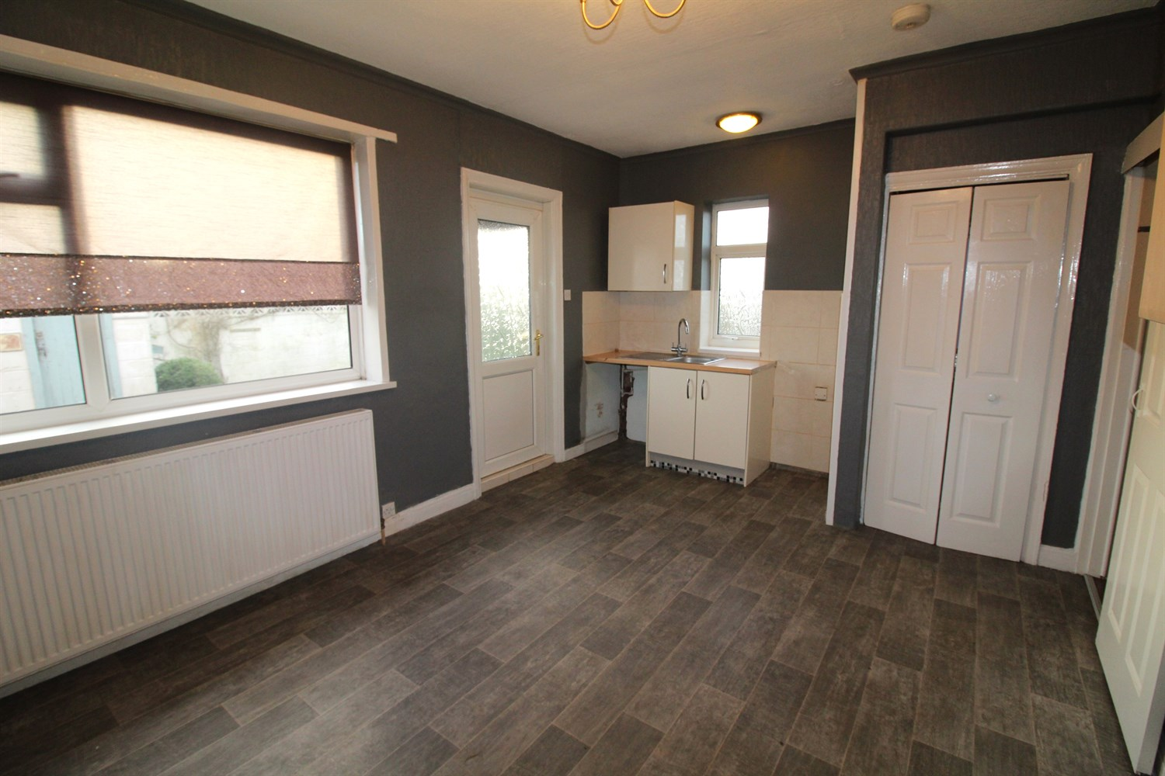

|  |
| --- |
| **Hallway**  Via front entrance door. Stairs to first floor. |
| **Lounge 3.78m (12'5) Into Bay x 3.17m (10'5)**  Light and Airy living room with double glazed bay window to front. Gas central heating radiator. |
| **Kitchen/Diner 4.96m (16'3) x 3.32m (10'11)**  Open plan kitchen/diner with double glazed window and double glazed door to rear. Gas central heating radiator. Storage cupboard. Fitted unit with stainless steel sink. Plumbed for washing machine. Space for cooker. double glazed window to side. |
| **Bedroom 1 3.17m (10'5) Max x 4.18m (13'9) Into Bay**  Double bedroom with double glazed bay window to front. Gas central heating radiator. |
| **Bedroom 2 3.18m (10'5) Max x 3.23m (10'7)**  Second double bedroom with double glazed window to rear. Gas central heating radiator. |
| **Bedroom 3 2.57m (8'5) Max x 1.7m (5'7)**  Third bedroom with double glazed window to rear. Gas central heating radiator. |
| **Bathroom**  Fitted with a three piece white suite comprising; bath with hand shower over, WC and wash hand basin. Part tiled walls. Wall mounted heated towel rail. Double glazed window to rear. |
| **Outside**  To the front of the property is a driveway offering off street parking. The outside space is fully enclosed and has a lawned garden to the rear and front. |

|  |  |
| --- | --- |
| These particulars are intended to give a fair description of the property, but their accuracy cannot be guaranteed, and they do not constitute an offer of contract. Intending purchasers must rely on their own inspection of the property. None of the above appliances/services have been tested by ourselves. We recommend purchasers arrange for a qualified person to check all appliances/services before legal commitment.  **Property Ref:** 4807  **For more information, please contact**  0113 258 1150 **|** [sales@adairpaxton.co.uk](mailto:sales@adairpaxton.co.uk) **|** www.adairpaxton.co.uk |  |