

**Methley Grove, Chapel Allerton**

**For Sale £285,000.00**

***FOUR BEDROOM THROUGH TERRACE - NO ONWARD CHAIN*** Adair Paxton are pleased to offer to the market this spacious four bedroom mid-terrace property in the ever popular Methley's. The property occupies a prime location within the centre of sought after Chapel Allerton. Offering four double bedrooms, high ceilings, generous room sizes and plentiful character. The property is now in need of updating and briefly comprises: Entrance porch, lounge and dining kitchen to the ground floor. Cellar. To the first floor there are two double bedrooms and a house bathroom. The second floor offers a further two double bedrooms. Externally the property has a courtyard style garden to the front and rear.

**0113 258 1150**

**0800 000 000**

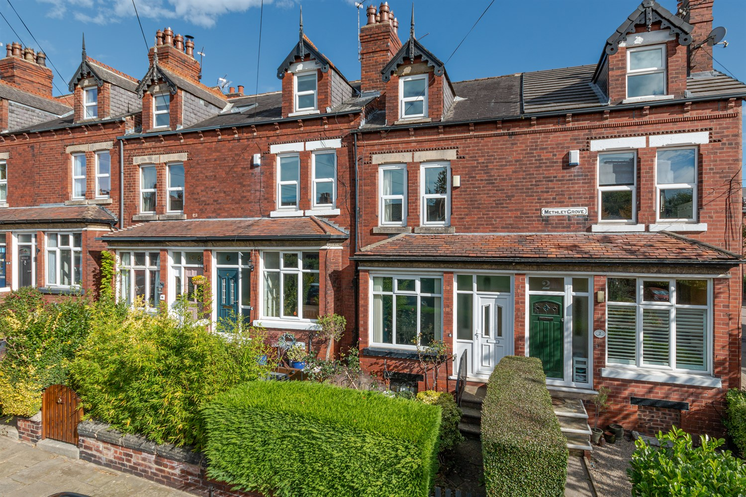

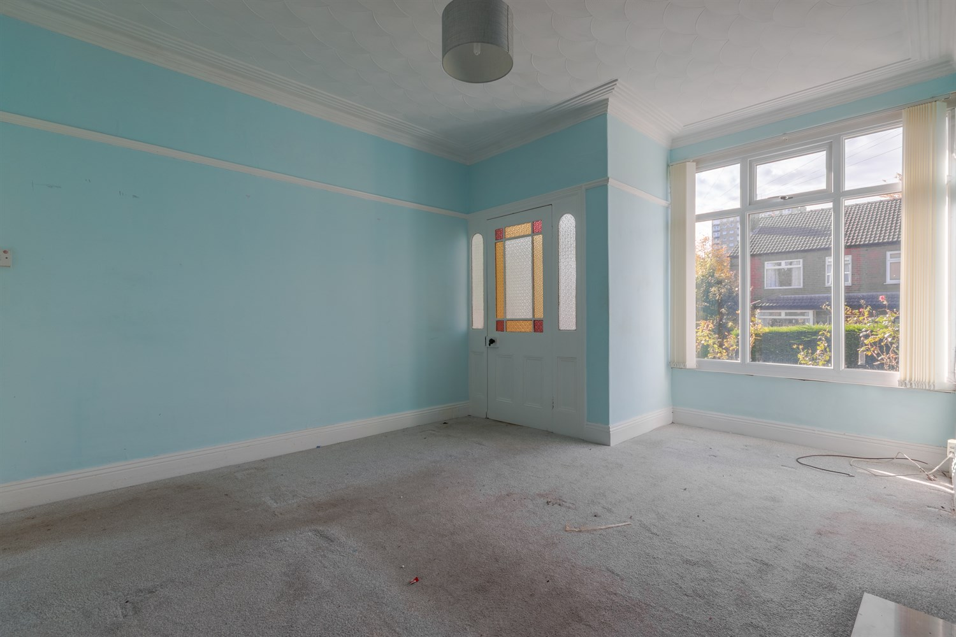

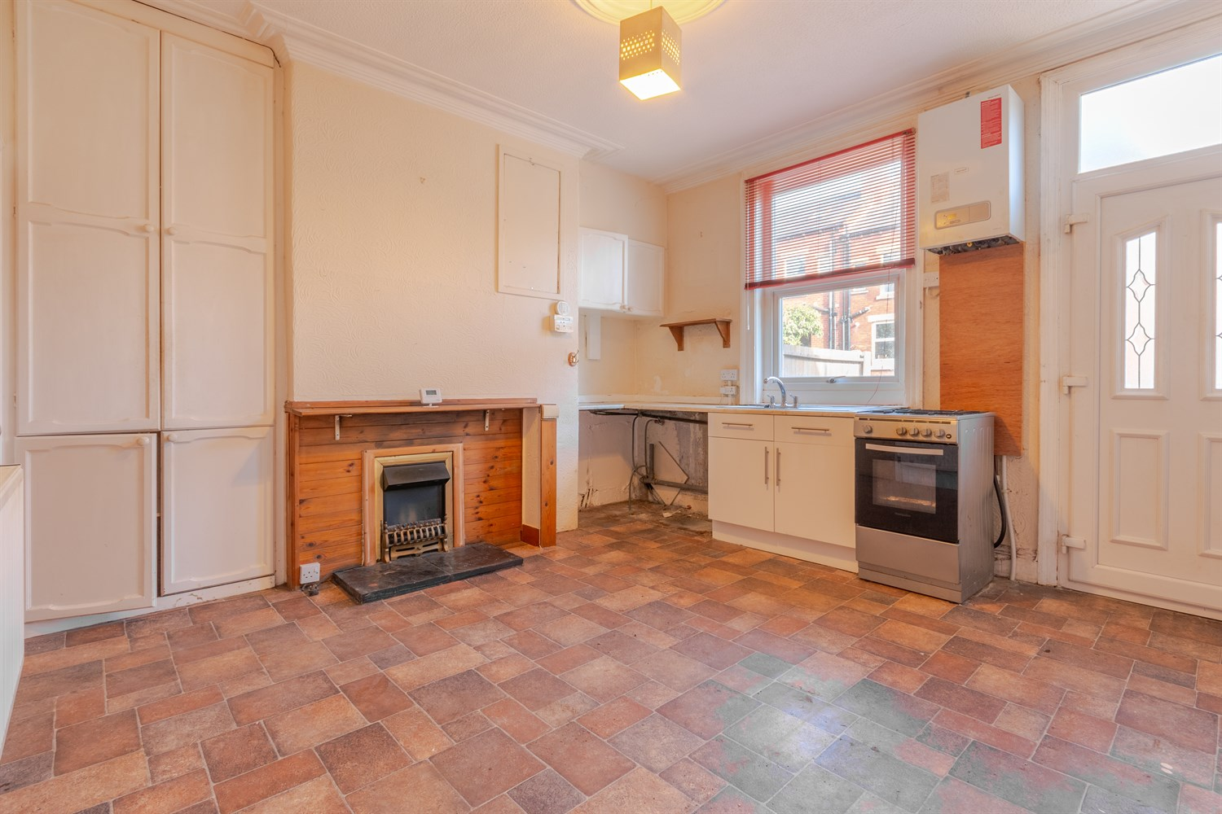

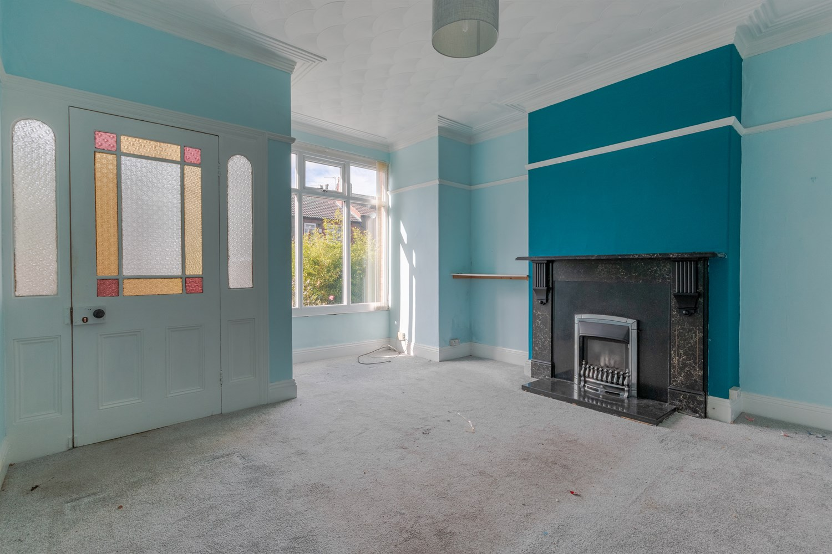

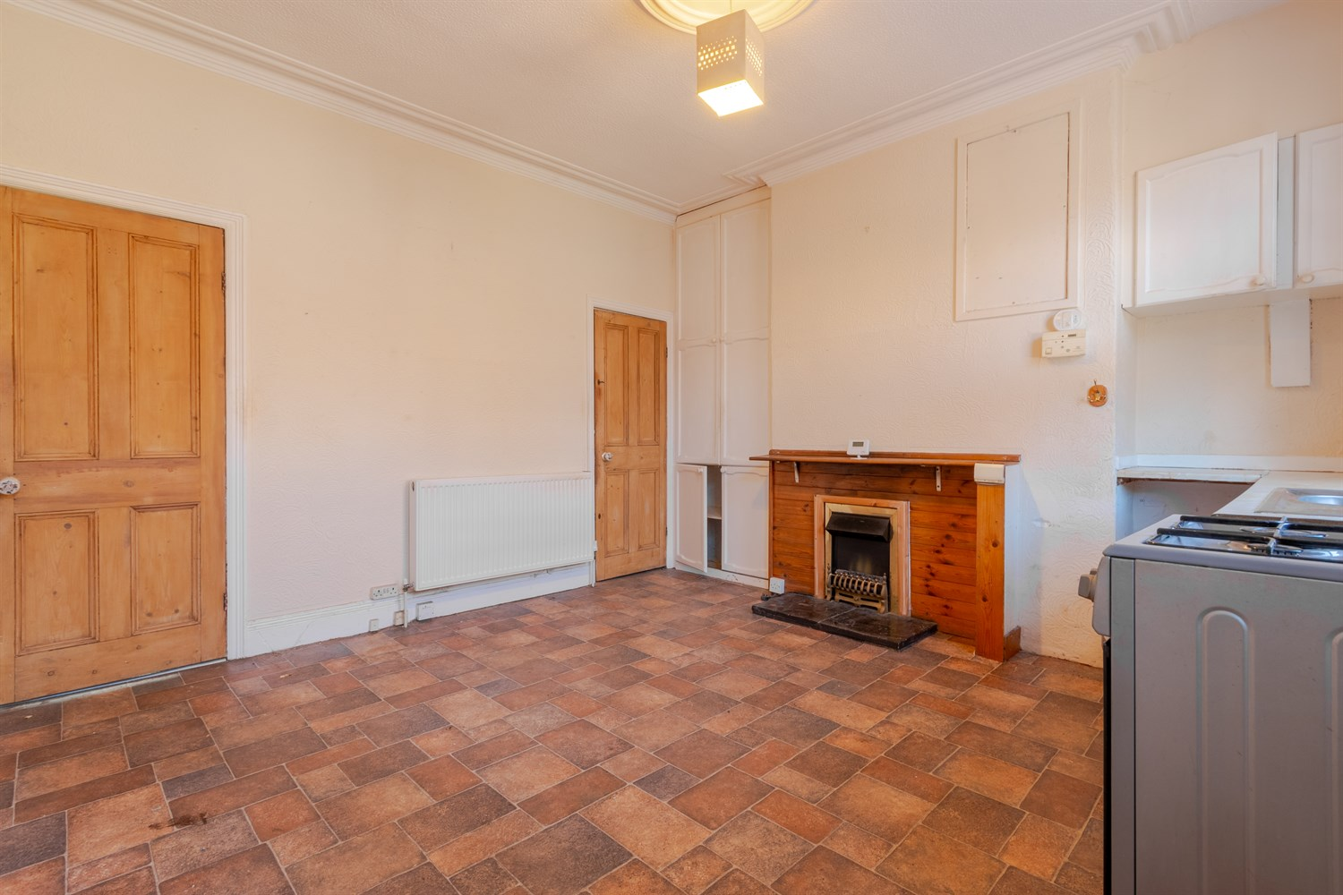

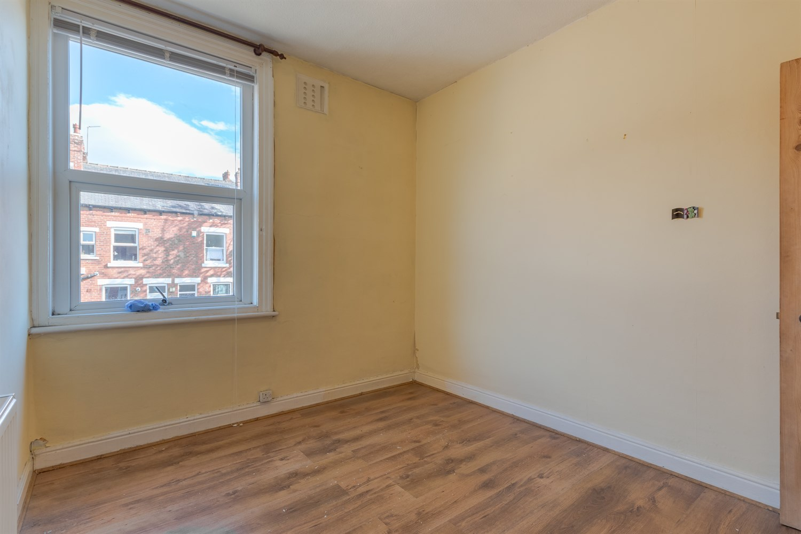

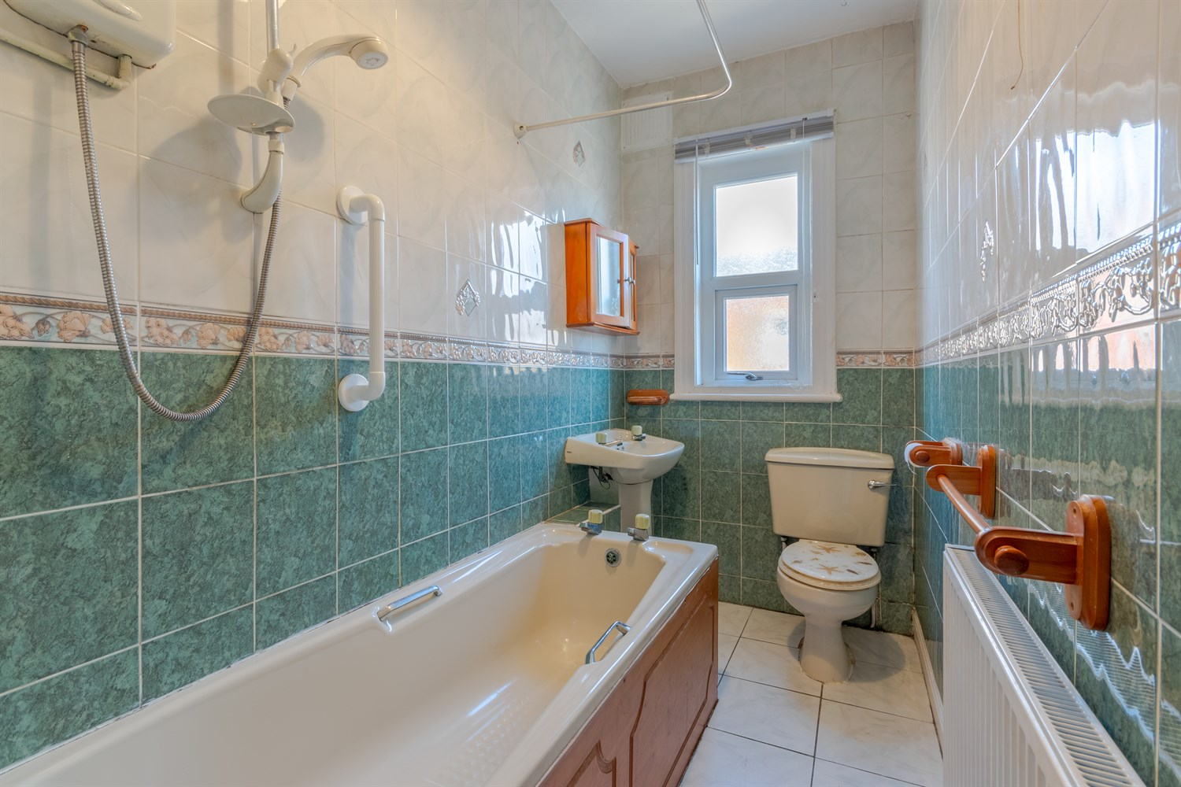

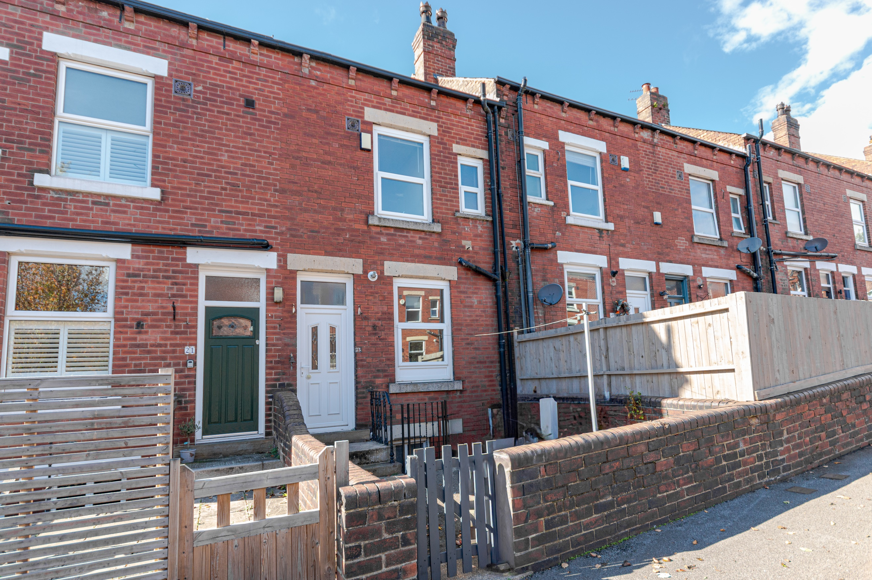

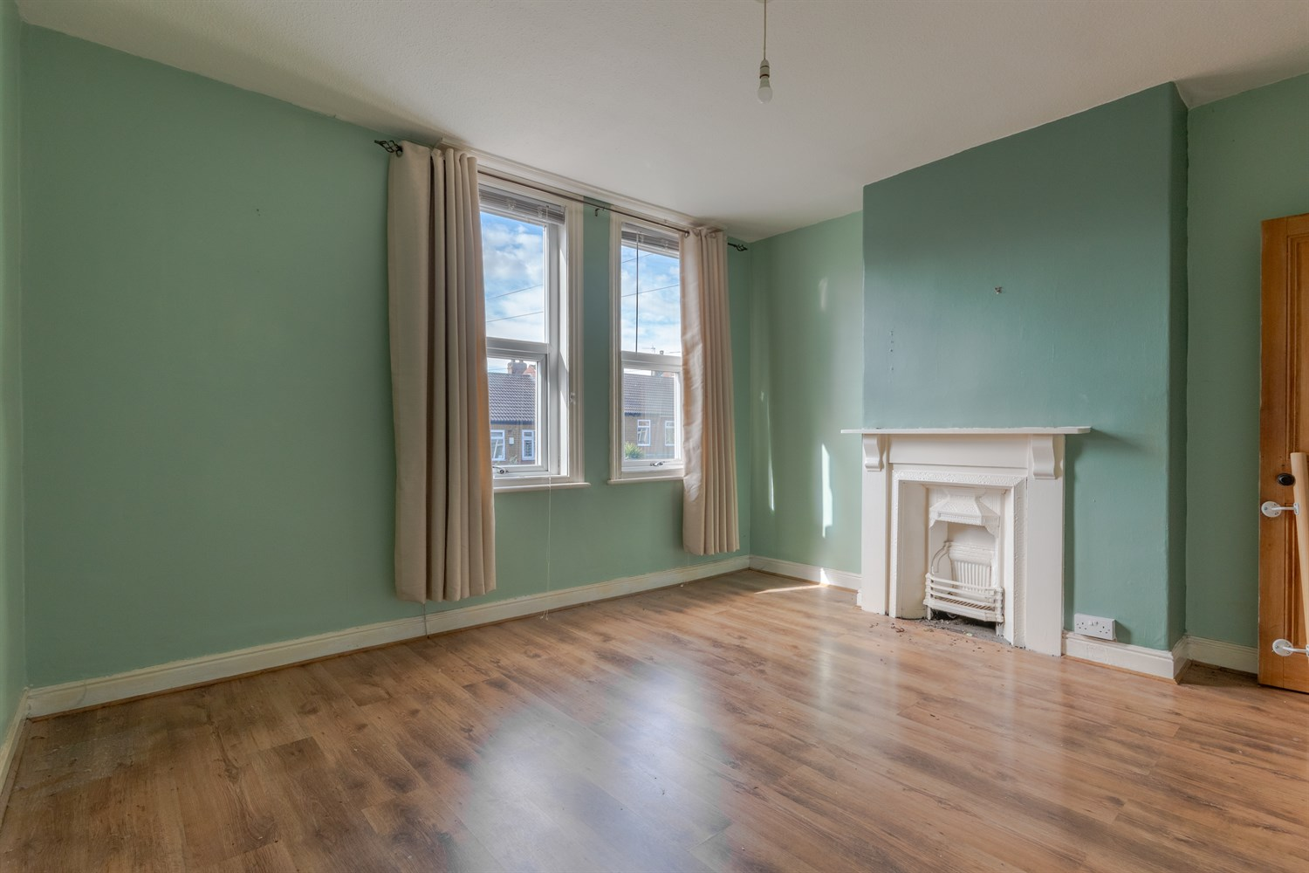

|  |
| --- |
| **Entrance Porch**  Via front entrance door. |
| **Sitting Room 4.08m (13'5) x 4.62m (15'2)**  Light and airy living room with uPVC double glazed window to front. Gas central heating radiator. |
| **Kitchen/Diner 4.08m (13'5) x 3.94m (12'11)**  Spacious kitchen/diner with uPVC double glazed window to front. Gas central heating radiator. uPVC double glazed door to rear. Access to cellar. |
| **Cellar**  Useful storage. |
| **First Floor** |
| **Master Bedroom 4.08m (13'5) x 3.69m (12'1)**  Double bedroom with two uPVC double glazed windows to the front. Gas central heating radiator. Built in cupboard. |
| **Bedroom Two 2.56m (8'5) x 3.1m (10'2)**  Second double bedroom with uPVC double glazed window to rear. Gas central heating radiator. |
| **Bathroom**  Fitted with a three piece suite comprising; bath with shower over, WC and wash hand basin. Tiled walls. Gas central heating radiator. uPVC double glazed window. |
| **Second Floor** |
| **Bedroom Three 4.08m (13'5) x 2.94m (9'8)**  Third double bedroom with Velux window. Gas central heating radiator. |
| **Bedroom Four 4.08m (13'5) x 2.43m (8')**  Fourth double bedroom with uPVC double glazed window to front. Gas central heating radiator. |
| **Outside**  Enclosed courtyard style garden to the front and rear. |

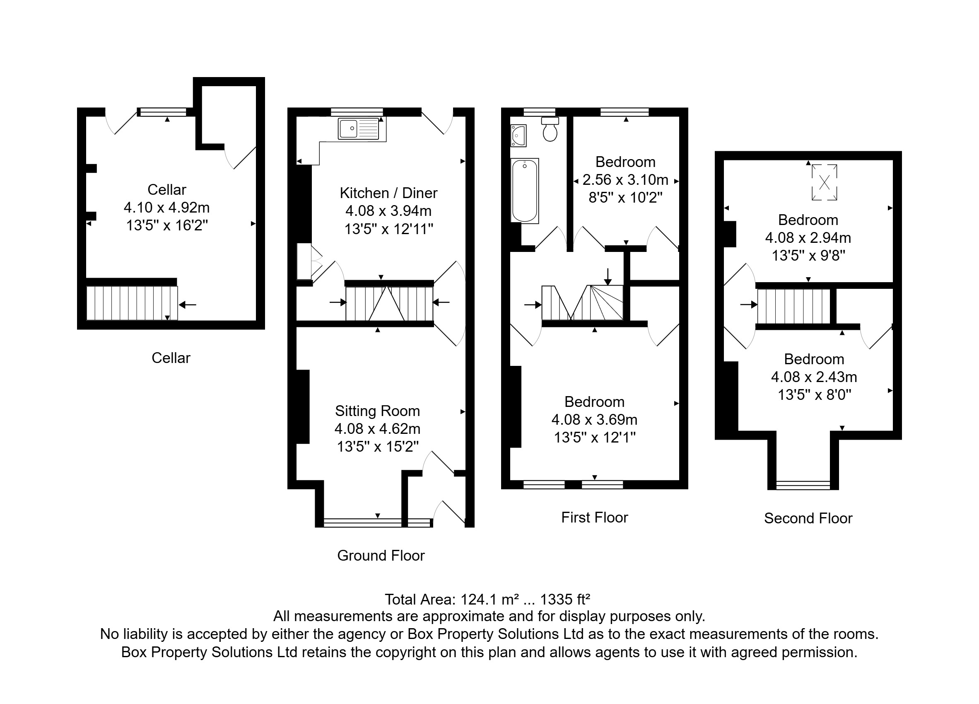

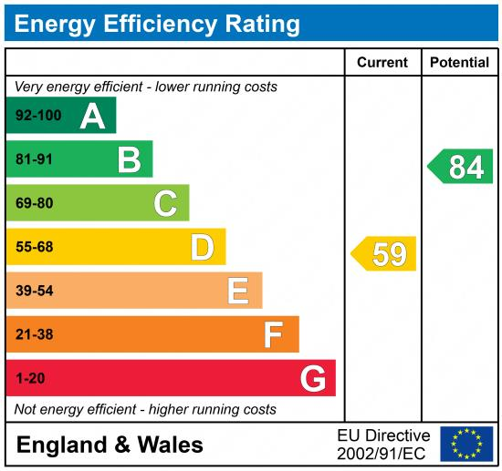

|  |
| --- |
|  |

These particulars are intended to give a fair description of the property, but their accuracy cannot be guaranteed, and they do not constitute an offer of contract. Intending purchasers must rely on their own inspection of the property. None of the above appliances/services have been tested by ourselves. We recommend purchasers arrange for a qualified person to check all appliances/services before legal commitment.

**Property Ref:** 7741

**For more information, please contact**

0113 258 1150 **|** [sales@adairpaxton.co.uk](mailto:sales@adairpaxton.co.uk) **|** www.adairpaxton.co.uk