
The Highlands, Harrogate Road
For Sale £249,950.00

**TWO BEDROOM, TWO BATHROOM FIRST FLOOR APARTMENT with NO ONWARD CHAIN** This purpose built development of luxury apartments on Harrogate Road in Alwoodley offers comfortable and secure living for OVER 50's. The property offers secure underground parking, a video/intercom entry system, a concierge and lifts to all floors. This spacious first floor apartment briefly comprises; communal entrance, private entrance hall, study, lounge, dining room with access to a larger than average balcony, kitchen, master bedroom with en-suite bathroom, second double bedroom and house bathroom. The master bedroom and second double bedroom both offer extensive fitted wardrobes and storage. The local area offers amenities including a Marks and Spencer's food hall, David Lloyd Leisure Centre, a selection of top golf courses and the nearby Roundhay and Golden Acre Parks. There are good local transport links providing access into Leeds City Centre and surrounding areas, and the Ring Road is close by for those requiring access to motorway networks leading to Wetherby, Harrogate, York and further afield.
0113 258 1150
0800 000 000
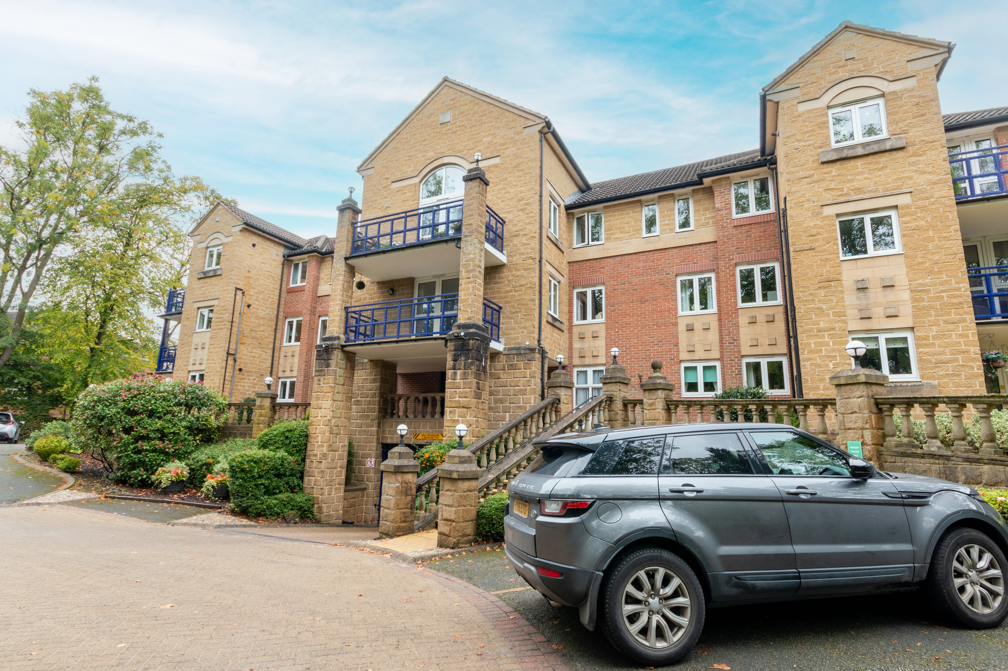
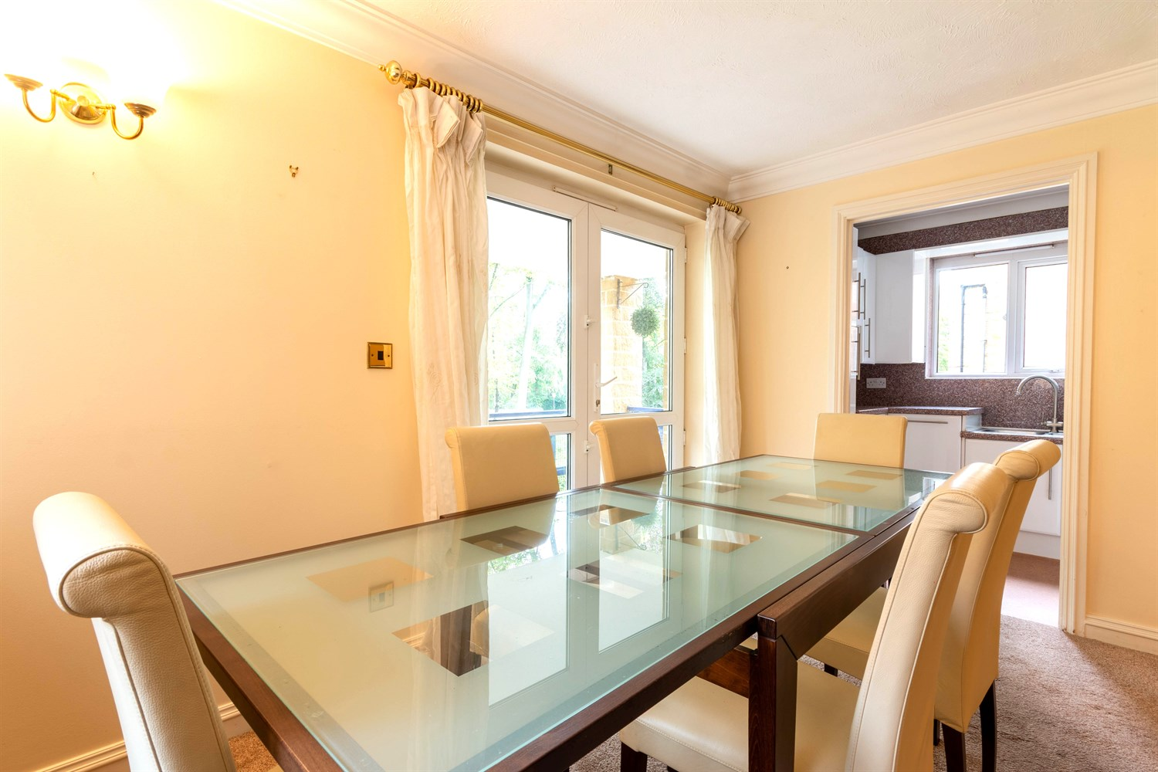
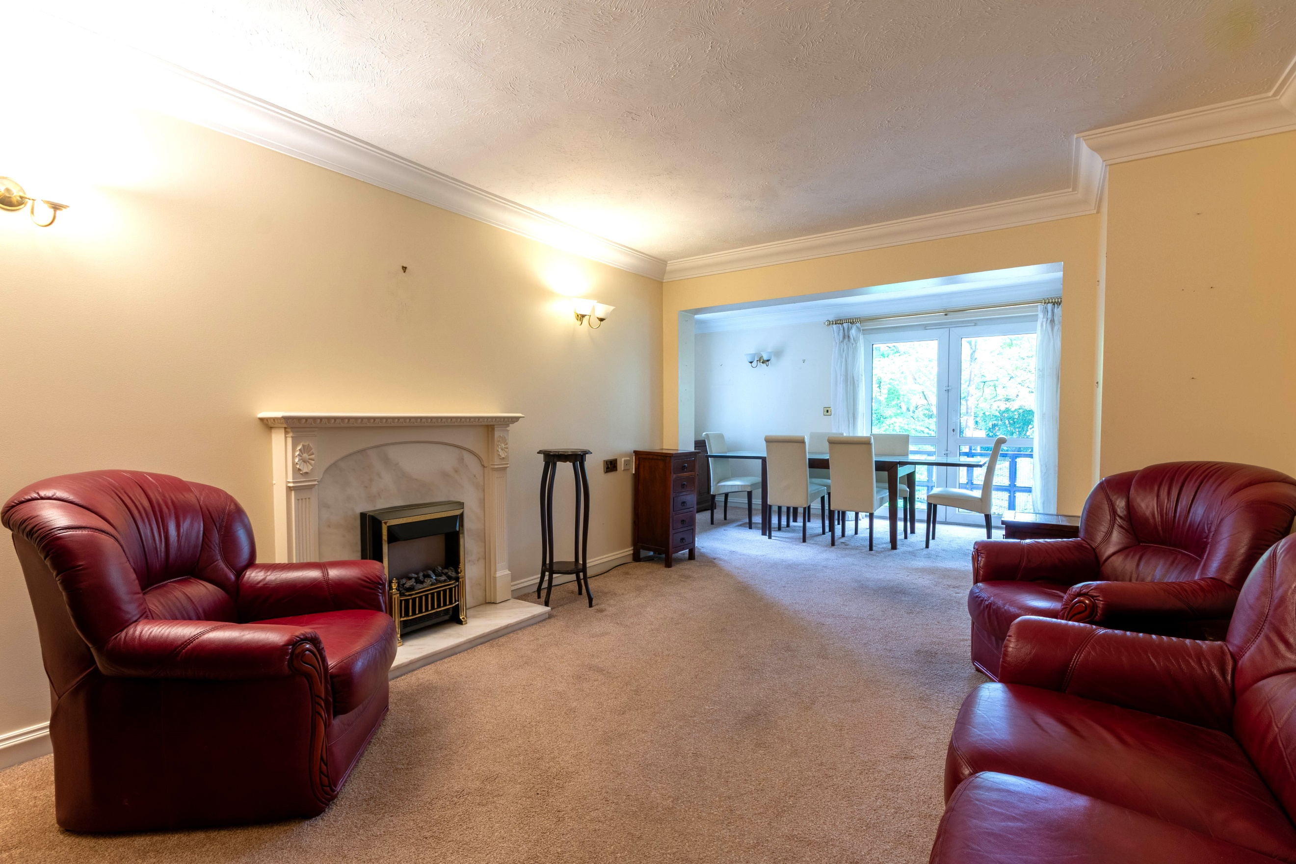
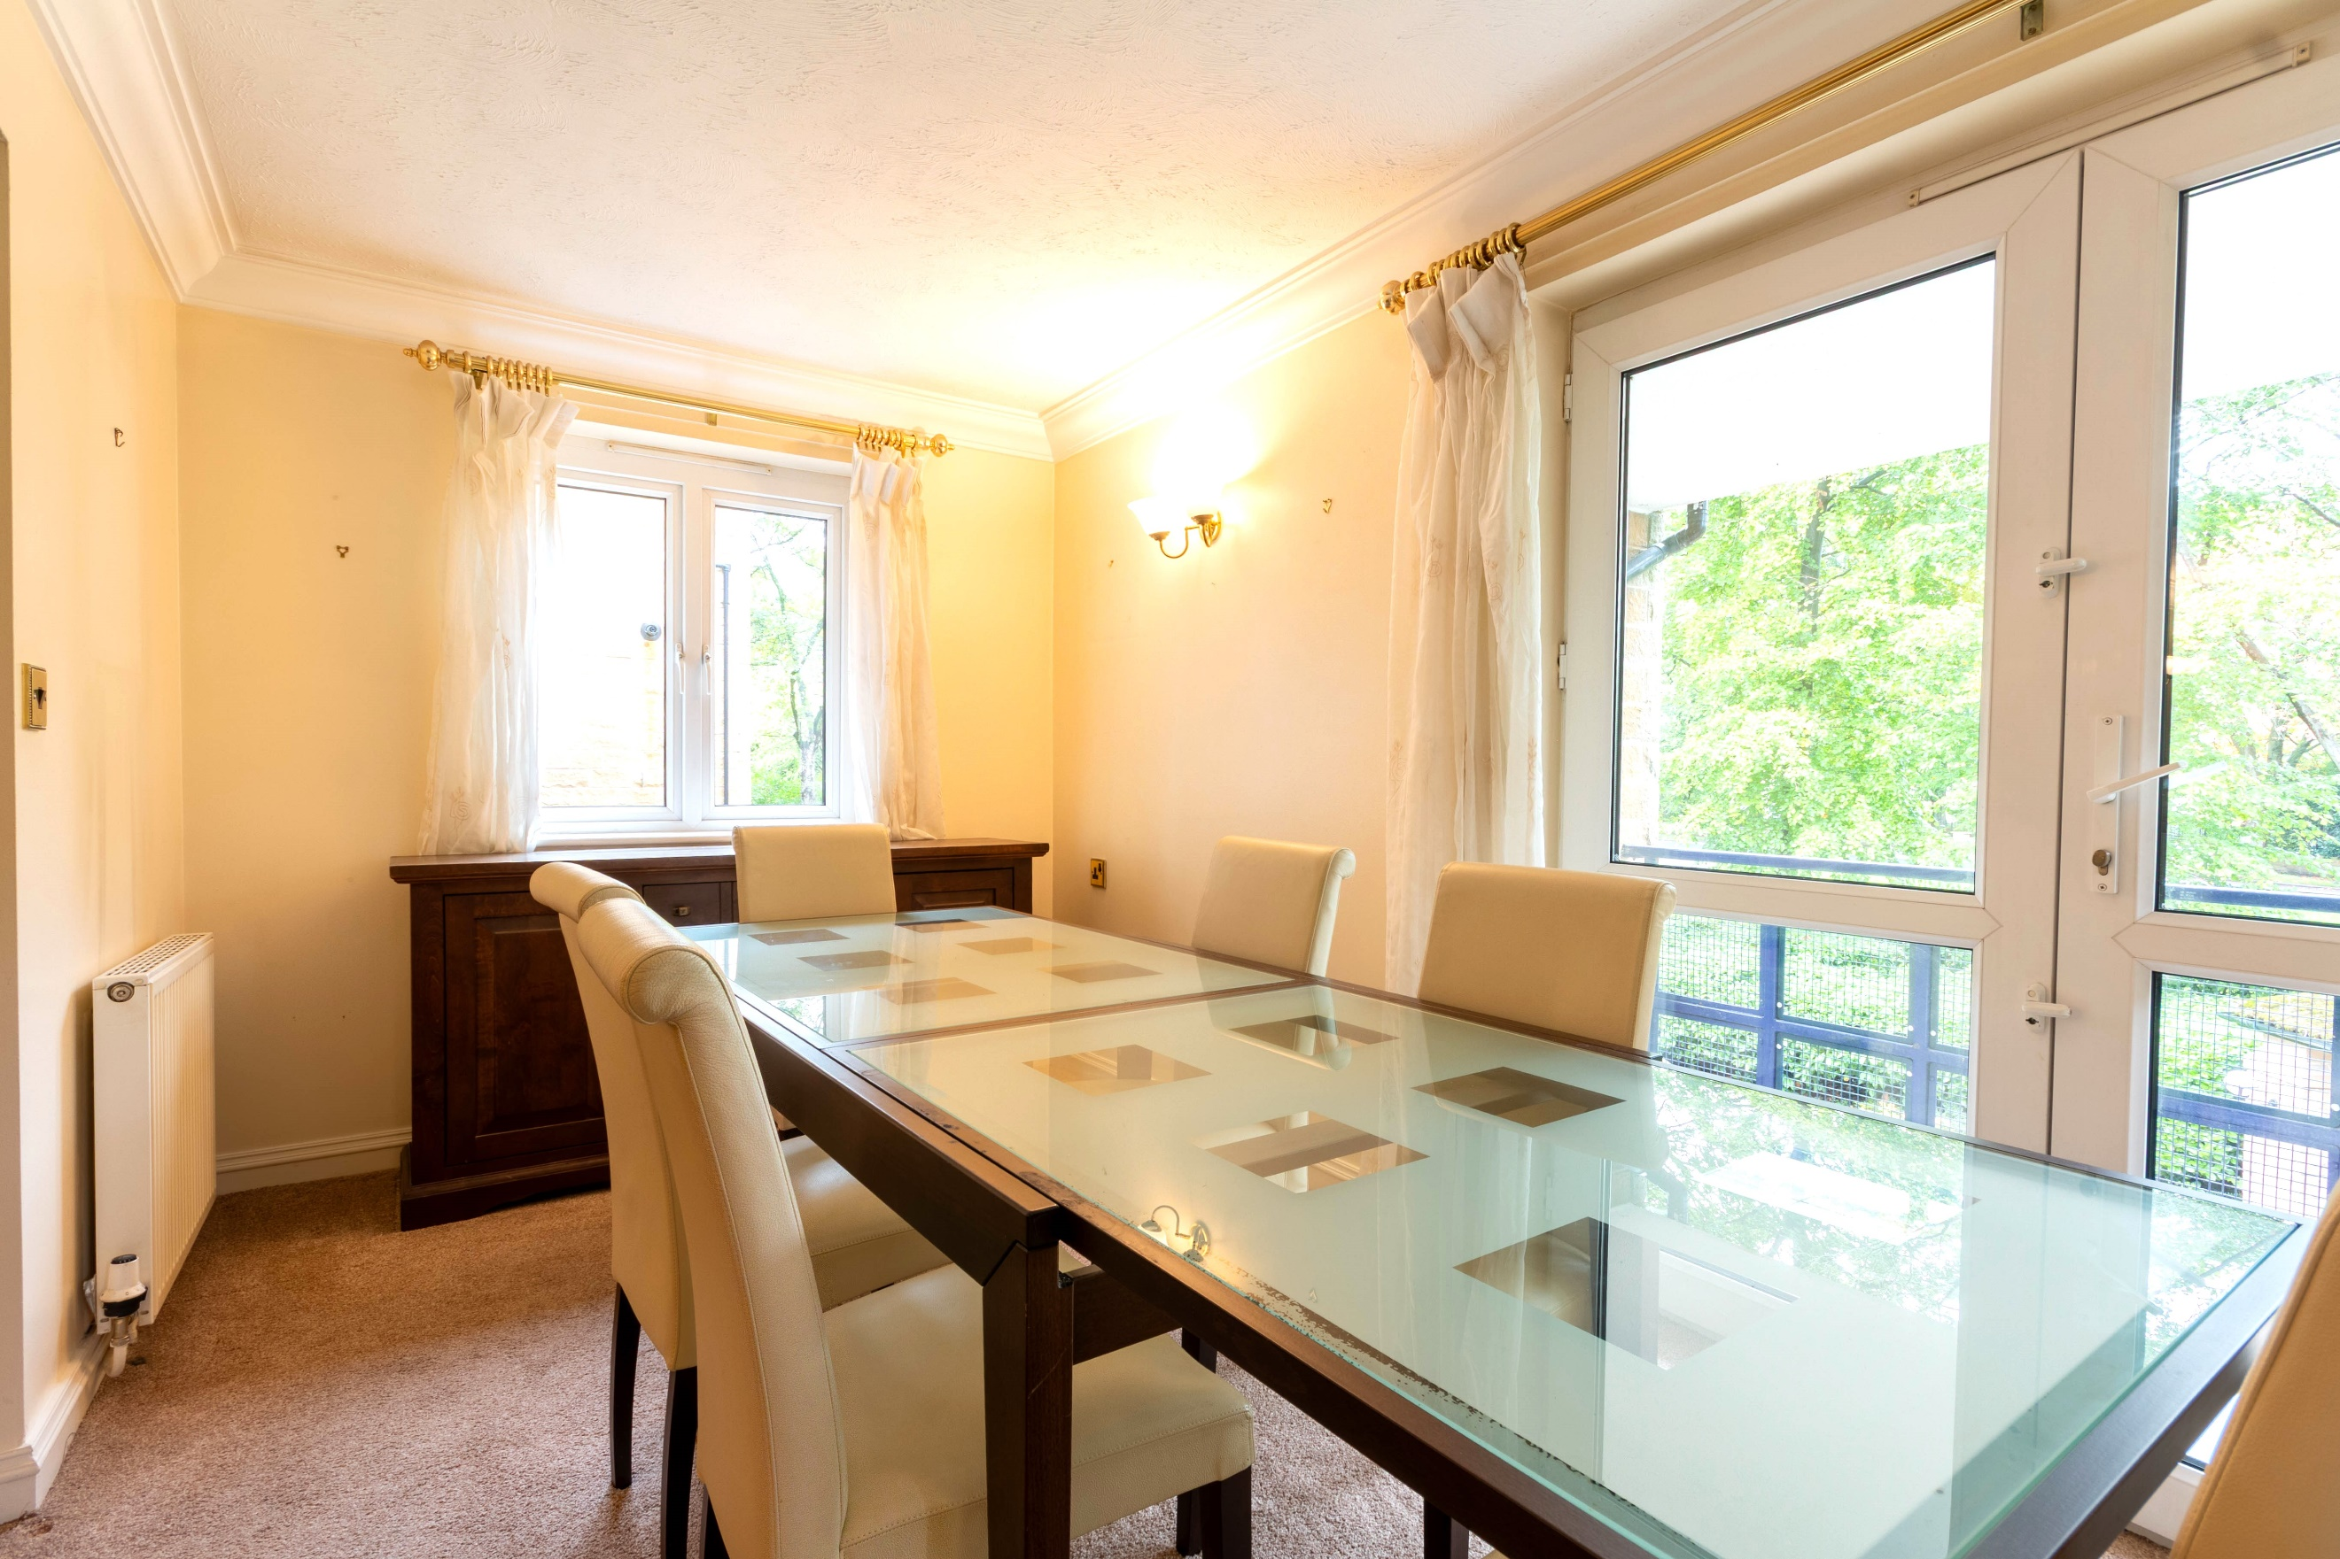
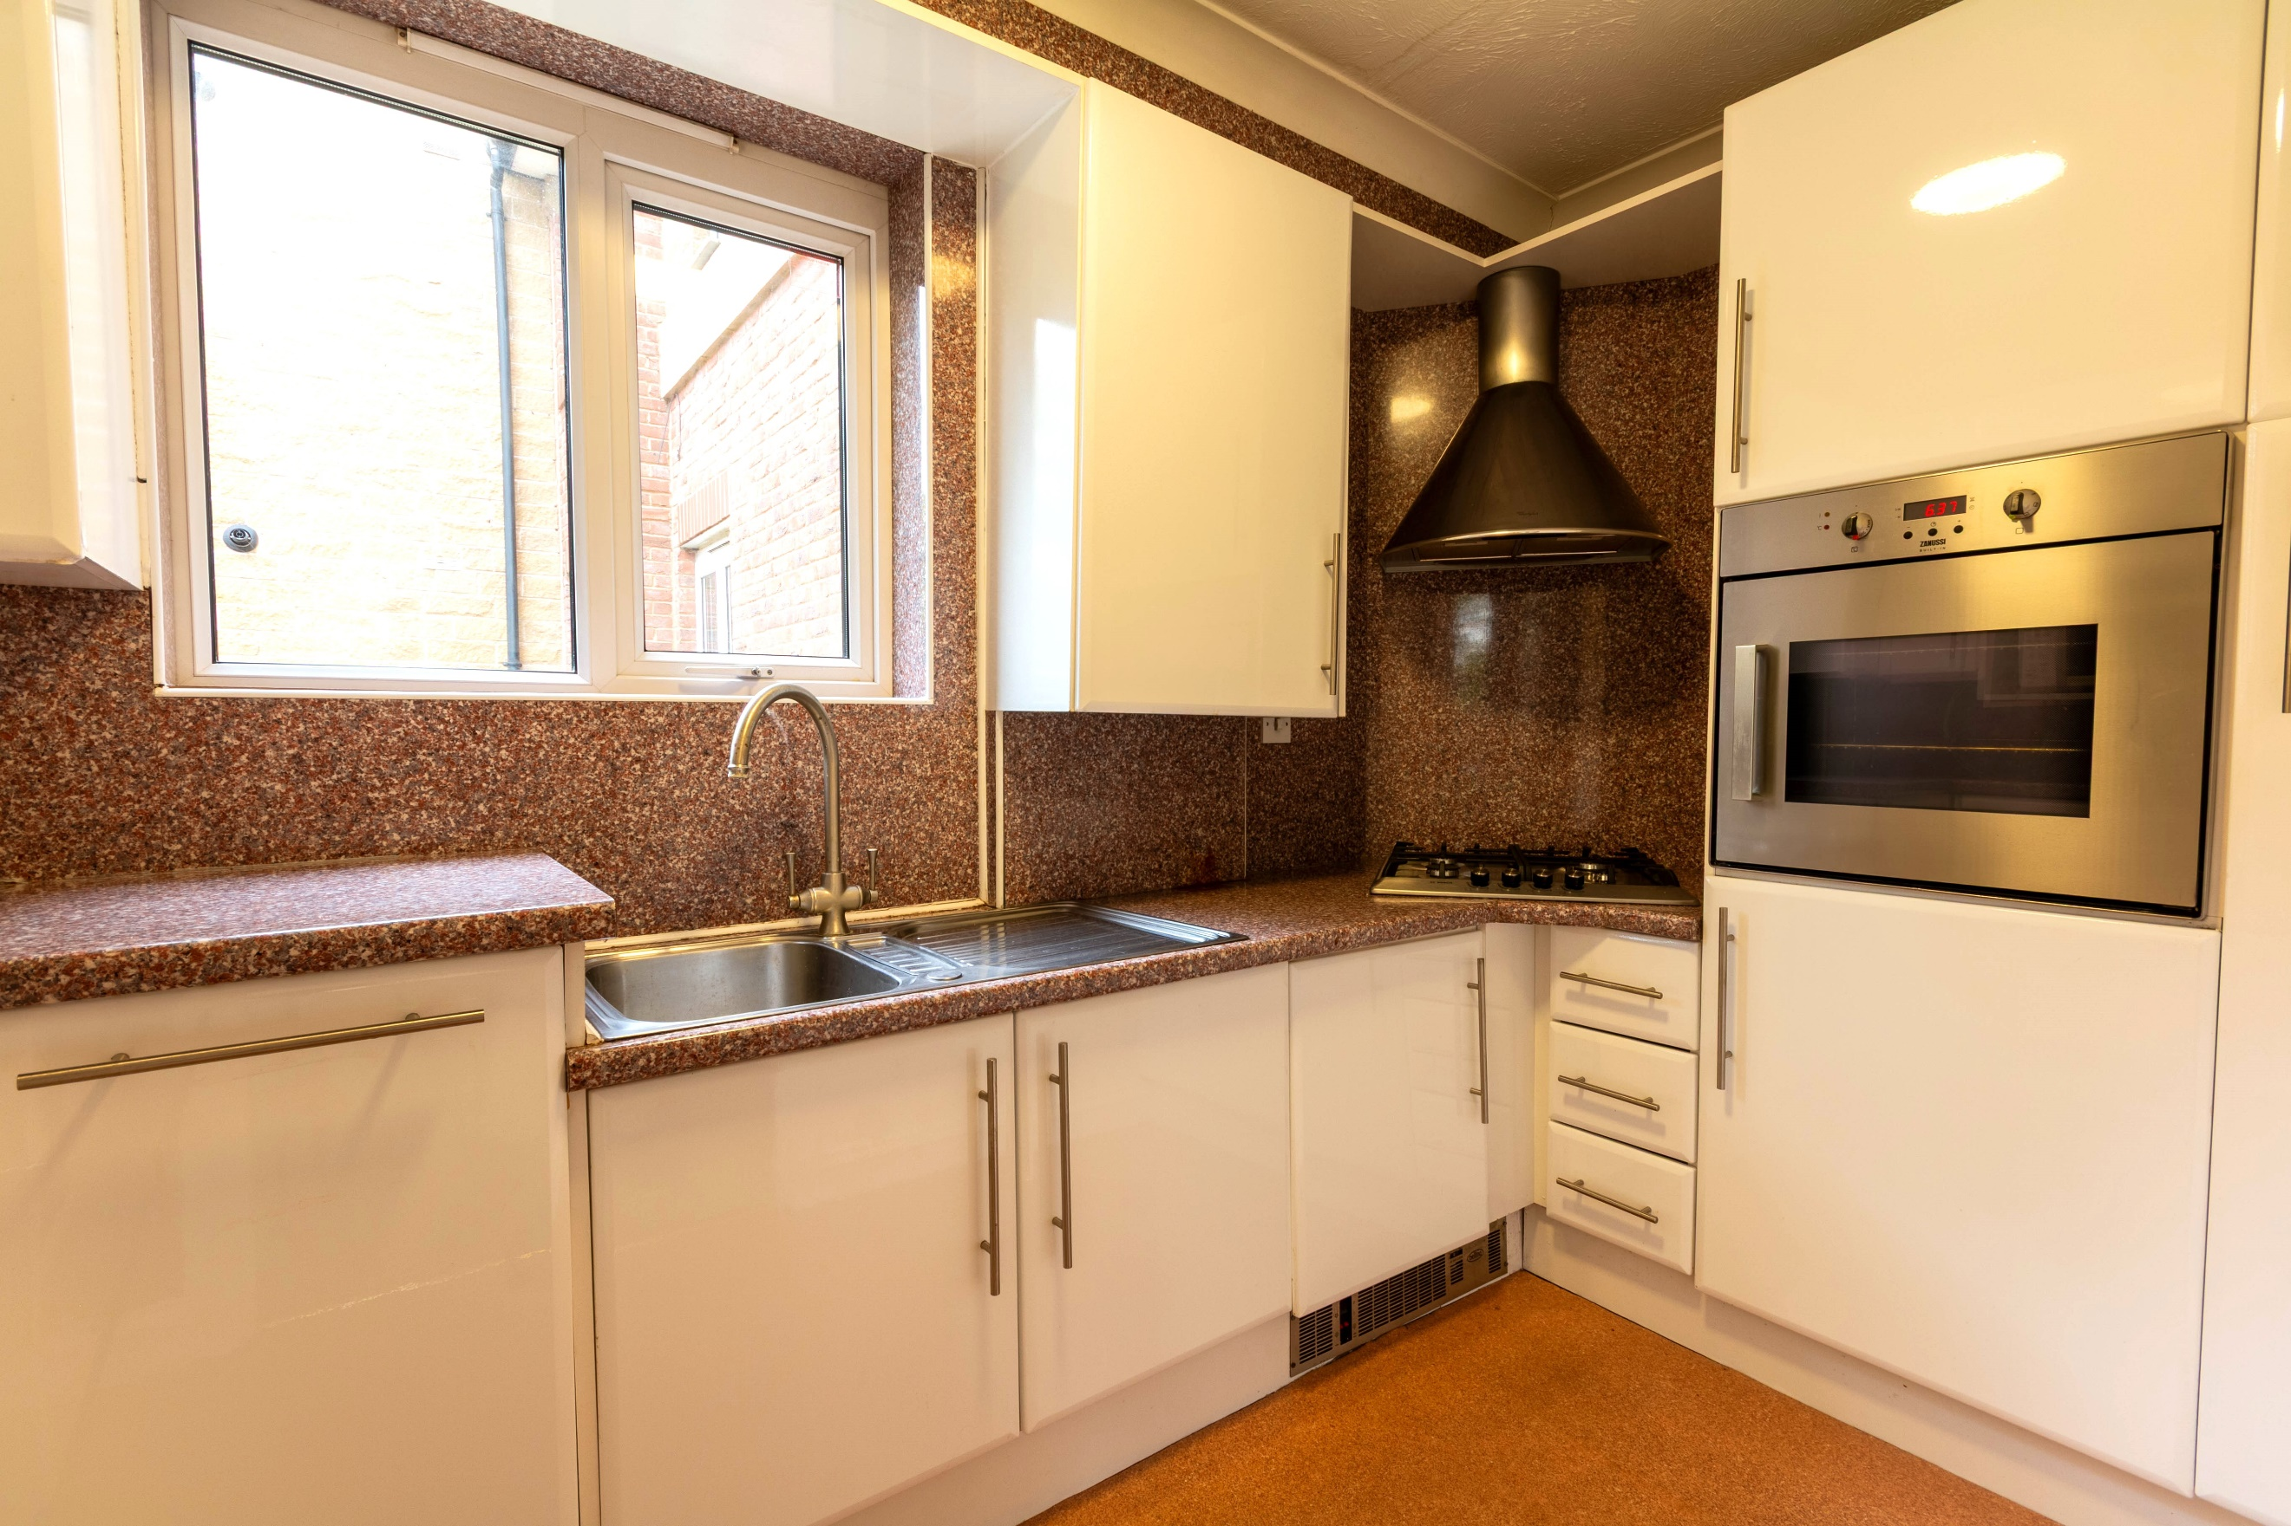
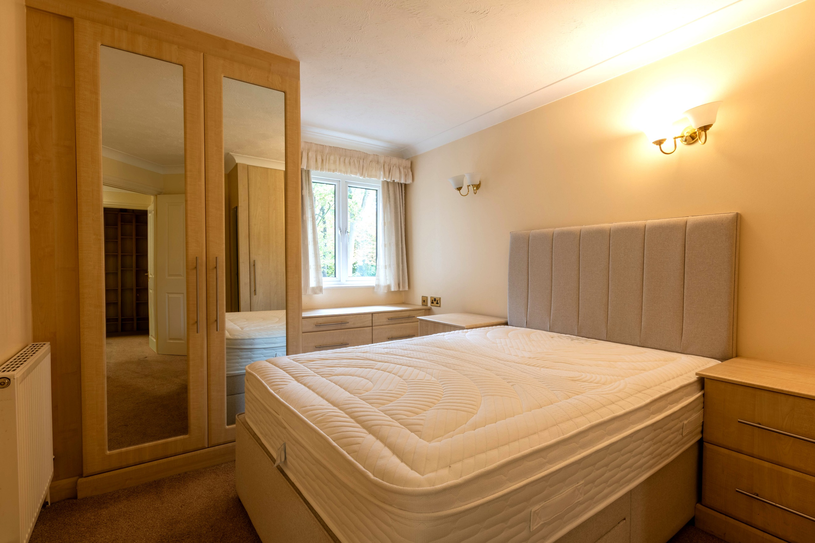
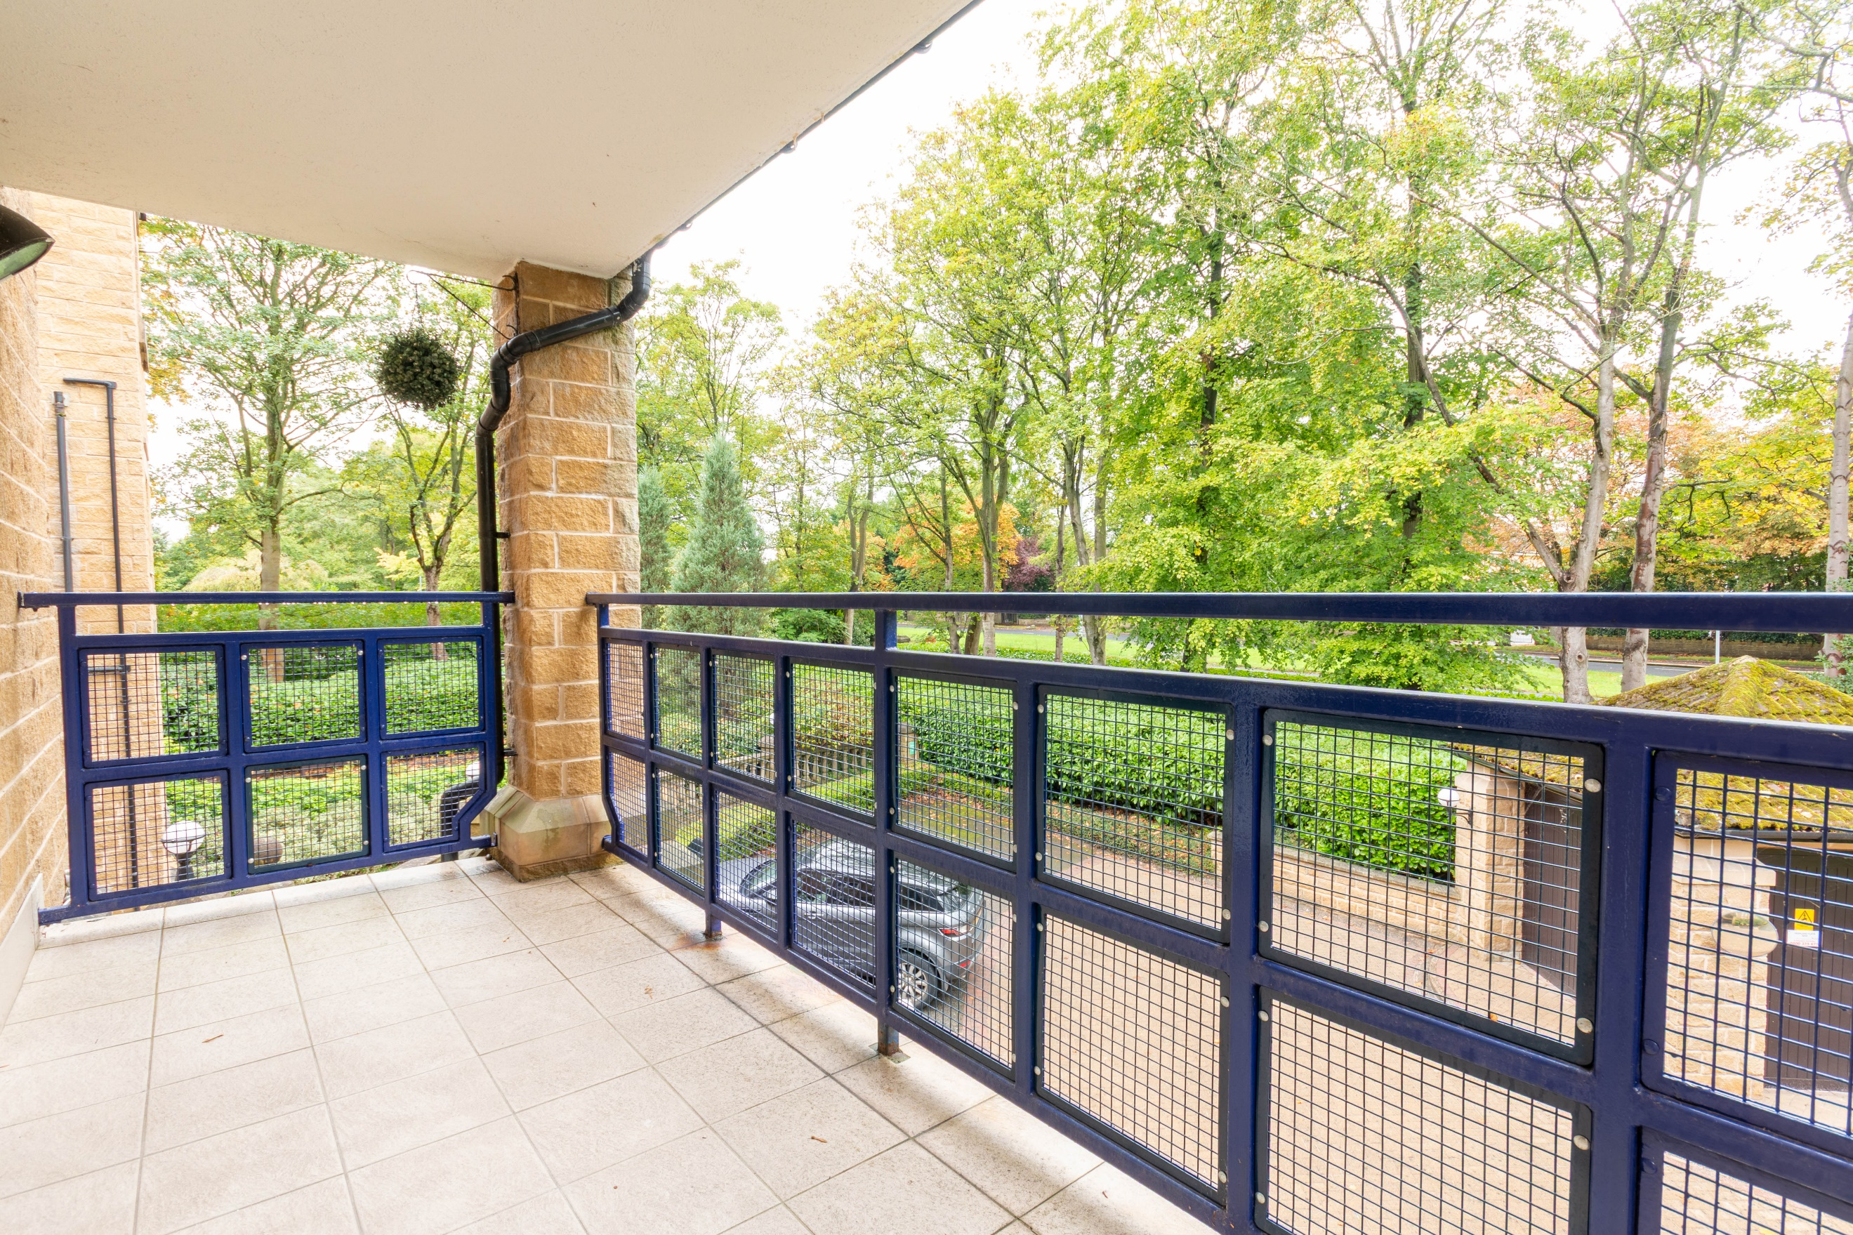
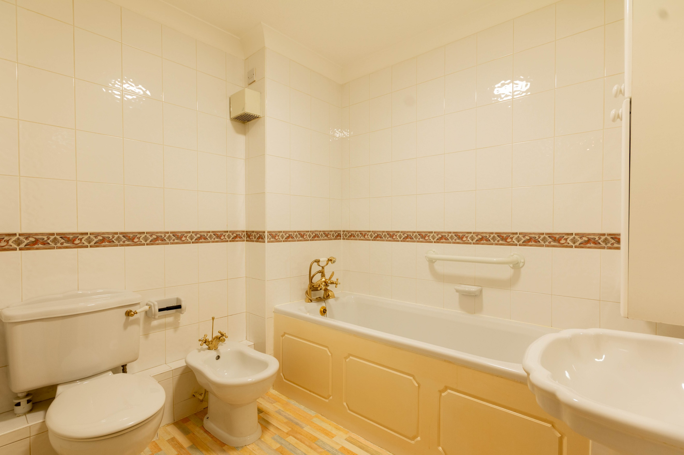
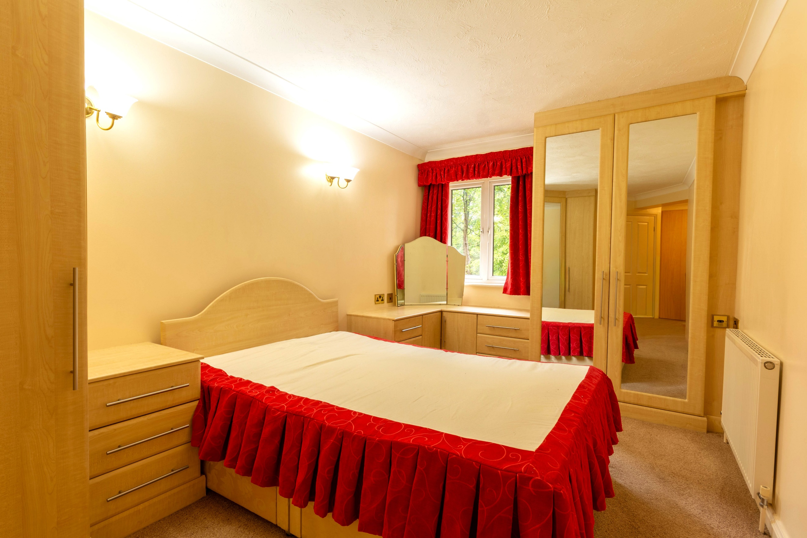

Communal Entrance
Secure entry phone system. stairs and lift to all floors.

Entrance Hallway
Spacious entrance hall with large store cupboard and built in cupboards. Secure entry phone system.

Study 2.6m (8'6) x 1.16m (3'10)
Home office.

Sitting Room 3.49m (11'5) x 4.68m (15'4)
Spacious sitting room opening to the dining room. Gas central heating radiator.

Dining Room 4.07m (13'4) x 2.38m (7'10)
Light and airy dining area with uPVC double glazed window to side and uPVC double door leading out the balcony. Gas central heating radiator.

Kitchen 1.8m (5'11) x 3.25m (10'8)
Fitted with a range of wall, base and drawer units with worktops over. 4-ring gas hob with extractor hood over. Integrated oven, dishwasher, fridge and washing machine. uPVC double glazed window. Stainless steel sink with mixer tap and drainer.

Master Bedroom 2.65m (8'8) x 4.68m (15'4)
Double bedroom with uPVC double glazed window. Gas central heating radiator. Built in wardrobes and drawers.

En-Suite Bathroom
Fitted with a four piece suite comprising; bath with hand shower over, WC, wash hand basin and bidet. Tiled walls.

Bedroom Two 2.81m (9'3) x 4.11m (13'6)
Second double bedroom with uPVC double glazed window. Gas central heating radiator. Built in wardrobes, bedside tables and drawers.

Shower Room
Fitted with a three piece suite comprising; shower cubicle, WC and wash hand basin. Tiled walls.

Tenure
Leasehold - 125 years from 1 August 1997
Ground rent - £715 per annum

Service Charge
The service charges are £286.51 per month.

Communal Garden
Well maintained communal gardens. Secure allocated Parking.

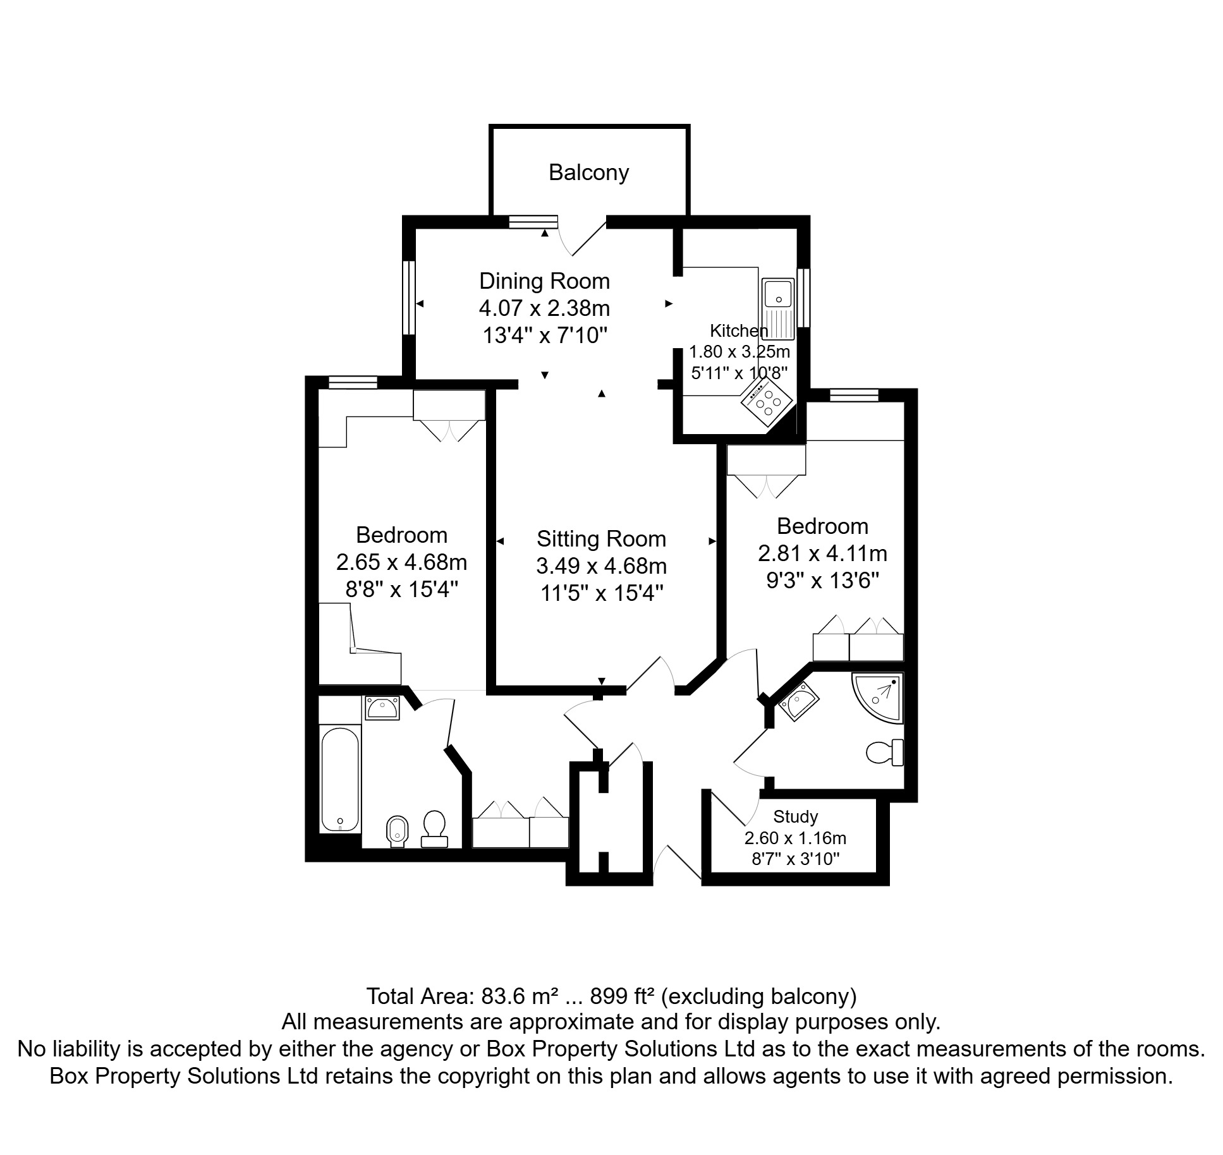

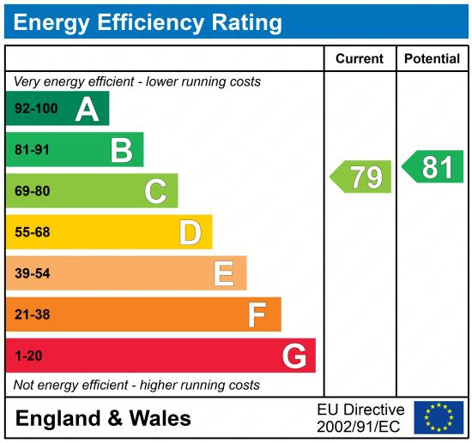

These particulars are intended to give a fair description of the property, but their accuracy cannot be guaranteed, and they do not constitute an offer of contract. Intending purchasers must rely on their own inspection of the property. None of the above appliances/services have been tested by ourselves. We recommend purchasers arrange for a qualified person to check all appliances/services before legal commitment.

Property Ref: 7687

For more information, please contact

0113 258 1150 | sales@adairpaxton.co.uk | www.adairpaxton.co.uk

