
Foundry Lane, Leeds
For Sale £239,950.00

**THREE BEDROOM SEMI-DETACHED HOUSE - NO ONWARD CHAIN** Adair Paxton are pleased to offer to the market this three bedroom semi-detached family home in this convenient area of Leeds 14. This spacious property is ready to move into and briefly comprises; entrance hall, lounge, open plan kitchen/diner and guest WC to the ground floor. To the first floor there are two double bedrooms, a single bedroom and a house bathroom. Externally, the property has a driveway offering off street parking and lawned gardens to the front and rear.
0113 258 1150
0800 000 000
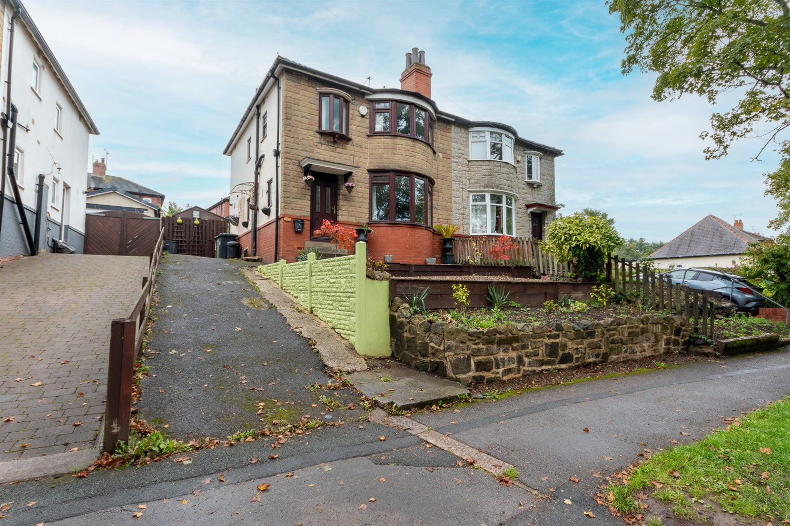



2 Receptions
1 Bathroom
3 Bedrooms
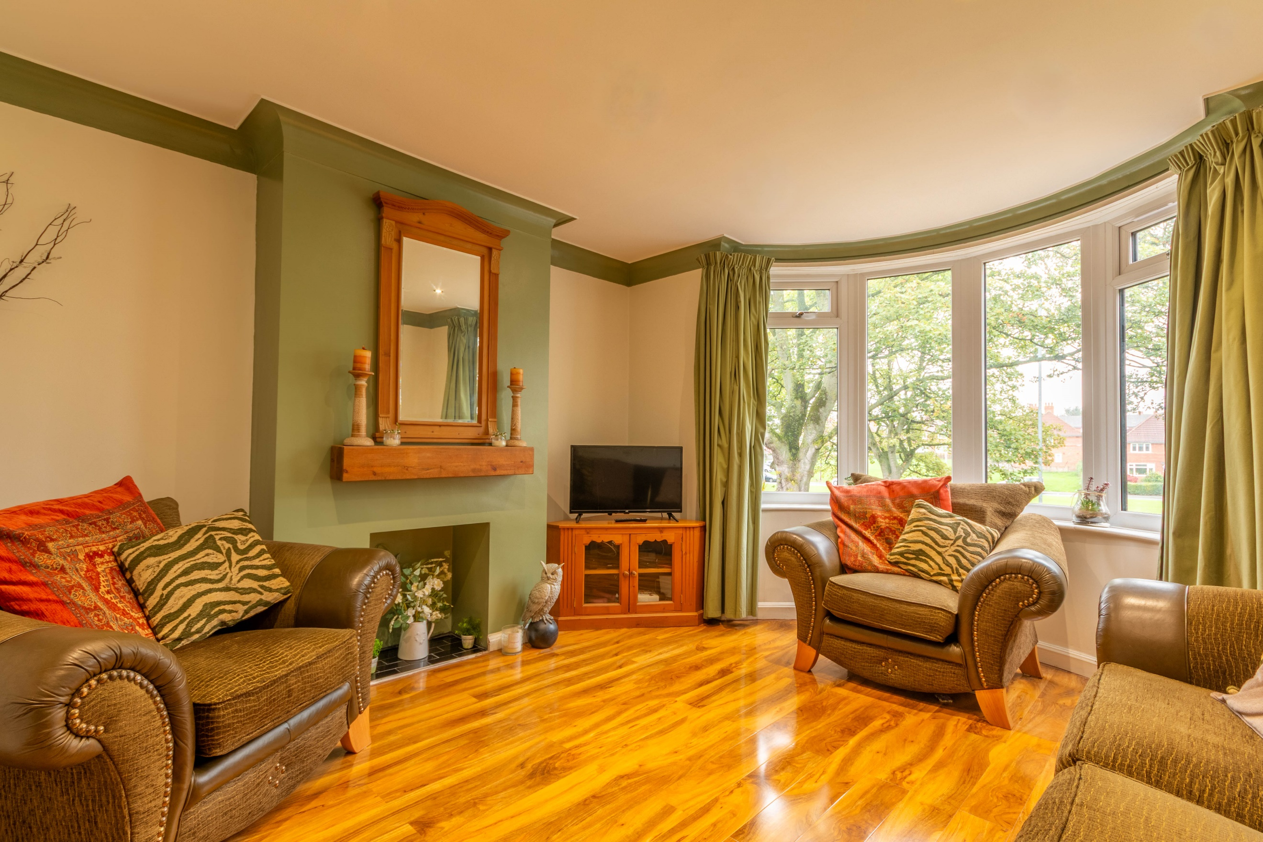
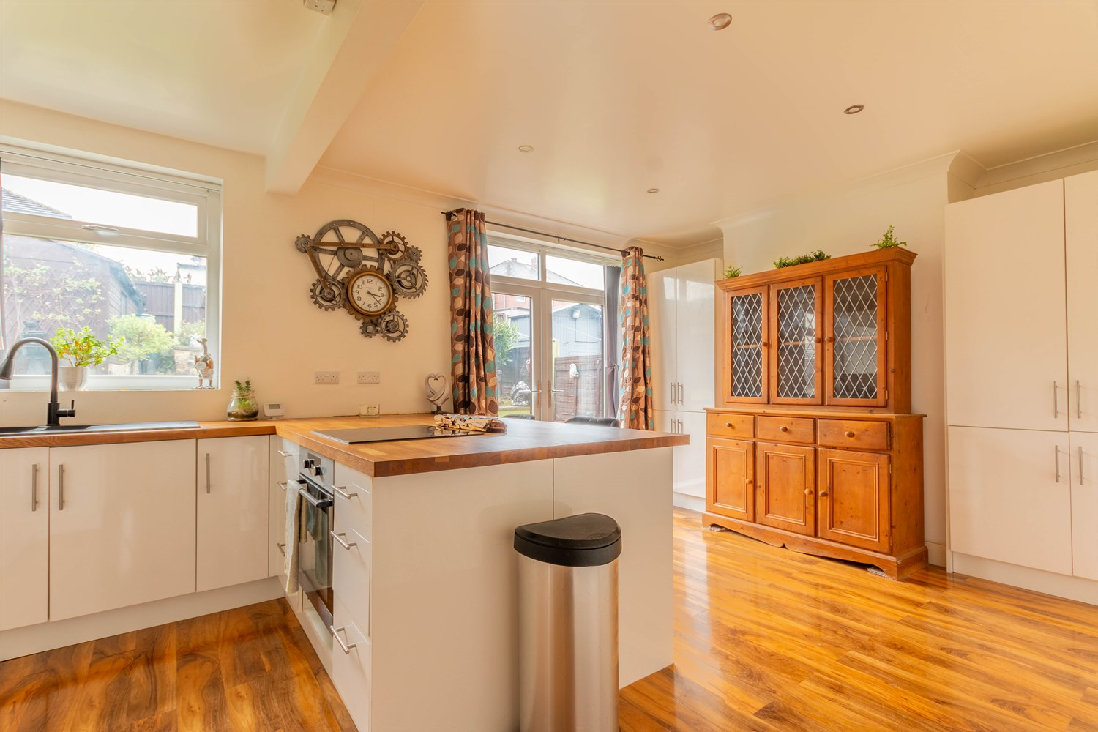
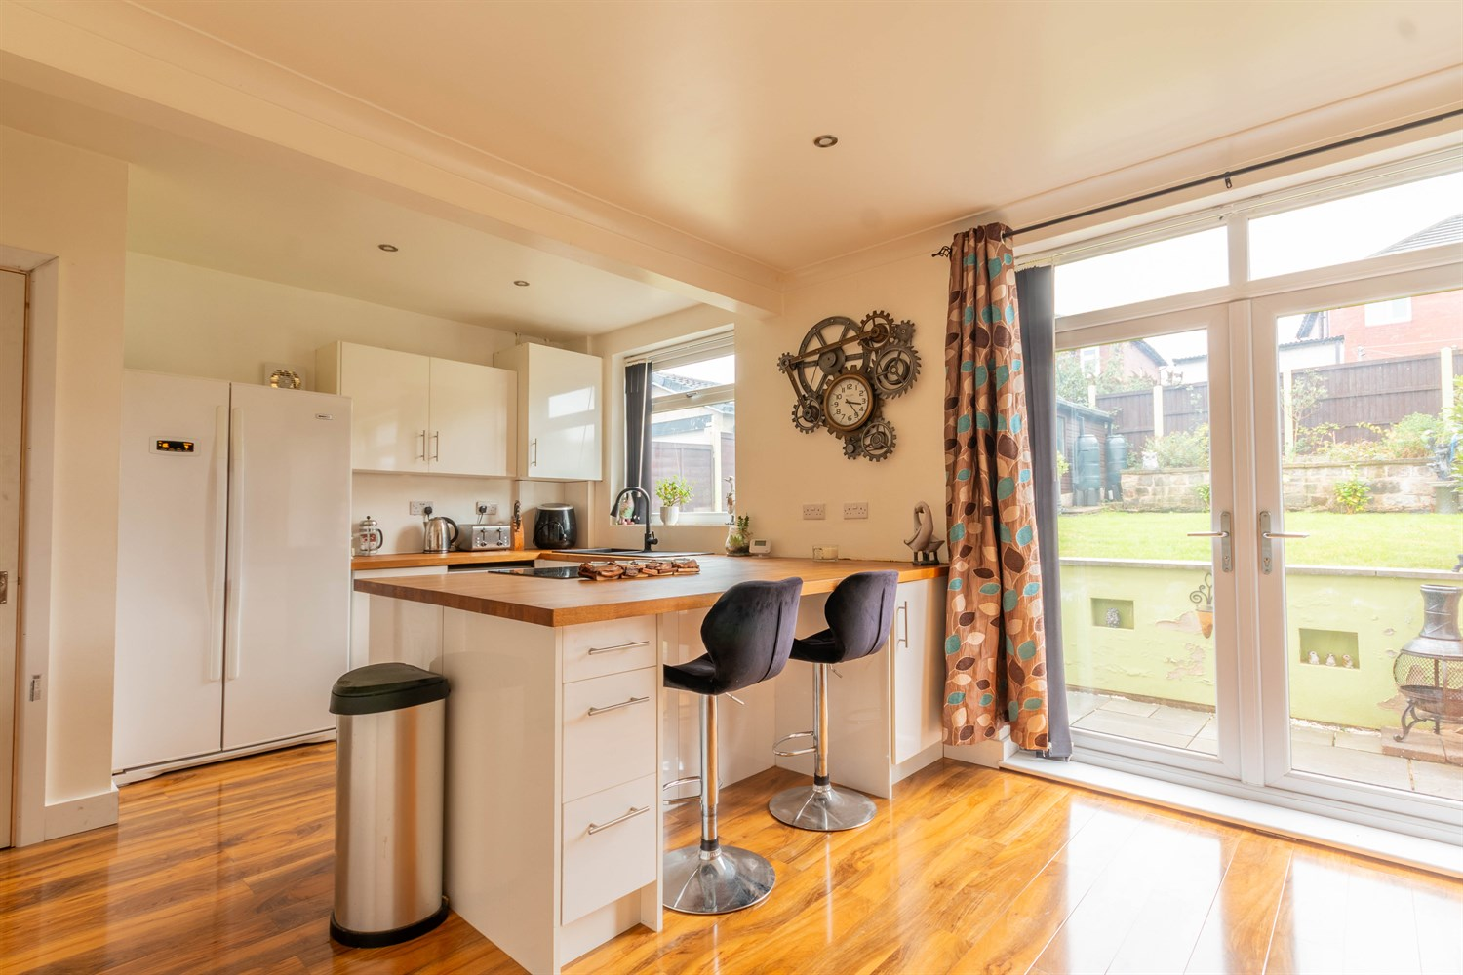
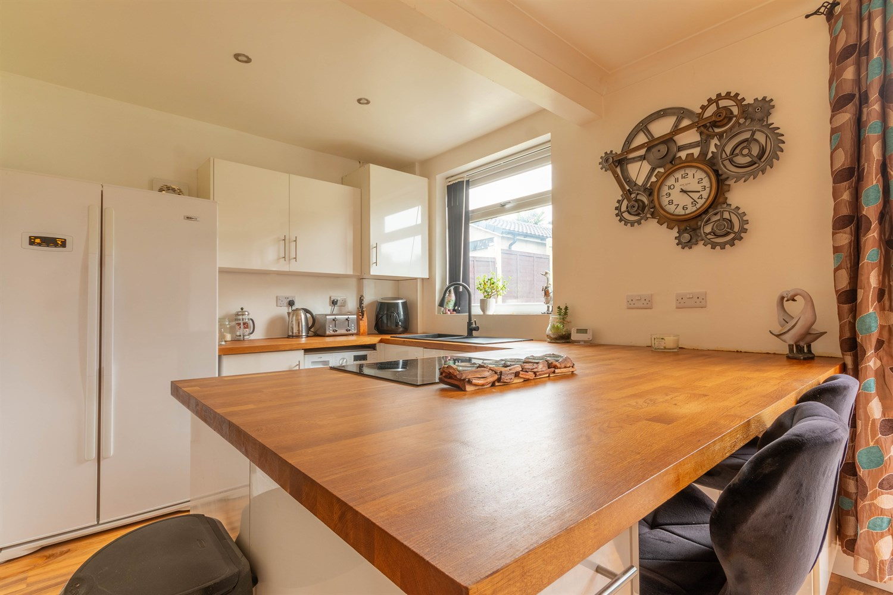
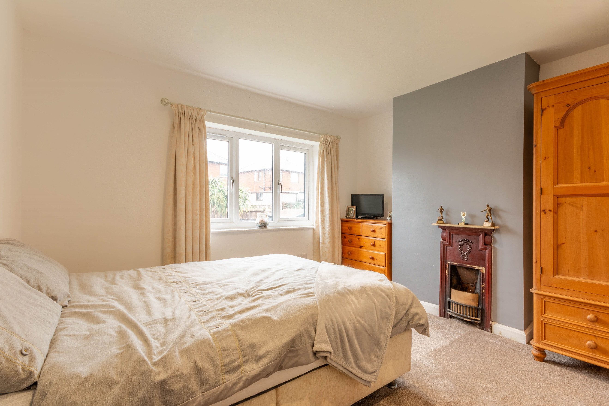
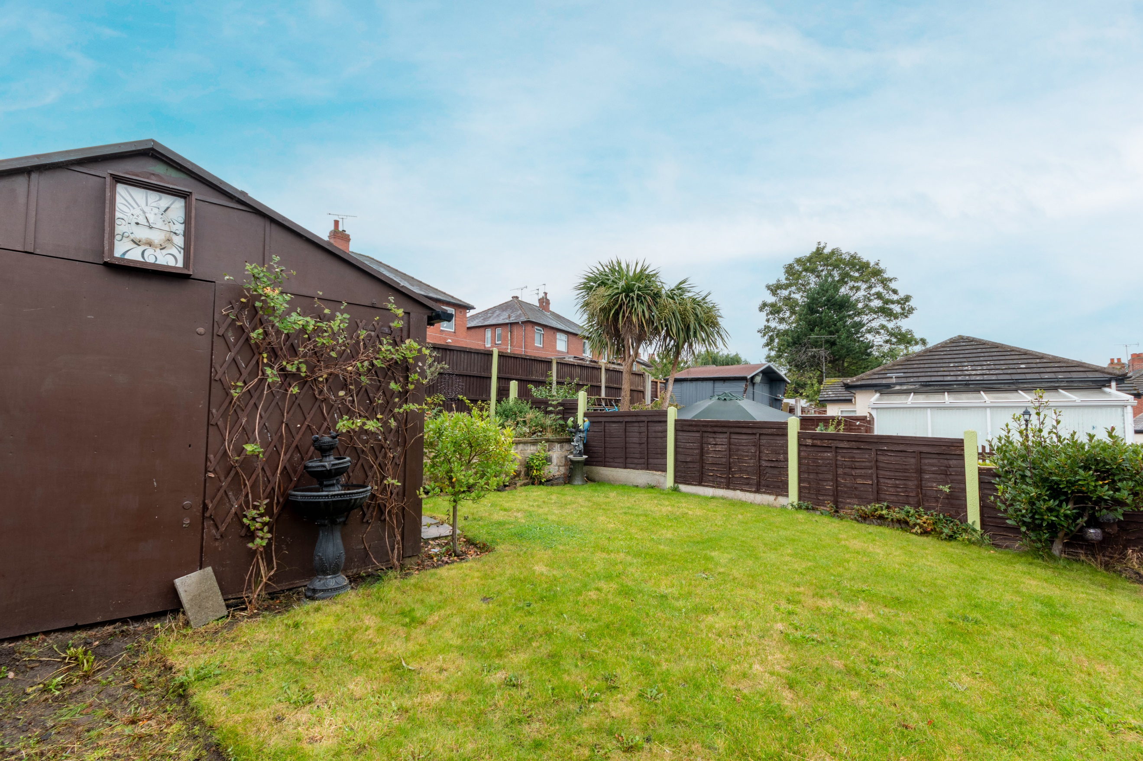
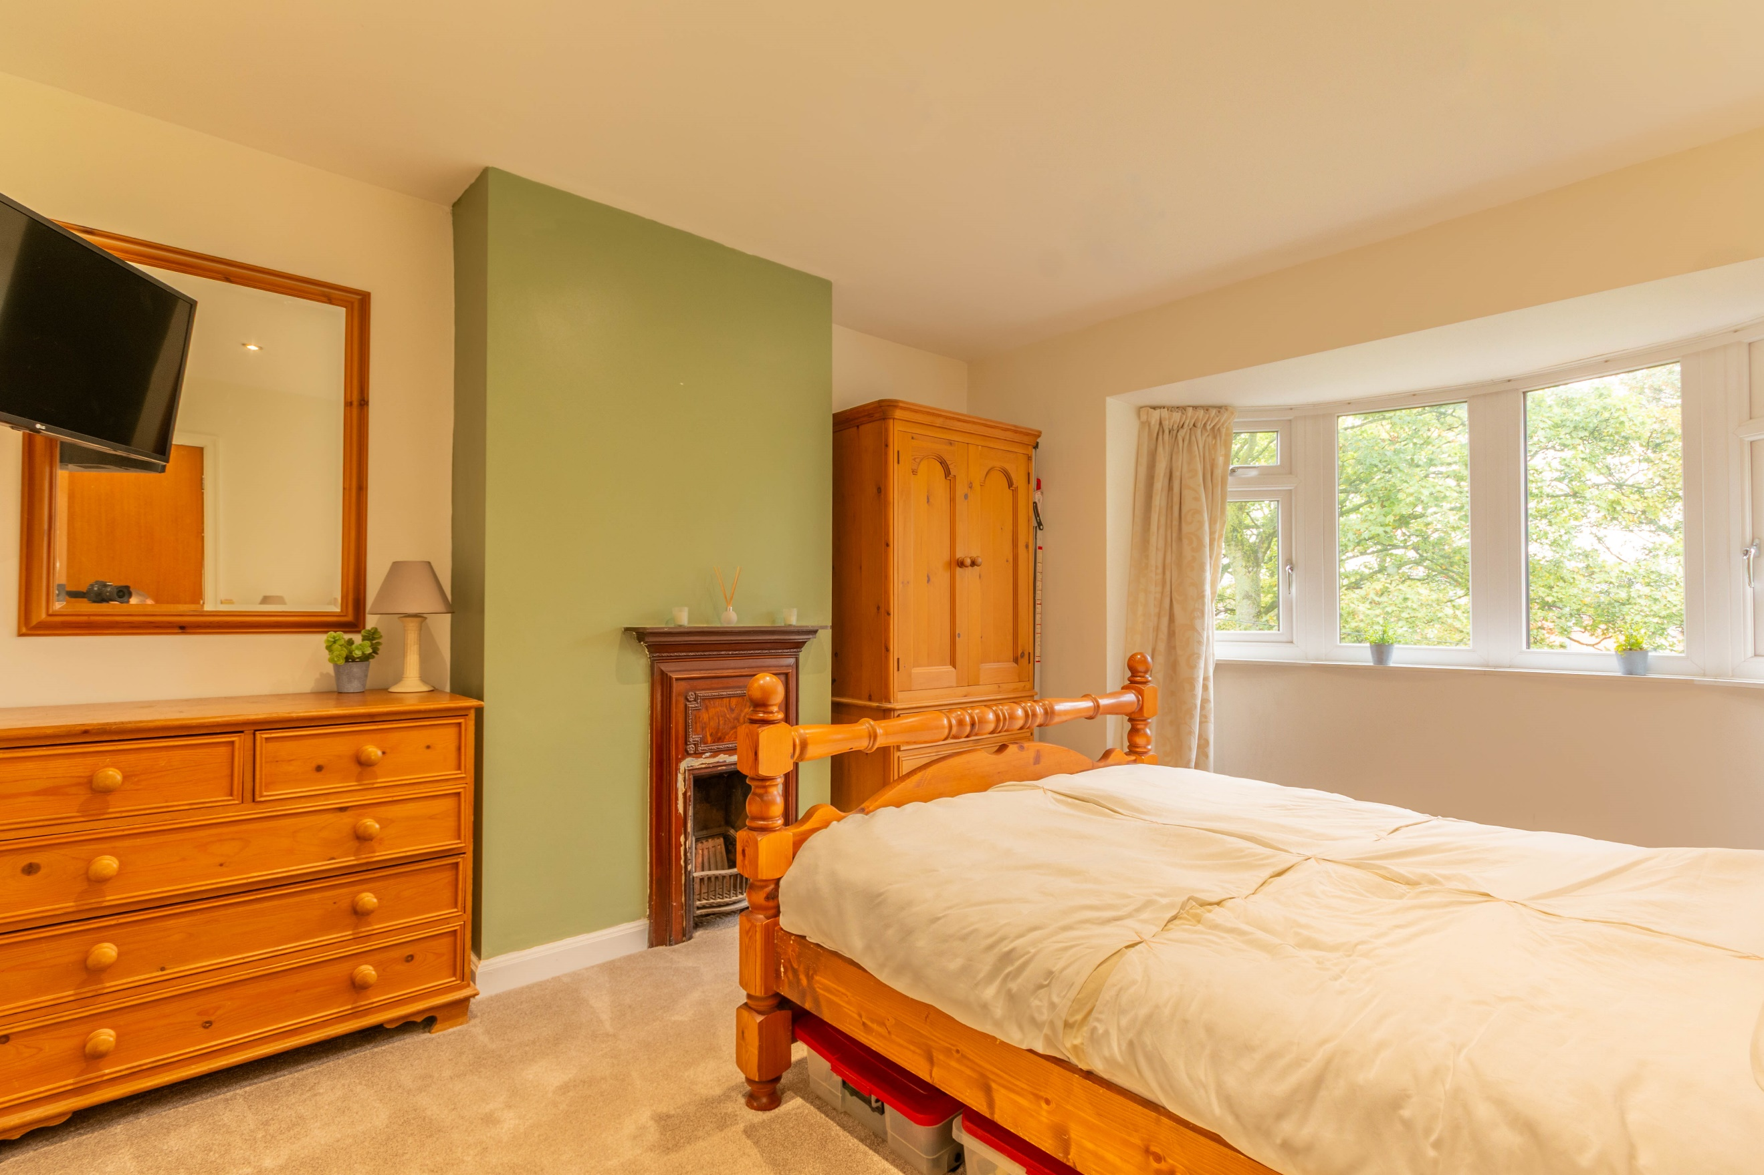
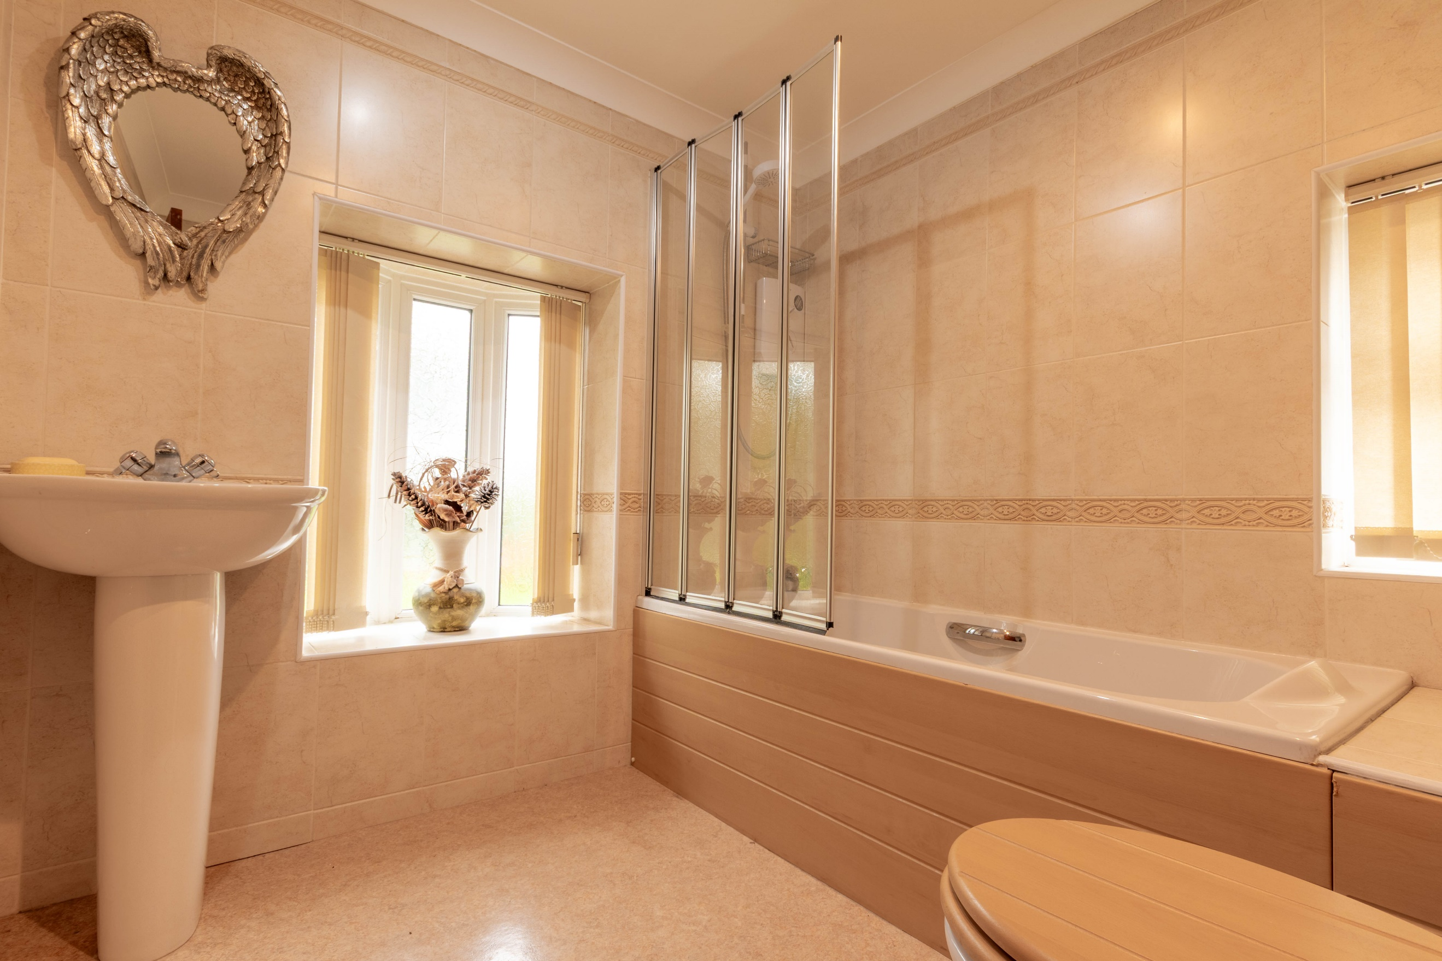

Entrance Hall
Via front entrance door. Gas central heating radiator. Stairs to first floor.

Lounge 3.88m (12'9) x 3.64m (11'11)
Light and airy living room with uPVC double glazed bay window to front. Gas central heating radiator.

Open Plan Kitchen/Diner 5.84m (19'2) x 3.57m (11'9)
Open plan kitchen fitted with a range of wall, base and drawer units with worktops over. Breakfast bar. Integrated electric oven with 4-ring hob over. 1.5 bowl sink with mixer tap and drainer. Space for double fridge/freezer. uPVC double glazed window to rear. Inset ceiling spotlights. Opening to the dining room uPVC double glazed doors leading out to the rear garden. Gas central heating radiator.

Guest WC / Cloak Room
Guest WC fitted with combined two-in-one wash hand basin and toilet. uPVC double glazed window.

First Floor Landing

Bedroom 1 3.5m (11'6) x 3.67m (12'0)
Spacious double bedroom with uPVC double glazed bay window to front. Gas central heating radiator. Feature fire surround.

Bedroom 2 3.65m (12') x 3.54m (11'7)
Second double bedroom with uPVC double glazed window to rear. Gas central heating radiator. Feature fire surround.

Bedroom 3 2.03m (6'8) x 2.75m (9'0)
Third bedroom with uPVC double glazed window to front. Gas central heating radiator.

Bathroom
Fitted with a three piece suite comprising; bath with shower over, WC and wash hand basin. Tiled walls. uPVC double glazed window.

Outside
To the front of the property is a lawned garden and a driveway offering off street parking. To the rear is an enclosed garden which has been mainly laid to lawn with a patio ideal for entertaining.

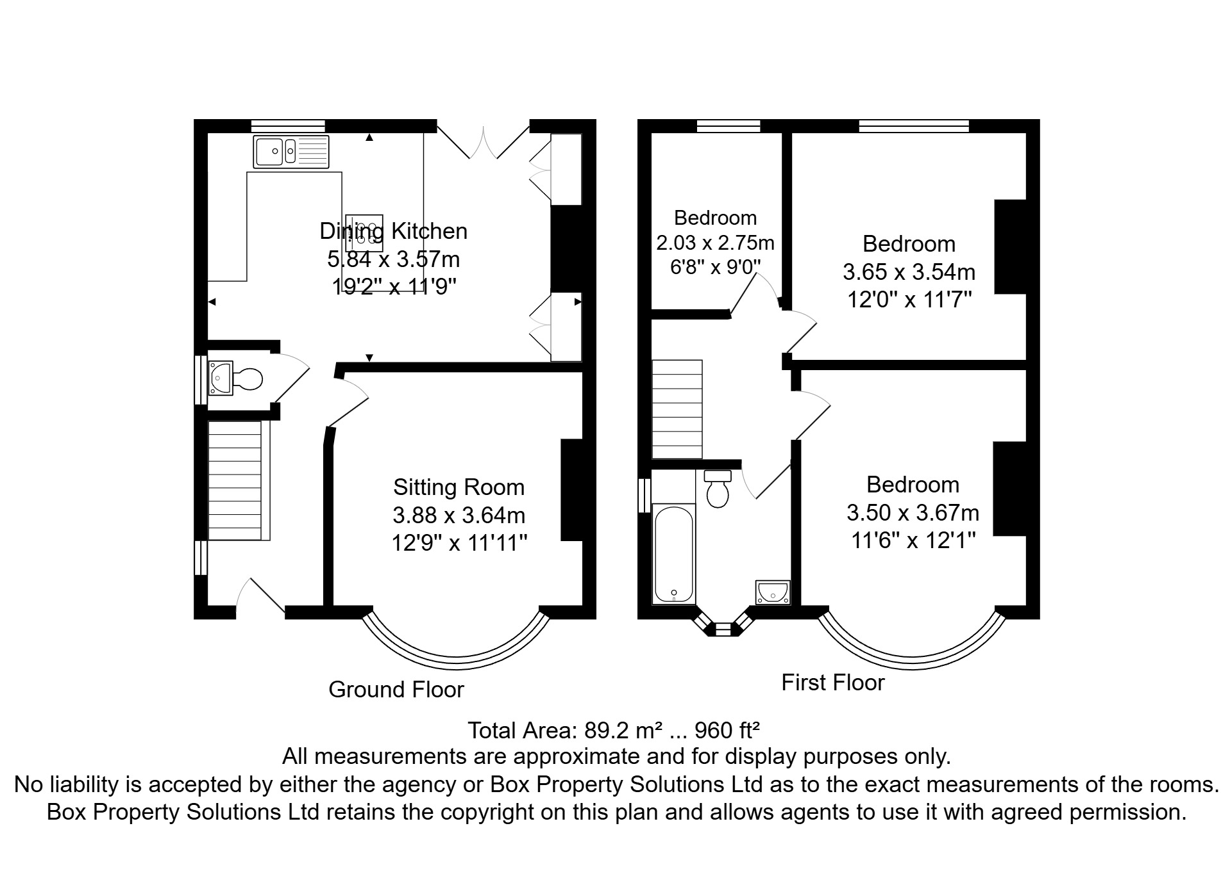

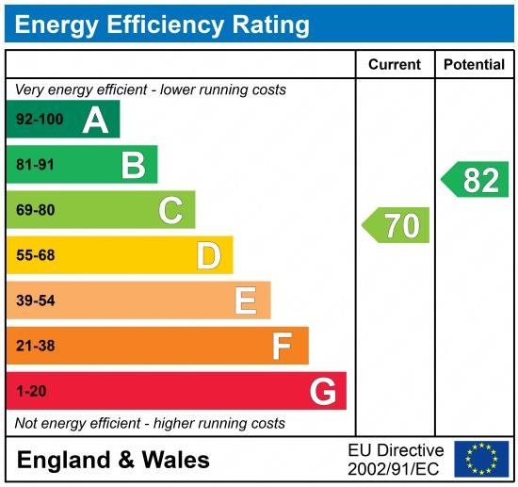

These particulars are intended to give a fair description of the property, but their accuracy cannot be guaranteed, and they do not constitute an offer of contract. Intending purchasers must rely on their own inspection of the property. None of the above appliances/services have been tested by ourselves. We recommend purchasers arrange for a qualified person to check all appliances/services before legal commitment.

Property Ref: 7599

For more information, please contact

0113 258 1150 | sales@adairpaxton.co.uk | www.adairpaxton.co.uk

