

**Little Church Lane, LS26**

**£750.00pcm**

**House**

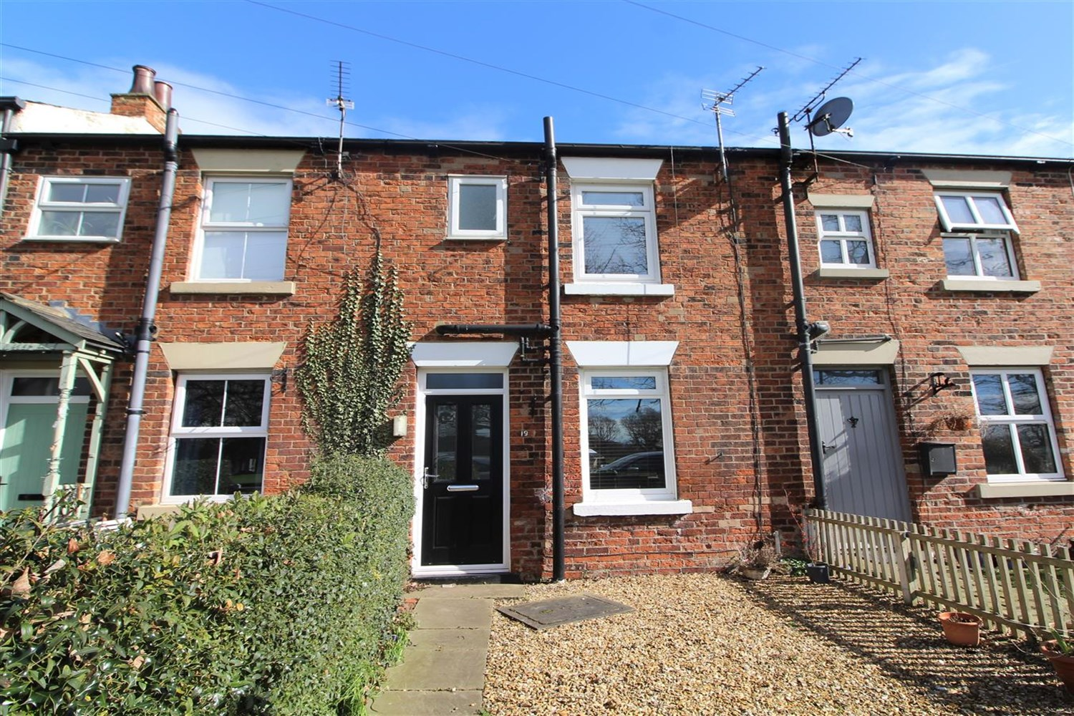

1 Bathroom(s)

1 Reception(s)

1 Bedroom(s)

Two bedroom mid terrace house in the popular village location of Methley with lovely views across the cricket field. Comprising; lounge, kitchen with freestanding gas cooker, two double bedrooms, and house bathroom with shower over the bath. Gas central heating. Garden to the front of the property and to the rear. Council tax band B. EPC rating D. Unfurnished. Deposit £865. Sorry no pets. Available 25th October.



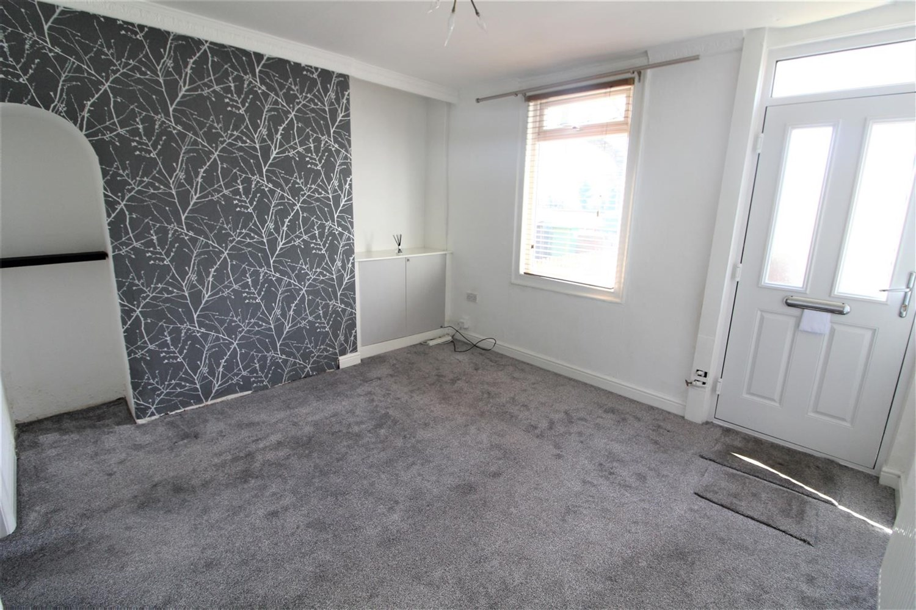

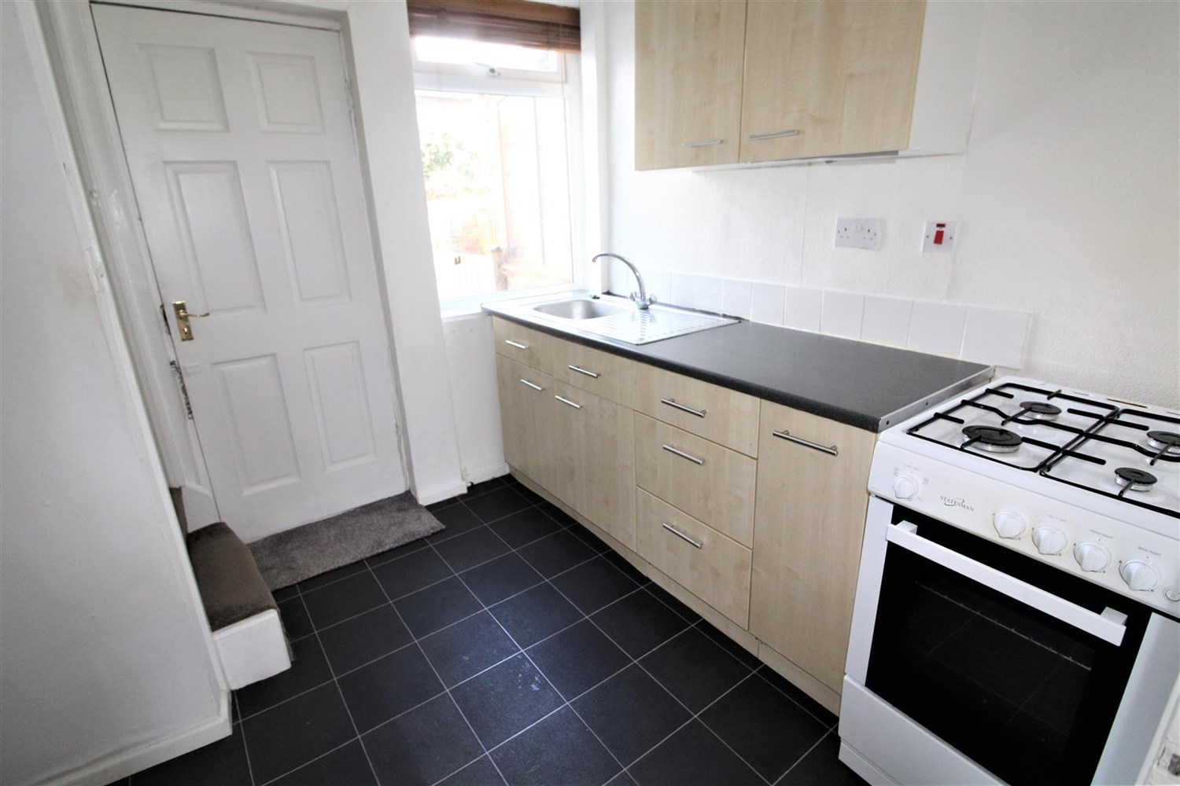

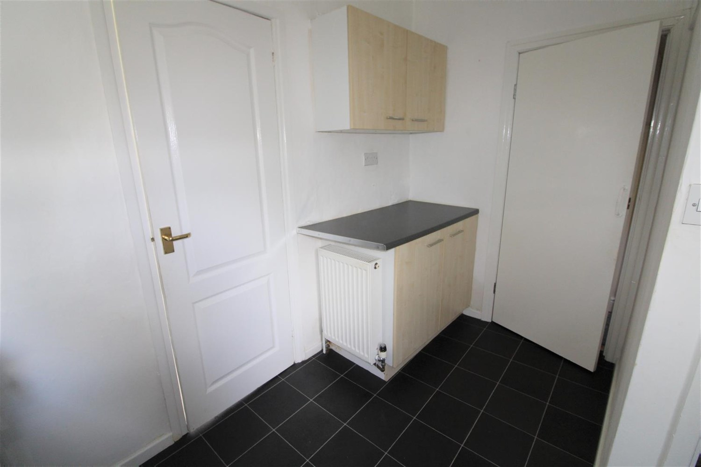

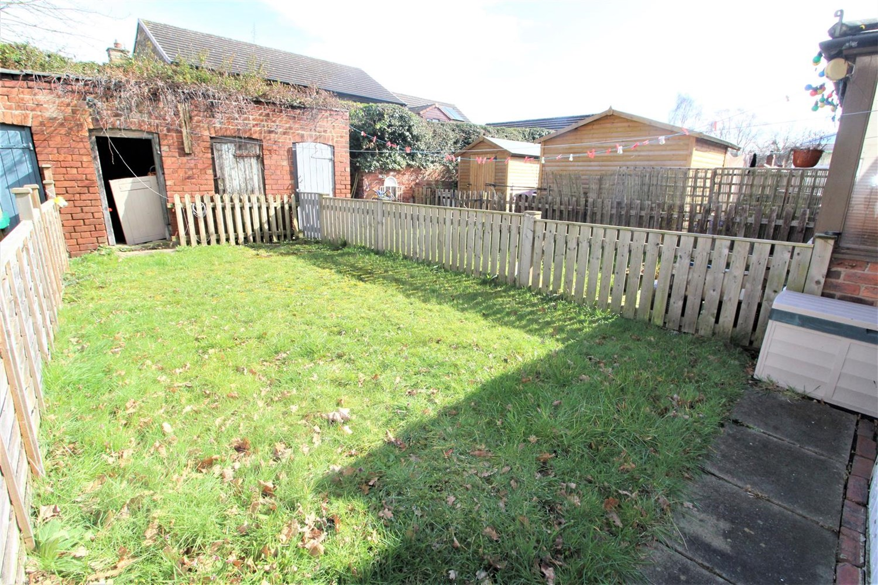

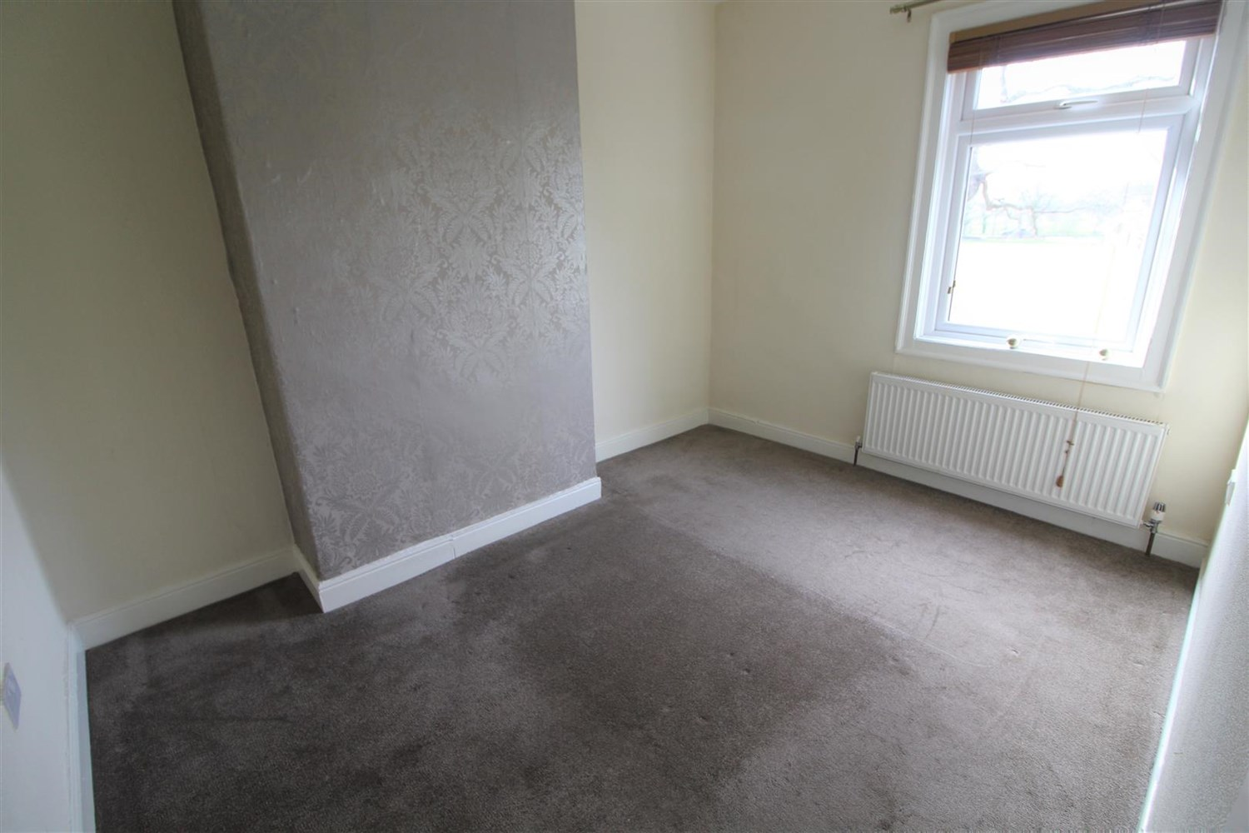

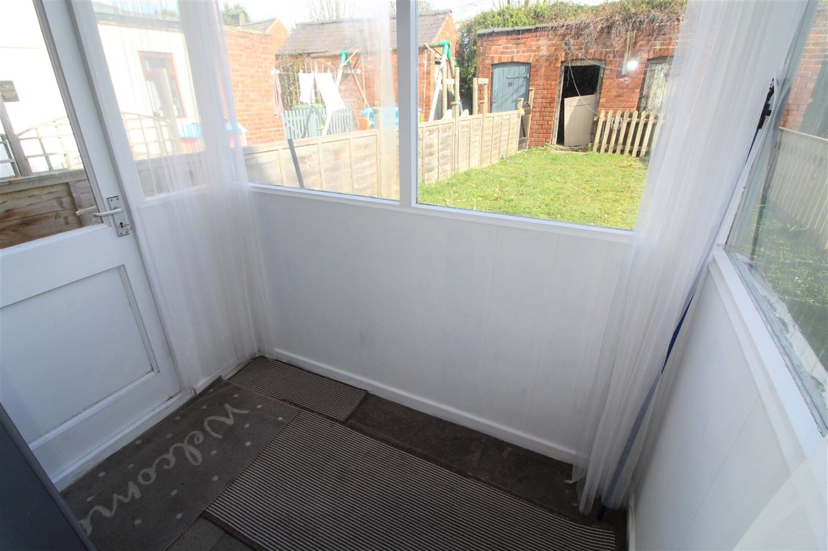



|  |
| --- |
| **Living Room**  Light and airy carpeted lounge with uPVC double glazed window to front, uPVC front door, gas central heating radiator. |
| **Kitchen**  Fitted with a range of wall and base units with worktops over, free standing gas cooker, stainless steel sink with mixer tap and drainer. uPVC door leading to rear garden and stairs leading to first floor. |
| **bedroom**  Carpeted double bedroom with uPVC window to front, and gas central heating radiator. |
| **Bedroom 2**  Second carpeted room with uPVC double glazed window to rear, gas central heating radiator. |
| **Bathroom**  Three piece white bathroom suite compromising of bath, hand wash basin and w/c. Tiled walls and gas central heating radiator. |
| **Gardens to front and Rear**  Low maintenance garden to front with pebble stones. The rear of the garden is lawned with shrubs . |
| COUNCIL TAX BAND: B EPC Rating D  Freehold property: Street parking  Broadband: Standard 4 Mbps 0.5 Mbps Good Superfast 80 Mbps 20 Mbps Good Ultrafast 9000 Mbps 9000 Mbps Mobile availability: EE None. Three None. O2 Limited. Vodafone limited.  Utilities: Water supplied on standard meters. Gas and Electric mains supplied on standard meters. |

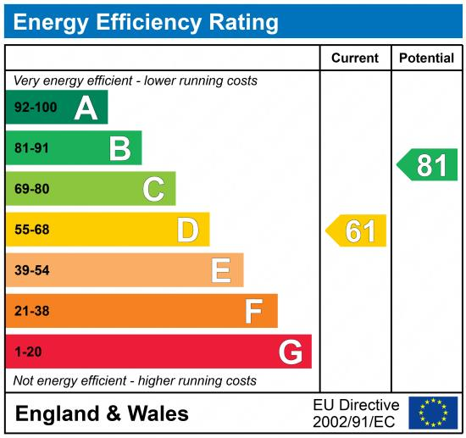

|  |
| --- |
|  |

These particulars are intended to give a fair description of the property, but their accuracy cannot be guaranteed, and they do not constitute an offer of contract. Intending purchasers must rely on their own inspection of the property. None of the above appliances/services have been tested by ourselves. We recommend purchasers arrange for a qualified person to check all appliances/services before legal commitment.

**Property Ref:** 4001

**For more information, please contact**

0113 258 1150 **|** [lettings@adairpaxton.co.uk](mailto:lettings@adairpaxton.co.uk) **|** www.adairpaxton.co.uk