

**Silver Royd Road, LS12**

**Available to let £850.00pcm**TWO BEDROOM MID TOWN HOUSE situated in a popular residential area of Wortley within walking distance of local amenities and bus routes to Leeds City centre and surrounding areas. The property is unfurnished and offers good sized accommodation over two floors with the benefits of good size kitchen, living room with French doors, two bedrooms one double one single bedroom and house bathroom. Internal viewing is recommended to fully appreciate the benefits and potential that this property has to offer. Deposit is £980.00. EPC Rating: E, council tax band A, Available 24th October.

**0113 258 1150**

**0800 000 000**

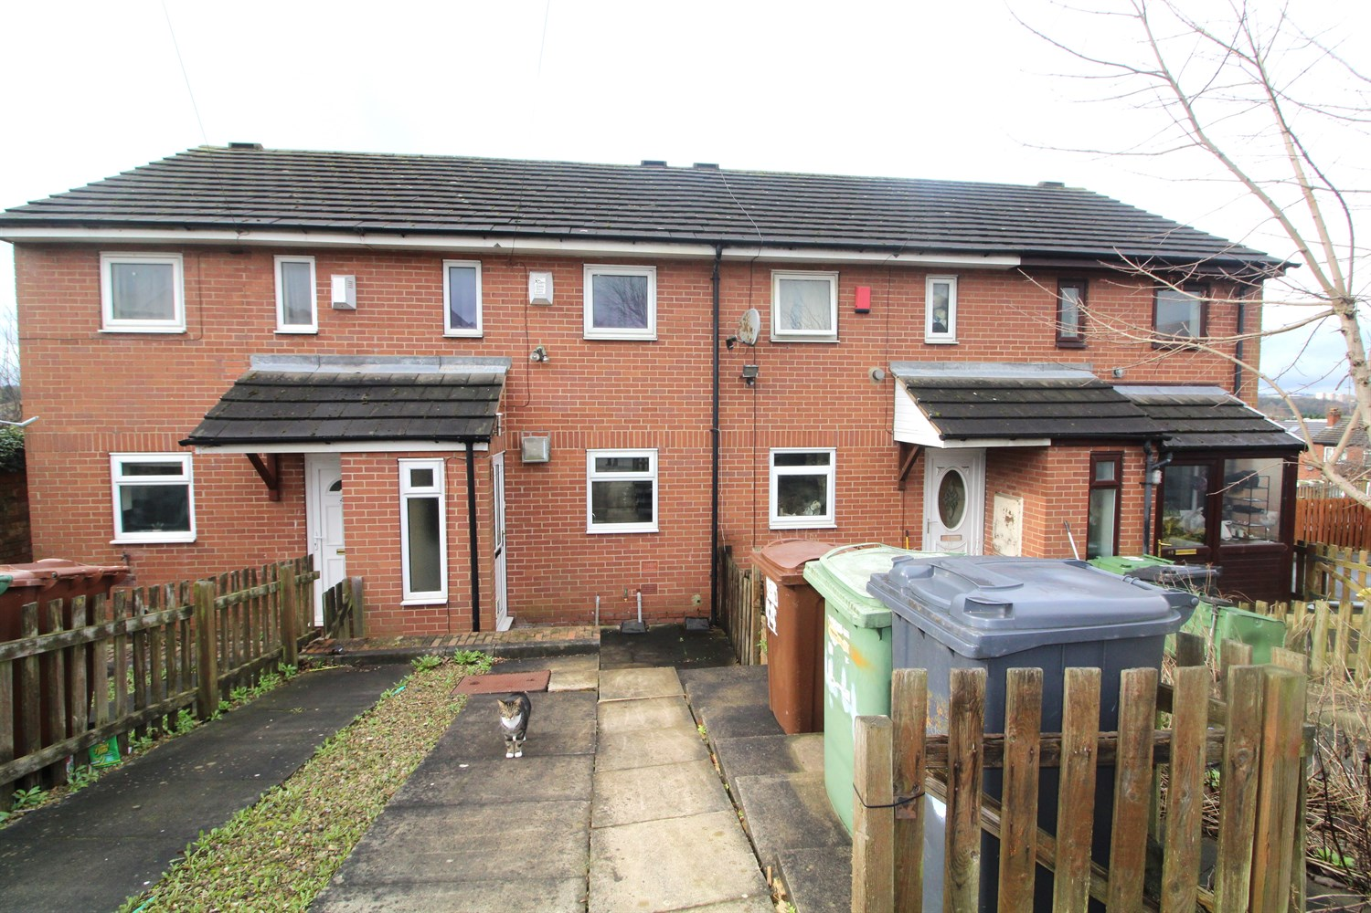

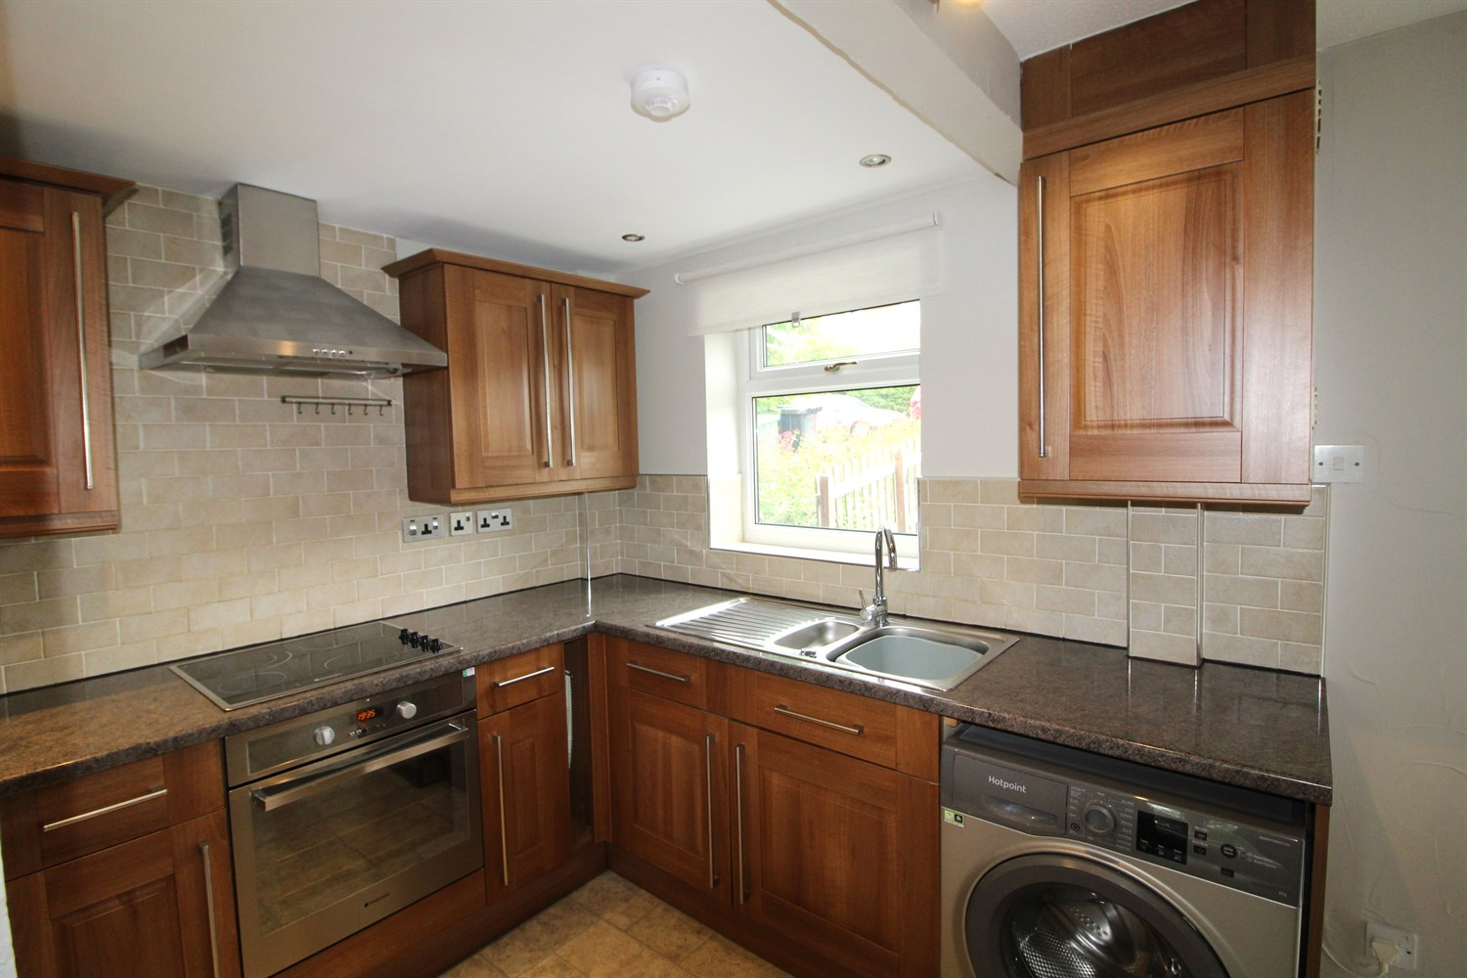

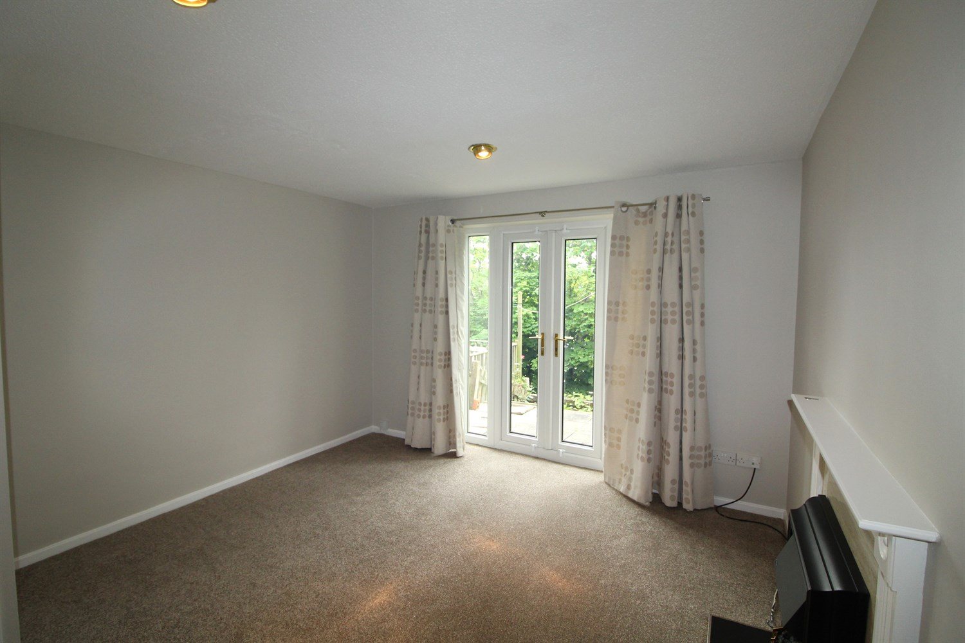

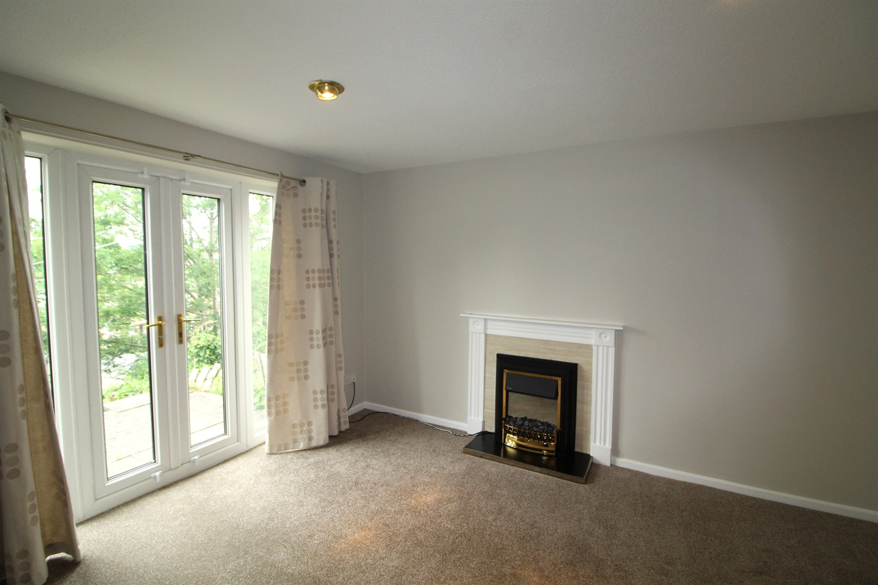

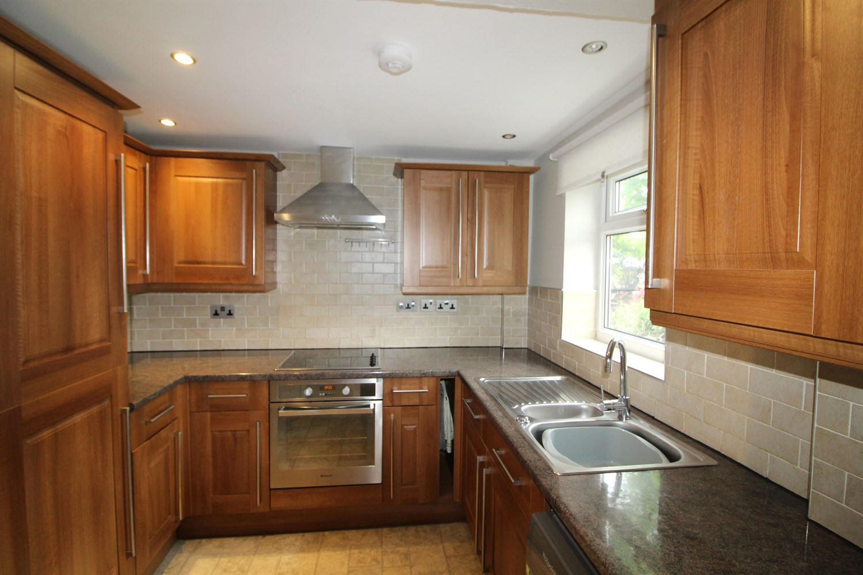

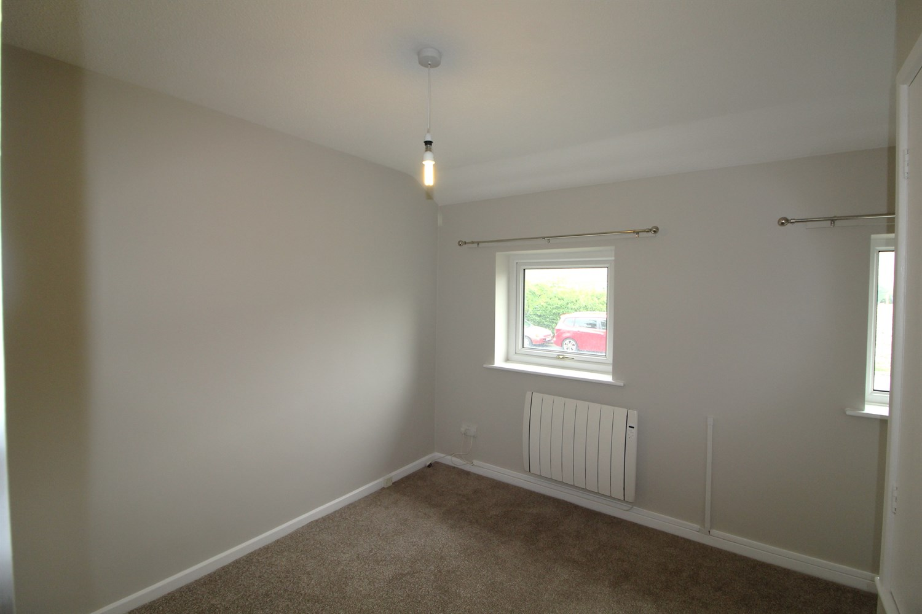

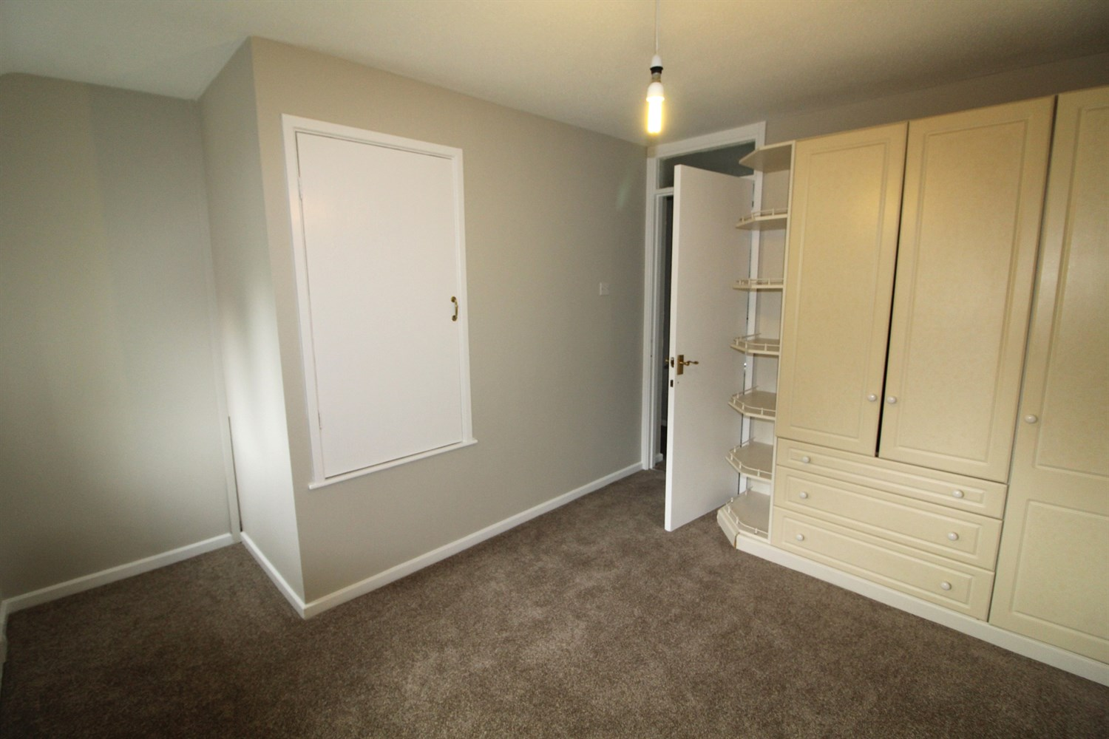

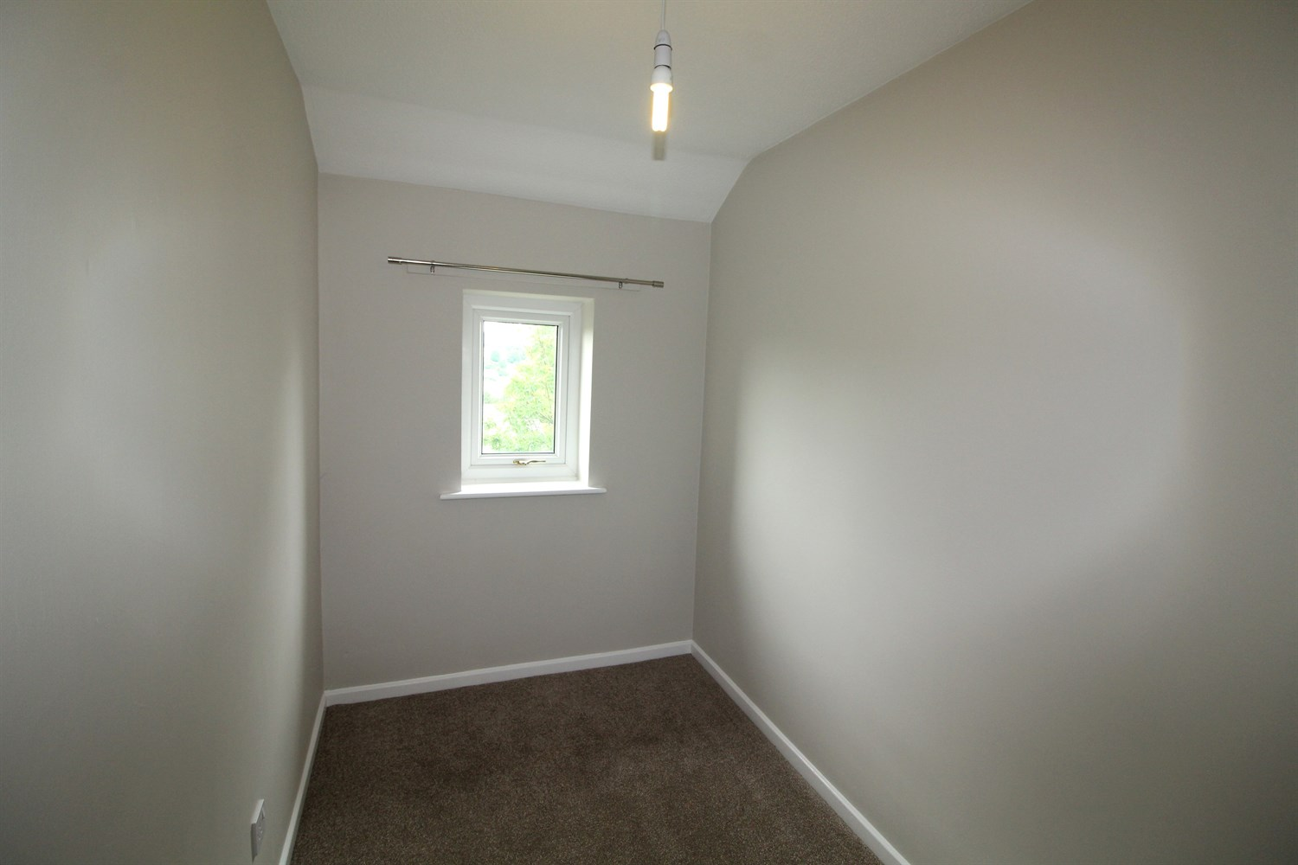

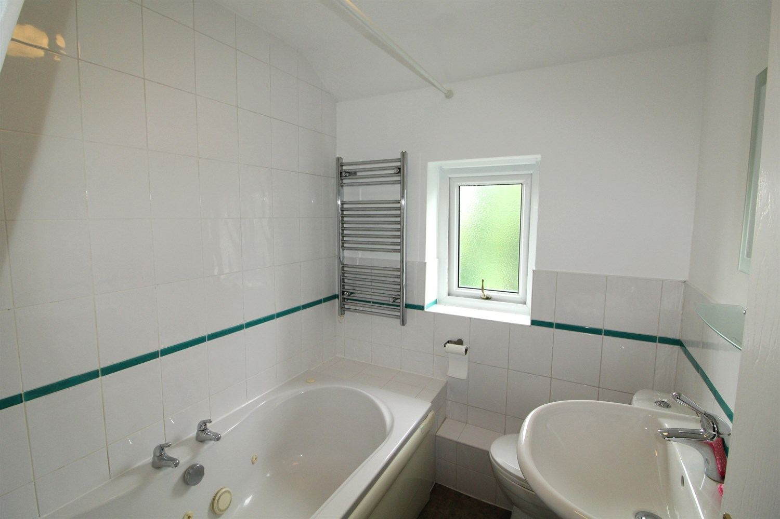

|  |
| --- |
| **Entrance Hall**  Hallway with stairs to first floor. |
| **Lounge**  Light and airy lounge with French doors opening up to the rear of the property. Electric heating radiator. |
| Fitted with a range of wall and base units with worktops over, stainless steel sink with mixer tap, integrated fridge freezer, electric oven and hob. Window to front. |
| **Bedroom 1**  Large double bedroom with windows to the front, gas central heating radiator. Built-in wardrobes and storage cupboard. |
| **Bedroom 2**  Single bedroom with window to rear, gas central heating radiator. |
| **Bathroom**  Three piece white bathroom suite with shower over bath, w/c and hand wash basin, tiled walls. |
| **Home Information**  COUNCIL TAX BAND: A EPC Rating E  Freehold property   Broadband: Standard 16 Mbps 1 Mbps Good Superfast 201 Mbps 29 Mbps Good Ultrafast 1000 Mbps 1000 Mbps Mobile availability: EE limited coverage. Three limited coverage. O2 likely to have good coverage. Vodafone limited coverage.  Utilities: Water supplied on standard meters. Electric mains supplied on standard meters. |

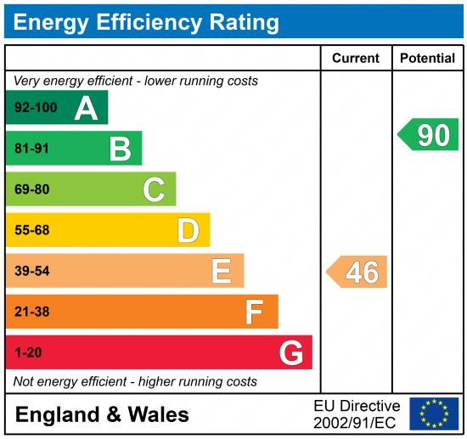

|  |
| --- |
|  |

These particulars are intended to give a fair description of the property, but their accuracy cannot be guaranteed, and they do not constitute an offer of contract. Intending purchasers must rely on their own inspection of the property. None of the above appliances/services have been tested by ourselves. We recommend purchasers arrange for a qualified person to check all appliances/services before legal commitment.

**Property Ref:** 1352

**For more information, please contact**

0113 258 1150 **|** [lettings@adairpaxton.co.uk](mailto:lettings@adairpaxton.co.uk) **|** www.adairpaxton.co.uk