
Oxford Terrace, Baildon
For Sale £259,950

***DELIGHTFUL & WELL EXTENDED SEMI-DETACHED HOUSE WITH DOUBLE GARAGE, GENEROUS PLOT & NO ONWARD CHAIN*** This stunning property simply must be viewed to be appreciated! Boasting an immaculate and recently refurbished Kitchen & bathroom, this lovely end terraced house is ready to move in to and offered to the market with immediate vacant possession. The property briefly comprises: entrance hall/study, sitting room, superb kitchen/diner, and formal dining room/second reception room to the ground floor. To the first floor there are two generous double bedrooms and a recently refurbished modern shower room. Externally the property is set back from the road and enjoys a landscaped front garden. To the rear there is a courtyard patio leading to a parking area, double garage and rear landscaped garden which enjoys a good deal of privacy. This property has been well maintained throughout and early internal viewing is highly recommended.
0113 258 1150
0800 000 000
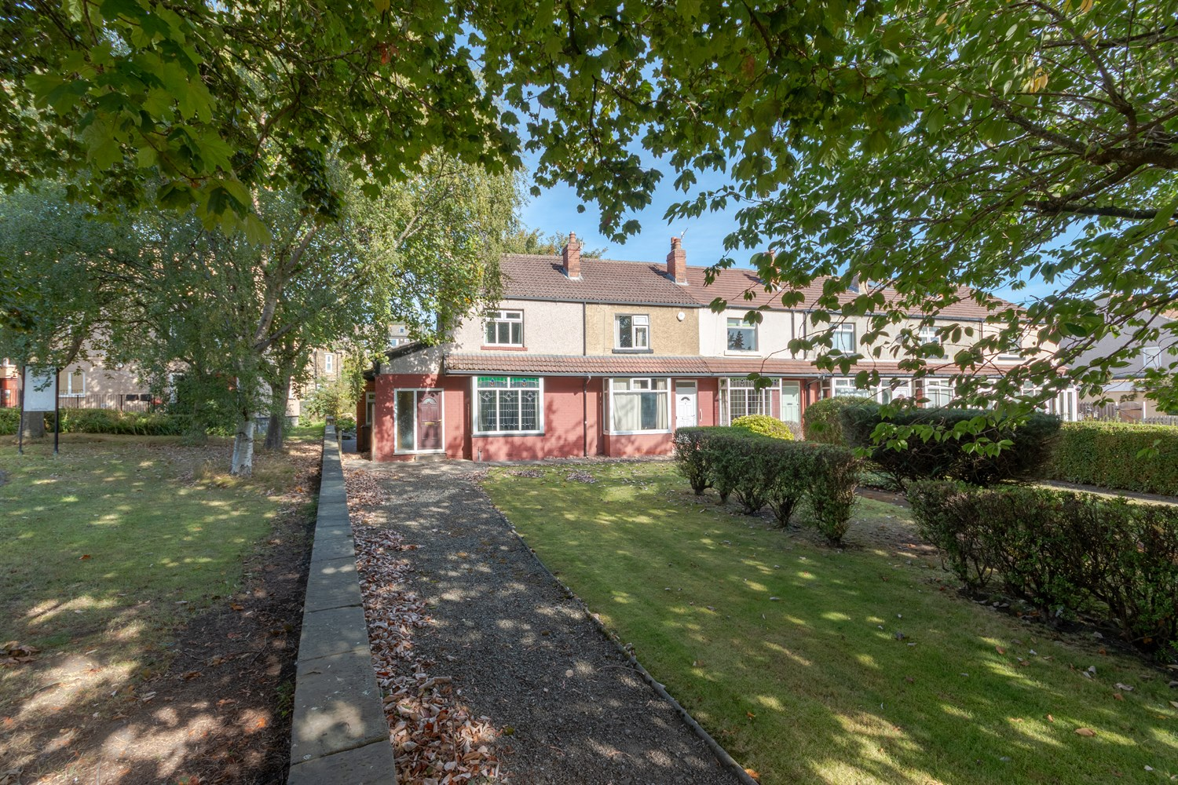
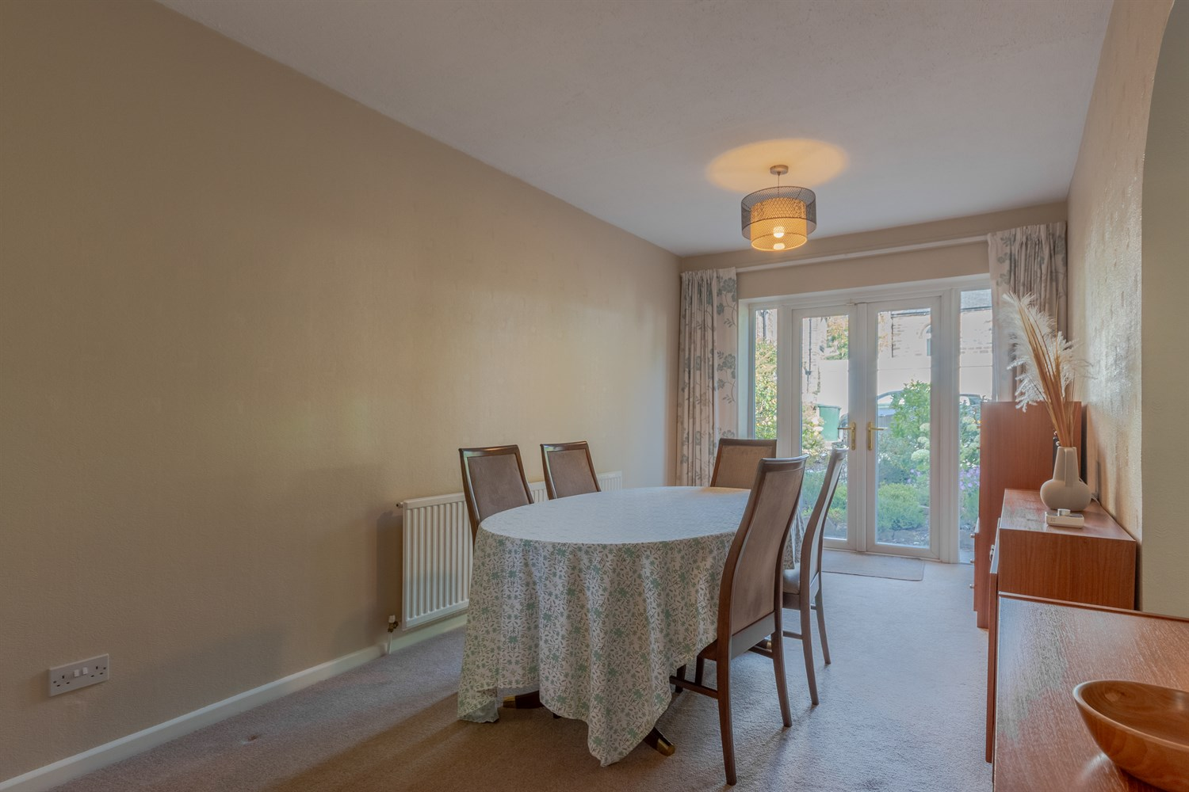
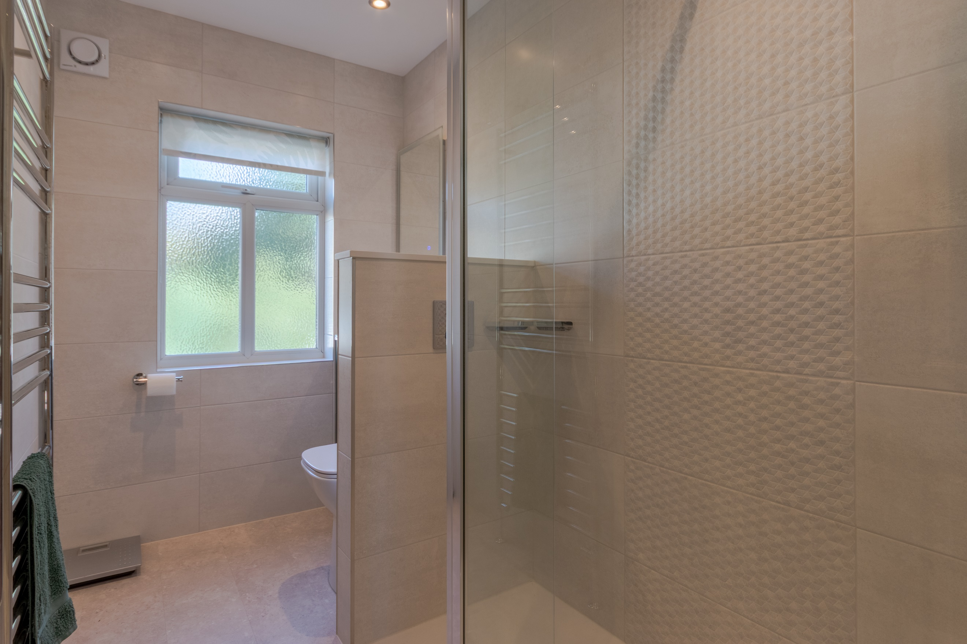
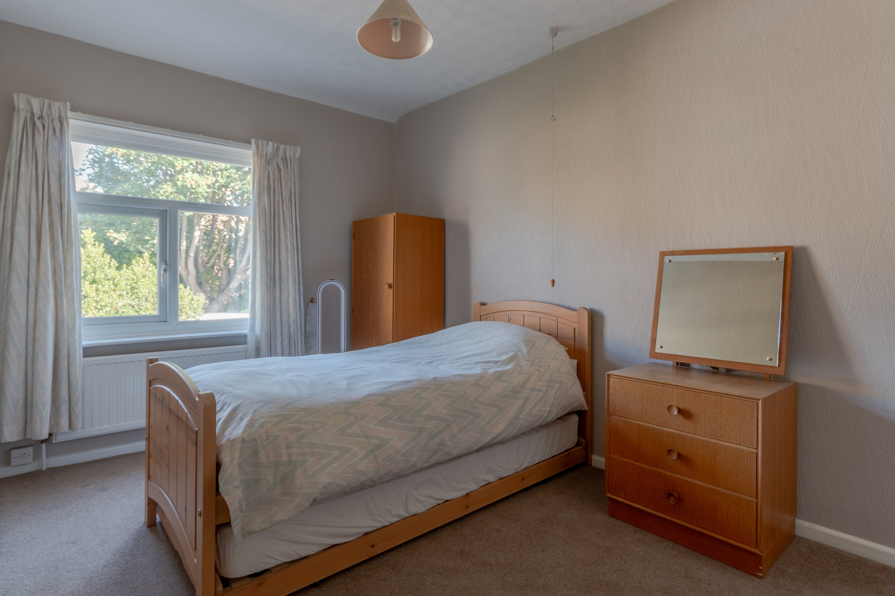
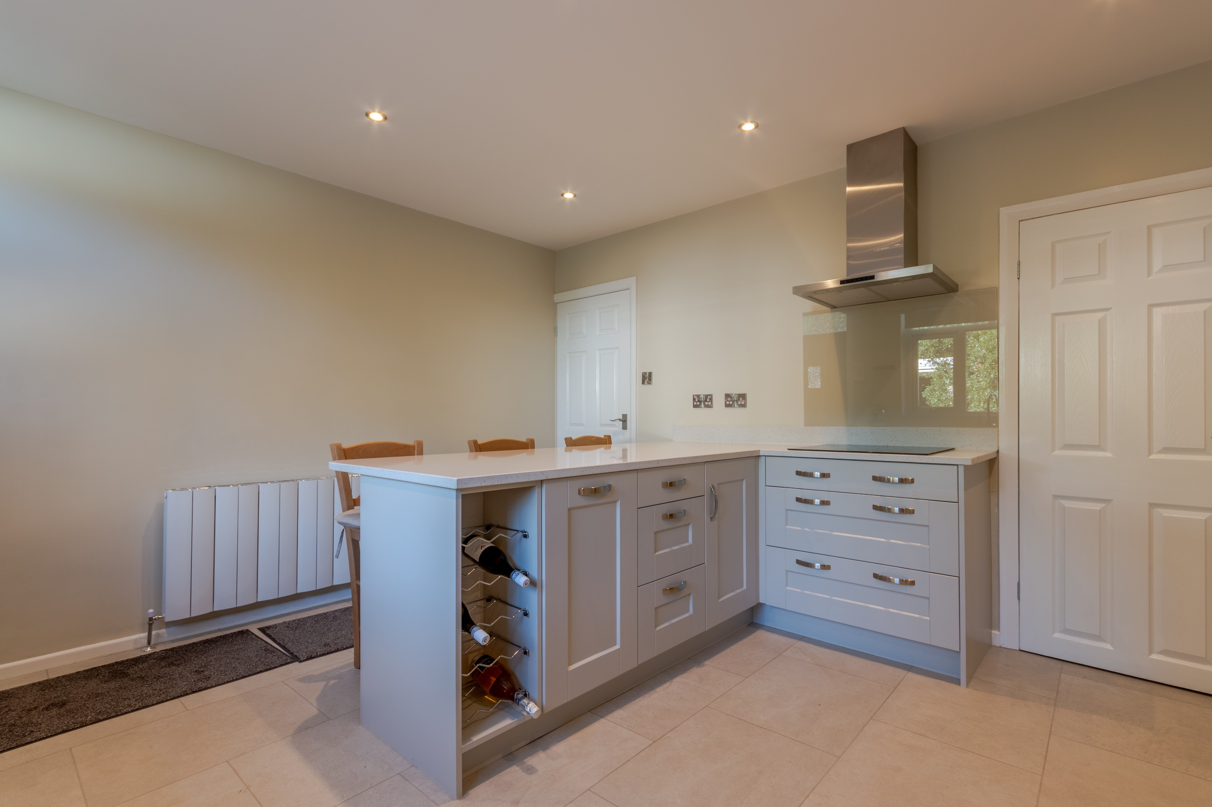
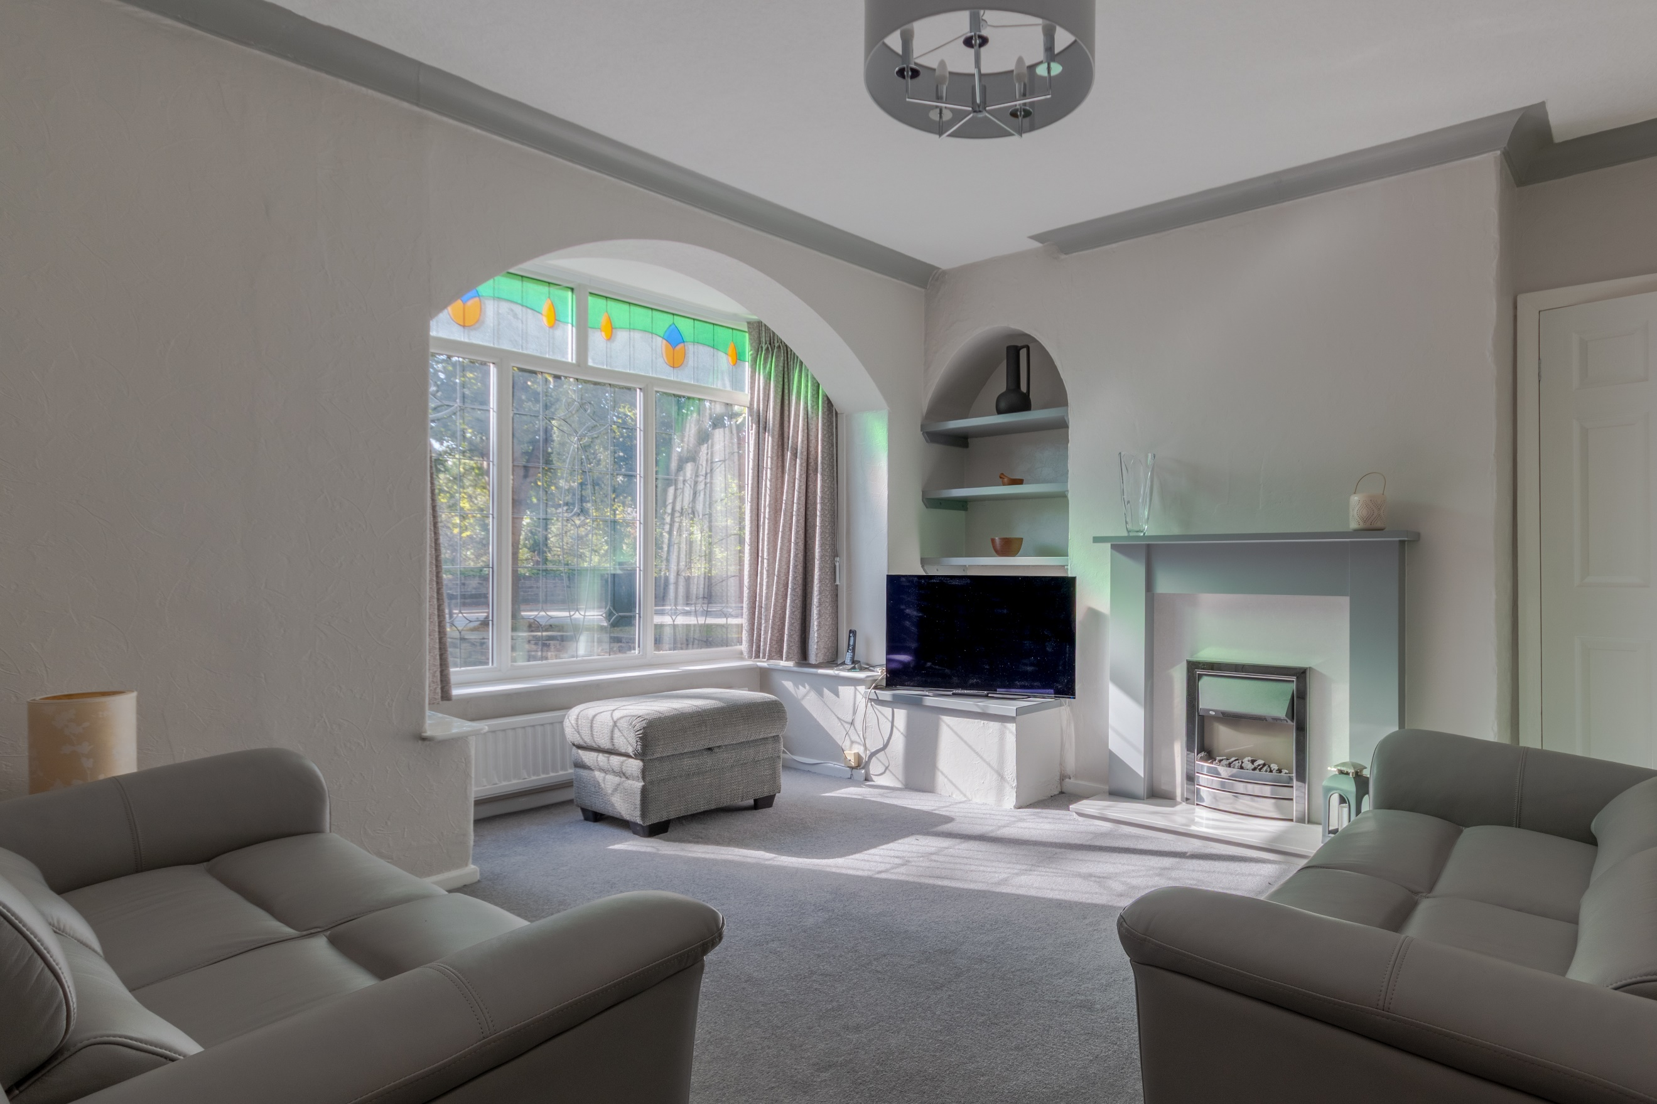
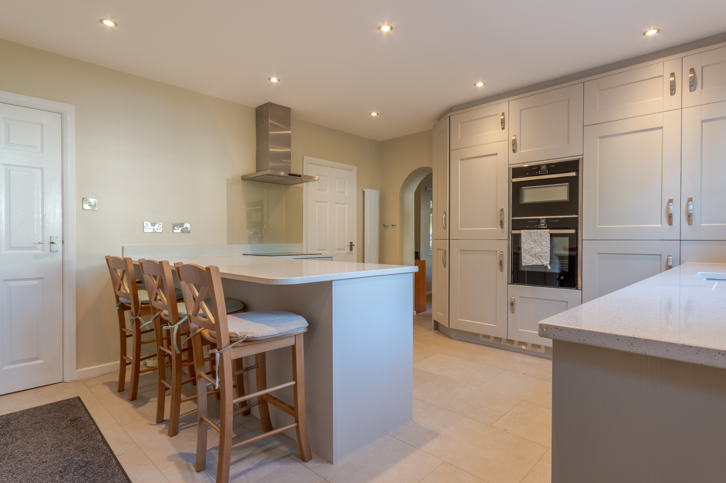
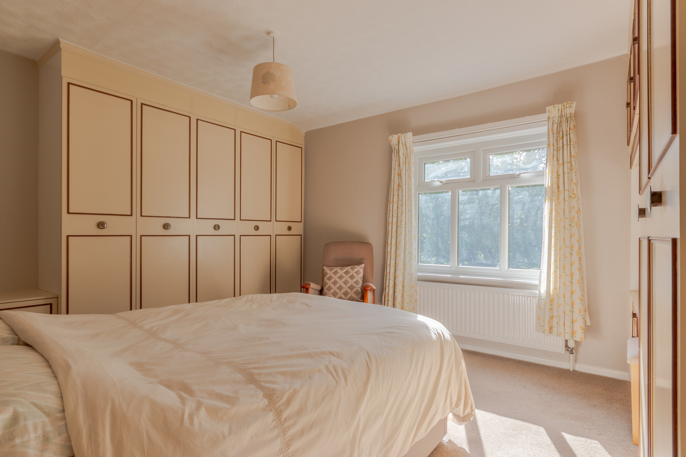
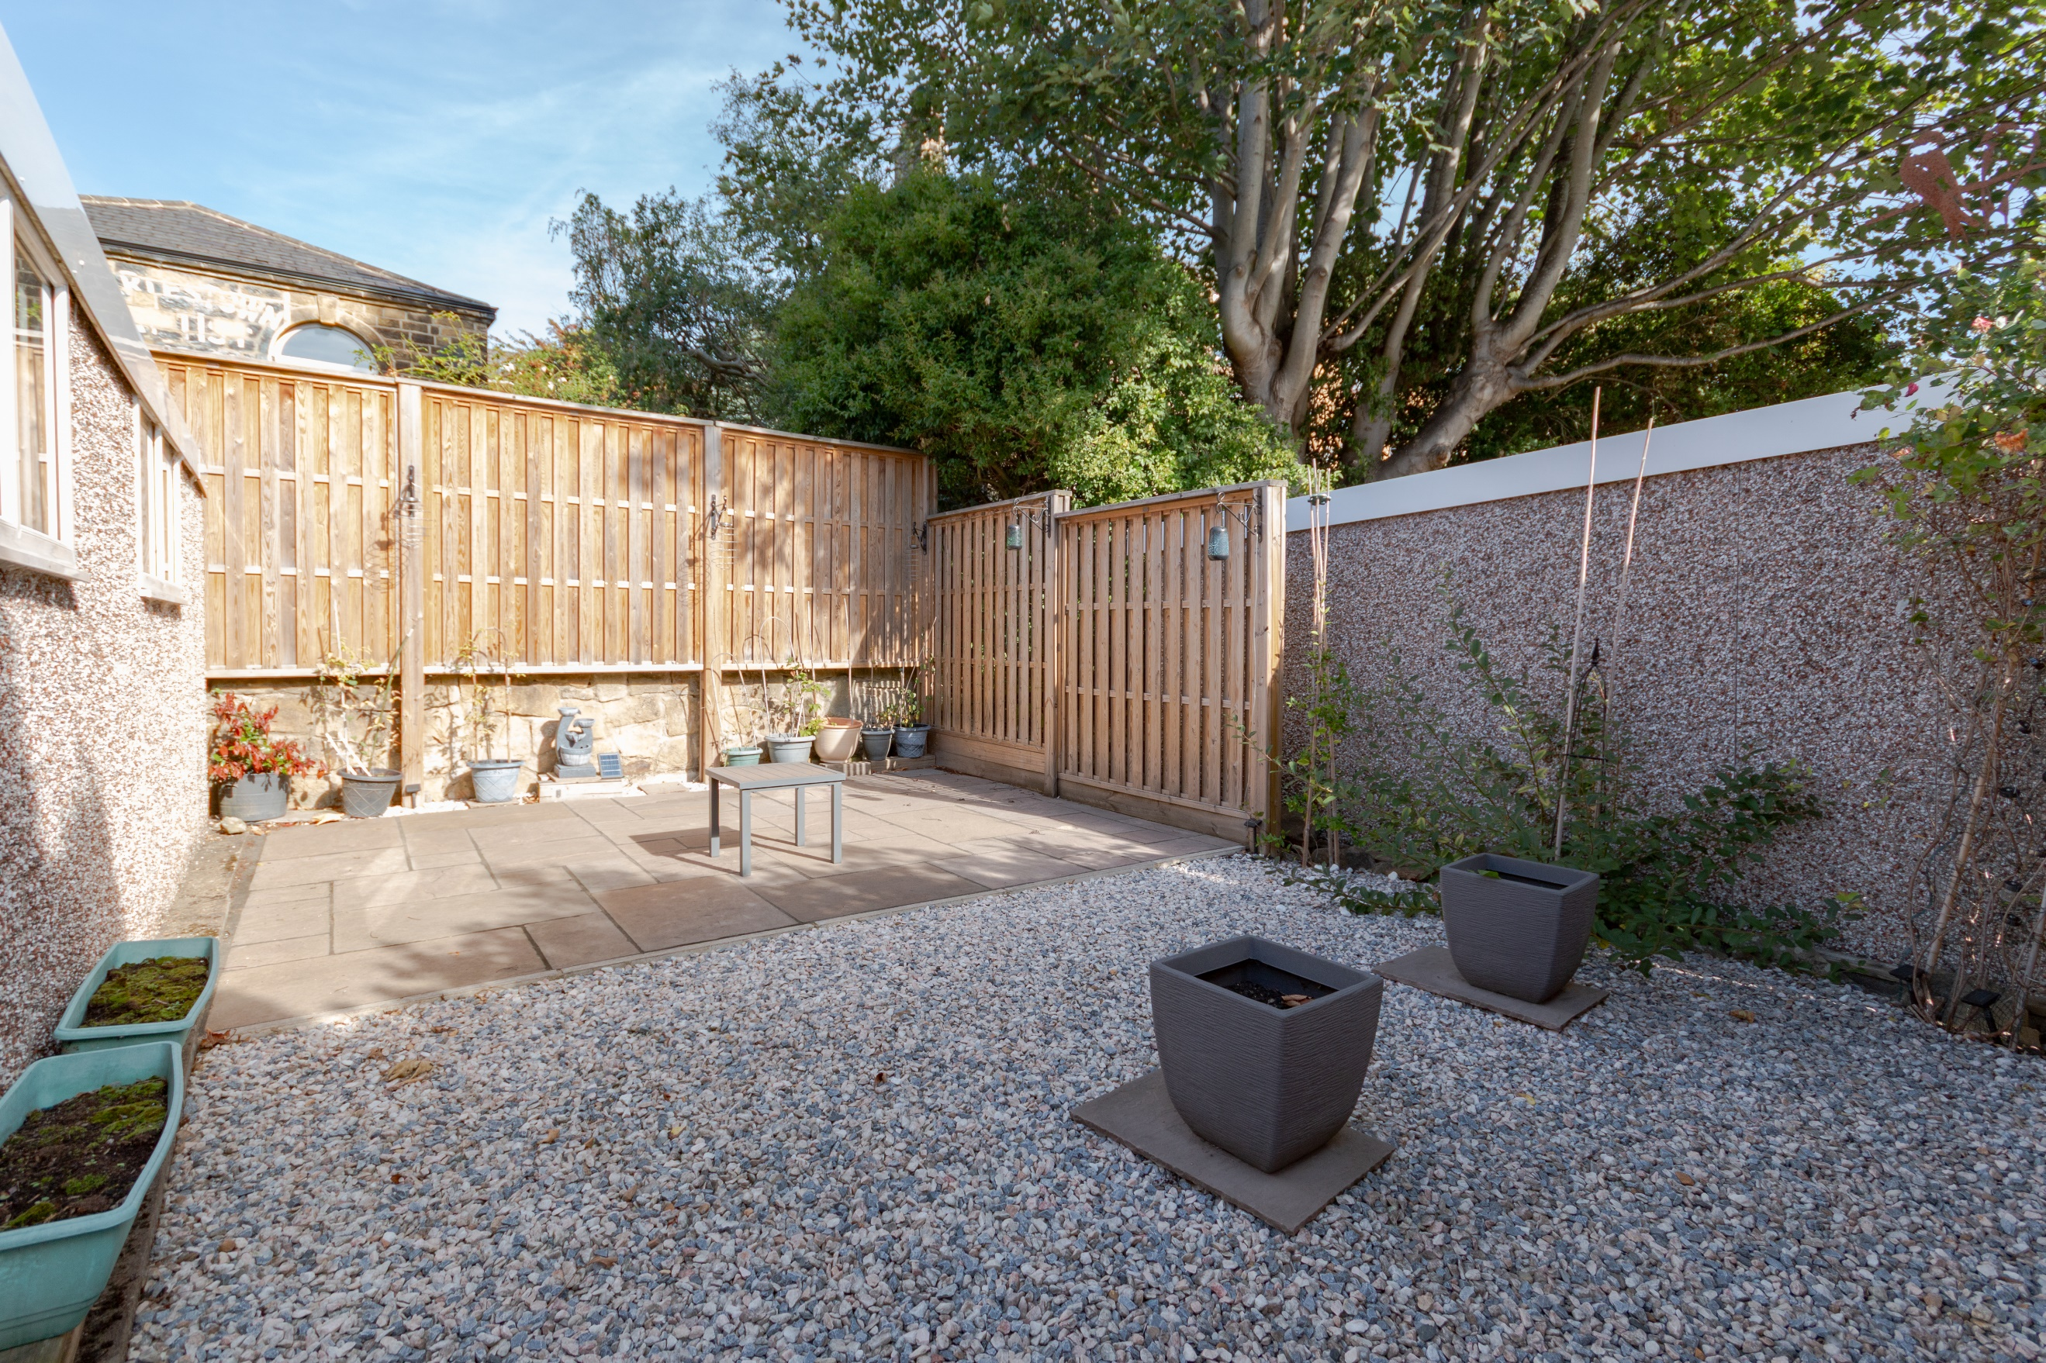

Entrance Hall/Study
A spacious entrance hall, currently used as a study area. Front entrance door with uPVC double glazed window to side.

Sitting Room 4.34m (14'3) x 3.53m (11'7)
A spacious reception room with uPVC double glazed bay window to the front. Gas central heating radiator. Electric fire set in modern surround.

Kitchen/Diner 4.34m (14'3) x 3.91m (12'10)
A superb and beautifully presented kitchen/diner, fitted with a range of wall, base and drawer units with quartz work surfaces over. 1.5 bowl sink with mixer tap. Eye level integrated electric oven and microwave combination oven. Integrated washing machine, dishwasher and concealed bins. Electric induction hob with extractor hood over. Tile effect flooring. Inset ceiling spotlights. Two radiators. Useful pantry style storage cupboard. uPVC double glazed window to the rear and rear entrance door.

Dining Room
A great addition to the property, this spacious room just off the kitchen boasts uPVC double glazed French style doors opening out to the rear garden. Radiator.

Hall
Stairs to first floor landing. uPVC double glazed window to the side.

Bedroom One 4.52m (14'10) x 3.53m (11'7)
A generous master bedroom with uPVC double glazed window to the front. Radiator. Fitted wardrobes providing hanging and shelving storage.

Bedroom Two 2.65m (8'8) x 3.92m (12'10)
A second double bedroom with uPVC double glazed window to the rear. Radiator. Built in storage cupboard.

Bathroom
Recently refurbished bathroom with walk in double shower, WC and wash hand basin. Tiled walls and floor. Heated towel rail. uPVC double glazed window to side and rear.

Double Garage 5.46m (17'11) x 4.94m (16'2)
A spacious double garage with two up and over doors. uPVC double glazed window to the side.

Outside the Property
The property is set back from the main road and enjoys a good sized front garden which has been mostly laid to lawn. To the rear the garden is paved with planted beds. There is an additional garden, adjacent to the double garage which has been landscaped with paving and gravel to provide another sitting area.

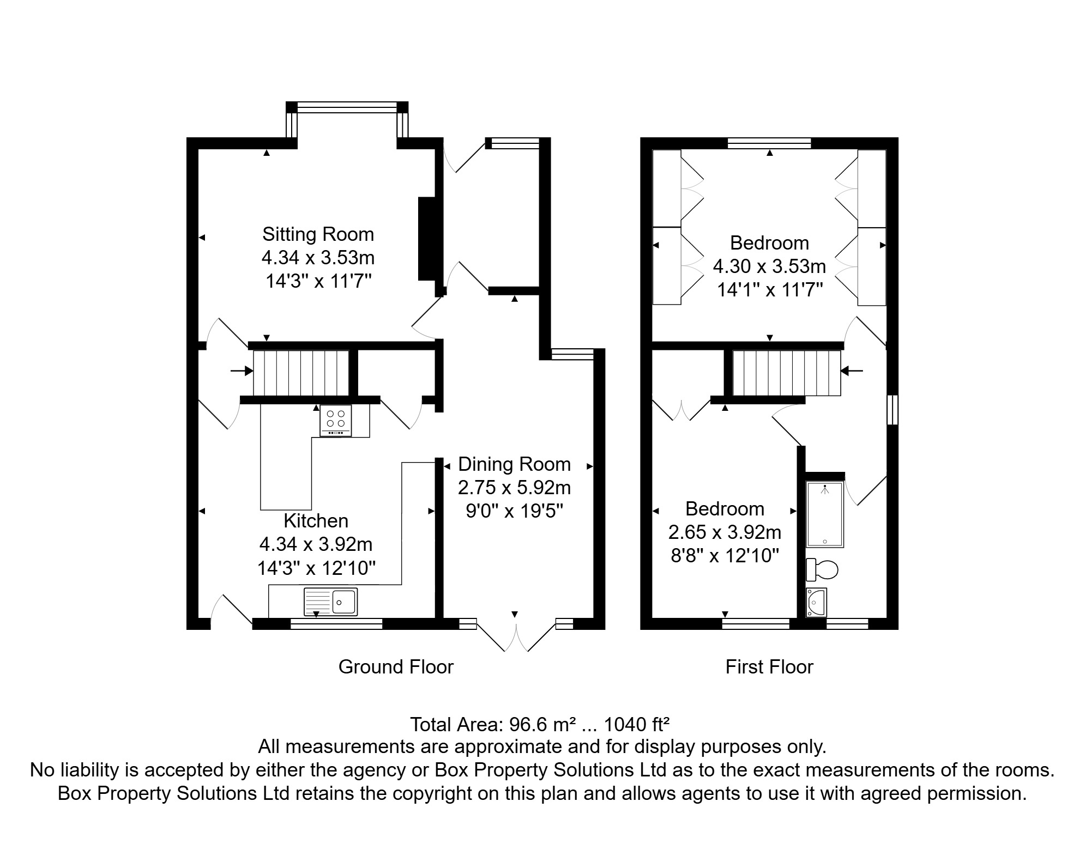

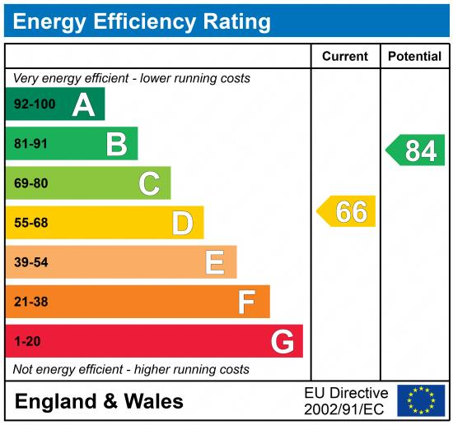

These particulars are intended to give a fair description of the property, but their accuracy cannot be guaranteed, and they do not constitute an offer of contract. Intending purchasers must rely on their own inspection of the property. None of the above appliances/services have been tested by ourselves. We recommend purchasers arrange for a qualified person to check all appliances/services before legal commitment.

Property Ref: 7472

For more information, please contact

0113 258 1150 | sales@adairpaxton.co.uk | www.adairpaxton.co.uk

