

**0113 258 1150**

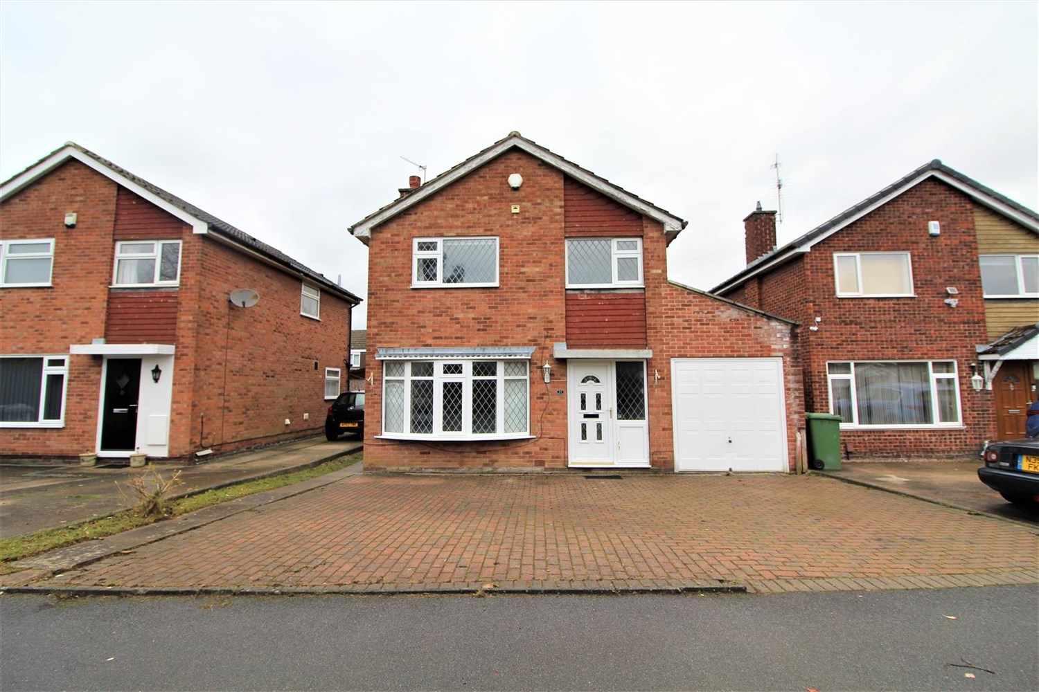



**Available to let £1,600.00pcm**

**Birkdale Drive, LS17**

***FOUR BEDROOM DETACHED FAMILY HOME IN THE SOUGHT AFTER NORTH LEEDS SUBURB OF ALWOODLEY*** The property is well placed for outstanding local schools and all amenities including great transport links. Briefly comprising; hallway, lounge with feature fire surround and gas fire, spacious open plan living/dining area with patio doors looking out to the rear garden, kitchen with oven/hob/extractor/dishwasher, utility area with fridge/freezer/washing machine/tumble dryer, ground floor cloakroom/wc. Staircase to two double bedrooms, third good size bedroom and single bedroom, house bathroom with shower over bath. Gas central heating and double glazing. Neutral decor and carpets throughout. Large enclosed rear garden, integral garage and driveway.   
Part furnished. Bond £1,845. Available 13th August.

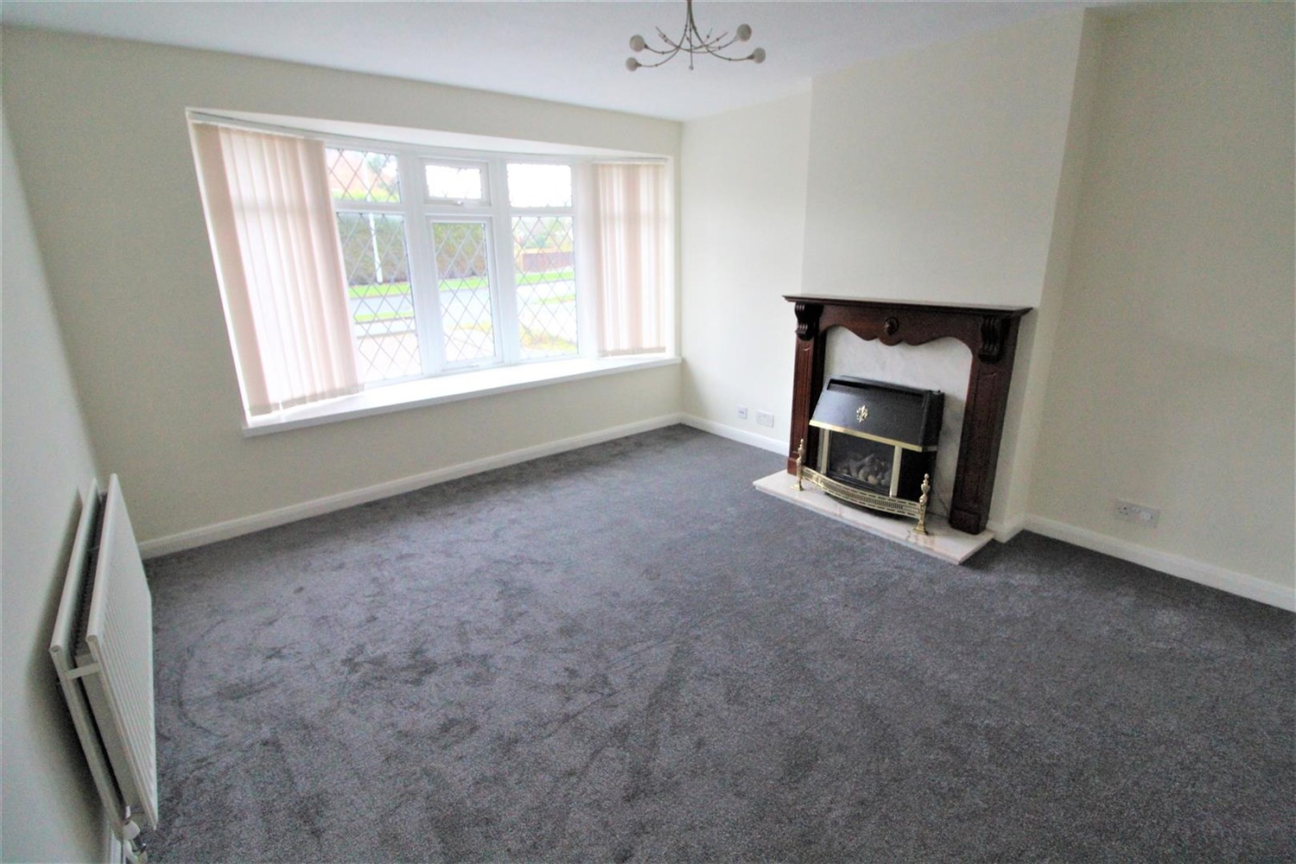

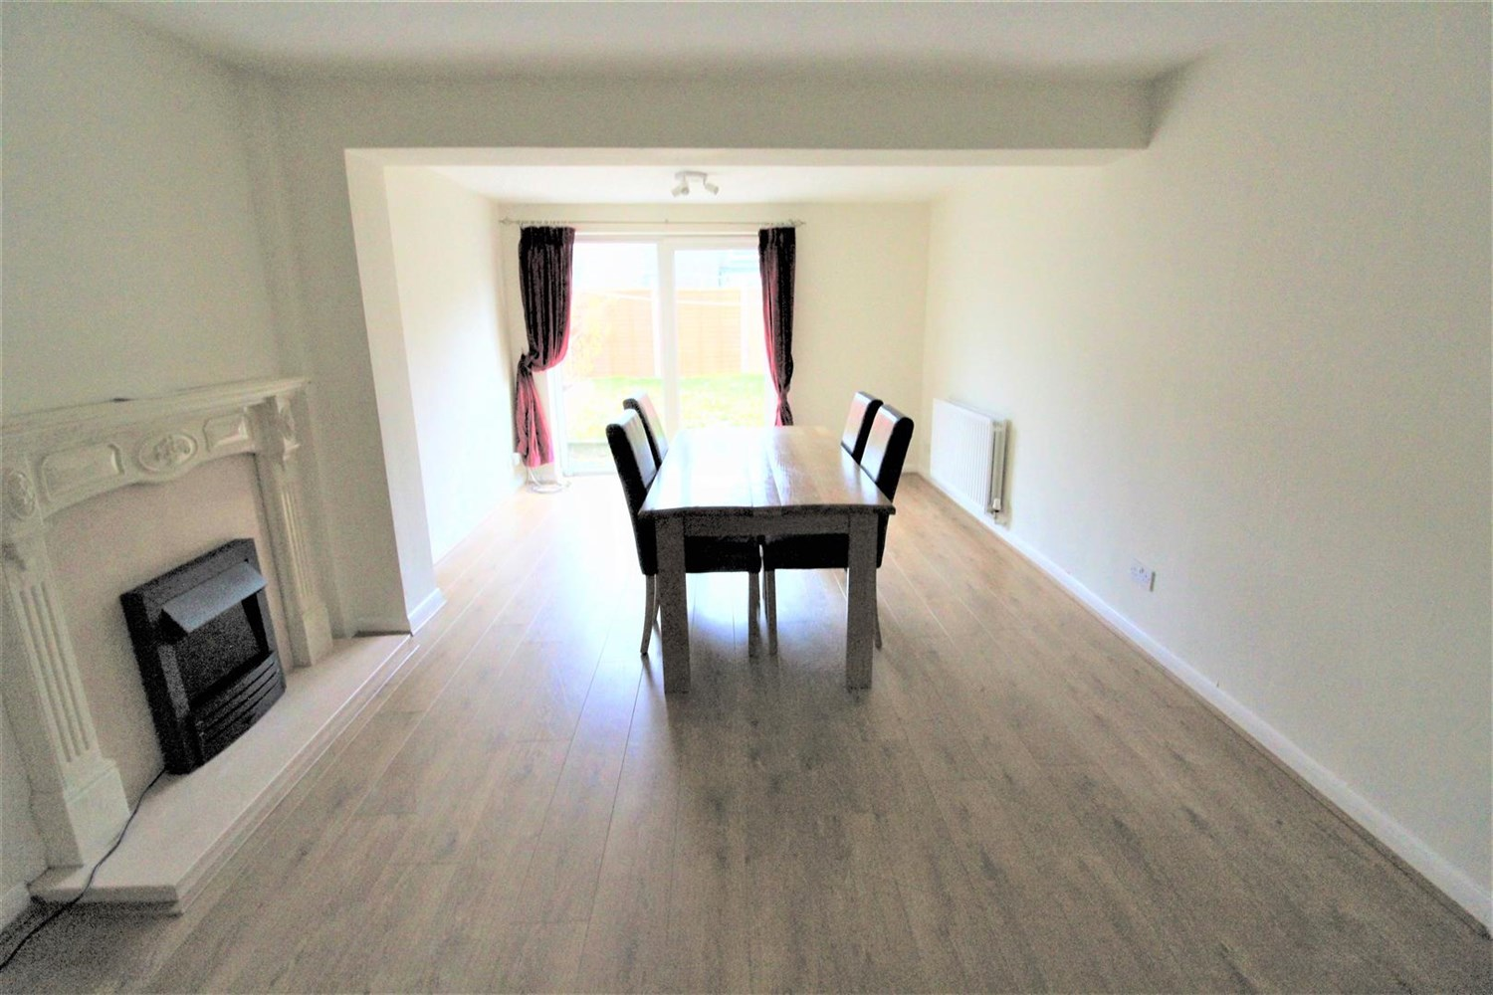

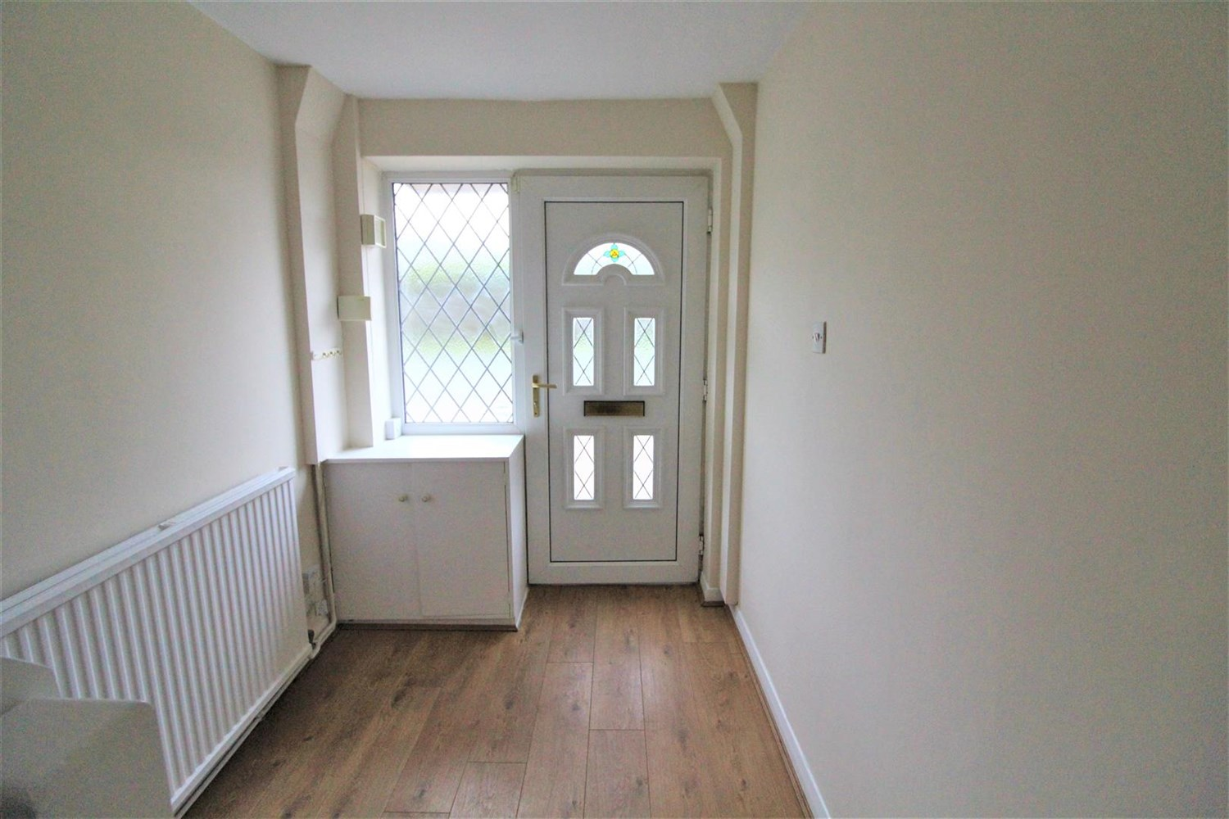

1 Bathroom(s)

2 Reception(s)

4 Bedroom(s)

00

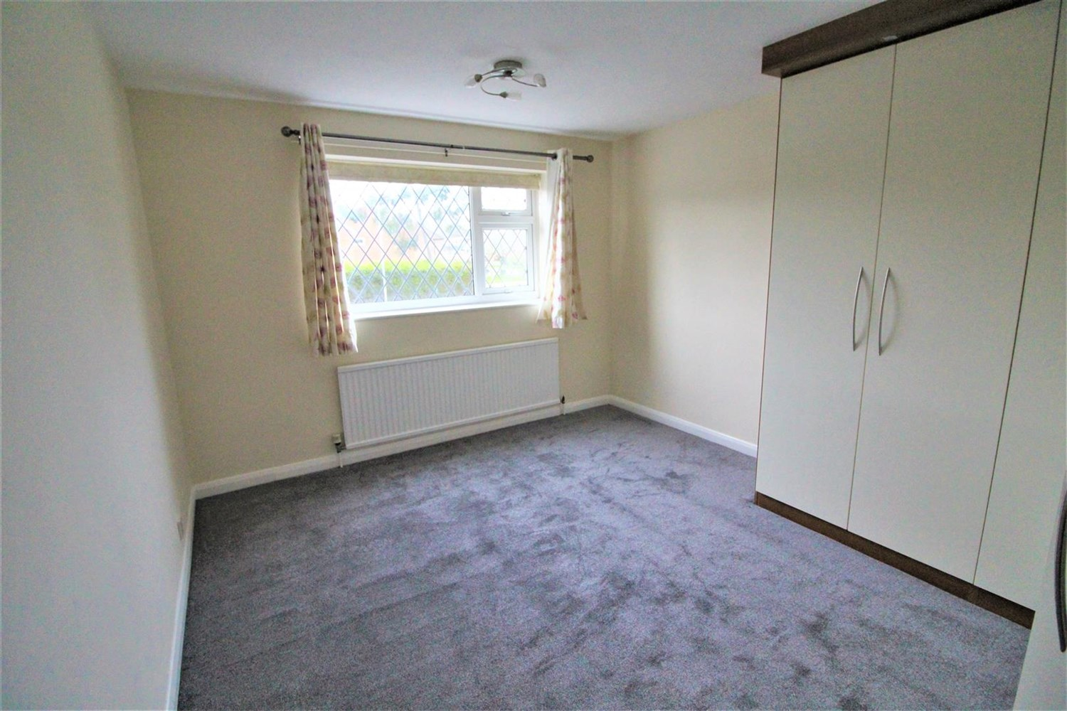

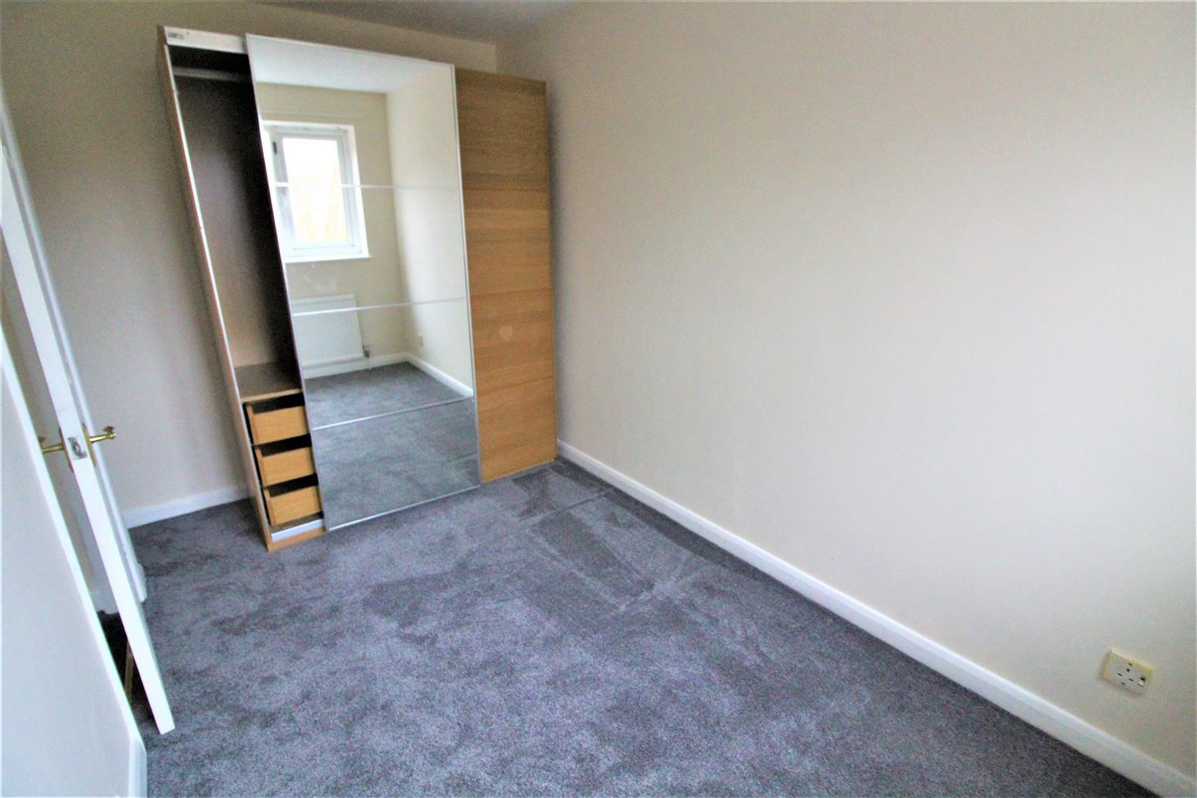

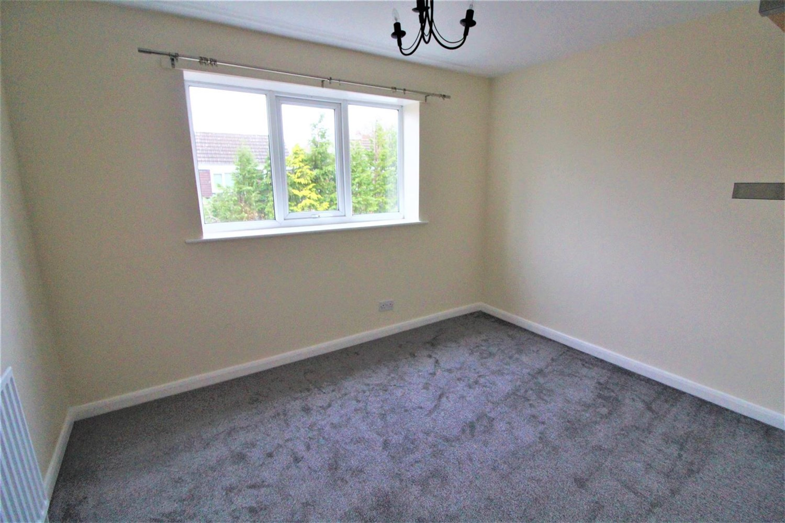

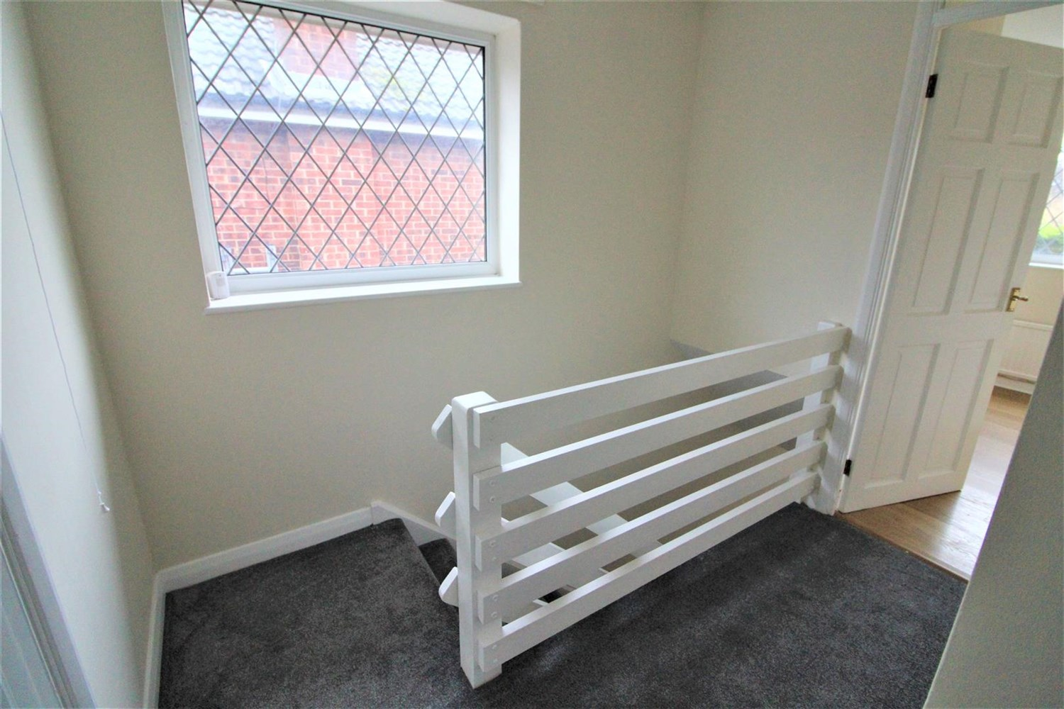

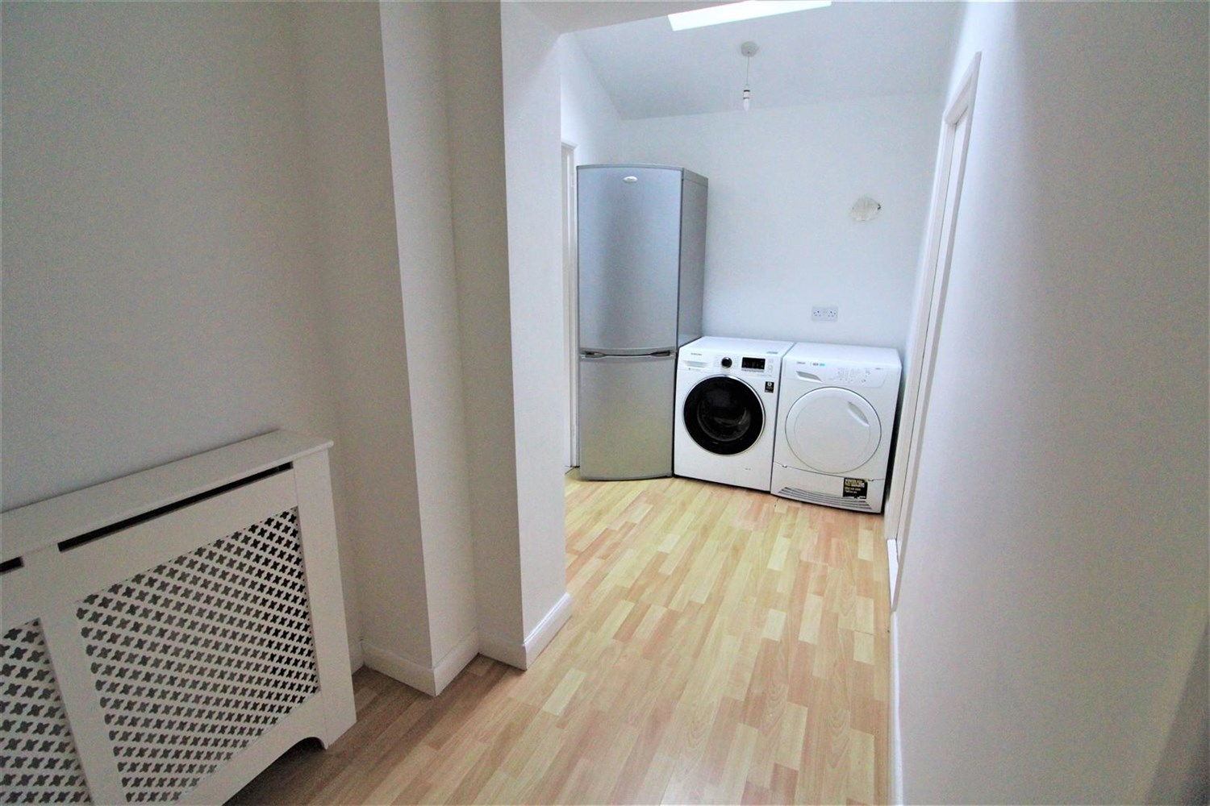

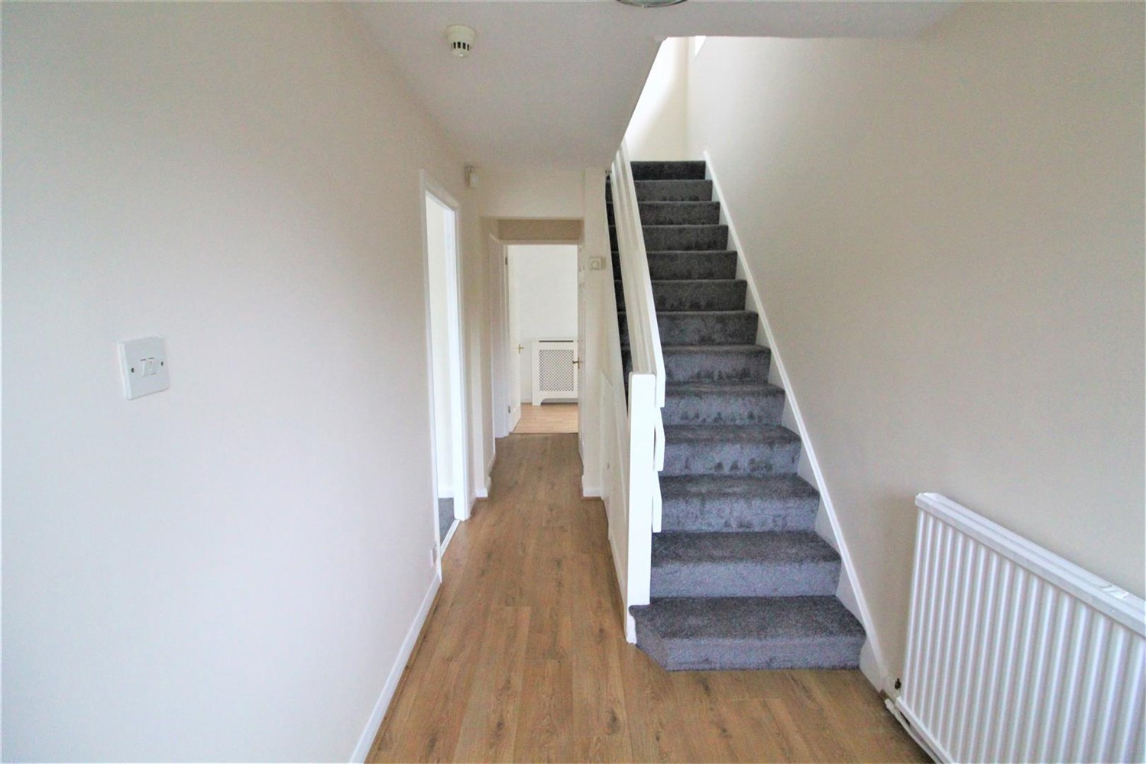

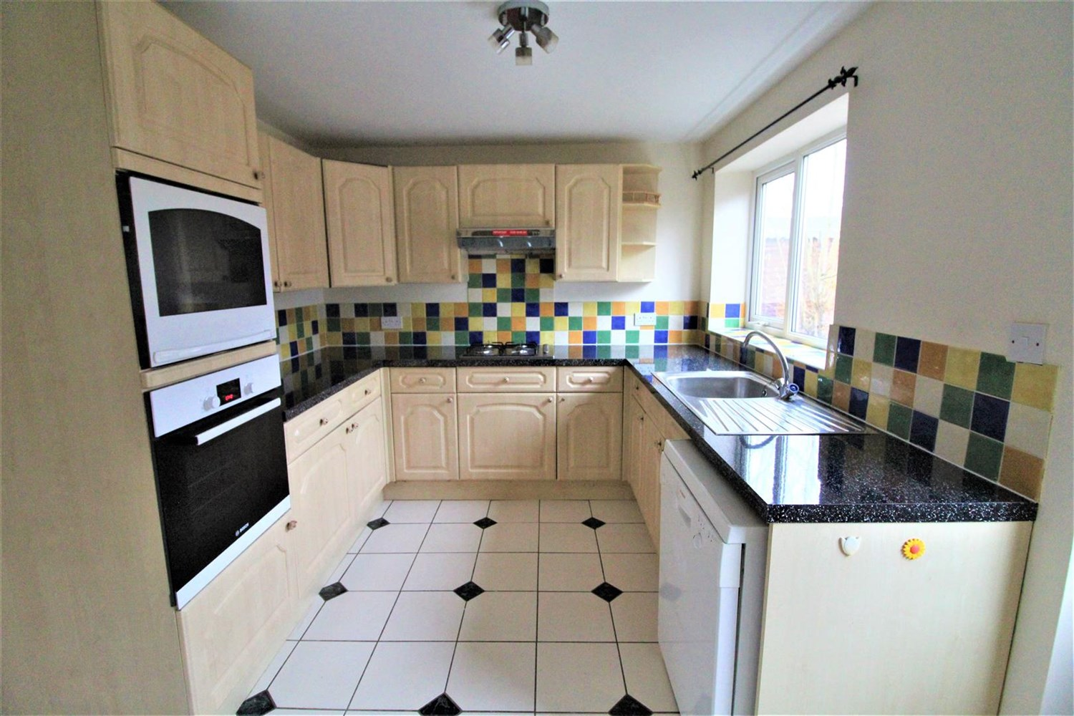

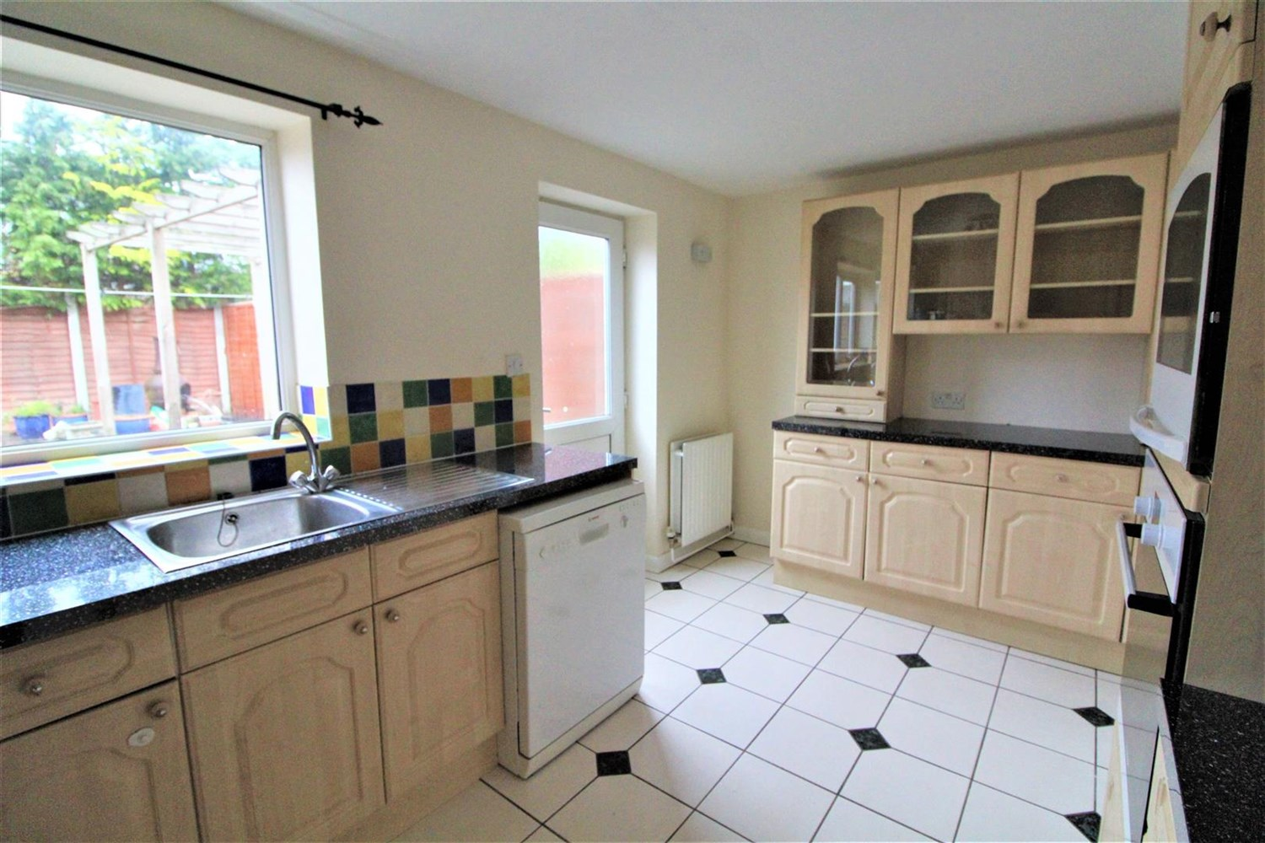

|  |
| --- |
| **Entrance Hall**  Hallway with stairs leading to first floor. |
| **Living Room**  Large light and airy room with fire and surround. Gas central heating window to front. |
| **Kitchen**  Large kitchen fitted with a range of wall and base units with worktops over, stainless steel sink with drainer and mixer tap, gas cooker top with electric oven, extractor over head. Window to rear. |
| **Dining Area**  Dinning room with fire and surround, doors leading to the rear opening to garden. |
| **Master Bedroom**  Double bedroom with window to front, gas central heating radiator. |
| **Bedroom 2**  Double bedroom with window to rear, gas central heating radiator. |
| **Bedroom 3**  Third bedroom with window to front , wardrobe and gas central heating radiator. |
| **Bedroom 4**  Fourth bedroom/dressing room. |
| **House Bathroom**  Fitted with bath, shower over head, shower screen, W/C and hand wash basin. |
| **Home Information**  COUNCIL TAX BAND: C EPC Rating C Freehold property. Driveway.  Broadband: Standard 7 Mbps 0.8 Mbps Good Superfast --Not available --Not available Unlikely Ultrafast 1000 Mbps 100 Mbps  Mobile availability: EE likely to have good coverage. Three likely to have good coverage. O2 likely to have good coverage. Vodafone likely to have good coverage.  Utilities: Water supplied on standard meters. Gas and Electric mains supplied on standard meters. |

|  |  |
| --- | --- |
| These particulars are intended to give a fair description of the property, but their accuracy cannot be guaranteed, and they do not constitute an offer of contract. Intending purchasers must rely on their own inspection of the property. None of the above appliances/services have been tested by ourselves. We recommend purchasers arrange for a qualified person to check all appliances/services before legal commitment.  **Property Ref:** 6652  **For more information, please contact**  0113 258 1150 **|** [lettings@adairpaxton.co.uk](mailto:lettings@adairpaxton.co.uk) **|** www.adairpaxton.co.uk |  |