

**0113 258 1150**

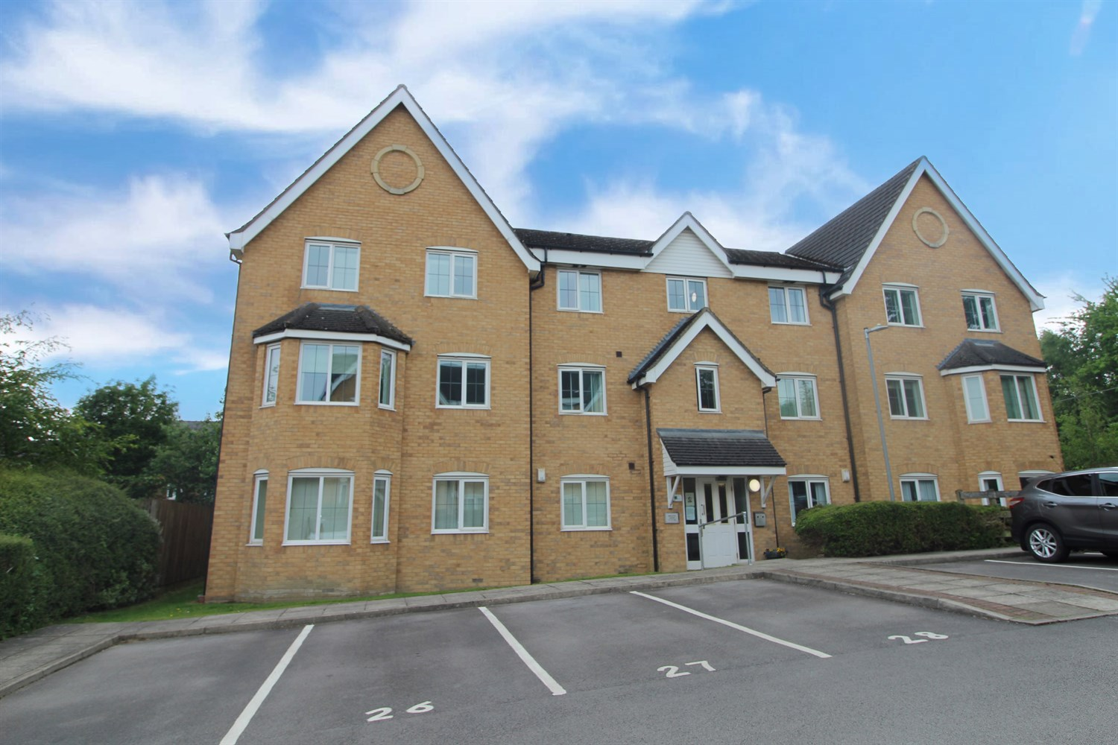



**For Sale £99,950.00**

**Bracken Green, East Ardsley**

***SPACIOUS TWO BEDROOM APARTMENT with ALLOCATED PARKING SPACE*** The property is within easy access to Leeds and Wakefield, close to the motorway network and handy for all amenities. The apartment is located on the top floor and briefly comprises; entrance hall, lounge/diner/kitchen, two double bedrooms and bathroom with shower over bath. Externally there are well maintained communal gardens and an allocated parking space.

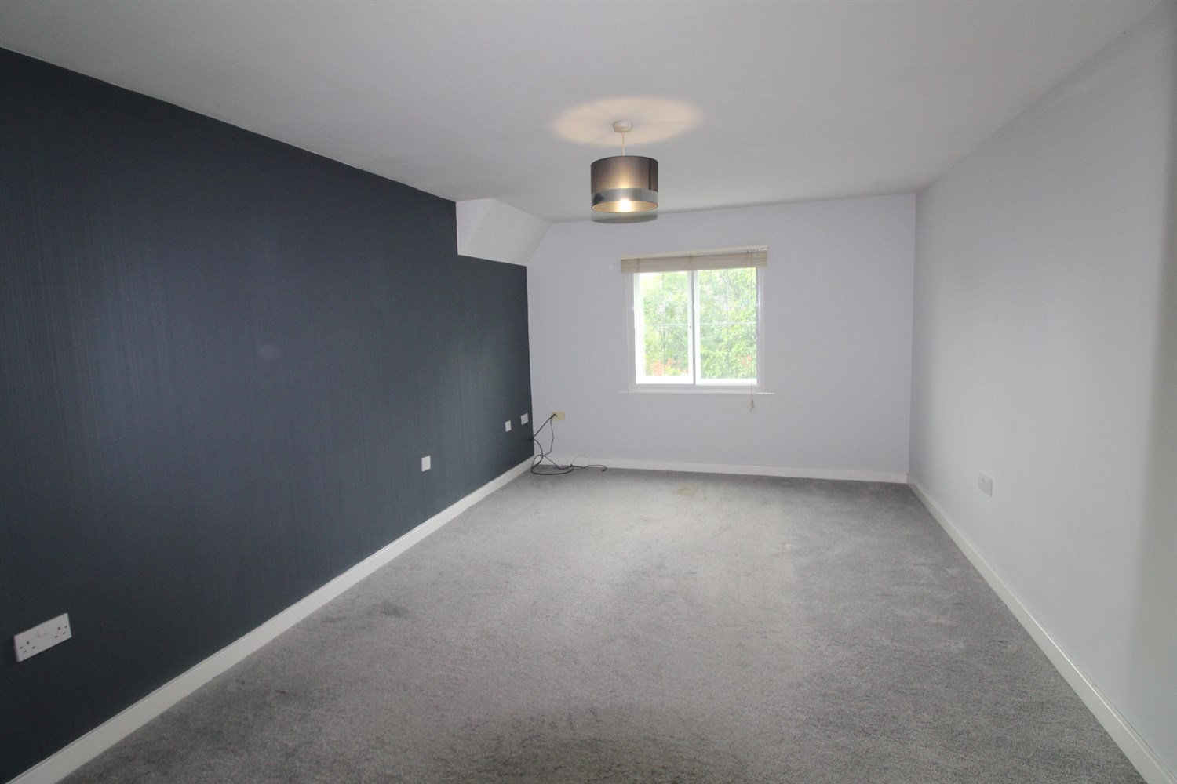

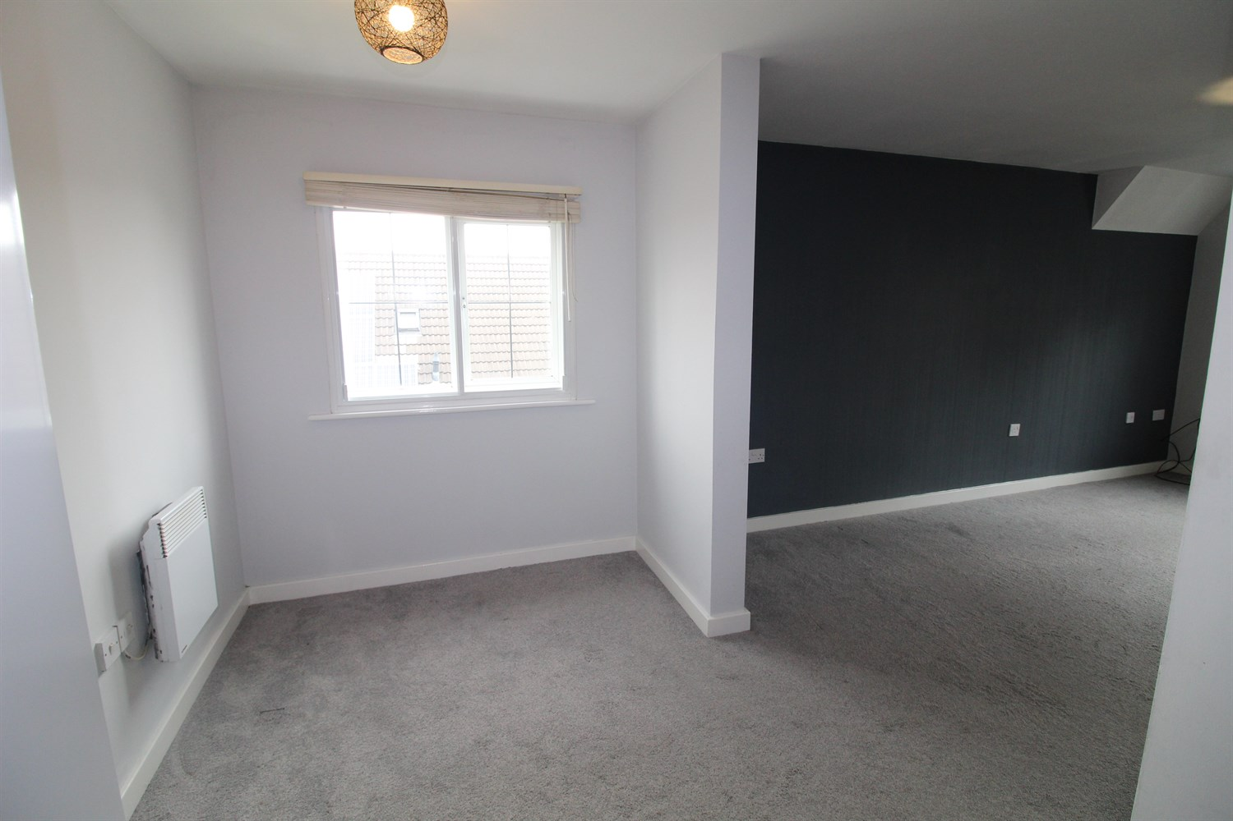

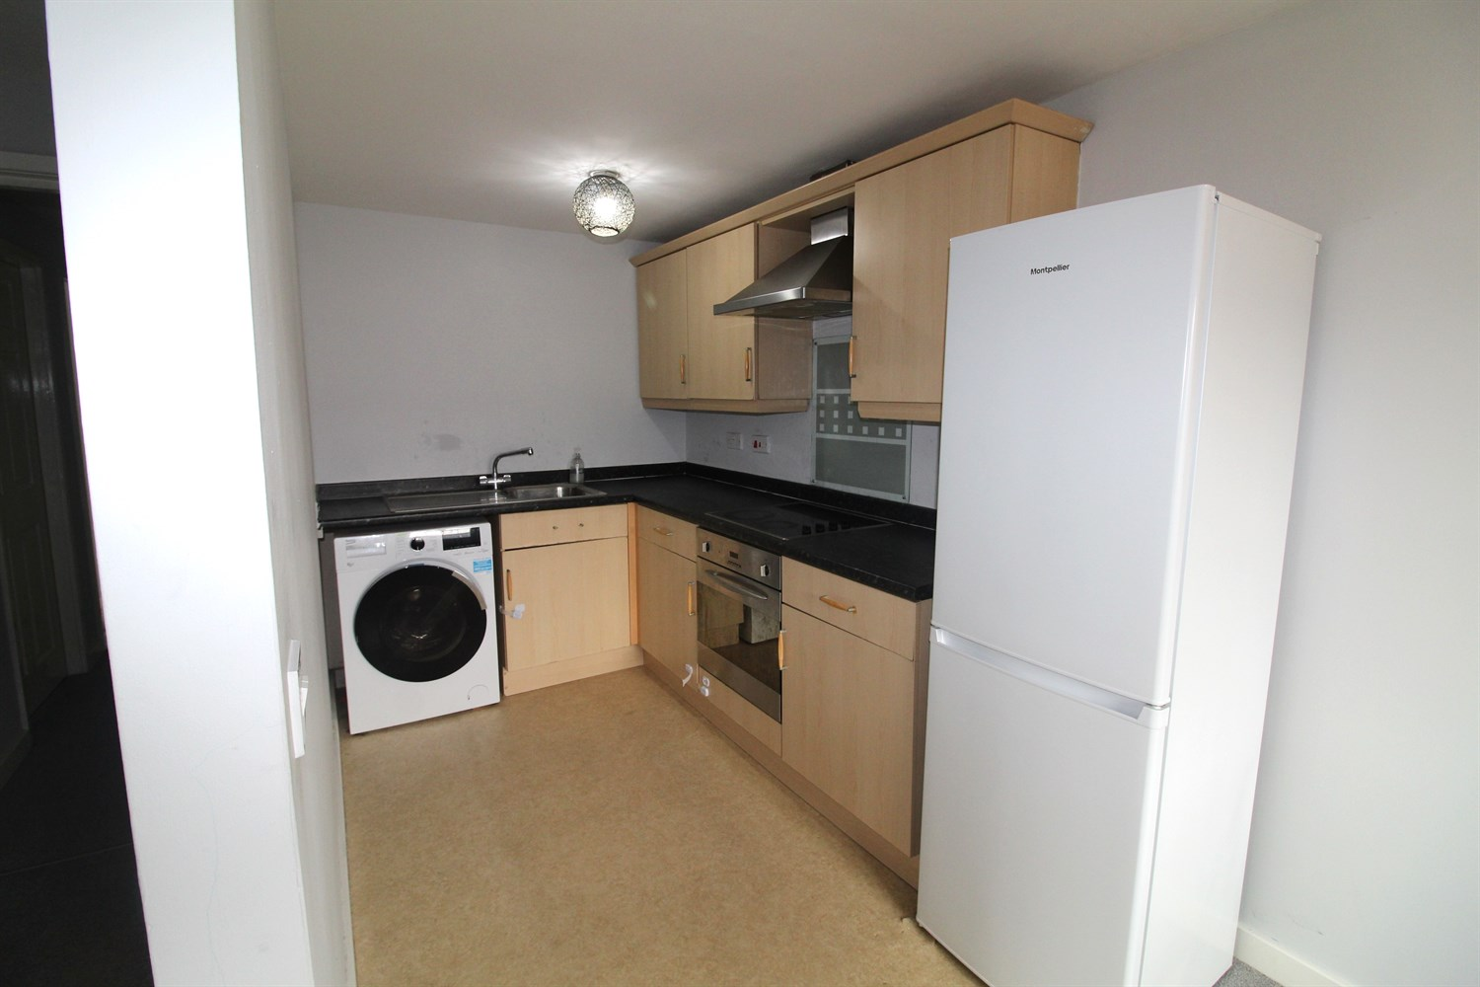

1 Bathroom(s)

1 Reception(s)

2 Bedroom(s)

00

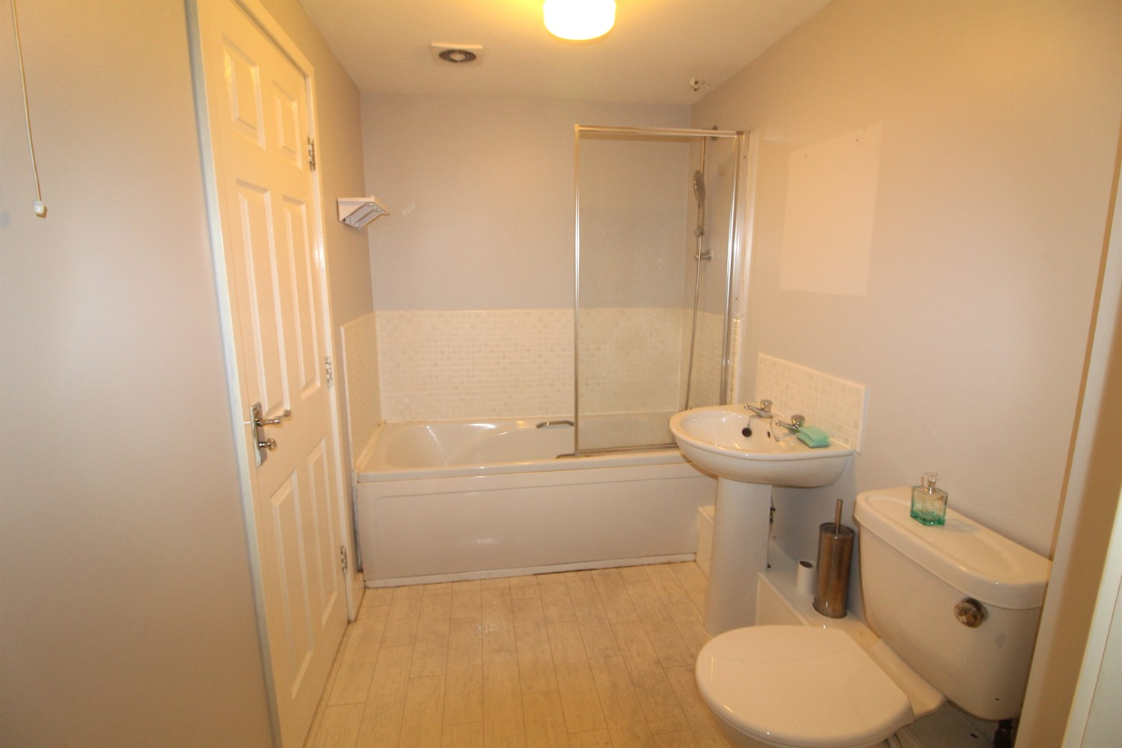

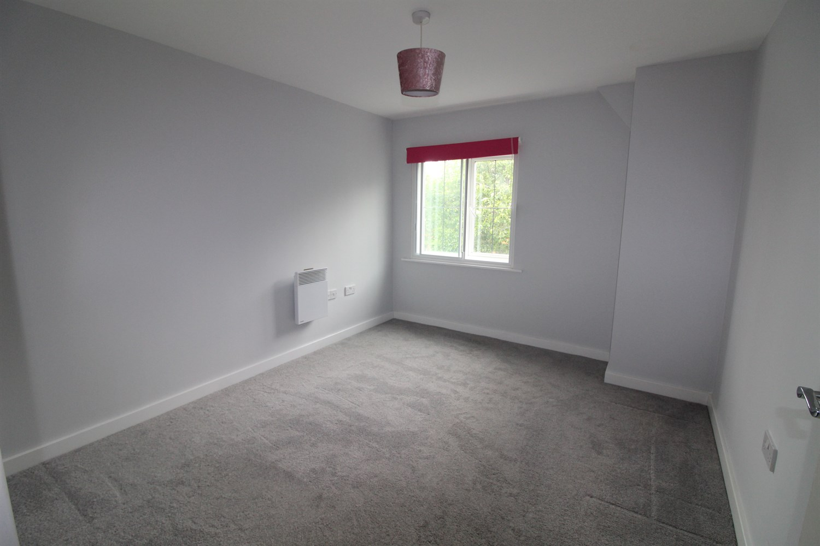

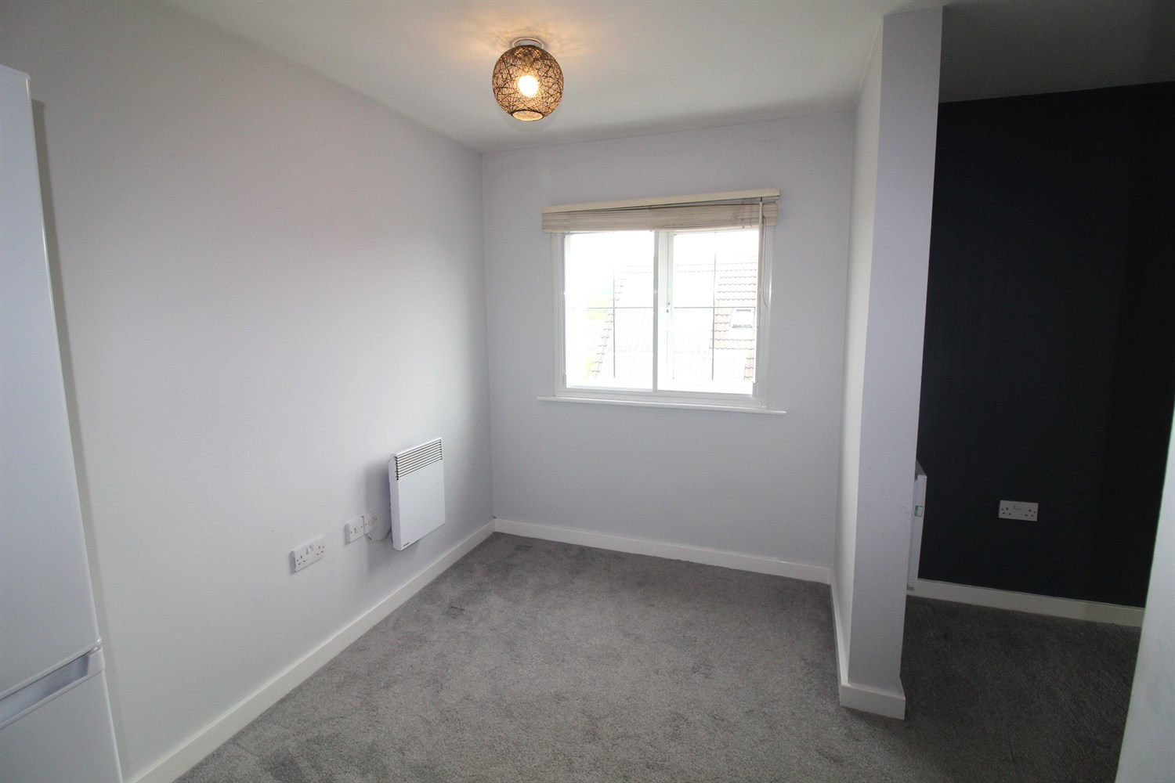

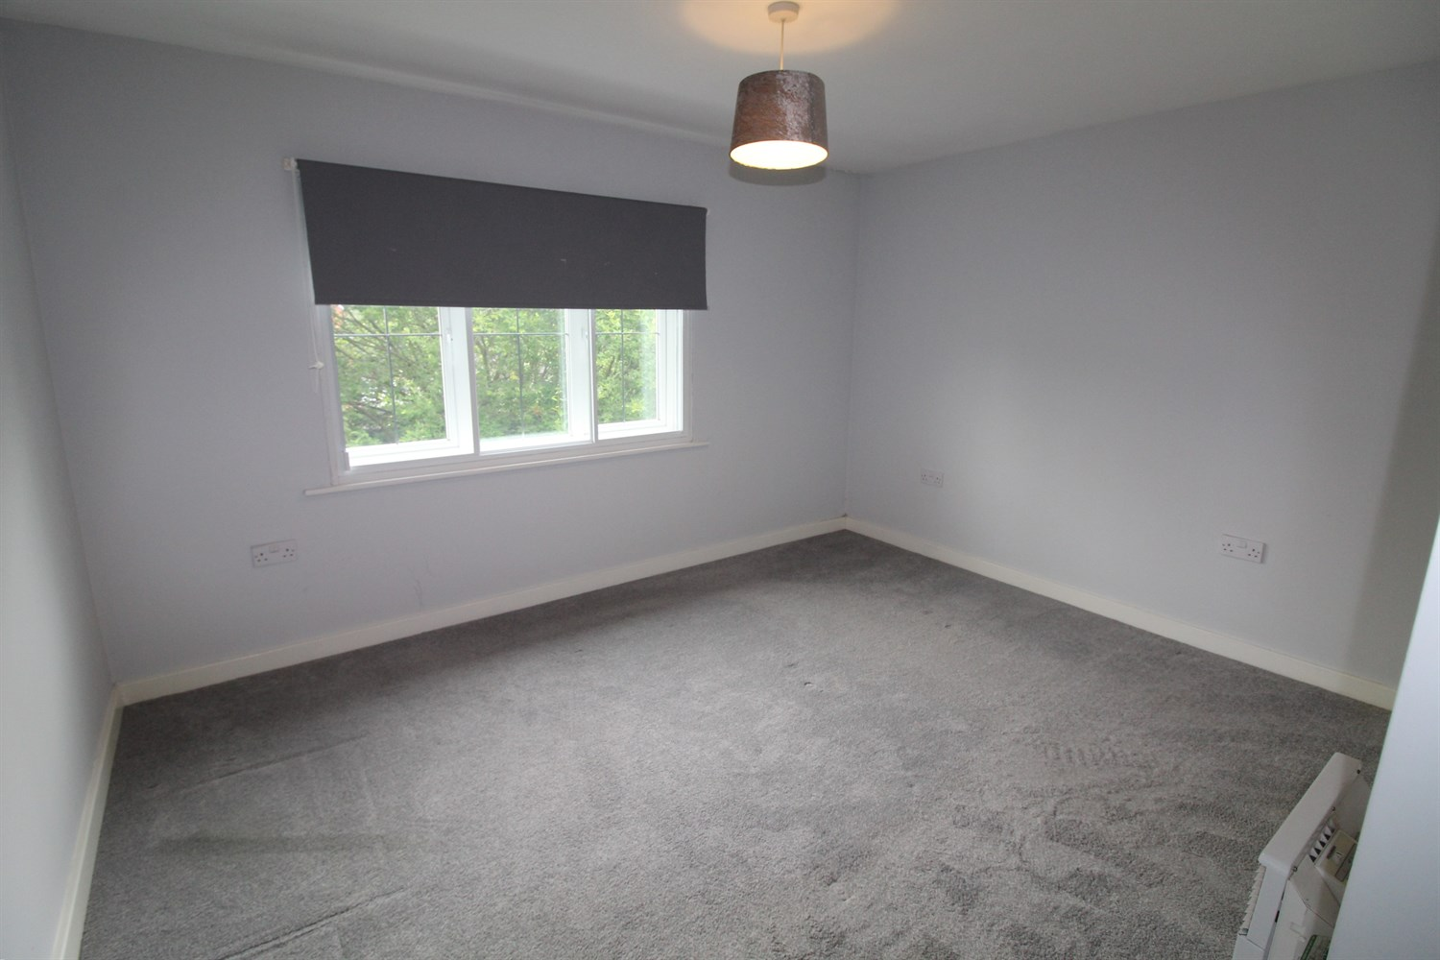

|  |
| --- |
| **Communal Entrance**  Secure communal entrance with stairs to all floors. |
| **Hallway**  Entrance hall with storage cupboard |
| **Kitchen**  Fitted with a range of wall, base and drawer units with worktops over. Single drainer stainless steel sink with mixer tap and drainer. Integrated over with 4-ring hob and extractor above. Plumbed for washing machine. Part tiled walls. Space for fridge freezer. Window to dining area. |
| **Lounge**  Partly open to the dining area/kitchen. uPVC double glazed window. Wall mounted heated towel rail. |
| **Master Bedroom**  Double bedroom with double glazed window. Wall mounted electric radiator. |
| **Bedroom Two**  Second double bedroom. Double glazed window and electric panel radiator. |
| **House Bathroom**  White suite comprising bath, WC and wash hand basin, vinyl flooring and heated towel rail. Also accessed from bedroom 1. |
| **Outside**  Well maintained communal gardens. |
| **Parking**  Allocated Parking. |
| **Tenure**  Leasehold - 125 years from 01/01/2006 Ground rent - £341.71 |
| **Service Charge**  Service Charge - £739.20 per six months. |
| **Home Information**  COUNCIL TAX BAND: A EPC Rating: D Broadband: Standard 5 Mbps 0.7 Mbps Superfast 80 Mbps 20 Mbps  Ultrafast 1000 Mbps 1000 Mbp  Mobile availability: EE limited. Three Limited. O2 good. Vodafone good.utilities: Water supplied on standard meters. Electric mains supplied on standard meters. |

|  |  |
| --- | --- |
| These particulars are intended to give a fair description of the property, but their accuracy cannot be guaranteed, and they do not constitute an offer of contract. Intending purchasers must rely on their own inspection of the property. None of the above appliances/services have been tested by ourselves. We recommend purchasers arrange for a qualified person to check all appliances/services before legal commitment.  **Property Ref:** 6400  **For more information, please contact**  0113 258 1150 **|** [sales@adairpaxton.co.uk](mailto:sales@adairpaxton.co.uk) **|** www.adairpaxton.co.uk |  |