

**Lakeview Court, Roundhay**

**For Sale £**

**BEAUTIFULLY PRESENTED TWO BEDROOM GROUND FLOOR APARTMENT** Situated in this much sought after gated development and having been recently refurnished by the current owner, this delightful apartment simply must be viewed to be appreciated. The property is ready to move into and briefly comprises; communal entrance, private entrance hall with store cupboard, guest WC, open plan lounge/dining room, newly refurbished breakfast kitchen, master bedroom with en-suite bathroom and second double bedroom. Externally, the property benefits from a private garage and visitor parking. Situated in well maintained communal gardens, the property enjoys a semi-rural feel, while being on the doorstep of all of the amenities available at Oakwood and Street Lane.

**0113 258 1150**

**0800 000 000**

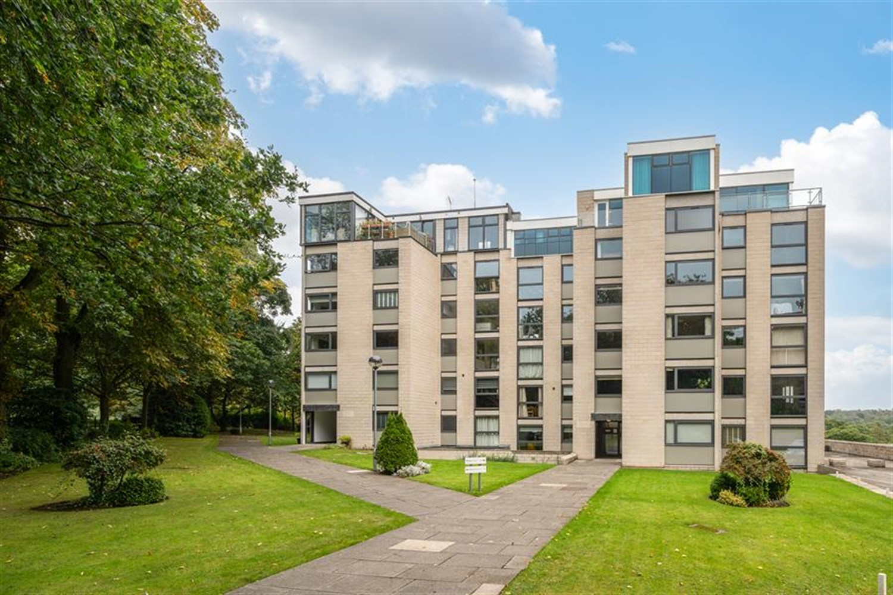

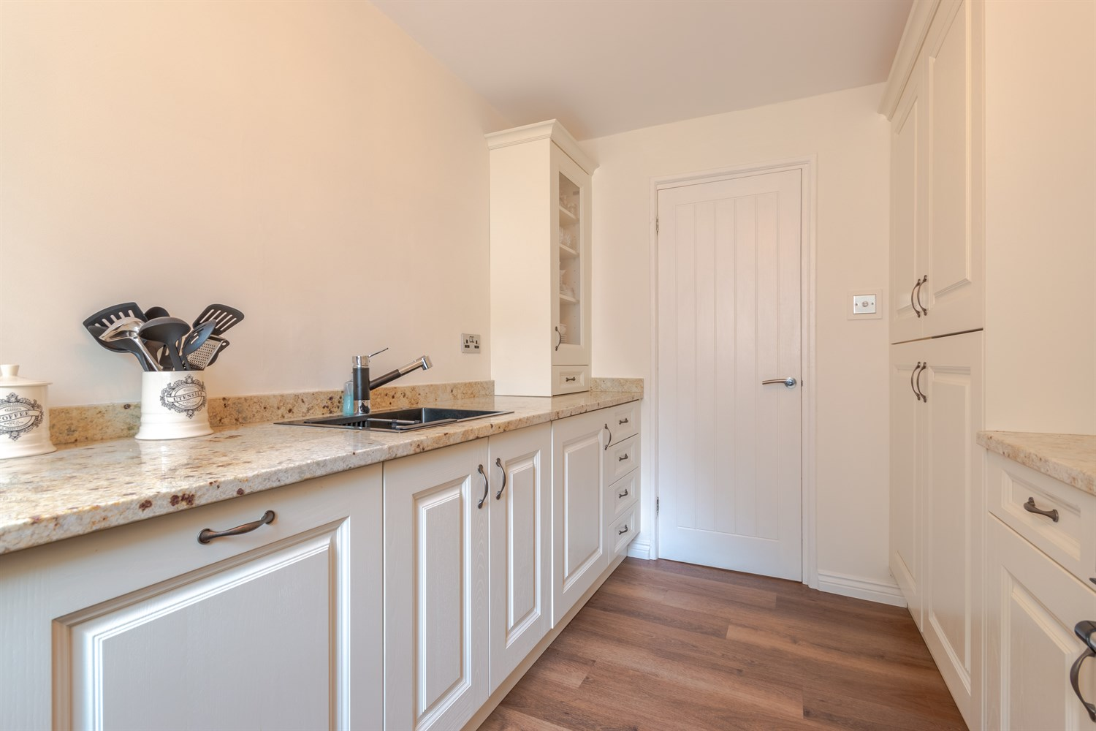

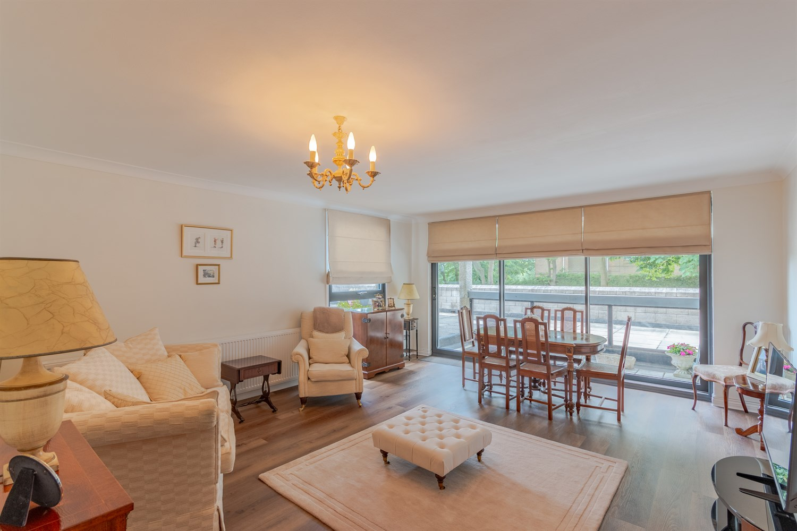

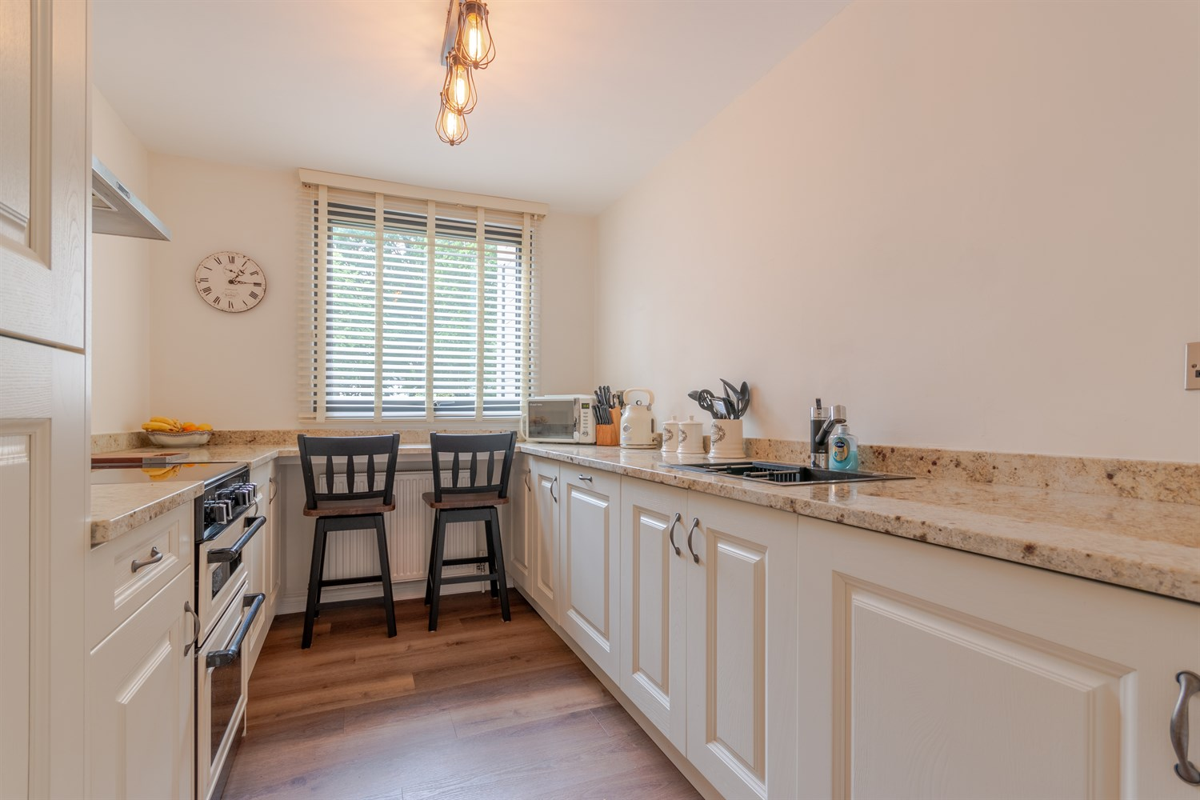

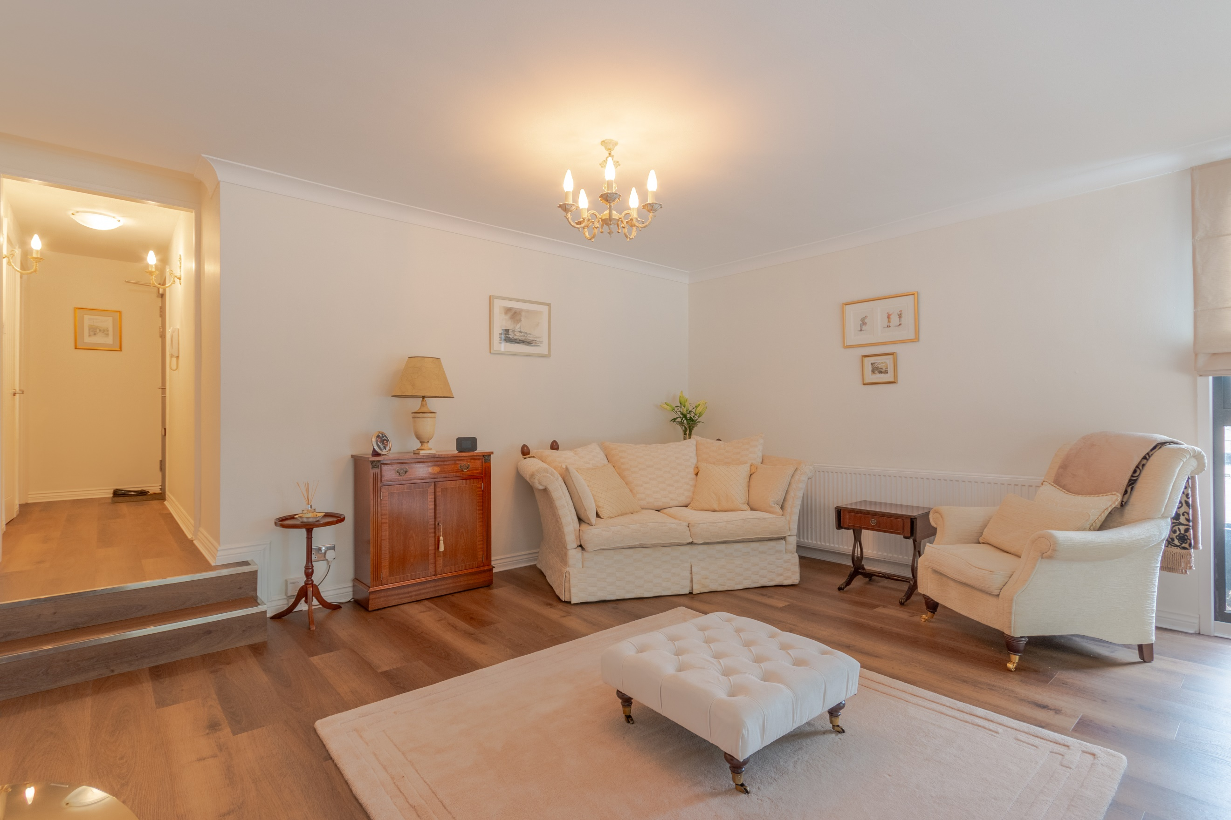

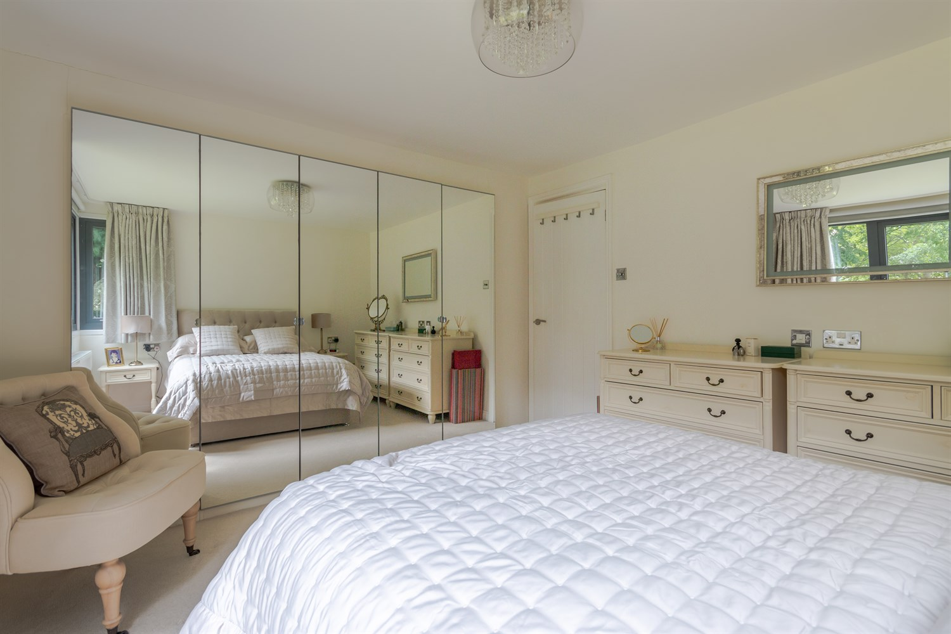

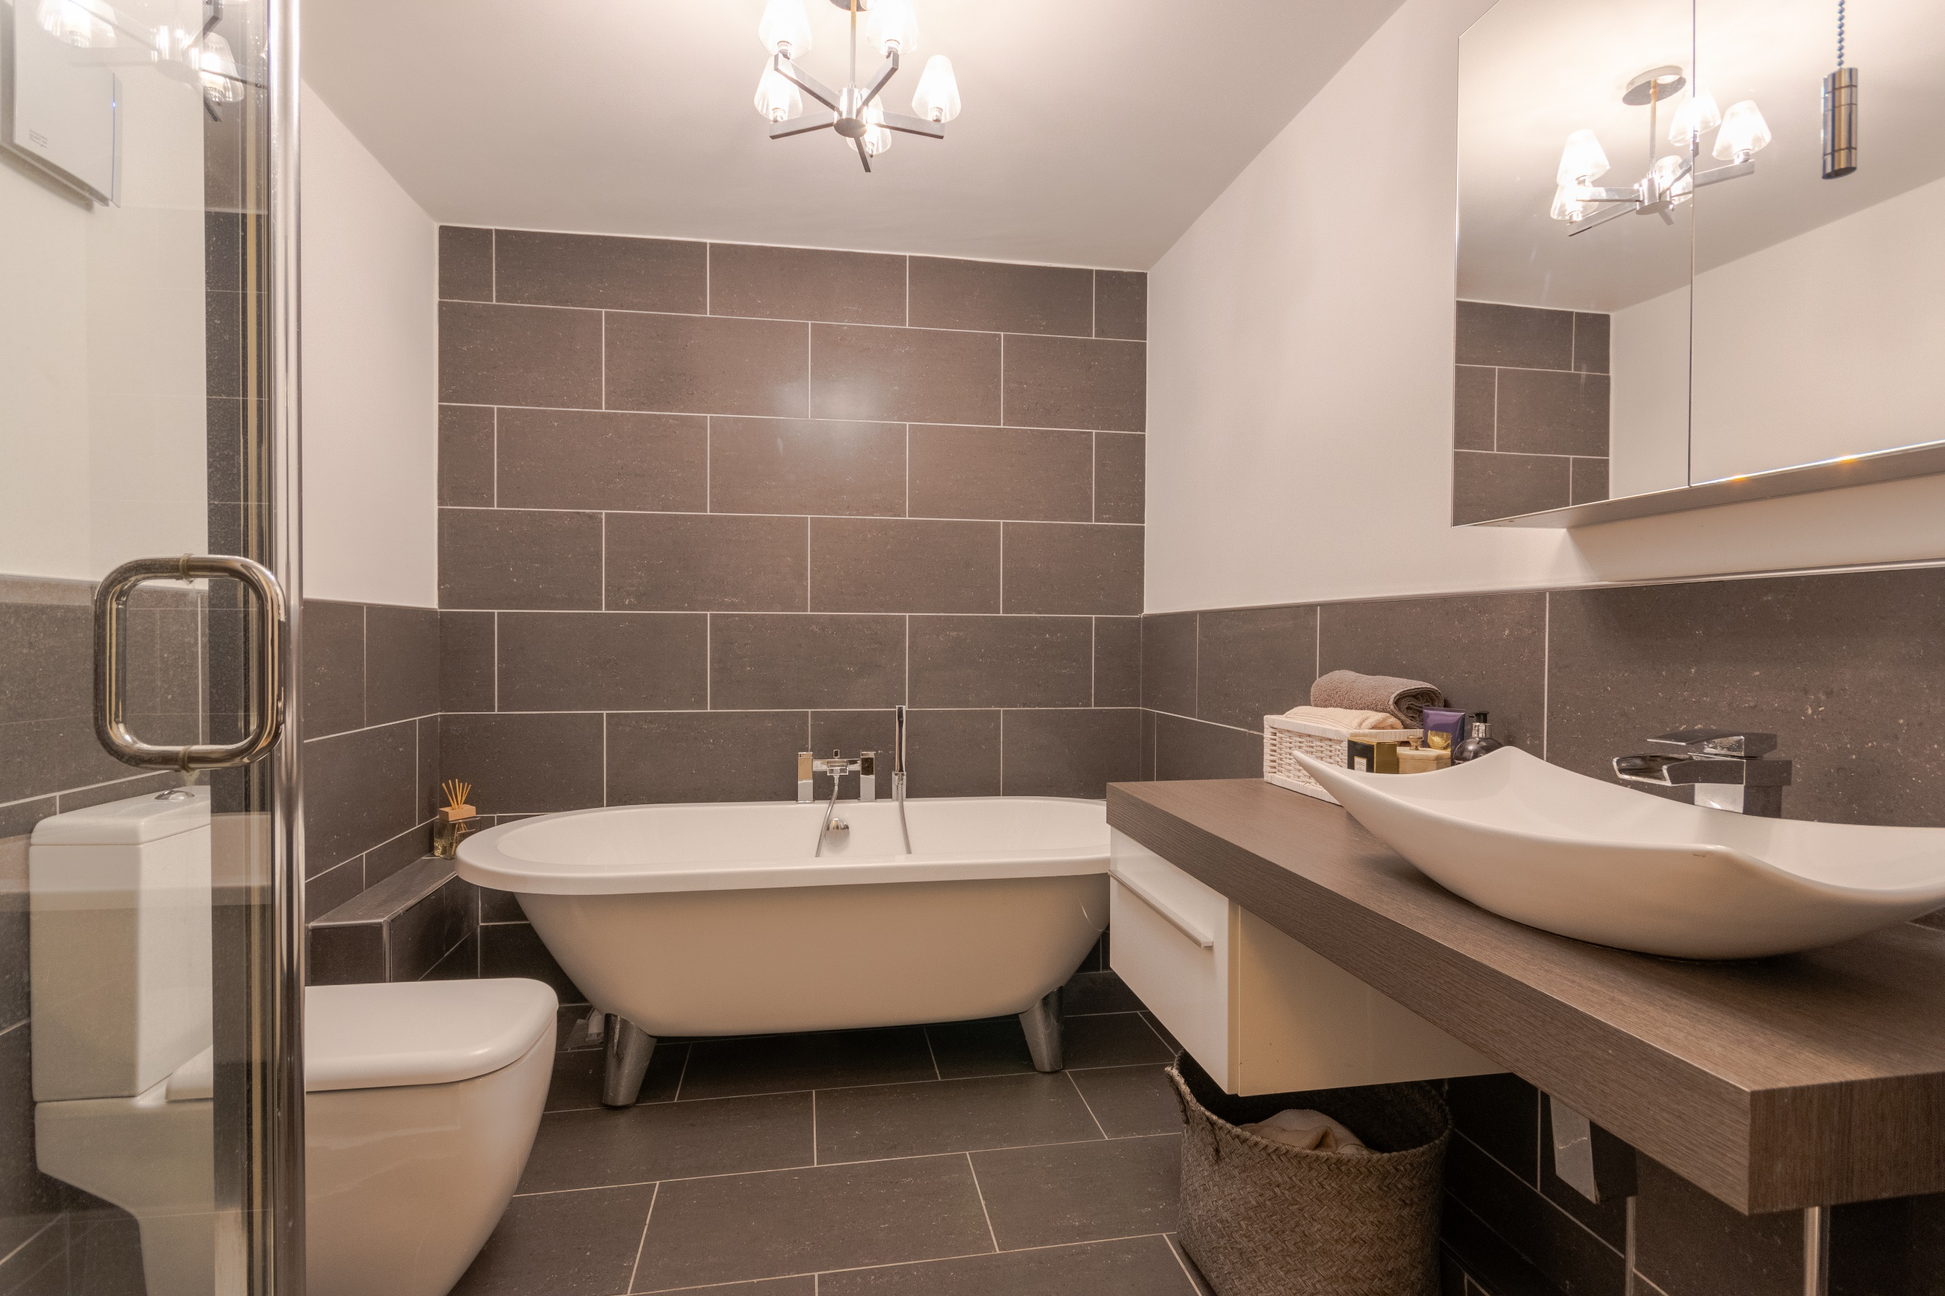

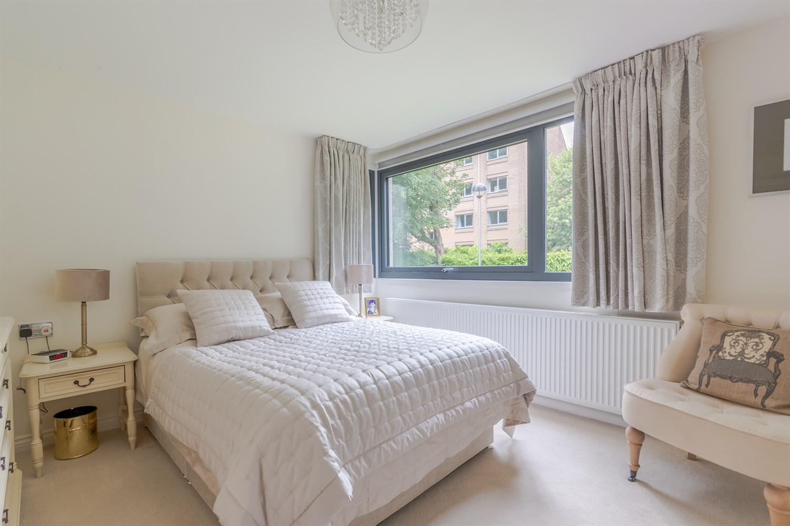

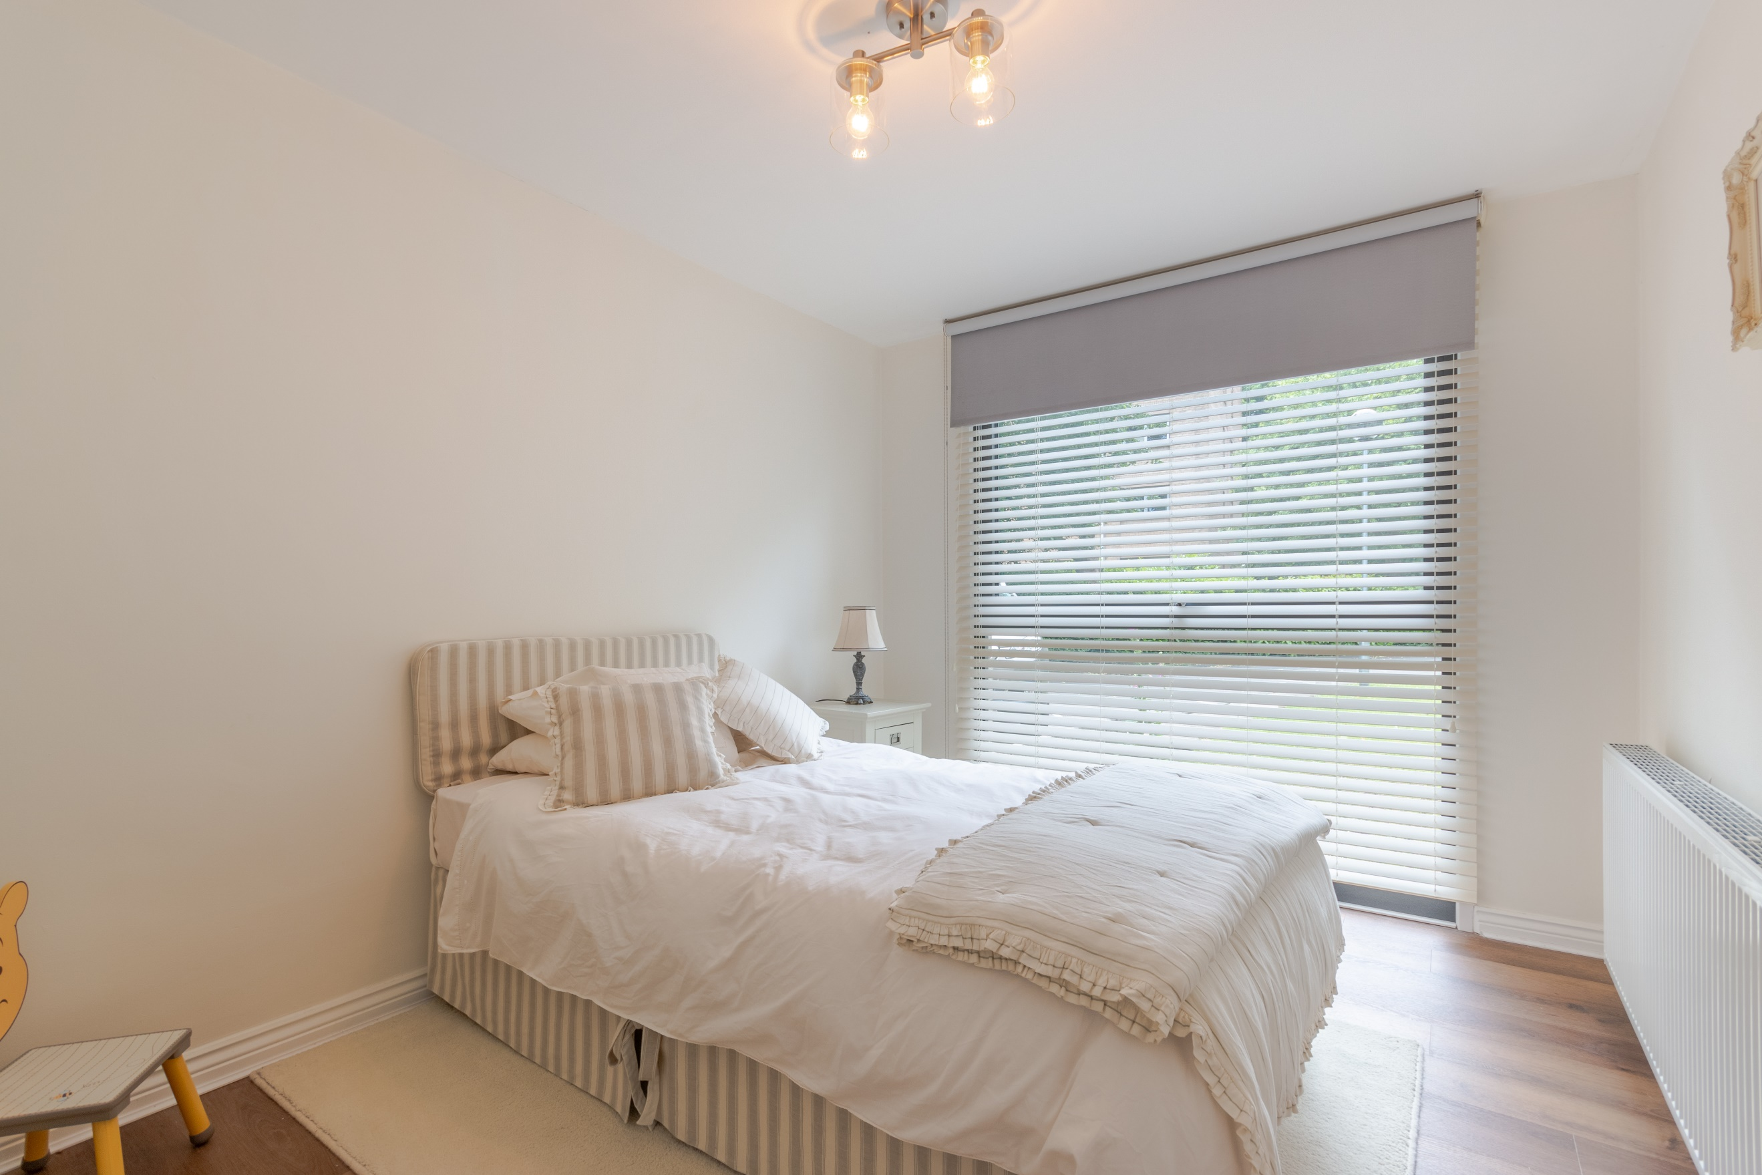

|  |
| --- |
| **Communal Entrance**  With video intercom entry system. Stairs and lift access to all floors. |
| **Private Entrance Hall**  Via front entrance door. Store cupboard. Steps leading down to the open plan living area. |
| **Guest WC**  Fitted with a two piece suite comprising; WC and wash hand basin. |
| **Open Plan Lounge/Dining Area**  Light and airy living area with uPVC double glazed window to side and uPVC double glazed sliding doors leading out to the balcony. Electric radiator. |
| **Kitchen**  Newly fitted kitchen. Fitted with a range of wall, base and drawer units with granite worktops over. Breakfast bar. Freestanding oven with extractor hood over. Integrated fridge, freezer and dishwasher. Sink with mixer tap. Electric radiator. uPVC double glazed window. |
| **Master Bedroom**  Double bedroom with uPVC double glazed window. Built in wardrobes. Electric radiator. |
| **Bedroom Two**  Second double bedroom with floor to ceiling uPVC double glazed window. Electric radiator. |
| **House Bathroom**  Beautiful four piece suite comprising; freestanding bath tub with mixer tap and hand shower over, shower cubicle, vanity wash hand basin and WC. Tiled walls and tiled floor. |
| **Communal Gardens**  This gated development enjoys well maintained communal gardens and superb views over Roundhay Park and Soldiers Field. |
| **Garage**  Private Garage |
|  |
| **Service Charge**  Service charge: £955 Quarterly. This includes buildings insurance. |
| **Tenure**  Ground Rent - £25 per annum. |

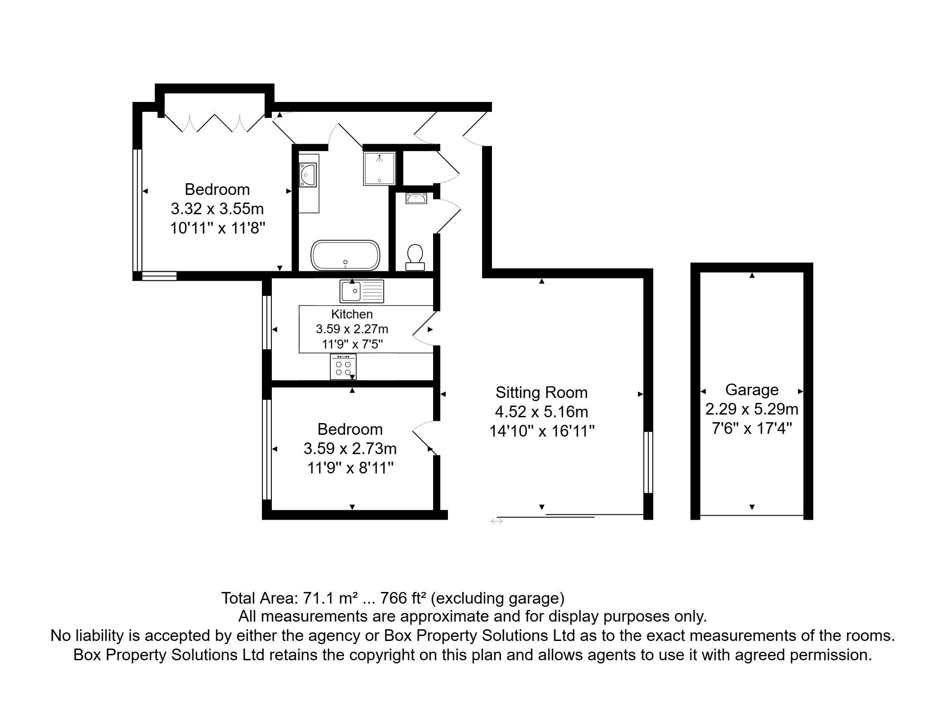

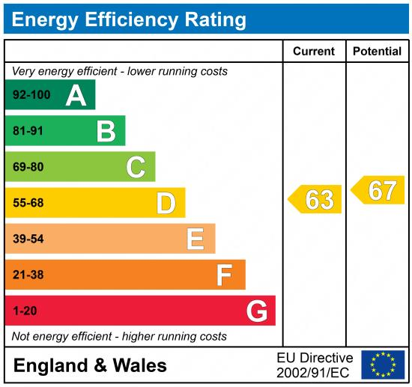

|  |
| --- |
|  |

These particulars are intended to give a fair description of the property, but their accuracy cannot be guaranteed, and they do not constitute an offer of contract. Intending purchasers must rely on their own inspection of the property. None of the above appliances/services have been tested by ourselves. We recommend purchasers arrange for a qualified person to check all appliances/services before legal commitment.

**Property Ref:** 6517

**For more information, please contact**

0113 258 1150 **|** [sales@adairpaxton.co.uk](mailto:sales@adairpaxton.co.uk) **|** www.adairpaxton.co.uk