

**0113 258 1150**

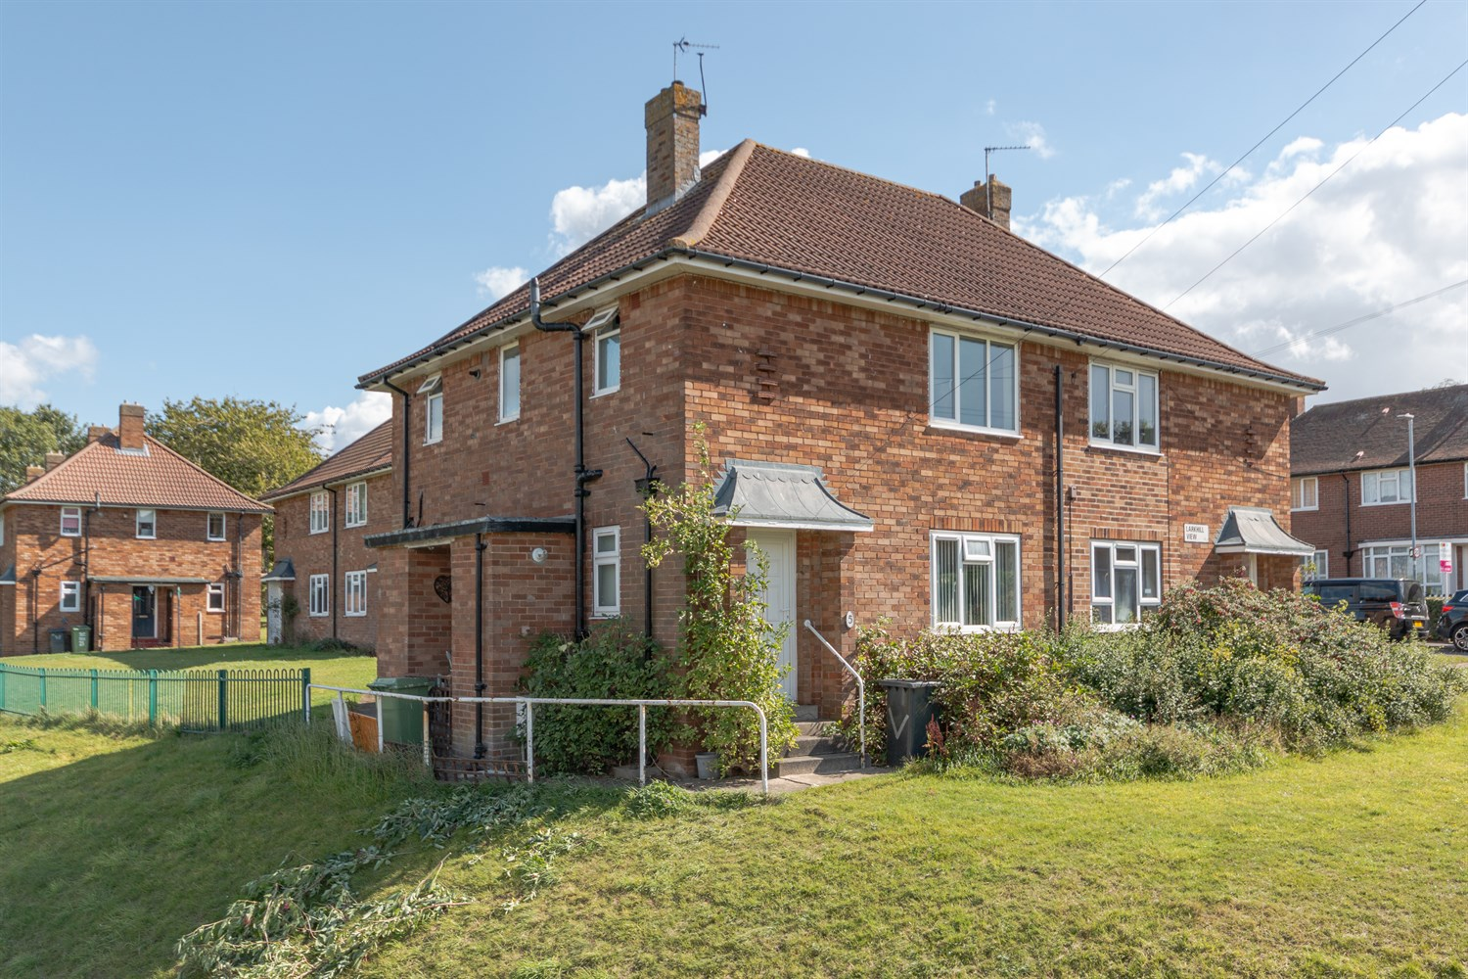



**For Sale £90,000.00**

**Larkhill View, Gledhow**

**ONE BEDROOM FIRST FLOOR APARTMENT - NO ONWARD CHAIN** Adair Paxton are pleased to offer to the market this one bedroom first floor apartment with its own private entrance. Situated in this convenient residential area of Gledhow, close to a host of amenities at both Roundhay and Chapel Allerton. The property would suit a variety of buyers from first time buyers to investors. The property is now in need of updating but does benefit from gas central heating and double glazing, and briefly comprises; Private entrance with stairs to first floor, spacious lounge with access to a balcony, double bedroom, separate kitchen and bathroom. Externally, the property has communal lawned gardens to the front and rear.

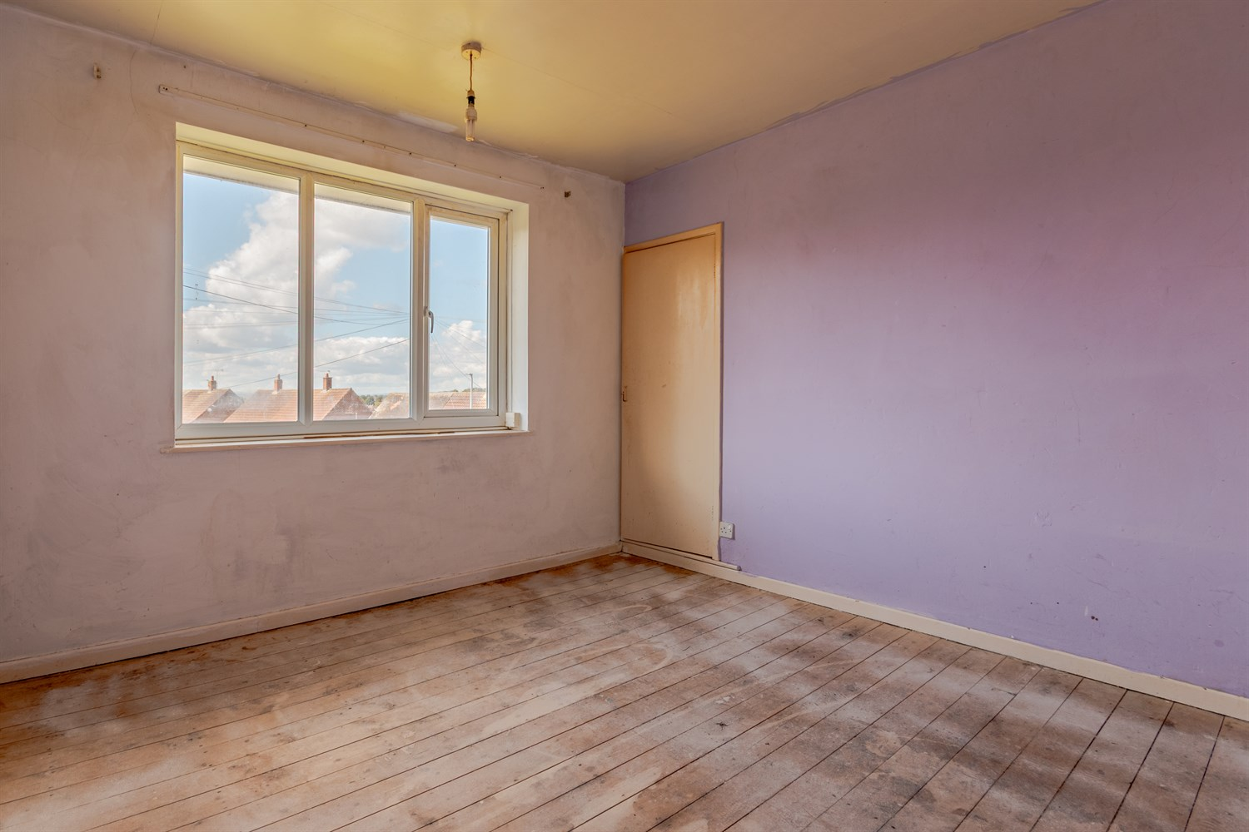

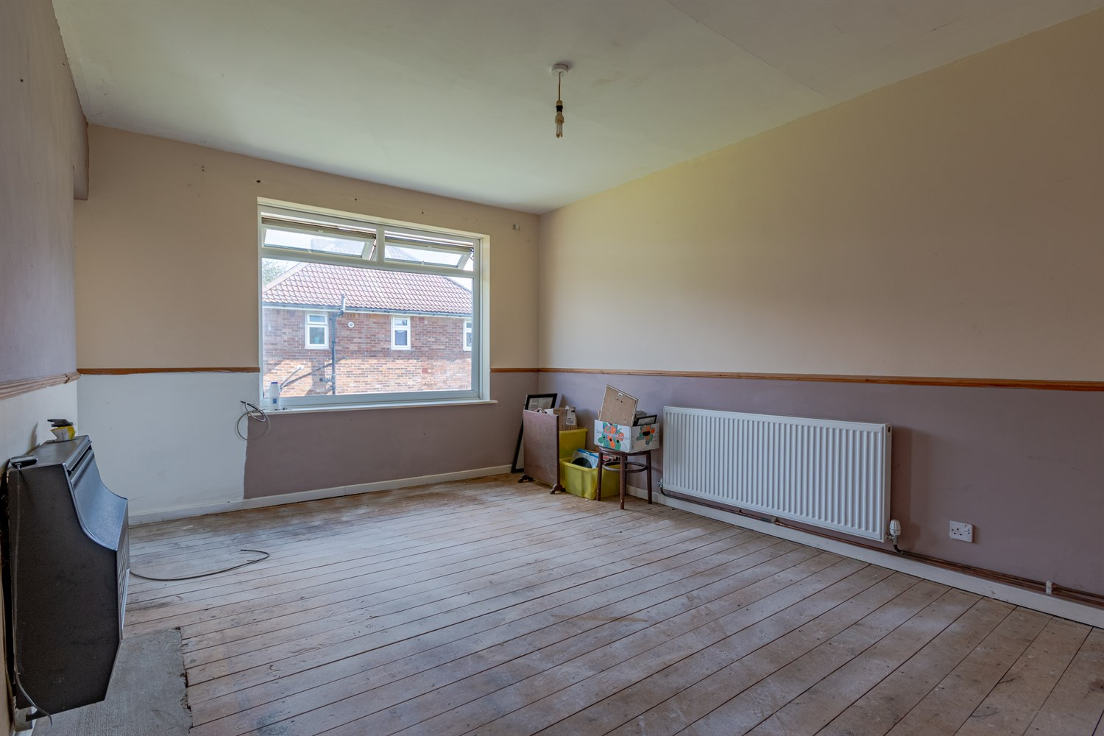

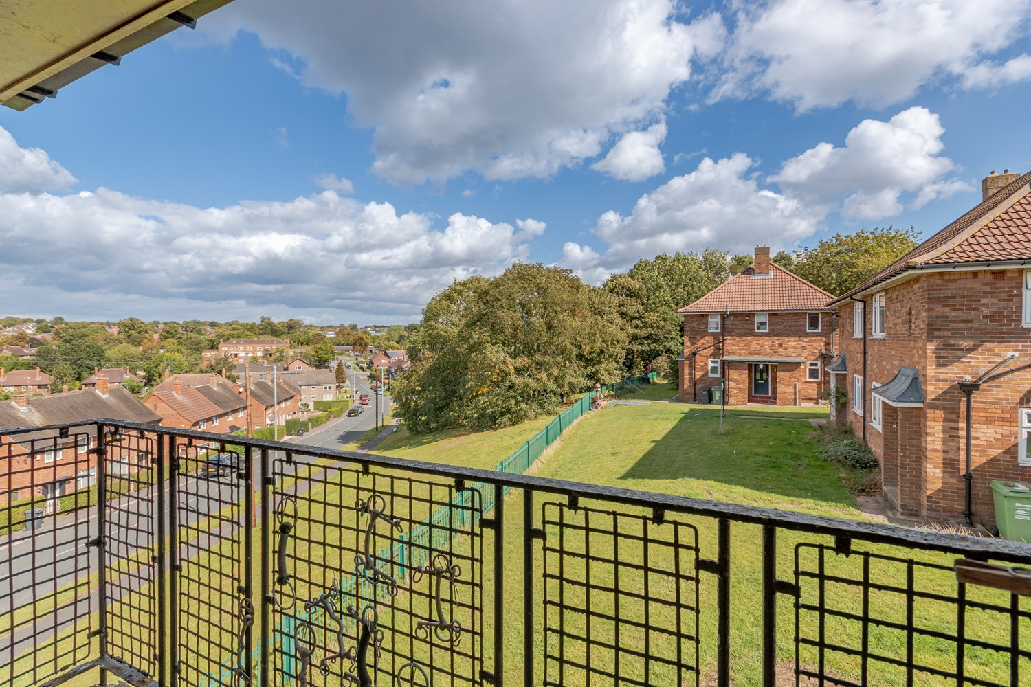

1 Bathroom(s)

1 Reception(s)

1 Bedroom(s)

00

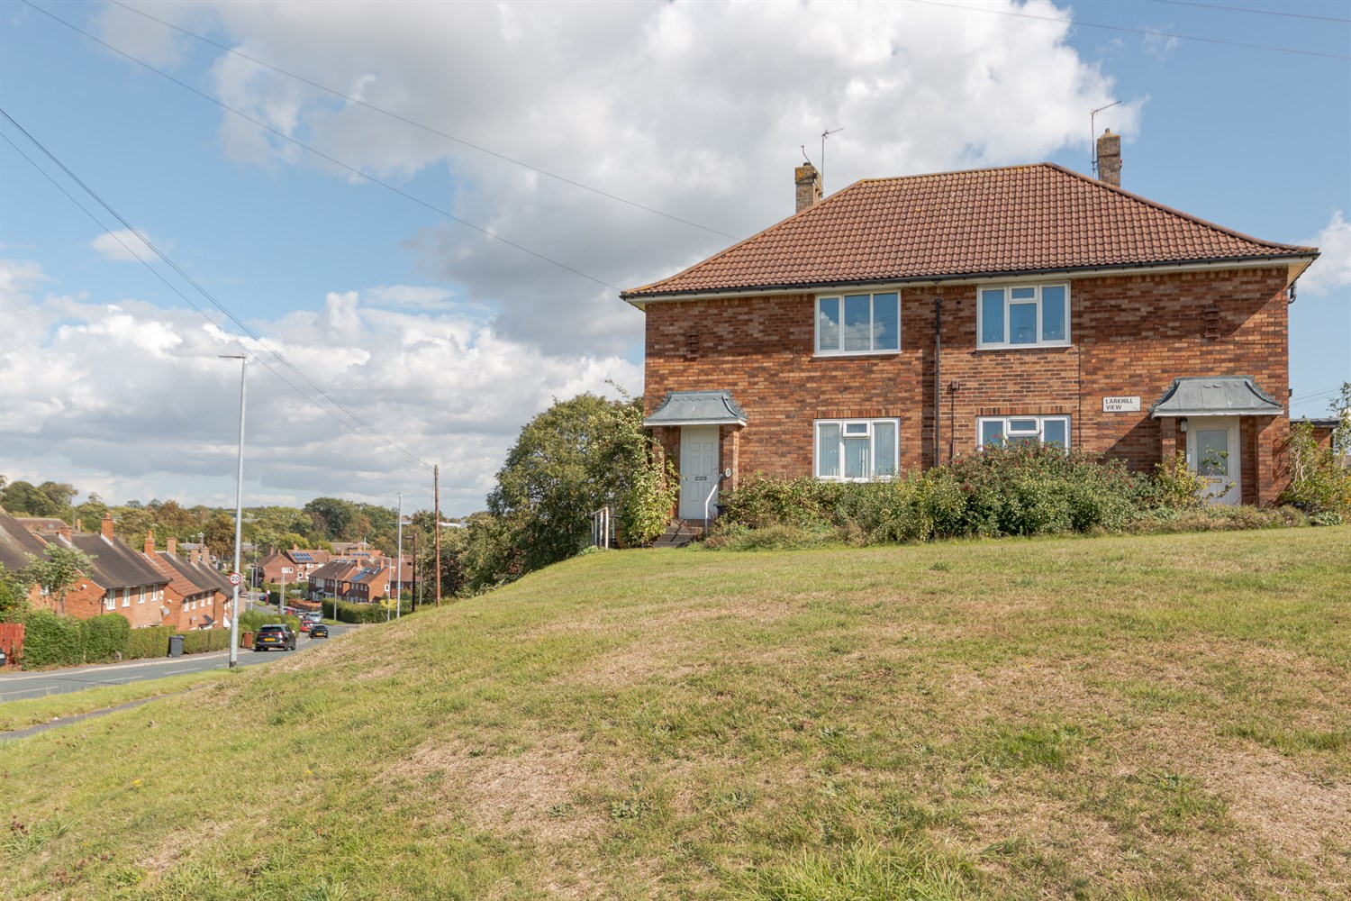

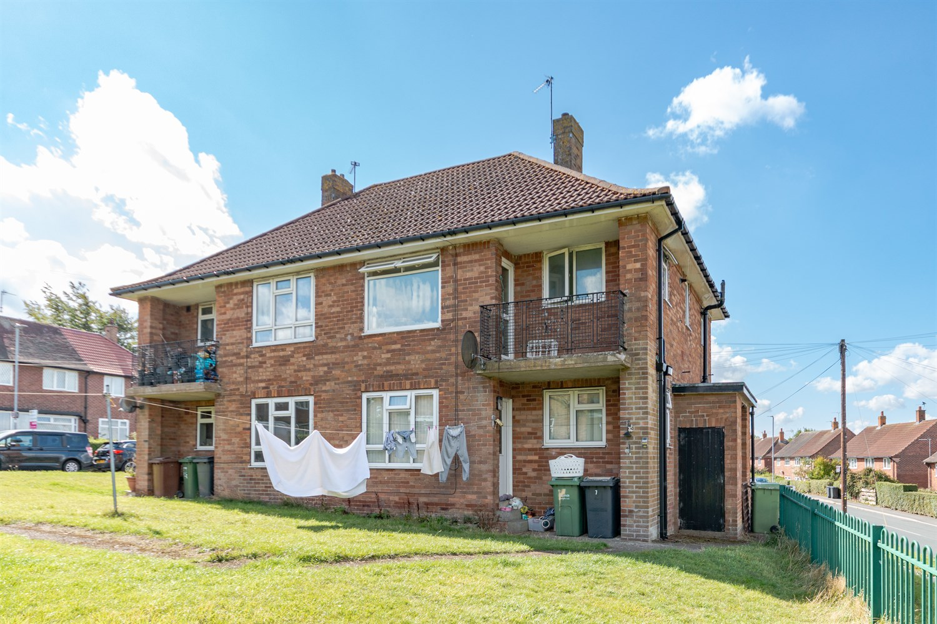

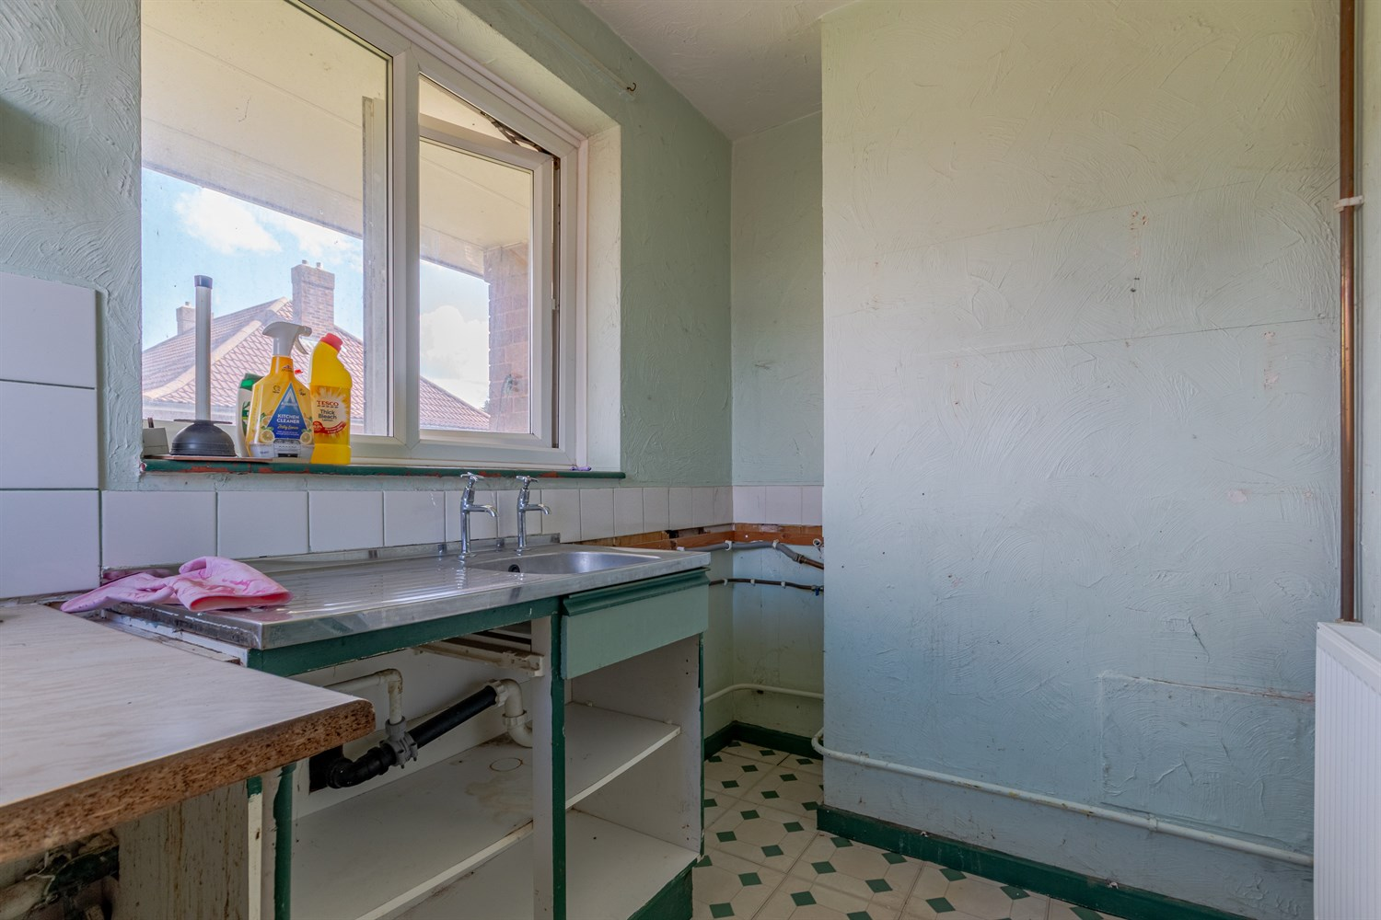

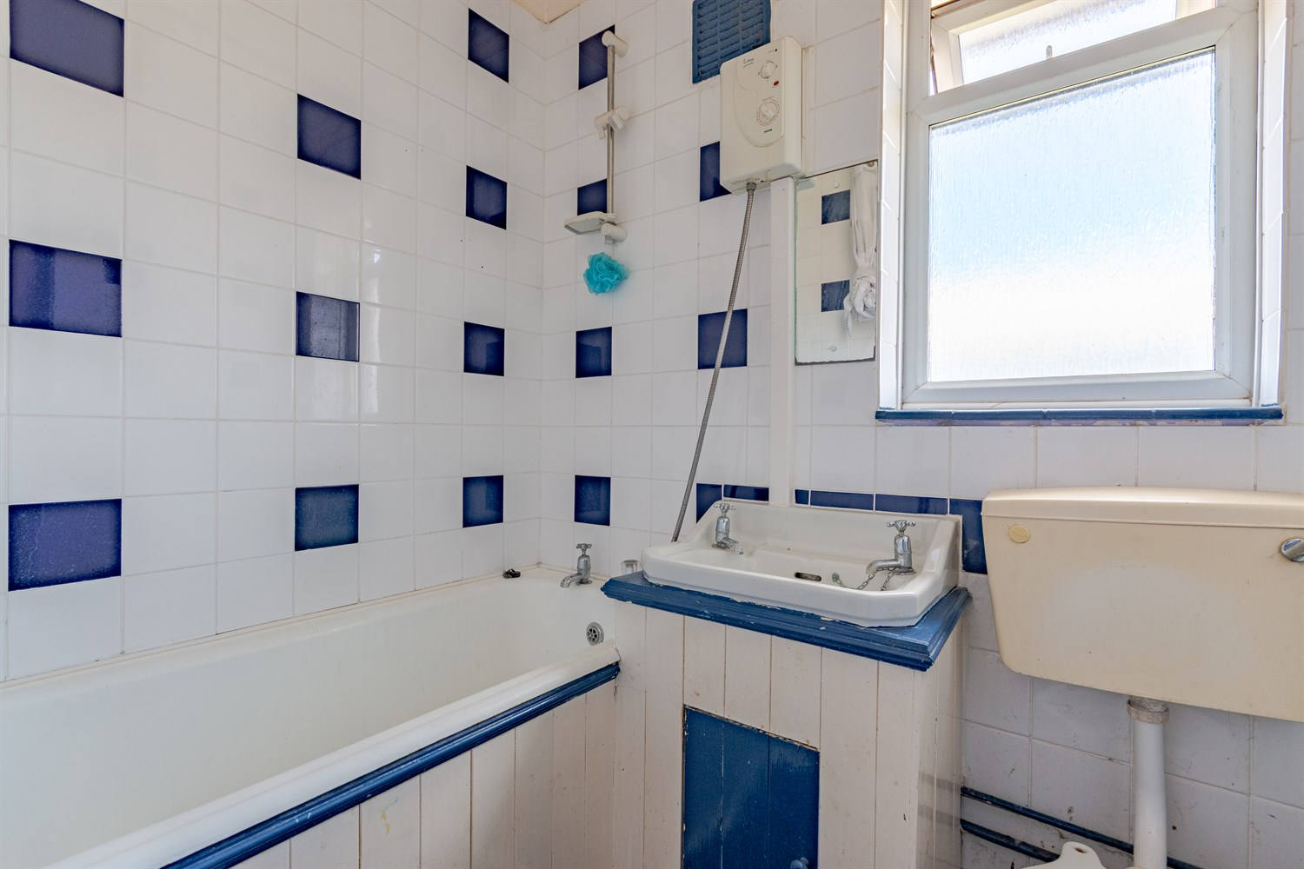

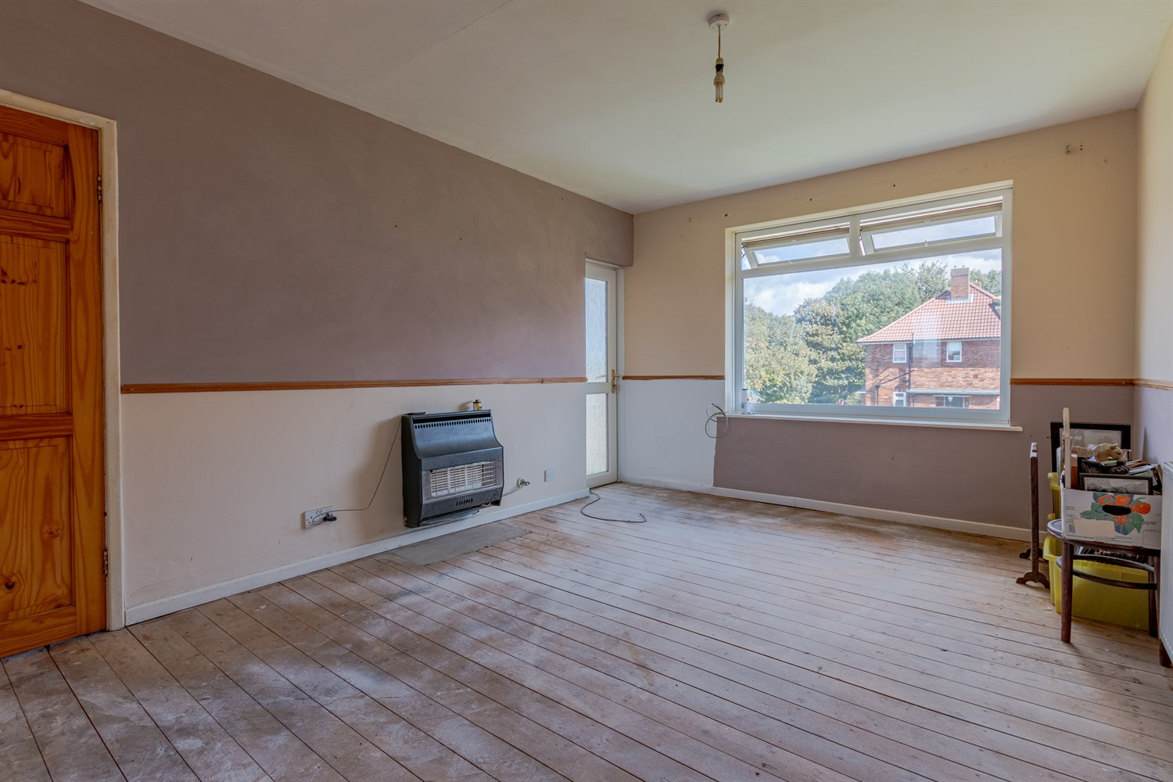

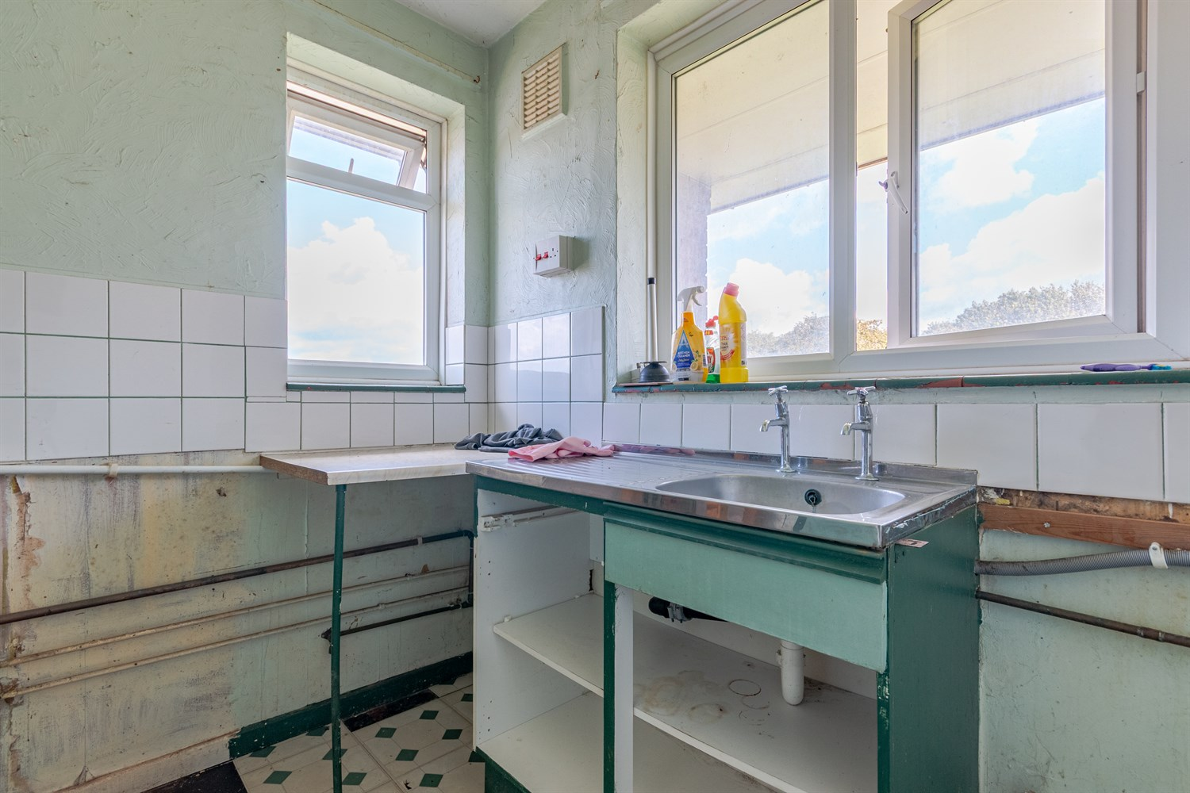

|  |
| --- |
| **Entrance**  Via front entrance door. Stairs to first floor. |
| **Sitting Room 3.25m (10'8) x 4.54m (14'11)**  Light and airy living area with uPVC double glazed window to rear. Door leading out the balcony. Gas central heating radiator. |
| **Kitchen 2.2m (7'3) x 2.35m (7'9)**  uPVC double glazed window to rear and side. Stainless steel sink. Gas central heating radiator. |
| **Bedroom 1 3.25m (10'8) x 3.34m (10'11)**  Double bedroom with uPVC double glazed window. Gas central heating radiator. |
| **Bathroom**  Fitted with a three piece suite comprising; bath, WC and wash hand basin. Tiled walls. uPVC double glazed window. |
| **Service Charge**  Service charge - £230.62 per annum |
| **Tenure**  Leasehold - 125 years from 11 September 1995 Ground rent £10 per annum |
|  |

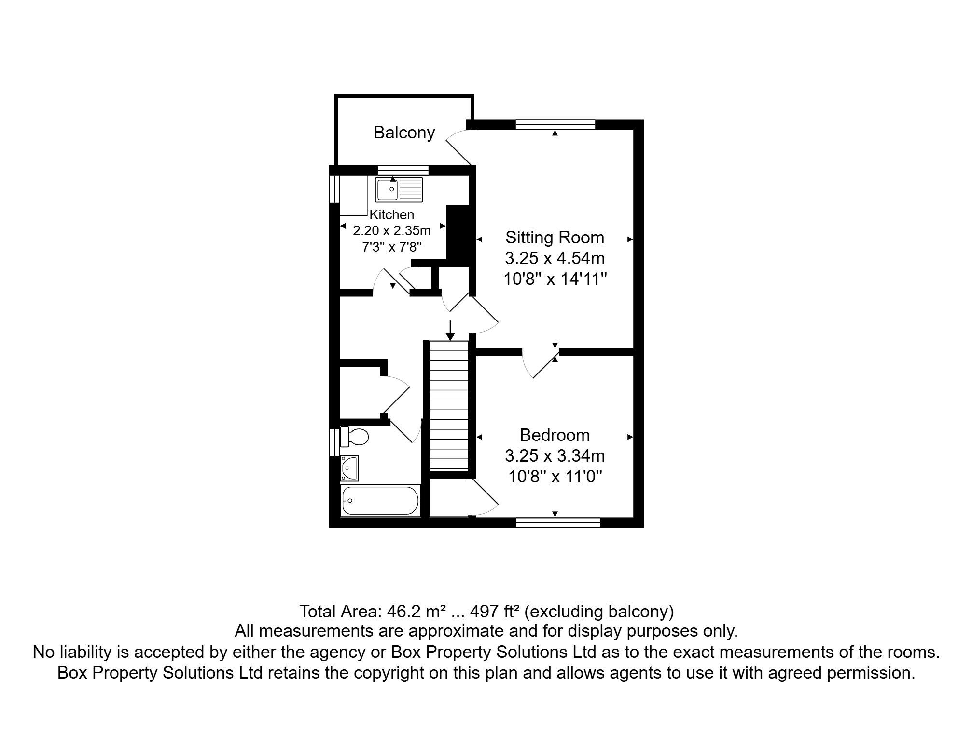

|  |  |
| --- | --- |
| These particulars are intended to give a fair description of the property, but their accuracy cannot be guaranteed, and they do not constitute an offer of contract. Intending purchasers must rely on their own inspection of the property. None of the above appliances/services have been tested by ourselves. We recommend purchasers arrange for a qualified person to check all appliances/services before legal commitment.  **Property Ref:** 7500  **For more information, please contact**  0113 258 1150 **|** [sales@adairpaxton.co.uk](mailto:sales@adairpaxton.co.uk) **|** www.adairpaxton.co.uk |  |