

**0113 258 1150**

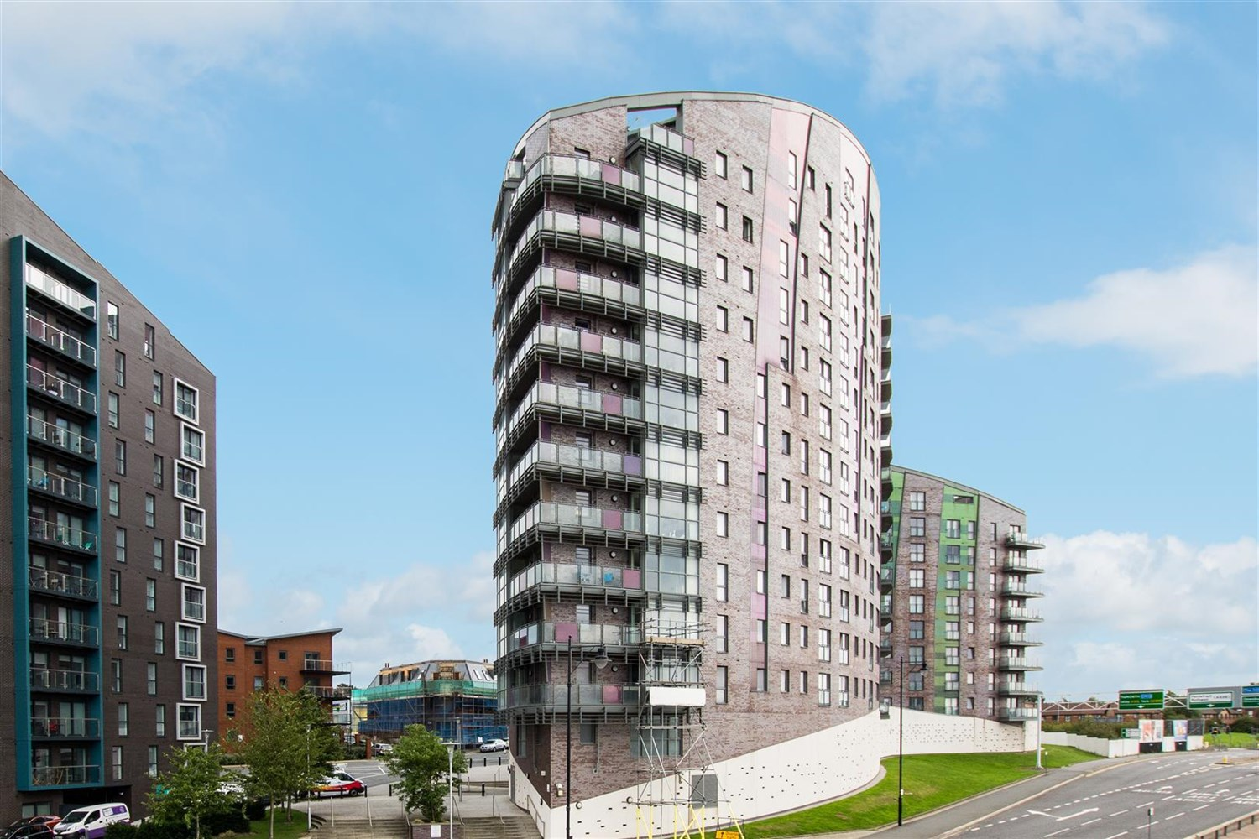



**For Sale £129,950.00**

**Echo Central One, Leeds**

***SPACIOUS TWO DOUBLE BEDROOM/TWO BATHROOM APARTMENT WITH SECURE PARKING*** Just a short walk from Clarence Dock and Leeds City Centre is this beautiful apartment, stylishly finished and viewing highly recommended to appreciate the high standard of living accommodation on offer. Comprising: Hallway with security intercom entry system and utility store, open plan living/kitchen/dining area with Juliet balcony offering far reaching views of Leeds, kitchen with integrated appliances, master bedroom with study area and en-suite shower room, second double bedroom and house bathroom with bath. Secure Underground Parking. Council tax band C, EPC rating C. Available Now.

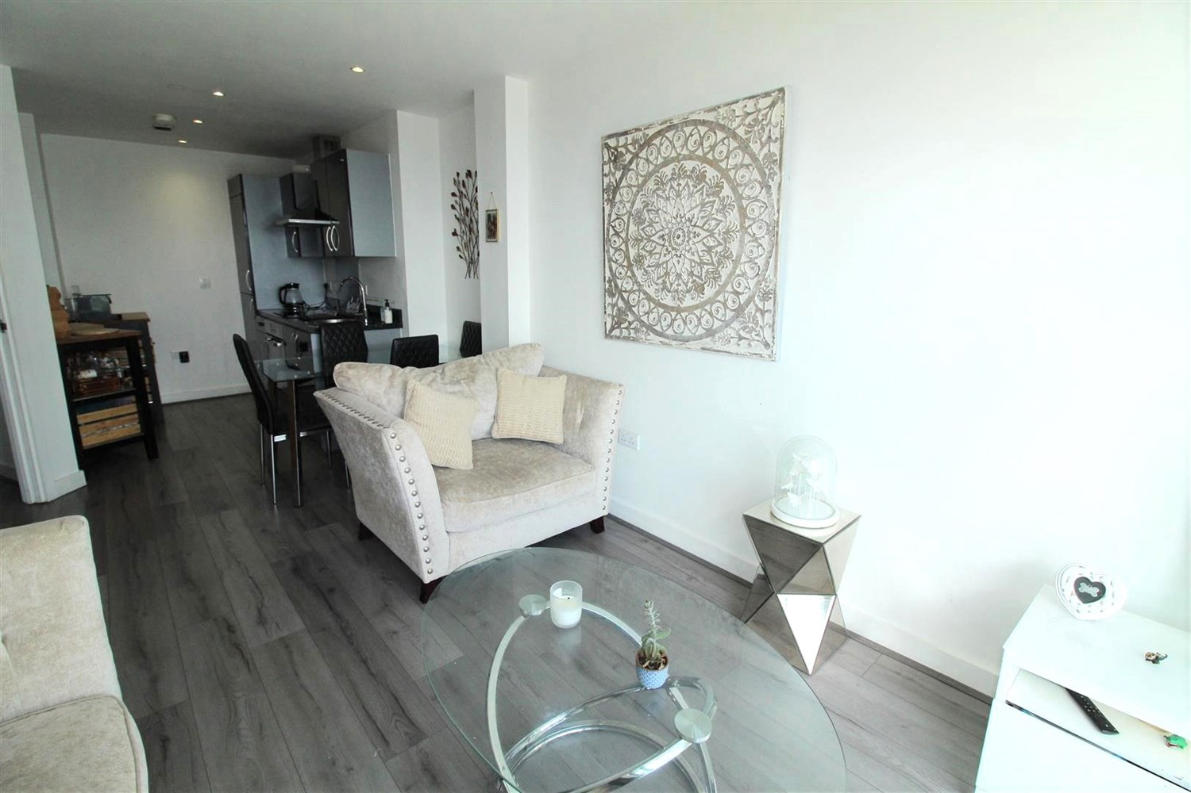

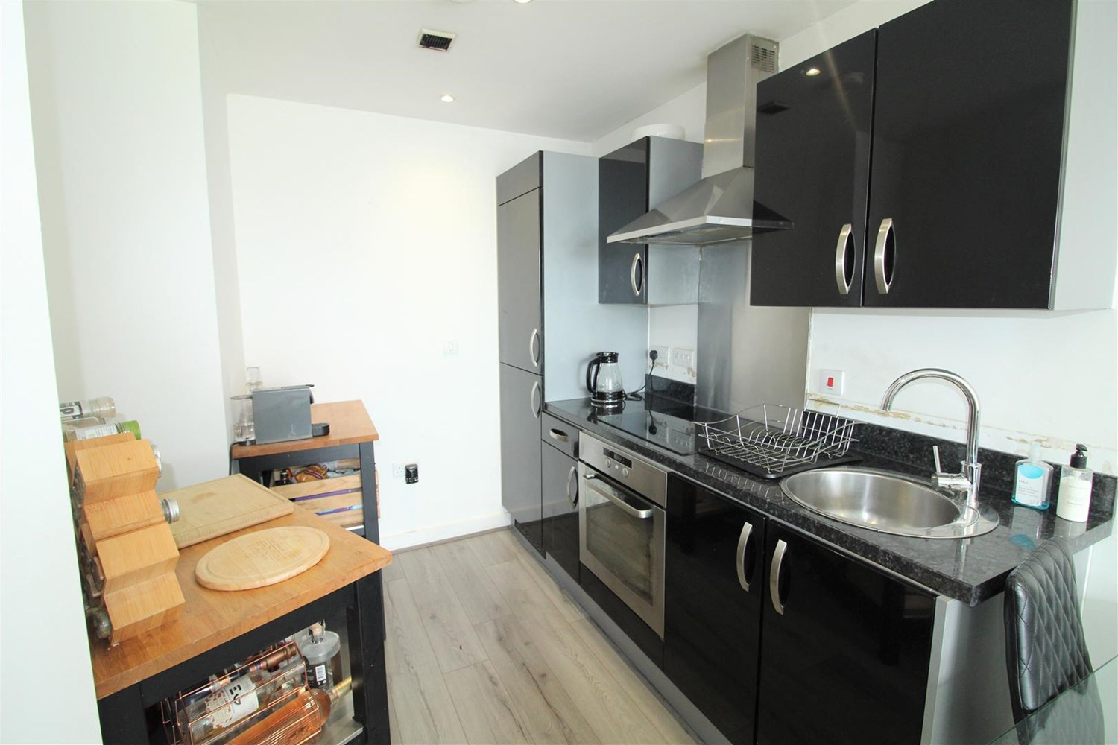

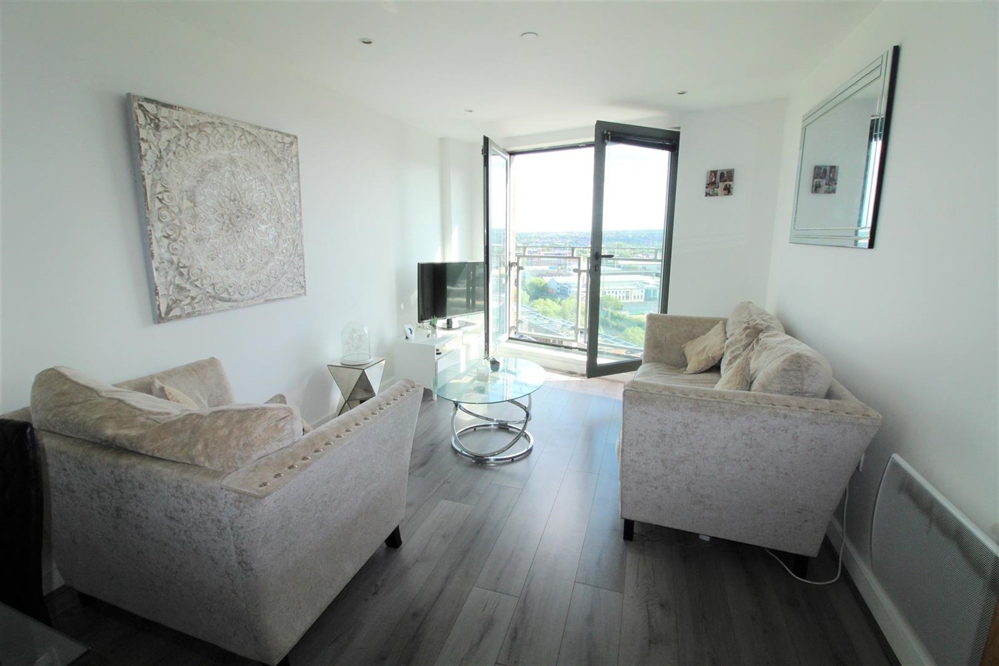

2 Bathroom(s)

0 Reception(s)

2 Bedroom(s)

00

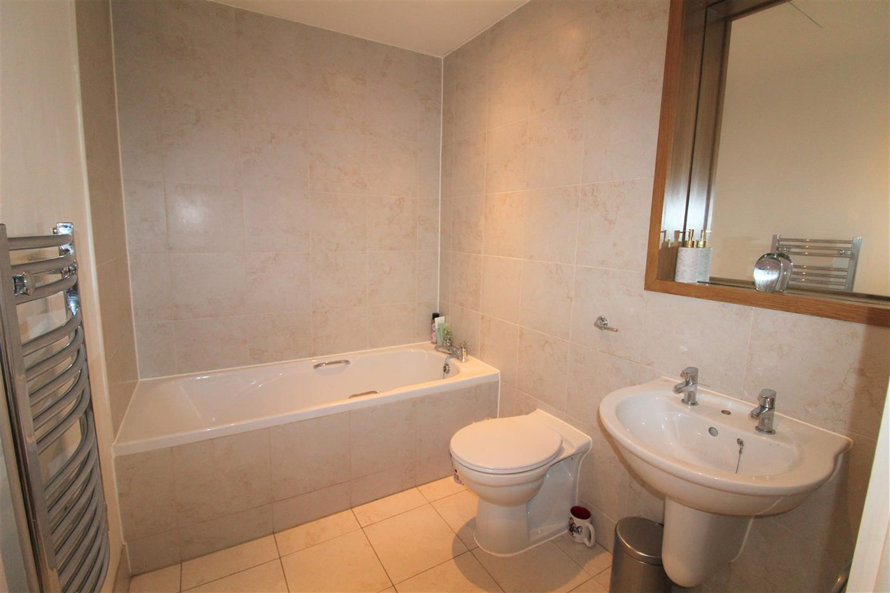

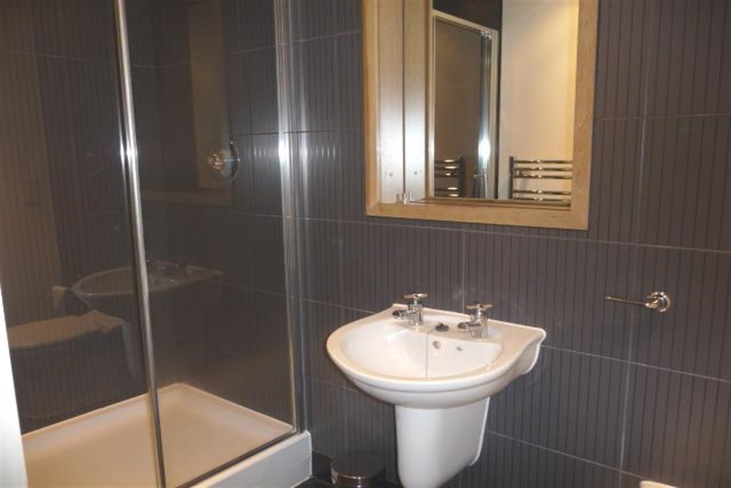

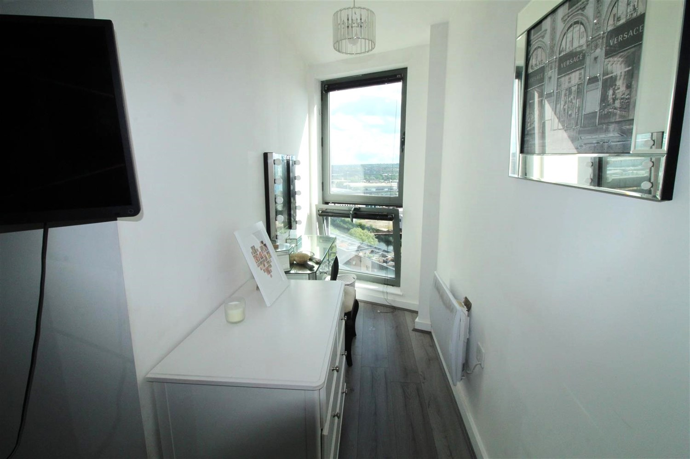

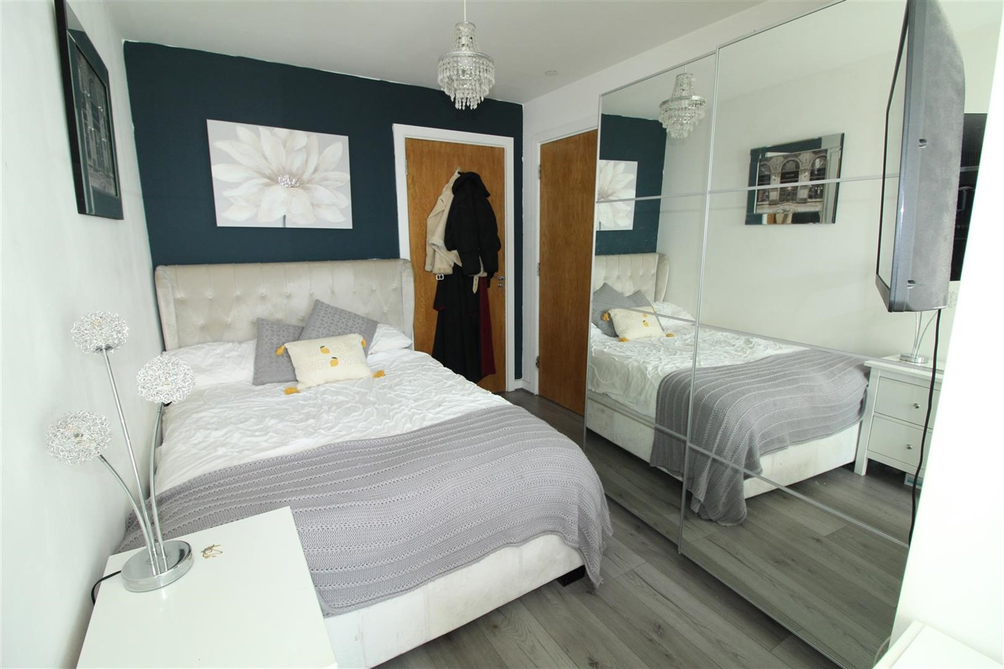

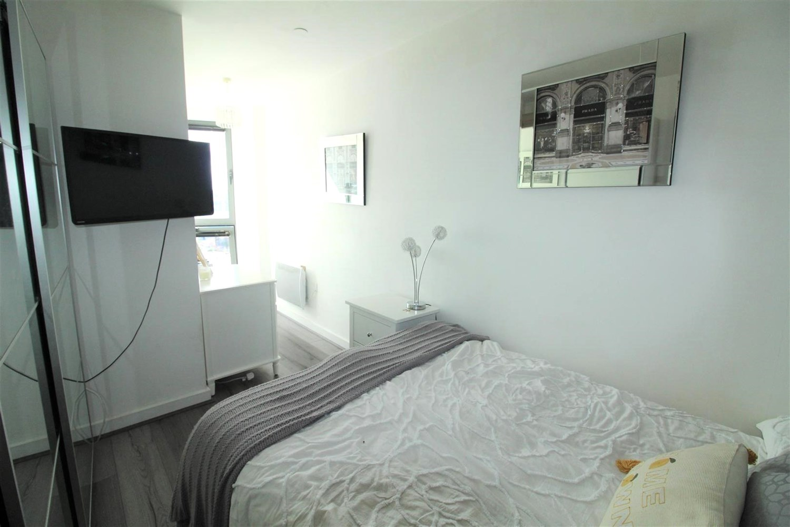

|  |
| --- |
| **Hallway**  Spacious entrance hall with wall mounted electric heater. Useful storage cupboard housing the boiler and plumbing for automatic washing machine. |
| **Kitchen/Living Area**  Good sized open plan living/kitchen/diner. Fitted with a range of wall & base units with work surfaces over. Circular sink with mixer tap. Integrated electric oven and hob with extractor hood over. Integrated fridge/freezer. Double doors to Juliet balcony. Wall mounted electric heater. |
| **Bedroom 1**  A good sized master bedroom with double glazed window. Wall mounted electric heater. Door to ensuite, |
| **En-Suite Shower Room**  Fitted with a modern, three piece white suite comprising shower cubicle, wc and wash hand basin. Tiled walls. Inset ceiling spotlights. Chrome heated ladder towel rail. |
| **Bedroom 2**  A good sized double bedroom with double glazed window. Wall mounted electric heater. |
| **Bathroom**  Fitted with a modern, three piece white suite comprising bath, wc and wash hand basin. Tiled walls. Inset ceiling spotlights. Chrome heated ladder towel rail. |
| **Allocated Parking** |
| **Tenure**  Tenants not required to pay this.  Service Charge is £685.97 per quarter. Ground rent is £200 per annum |
| **Home Information**  Service Charge - £685.97 per quarter Ground Rent - £200 per annum Council Tax - Band C Lease Term - 150 years from Jan 2007 - 134 years remaining Heating - Electric Water - Mains connected Broadband - No issues to report Mobile availability - No issues to report EWS1 Rating - B1 Construction type - Concrete and steel frame Flood Risk - Very Low |

|  |  |
| --- | --- |
| These particulars are intended to give a fair description of the property, but their accuracy cannot be guaranteed, and they do not constitute an offer of contract. Intending purchasers must rely on their own inspection of the property. None of the above appliances/services have been tested by ourselves. We recommend purchasers arrange for a qualified person to check all appliances/services before legal commitment.  **Property Ref:** 2488  **For more information, please contact**  0113 258 1150 **|** [sales@adairpaxton.co.uk](mailto:sales@adairpaxton.co.uk) **|** www.adairpaxton.co.uk |  |