

**Crown Street Buildings,**

**Available To Let £825.00pcm**

Spacious one bed apartment with close to the Corn Exchange, Kirkgate Market and all the amenities Leeds City Centre has to offer. Located a short walk to the train and bus station. Comprising; hallway, spacious open plan lounge/kitchen/diner with patio door leading to patio area, double bedroom, house bathroom with shower over the bath. This property also boasts a large communal patio area. Council Tax Band C. EPC rating D Deposit £950. Furnished. Water rates included. Available Now.

**0113 258 1150**

**0800 000 000**

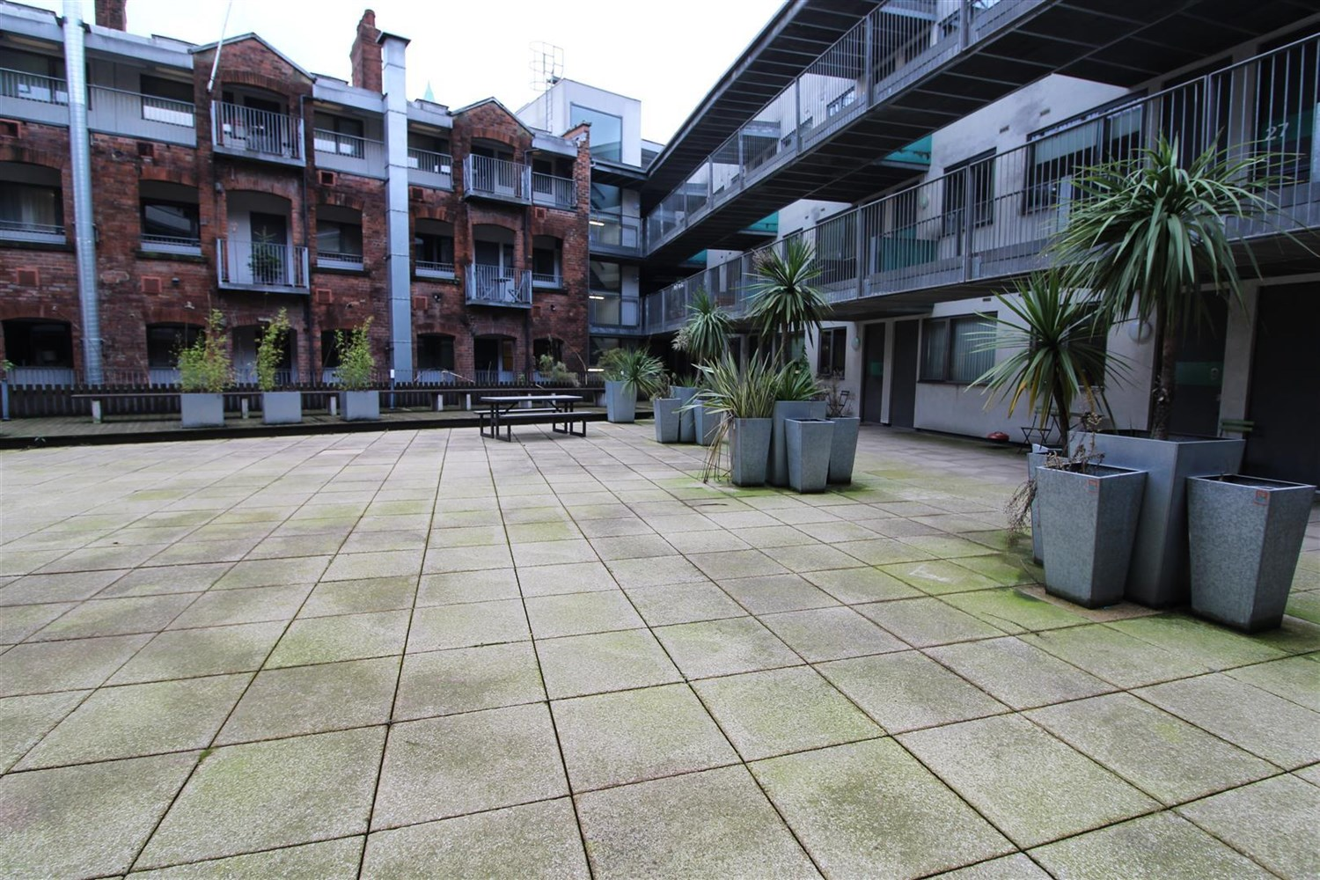

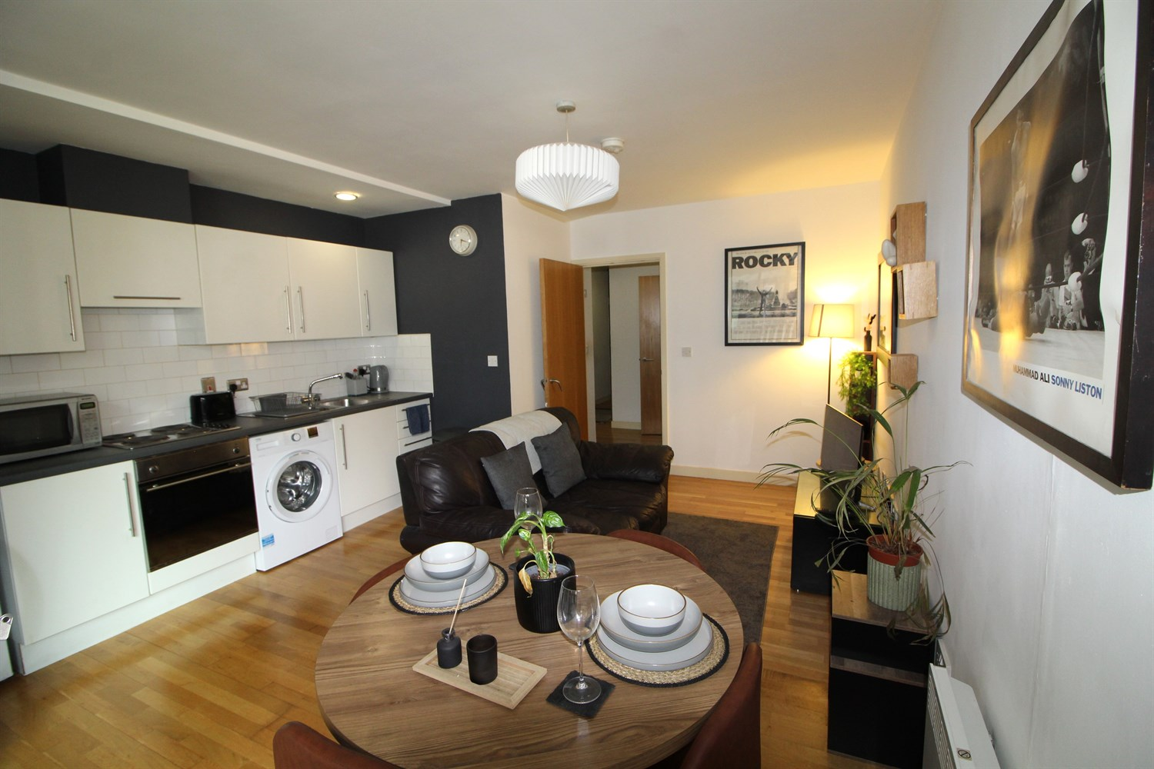

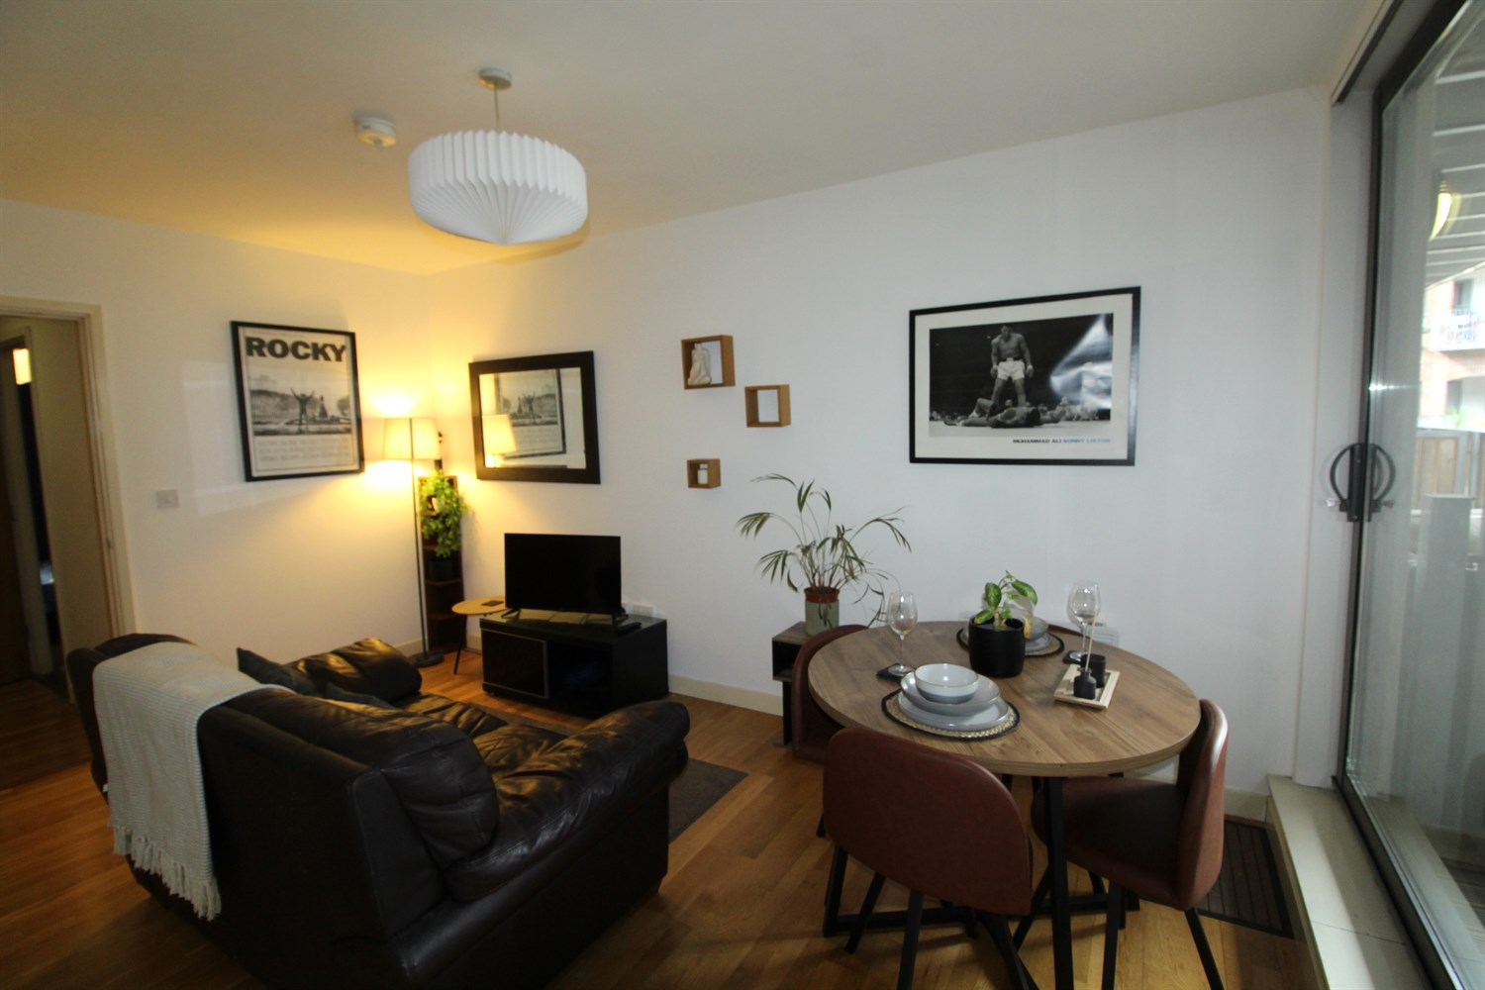

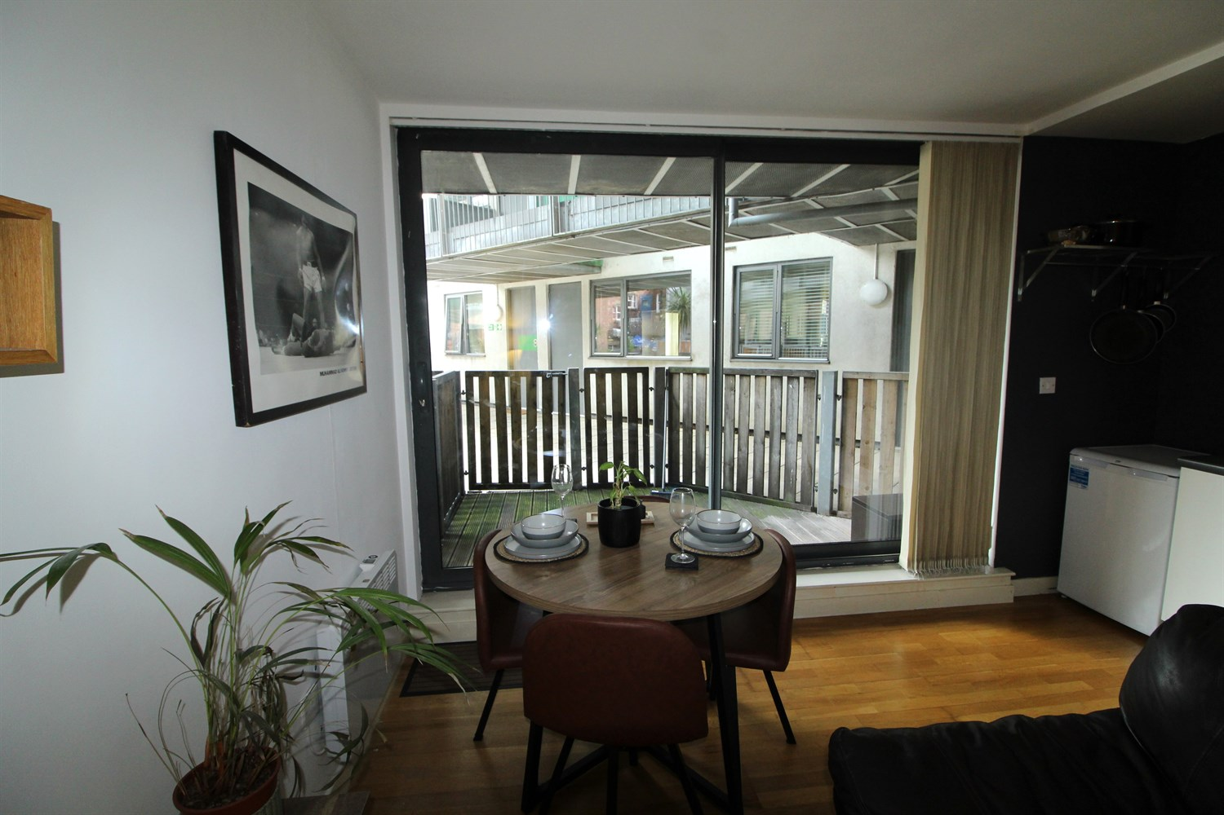

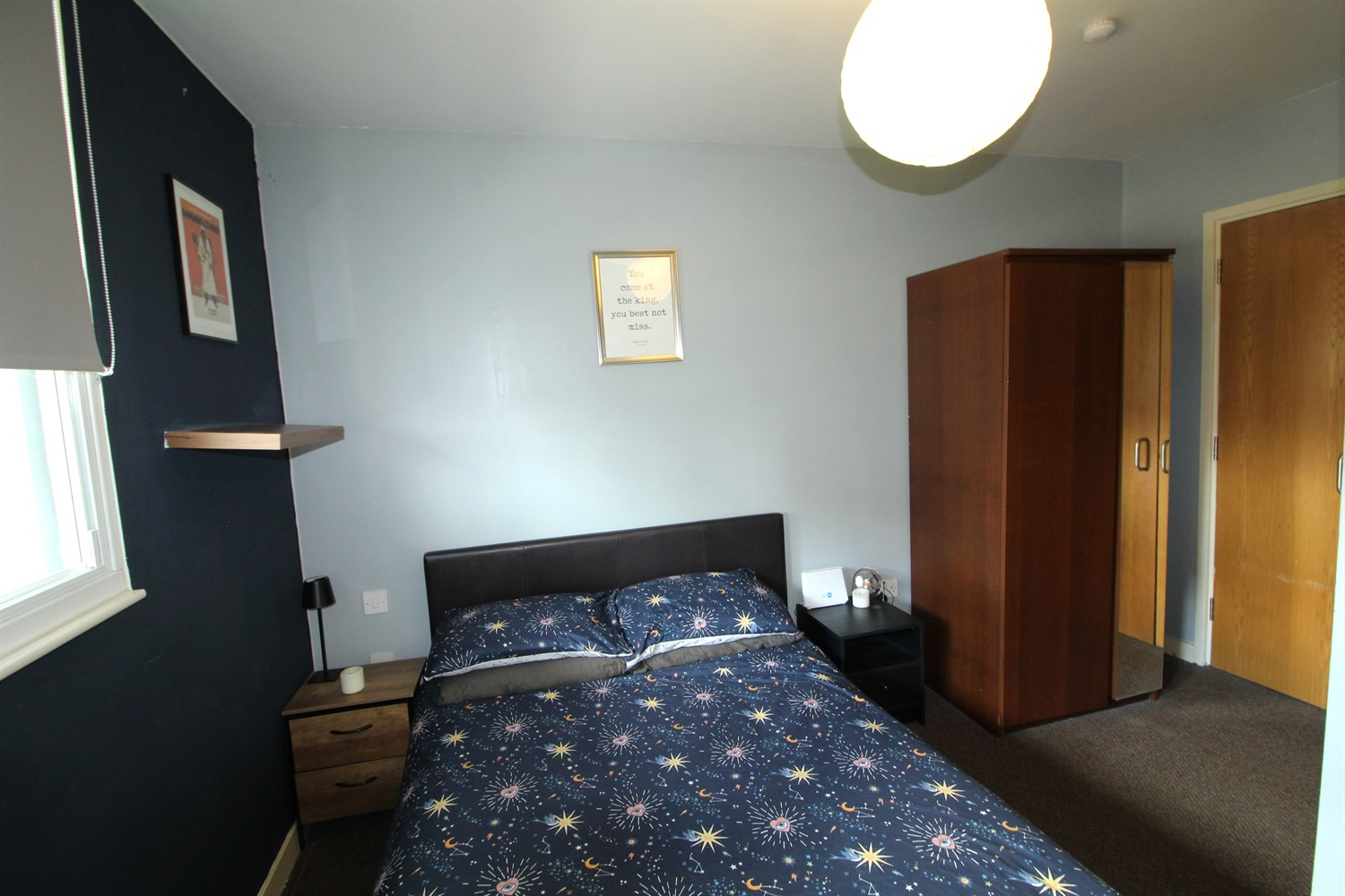

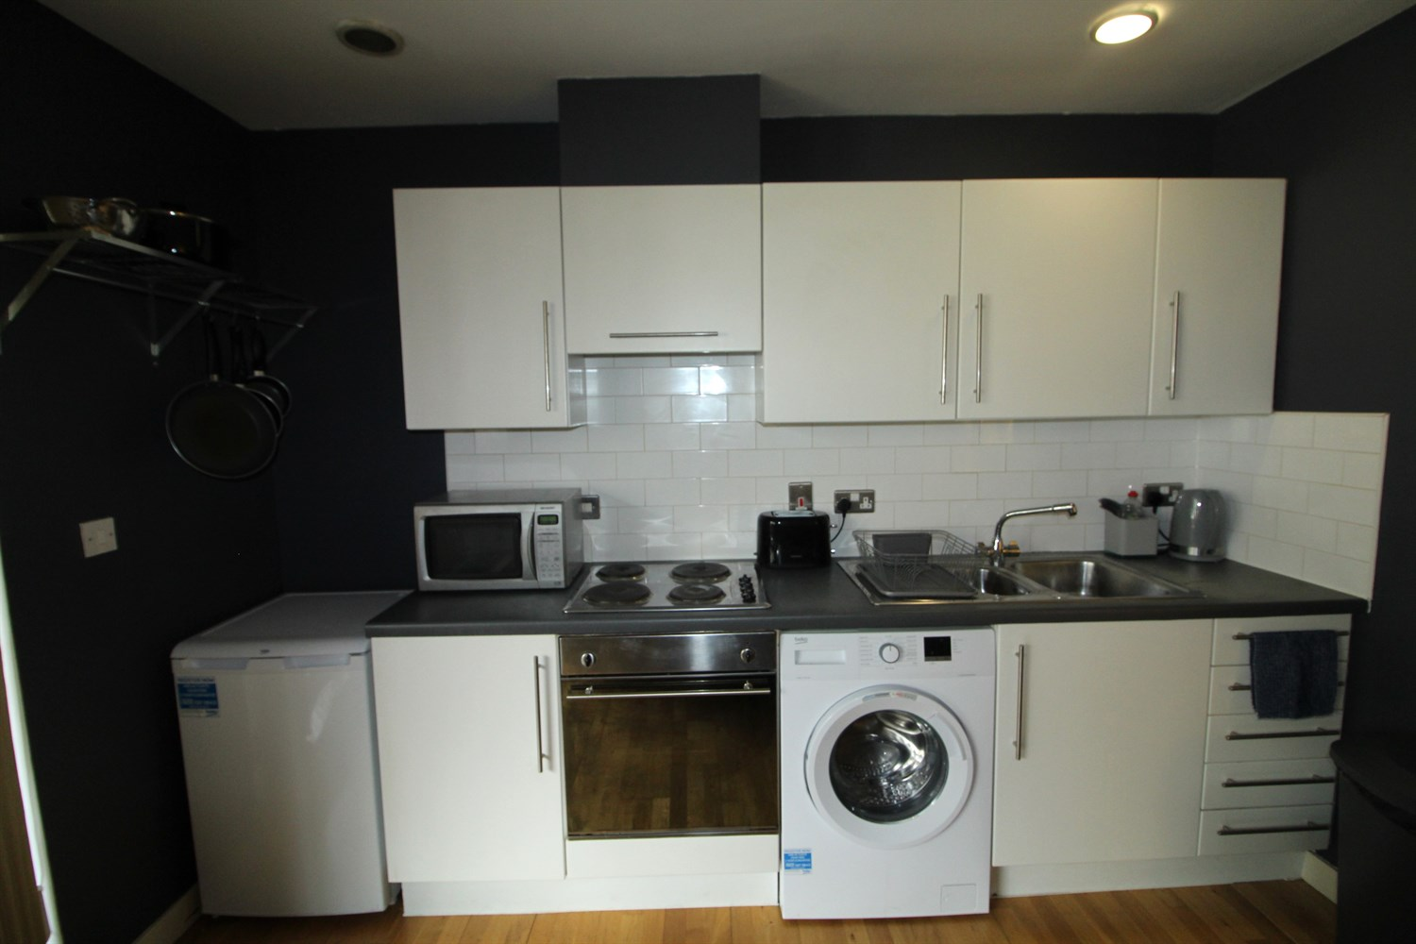

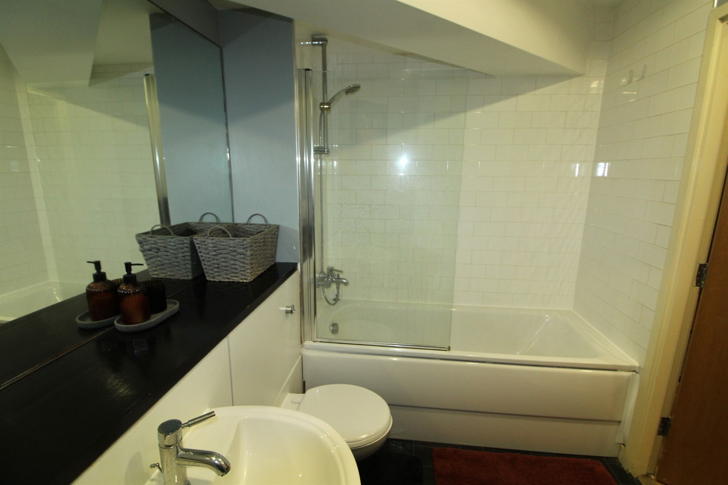

|  |
| --- |
| **Open Plan Kitchen and Living Room 4.08m (13'5) x 4.72m (15'6)**  Living area with sliding doors leading to balcony, kitchen fitted with a range of wall and base units with worktops over, electric oven and hob. Electric heating. |
| **Bedroom 1 2.94m (9'8) x 3.89m (12'9)**  Spacious double bedroom with double glaze window, electric wall heater. |
| **Bathroom 1.71m (5'7) x 2.85m (9'4)**  White bathroom suite compromising of bath with shower over and shower screen, WC and hand wash basin. Tiled walls. |
| COUNCIL TAX BAND: C EPC Rating C  Leasehold property No Parking  Broadband: Standard 16 Mbps 1 Mbps Good Superfast --Not available --Not available Unlikely Ultrafast 1000 Mbps 1000 Mbps Mobile availability: EE Limited Three Limited O2 Likely Vodafone Likely  Electric mains supply, water on mains supply. |

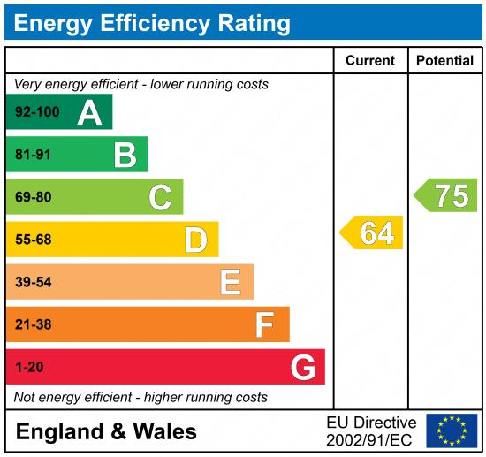

|  |
| --- |
|  |

These particulars are intended to give a fair description of the property, but their accuracy cannot be guaranteed, and they do not constitute an offer of contract. Intending purchasers must rely on their own inspection of the property. None of the above appliances/services have been tested by ourselves. We recommend purchasers arrange for a qualified person to check all appliances/services before legal commitment.

**Property Ref:** 124

**For more information, please contact**

0113 258 1150 **|** [lettings@adairpaxton.co.uk](mailto:lettings@adairpaxton.co.uk) **|** www.adairpaxton.co.uk