

**Seven Hills Point, Morley,**

**£795.00pcm**

**Apartment**

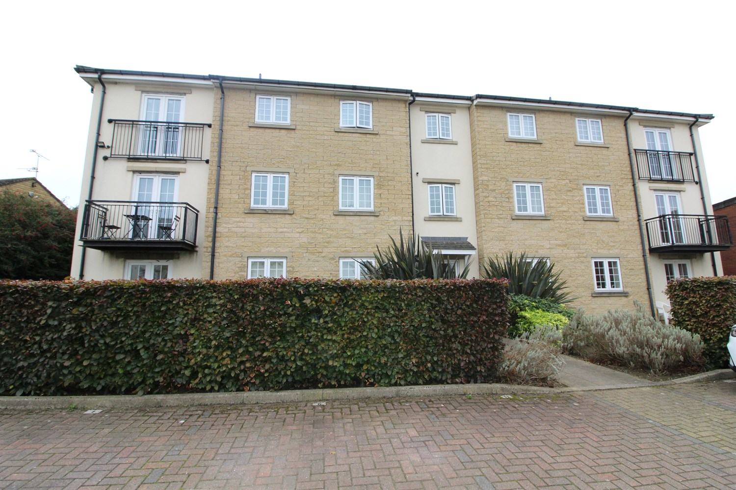

2 Bathroom(s)

1 Reception(s)

1 Bedroom(s)

Well presented and spacious two bedroom top floor apartment, situated in this lovely modern development close to Morley town centre and a short walk to the train station. Accommodation on offer briefly comprises; open plan Living area; Lounge with Juliette balcony and space for dining, stylish fitted Kitchen with integrated appliances, good sized main double Bedroom, with en-suite Shower room, second Bedroom and main Bathroom with shower over bath. The property also benefits from electric heating, UPVC double glazing and has an allocated parking space. Council Tax Band B, EPC rating C, This property must be viewed to be appreciated. Unfurnished. Available 11th October 2024. Deposit £915.



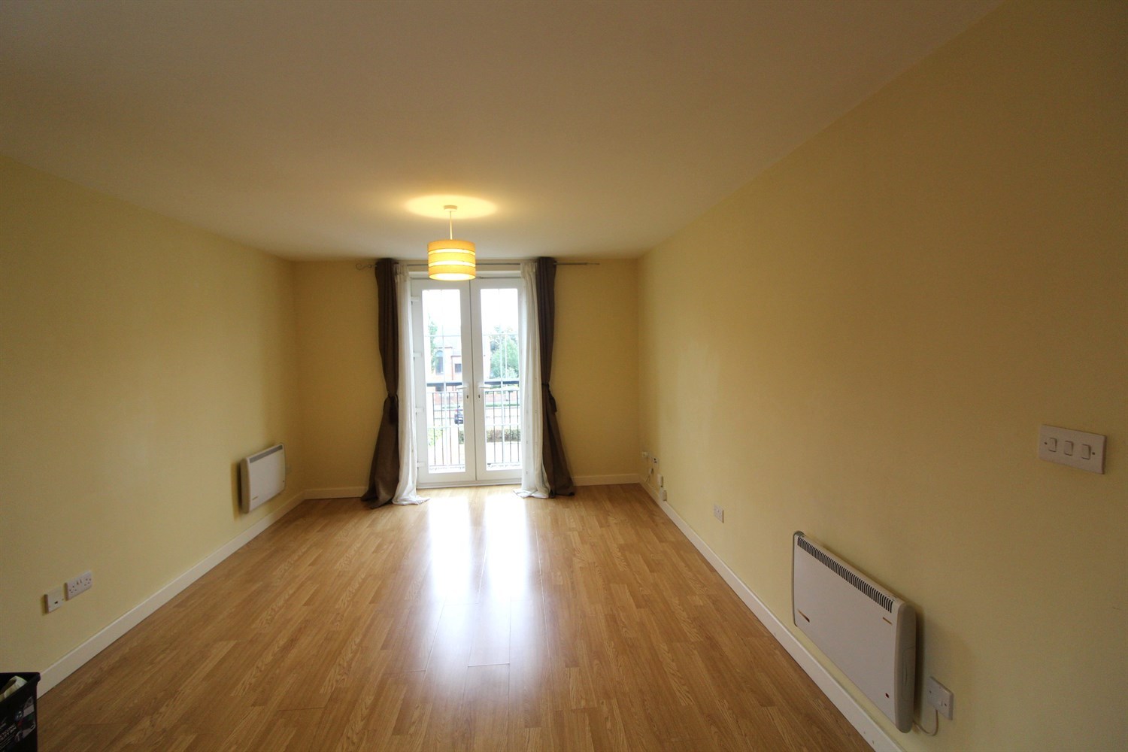

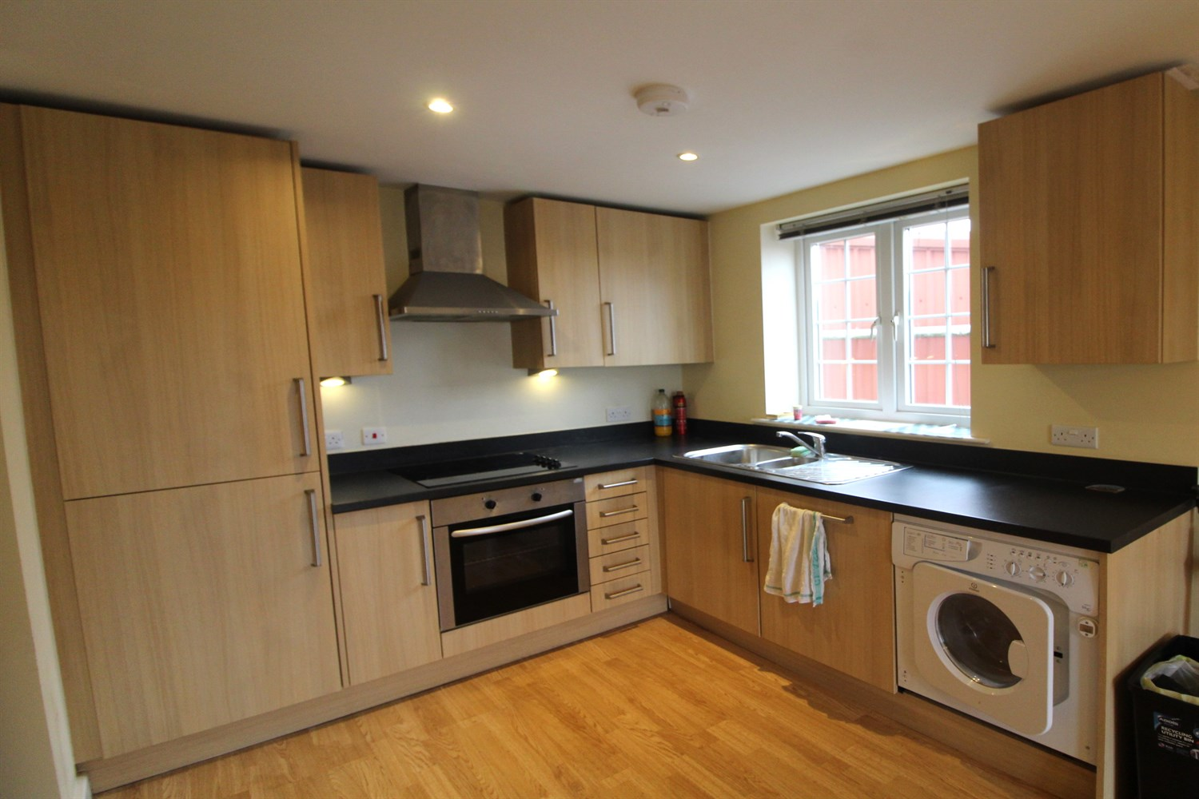

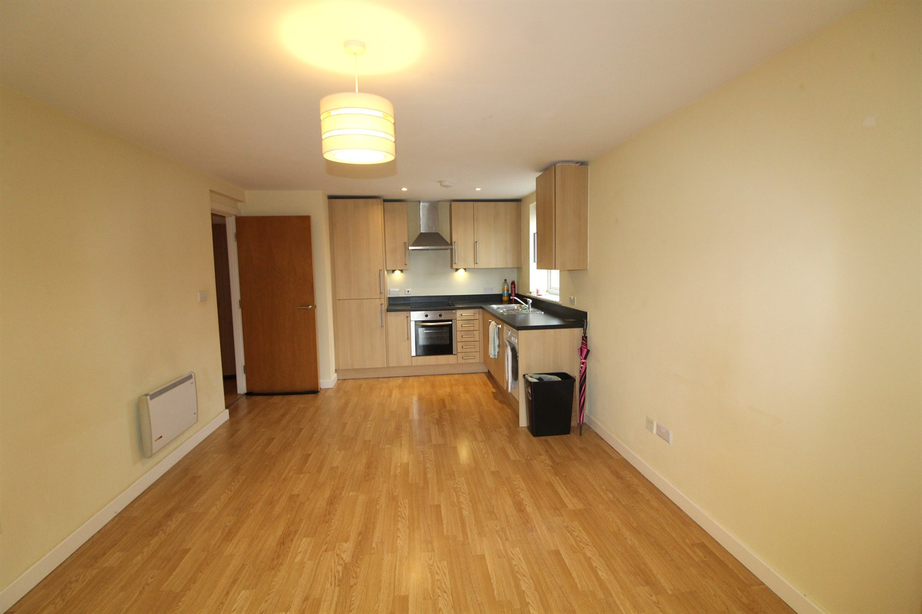

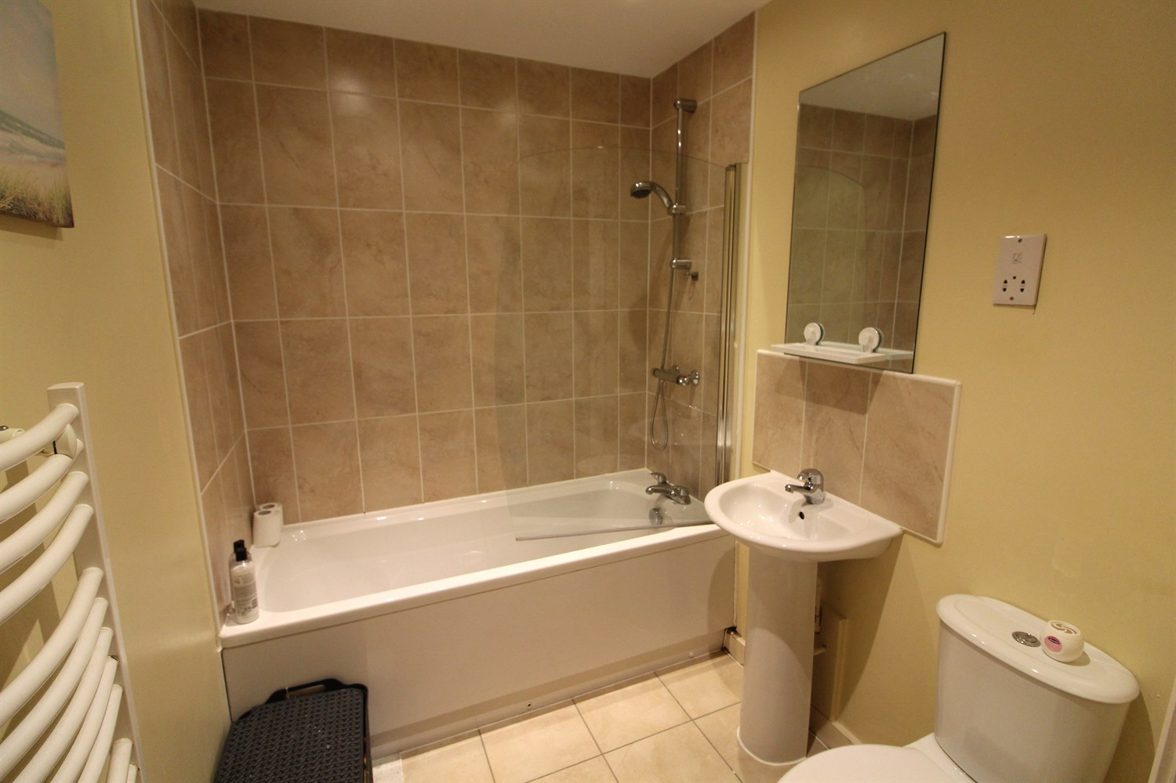

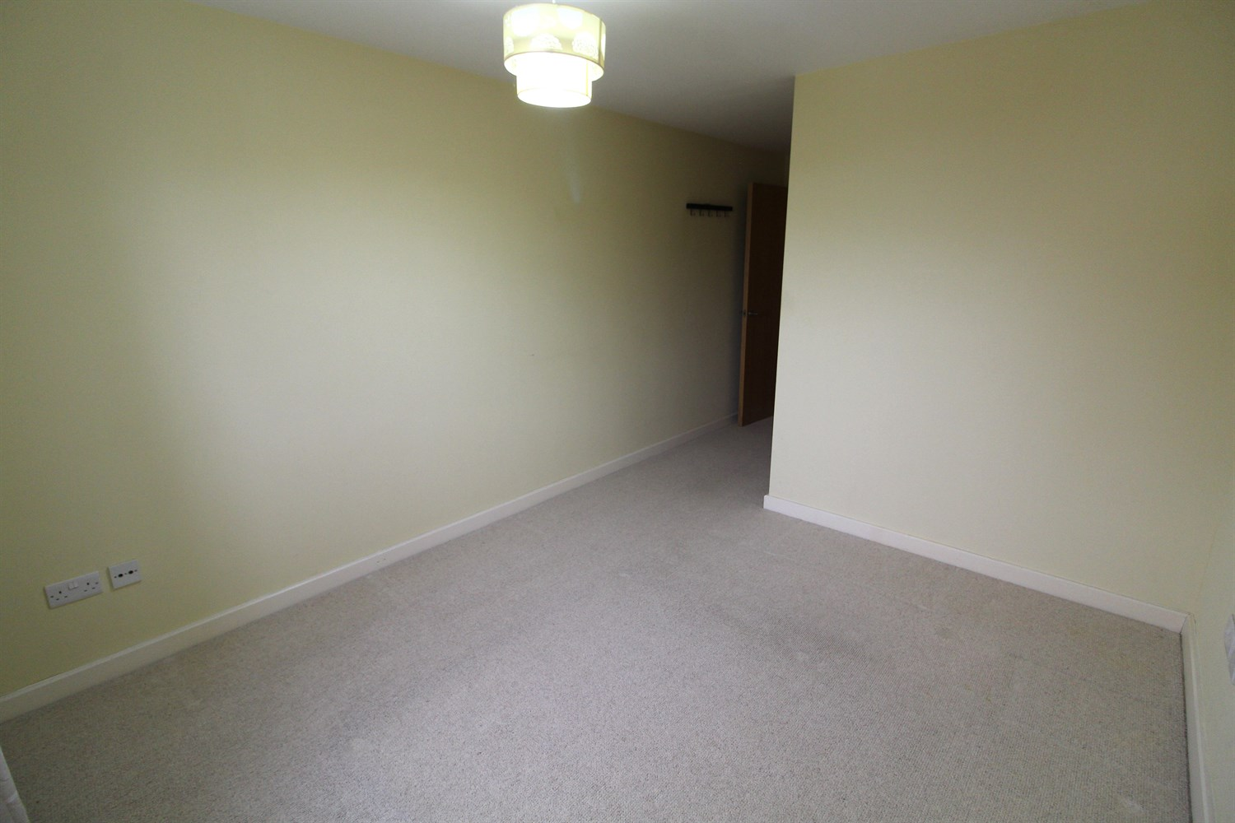

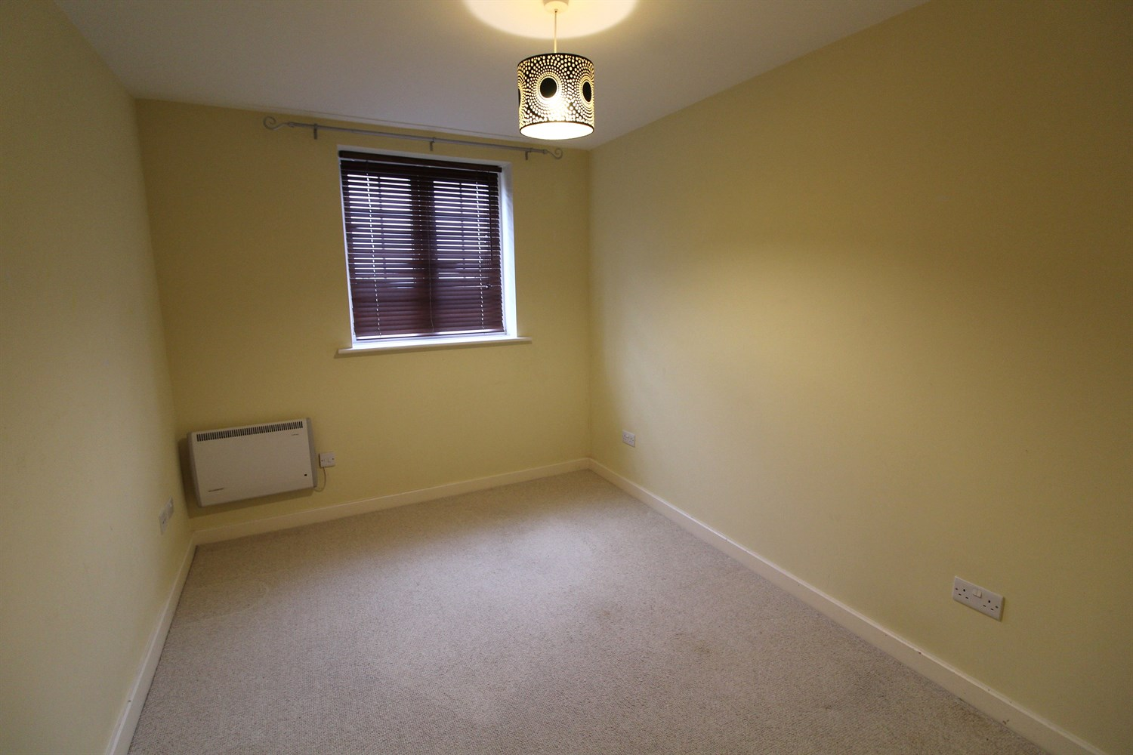



|  |
| --- |
| **Open Plan Kitchen and Living Room 6.38m (20'11) x 3.42m (11'3)**  Open Plan living and kitchen with French doors opening to a Juliet balcony. Kitchen fitted with a range of wall and base units with worktops over, Electric oven and hob with extractor over head, Stainless steel sink with drainer and mixer tap. |
| **Bedroom 1 5.54m (18'2) x 2.96m (9'9)**  Double bedroom with access to ensuite. Double glazed window and electric heater. |
| **Bedroom 2 4.61m (15'1) x 2.58m (8'6)**  Bedroom 2 with double glazed window and electric heater. |
| **Bathroom 2.1m (6'11) x 1.71m (5'7)**  Three piece white bathroom suite with shower over head, shower screen, w/c and hand wash basin. Part tiled, electric heater. |
| **En Suite 1.22m (4'0) x 2.1m (6'11)**  Ensuite fitted with a walk in shower, w/c and hand wash basin. part tiled walls. |
| **Allocated Parking**  Allocated parking space. |
| COUNCIL TAX BAND: B EPC Rating C  Leasehold property Parking included  Broadband: Standard 17 Mbps 1 Mbps Good Superfast 48 Mbps 8 Mbps Good Ultrafast 1000 Mbps 1000 Mbps  Mobile availability: EE limited. Three likely to have good coverage. O2 likely to have good coverage. Vodafone likely to have good coverage.  Utilities: Water supplied on standard meters. Electric mains supplied on standard meters. |

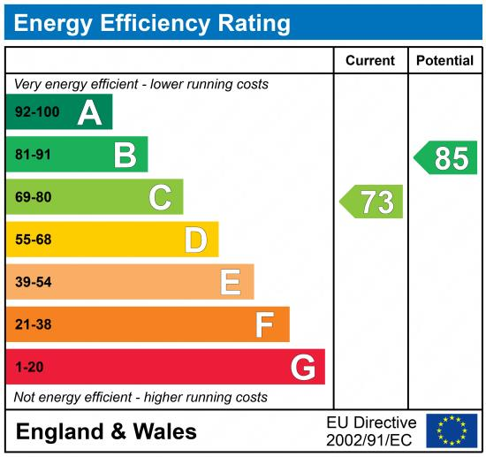

|  |
| --- |
|  |

These particulars are intended to give a fair description of the property, but their accuracy cannot be guaranteed, and they do not constitute an offer of contract. Intending purchasers must rely on their own inspection of the property. None of the above appliances/services have been tested by ourselves. We recommend purchasers arrange for a qualified person to check all appliances/services before legal commitment.

**Property Ref:** 3596

**For more information, please contact**

0113 258 1150 **|** [lettings@adairpaxton.co.uk](mailto:lettings@adairpaxton.co.uk) **|** www.adairpaxton.co.uk