

**0113 258 1150**

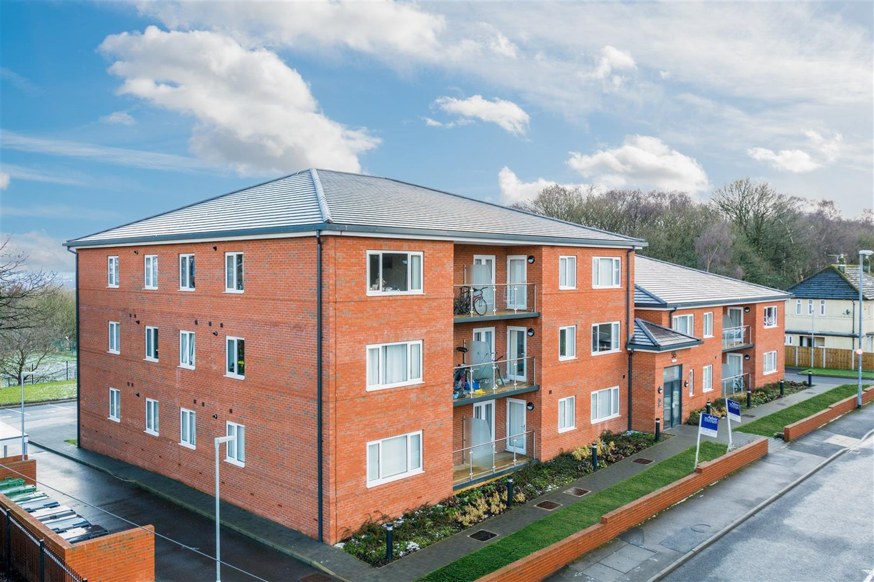



**Available to let £850.00pcm**

**55, Iveson Drive Leeds**

***TWO BEDROOM APARTMENT*** Set in this convenient location. Apartment located on Iveson Drive, between Horsforth and Adel. The apartments are finished to an exceptional standard throughout. The apartments are all two double bedrooms and comprise: entrance hall, open plan living room/kitchen/diner with balcony or juliet balcony, master bedroom with en suite shower room, second double bedroom and house bathroom. All apartments have parking and in addition visitor parking. Unfurnished. Bond £795. Available Now

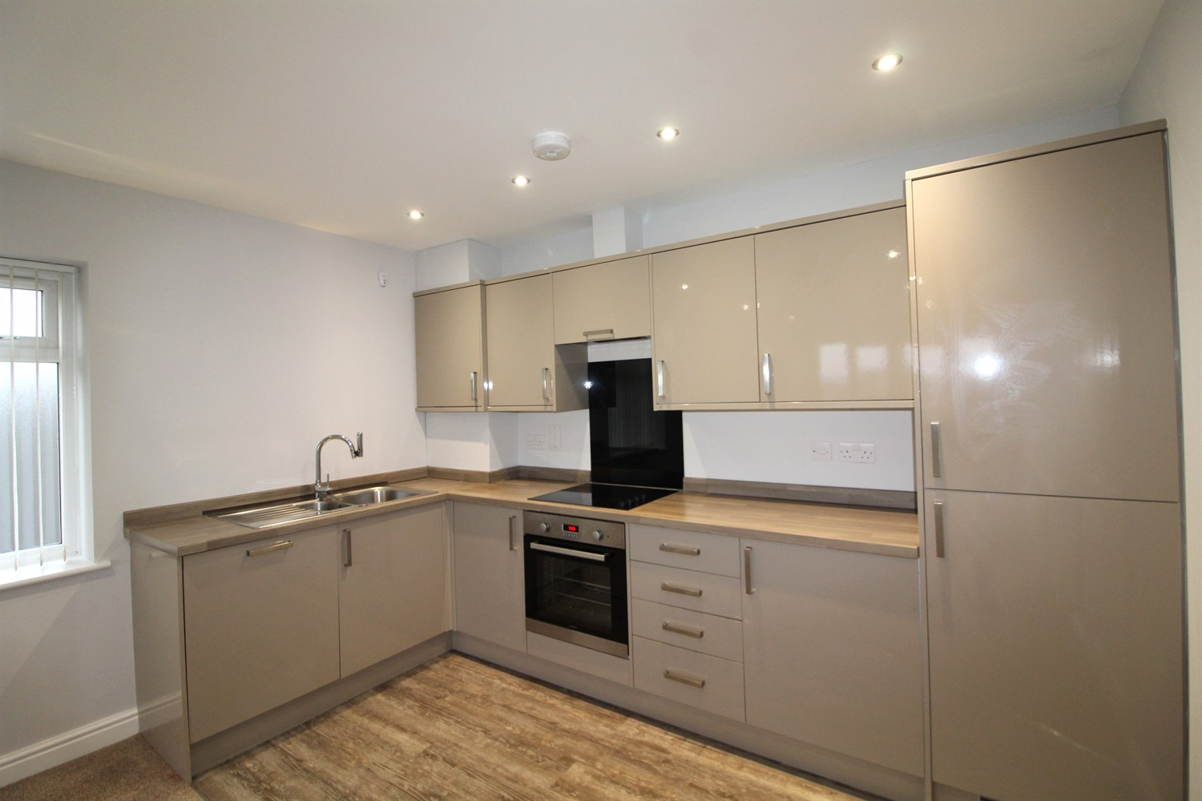

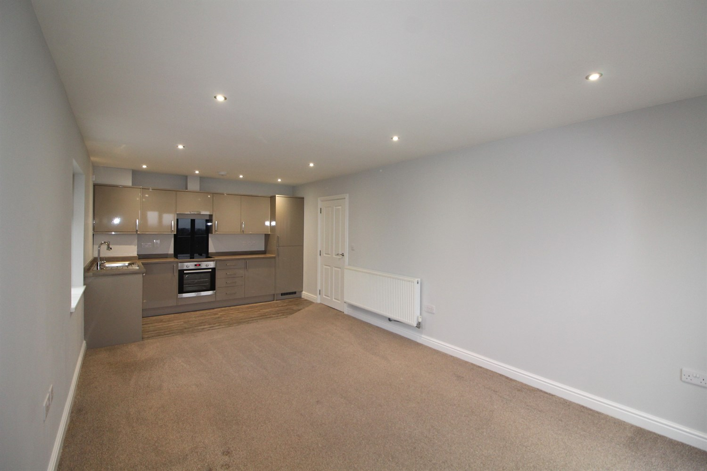

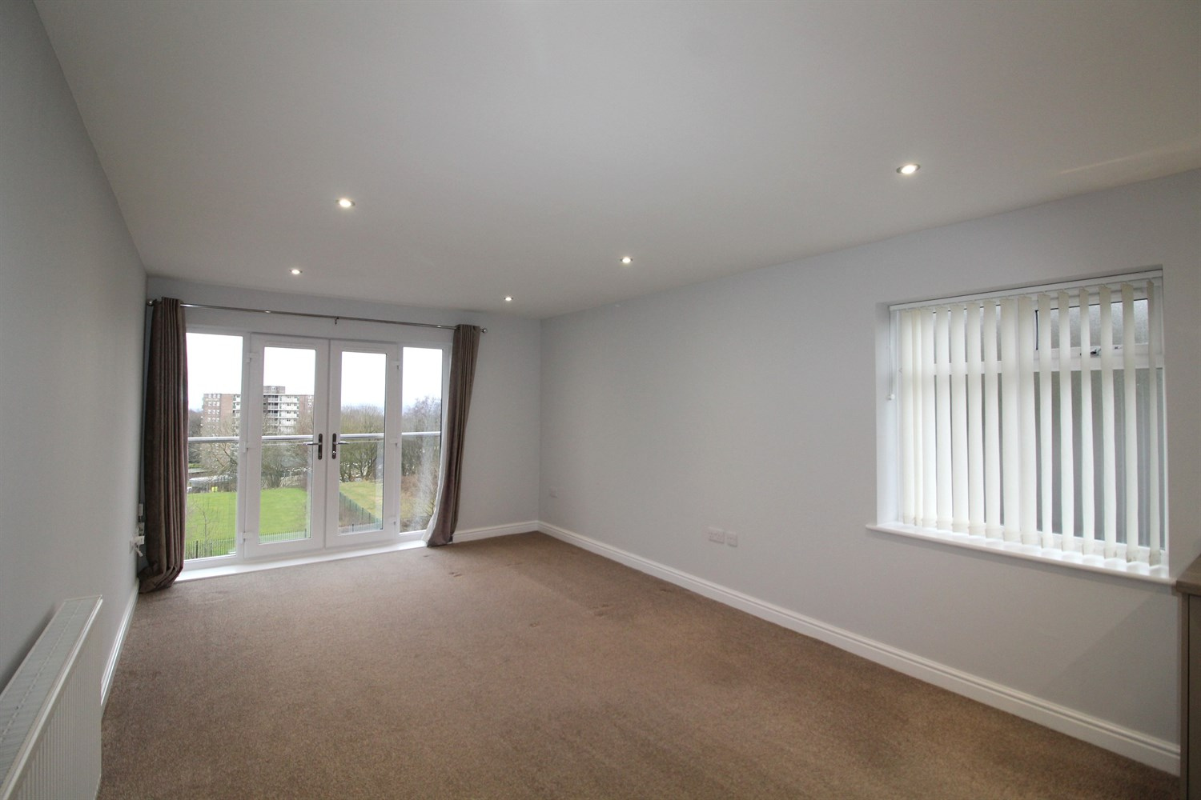

2 Bathroom(s)

1 Reception(s)

2 Bedroom(s)

00

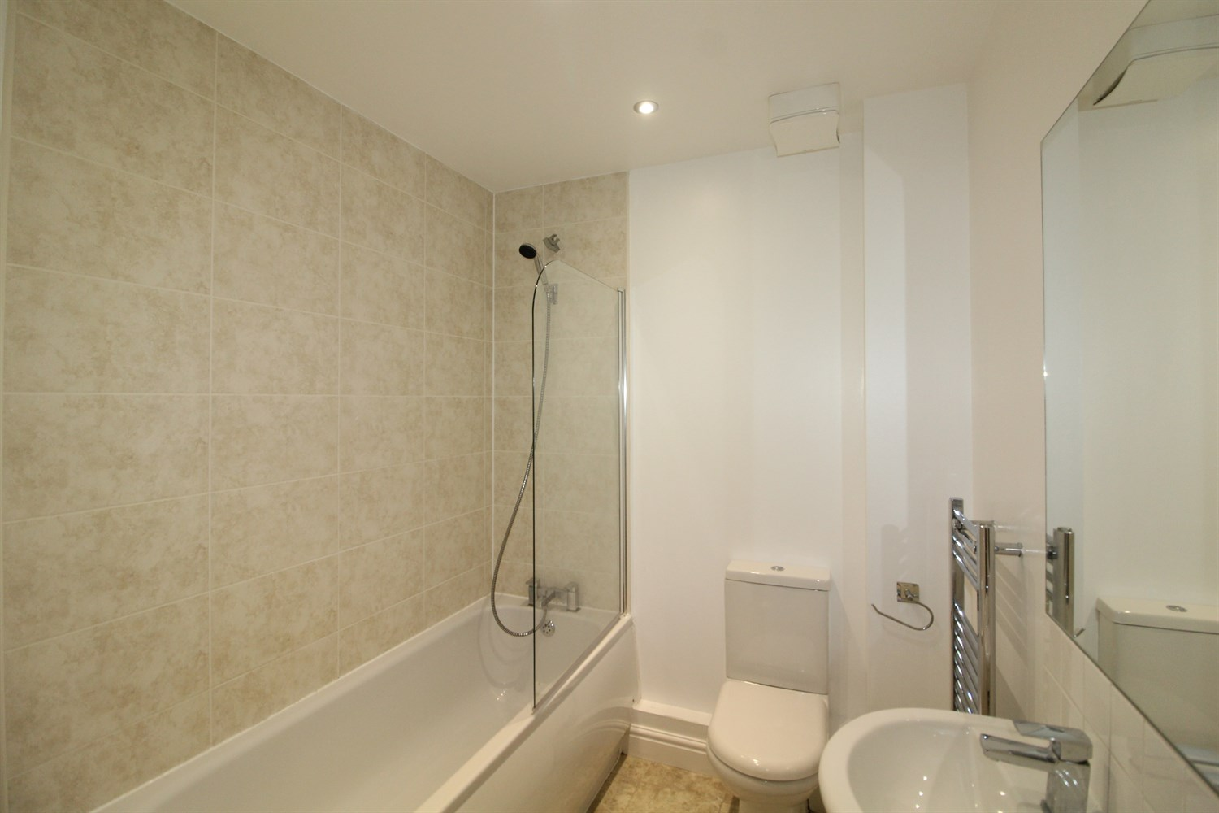

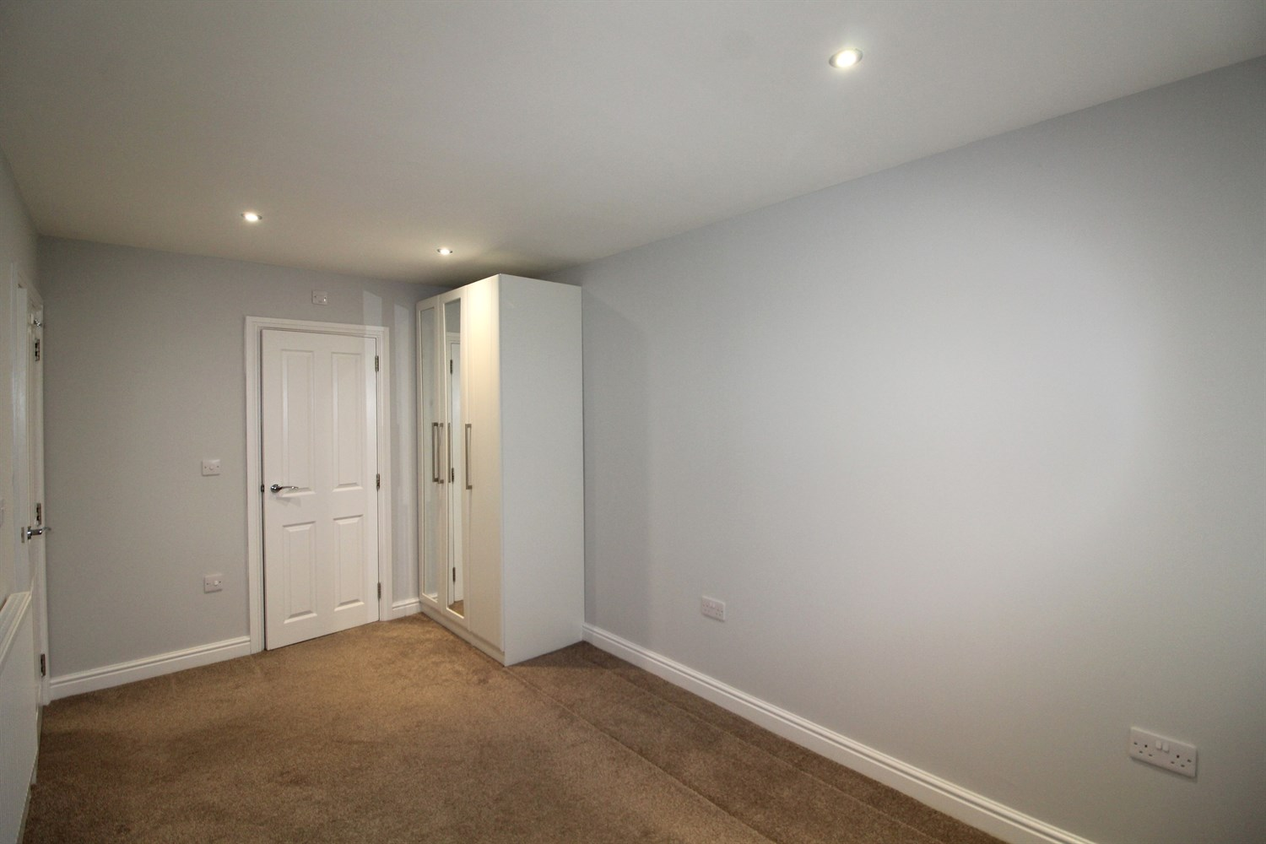

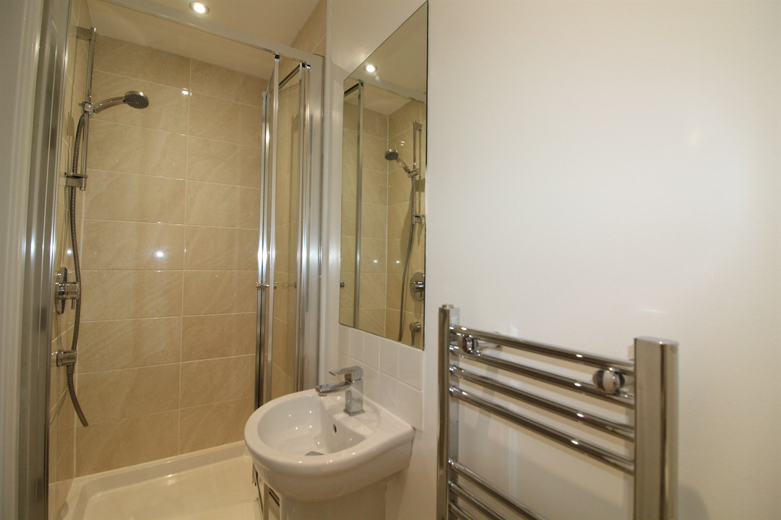

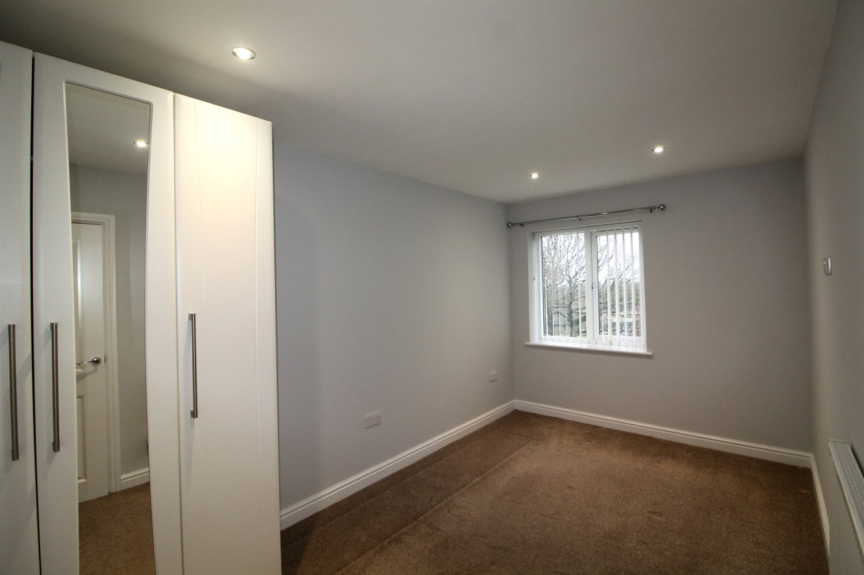

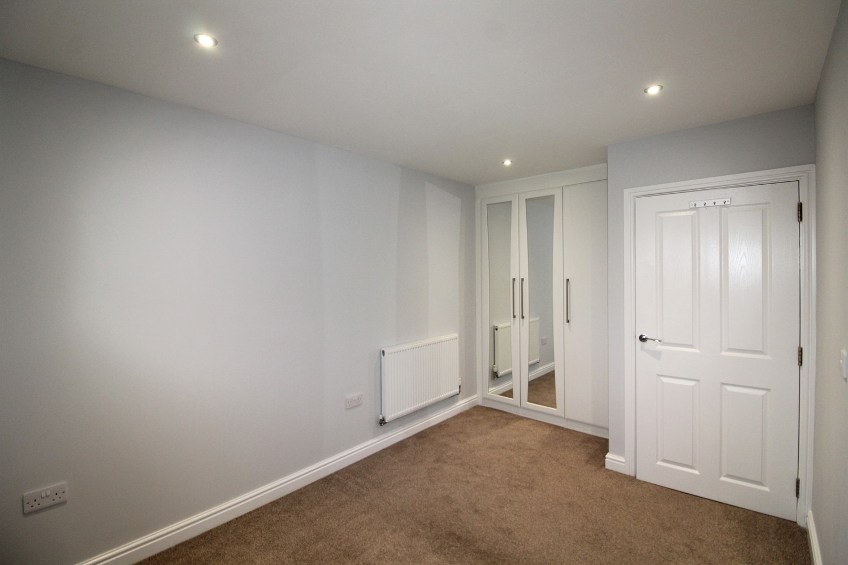

|  |
| --- |
| **Communal Entrance Hall**  Stairs and lift to all floors. |
| **Entrance Hall**  intercom and storage cupboard housing washing machine. |
| **Living/Dining and Kitchen**  light and airy living area with French doors opening on a Juliet balcony, gas central heating radiator. Modern kitchen fitted with a range of wall and base units with work tops over, integrated appliances, including fridge freezer, and dishwasher. |
| **Bedroom**  Double bedroom with wardrobes, uPVC window, gas central heating radiator. Access to ensuite. |
| **En Suite**  Ensuite compromising of walk in shower, w/c and hand wash basin, tiled walls, towel radiator. |
| **Bedroom**  Double bedroom with wardrobes, uPVC window, gas central heating radiator. |
| **House Bathroom**  Bathroom compromising of bath with shower over head, shower screen, w/c and hand wash basin, tiled walls, towel radiator. |
| **Home Information**  COUNCIL TAX BAND:  EPC Rating B.  Leasehold property. Parking.  Broadband: Standard 8 Mbps 0.8 Mbps Good Superfast --Not available --Not available Unlikely Ultrafast 1800 Mbps 220 Mbps  Mobile availability:  EE limited coverage . Three likely to have good coverage. O2 limited coverage. Vodafone limited coverage.  Utilities: Water supplied on standard meters. Gas and Electric mains supplied on standard meters. |

|  |  |
| --- | --- |
| These particulars are intended to give a fair description of the property, but their accuracy cannot be guaranteed, and they do not constitute an offer of contract. Intending purchasers must rely on their own inspection of the property. None of the above appliances/services have been tested by ourselves. We recommend purchasers arrange for a qualified person to check all appliances/services before legal commitment.  **Property Ref:** 5129  **For more information, please contact**  0113 258 1150 **|** [lettings@adairpaxton.co.uk](mailto:lettings@adairpaxton.co.uk) **|** www.adairpaxton.co.uk |  |