

**0113 258 1150**

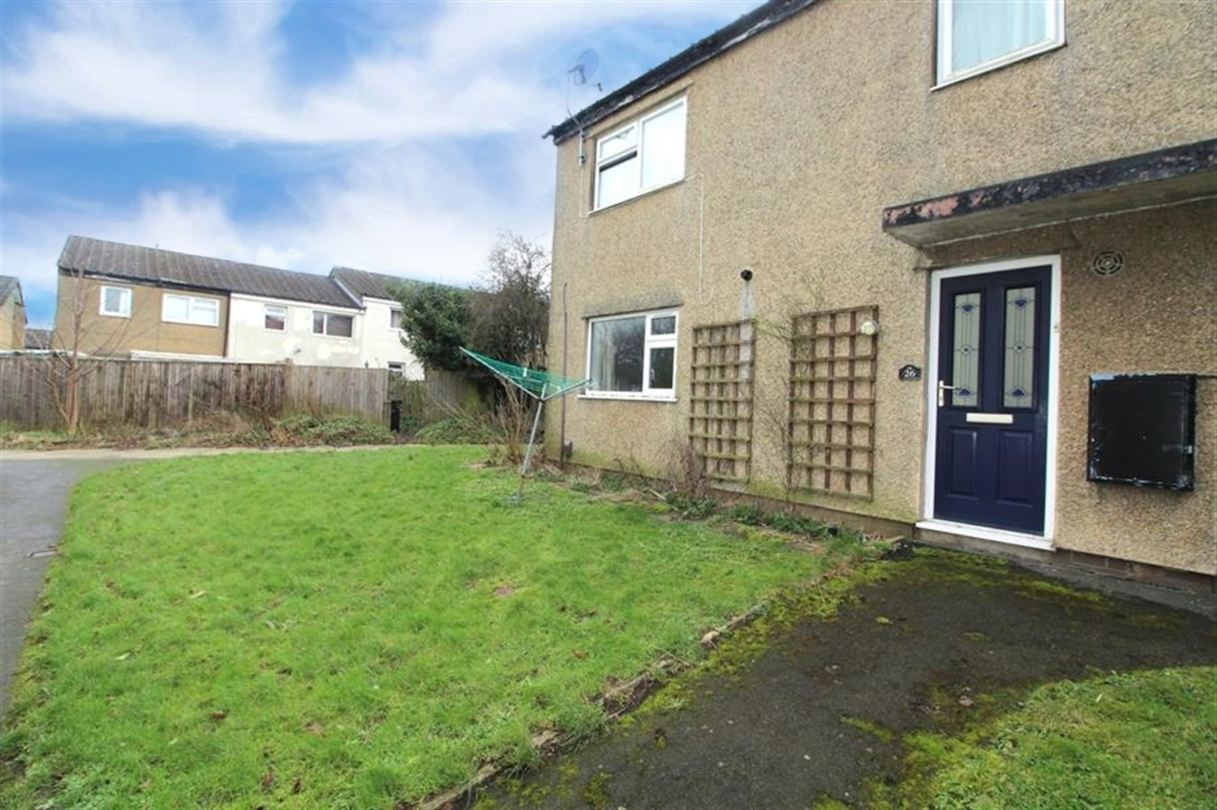



**For Sale £85,000.00**

**Holtdale Croft, Adel**

**ONE BEDROOM GROUD FLOOR APARTMENT** This spacious one bedroom property is offered to the market with NO ONWARD CHAIN. Located in this popular area of Holt Park, close to local amenities including Asda supermarket and Holt Park Active Leisure Centre. The property comprises: Entrance hall, lounge, kitchen, double bedroom and house bathroom. The property is a great investment opportunity. Further benefits include gas central heating and uPVC double glazing.

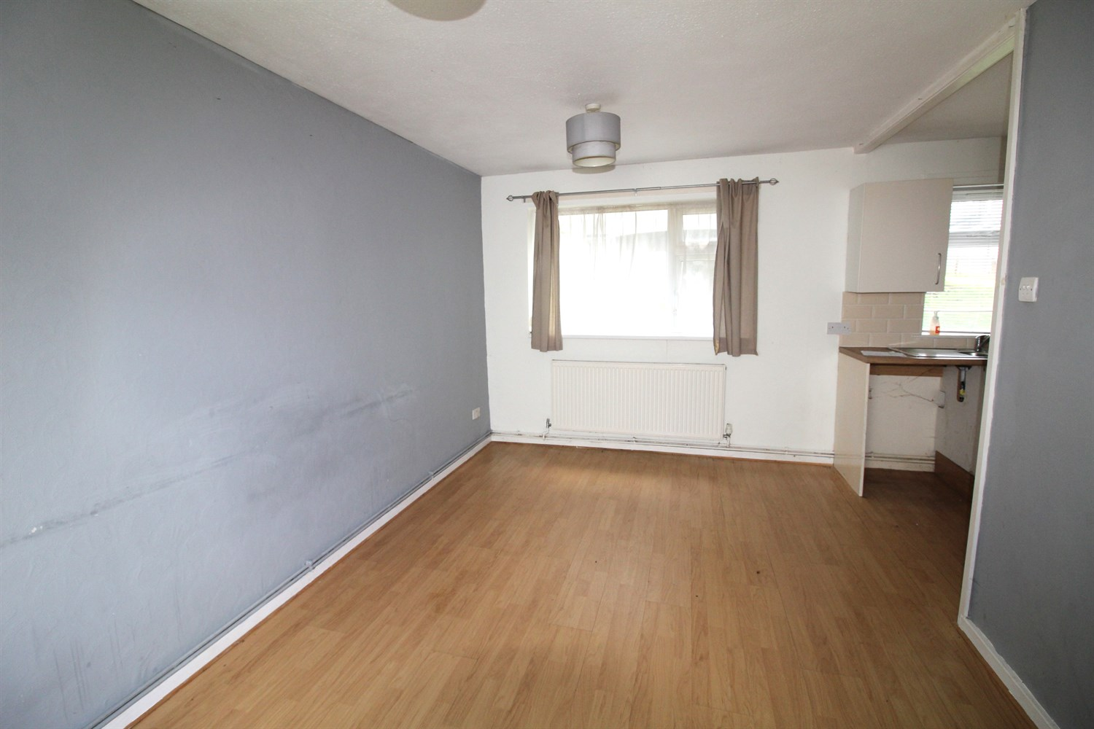

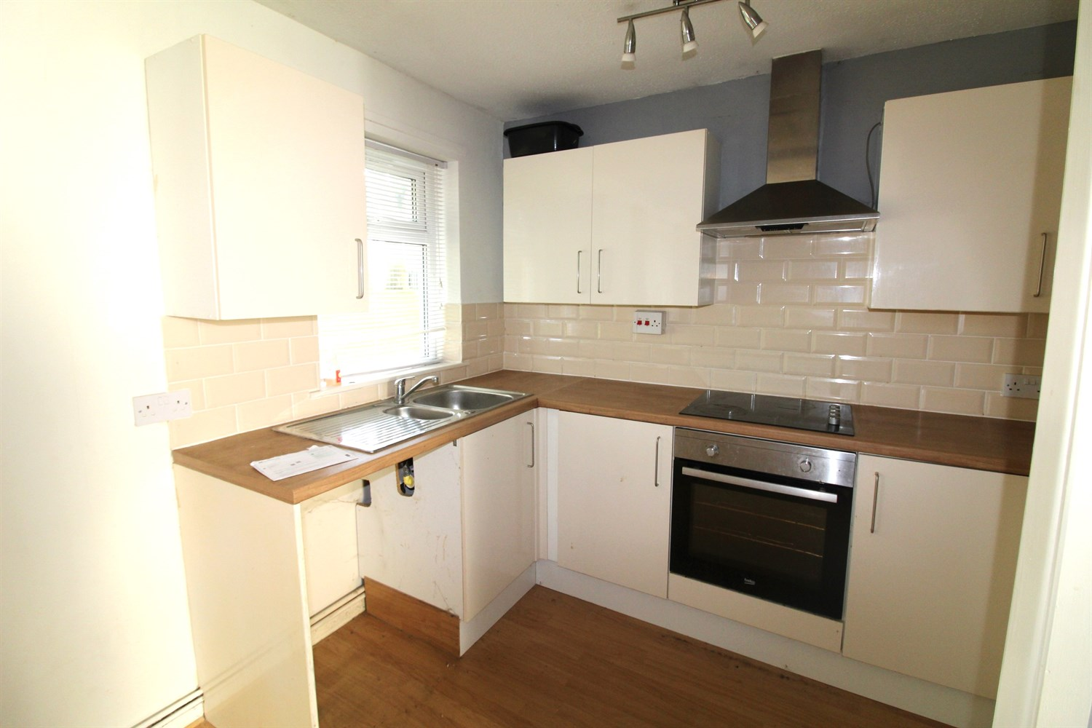

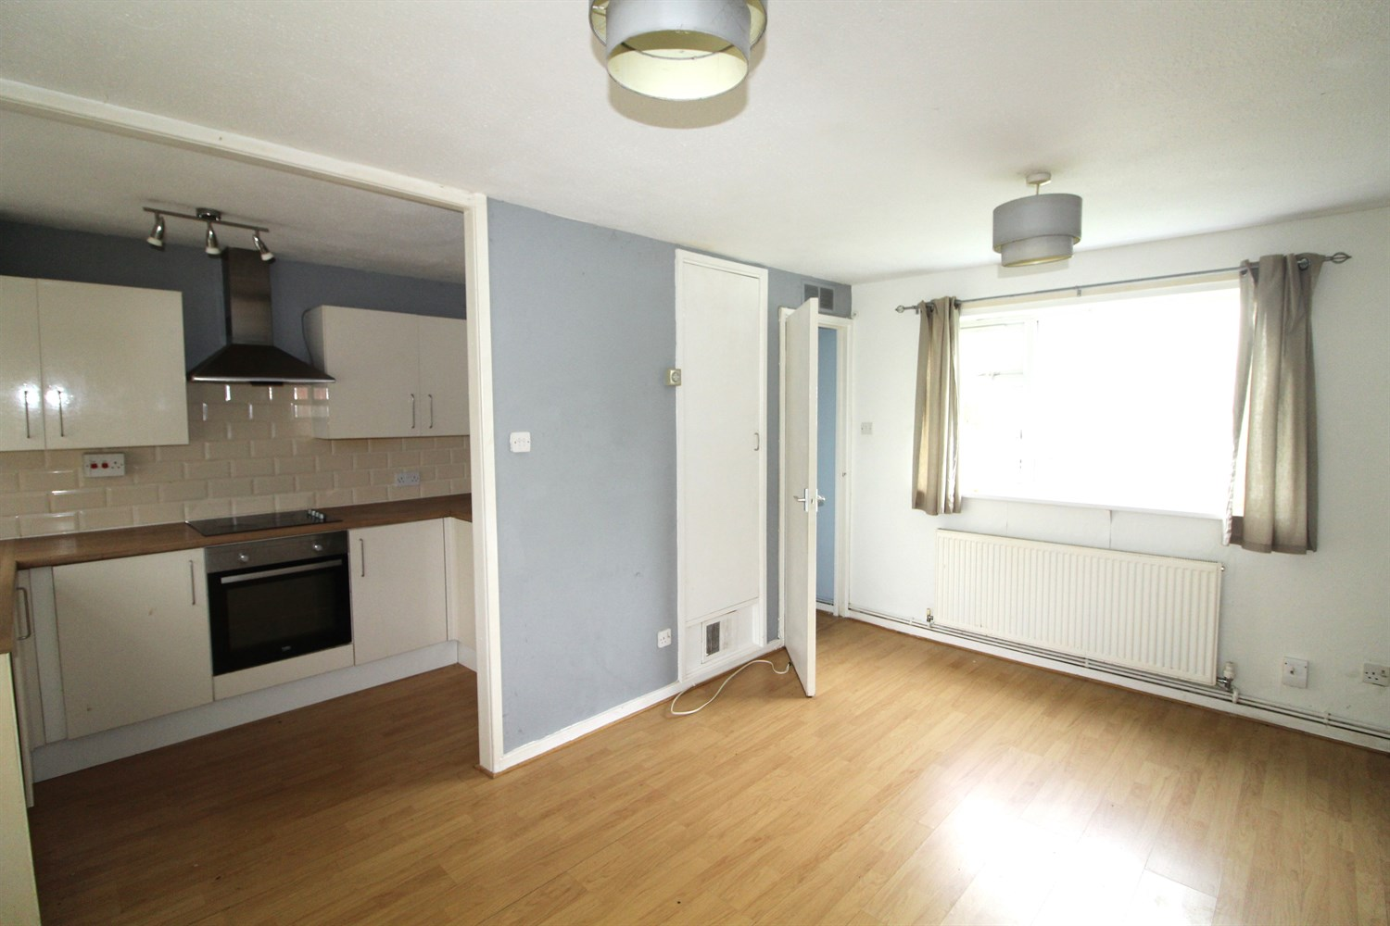

1 Bathroom(s)

1 Reception(s)

1 Bedroom(s)

00

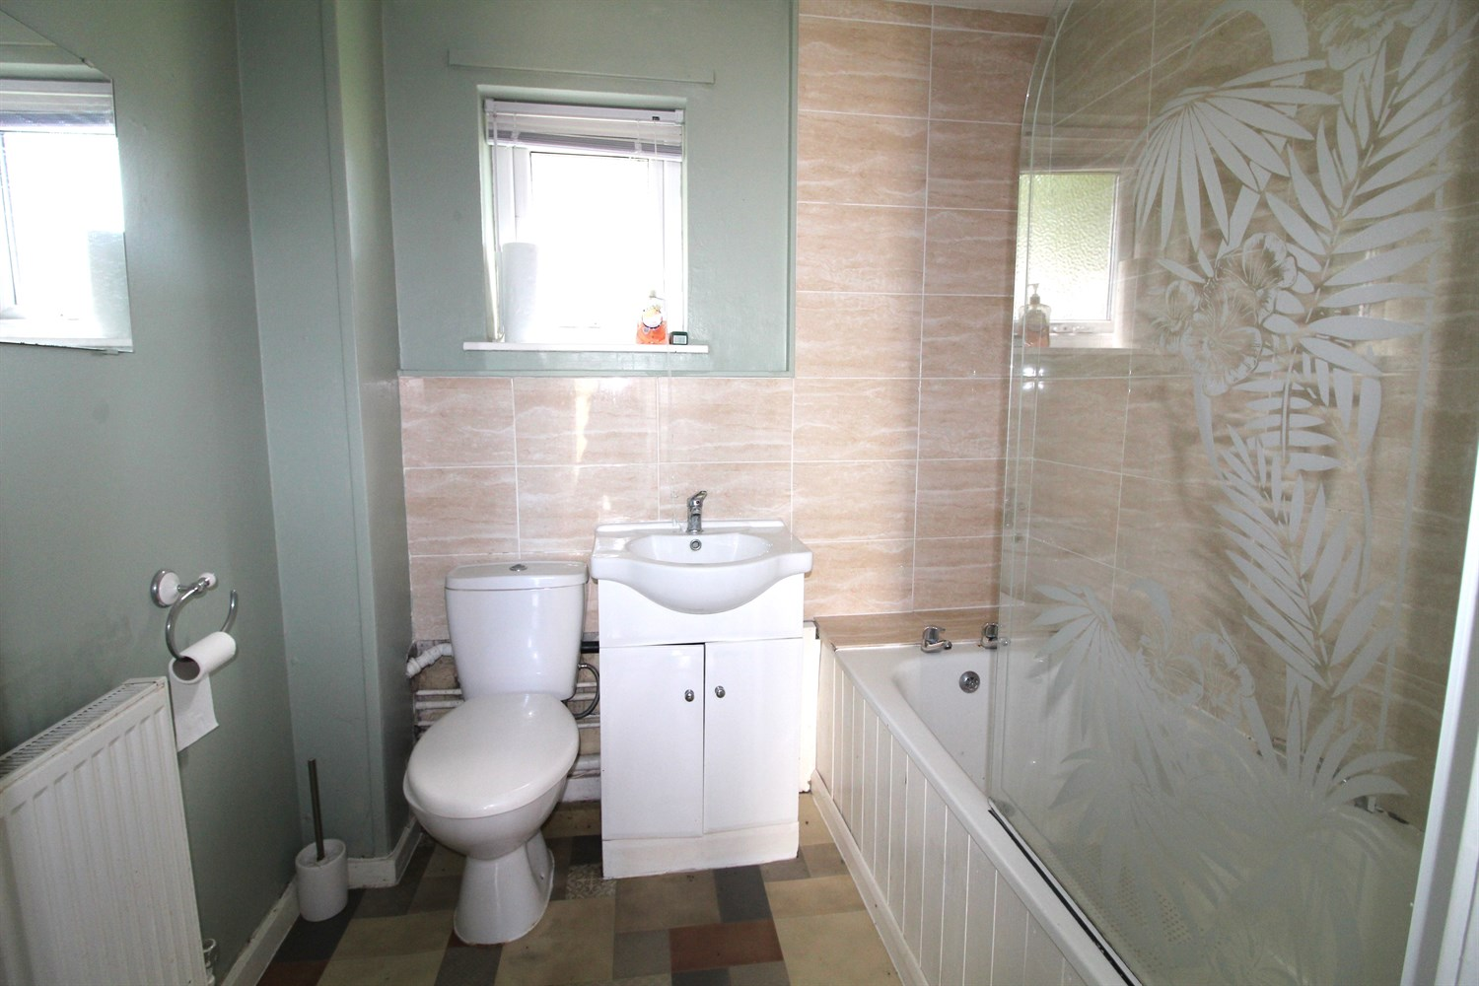

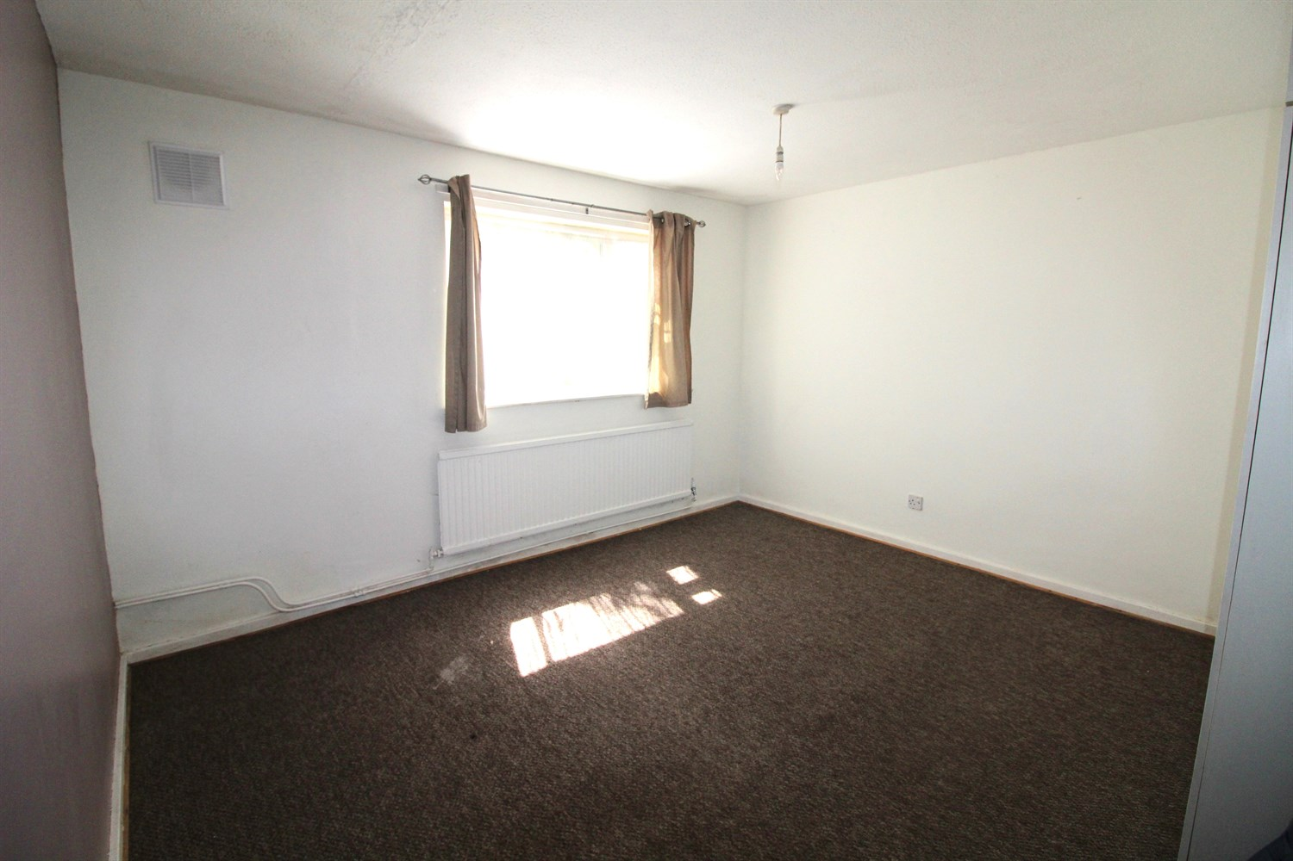

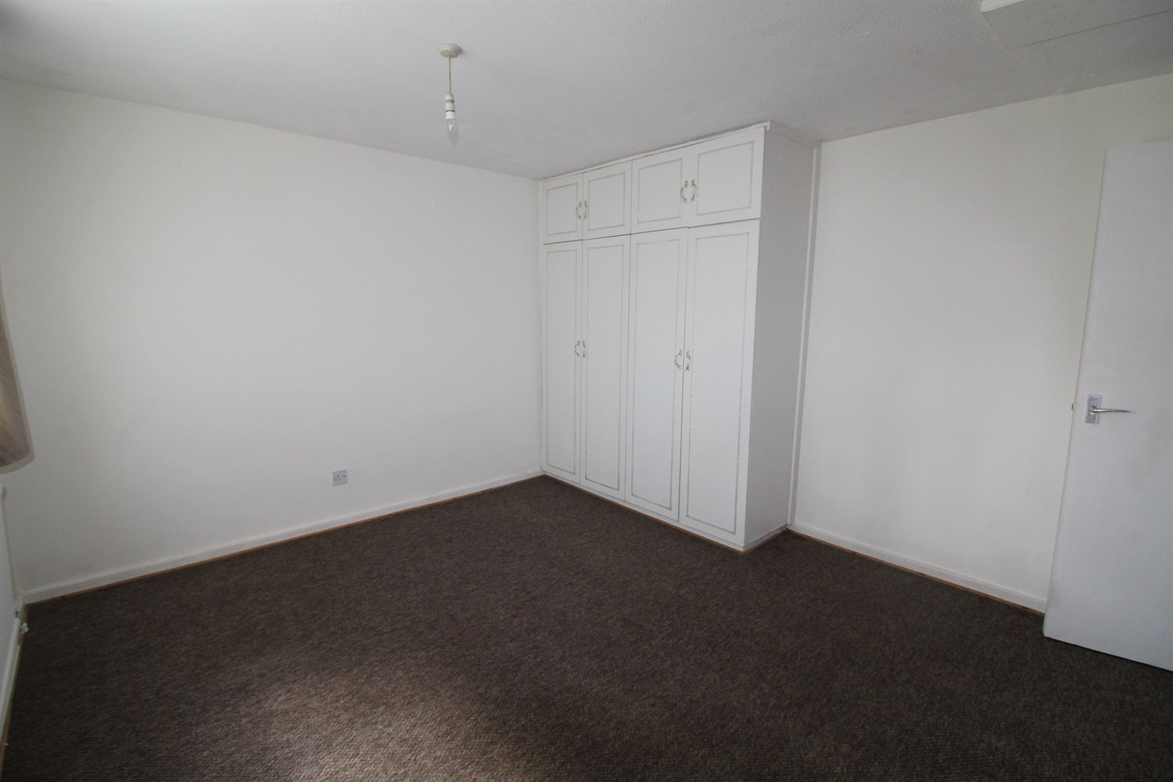

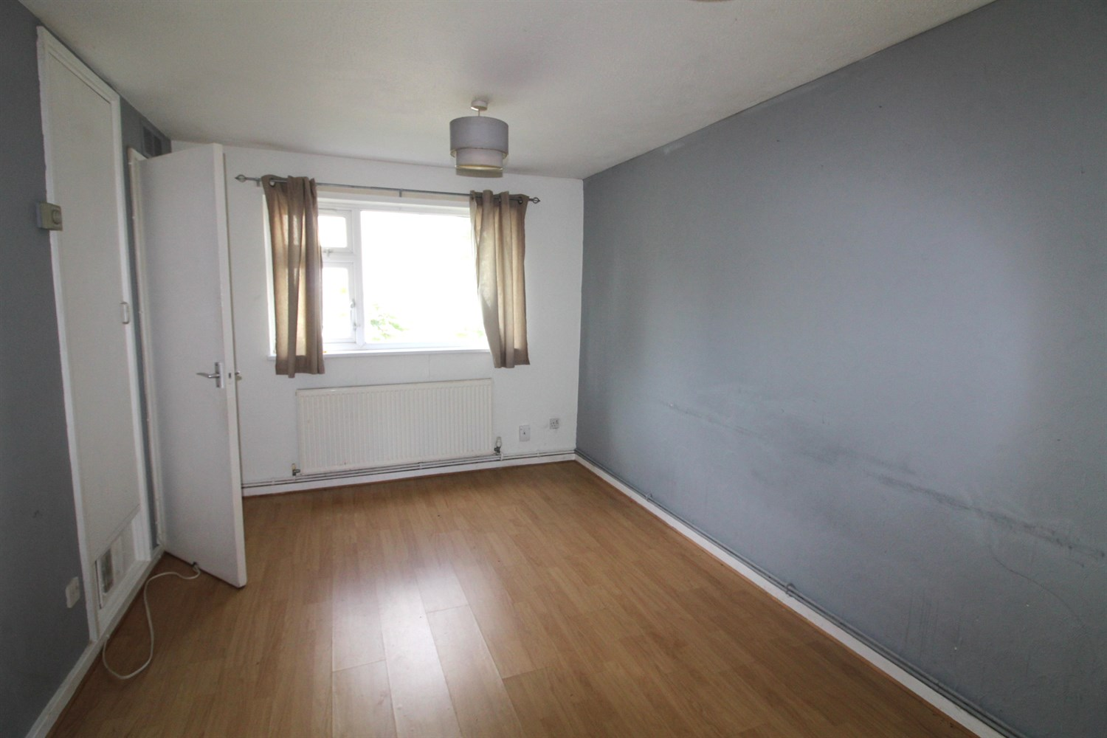

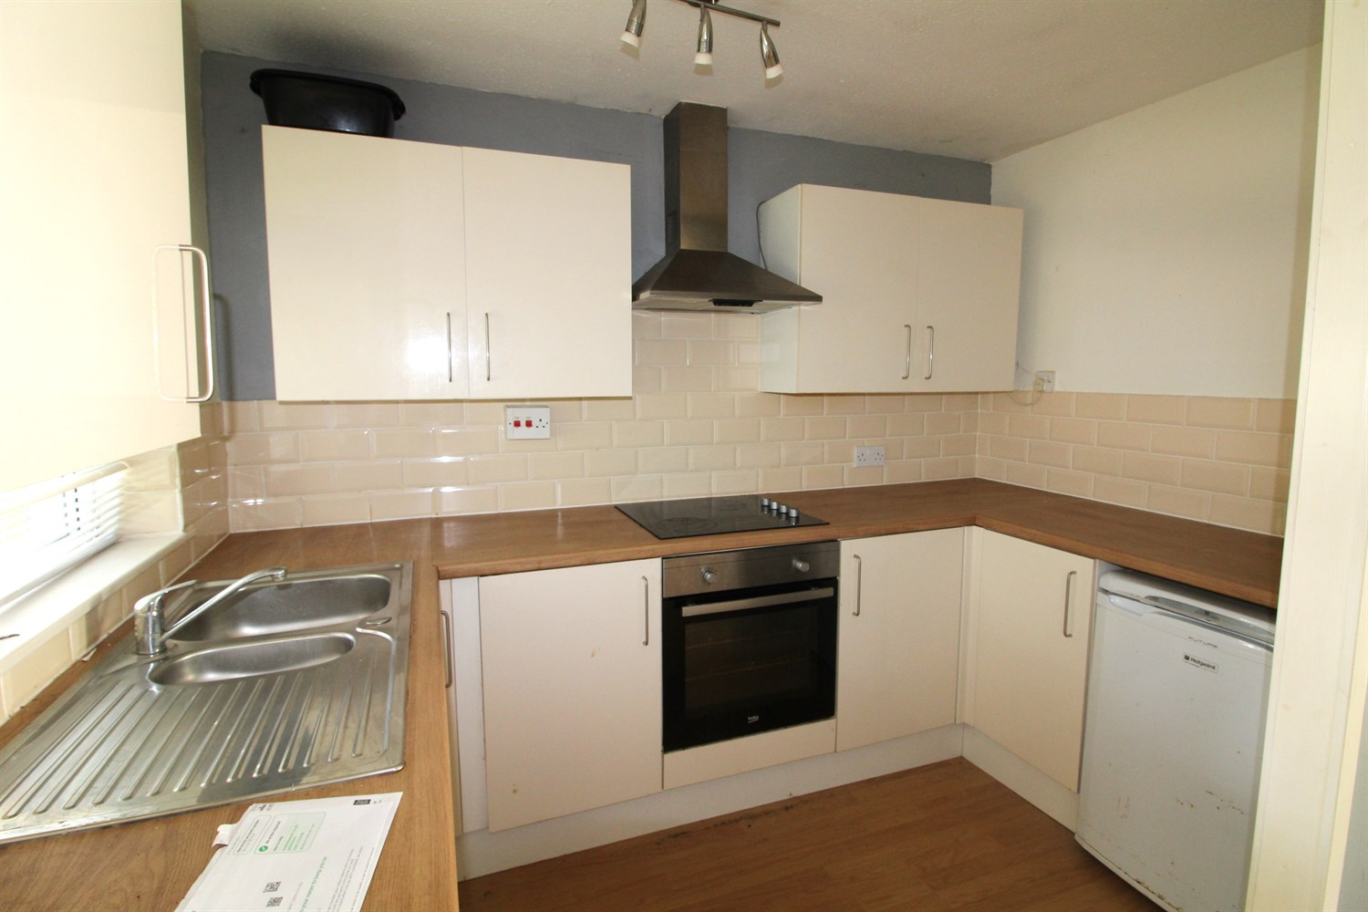

|  |
| --- |
| **Hallway**  Via front entrance door. Store cupboard. |
| **Lounge 4.7m (15'5) x 2.8m (9'2)**  Spacious living area with uPVC double glazed window to front and rear. Two gas central heating radiators. |
| **Kitchen**  Fitted with a range of wall, base and drawer units with worktops over. Integrated electric oven with 4-ring hob and extractor hood over. Space for washing machine and fridge. 1.5 bowl sink with mixer tap and drainer. Part tiled walls. uPVC double glazed window. |
| **Bedroom 3.9m (12'10) x 3.6m (11'10)**  Double bedroom with uPVC double glazed window. Gas central heating radiator. Built in wardrobe. |
| **Bathroom**  Fitted with a three piece white suite comprising; bath with shower over, WC and wash hand basin. uPVC double glazed window. Gas central heating radiator. |
| **Tenure**  Leasehold - 125 years from 2005 Ground Rent £10 per annum |
| **Service Charge**  The service charge for this year is £60.24 a quarter. |

|  |  |
| --- | --- |
| These particulars are intended to give a fair description of the property, but their accuracy cannot be guaranteed, and they do not constitute an offer of contract. Intending purchasers must rely on their own inspection of the property. None of the above appliances/services have been tested by ourselves. We recommend purchasers arrange for a qualified person to check all appliances/services before legal commitment.  **Property Ref:** 7353  **For more information, please contact**  0113 258 1150 **|** [sales@adairpaxton.co.uk](mailto:sales@adairpaxton.co.uk) **|** www.adairpaxton.co.uk |  |