

**Greenlea Close, Yeadon**

**Available to let £1,700.00pcm**

An ideal family home benefiting from spacious accommodation throughout. The property is is situated within this highly desirable cul de sac with close proximity to highly regarded local schools, woodland walks and a train station. Accommodation briefly consists of an entrance hallway, cloakroom / WC, spacious lounge, modern dining kitchen with access out to the rear garden. To the first floor can be found the guest bedroom with en suite shower, three other good-sized bedrooms and the house bathroom. The master suite occupies the second floor and also has an adjoining en suite shower room. Externally there is a small garden to the front with a driveway to the side leading to the single garage. The rear garden is lawned and paved with fencing around the back. Available Now. EPC rating C, Council tax band E. Deposit £1960.

**0113 258 1150**

**0800 000 000**

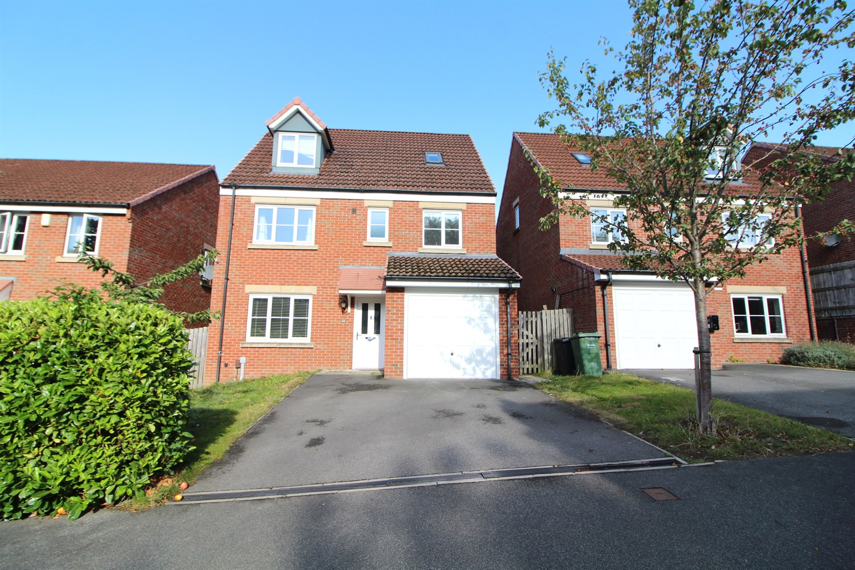

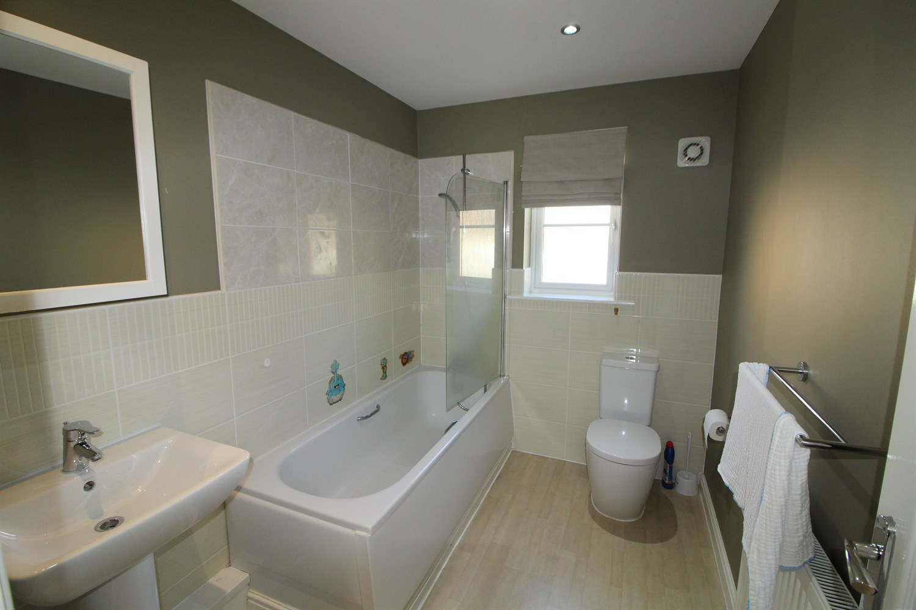

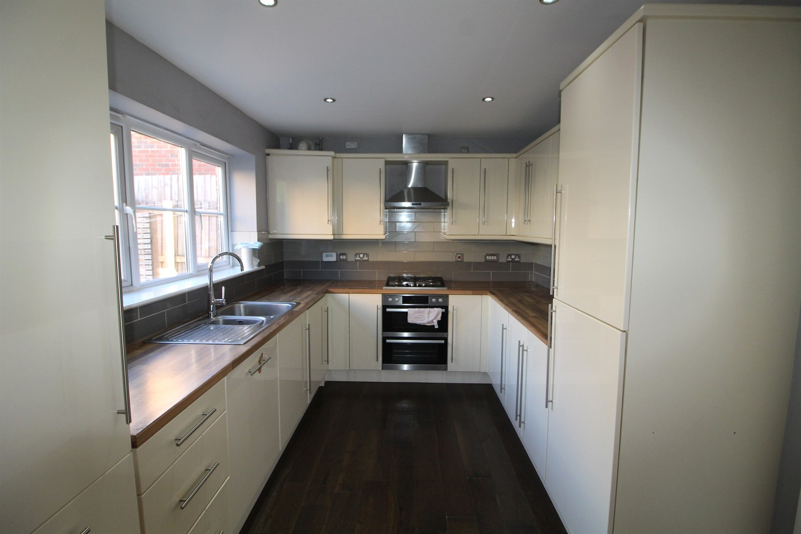

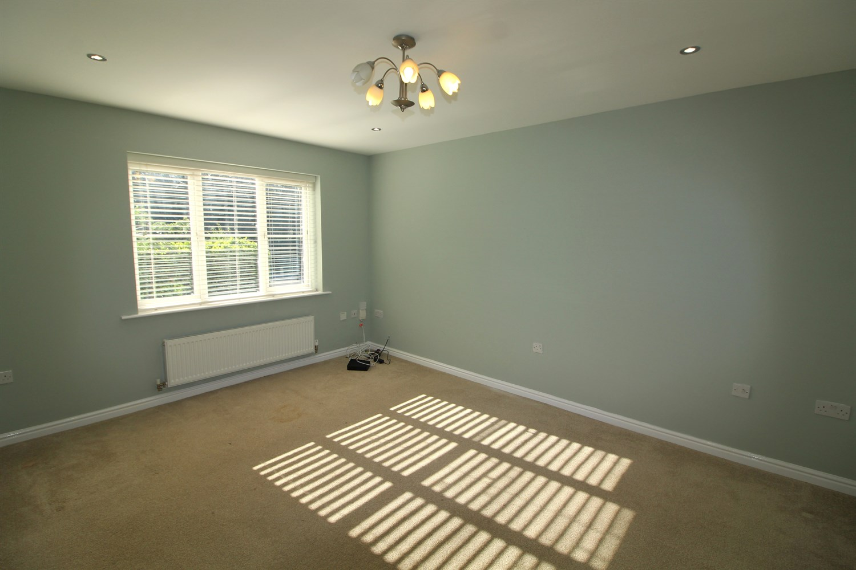

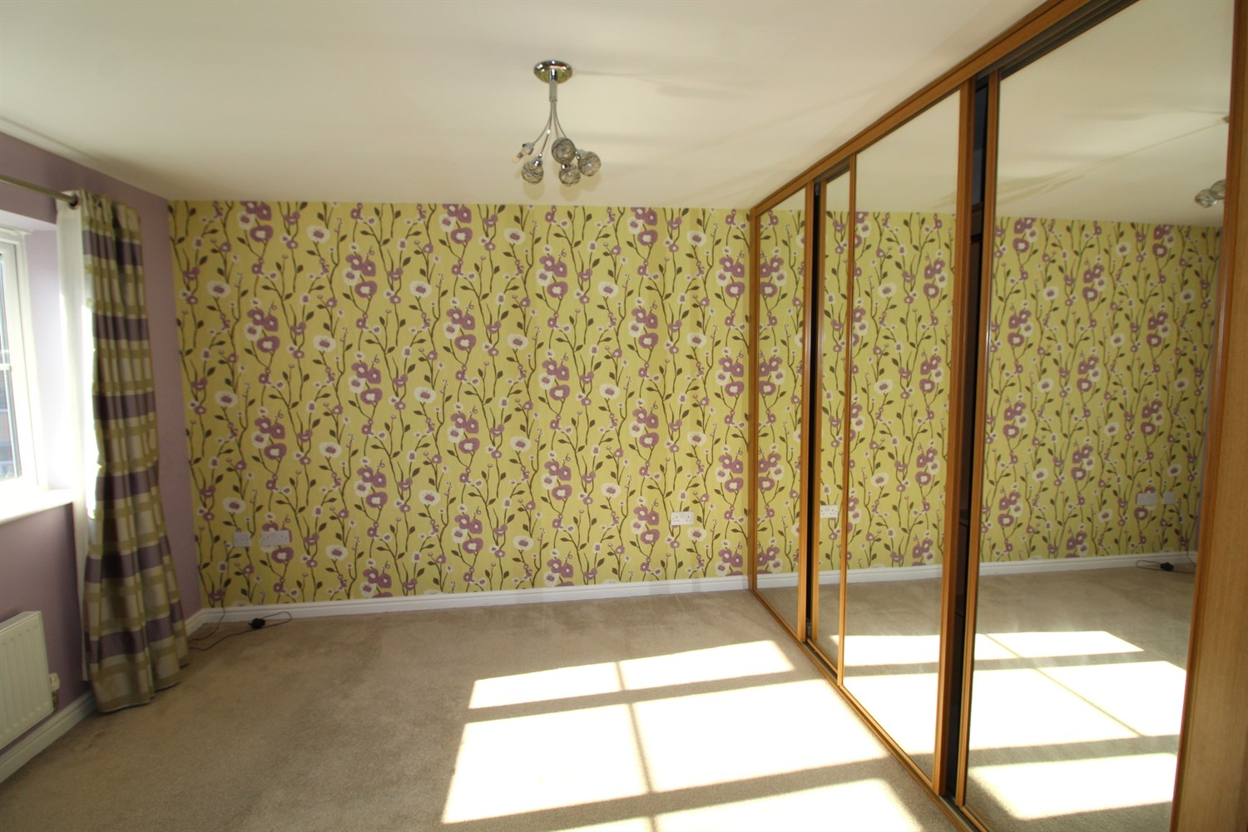

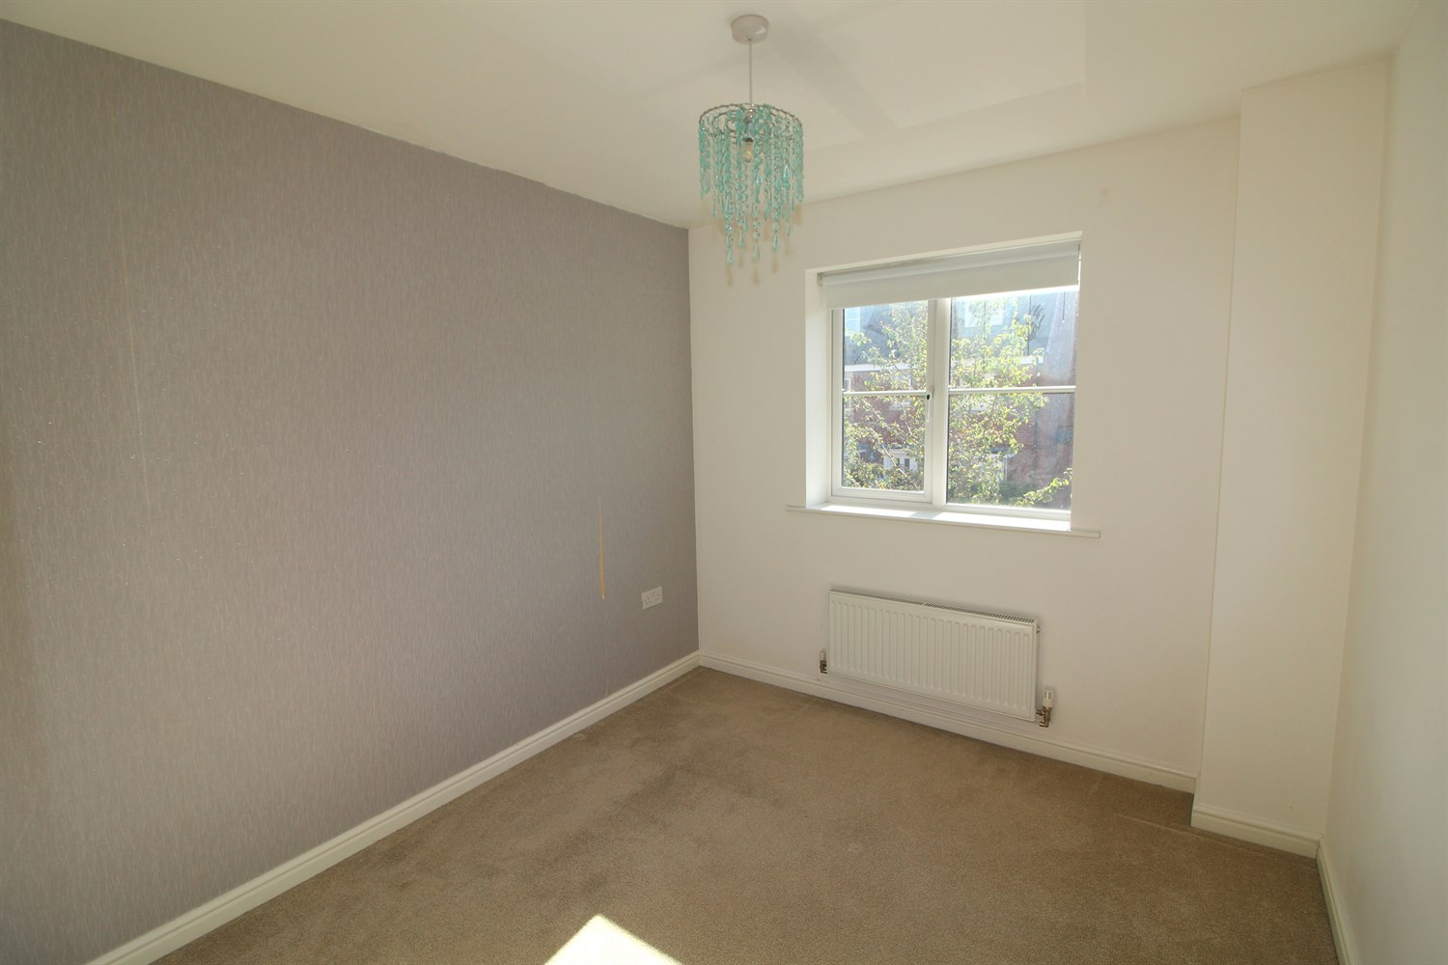

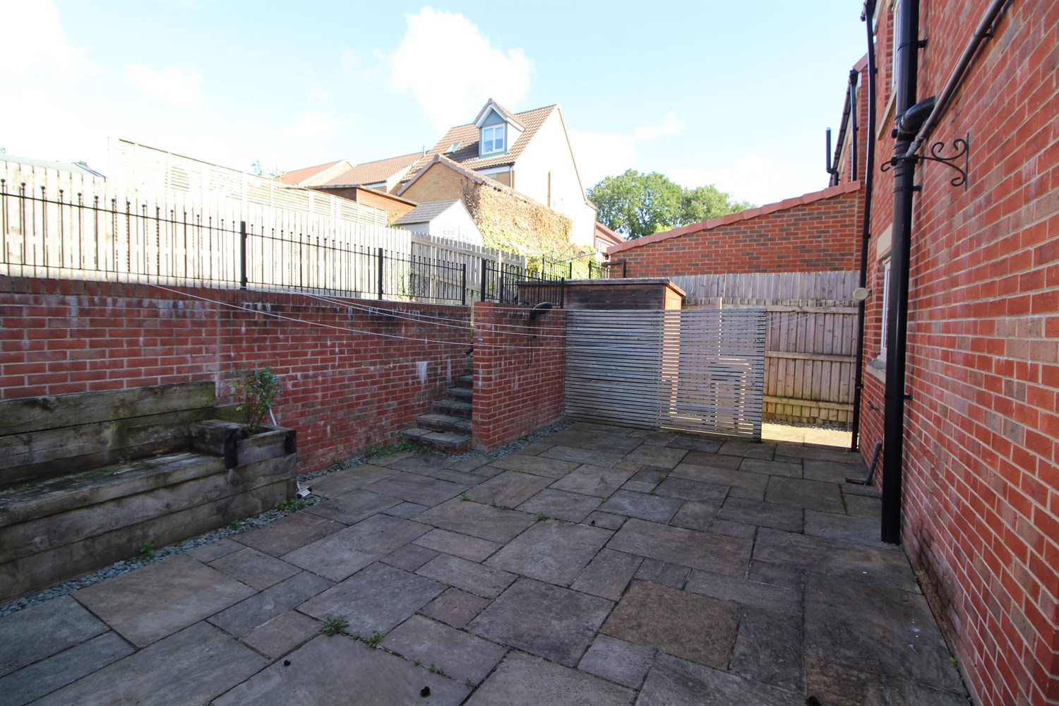

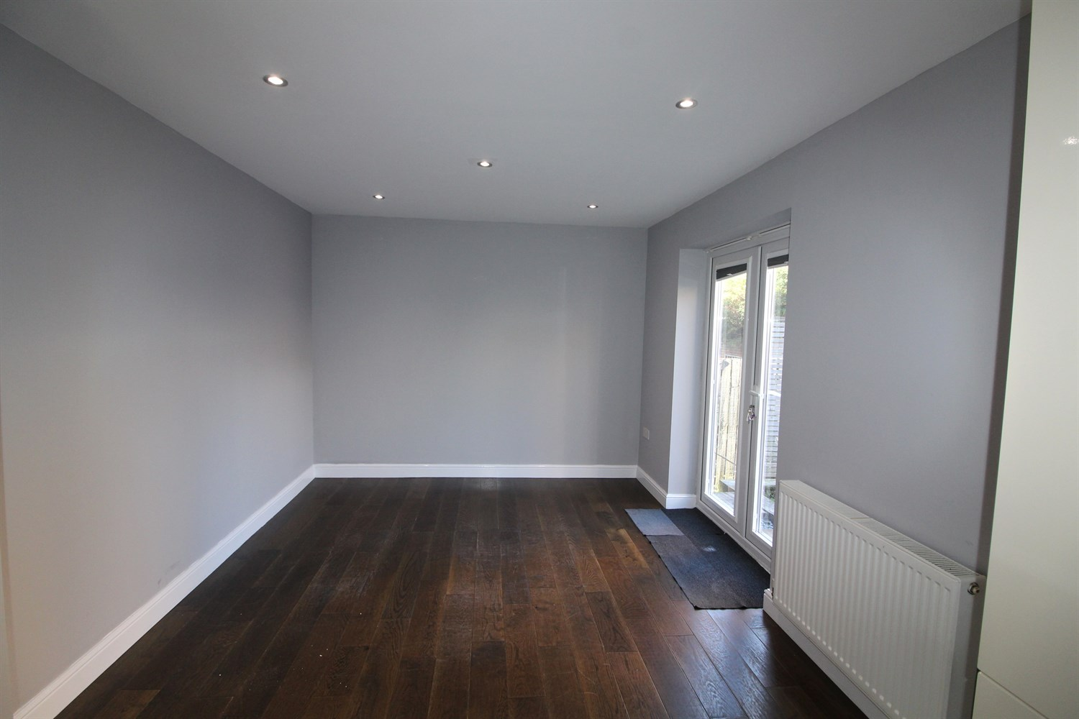

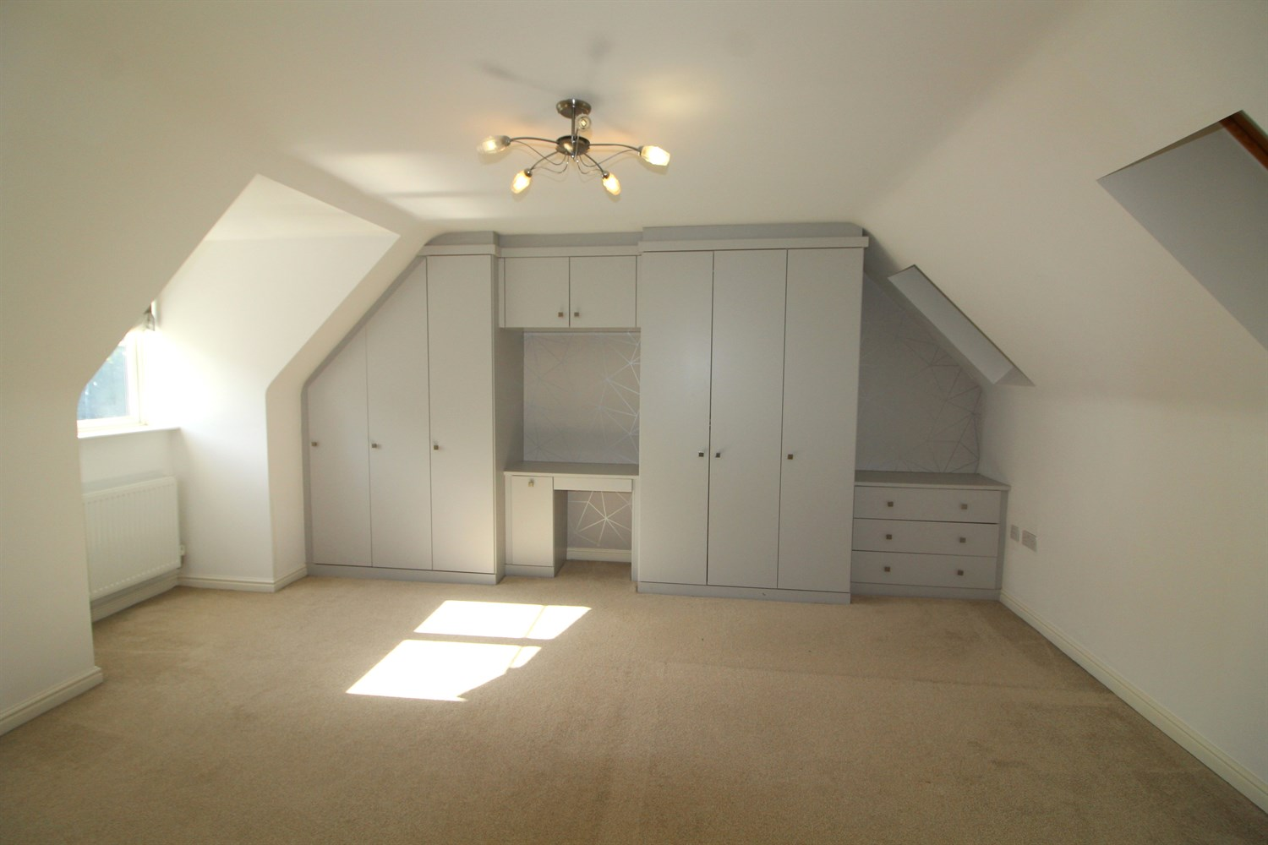

|  |
| --- |
| **Reception 1**  Light and Airey living room with window to front. gas central heating radiator. |
| **Kitchen**  Open-plan kitchen dining room is situated to the rear of the property, offering a range of fitted base and wall units. Integrated appliances include a gas oven and hob, overhead extractor and dishwasher, leaving space for a washing machine. The dining area overlooks the rear garden via patio doors. |
| **Bedroom 1**  Located on the second floor is a large bedroom with fitted wardrobes and ensuite. Two Velux windows to rear and one window to front, gas central heating radiator. Door for storage cupboard. |
| **Ensuite**  Fitted with a walk in shower, w/c and hand wash basin. Part tiled walls. |
| **Bedroom 2**  Large double bedroom with window to front large mirrored wardrobes. gas central heating radiator. Access to ensuite. |
| **Ensuite**  Fitted with a walk in shower, w/c and hand wash basin. Part tiled walls. |
| **Bedroom 3**  Double bedroom with window to rear, gas central heating radiator. |
| **Bedroom 4**  Small double room with window to front, gas central heating radiator. |
| **Bedroom 5**  Small double room with window to front, gas central heating radiator. |
| **House Bathroom**  Modern fitted bathroom with shower over bath, shower screen, w/c and hand wash basin, part tiled walls and window to rear. |
| **Garage**  Up and over door. |
| **Parking**  Driveway for 2 cars. |
| **Home information**  Council Tax Band E. EPC rating C.  Freehold Property. Driveway and garage.  MAINS UTILITY CONNECTIONS - gas, electricity and water.   MOBILE AND BROADBAND AVAILABILITY: (Please refer to OFCOM Mobile and Broadband Checker for full details) -- Mobile voice and data services are available indoors and outdoors from all four major mobile providers. Broadband service is available up to 1000 Mbps from the Open Reach and Virgin networks. |

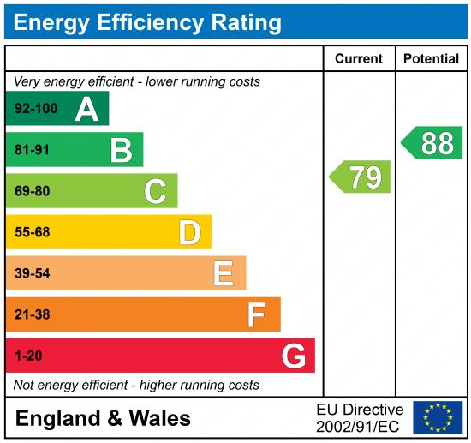

|  |
| --- |
|  |

These particulars are intended to give a fair description of the property, but their accuracy cannot be guaranteed, and they do not constitute an offer of contract. Intending purchasers must rely on their own inspection of the property. None of the above appliances/services have been tested by ourselves. We recommend purchasers arrange for a qualified person to check all appliances/services before legal commitment.

**Property Ref:** 7426

**For more information, please contact**

0113 258 1150 **|** [lettings@adairpaxton.co.uk](mailto:lettings@adairpaxton.co.uk) **|** www.adairpaxton.co.uk