

**0113 258 1150**

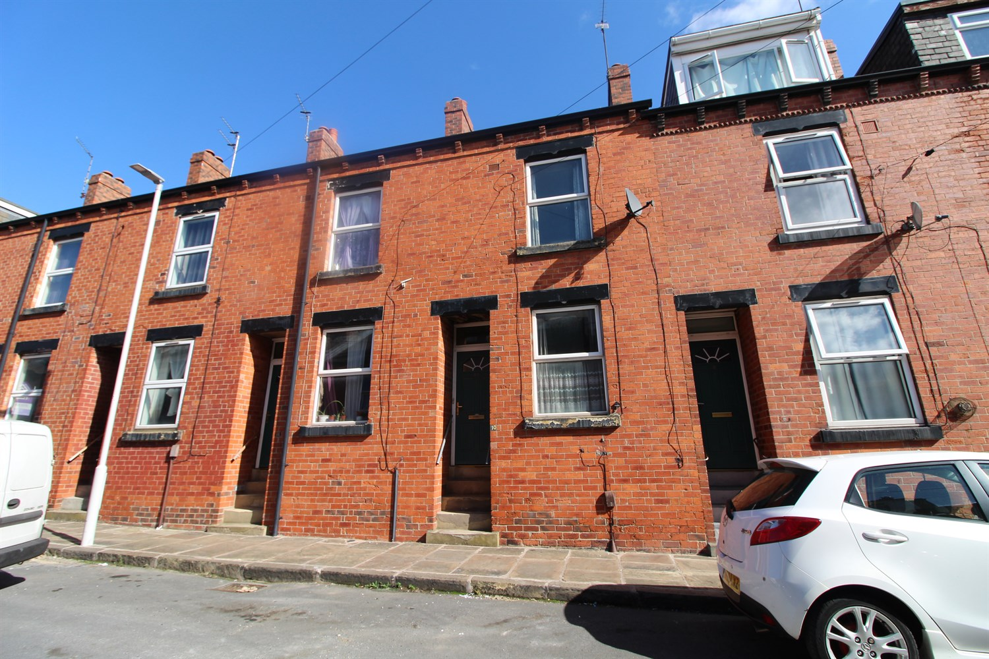



**For Sale £125,000.00**

**Burley Lodge Terrace, Leeds**

**TWO BEDROOM THROUGH MID-TERRACED HOUSE IN NEED OF A FULL RENOVATION** Adair Paxton are pleased to offer this spacious mid-terraced house, located in the popular area of Burley which provides great commuter links to the University, Headingley and the City Centre as well as local shopping and amenities. This is an ideal investment opportunity. The property is now in need of a full refurbishment and briefly comprises; Lounge and kitchen/diner to the ground floor. To the first floor there is a double bedroom, single bedroom and house bathroom. Externally, the property has a small courtyard style garden to the rear.

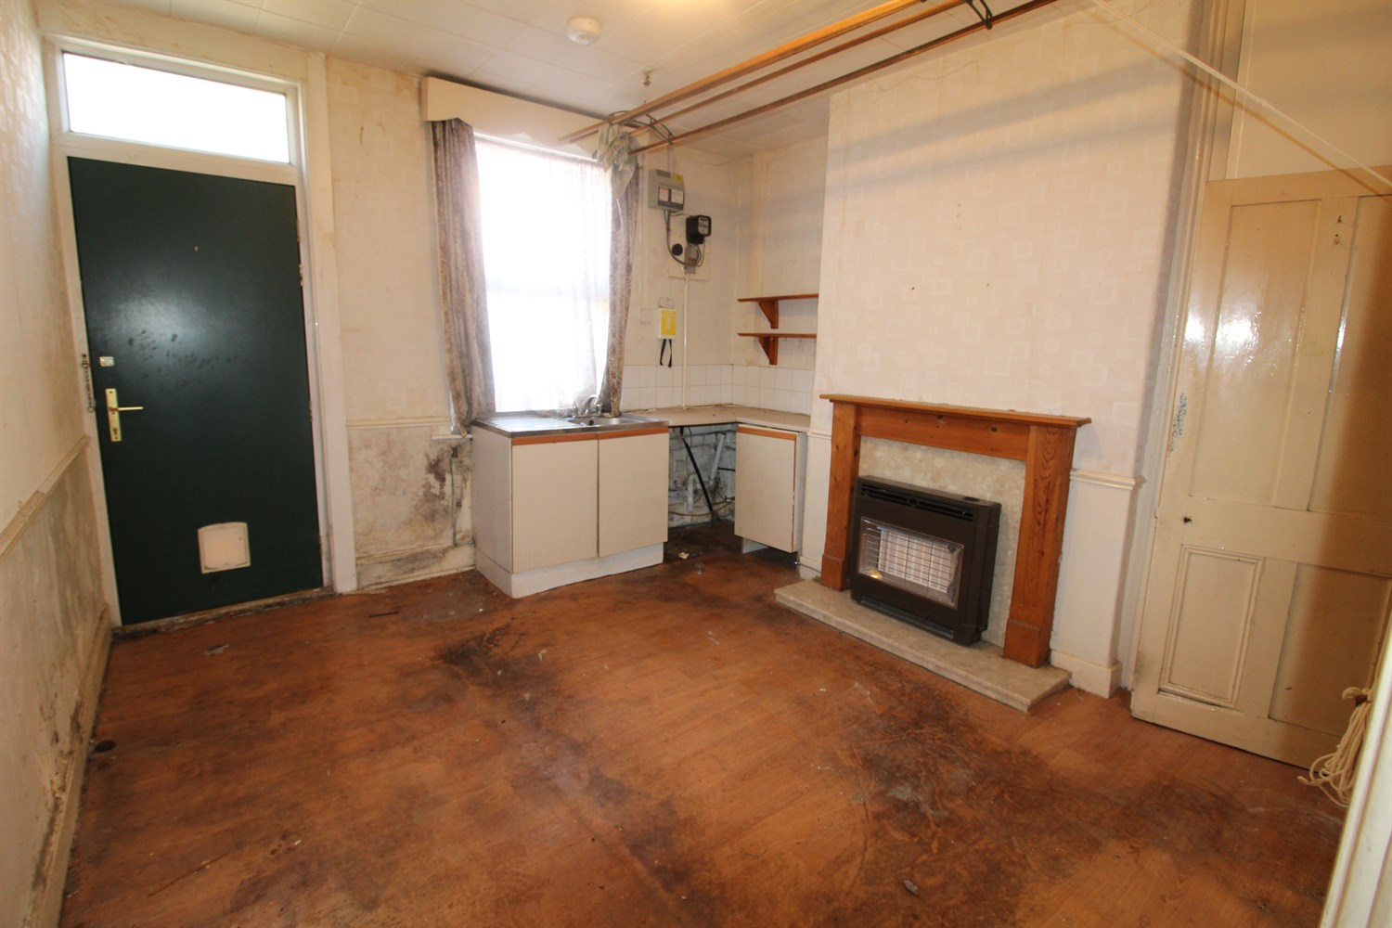

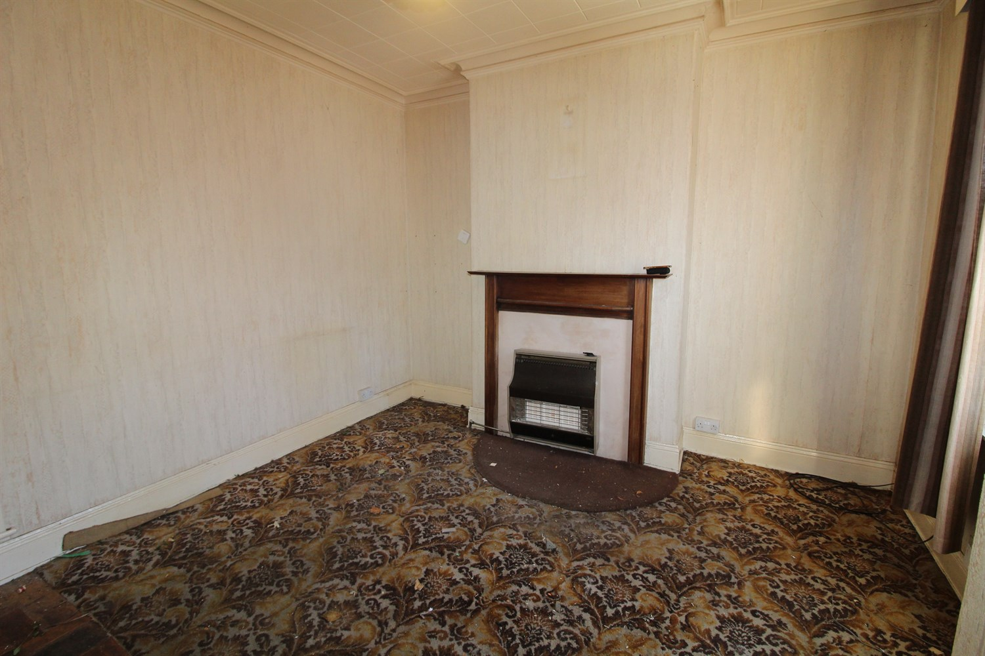

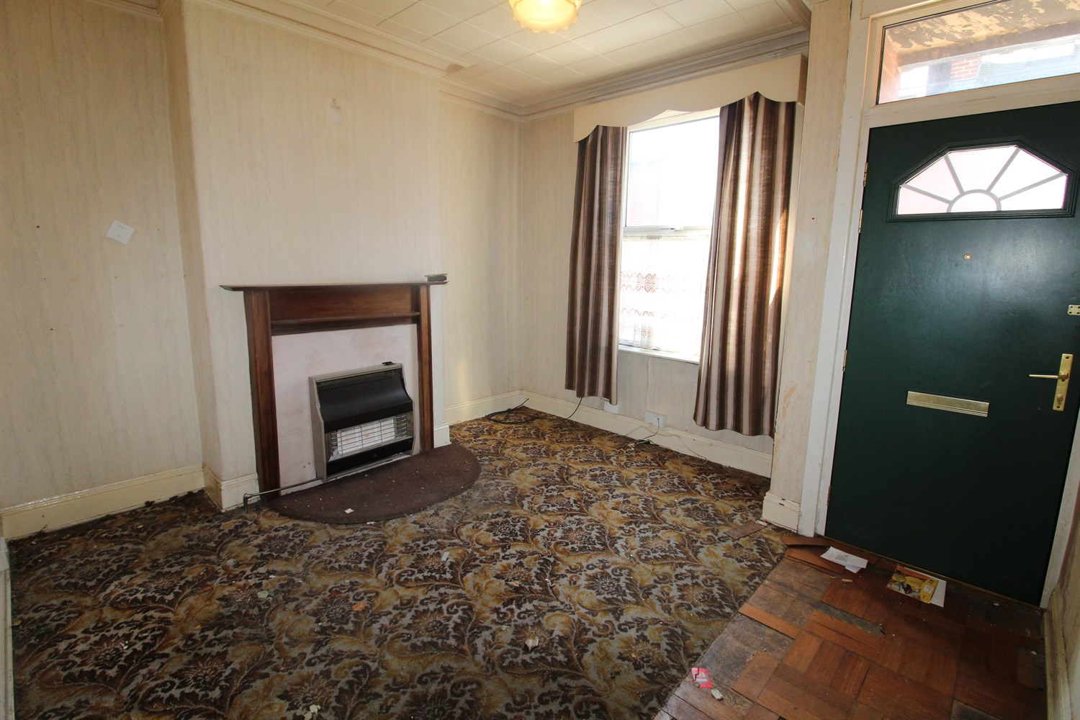

1 Bathroom(s)

1 Reception(s)

2 Bedroom(s)

00

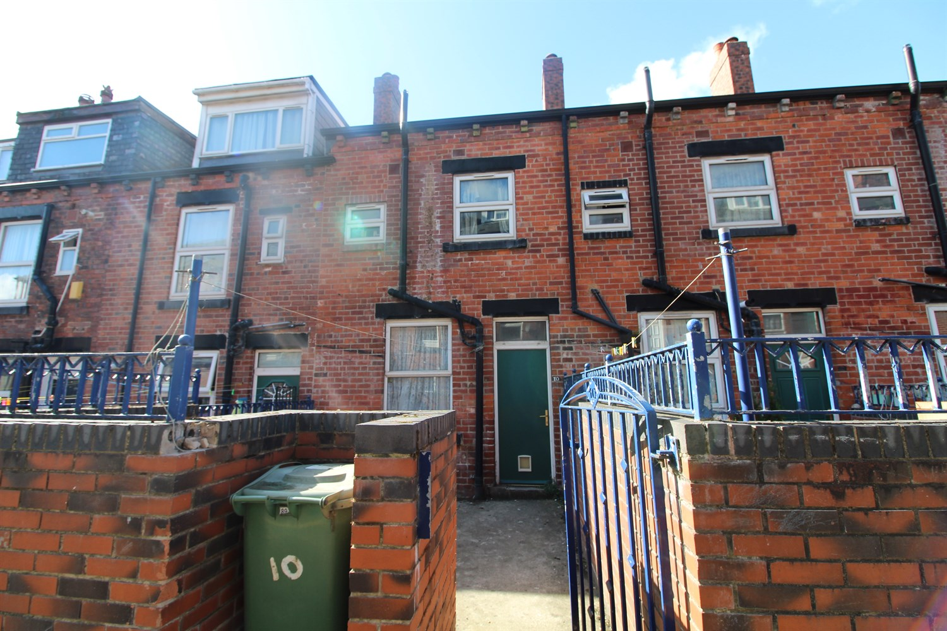

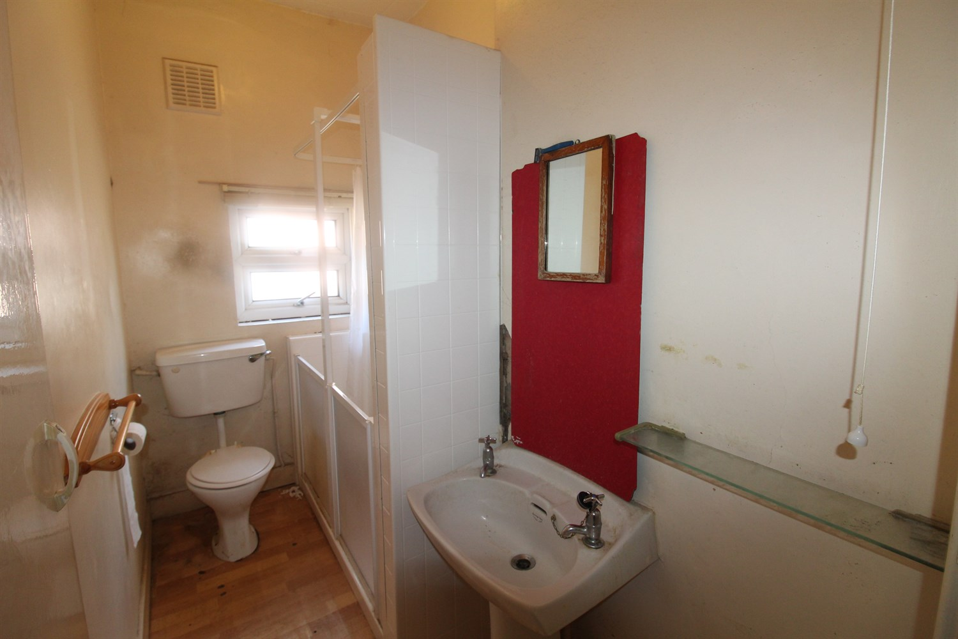

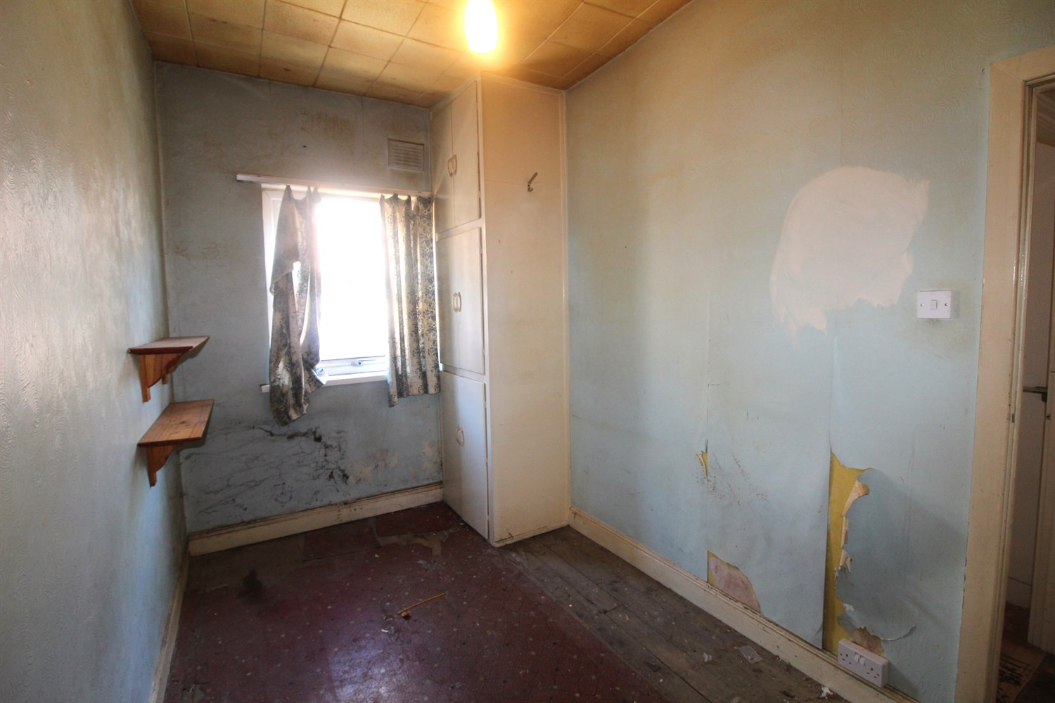

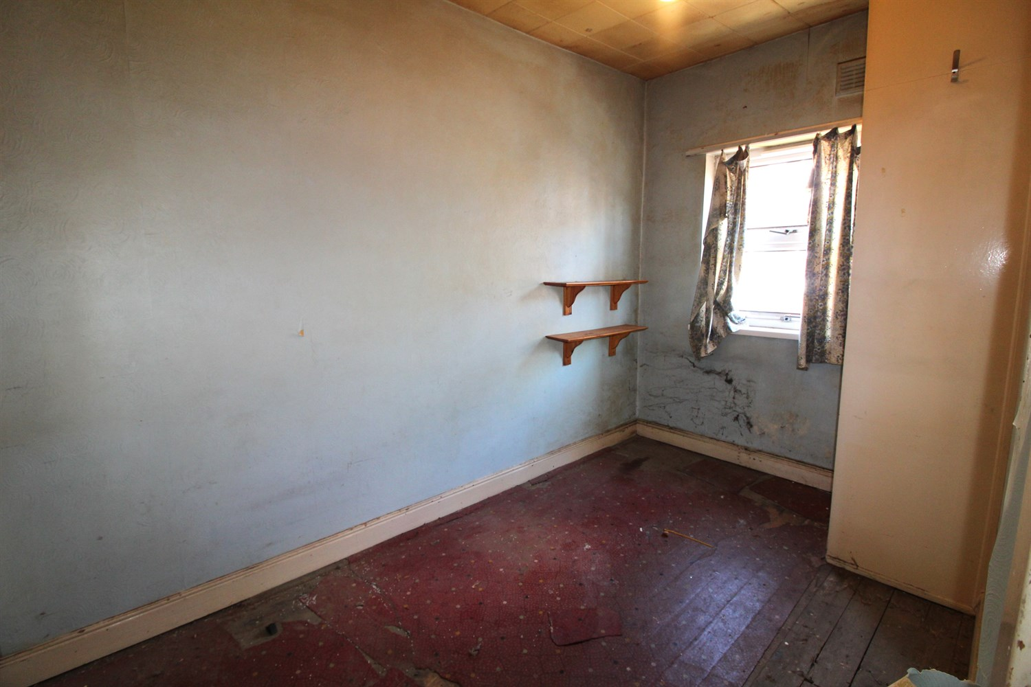

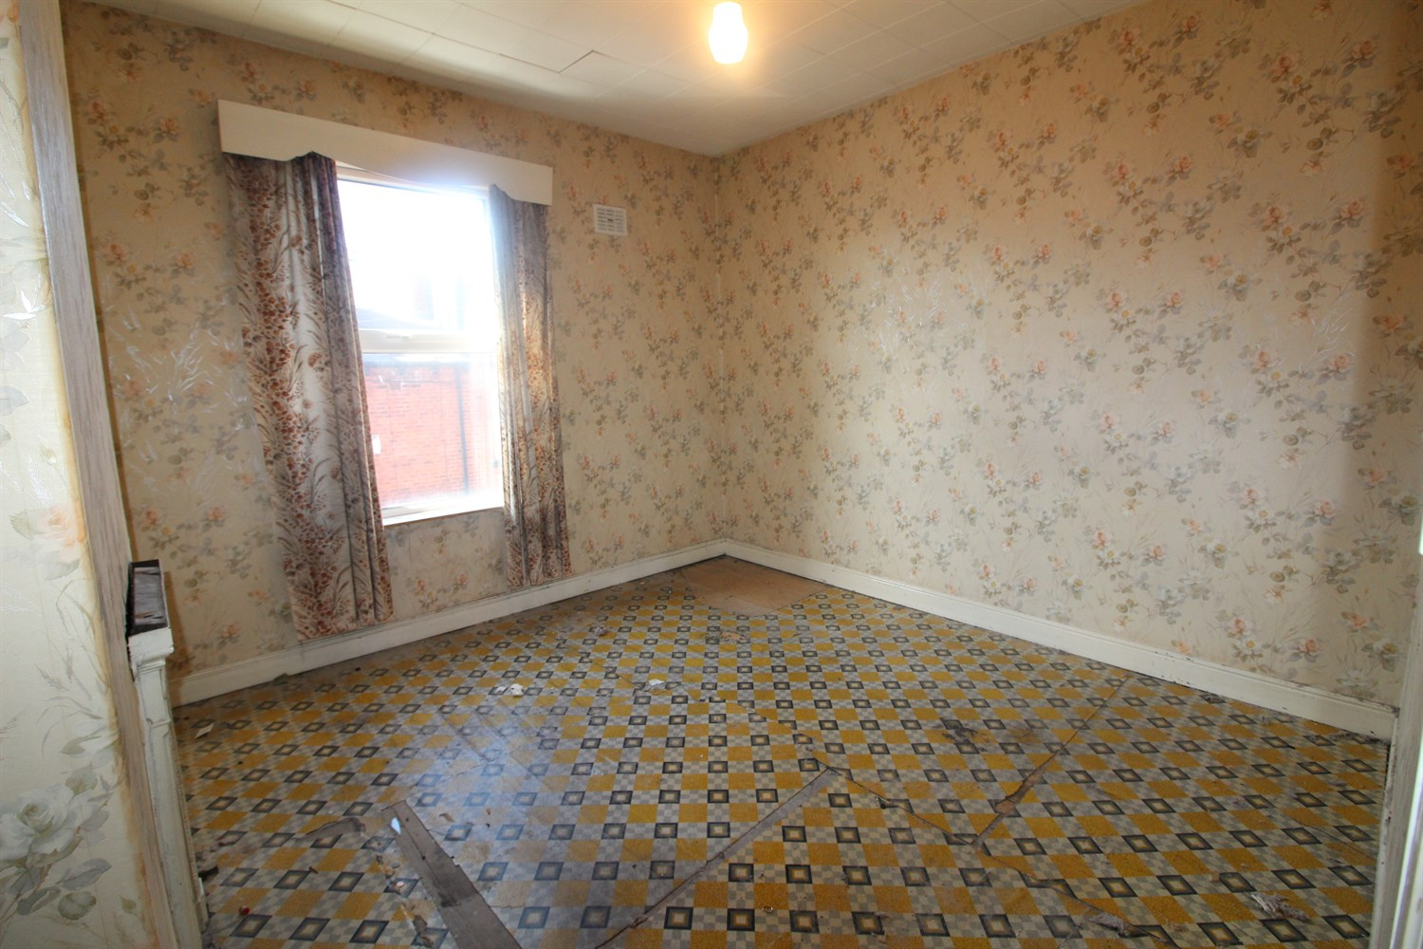

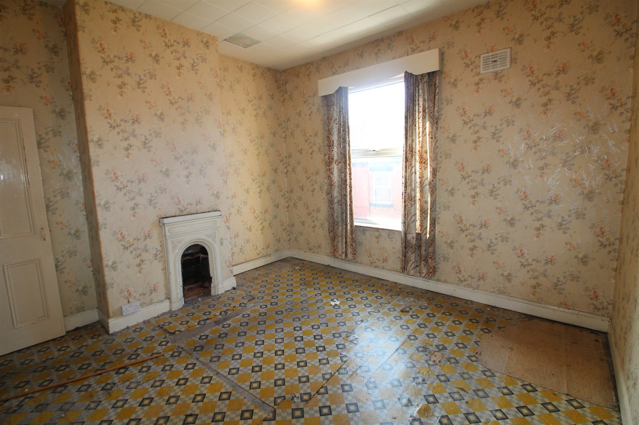

|  |
| --- |
| **Lounge 3.73m (12'3) Max x 3.58m (11'9)**  Via front entrance door. Double glazed window to front. |
| **Kitchen/Diner 3.7m (12'2) x 3.71m (12'2) Max**  Spacious kitchen/diner with double glazed window and door to rear. Store cupboard. |
| **First Floor** |
| **Bedroom 1 3.59m (11'9) x 3.75m (12'4) Max**  Double bedroom with double glazed window to front. |
| **Bedroom 2 3.18m (10'5) x 3.69m (12'1)**  Second bedroom. Built in cupboard. Double glazed window to rear. |
| **Shower Room**  Fitted with a walk in shower cubicle, WC and wash hand basin. Double glazed window. |

|  |  |
| --- | --- |
| These particulars are intended to give a fair description of the property, but their accuracy cannot be guaranteed, and they do not constitute an offer of contract. Intending purchasers must rely on their own inspection of the property. None of the above appliances/services have been tested by ourselves. We recommend purchasers arrange for a qualified person to check all appliances/services before legal commitment.  **Property Ref:** 7427  **For more information, please contact**  0113 258 1150 **|** [sales@adairpaxton.co.uk](mailto:sales@adairpaxton.co.uk) **|** www.adairpaxton.co.uk |  |