

**Pasture Parade, Chapel Allerton**

**For Sale £280,000**

**WELL PRESENTED TWO/THREE BEDROOM MID-TERRACED HOUSE IN THE HEART OF CHAPEL ALLERTON** This delightful period house sits in a sought after Chapel Allerton location and simply must be viewed to be appreciated. The property is well placed for the amenities locally, as well as access to Leeds city centre. The property is set over three floors and briefly comprises; Light and airy living room with log burning stove and fitted kitchen to the ground floor. To the first floor there is a master bedroom and house bathroom. A second double bedroom and single bedroom/office to the second floor. Externally, there is a courtyard style garden to the front that has been partly decked and paved with borders of plants and shrubs. Located in this much sought after Chapel Allerton location, with good access to local amenities including schools, shops, bars and restaurants, as well as transport links into Leeds. An early internal viewing is highly recommended.

**0113 258 1150**

**0800 000 000**

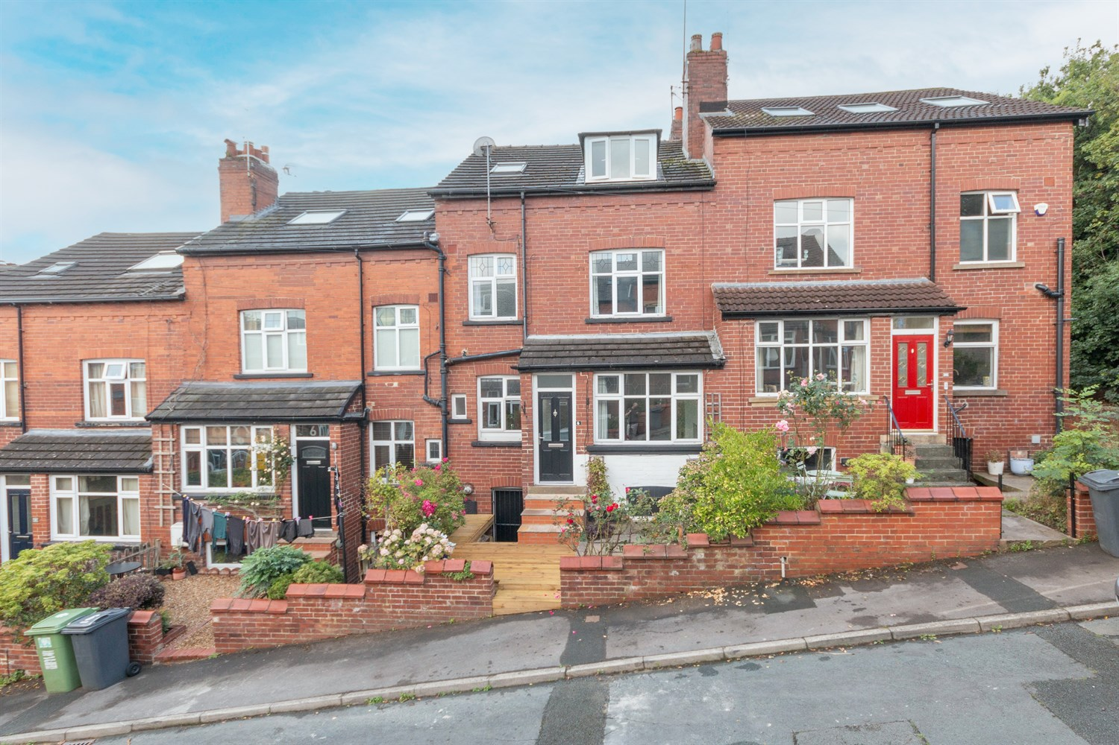



2/3 Bedrooms

1 Bathroom

1 Reception

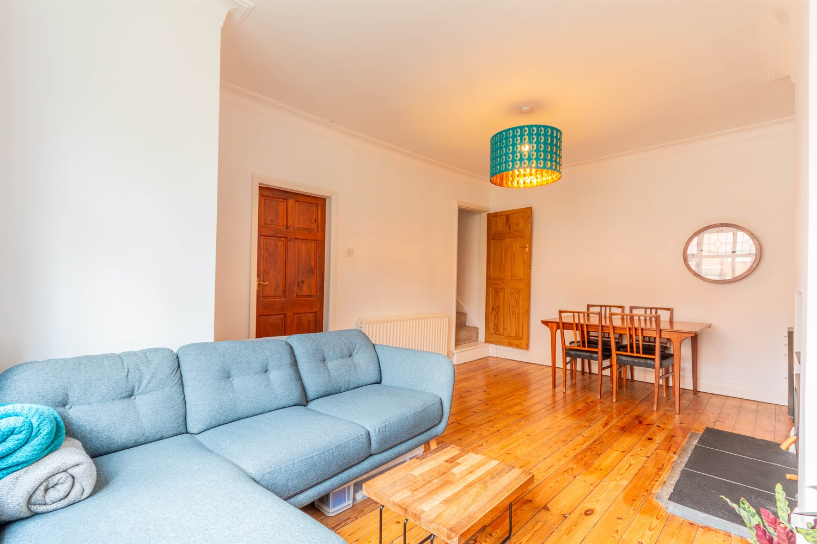

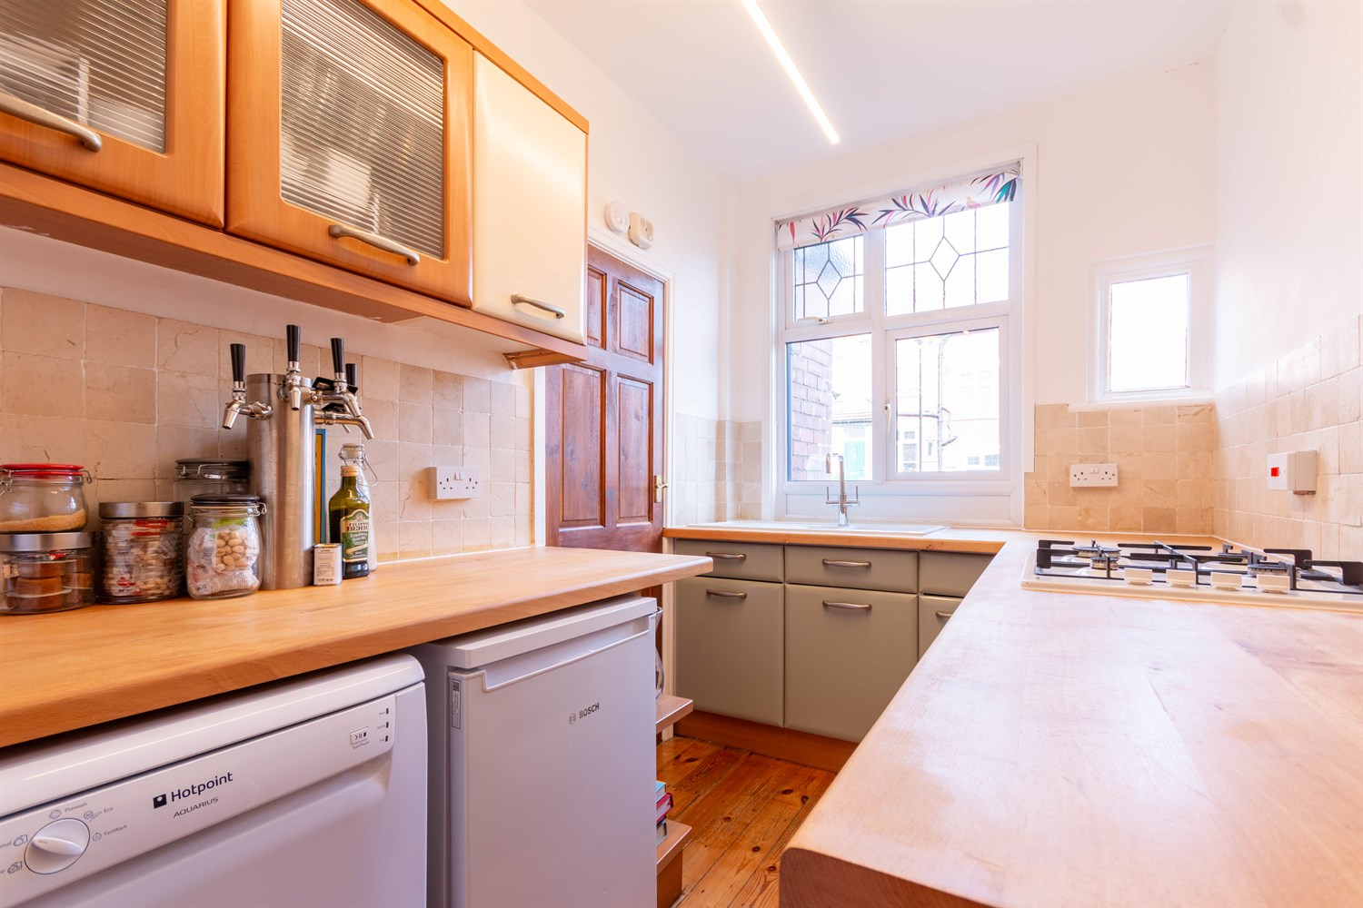

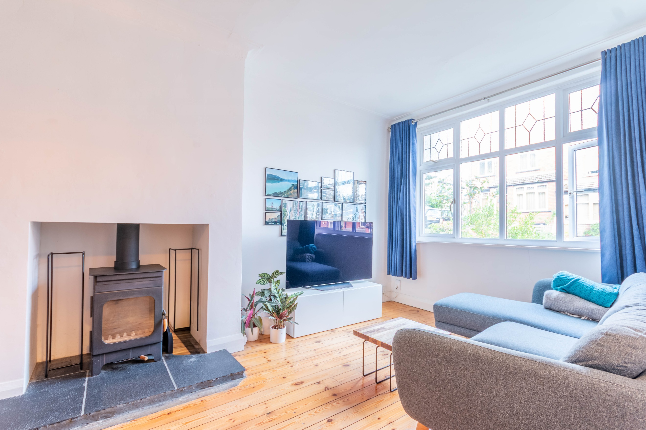

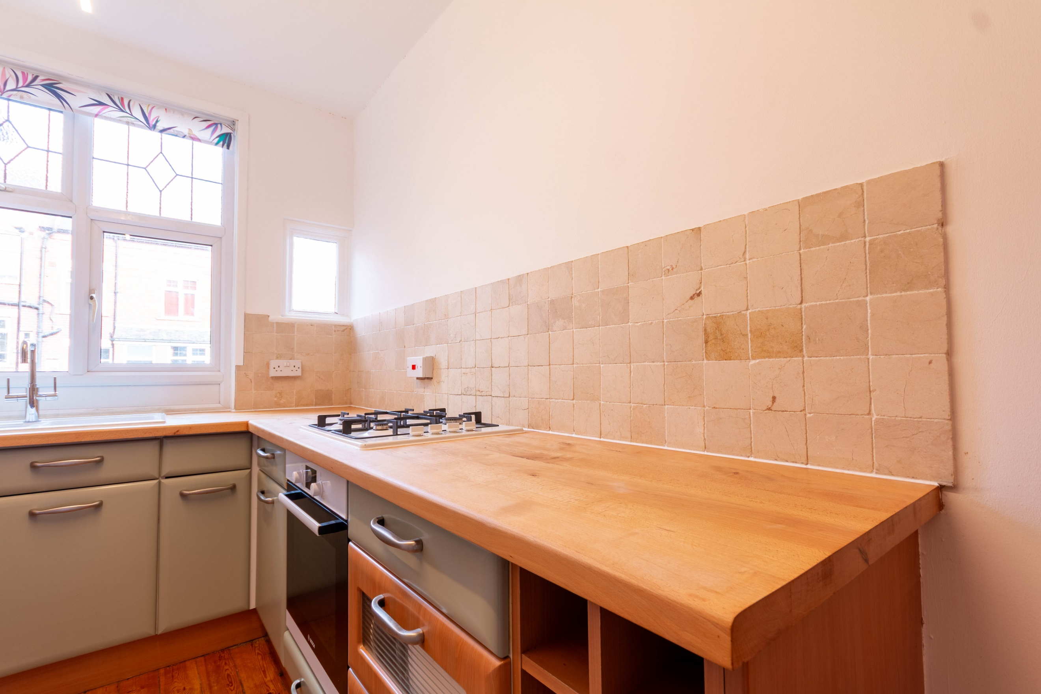

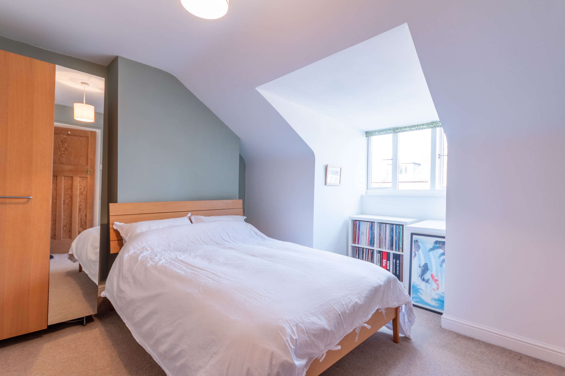

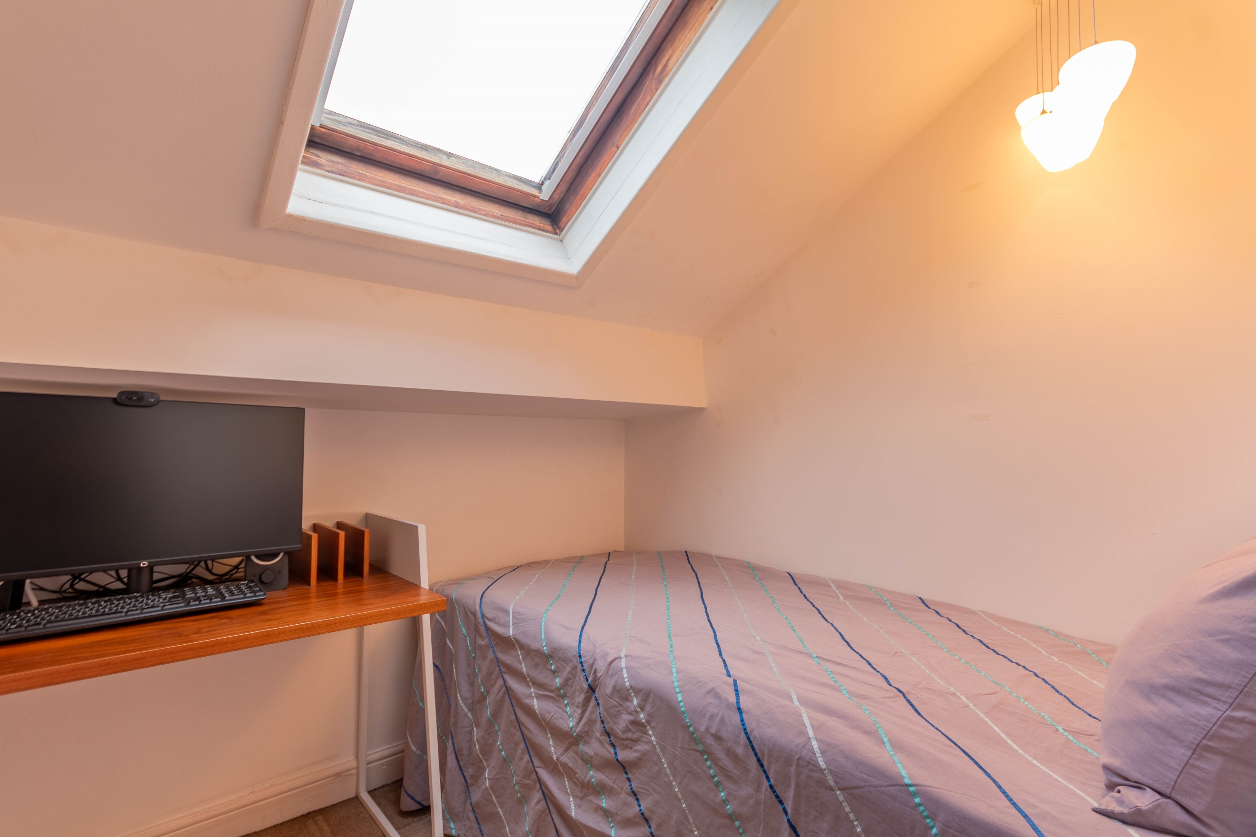

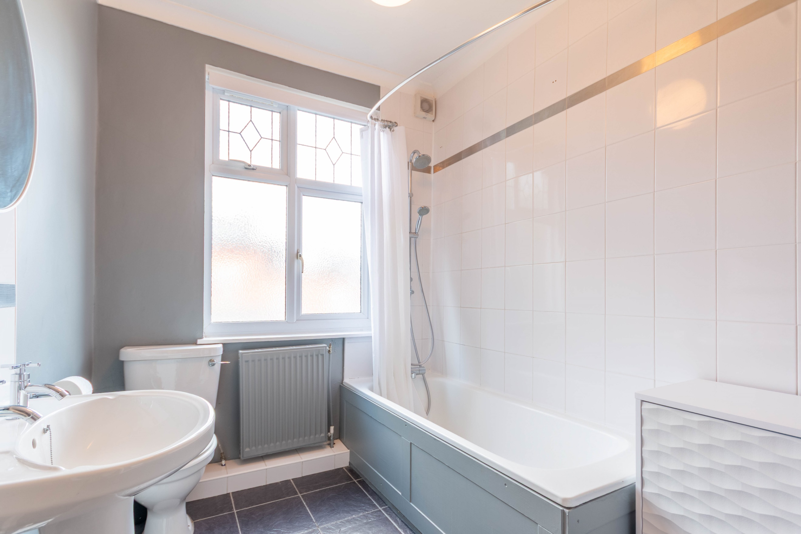

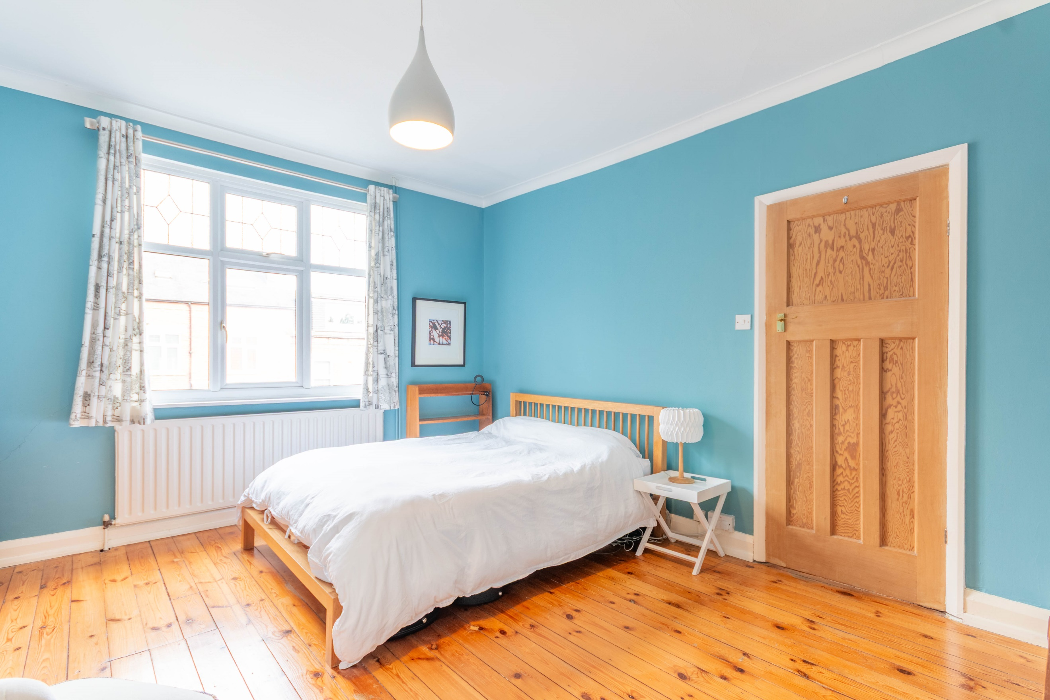

|  |
| --- |
| **Entrance Porch**  Via front entrance door. |
| **Lounge 3.68m (12'1) x 5.46m (17'11)**  Light and Airy living room with uPVC double glazed window to front. Log burning stove inset to chimney breast. Gas central heating radiator. |
| **Kitchen 2m (6'7) x 3.3m (10'10)**  Fitted with a range of wall, base and drawer units with worktops over. Space for fridge and dishwasher. Integrated electric oven with 4-ring gas hob. Part tiled walls. 1.5 bowl sink with mixer tap and drainer. uPVC double glazed window to front. Door leading to cellar.  **Cellar**  Useful storage. Door leading to front. |
| **First Floor** |
| **Master Bedroom 3.54m (11'7) x 4.24m (13'11)**  Double bedroom with uPVC double glazed window to front. Built in wardrobe. Gas central heating radiator. |
| **Bathroom**  Fitted with a three piece suite comprising; bath with shower over, WC and wash hand basin. Double glazed window to front. Gas central heating radiator. Part tiled walls and tiled floor. |
| **Second Floor** |
| **Bedroom 2 3.71m (12'2) x 4.24m (13'11)**  Second double bedroom with uPVC double glazed window to front. Gas central heating radiator. |
| **Study/Bedroom Three 1.97m (6'6) x 1.84m (6'0)**  Single bedroom/Study with Velux window. Gas central heating radiator. |
|  |
|  |

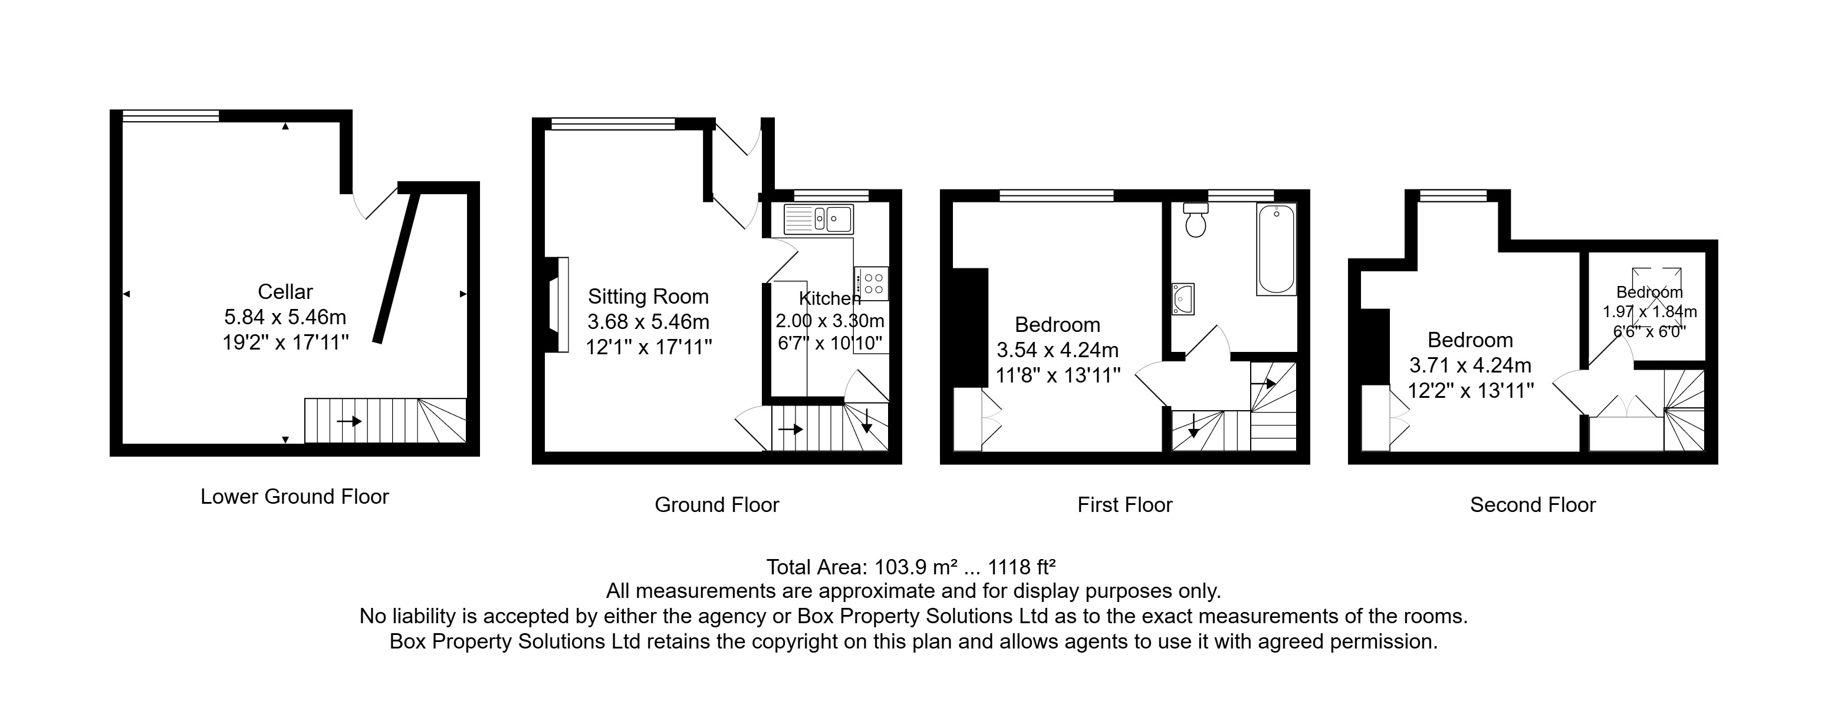

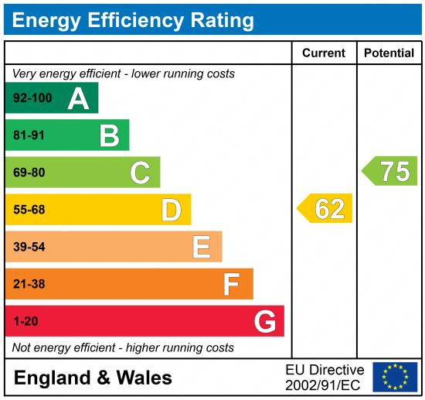

|  |
| --- |
|  |

These particulars are intended to give a fair description of the property, but their accuracy cannot be guaranteed, and they do not constitute an offer of contract. Intending purchasers must rely on their own inspection of the property. None of the above appliances/services have been tested by ourselves. We recommend purchasers arrange for a qualified person to check all appliances/services before legal commitment.

**Property Ref:** 6929

**For more information, please contact**

0113 258 1150 **|** [sales@adairpaxton.co.uk](mailto:sales@adairpaxton.co.uk) **|** www.adairpaxton.co.uk