

**0113 258 1150**

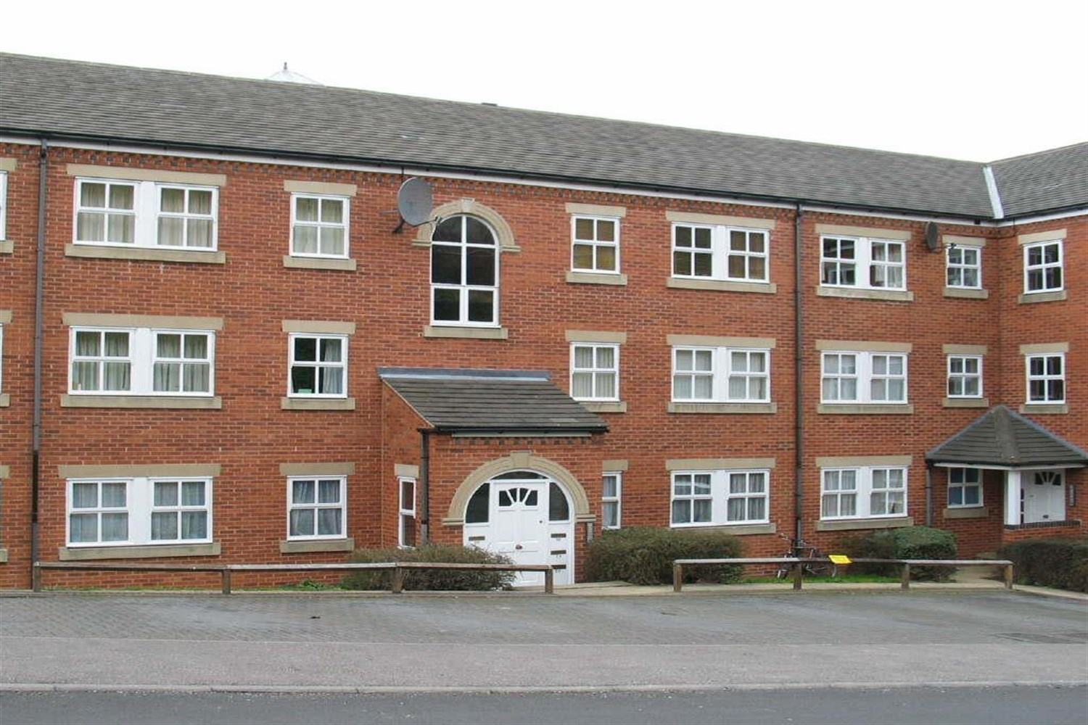



**Available to let £825.00pcm**

**The Cricketers, LS5**

Located close to Headingley Railway Station and within easy reach of local amenities is this well presented first floor apartment. Having a neutral modern interior, electric heating, sealed unit double glazing and security telephone intercom. The property briefly comprises of: Entrance Hall with useful storage, Spacious Lounge, Kitchen with white goods, Two good size bedrooms, Bathroom with electric shower over bath, well maintained communal grounds and allocated on-site parking. Council Tax Band B ECP Rating B. UNFURNISHED (Some white goods only). Deposit £950. Available 24th March.

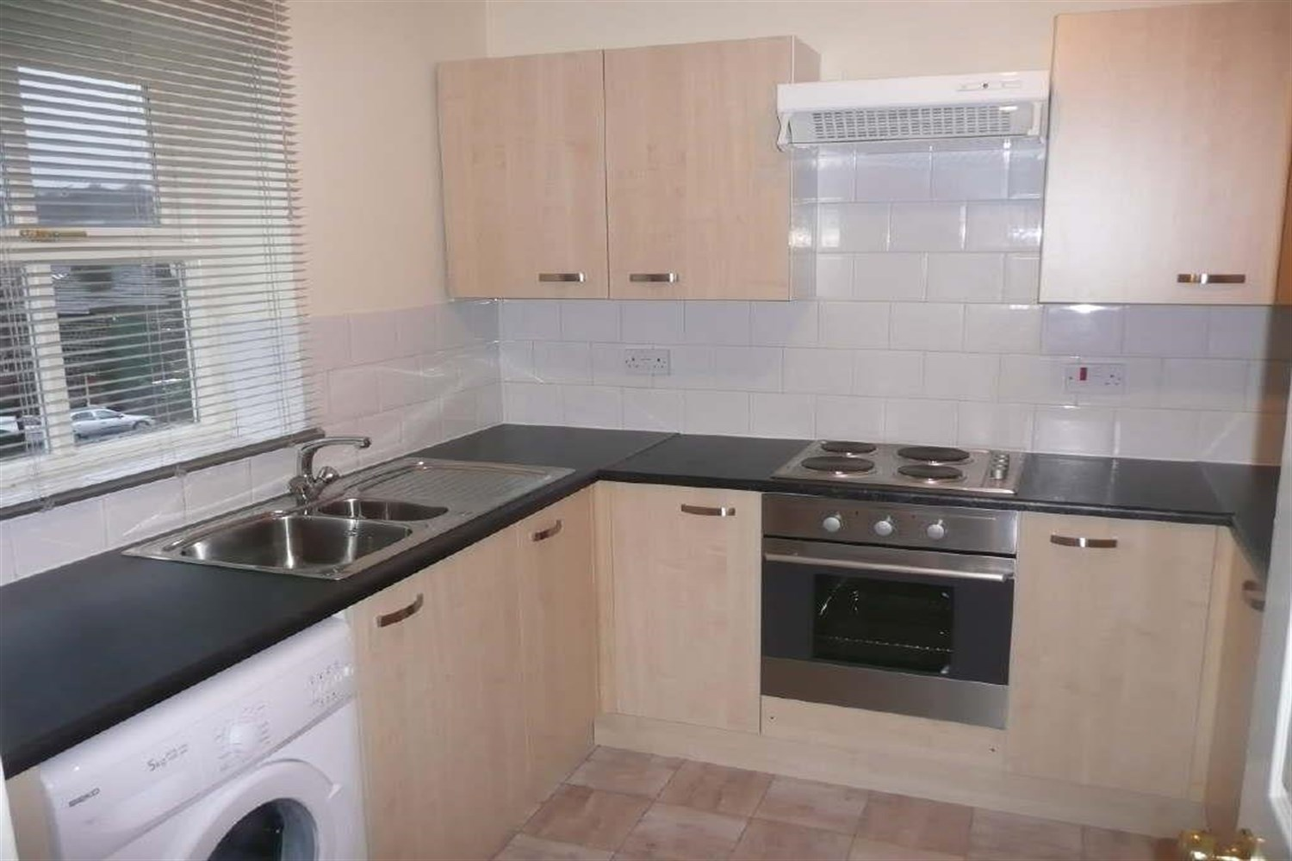

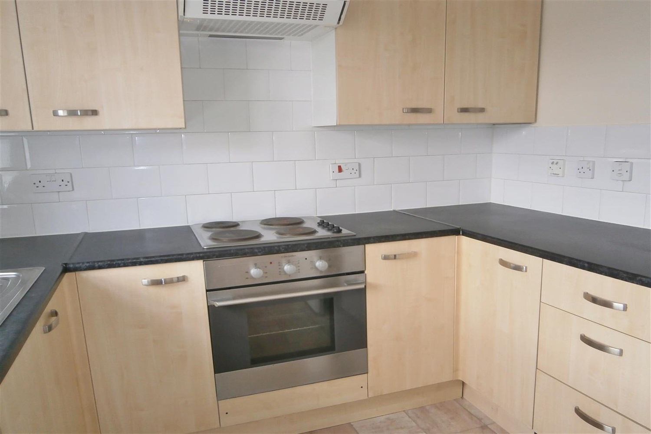

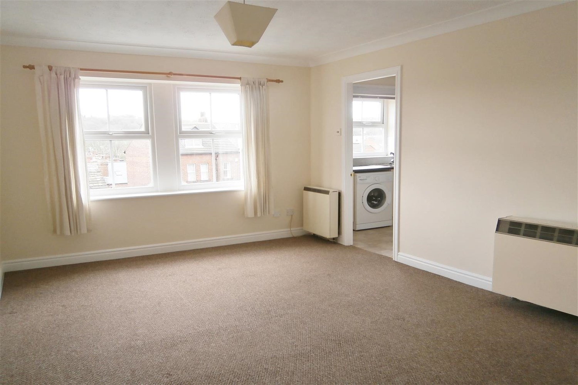

1 Bathroom(s)

1 Reception(s)

2 Bedroom(s)

00

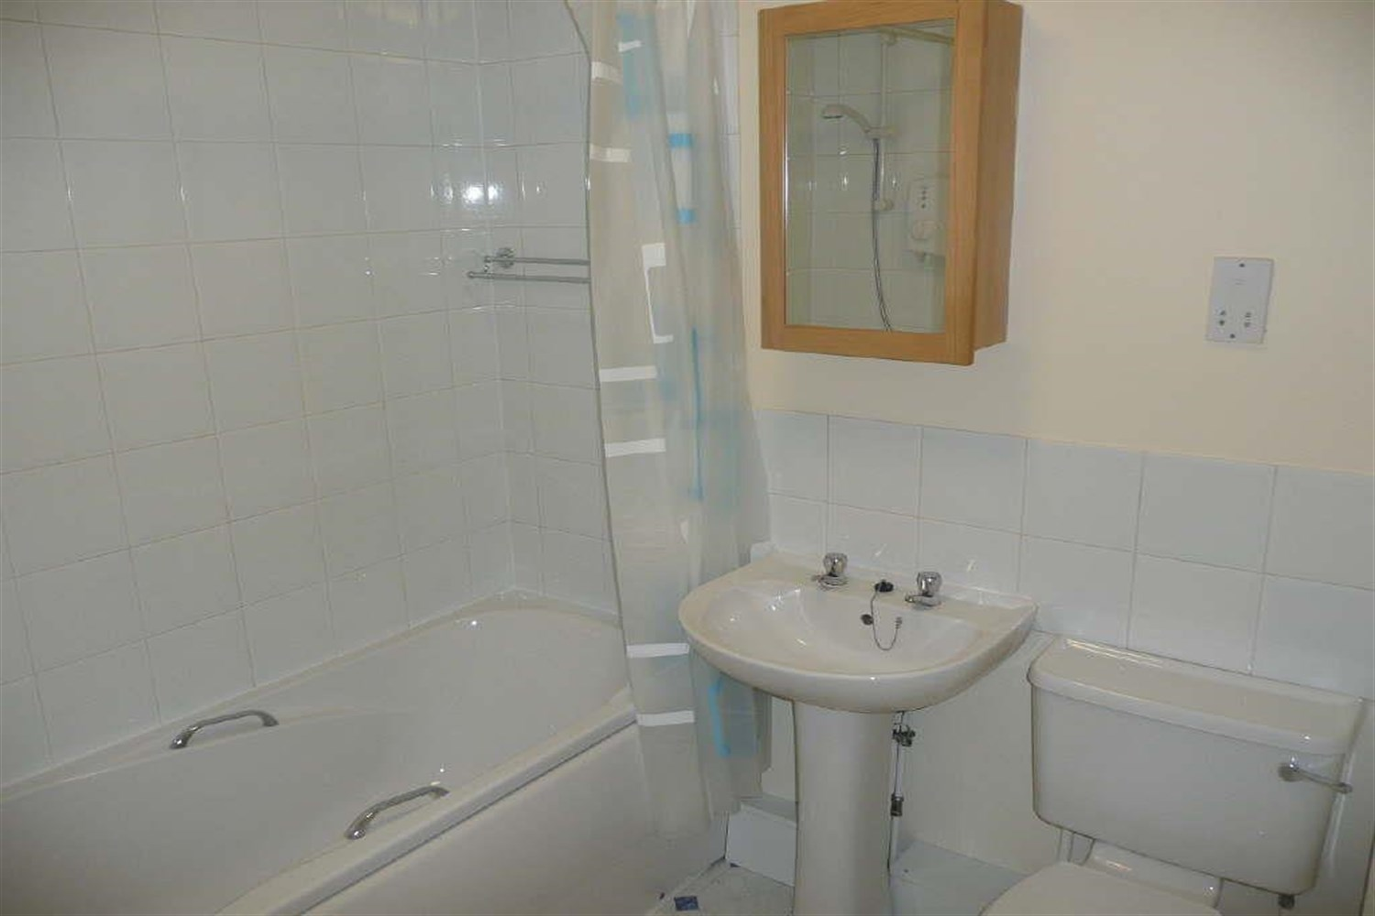

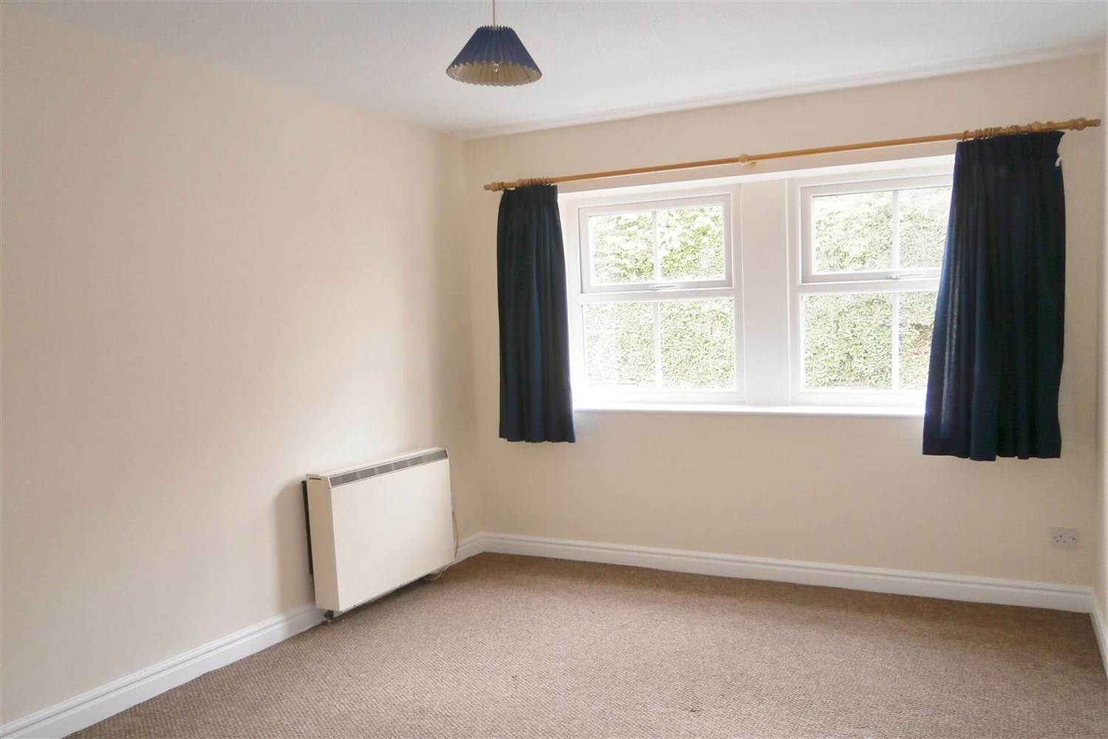

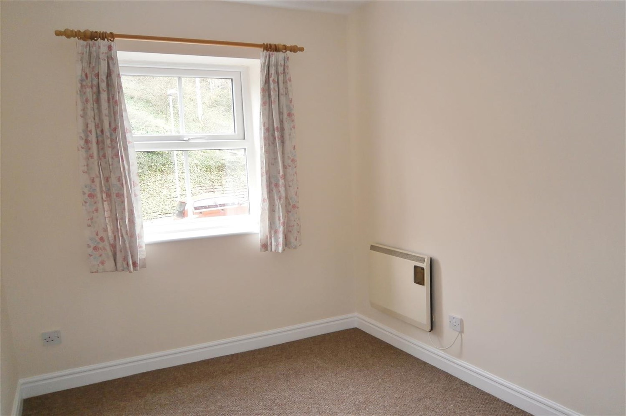

|  |
| --- |
| **Living Room**  Spacious lounge with window to rear, electric wall heater, door to kitchen. |
| **Kitchen**  Fitted with a range of wall base units with worktops over, stainless steel sink with mixer tap, electric oven and hob with extractor over head. |
| **Bedroom**  Carpeted double bedroom with window to front, electric wall heater. |
| **Bedroom 2**  Carpeted bedroom with window to front, electric wall heater. |
| **Bathroom**  Three piece bathroom suite with shower over bath, w/c and hand wash basin, Part tiled walls. |
| **Home Information**  COUNCIL TAX BAND: B EPC Rating B  Leasehold property Parking included Broadband: Standard 15 Mbps 1 Mbps Good Superfast 60 Mbps 14 Mbps Good Ultrafast 1000 Mbps 1000 Mbps  Mobile availability: EE limited coverage. Three likely to have good coverage. O2 likely to have good coverage. Vodafone likely to have good coverage.  Utilities: Water supplied on standard meters. Electric mains supplied on standard meters. |

|  |  |
| --- | --- |
| These particulars are intended to give a fair description of the property, but their accuracy cannot be guaranteed, and they do not constitute an offer of contract. Intending purchasers must rely on their own inspection of the property. None of the above appliances/services have been tested by ourselves. We recommend purchasers arrange for a qualified person to check all appliances/services before legal commitment.  **Property Ref:** 5291  **For more information, please contact**  0113 258 1150 **|** [lettings@adairpaxton.co.uk](mailto:lettings@adairpaxton.co.uk) **|** www.adairpaxton.co.uk |  |