

**0113 258 1150**

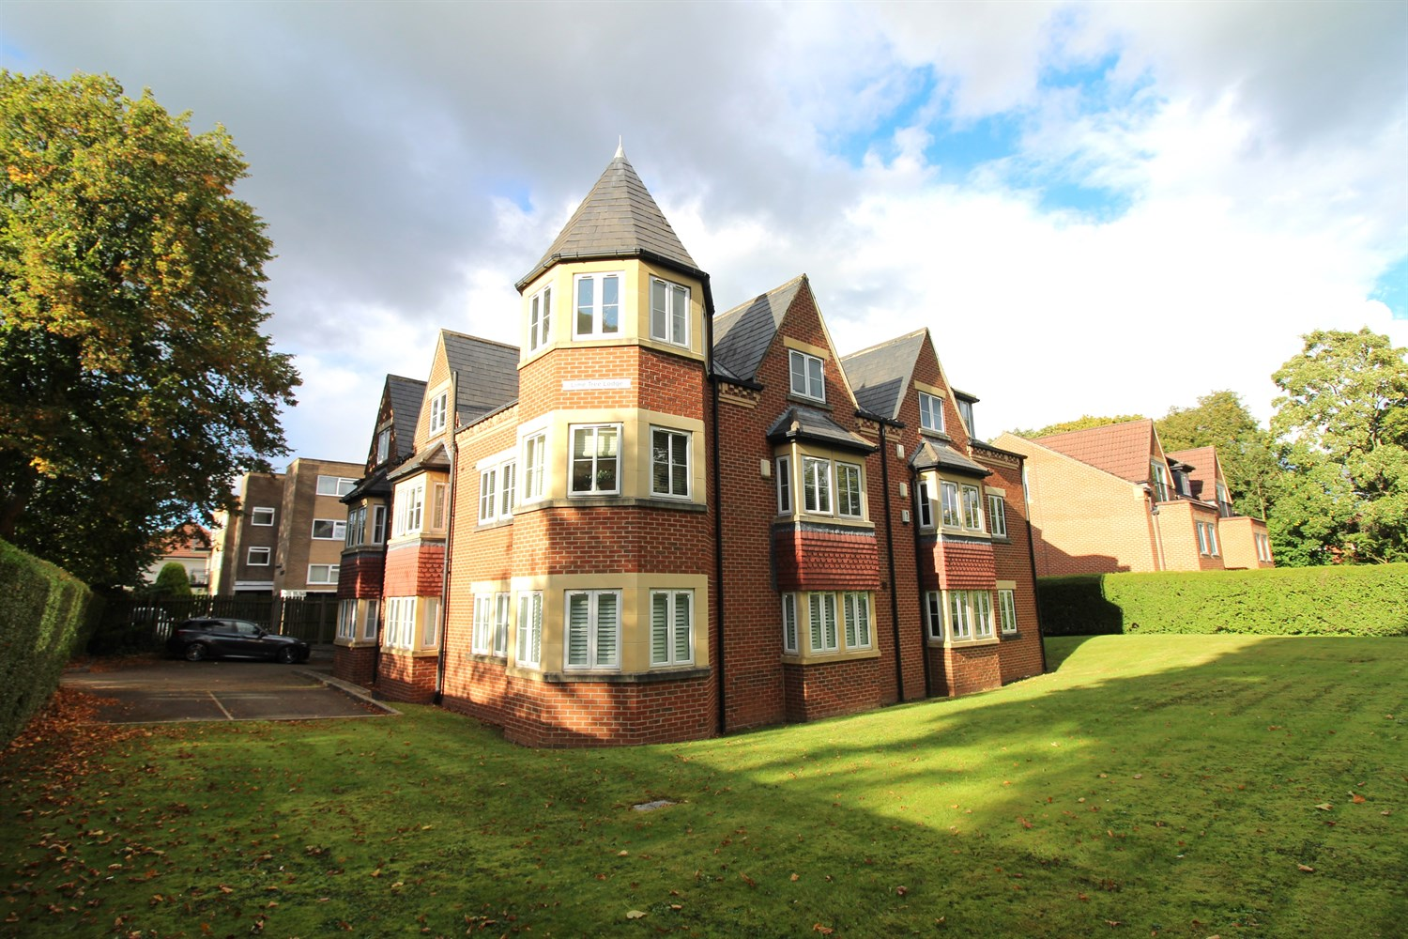



**Available Arranging tenancy £995.00pcm**

**Lime Tree Lodge, Street Lane**

***MODERN TWO BEDROOM, TWO BATHROOM FIRST FLOOR APARTMENT WITH PARKING*** The property is located in a prime position on Street Lane between Roundhay Park and Moortown Corner, close to shops, bars and restaurants in this popular suburb of Leeds. Comprising; Entrance hallway, spacious open plan kitchen/lounge, master bedroom with en-suite shower room, second double bedroom and house bathroom. Off street parking. Unfurnished. Council tax band C. Bond £1125. Available 24th October 2025.

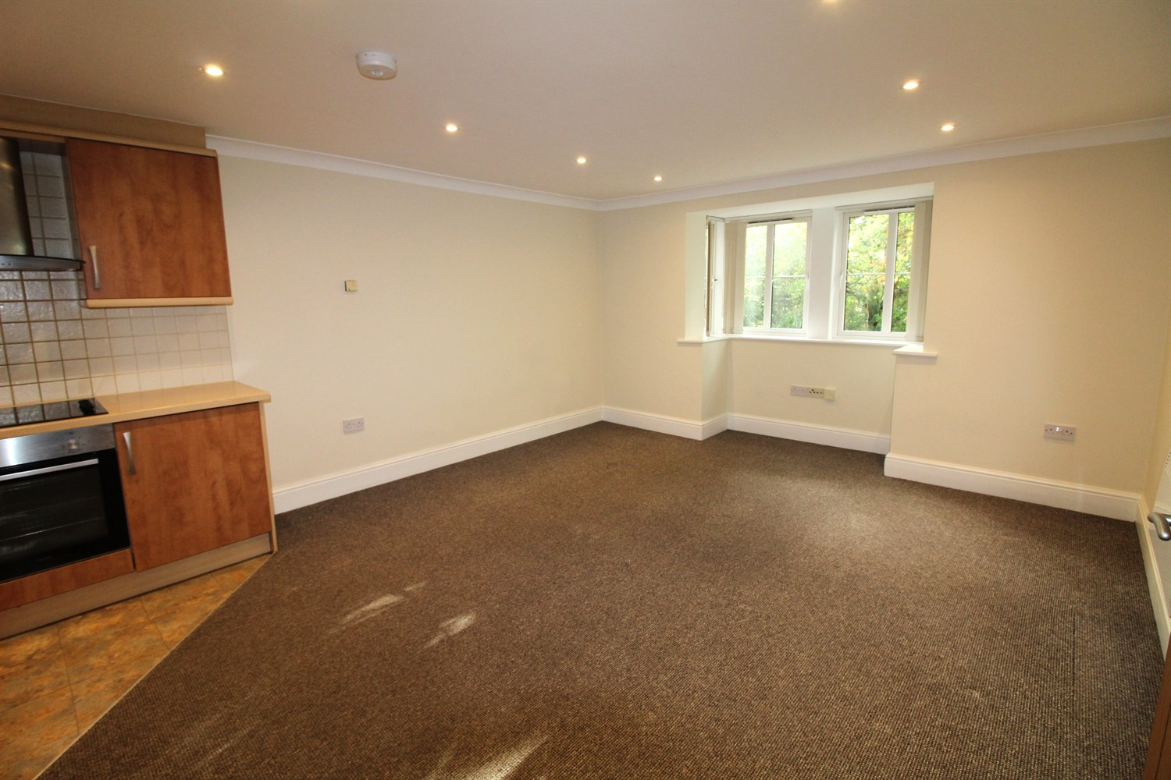

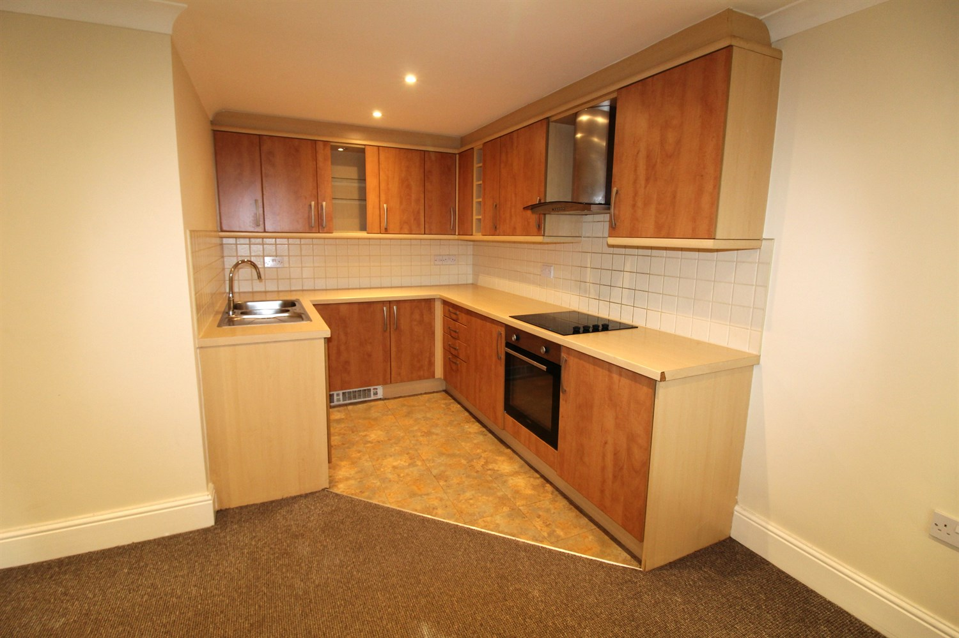

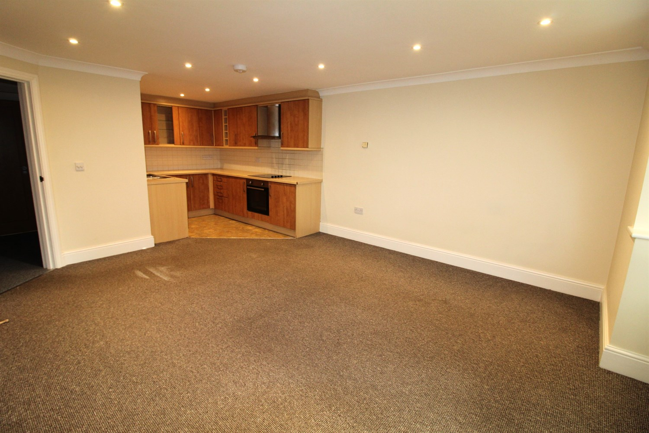

2 Bathroom(s)

0 Reception(s)

2 Bedroom(s)

00

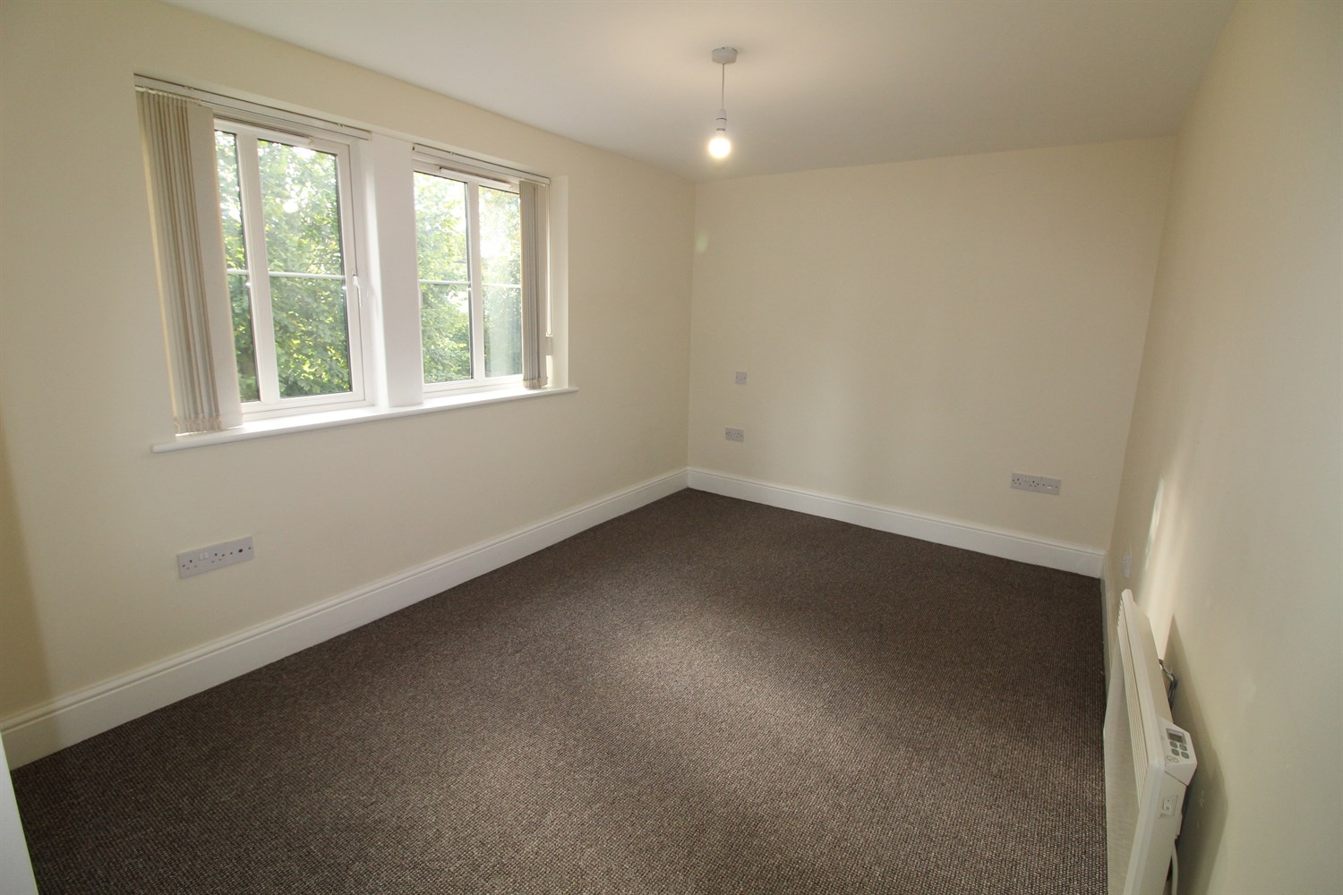

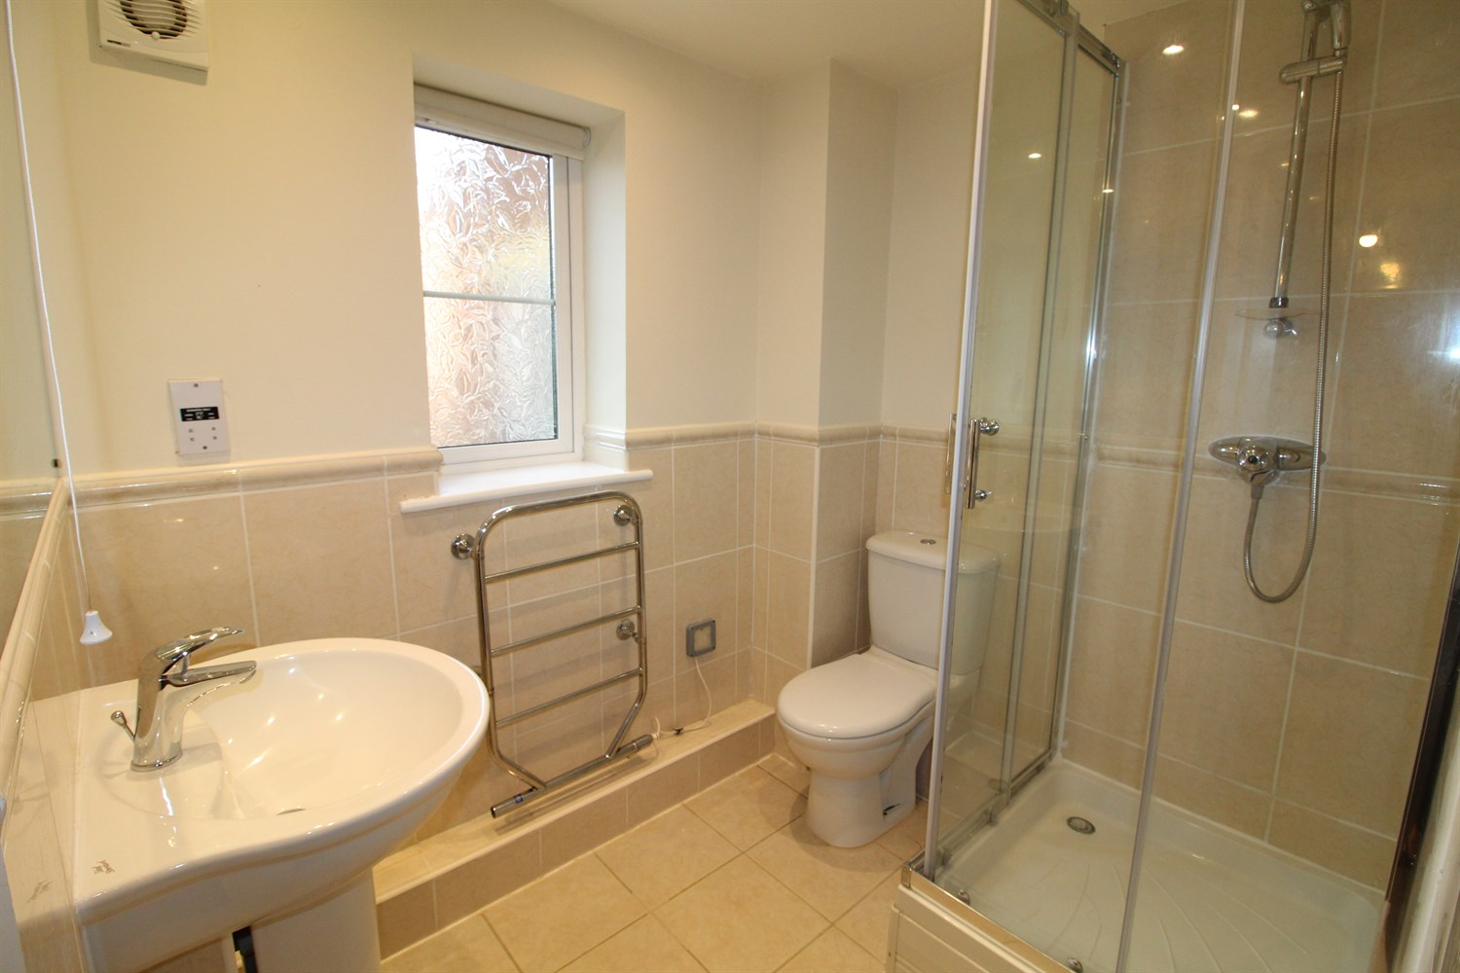

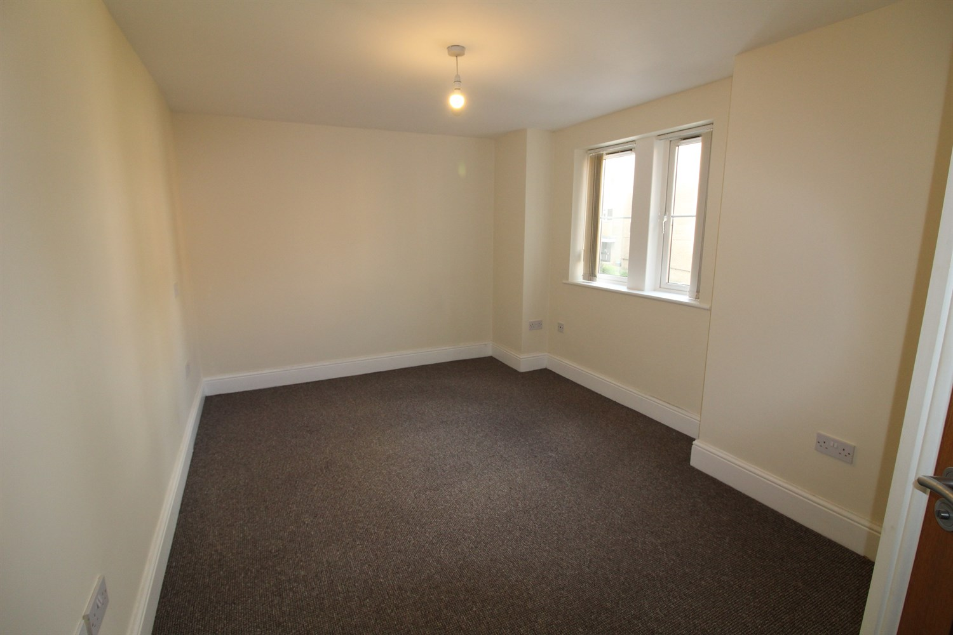

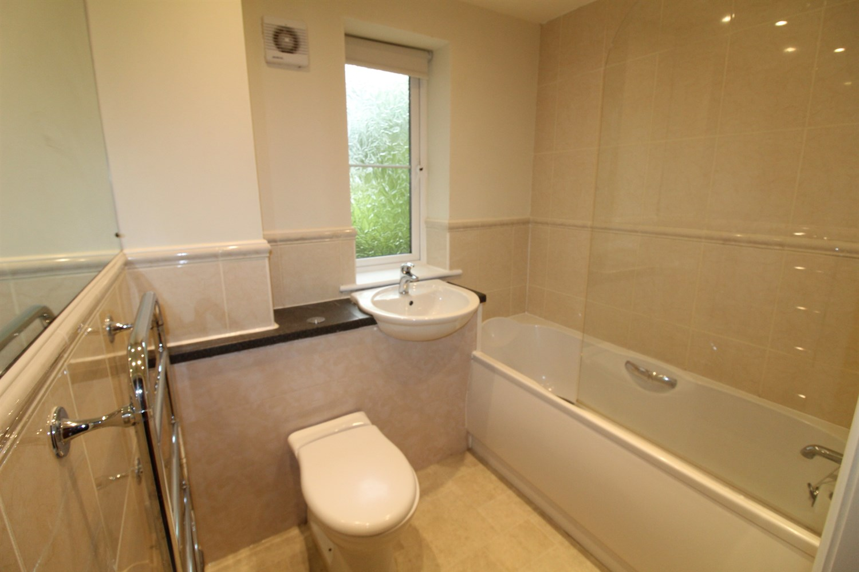

|  |
| --- |
| **Communal Hallway**  Via stairs to the first floor |
| **Hallway**  Via front entrance door. Storage cupboard. |
| **Open Plan Living Room/Kitchen 7.07m (23'2) x 4.1m (13'5)**  Spacious living area with double glazed bay window. Wall mounted electric radiator. Opening to a fitted kitchen with a range of wall, base and drawer units with worktops over. Integrated oven with hob and extractor hood over. Integrated dishwasher, fridge and washing machine. Stainless steel sink with mixer tap and drainer. Part tiled walls. |
| **Bedroom 1 5.07m (16'8) max x 2.7m (8'10)**  Double bedroom with double glazed window. Wall mounted electric radiator. |
| **En-Suite Shower Room**  Fitted with a three piece suite comprising; shower cubicle, WC and wash hand basin. |
| **Bedroom 2 5.14m (16'10) x 3.52m (11'7)**  Second double bedroom with double glazed window. Wall mounted electric radiator. |
| **Bathroom**  Fitted with a three piece suite comprising; bath with shower over, WC and wash hand basin. |
| **Holding Fee**  Please note, a holding fee of £225 will be payable upon application and will form part of the first month rent. |
| COUNCIL TAX BAND: C EPC Rating: C  Leasehold property Off Street parking for one vehicle  Mobile availability: EE: Limited Three: Likely O2: Likely Vodafone: likely Broadband:  Standard 16 Mbps 1 Mbps  Superfast --80 Mbps 20 Mbps Ultrafast N/A  Electric mains supply, gas on mains supply, water on mains supply. |

|  |  |
| --- | --- |
| These particulars are intended to give a fair description of the property, but their accuracy cannot be guaranteed, and they do not constitute an offer of contract. Intending purchasers must rely on their own inspection of the property. None of the above appliances/services have been tested by ourselves. We recommend purchasers arrange for a qualified person to check all appliances/services before legal commitment.  **Property Ref:** 3744  **For more information, please contact**  0113 258 1150 **|** [lettings@adairpaxton.co.uk](mailto:lettings@adairpaxton.co.uk) **|** www.adairpaxton.co.uk |  |