
Yarm Cottage, Holywell Lane, Shadwell
For Sale £495,000.00

***SPACIOUS FOUR BEDROOM FAMILY HOME IN THE HEART OF SHADWELL VILLAGE - NO ONWARD CHAIN*** Adair Paxton are delighted to offer this four bedroom house situated in the most sought after village of Shadwell, North Leeds. The property has beautiful gardens to the front and rear. Single Garage and ample off street parking. The property is now in need of some cosmetic updating and briefly comprises; Entrance porch, spacious dining kitchen with utility/store room, sitting room and lounge to the ground floor. To the first floor there are four double bedrooms and a house bathroom. Shadwell is a highly desirable village, located right on the northern fringe of Leeds and set within attractive open countryside. It benefits from excellent amenities including a post office, pub and local independent shops. The primary school is first rate, and Leeds centre is easily accessible.
0113 258 1150
0800 000 000
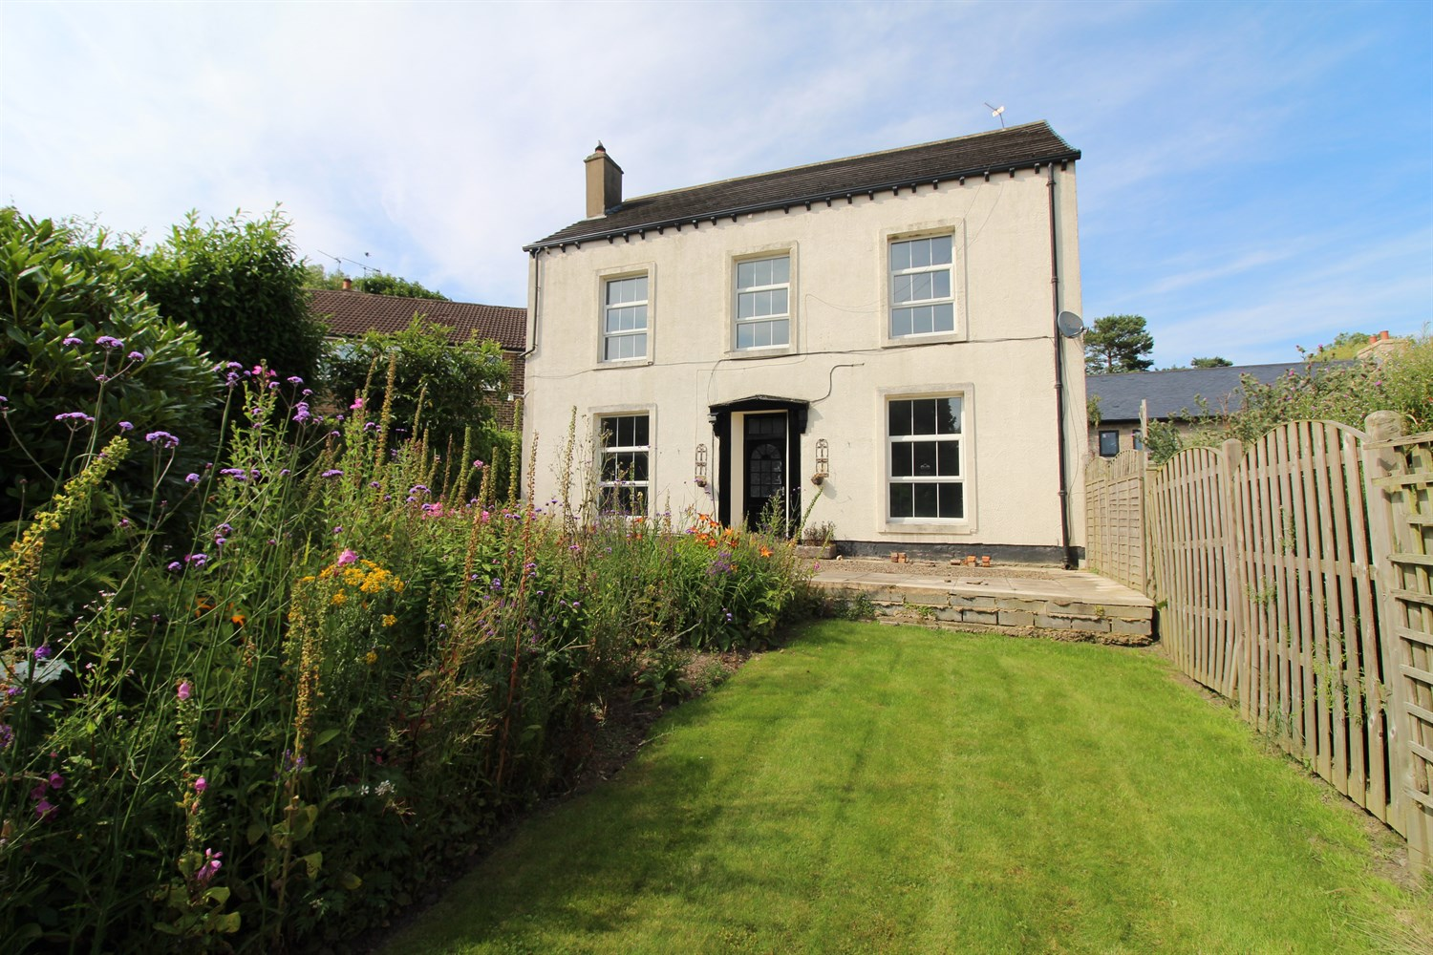
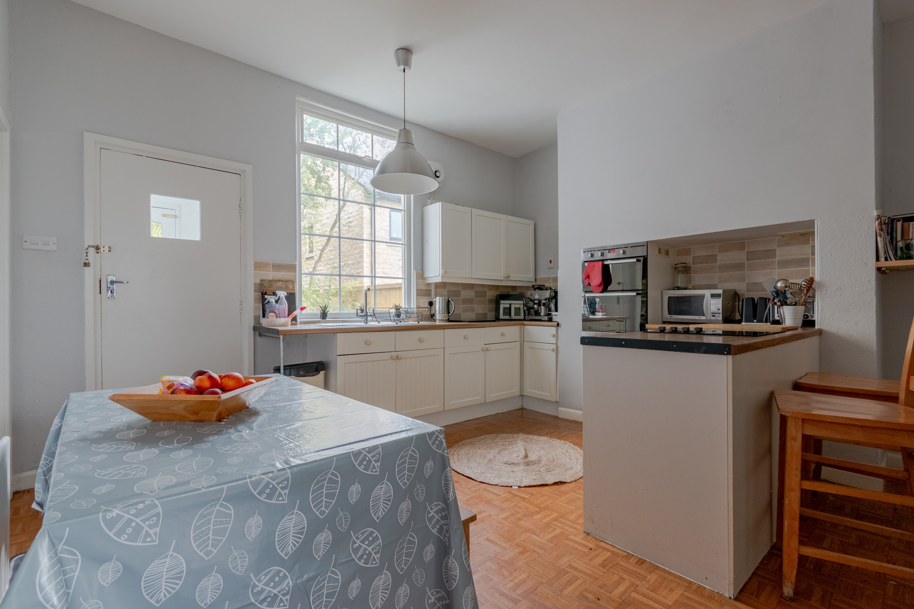
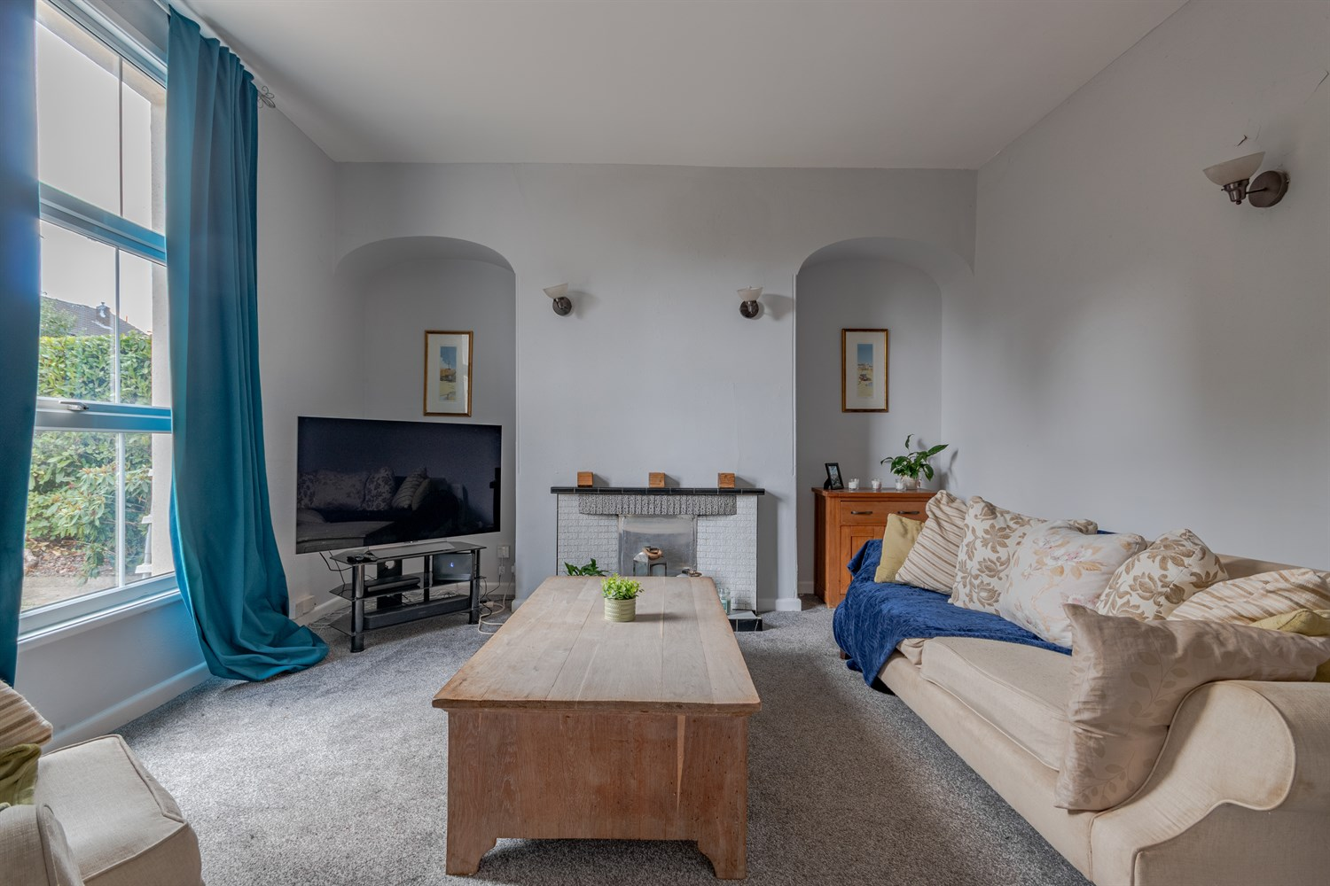
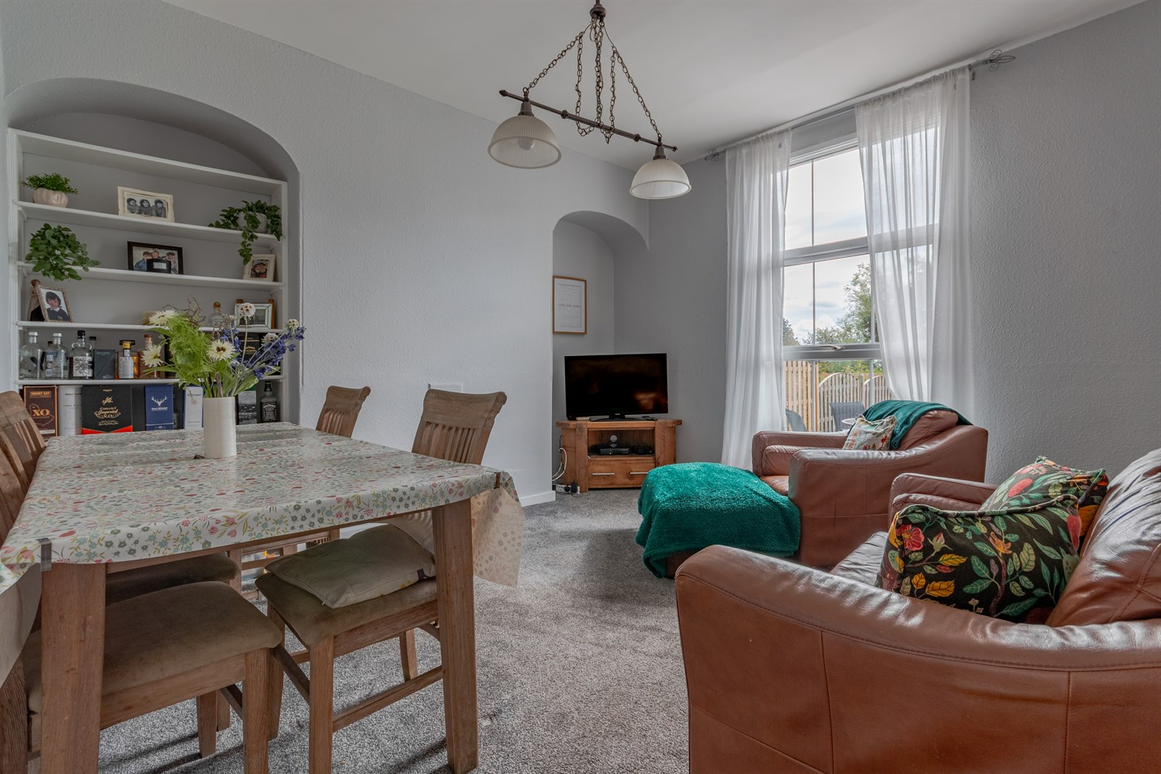
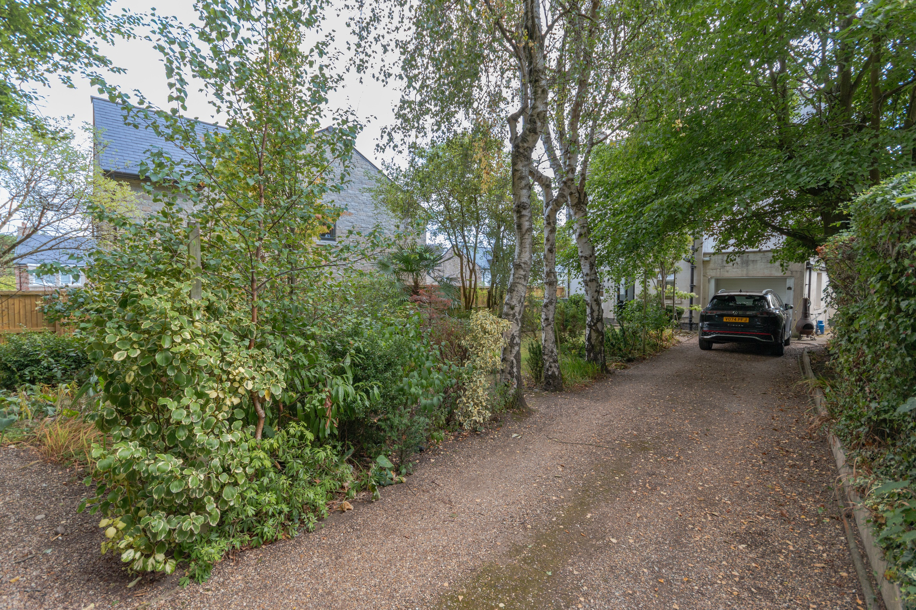
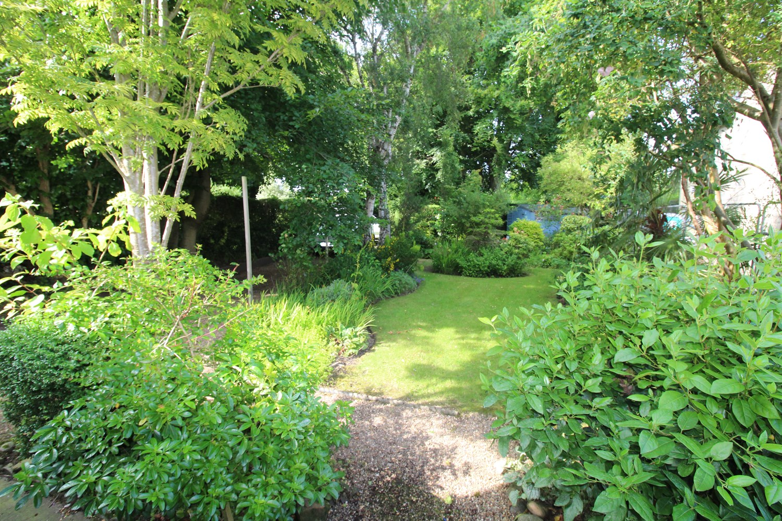
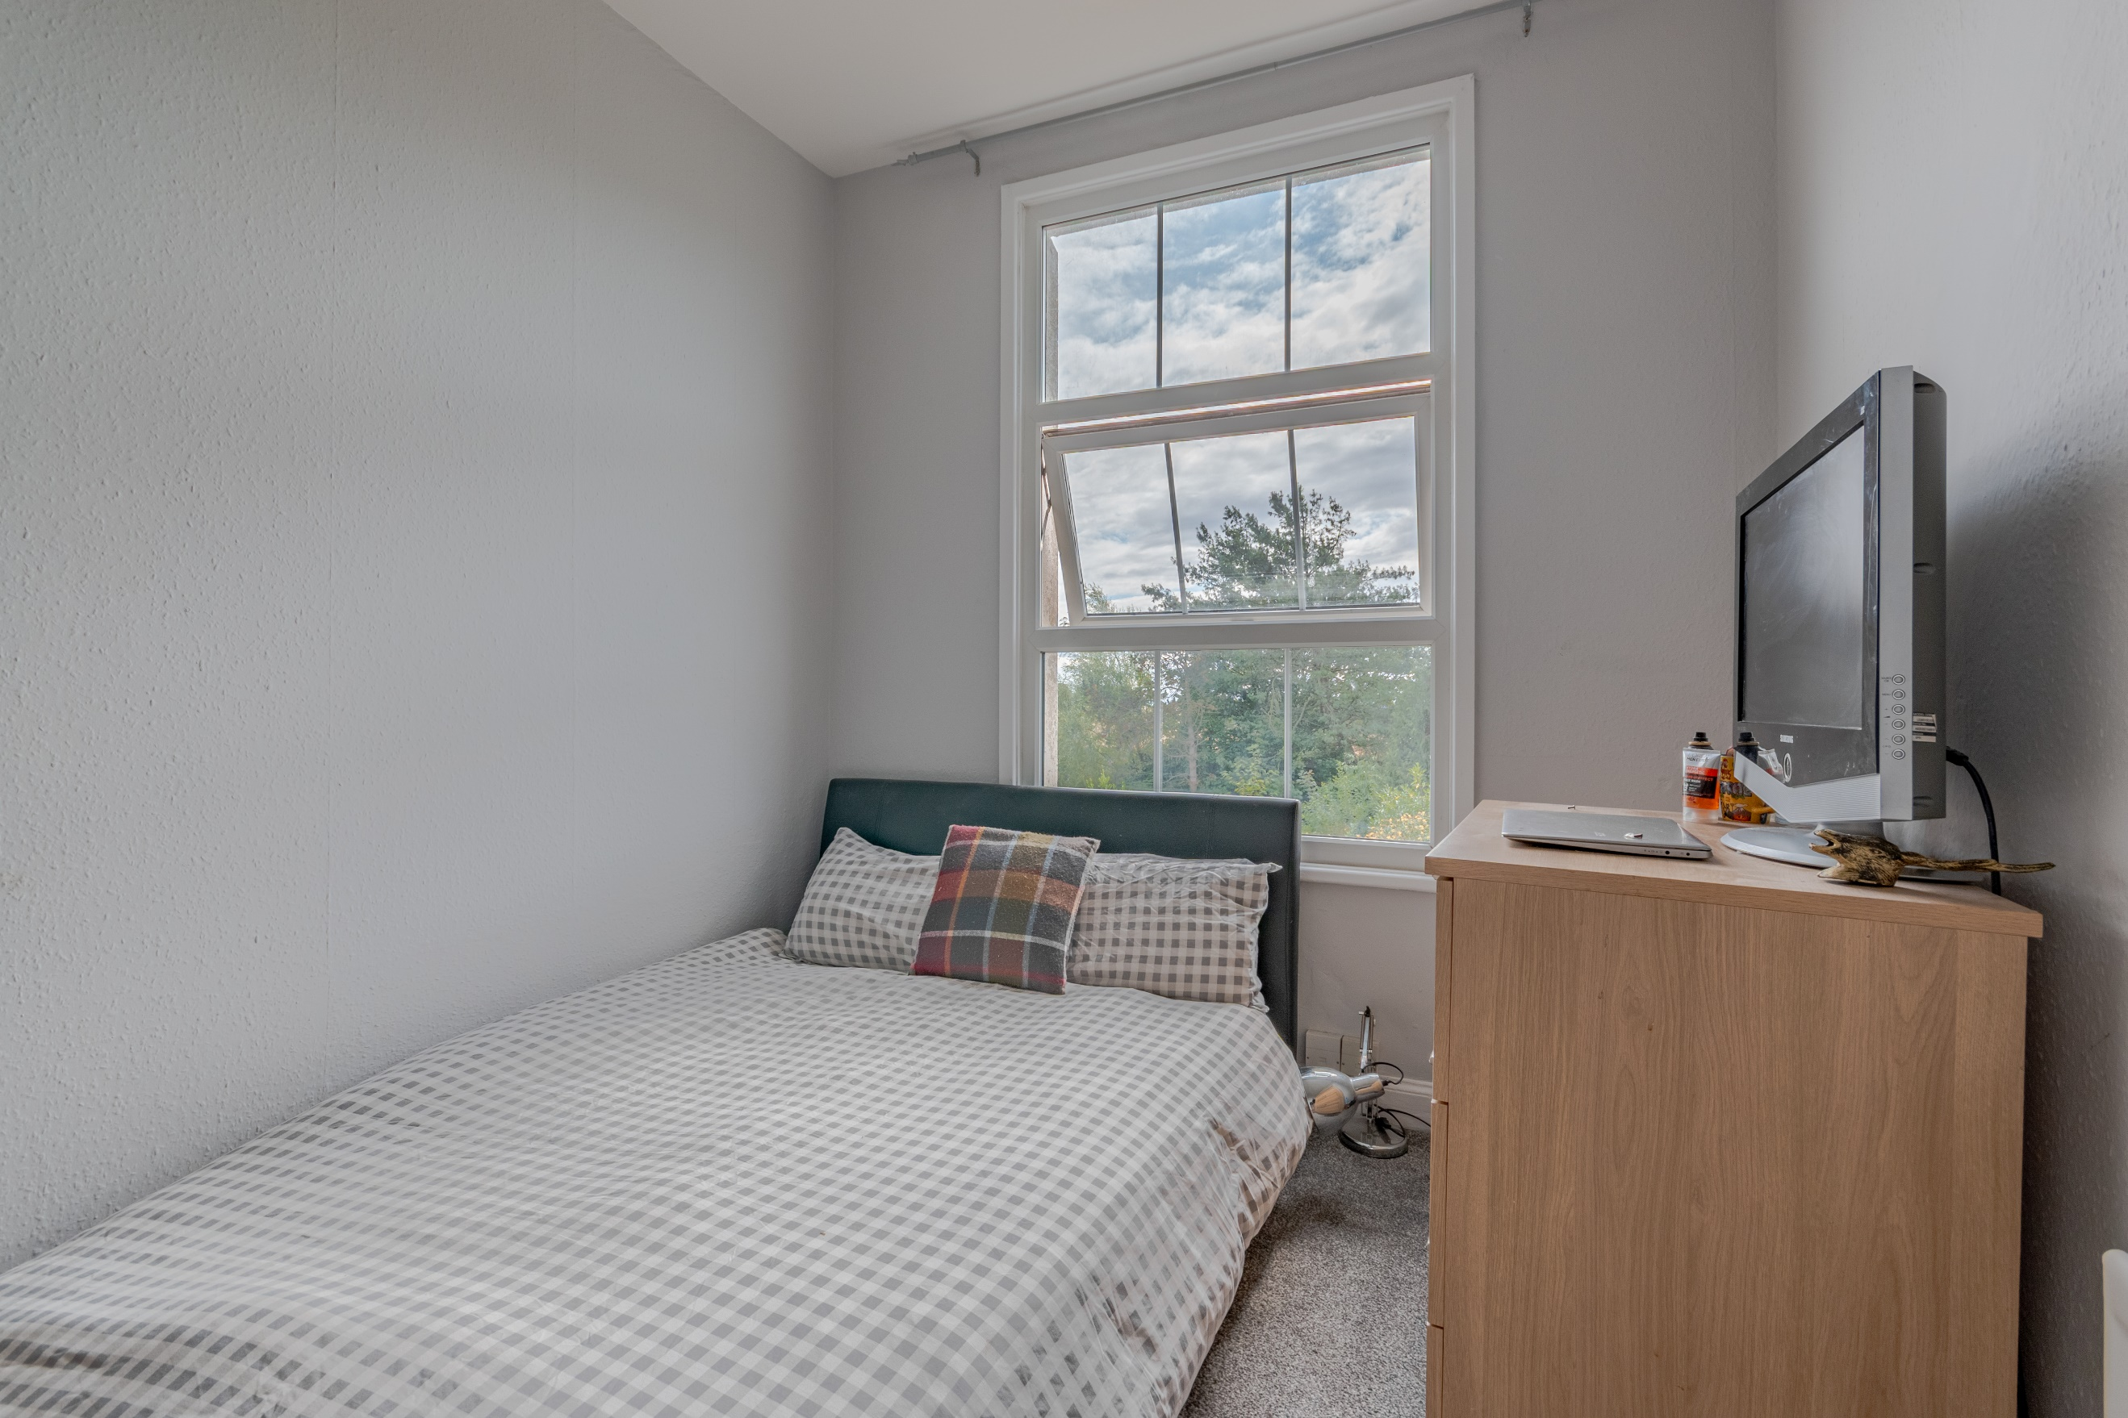
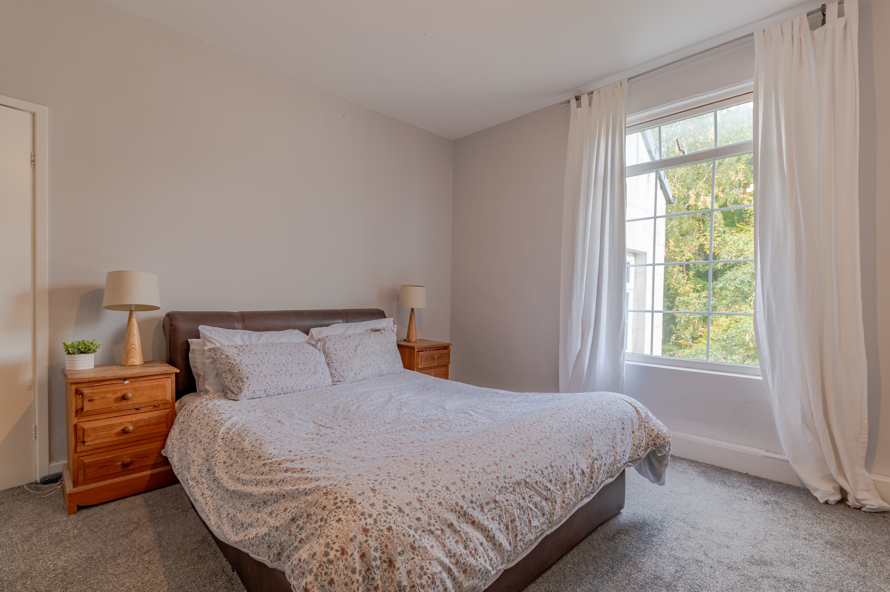
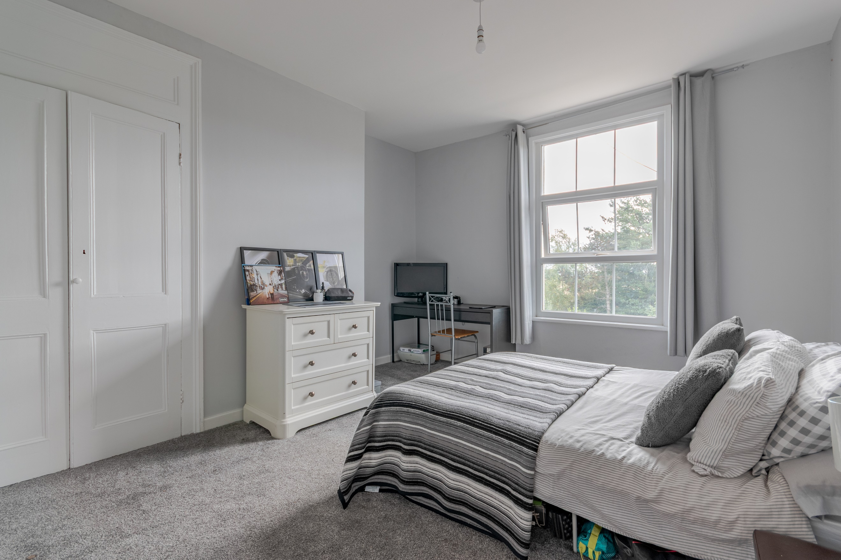

Entrance Porch
Via front entrance door.

Kitchen/Diner 4.34m (14'3) x 4.3m (14'1)
Fitted with a range of wall, base and drawer units with worktops over. Integrated oven. 4-ring hob. Stainless steel sink with mixer tap and drainer. Window to front. Part tiled walls. Gas central heating radiator.

Utility/Store Room
Plumbed for washing machine. Window to front.

Dining Room 4.34m (14'3) x 4.32m (14'2)
Great sized reception room with double glazed window looking out to the rear garden. Gas central heating radiator.

Sitting Room 4.37m (14'4) x 4.32m (14'2)
Second good sized reception room with double glazed window looking out to the rear garden. Gas central heating radiator.

Hallway
Rear door leading out to the garden. Stairs to first floor.

First Floor
First Floor Landing

Bedroom One 4.37m (14'4) x 4.3m (14'1)
Master bedroom with two built in wardrobes. Double glazed window looking out to the front. Gas central heating radiator.

Bedroom Two 3.88m (12'9) x 4.32m (14'2)
Spacious double bedroom with build in wardrobes. Double glazed window looking out to the rear garden. Gas central heating radiator.

Bedroom Three 3.85m (12'8) x 4.32m (14'2)
Third bedroom with double glazed window looking out to the rear garden. Gas central heating radiator.

Bedroom Four 2.52m (8'3) x 3.07m (10'1)
Good sized fourth bedroom with double glazed window looking out to the rear garden. Gas central heating radiator.

House Bathroom
Fitted with a three piece suite comprising; Bath with shower over, WC and wash hand basin. Window to front and side.

Outside
To the front of the property is a driveway offering off street parking for several cars. Well maintained gardens to the front and rear.

Garage 2.74m (9') x 5.46m (17'11)
Fitted with an electric roll shutter, electric in garage, window to side.

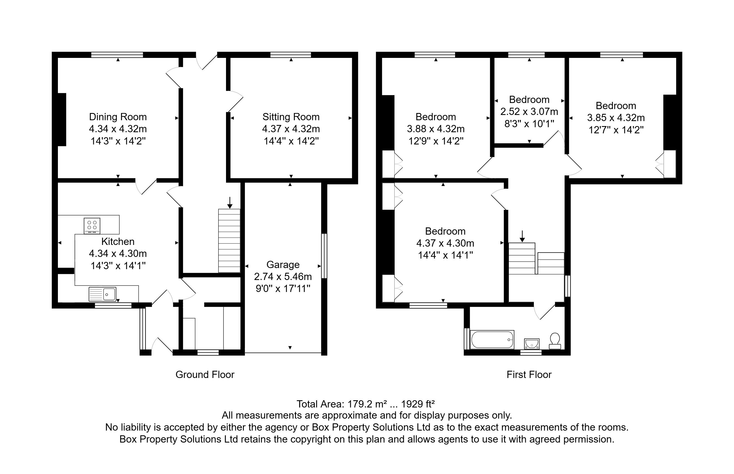

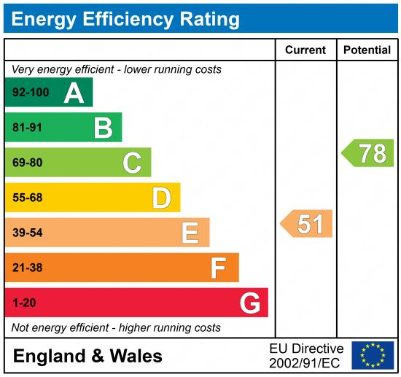

These particulars are intended to give a fair description of the property, but their accuracy cannot be guaranteed, and they do not constitute an offer of contract. Intending purchasers must rely on their own inspection of the property. None of the above appliances/services have been tested by ourselves. We recommend purchasers arrange for a qualified person to check all appliances/services before legal commitment.

Property Ref: 7365

For more information, please contact

0113 258 1150 | sales@adairpaxton.co.uk | www.adairpaxton.co.uk

