

**0113 258 1150**

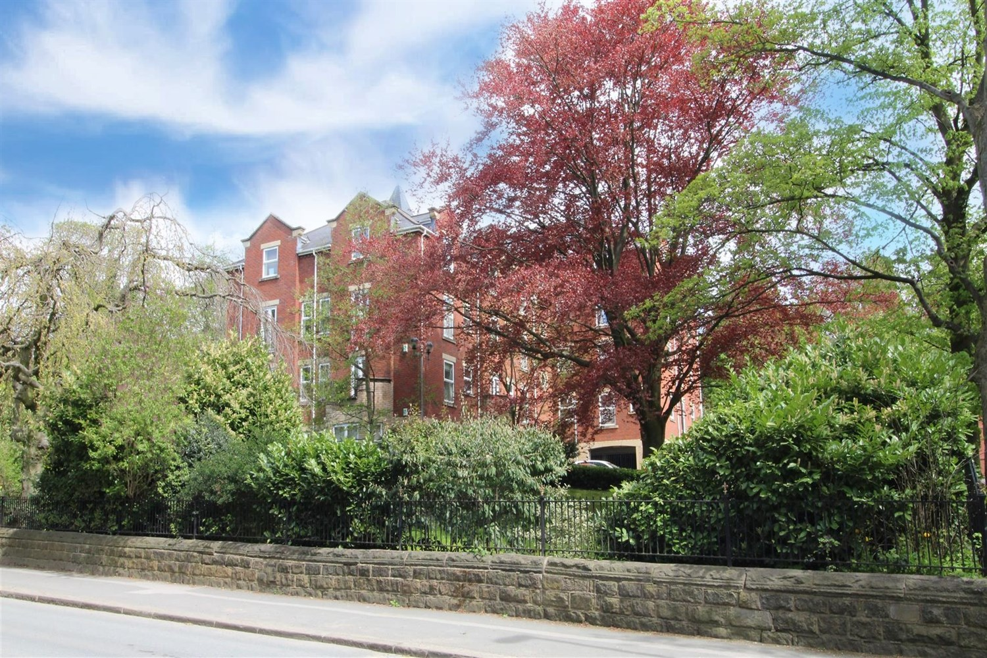



**For Sale £175,000.00**

**Gardenhurst, Cardigan Road**

*** TWO BEDROOM, TWO BATHROOM TOP FLOOR APARTMENT WITH PARKING-NO ONWARD CHAIN*** Situated in a delightful position, just off Cardigan Road, the property is ideally situated close to the cafes, restaurants and shops of Headingley. Set in well maintained, gated communal grounds, the property briefly comprises: communal entrance, private entrance hall, spacious lounge, modern fitted kitchen, master bedroom with ensuite shower room, second double bedroom, house bathroom. The property also benefits from a secure under croft designated car parking space and lift to all floors. Early internal viewing is highly recommended to appreciate the accommodation on offer.

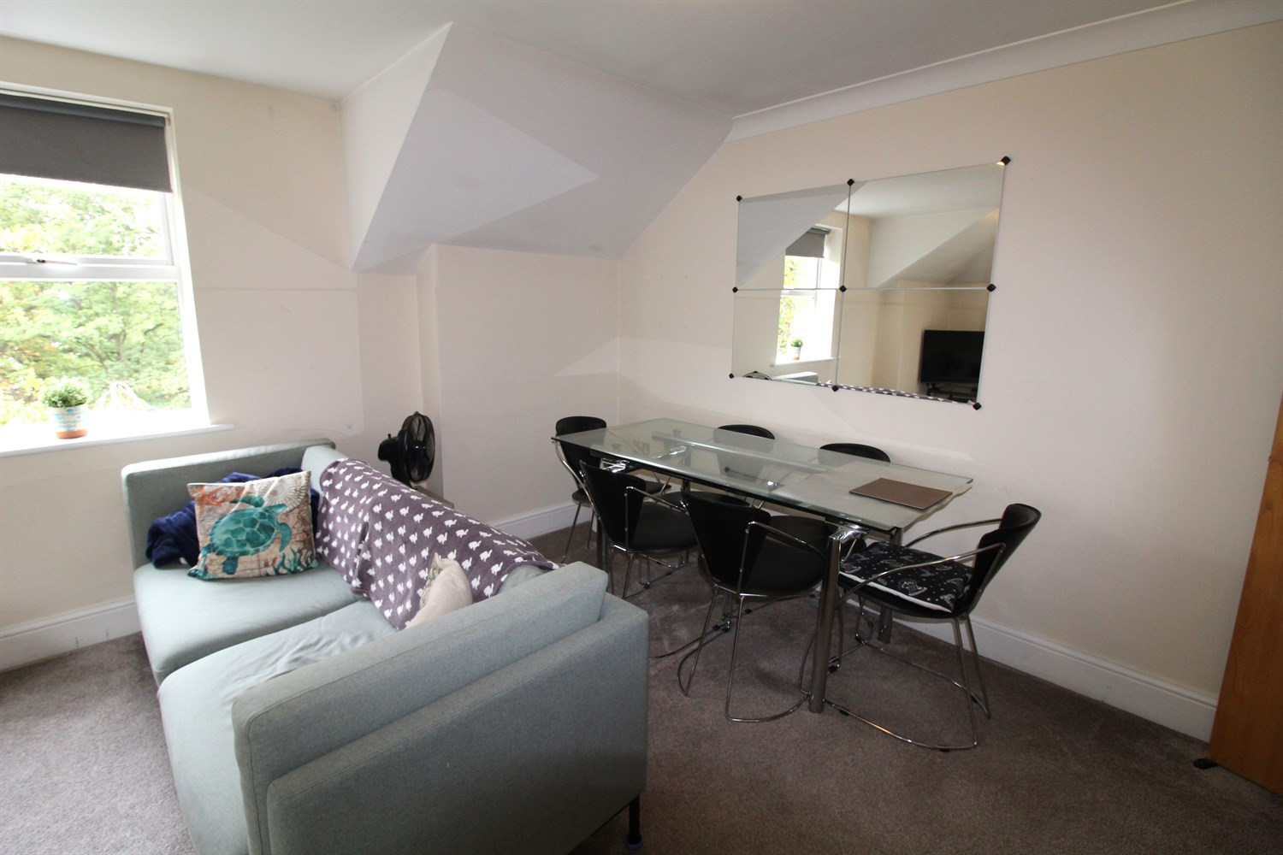

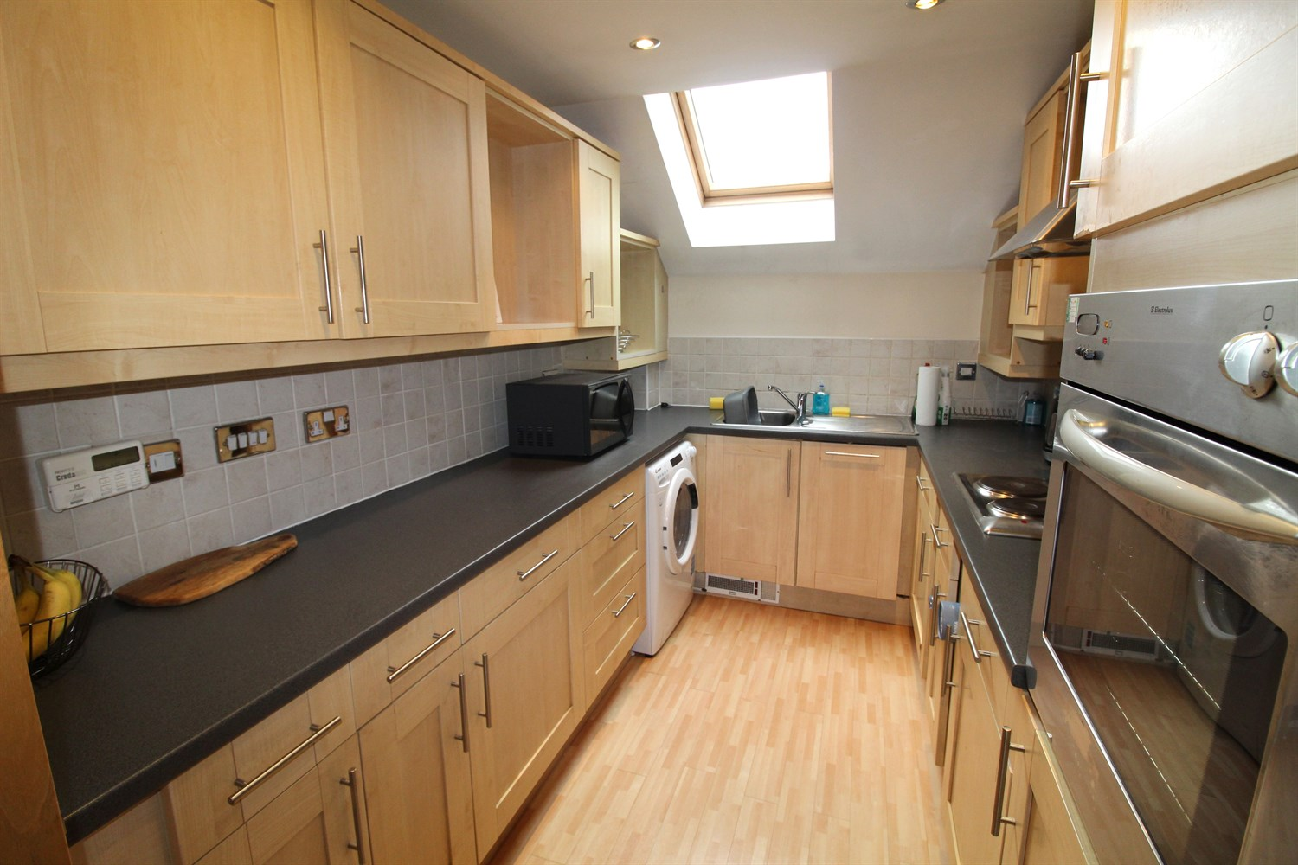

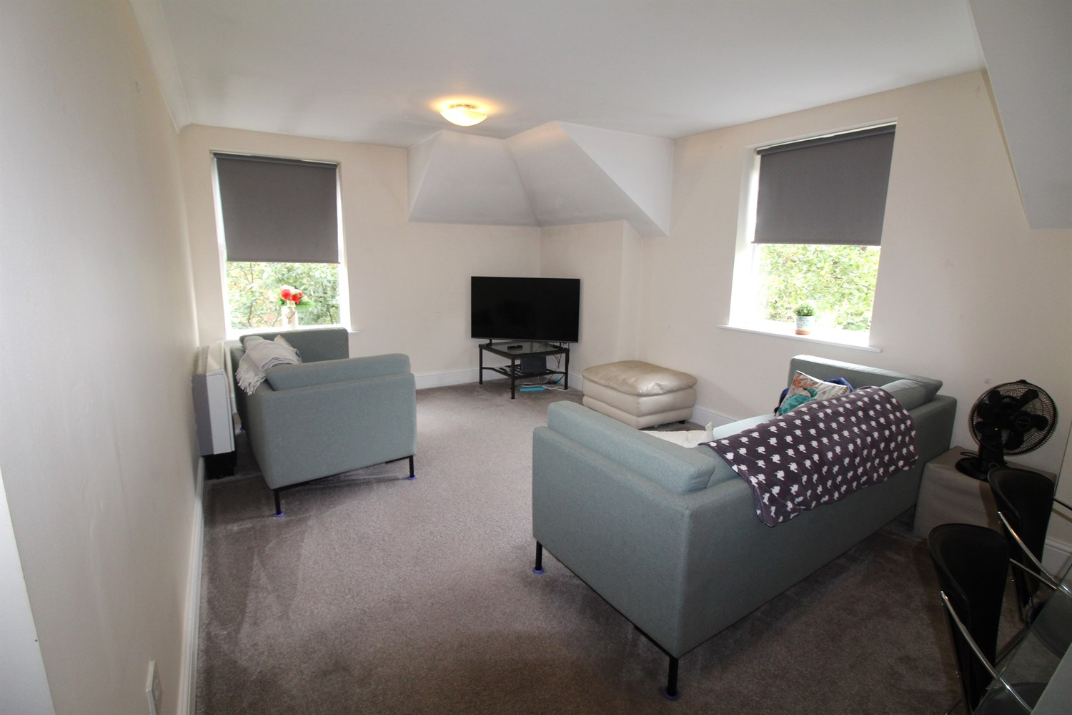

2 Bathroom(s)

1 Reception(s)

2 Bedroom(s)

00

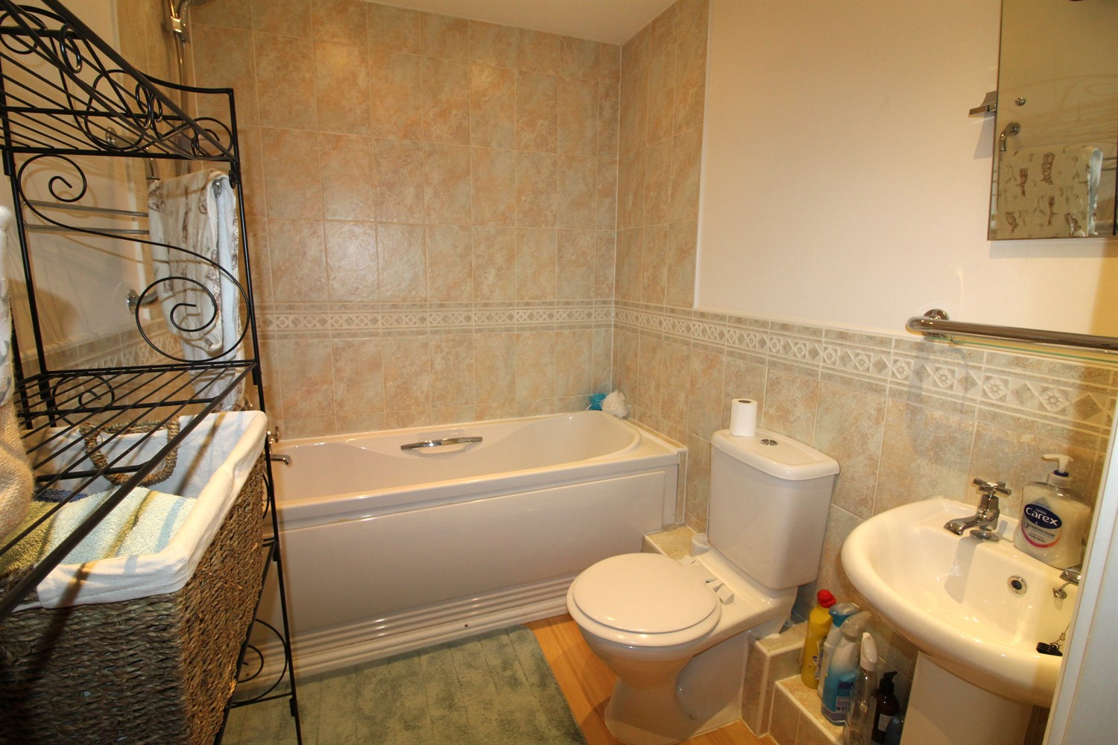

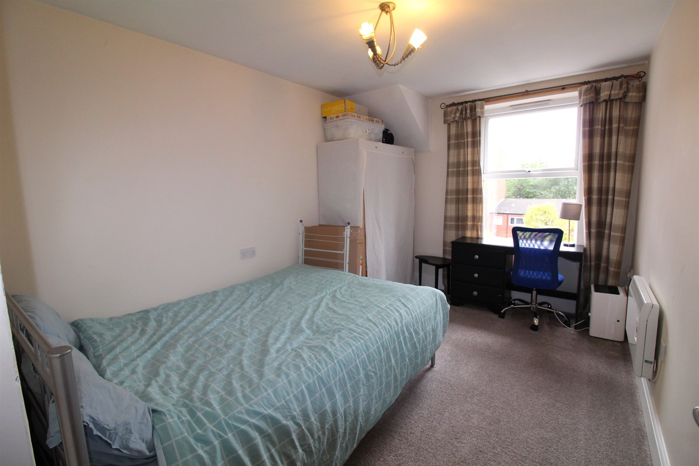

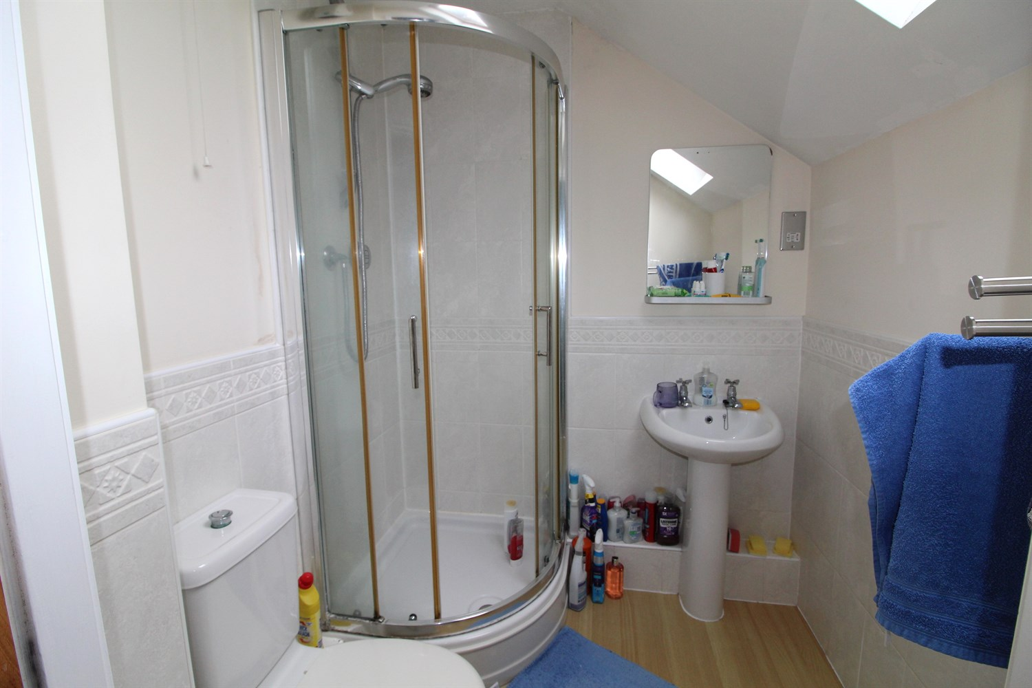

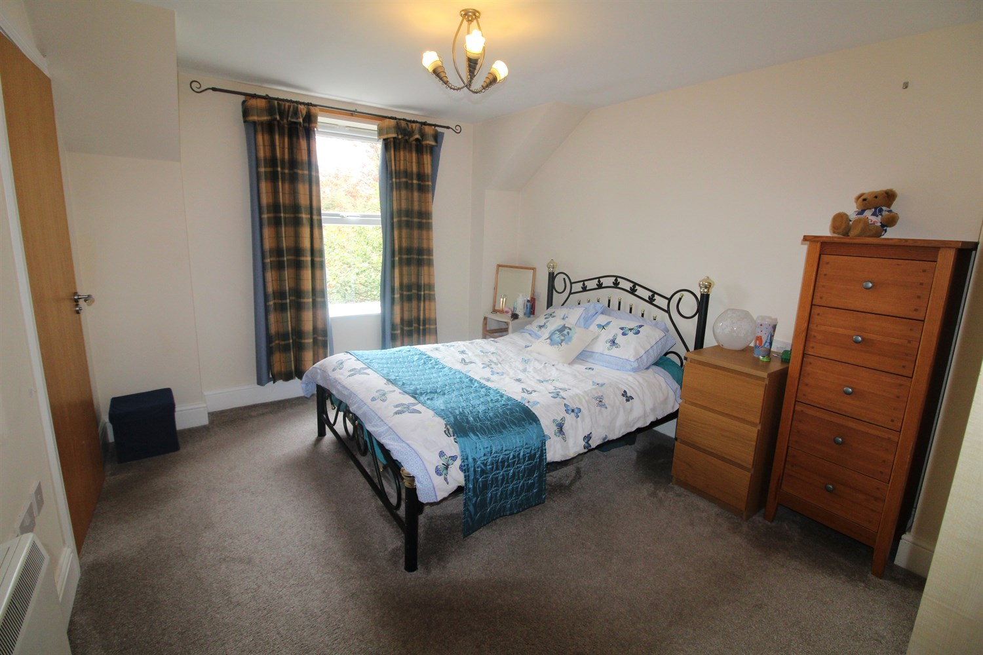

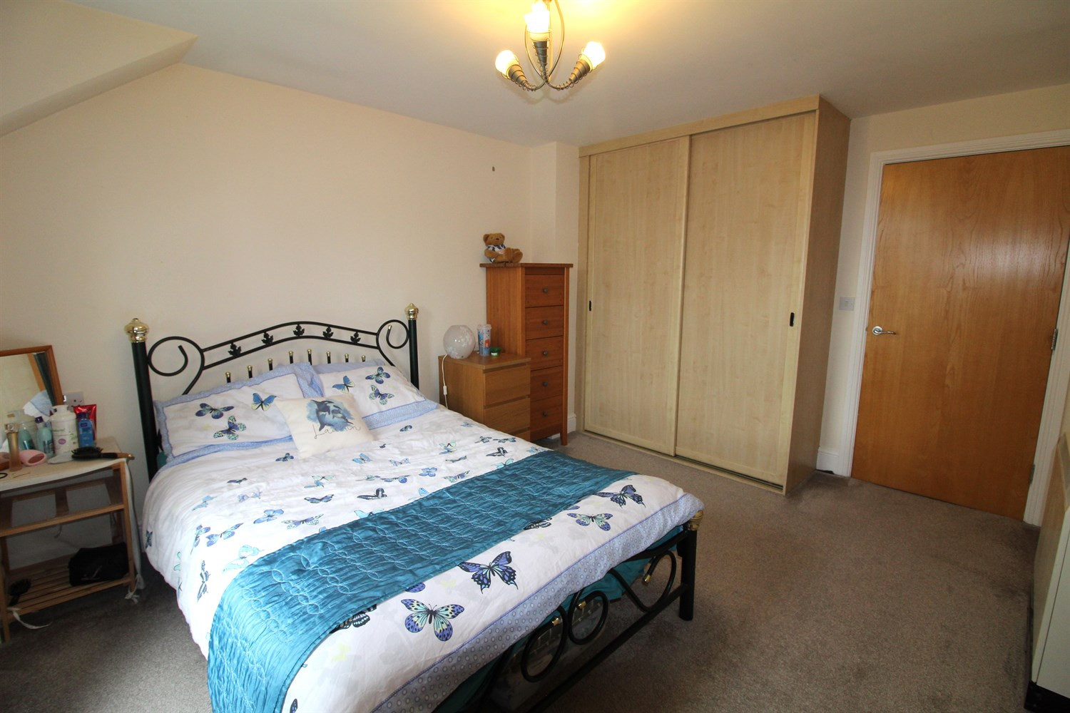

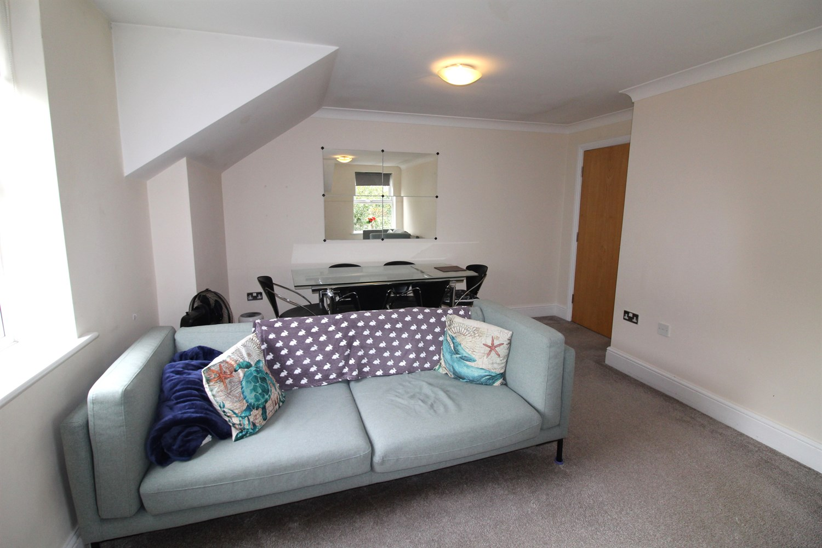

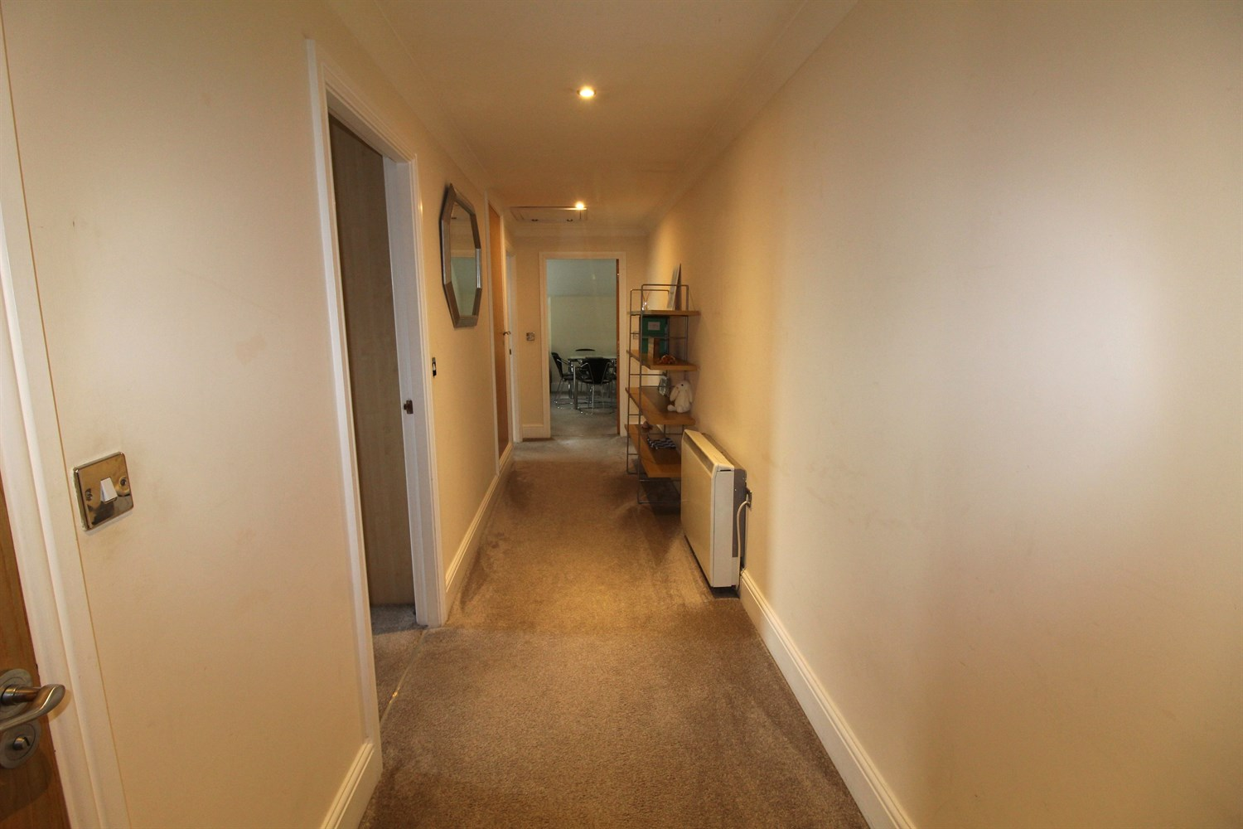

|  |
| --- |
| **Communal Entrance**  Communal entrance. Stairs and lift to all floors. |
| **Private Entrance Hall**  Via front entrance door. Secure Entryphone system. Wall mounted electric radiator. |
| **Kitchen**  Fitted with a range of wall, base and drawer units with work surfaces over. Stainless steel sink and drainer with mixer tap. Integrated electric oven and electric hob with extractor above. integrated washing machine and dishwasher. Plinth heater. Laminate flooring. Velux window. |
| **Lounge 5.49m (18'0) x 3.48m (11'5)**  Spacious and light living are. UPVC double glazed window to front and side. Wall mounted electric heater. |
| **Master Bedroom 3.61m (11'10) x 3.18m (10'5)**  A spacious double bedroom. UPVC double glazed window. Wall mounted electric heater. Built in wardrobes. |
| **En-Suite Shower Room**  Fitted with a three piece white suite comprising shower cubicle, WC and wash hand basin. Part tiled walls. Extractor fan. Velux window. |
| **Second Bedroom 3.96m (13') x 2.64m (8'8)**  A spacious second bedroom with UPVC double glazed window. Wall mounted electric heater. |
| **Bathroom**  Fitted with a three piece white suite comprising bath with mixer tap and hand shower, WC and wash hand basin. Part tiled walls. Extractor fan. |
| **Outside**  The property benefits from gated access leading to secure under croft parking. Visitor car parking and well maintained gardens. |
| **Tenure**  Leasehold - The Lease is 999 years from 1st January 2001. Ground Rent - We understand the ground rent to be £350 per annum. |
| **Service charge**  The service charge is £2280.00 per year. |

|  |  |
| --- | --- |
| These particulars are intended to give a fair description of the property, but their accuracy cannot be guaranteed, and they do not constitute an offer of contract. Intending purchasers must rely on their own inspection of the property. None of the above appliances/services have been tested by ourselves. We recommend purchasers arrange for a qualified person to check all appliances/services before legal commitment.  **Property Ref:** 7370  **For more information, please contact**  0113 258 1150 **|** [sales@adairpaxton.co.uk](mailto:sales@adairpaxton.co.uk) **|** www.adairpaxton.co.uk |  |