

**Croft Court, Horsforth, LS18**

**Available to let £925.00pcm**

Spacious and attractive ground floor apartment located in highly convenient and desirable area of Horsforth. Having gas central heating, sealed unit double glazing and security intercom. The property would well suit the needs of the young or retiring couple alike, being ideally placed close to shops and amenities. Briefly comprising: Lounge, Modern fitted Kitchen, Two Bedrooms, Bathroom with walk in shower, Communal Gardens, on-site Parking and garage. Council Tax Band B EPC rating B. UNFURNISHED. Available Now. Deposit £1065

**0113 258 1150**

**0800 000 000**

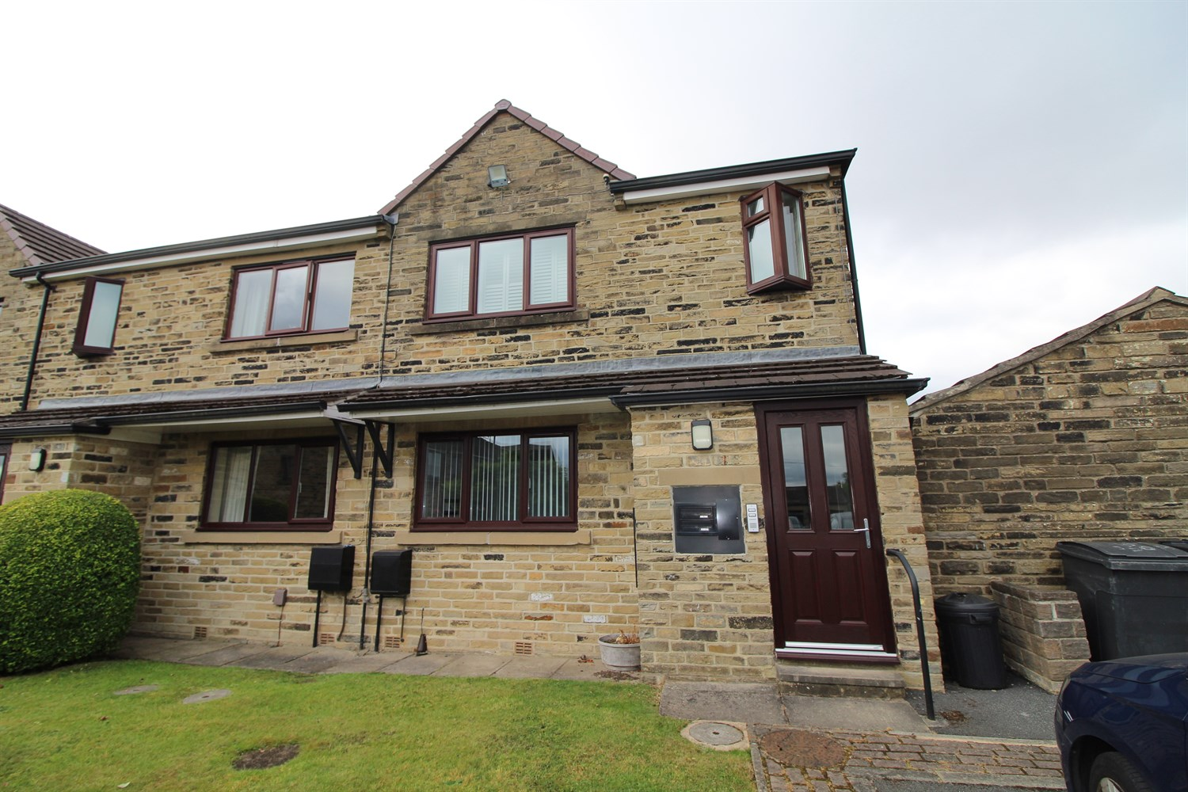

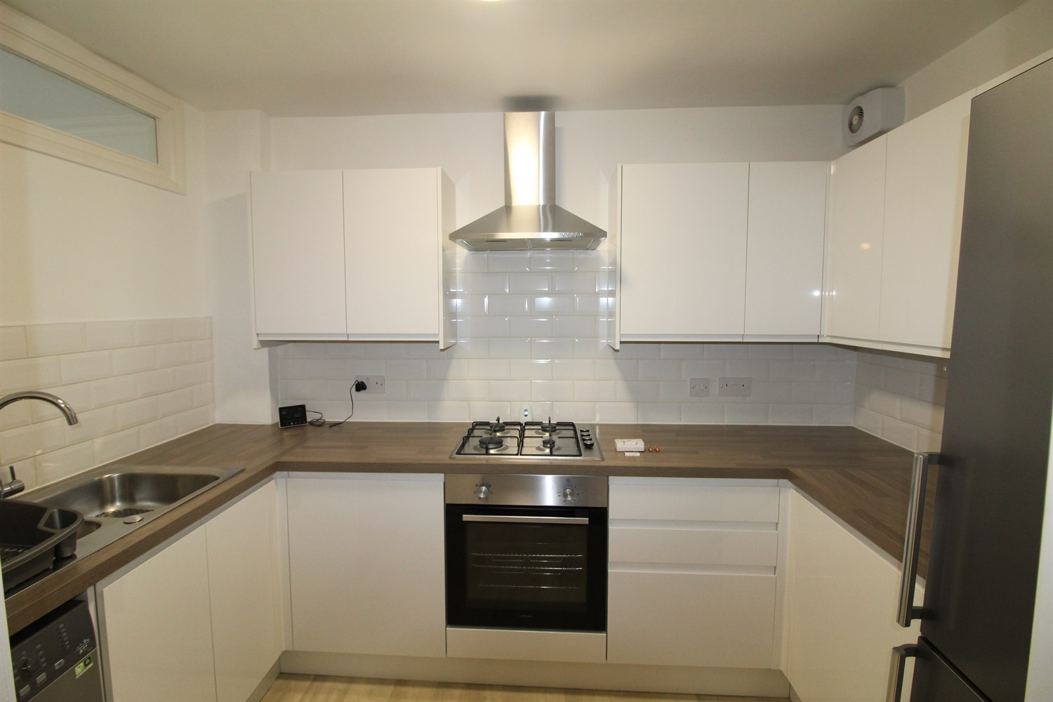

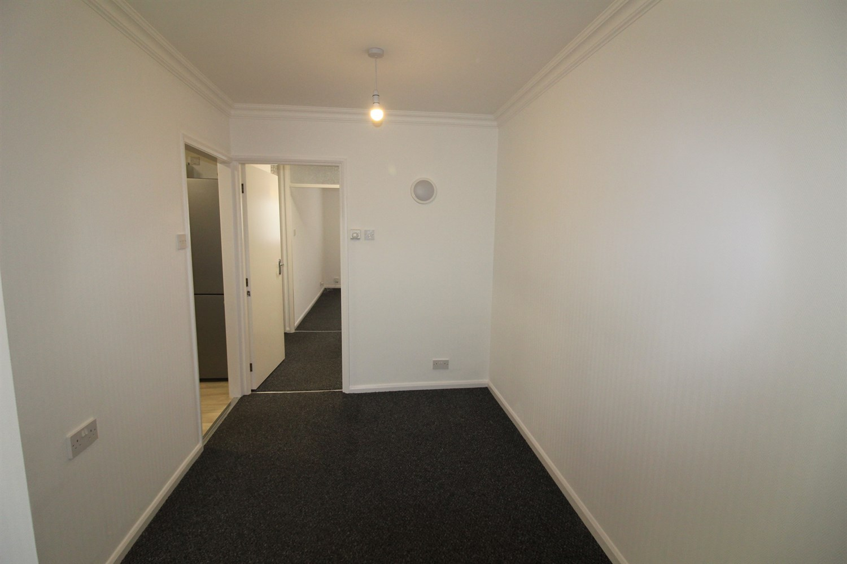

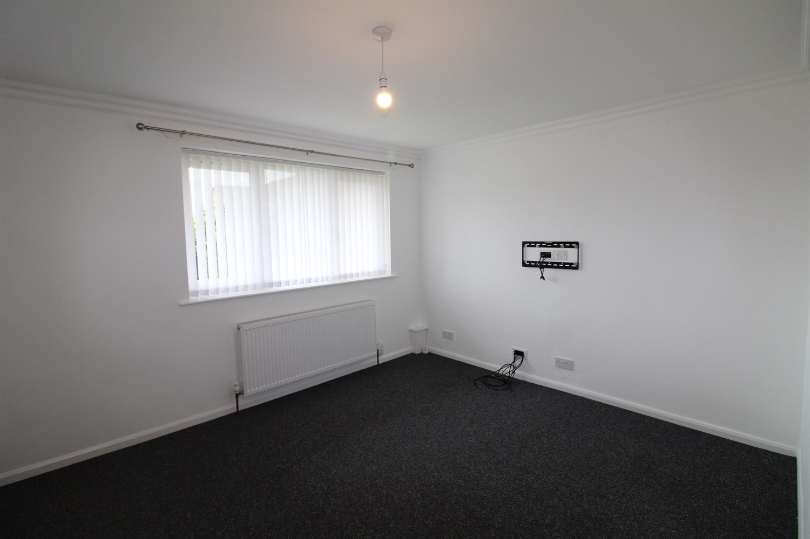

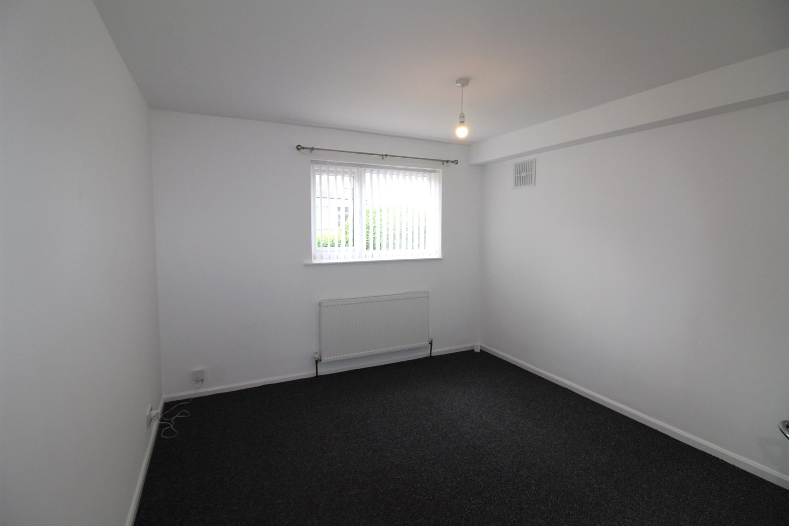

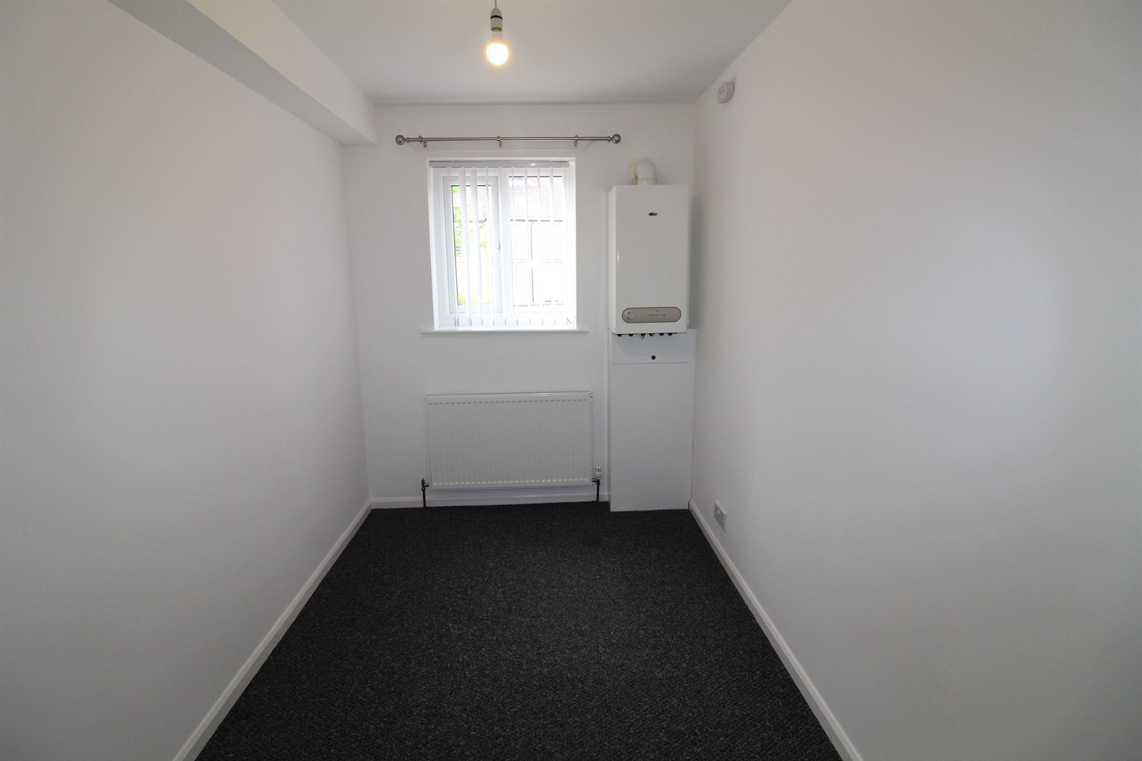

|  |
| --- |
| **Communal Entrance**  Stairs to all floors. |
| **Living Room**  Light and airy living room with window to front, Dinning area, gas central heating radiator. |
| **Kitchen**  Modern fitted kitchen with a range of wall and base units with worktops over, stainless steel sink with mixer tap. |
| **bedroom One**  Double bedroom with window to rear, gas central heating radiator. |
| **Bedroom Two**  Second bedroom with window to rear, gas central heating radiator. |
| **Bathroom**  Three piece bathroom suite walk in shower, W/C and hand wash basin, tiled walls. |
| **Garage**  Garage with electric. |
| **Home Information**  COUNCIL TAX BAND: B EPC Rating: D  Leasehold Property Allocating Parking  Broadband: Standard 9 Mbps 0.9 Mbps  Superfast 74 Mbps 20 Mbps  Ultrafast 1800 Mbps 220 Mbps   Mobile availability: EE coverage Limited. Three coverage Limited. O2 coverage Likely. Vodafone coverage Likely.  Utilities: Water supplied on standard meters. Electric mains supplied on standard meters. |

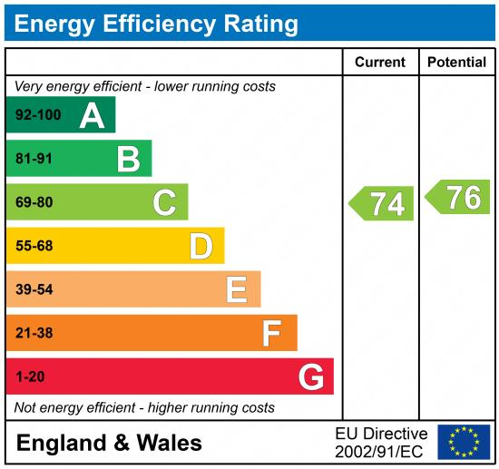

|  |
| --- |
|  |

These particulars are intended to give a fair description of the property, but their accuracy cannot be guaranteed, and they do not constitute an offer of contract. Intending purchasers must rely on their own inspection of the property. None of the above appliances/services have been tested by ourselves. We recommend purchasers arrange for a qualified person to check all appliances/services before legal commitment.

**Property Ref:** 7256

**For more information, please contact**

0113 258 1150 **|** [lettings@adairpaxton.co.uk](mailto:lettings@adairpaxton.co.uk) **|** www.adairpaxton.co.uk