

**0113 258 1150**

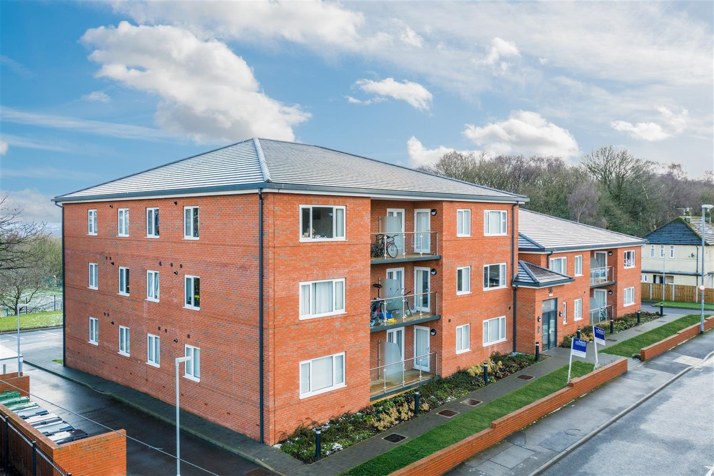

**For Sale £165,000.00**

**Iveson Drive, Cookridge**

**TWO BEDROOM, TWO BATHROOM APARTMENT - NO ONWARD CHAIN** This well presented ground floor apartment is conveniently located on Iveson Drive, between Horsforth and Adel. This delightful apartment has been one of the show flats and boasts a composite entrance door through to a spacious hallway, contemporary open plan living/dining room with French doors to a Juliet balcony. The lounge is open plan to the kitchen which is fitted with a range of white high gloss wall, base and drawer units with work surfaces over. Stainless steel sink and drainer with mixer tap. Integrated electric oven and hob with extractor hood over. Integrated fridge/freezer and dishwasher. Master bedroom with en-suite shower room, second double bedroom and house bathroom. Externally, the property has well maintained communal grounds and allocated parking. Offered for sale with NO ONWARD CHAIN, early internal inspection is highly recommended.

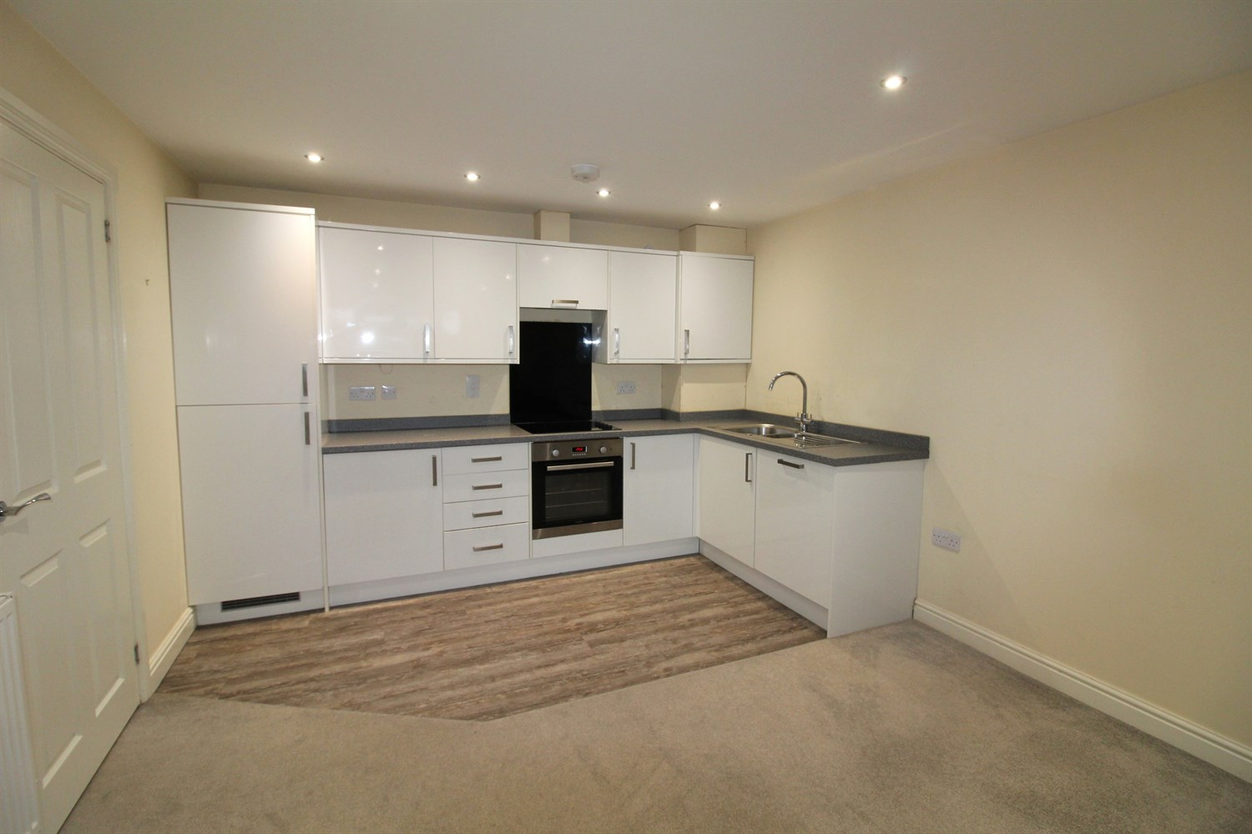

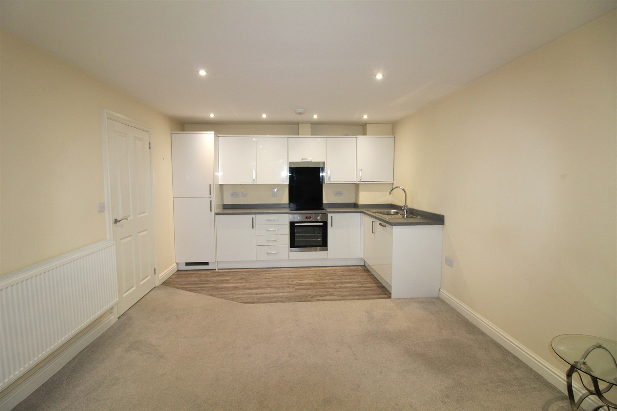

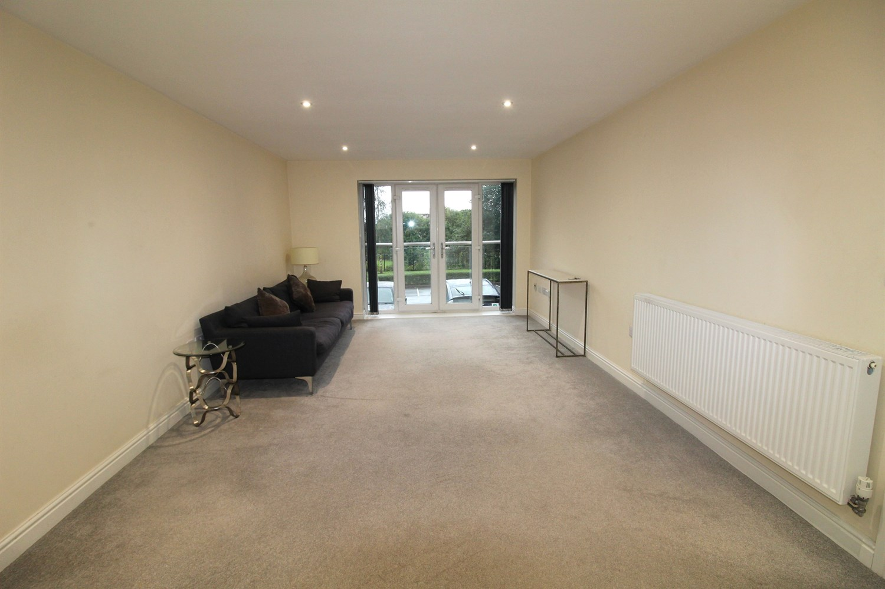

00

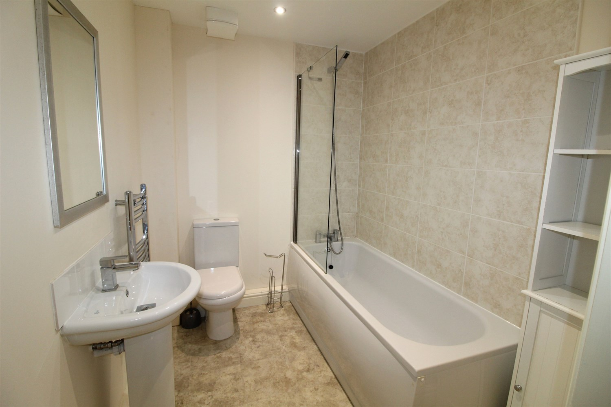

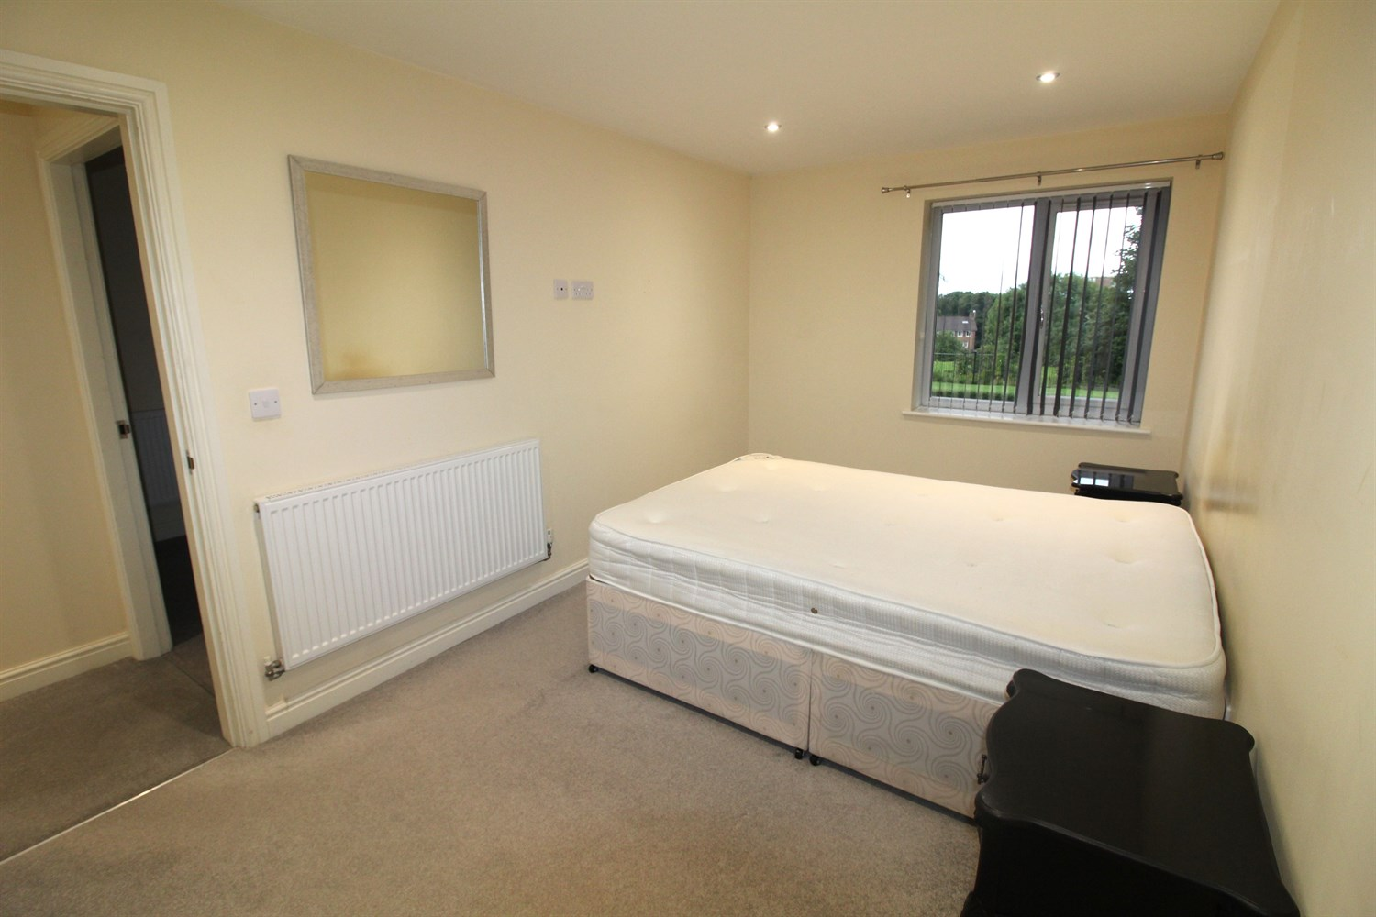

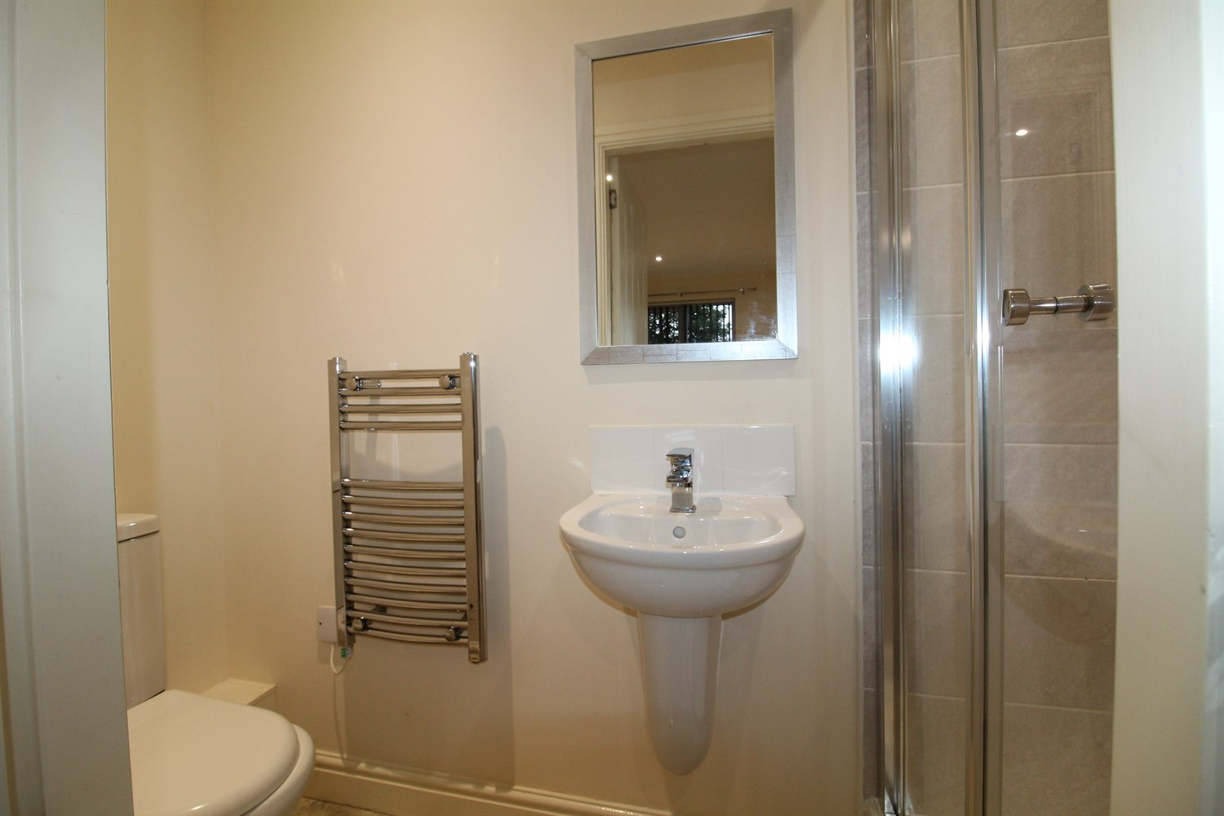

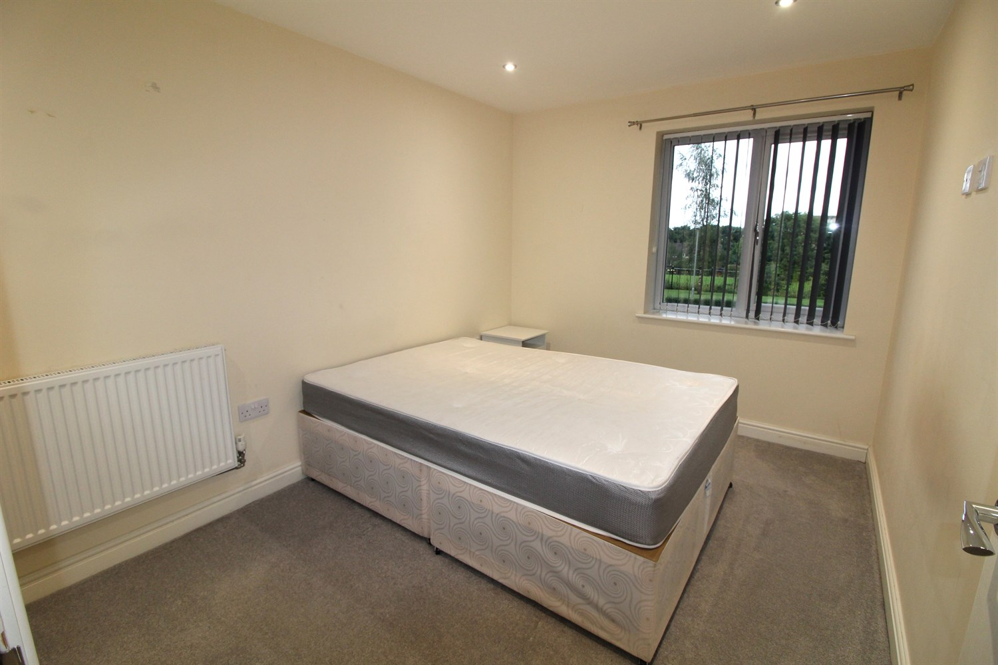

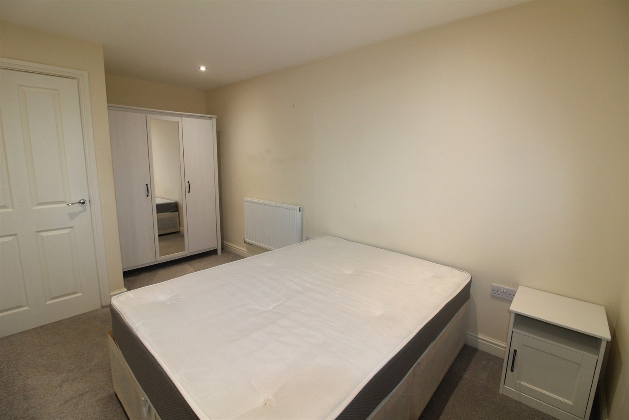

|  |
| --- |
| **Communal Entrance**  Via entrance door. Secure entry phone system. |
| **Hallway**  Via front entrance door. Store cupboard house washing machine. |
| **Open Plan Kitchen/Diner/Lounge 6.99m (22'11) x 3.5m (11'6)**  A contemporary, open plan living room with kitchen and space for a dining table. uPVC double glazed doors open to the Juliet balcony. Fitted kitchen with a range of white, high gloss wall, base and drawer units with work surfaces over. Featuring electric fan oven, gas hob with feature stainless steel extractor hood, stainless steel sink with chrome mixer taps. Integrated fridge/freezer and dishwasher. The plumbing for the washing machine is located in a cupboard in the hallway. |
| **Master Bedroom 4.5m (14'9) x 2.57m (8'5)**  A spacious double bedroom with uPVC double glazed window to the rear. Gas central heating radiator. |
| **En-Suite Shower Room**  Fitted with a three piece white suite comprising shower cubicle, WC and wash hand basin. Part tiled walls. Chrome heated ladder towel rail. |
| **Bedroom 2 3.38m (11'1) x 2.59m (8'6)**  A spacious double bedroom with uPVC double glazed window to the rear. Gas central heating radiator. |
| **Bathroom**  Fitted with a three piece white suite comprising bath with shower attachment to the taps and glass screen, WC and wash hand basin. Part tiled walls. Chrome heated ladder towel rail. |
| **Parking**  Allocated parking space. |
| **Tenure**  Leasehold. 999 years from 2016. Ground Rent - £175 per annum |
| **Service Charge**  Half Yearly Service Charge in advance £649.30  Insurance 2024-2025 £192.16 |

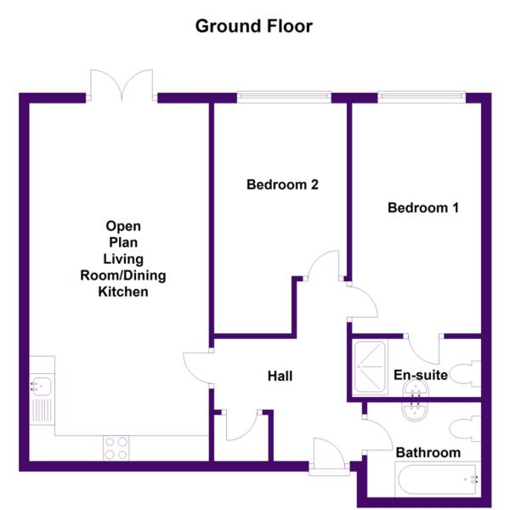

|  |  |
| --- | --- |
| These particulars are intended to give a fair description of the property, but their accuracy cannot be guaranteed, and they do not constitute an offer of contract. Intending purchasers must rely on their own inspection of the property. None of the above appliances/services have been tested by ourselves. We recommend purchasers arrange for a qualified person to check all appliances/services before legal commitment.  **Property Ref:** 7020  **For more information, please contact**  0113 258 1150 **|** [sales@adairpaxton.co.uk](mailto:sales@adairpaxton.co.uk) **|** www.adairpaxton.co.uk |  |