

**Troy Mills, Troy Road, Leeds Available To Let £825.00pcm**

Fabulous, LARGE 2nd floor apartment in this SOUGHT AFTER Troy Mills development! This converted mill retains some impressive features which combine so well with the modern & contemporary finish. Allocated parking. Stairs up to the 2nd floor. Troy Mills is minutes away from the TRAIN ST. excellent amenities & has easy access into the city centre, briefly, stairs up to the 2nd floor, hallway with useful fitted storage, stunning living/kitchen with feature beams & ceiling structure, Modern black, high gloss fitted kitchen with numerous integrated appliances. A good size double bedroom & three piece house bathroom. Available Now. EPC rating E, council tax band B, Deposit £950.

**0113 258 1150**

**0800 000 000**

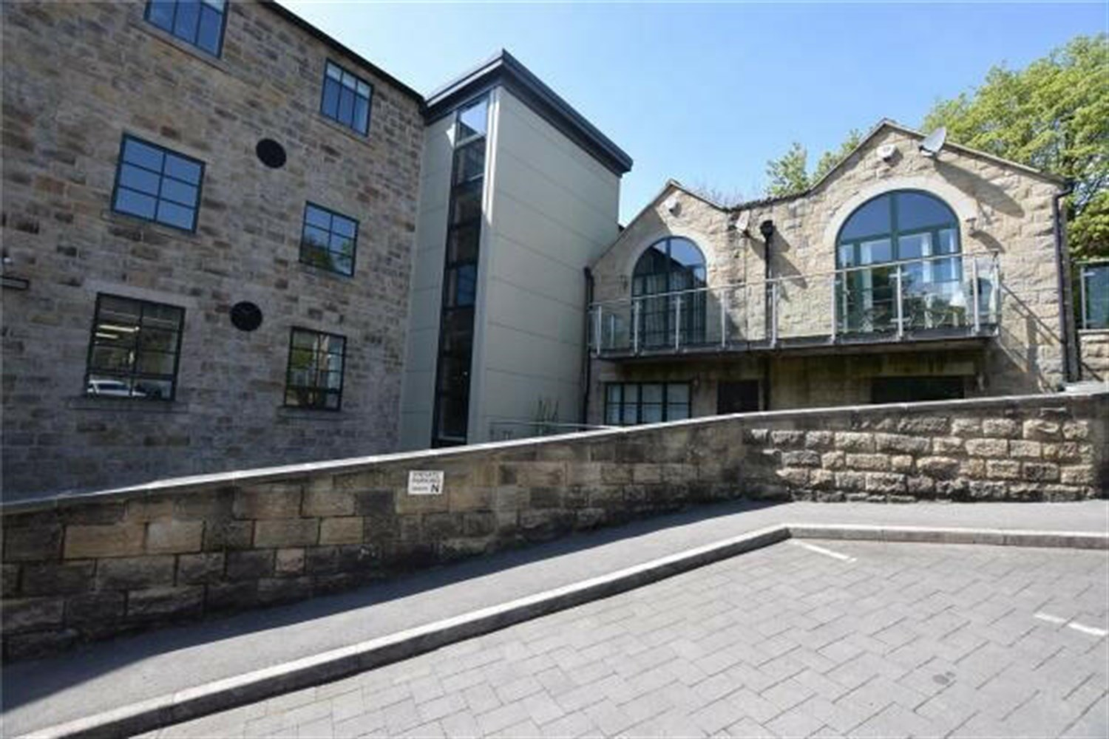

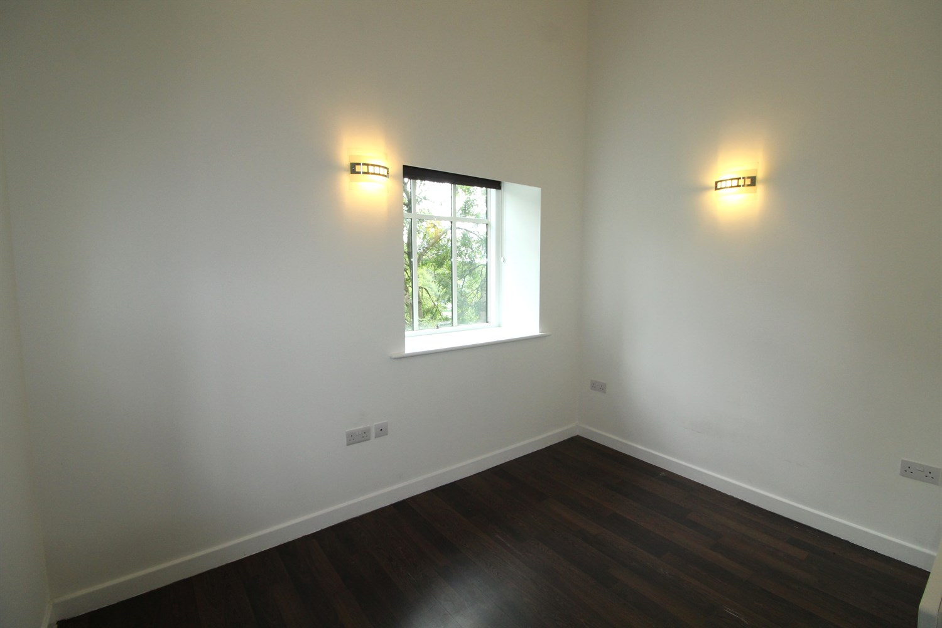

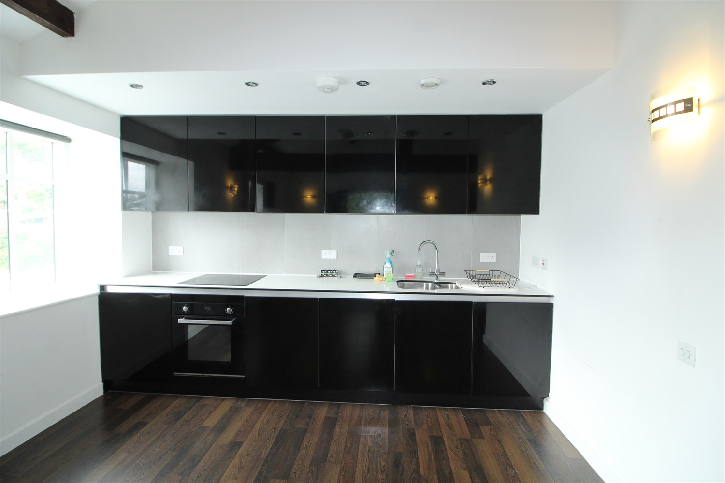

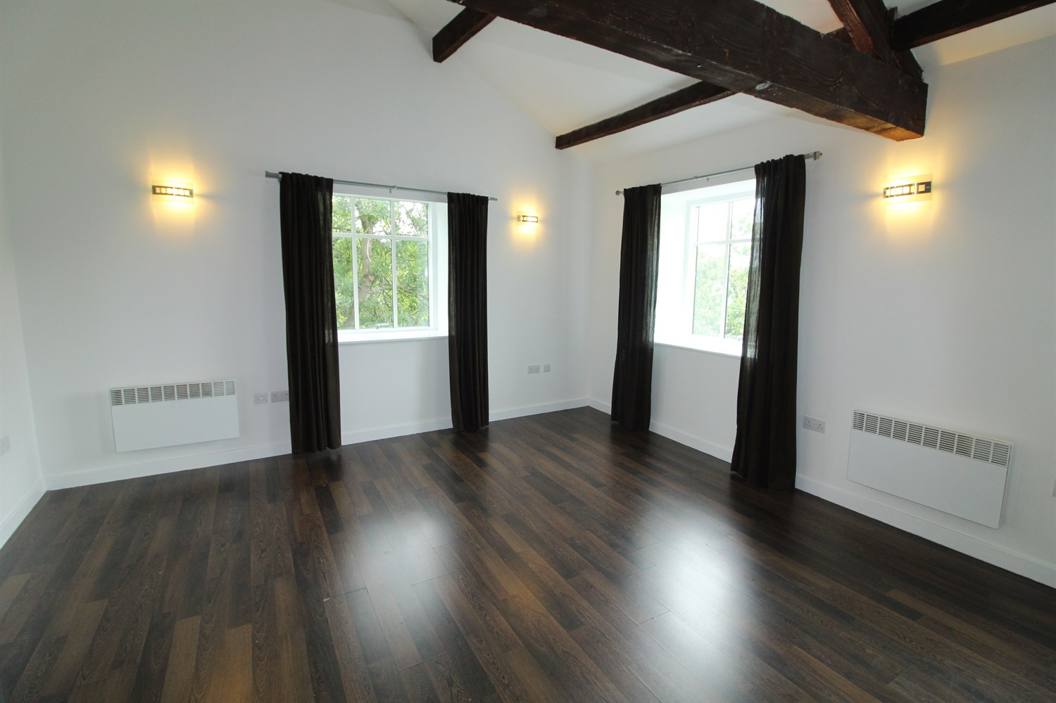

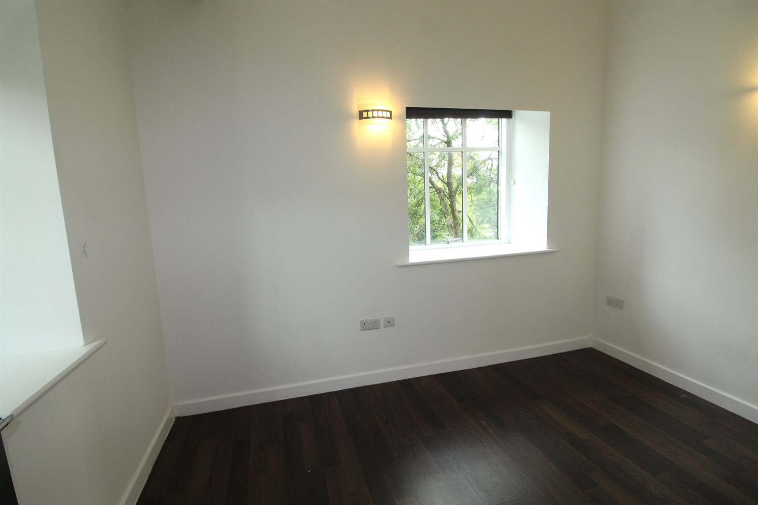

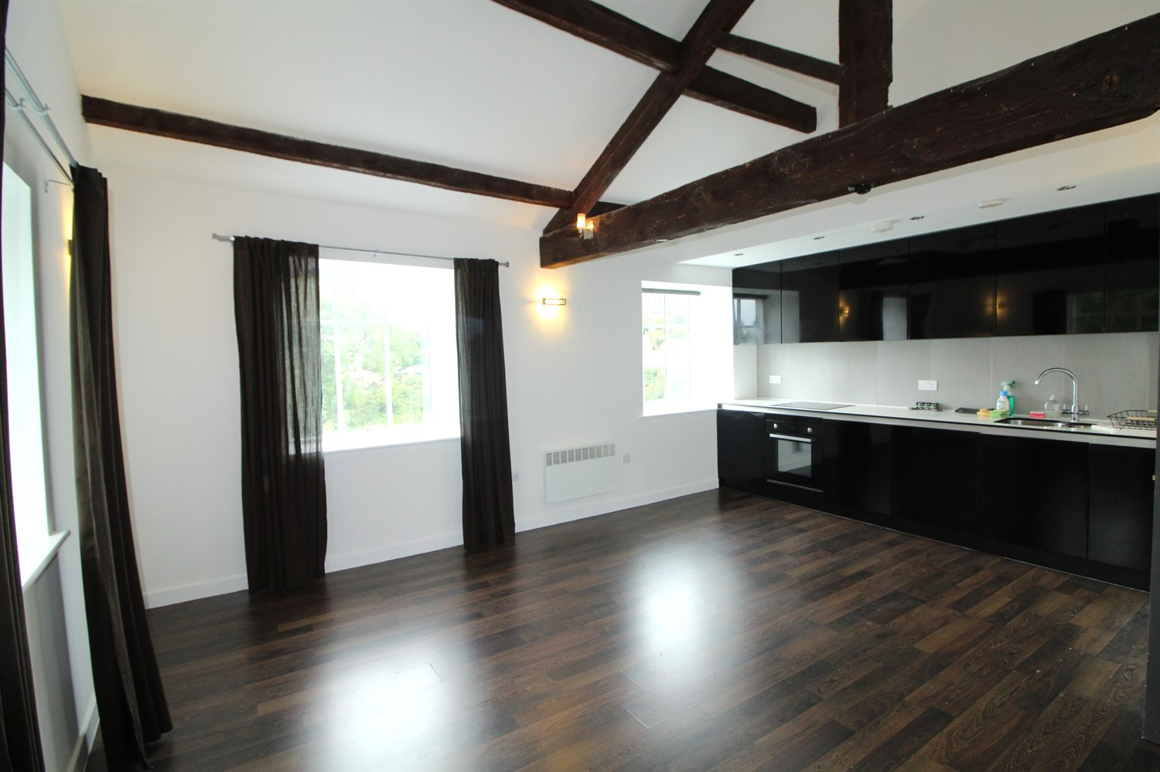

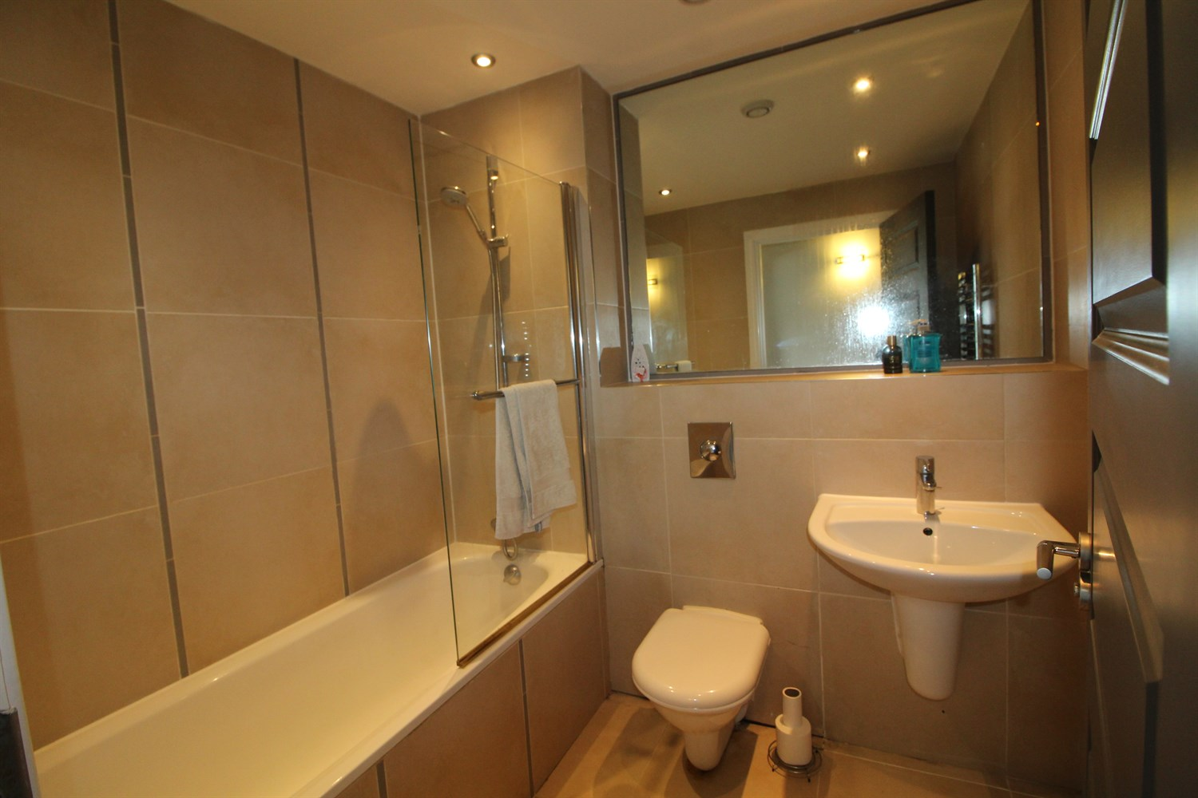

|  |
| --- |
| **Communal Entrance**  Stairs leading to all floors. |
| **Hallway**  hallway with storage cupboard housing washing machine. |
| **Reception 1**  Wow!!! A stunning, large contemporary space with those fabulous exposed beams, ceiling structures and high ceiling! Flooded with natural light from the dual aspect windows to the side and rear elevations. Continuation of the dark wood laminate flooring which contrasts. |
| **Kitchen**  The kitchen is impressive with black high gloss, seamless units and complementary worksurfaces along with integrated electric oven, induction hob, canopy over, fridge, freezer and inset sink with mixer tap. A fabulous day to day living space but perfect for entertaining too and fabulous views over the woods |
| **Bedroom 1**  A good size bedroom too, also with dual aspect windows to the rear and side elevations, the dark wood effect laminate flooring and feature lighting. |
| **Bathroom**  What a good size bathroom! Incorporates a tiled bath with mixer shower over, WC and pedestal wash hand basin. Fully tiled walls and floor. |
| **Parking**  Allocated Parking |
| **Home Information**  COUNCIL TAX BAND: B EPC Rating: E  Leasehold Property Allocating Parking  Broadband: Standard 6 Mbps 0.7 Mbps Superfast 80 Mbps 20 Mbps  Ultrafast 1800 Mbps 220 Mbps  Mobile availability: EE coverage Limited. Three coverage Likely. O2 coverage Likely. Vodafone coverage Likely.  Utilities: Water supplied on standard meters. Electric mains supplied on standard meters. |

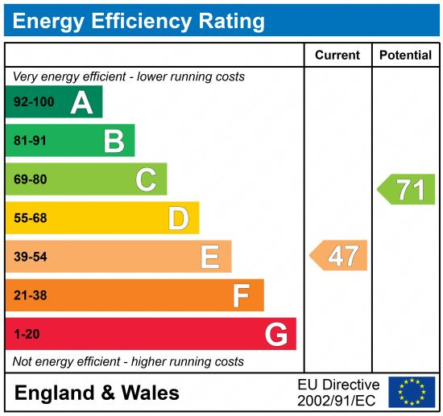

|  |
| --- |
|  |

These particulars are intended to give a fair description of the property, but their accuracy cannot be guaranteed, and they do not constitute an offer of contract. Intending purchasers must rely on their own inspection of the property. None of the above appliances/services have been tested by ourselves. We recommend purchasers arrange for a qualified person to check all appliances/services before legal commitment.

**Property Ref:** 7185

**For more information, please contact**

0113 258 1150 **|** [lettings@adairpaxton.co.uk](mailto:lettings@adairpaxton.co.uk) **|** www.adairpaxton.co.uk