

Leeds Road, Scholes
For Sale £395,000.00

***WELL EXTENDED THREE BEDROOM SEMI-DETACHED HOUSE WITH VIEWS OVER OPEN FIELDS*** Situated in a semi-rural location which offers all the benefits of village life yet is just a few minutes’ drive from Crossgates, Garforth and all the motorway links, this delightful home has been renovated and extended by the current owners to provide a contemporary family home. The property briefly comprises; entrance hall, living room, open plan kitchen/diner, utility room and guest WC to the ground floor. To the first floor there are two double bedrooms, a single bedroom and house bathroom. Externally there is off street parking to the front of the property and an enclosed rear garden with views over open fields. The property is convenient for the A64 and a number of other major road links to the A1/M1. There is also good access to York, central Leeds, Wetherby and Harrogate. This property is READY TO MOVE INTO and simply MUST BE VIEWED to be appreciated.
0113 258 1150
0800 000 000
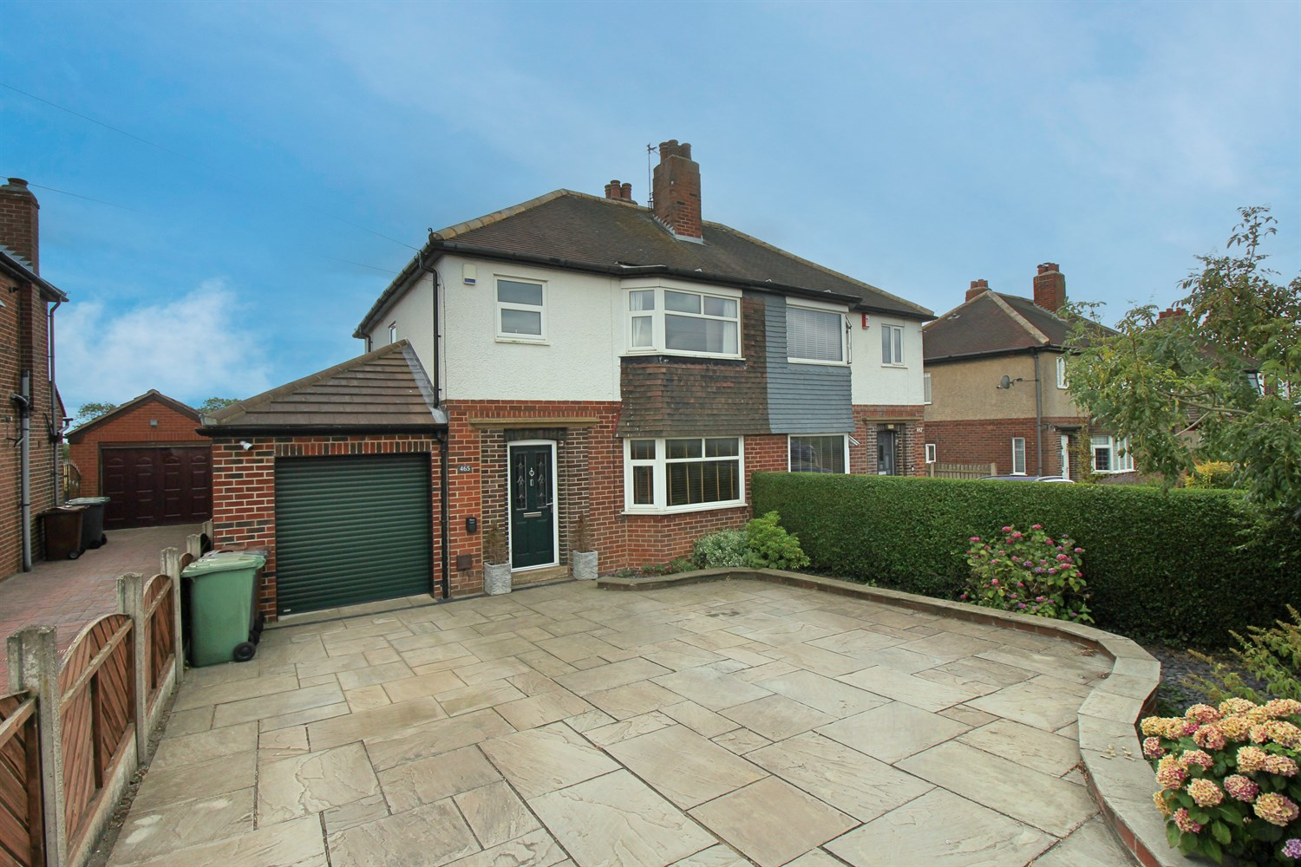
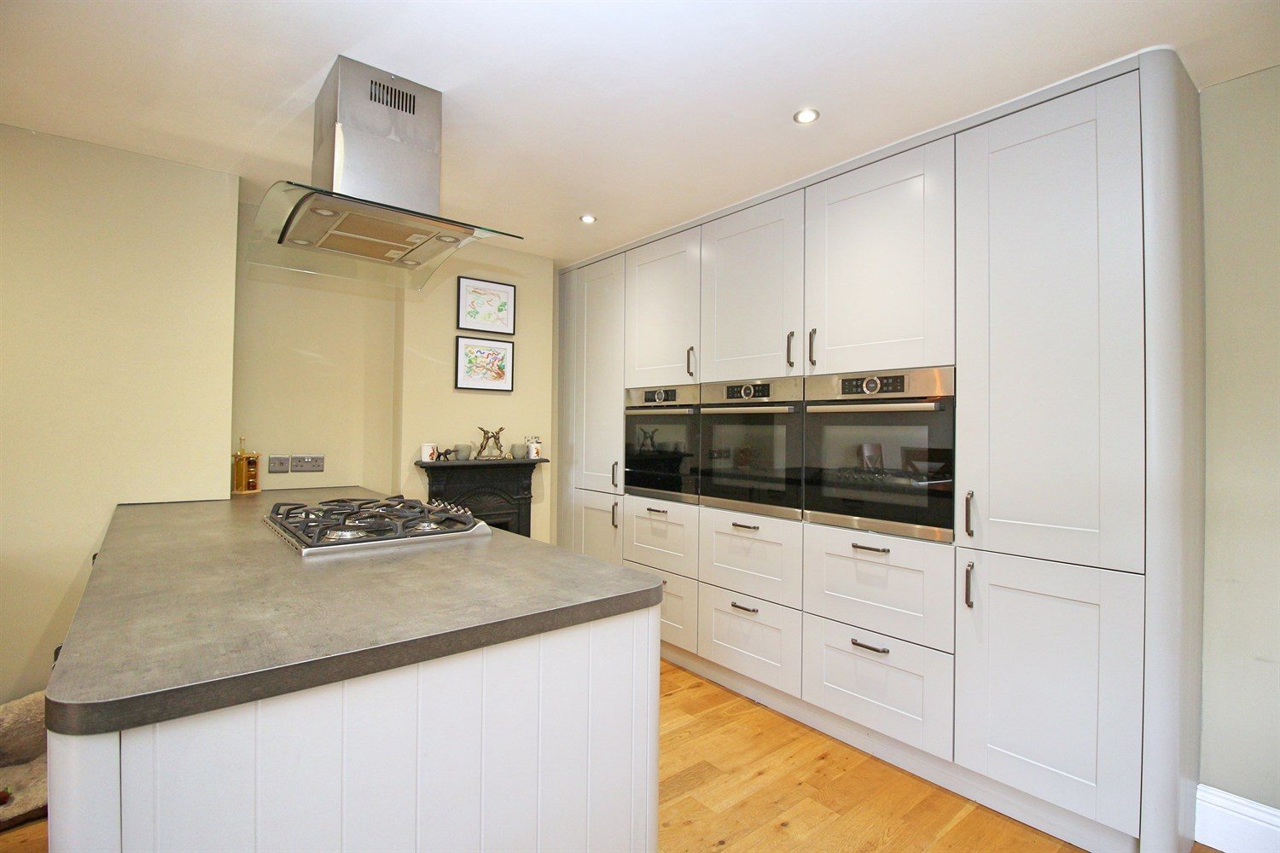
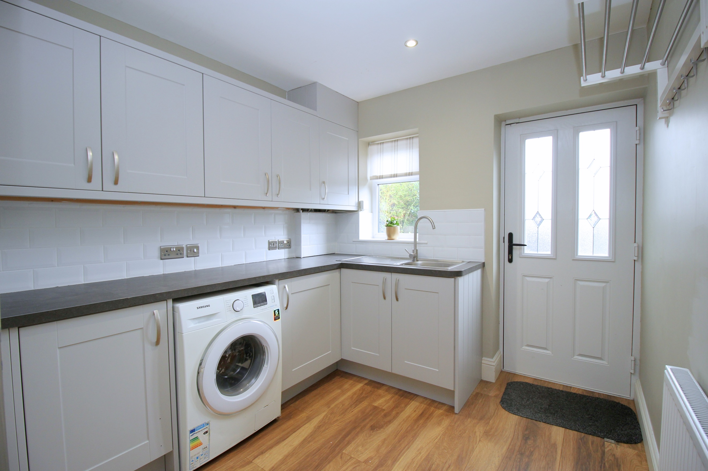
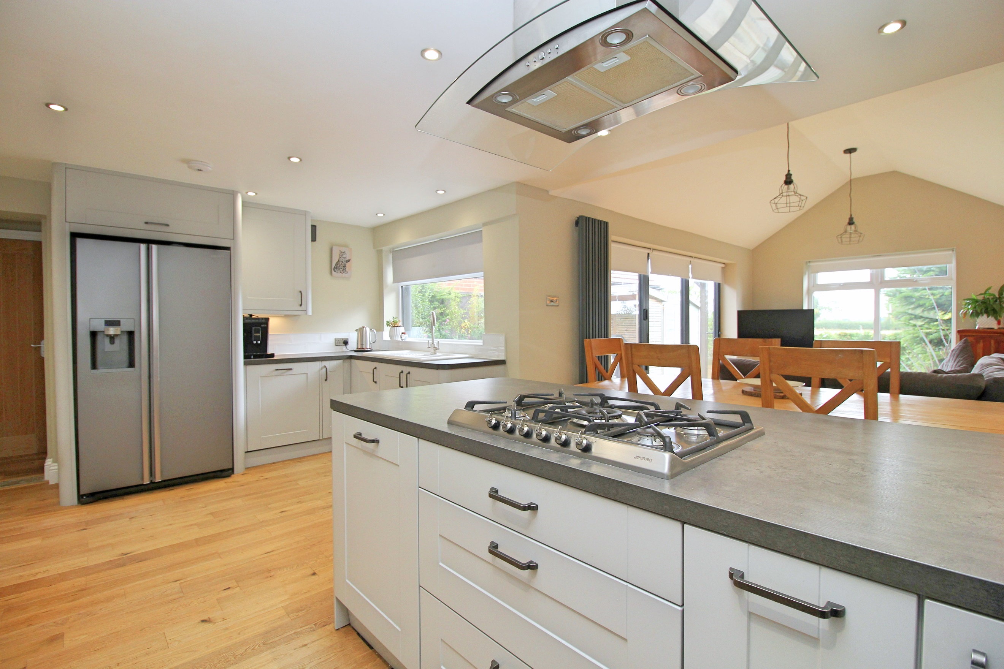
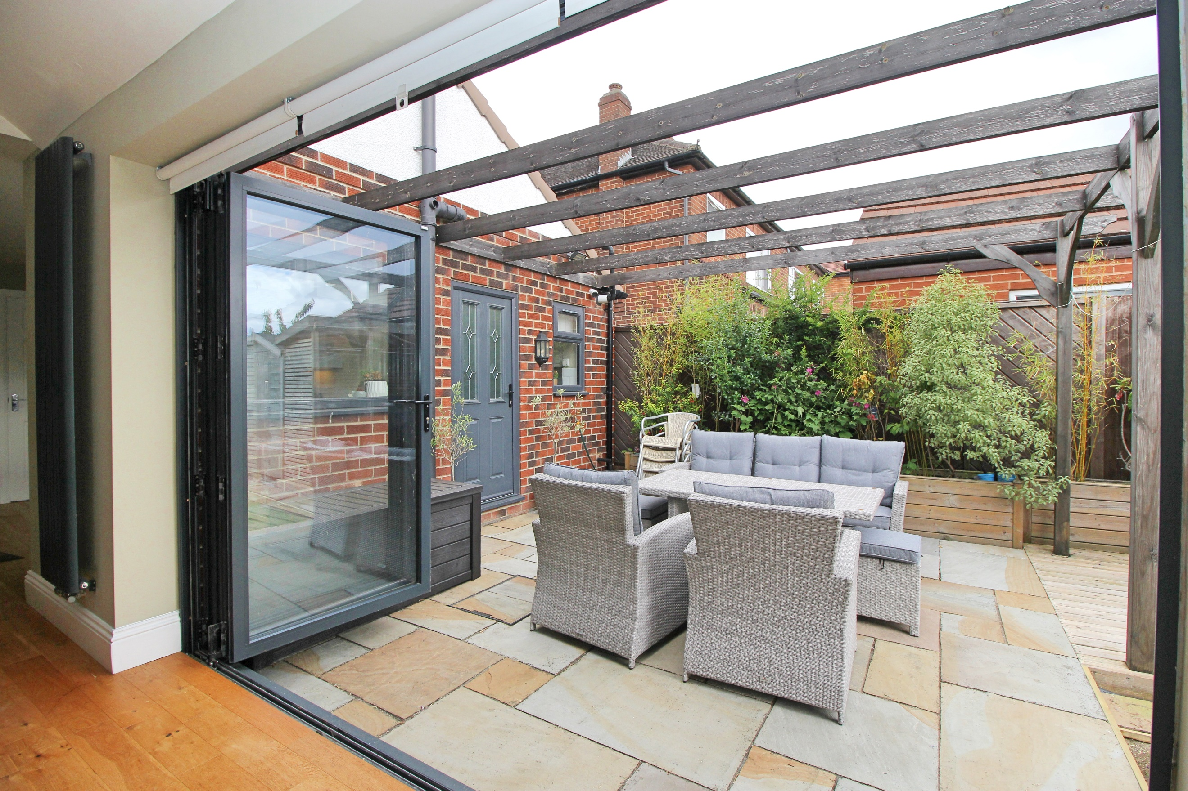
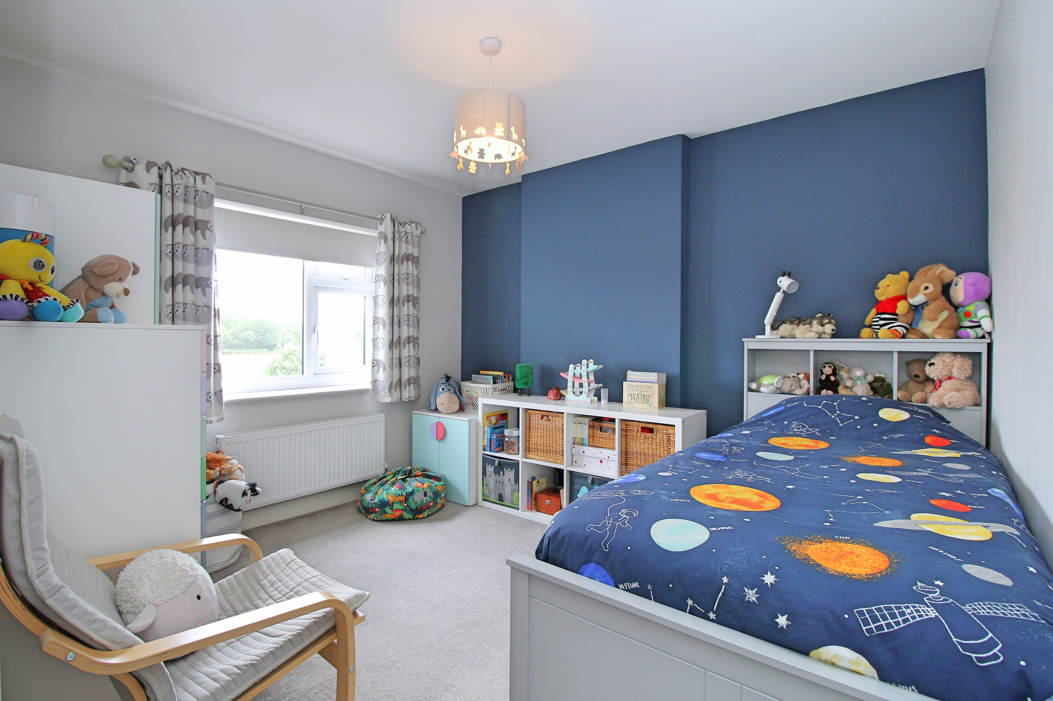
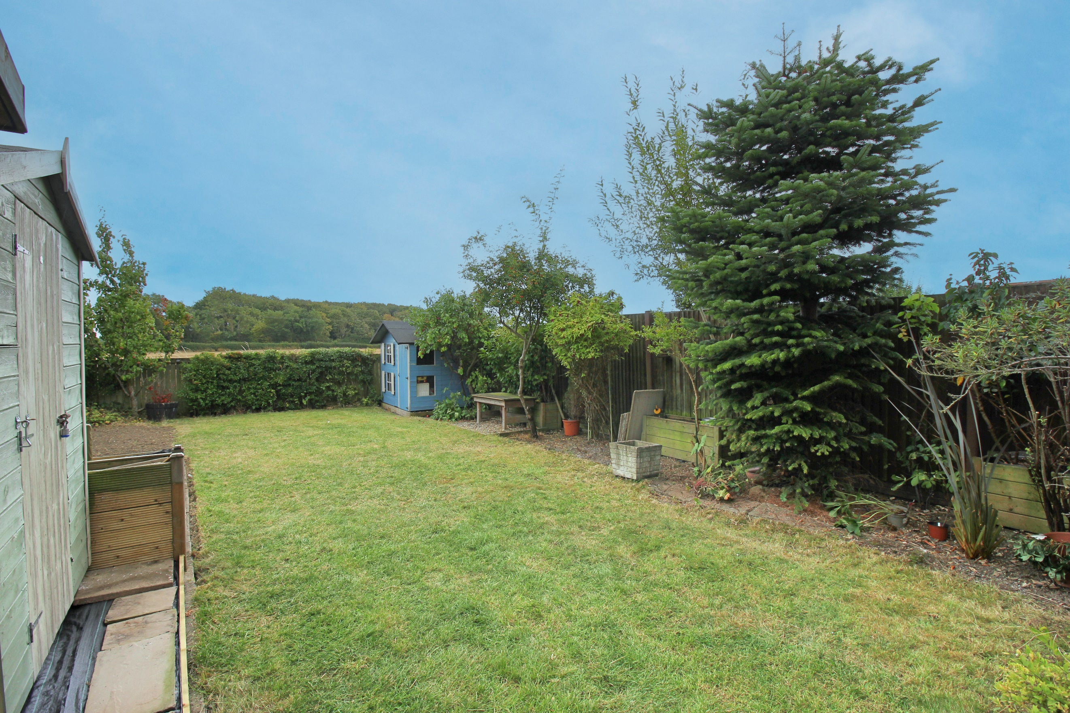
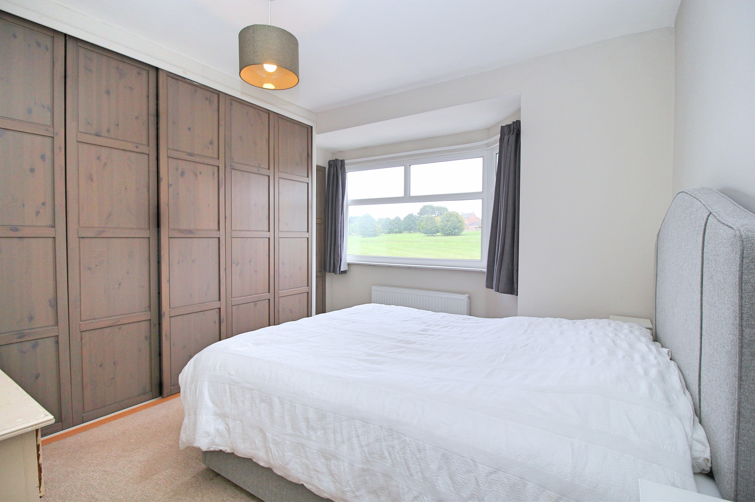
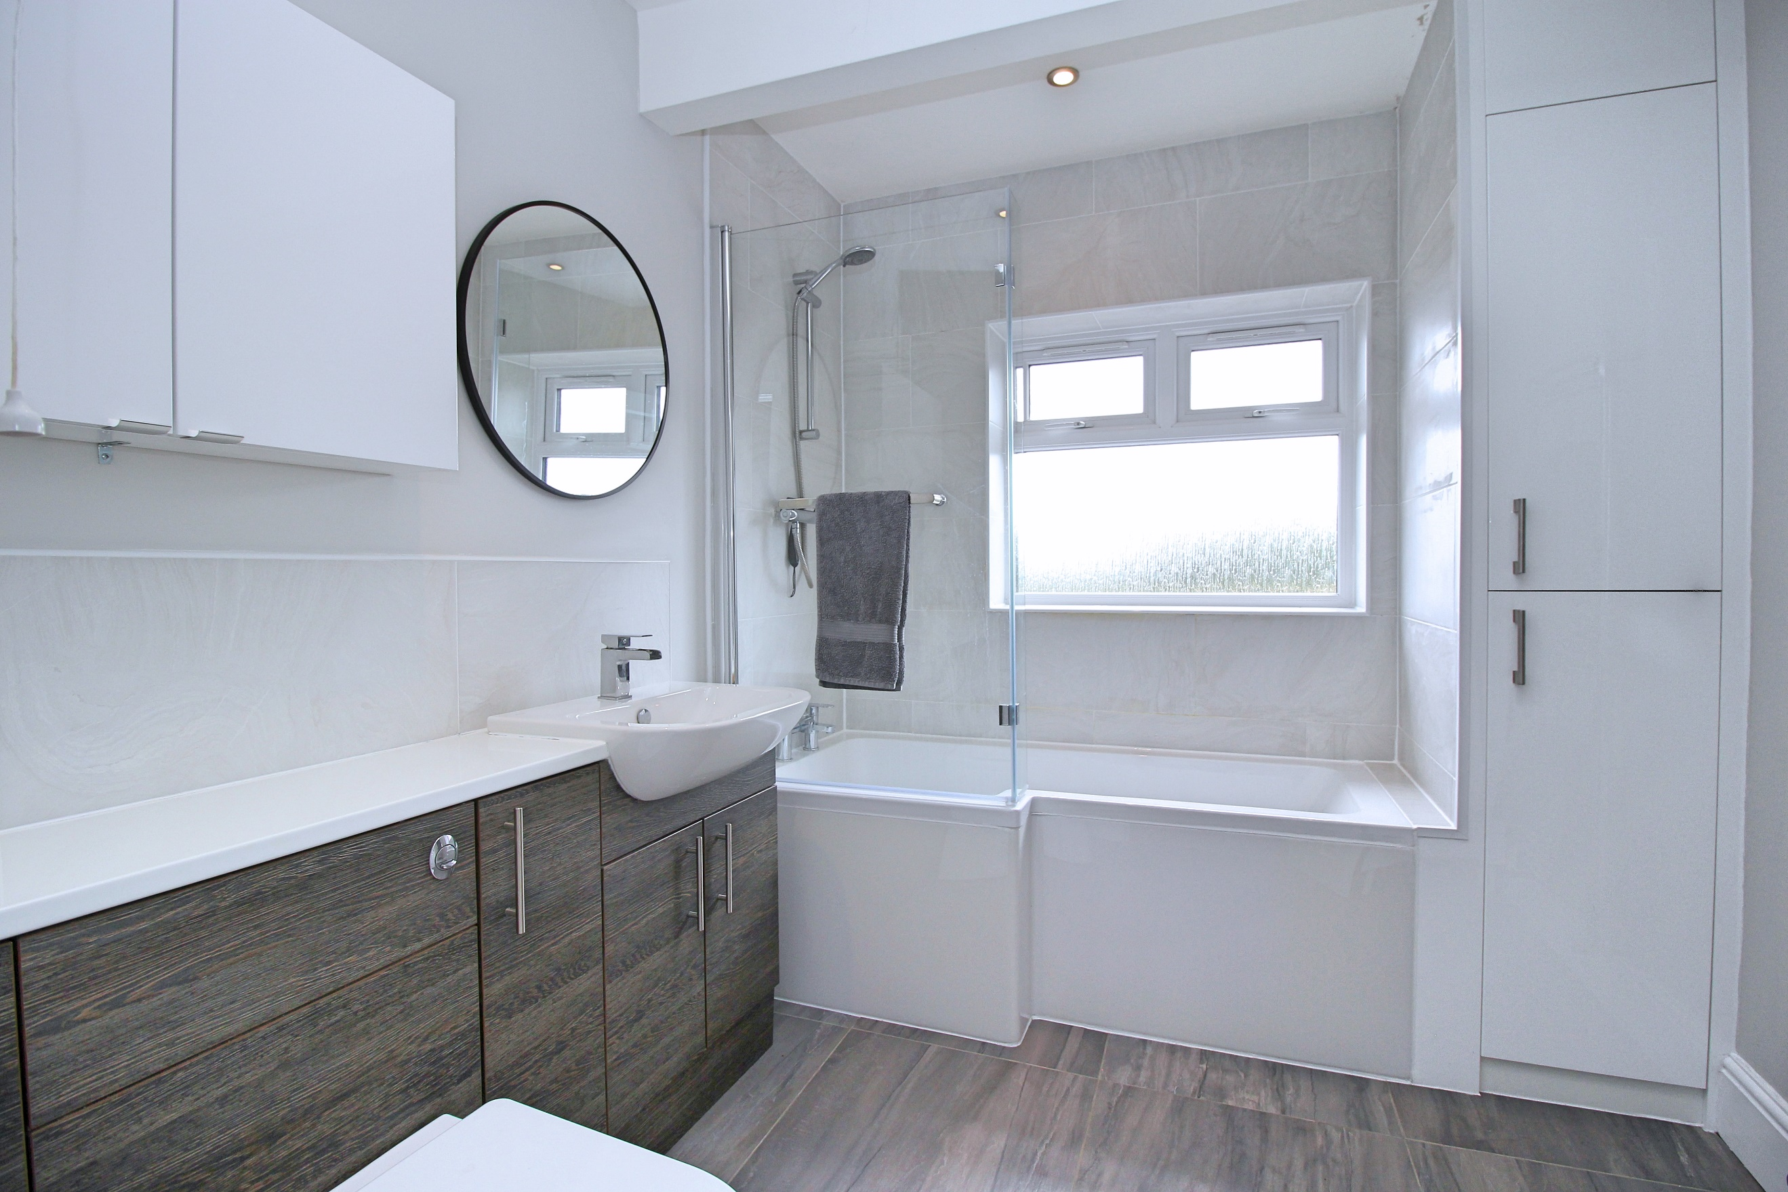

Hallway
Via front entrance door. Stairs to first floor. Gas central heating radiator.

Living Room 3.58m (11'9) x 4.56m (15')
Light and Airy living room with uPVC double glazed window to the front. Gas fire set in surround to chimney breast. Gas central heating radiator.

Open Plan Kitchen 5.53m (18'2) x 3.59m (11'9)
Fitted with a range of wall, base and drawer units with worktops over. Two Integrated ovens, an integrated microwave and integrated dishwasher. 1.5 bowl sink with mixer tap and drainer. 5-ring gas hob with extractor over. Space for American fridge/freezer. uPVC double glazed window to rear. Inset ceiling spotlights. Store cupboard.

Family Room 2.88m (9'5) x 4.81m (15'9)
With uPVC double glazed window to rear. Bi-fold doors to the side leading out to the rear garden. Tall gas central heating radiator. Inset ceiling spotlights.

Utility Room 2.46m (8'1) x 2.56m (8'5)
Fitted with a range of wall, base and drawer units with worktops over. Stainless steel sink with mixer tap and drainer. Space for washing machine. Part tiled walls. Inset ceiling spotlights. uPVC double glazed window to rear and door leading out to the rear garden. Gas central heating radiator.

Guest WC
Guest WC comprising WC and wash hand basin.

Integral Garage 2.46m (8'1) x 4.11m (13'6)
Access via the inner hallway or electric front door.

Second Floor
uPVC double glazed window to side. Loft access. Store cupboard.

Master Bedroom 3.68m (12'1) x 3.73m (12'3)
Double bedroom with uPVC double glazed bay window overlooking open fields. Built in wardrobes. Gas central heating radiator.

Bedroom Two 3.07m (10'1) x 3.47m (11'5)
Second double bedroom with uPVC double glazed window to rear. Gas central heating radiator.

Bedroom Three 1.79m (5'10) x 2.14m (7'0)
Third bedroom with uPVC double glazed window to front. Gas central heating radiator.

Bathroom
Modern bathroom fitted with a three piece suite comprising; bath with shower over, vanity wash hand basin and WC. Wall cupboard. Tiled walls. uPVC double glazed window to rear. Inset ceiling spotlights.

Outside
To the front of the property is a driveway offering off street parking and leading to an integral garage. To the rear of the property is an enclosed garden which has been mainly laid to lawn with a generous sized patio ideal for entertaining. A well maintained decked area with borders of shrubs and plants.

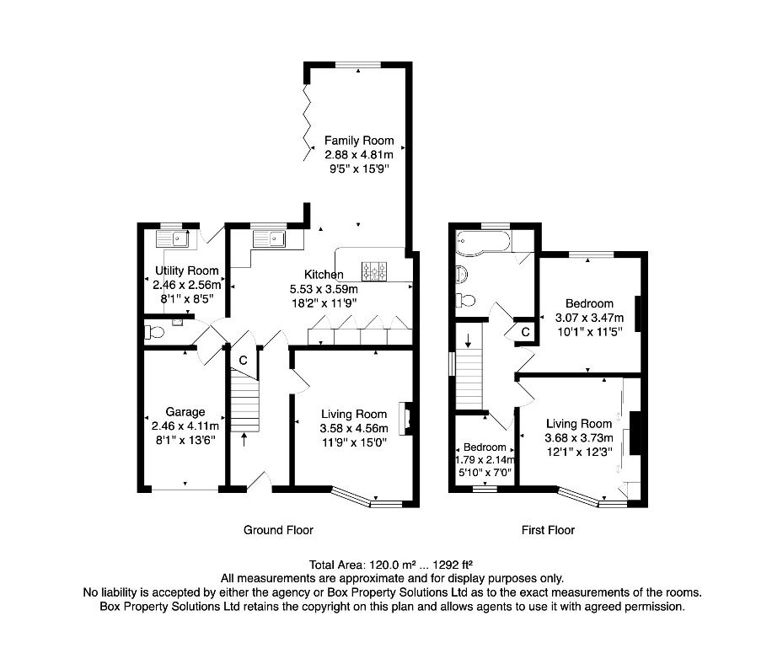

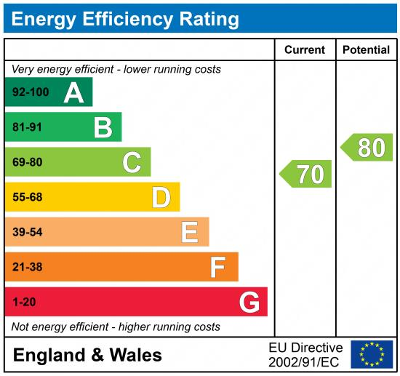

These particulars are intended to give a fair description of the property, but their accuracy cannot be guaranteed, and they do not constitute an offer of contract. Intending purchasers must rely on their own inspection of the property. None of the above appliances/services have been tested by ourselves. We recommend purchasers arrange for a qualified person to check all appliances/services before legal commitment.

Property Ref: 7260

For more information, please contact

0113 258 1150 | sales@adairpaxton.co.uk | www.adairpaxton.co.uk

