

**Garden Cottage, Wortley, LS12**

**Available to let £895.00pcm**

Quaint two-bedroom Stone Cottage nestled in a quiet corner with a secluded gravelled garden. The property is well placed for easy access to the City Centre and beyond. The benefit of large glazed doors, gas central heating, double glazing and neutral decor throughout. Comprising; Lounge, kitchen, two bedrooms with Velux windows, bathroom with shower over bath. Off street parking. Council Tax B. EPC rating D. Furnished. Bond £1030. Available Now. Due to the lease this property has a no pet policy.

**0113 258 1150**

**0800 000 000**

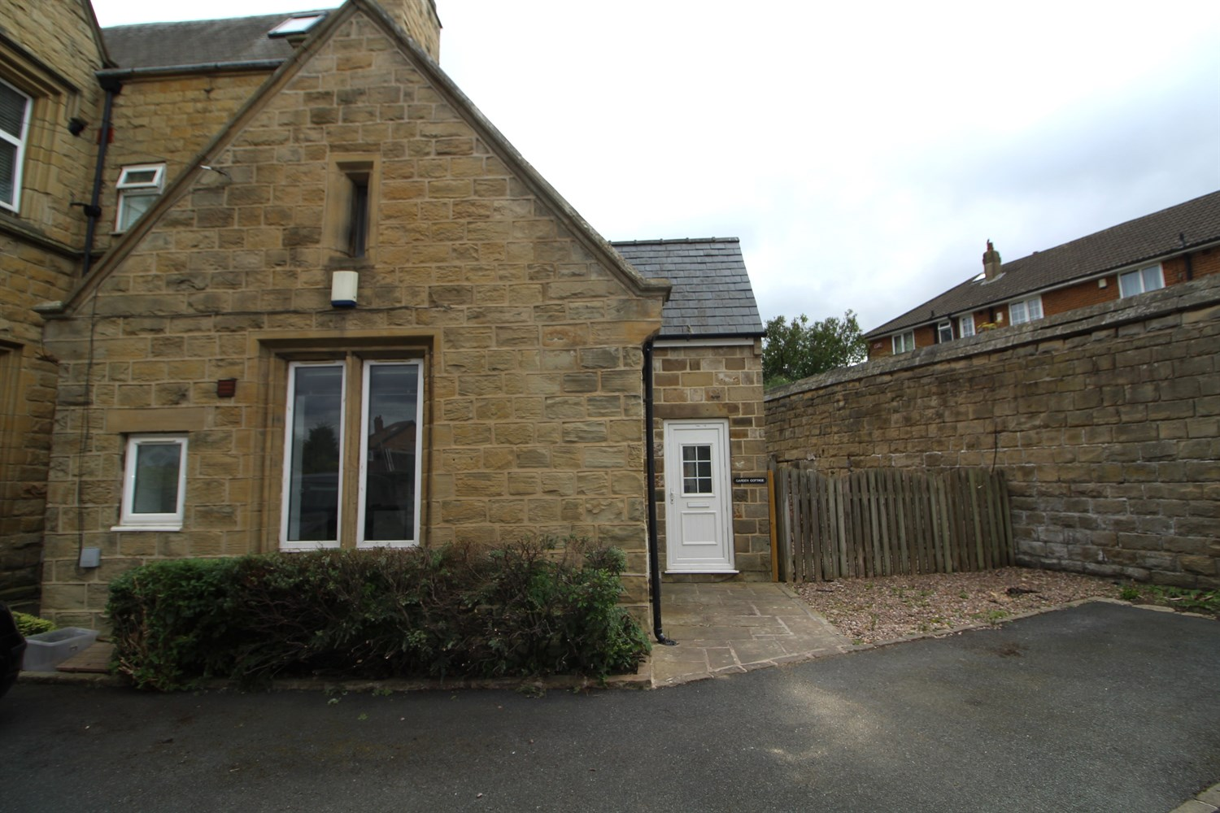

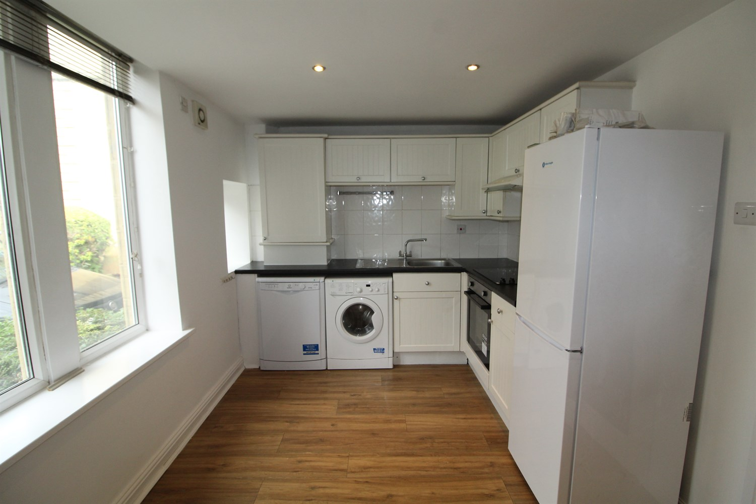

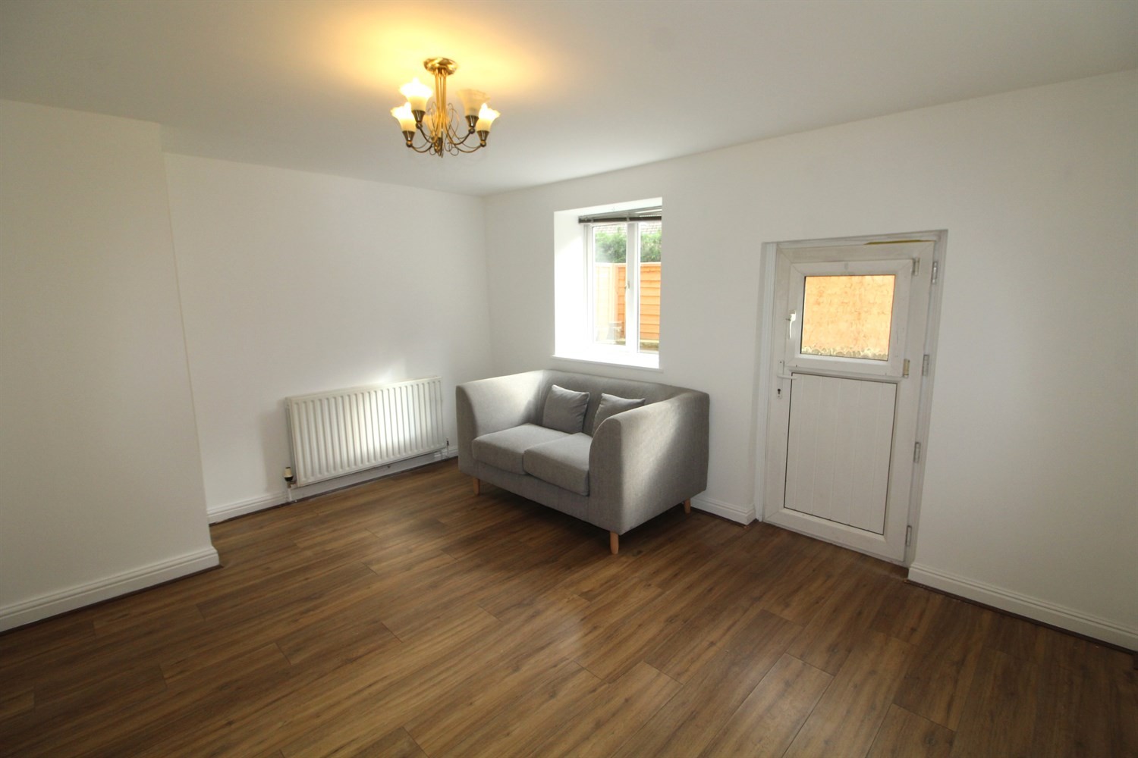

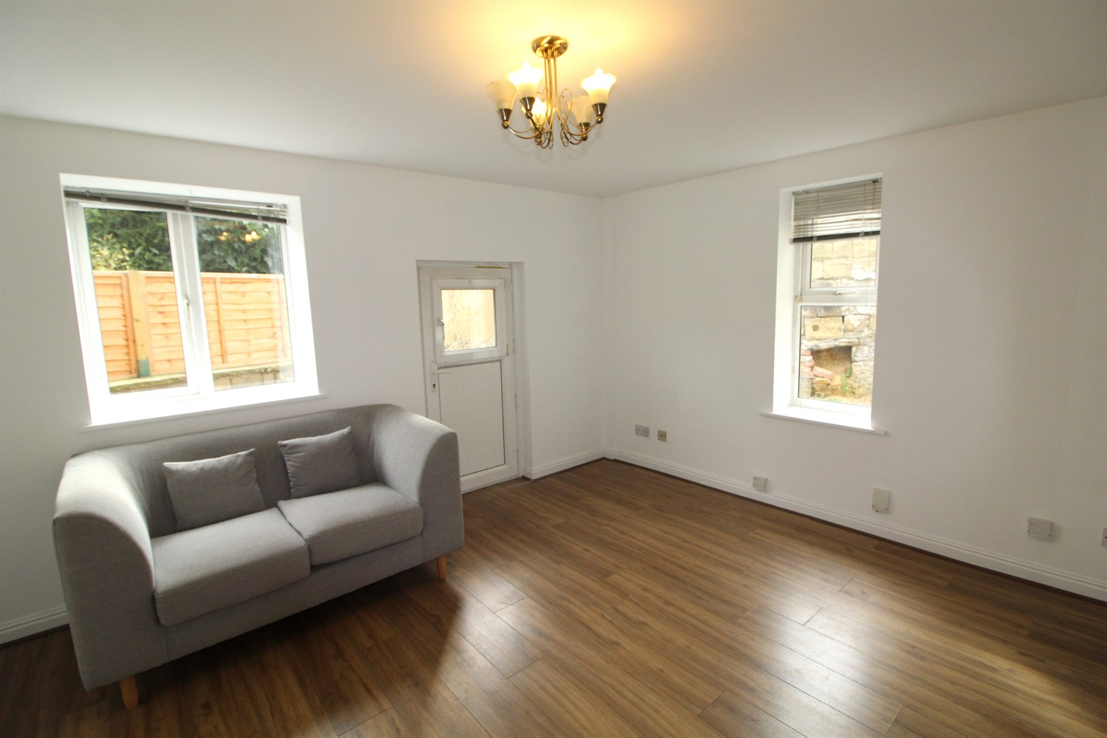

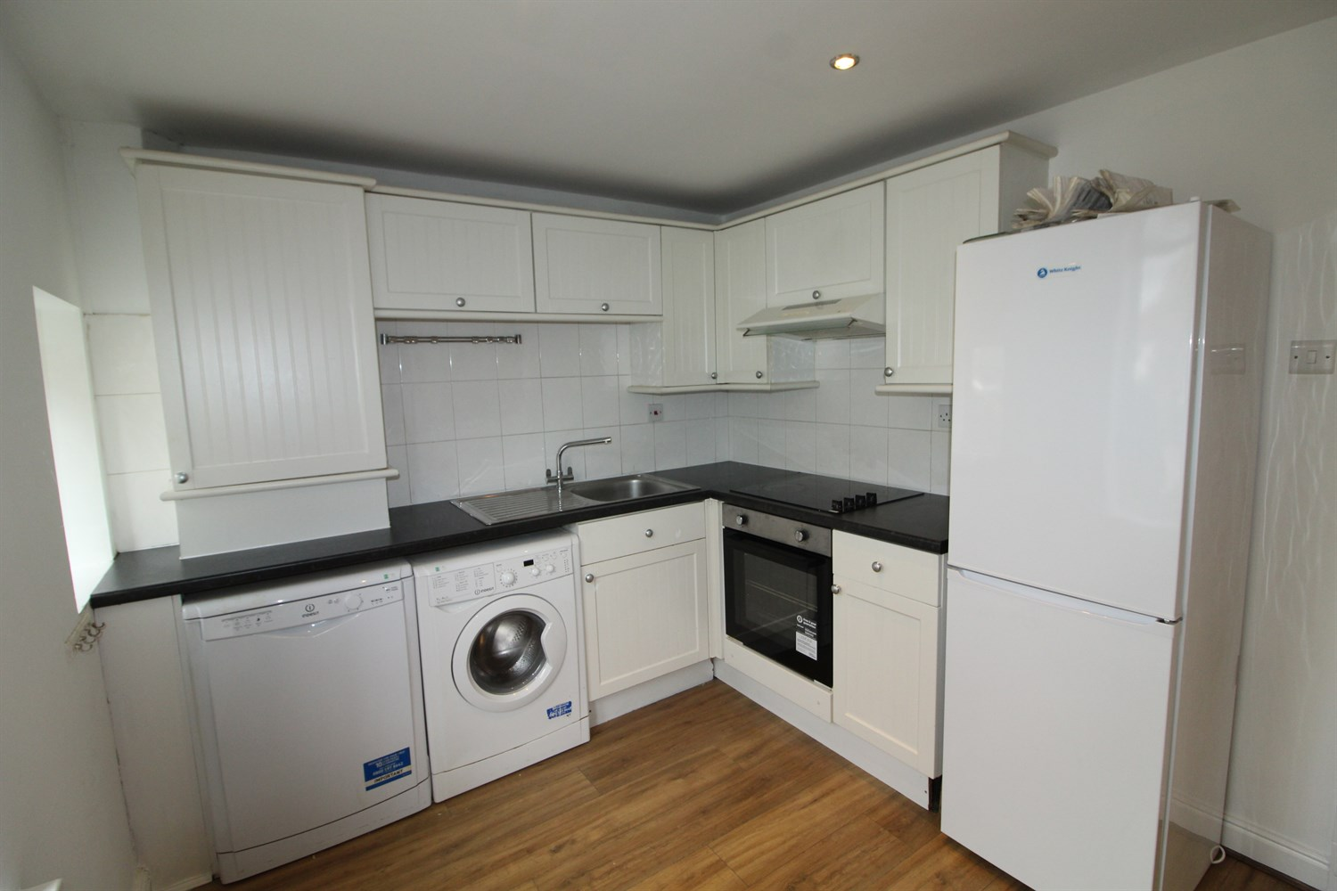

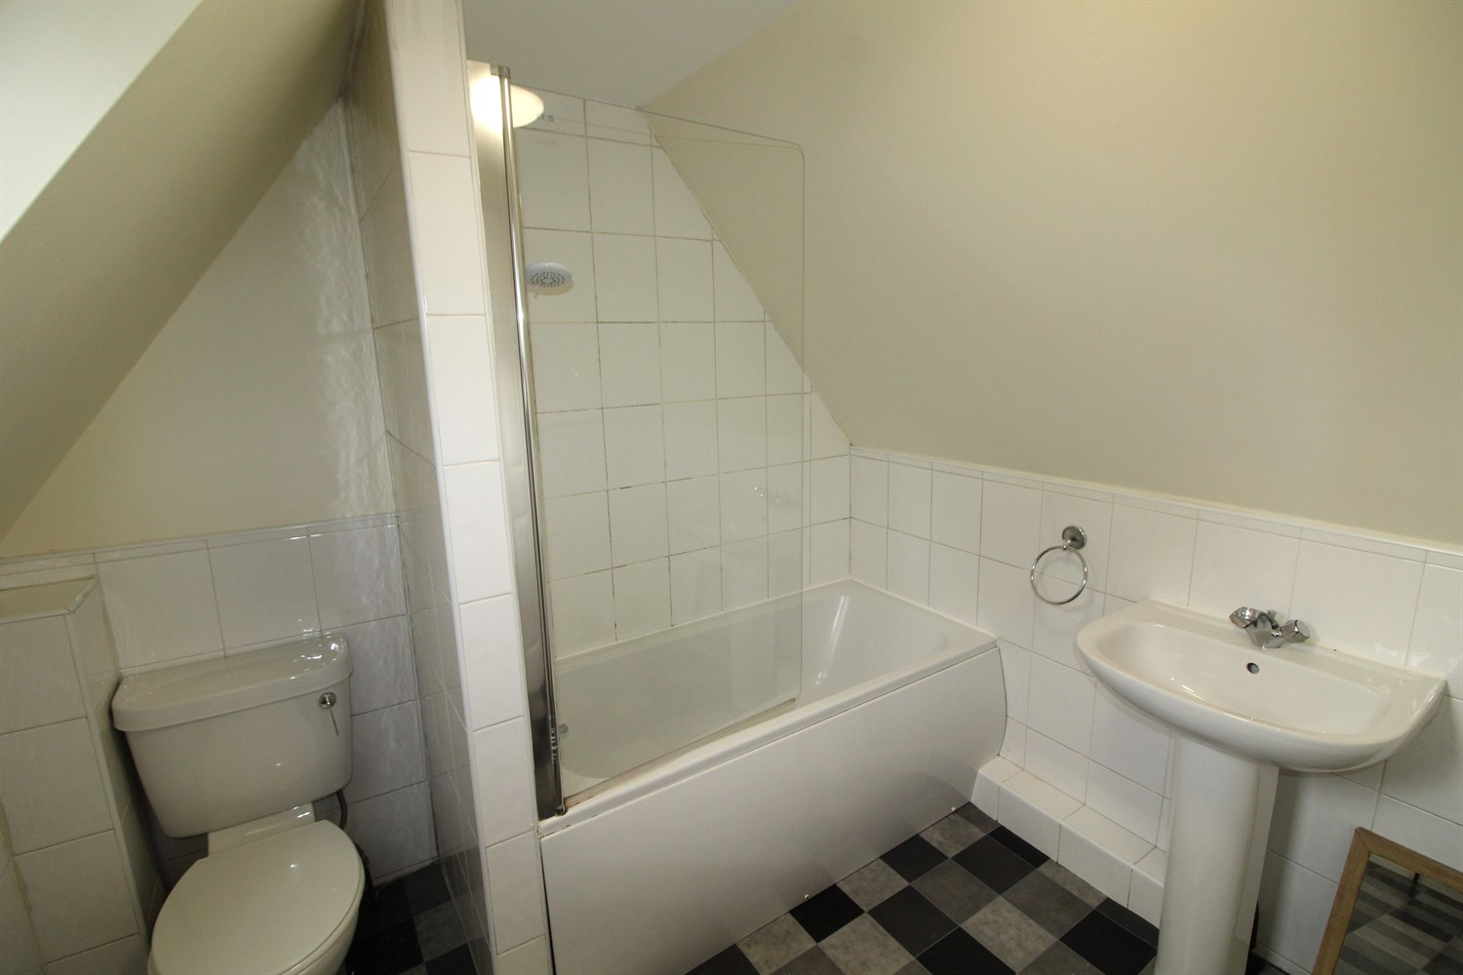

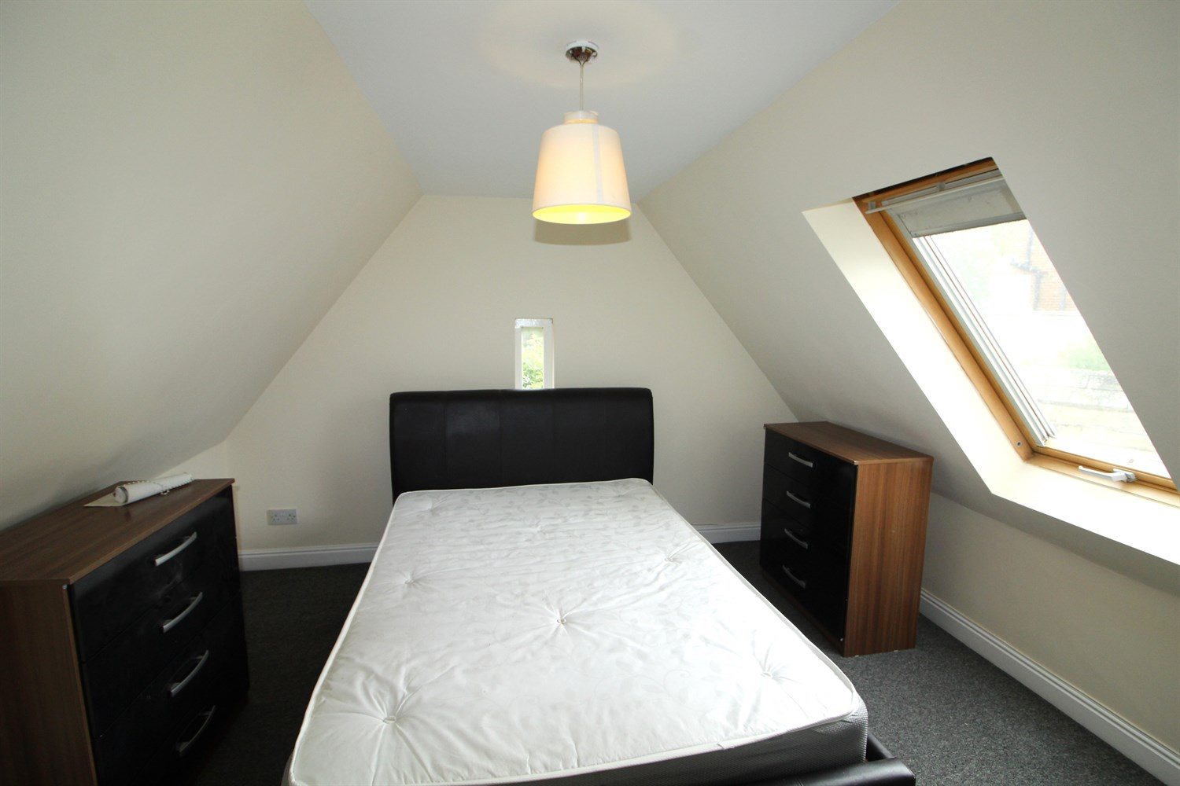

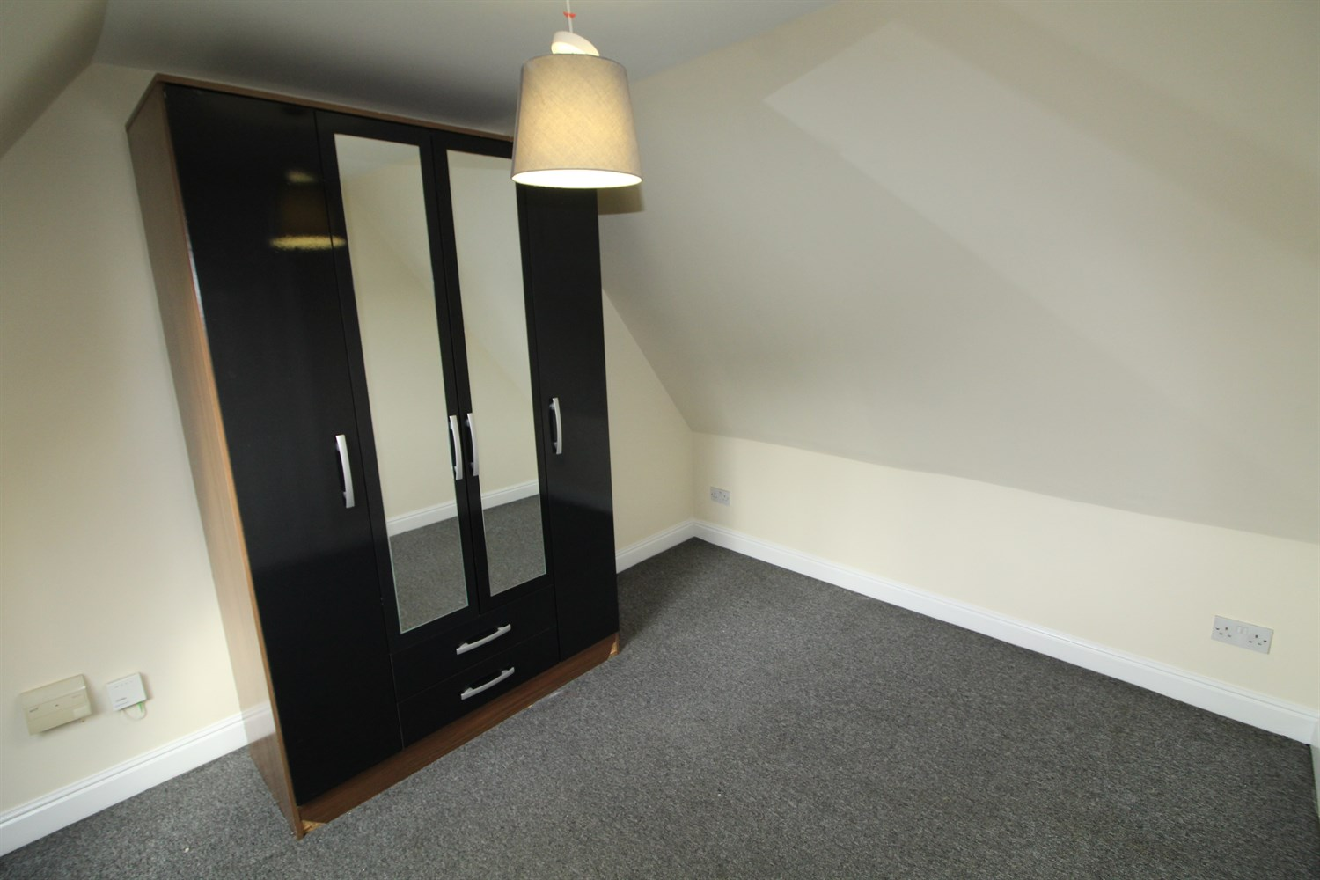

|  |
| --- |
| **Entrance Hall**  With storage cupboard. |
| **Living Room**  Large living area with window and door to rear, wood effect floor. Gas central heating radiator. |
| **Kitchen/Diner**  Fitted with a range of wall and base units with work tops over. Stainless steel sink with mixer tap, Washing machine, dishwasher, fridge-freezer, electric oven and hob with extractor over head. Space for dining table. |
| **Downstairs W/C**  W/C and hand wash basin. Part tiled walls. |
| **First Floor**  Stairs leading to first floor. |
| **Bedroom One**  Carpeted double bedroom with Velux window and gas central heating radiator. |
| **Bedroom 2**  Carpeted double bedroom with Velux window and gas central heating radiator. |
| **House Bathroom**  Three piece bathroom suite with shower over bath, W/C and hand wash basin, part tiled walls. |
| **Home Information**  12 month Tenancy. COUNCIL TAX BAND: B EPC Rating D  Leasehold property Off road parking.  Broadband: No Virgin Media:  Standard 18 Mbps 1 Mbps Good Superfast --Not available --Not available Unlikely Ultrafast 1000 Mbps 1000 Mbps Mobile availability: EE likely to have good coverage. Three likely to have good coverage. O2 likely to have good coverage. Vodafone limited coverage.  Utilities: Water supplied on standard meters. Electric mains supplied on standard meters. Gas supplied on main meters. |

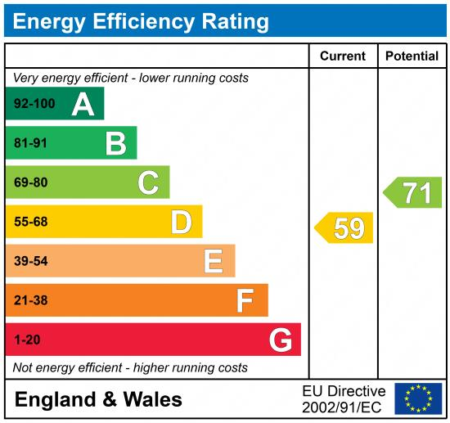

|  |
| --- |
|  |

These particulars are intended to give a fair description of the property, but their accuracy cannot be guaranteed, and they do not constitute an offer of contract. Intending purchasers must rely on their own inspection of the property. None of the above appliances/services have been tested by ourselves. We recommend purchasers arrange for a qualified person to check all appliances/services before legal commitment.

**Property Ref:** 7204

**For more information, please contact**

0113 258 1150 **|** [lettings@adairpaxton.co.uk](mailto:lettings@adairpaxton.co.uk) **|** www.adairpaxton.co.uk