

**Smithson Street, LS26**

**Available to let £850.00pcm**

Two double bedroom through terrace house, situated in the popular village of Rothwell. Close to all local amenities the accommodation briefly comprises: Lounge, good size fitted kitchen/diner, two double bedrooms and house bathroom. the property also benefits from double glazing and gas central heating. Garden to front and spacious garden to rear. Unfurnished. The property must be viewed to appreciate the accommodation on offer. Bond £980. Available 19th September, Council tax band A, EPC rating D.

**0113 258 1150**

**0800 000 000**

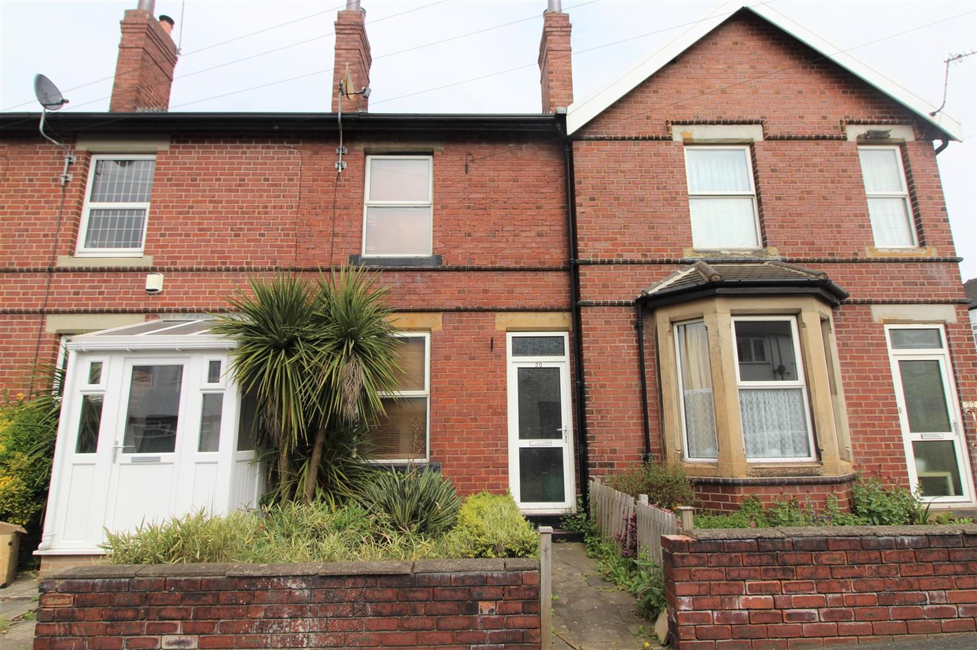



1 Reception(s)

1 Bathroom(s)

2 Bedroom(s)

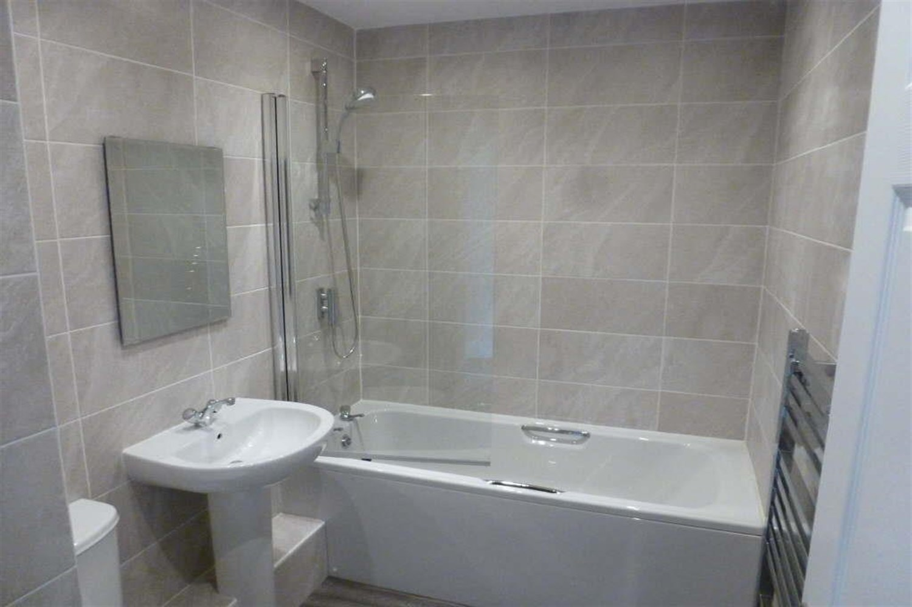

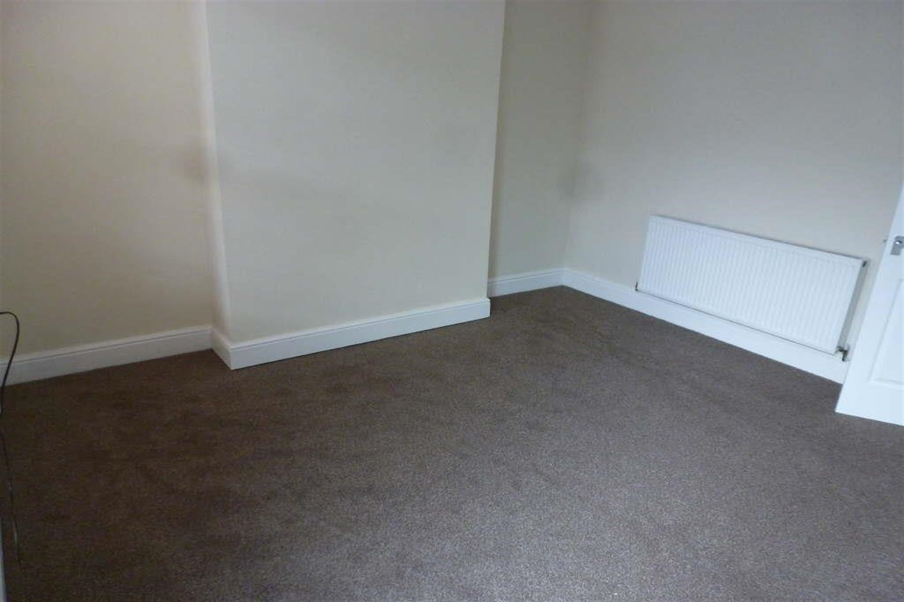

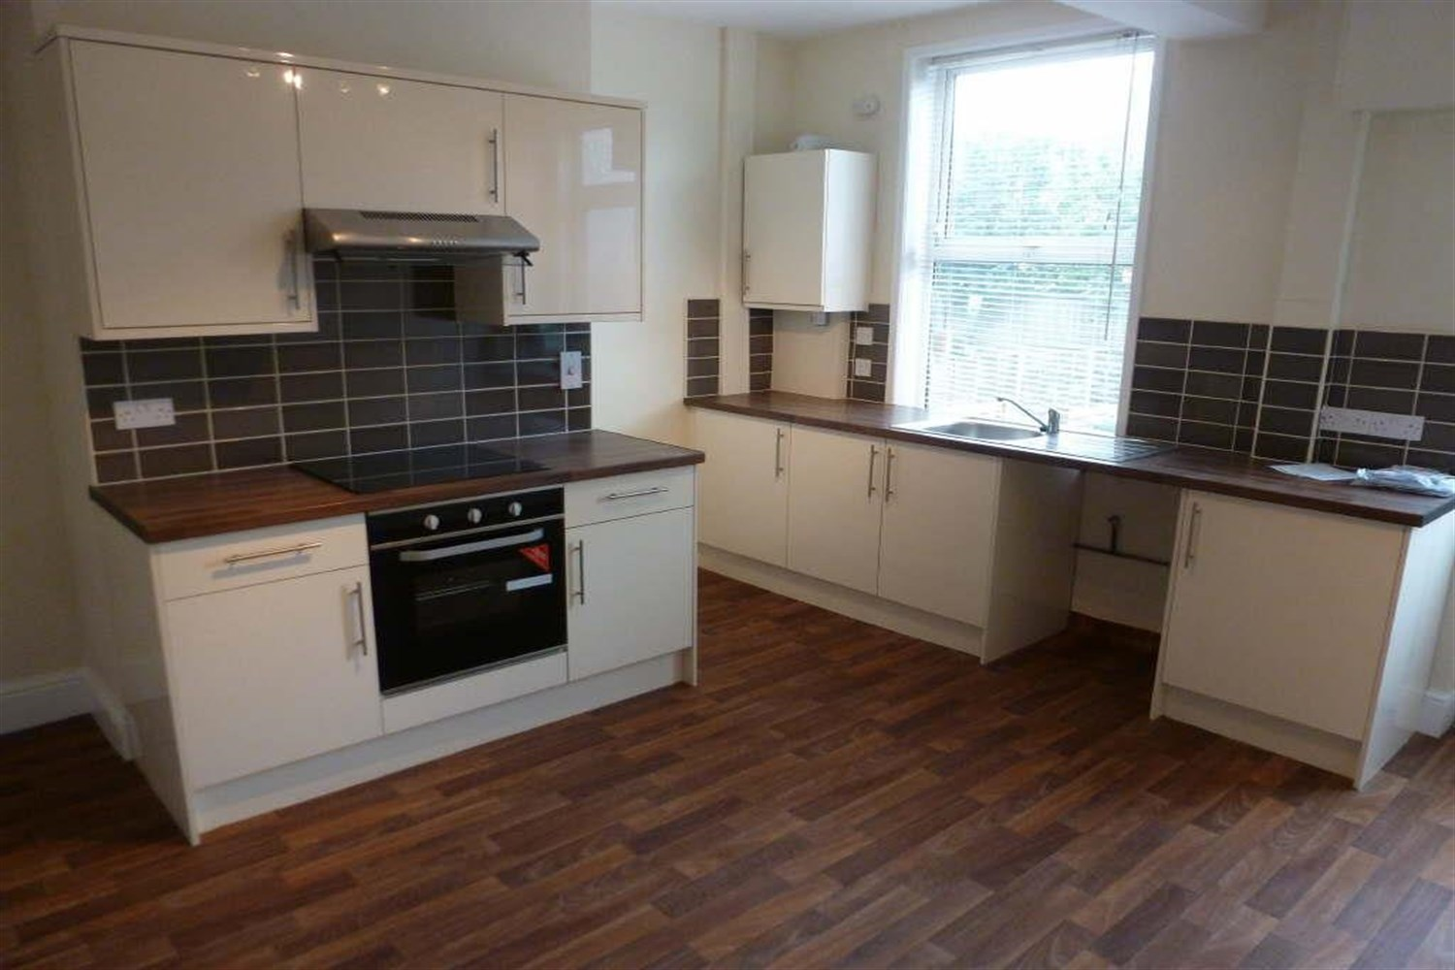

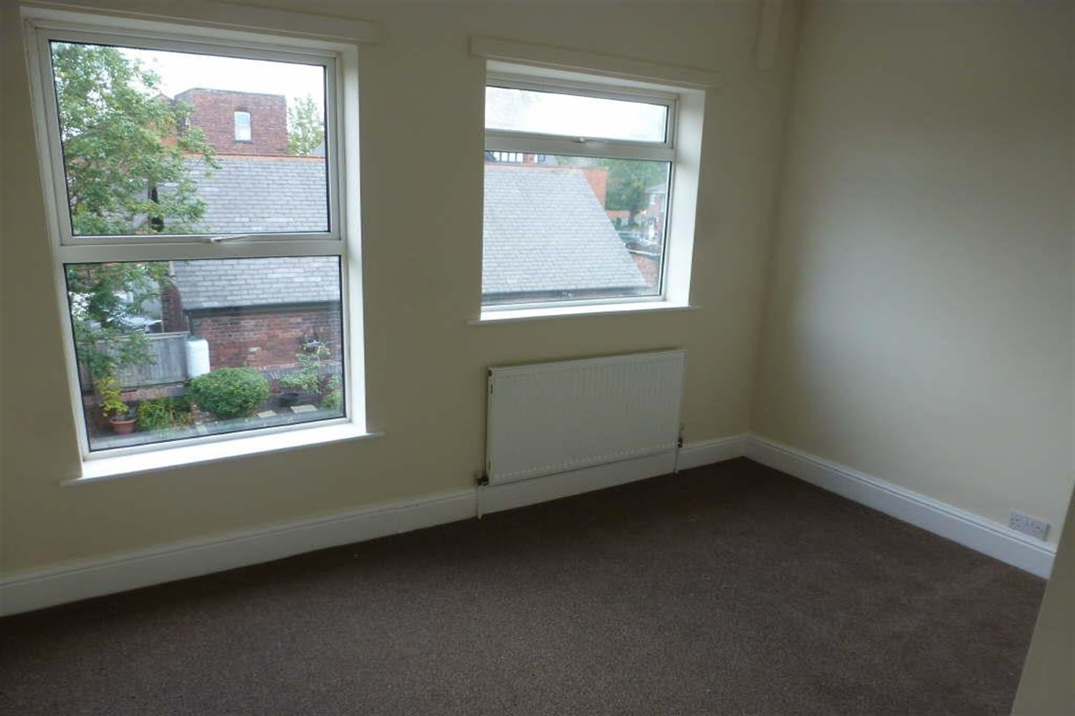

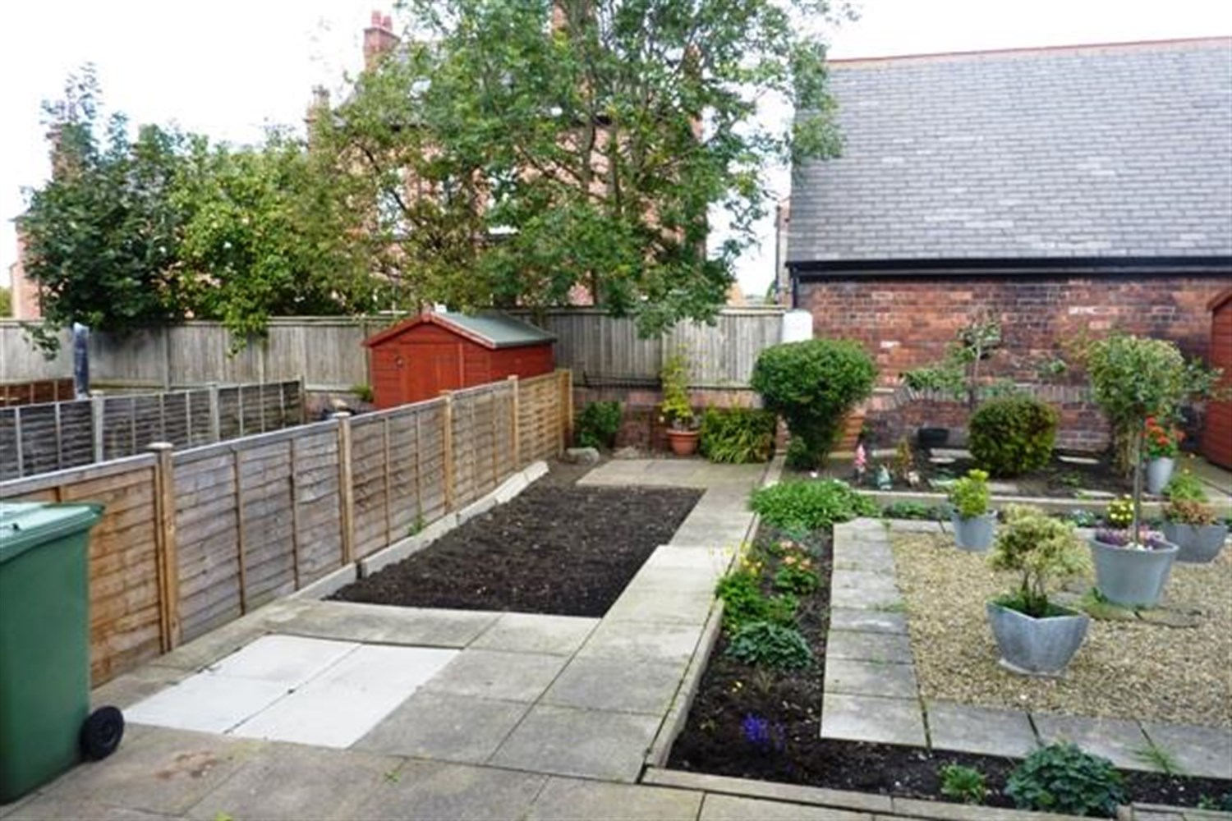

|  |
| --- |
| **Reception 1**  Spacious living area with uPVC double glazed window to front. Gas central heating radiator. |
| **Kitchen**  Spacious kitchen/diner with uPVC double glazed window to rear. Stainless steel sink. Electric oven and hob and plumbing for washing machine. Door leading out to rear garden. |
| **Bedroom 1**  Carpeted double bedroom with double glazed window to front. Gas central heating radiator. |
| **Bedroom 2**  Carpeted double bedroom with double glazed window to rear. Gas central heating radiator. |
| **Bathroom**  Fitted with a three piece white suite comprising; bath, WC and wash hand basin, tiled walls. Double glazed window to rear. |
| **Garden**  To the front of the property is an enclosed courtyard style garden with borders of plants and shrubs. To the rear is a good sized garden which is mainly paved with borders of plants and flowers. |
| **Parking**  On street parking. |
| **Home Information** |

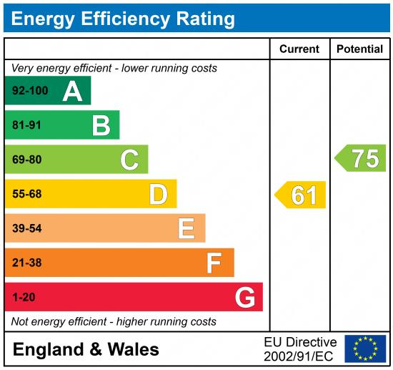

|  |
| --- |
|  |

These particulars are intended to give a fair description of the property, but their accuracy cannot be guaranteed, and they do not constitute an offer of contract. Intending purchasers must rely on their own inspection of the property. None of the above appliances/services have been tested by ourselves. We recommend purchasers arrange for a qualified person to check all appliances/services before legal commitment.

**Property Ref:** 7219

**For more information, please contact**

0113 258 1150 **|** [lettings@adairpaxton.co.uk](mailto:lettings@adairpaxton.co.uk) **|** www.adairpaxton.co.uk