

**Iveson Drive,, LS16**

**Available to let £850.00pcm**

***LUXURY FIRST FLOOR, TWO BEDROOM APARTMENT WITH PARKING***set in this convenient location. Ireland Wood is a stunning development of just 20 apartments located on Iveson Drive, between Horsforth and Adel. All of the apartments are finished to an exceptional standard. 2 double bedrooms and comprise: entrance hall, open plan living room/kitchen/diner with balcony or juliet balcony, master bedroom with en suite shower room, second double bedroom and house bathroom. Council Tax Band B, EPC rating , Deposit £800. Unfurnished with white goods. Available 26th September. Due to the lease this property has a no pet policy.

**0113 258 1150**

**0800 000 000**

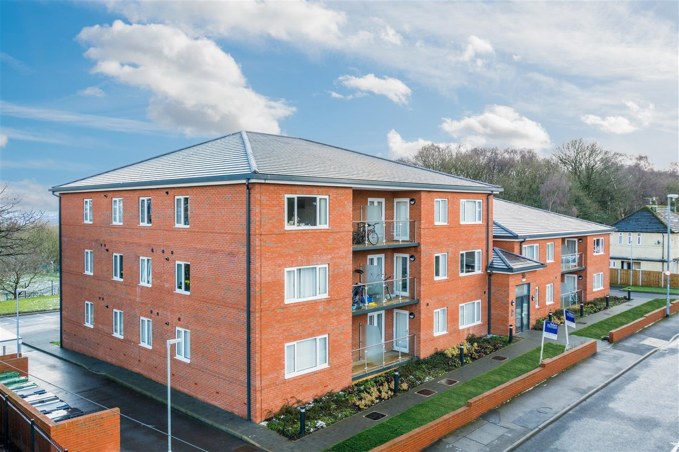

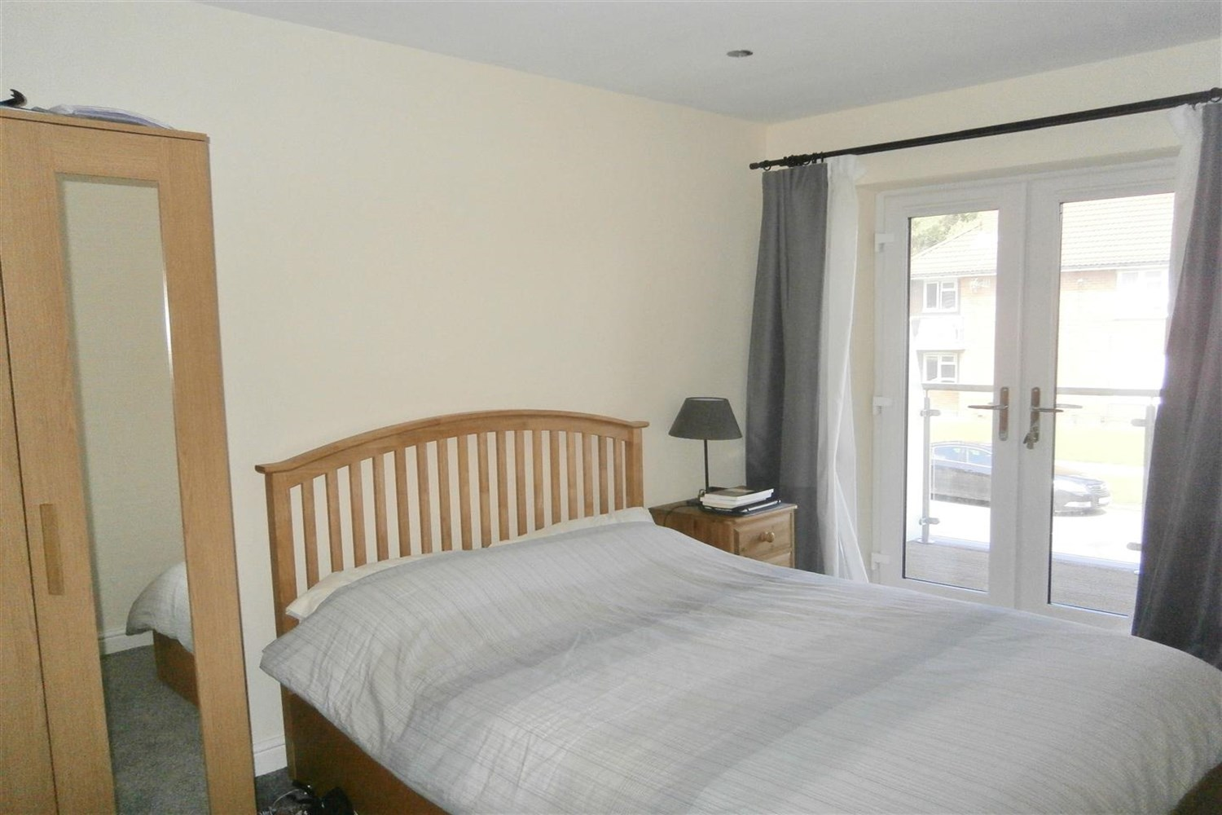

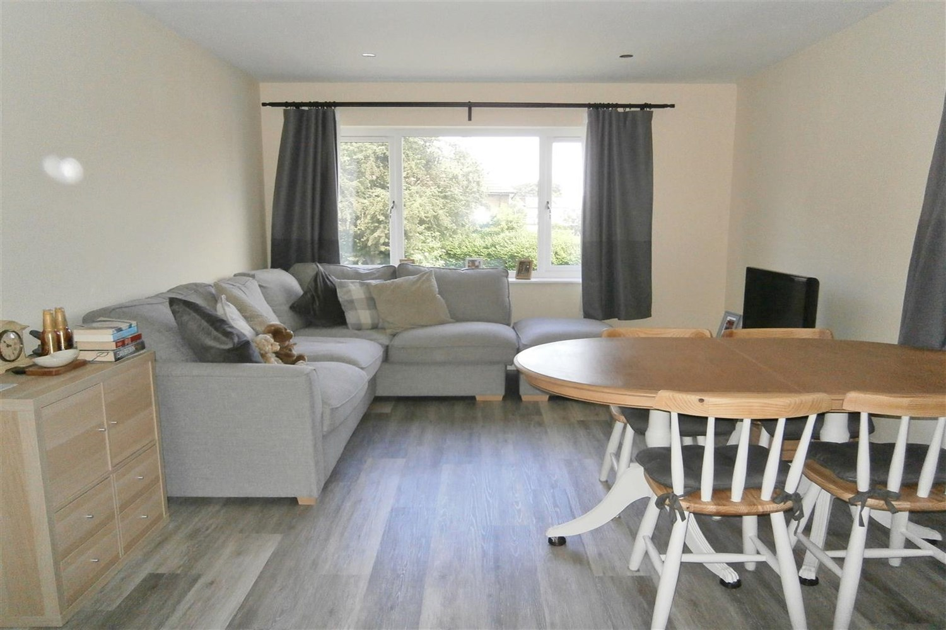

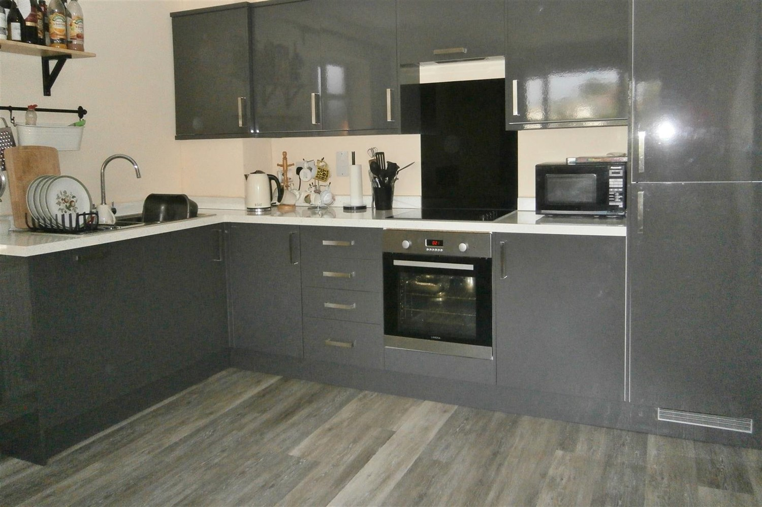

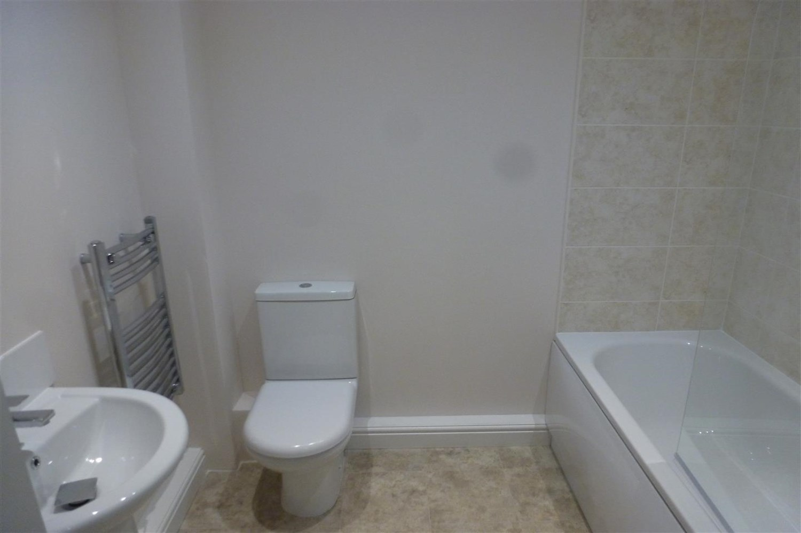

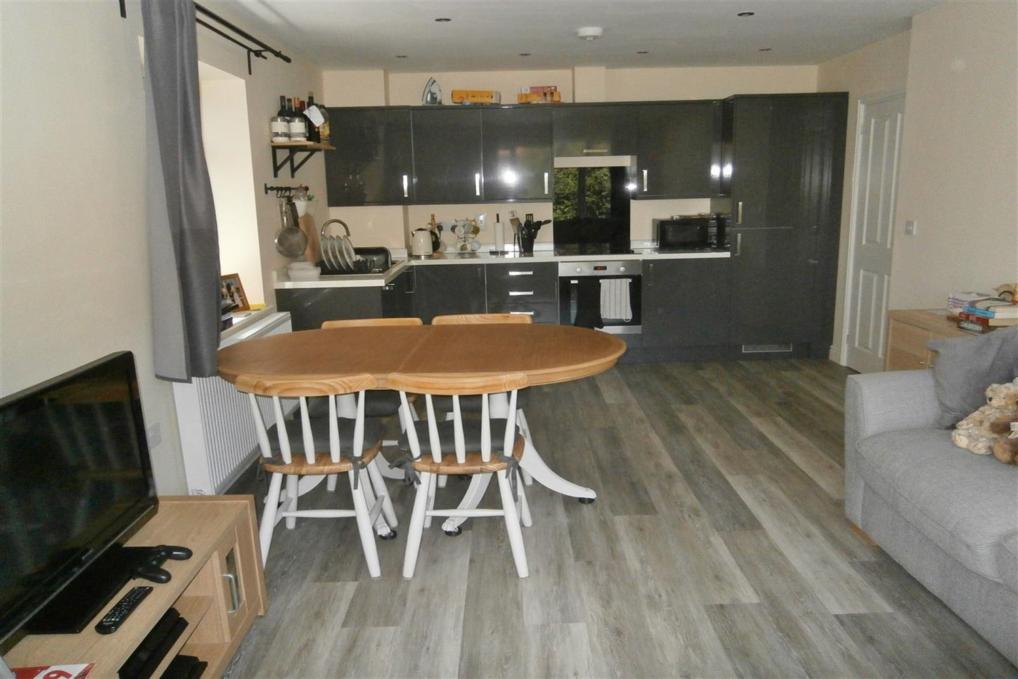

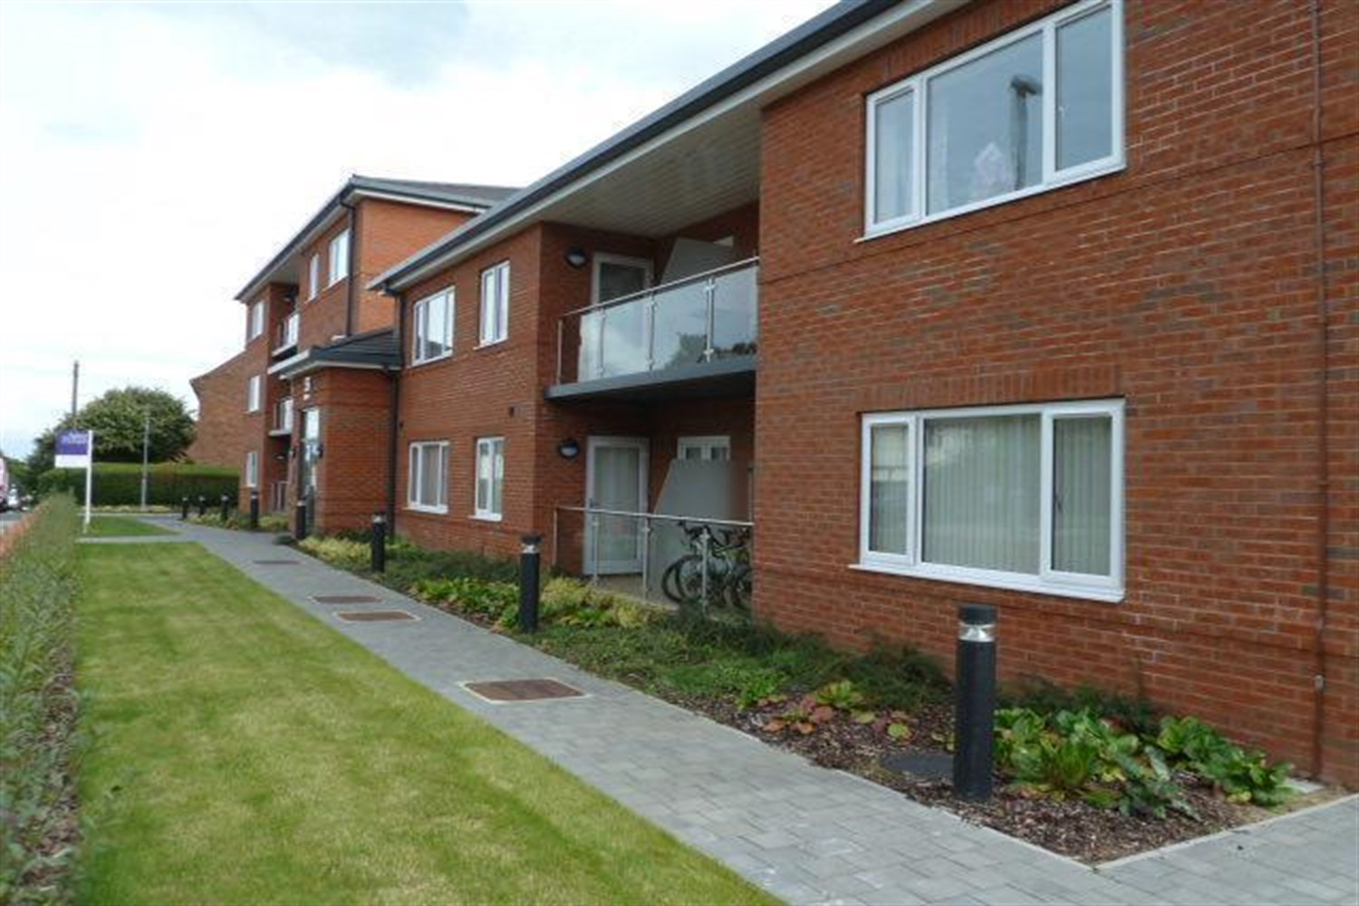

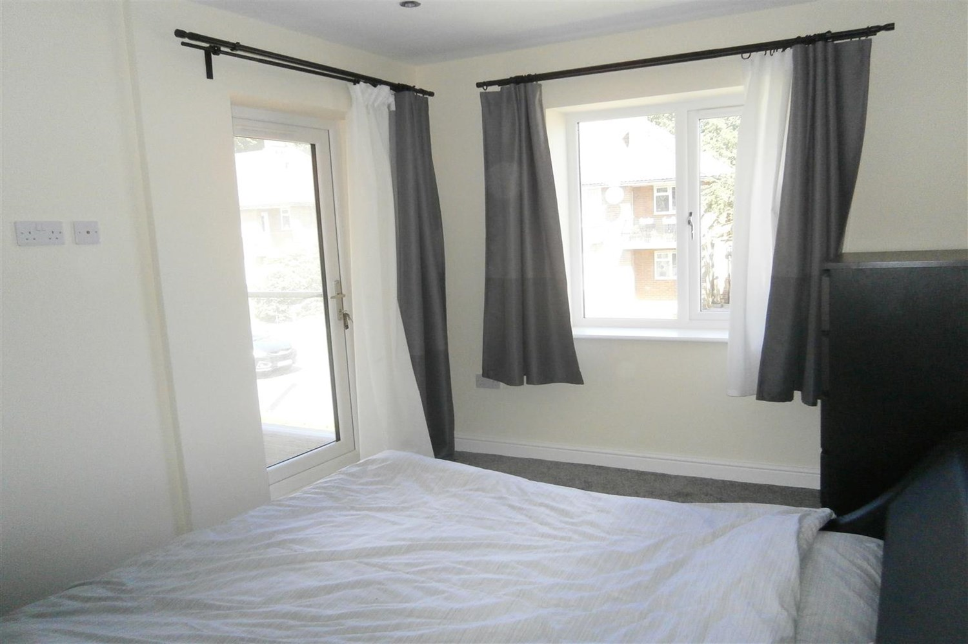

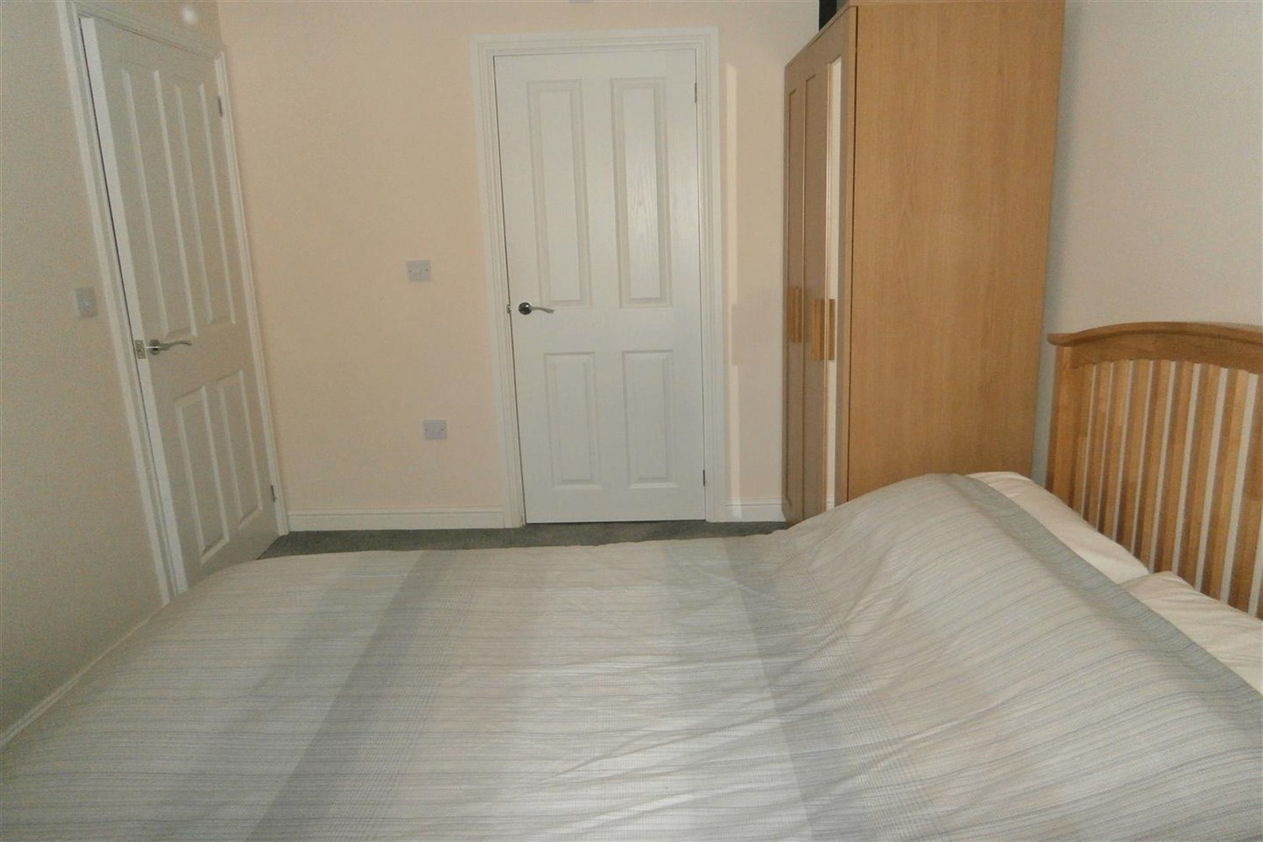

|  |
| --- |
| **Communal Entrance Hall**  Entry fob system with lift to all floors. |
| **Private Entrance Hall**  Via front entrance door. Store cupboard house washing machine. |
| **Open Plan Kitchen/Diner/Lounge**  A contemporary, open plan living room with kitchen and space for a dining table. uPVC double glazed doors open to the balcony. Fitted kitchen with a range of white, high gloss wall, base and drawer units with work surfaces over. Featuring electric fan oven, gas hob with feature stainless steel extractor hood, stainless steel sink with chrome mixer taps. Integrated fridge/freezer and dishwasher. The plumbing for the washing machine is located in a cupboard in the hallway. |
| **Bedroom 1**  A spacious double bedroom with uPVC double glazed window to the rear. Gas central heating radiator. |
| **Ensuite**  Fitted with a three piece white suite comprising shower cubicle, WC and wash hand basin. Part tiled walls. Chrome heated ladder towel rail. |
| **Bedroom 2**  A spacious double bedroom with uPVC double glazed window to the rear. Gas central heating radiator. |
| **House Bathroom**  Fitted with a three piece white suite comprising bath with shower attachment to the taps and glass screen, WC and wash hand basin. Part tiled walls. Chrome heated ladder towel rail. |
| **Home Information**  COUNCIL TAX BAND: B EPC Rating B.  Leasehold property. Parking.  Broadband: Standard 8 Mbps 0.8 Mbps Good Superfast --Not available --Not available Unlikely Ultrafast 1800 Mbps 220 Mbps  Mobile availability:  EE limited coverage . Three likely to have good coverage. O2 limited coverage. Vodafone limited coverage.  Utilities: Water supplied on standard meters. Gas and Electric mains supplied on standard meters |

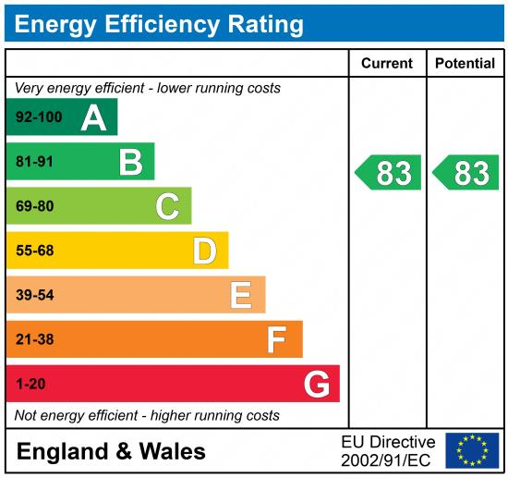

|  |
| --- |
|  |

These particulars are intended to give a fair description of the property, but their accuracy cannot be guaranteed, and they do not constitute an offer of contract. Intending purchasers must rely on their own inspection of the property. None of the above appliances/services have been tested by ourselves. We recommend purchasers arrange for a qualified person to check all appliances/services before legal commitment.

**Property Ref:** 7193

**For more information, please contact**

0113 258 1150 **|** [lettings@adairpaxton.co.uk](mailto:lettings@adairpaxton.co.uk) **|** www.adairpaxton.co.uk